**Documentation**

1. Conceptual architecture of the distributed system

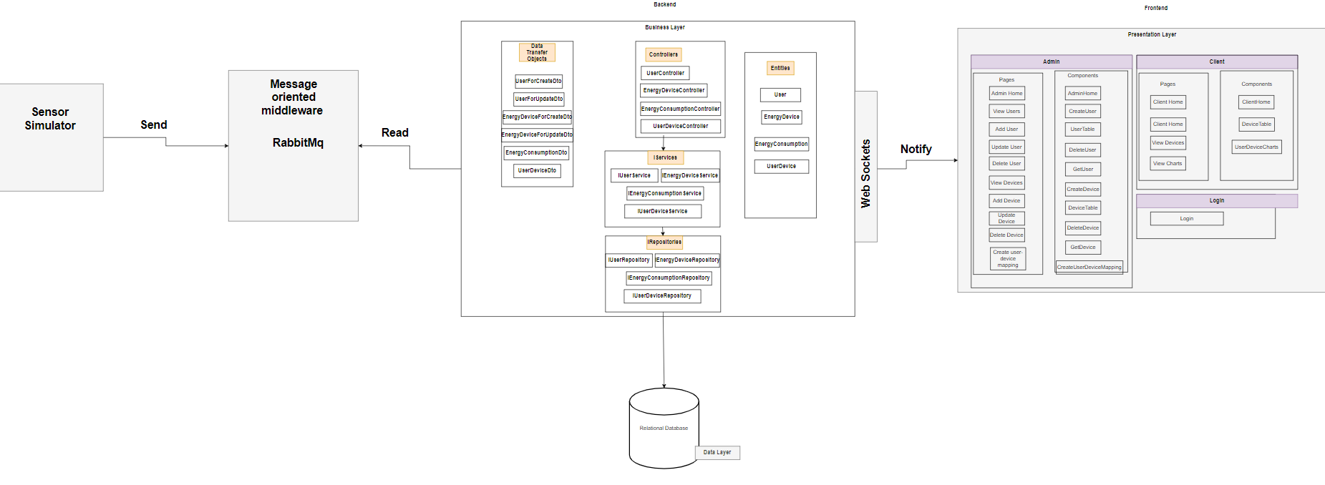

1. UML Deployment diagram

