**ELAMRI Ilyass 3iiR1:**

1. **[root@master ~]# grep cat /usr/share/dict/words**
   * This command searches for the word "cat" in the file located at **/usr/share/dict/words**.

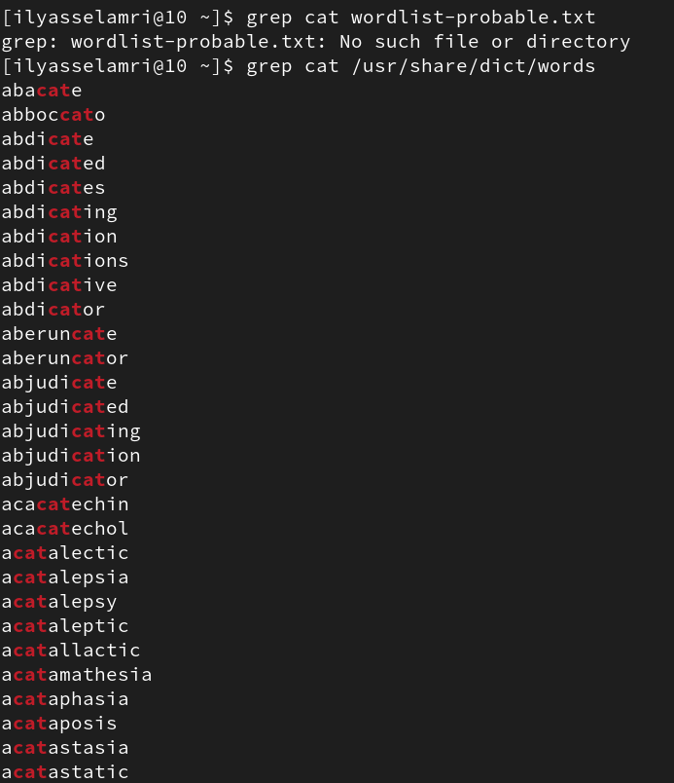

1. **[root@master ~]# grep ^cat /usr/share/dict/words**
   * This command searches for lines in the file located at **/usr/share/dict/words** that start with the word "cat".

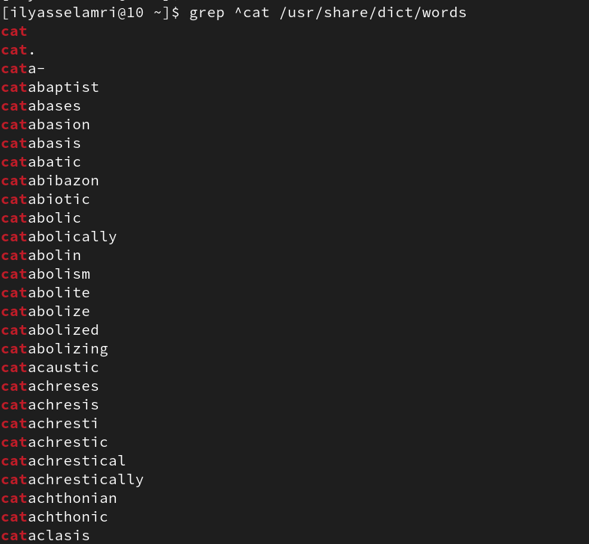

1. **[root@master ~]# grep cat$ /usr/share/dict/words**
   * This command searches for lines in the file located at **/usr/share/dict/words** that end with the word "cat".

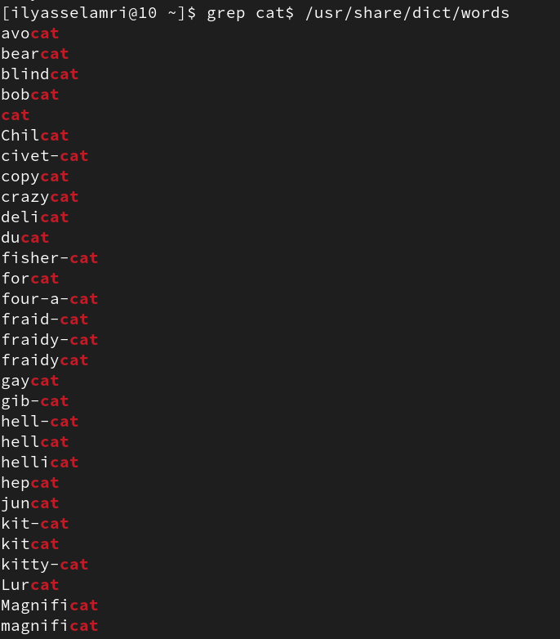

1. **[root@master ~]# grep ^cat$ /usr/share/dict/words**
   * This command searches for lines in the file located at **/usr/share/dict/words** that only contain the word "cat"

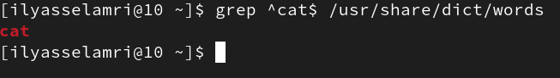

1. **[root@master ~]# grep c.t /usr/share/dict/words**
   * This command searches for lines in the file located at **/usr/share/dict/words** that have the letter 'c' followed by any character, then 't'.

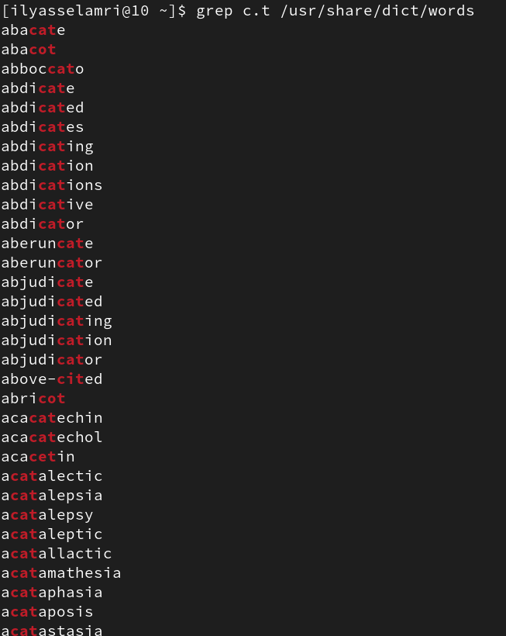

1. **[root@master ~]# grep ^c.t$ /usr/share/dict/words**
   * This command searches for lines in the file located at **/usr/share/dict/words** that start with 'c', followed by any character, then 't', and nothing else.

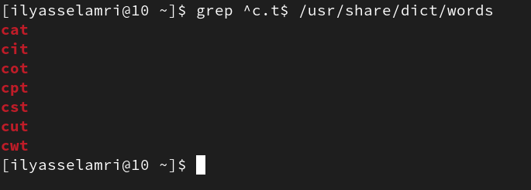

1. **[root@master ~]# grep c[aou]t /usr/share/dict/words**
   * This command searches for lines in the file located at **/usr/share/dict/words** that have 'c', followed by either 'a', 'o', or 'u', and then 't'.

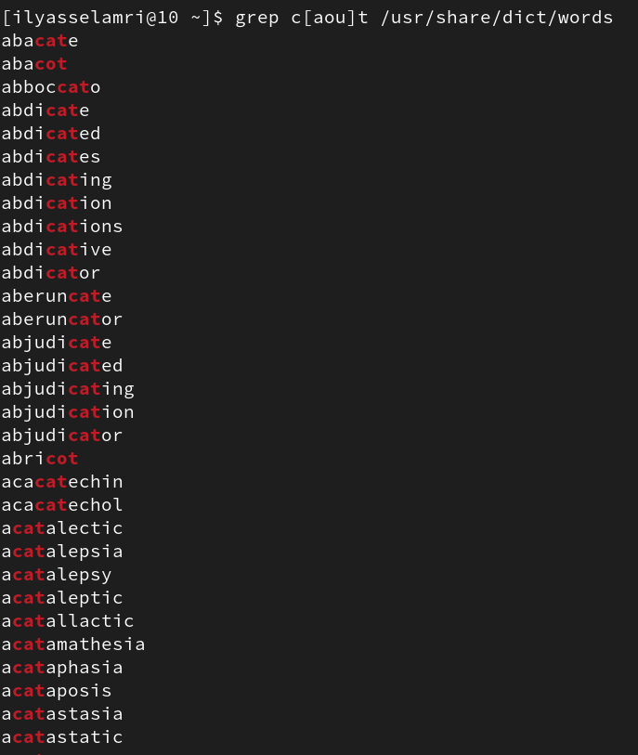

1. **[root@master ~]# grep ^c[aou]t$ /usr/share/dict/words**
   * This command searches for lines in the file located at **/usr/share/dict/words** that start with 'c', followed by either 'a', 'o', or 'u', and then 't', and nothing else.

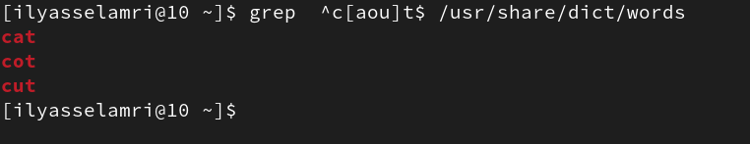

9.**[root@master ~]# grep -e cat -e tele /usr/share/dict/words**

* + This command searches for lines in the file located at **/usr/share/dict/words** that contain either the word "cat" or the word "tele".

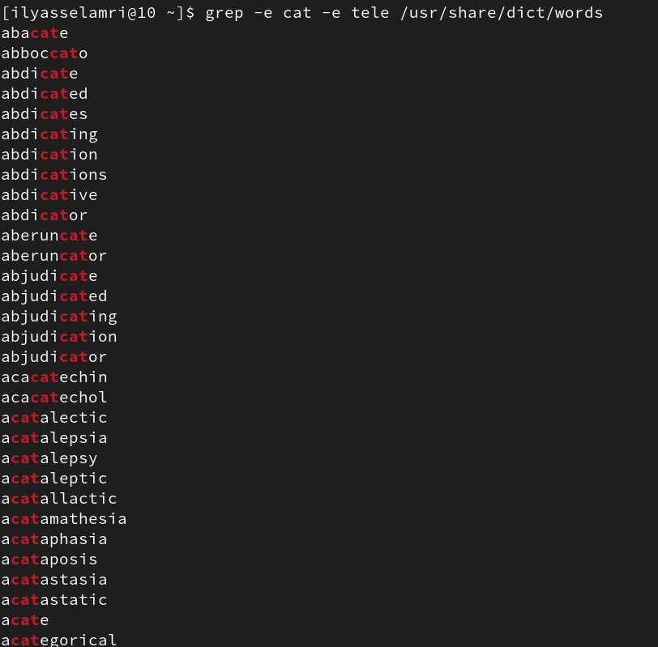

1. **[root@master ~]# grep -r simo /etc**
   * This command recursively searches for the word "simo" in all files and directories under the **/etc** directory.

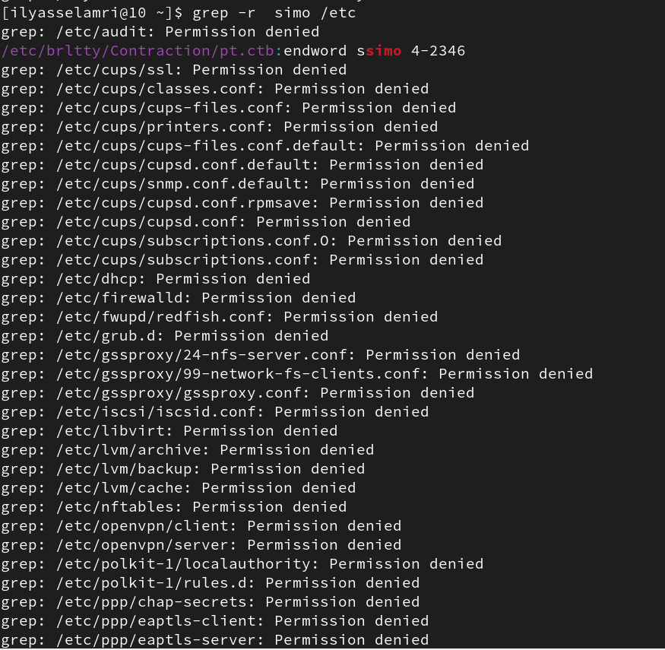

1. **[root@master ~]# grep -rl simo /etc** (list the file names only)
   * This command recursively searches for the word "simo" in all files and directories under the **/etc** directory and displays only the file names that match.
2. The lines starting with a dot (.) provide additional options for the **grep** command:
   * **. -i** performs a case-insensitive search.
   * **. -v** reverses the search to display non-matching lines.
   * **. -r** is already explained in line 10, it enables recursive searching.
   * **. -n** numbers the lines in the output.
   * **. -A3** displays three lines after the regular expression match.
   * **. -B3** displays three lines before the regular expression match.
   * **. -e** is used for specifying multiple search patterns.
3. **[root@master ~]# ps aux | grep root**

* [root@master ~]# ps aux | grep root: This command lists all running processes (ps aux) and filters the output to show only the lines containing the word "root" (grep root).

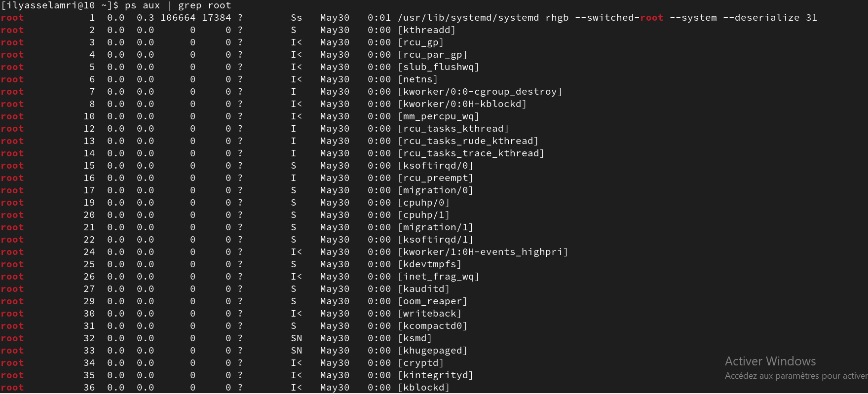

1. **[root@master ~]# ps aux | grep ^root**: This command is similar to the previous one, but it uses the caret (^) symbol to match lines that start with "root" instead of just containing it.

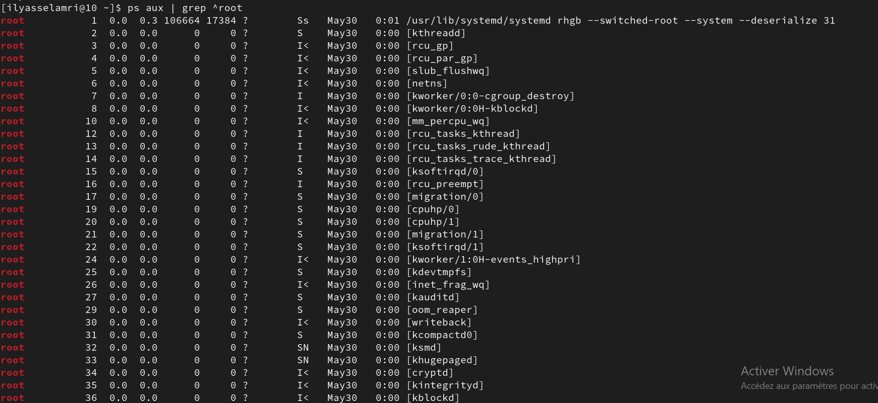

1. **[root@master ~]# cut -f 3 -d : /etc/passwd**: This command extracts the third field (-f 3) from the colon-separated lines in the **/etc/passwd** file. It specifically extracts the field containing user IDs.

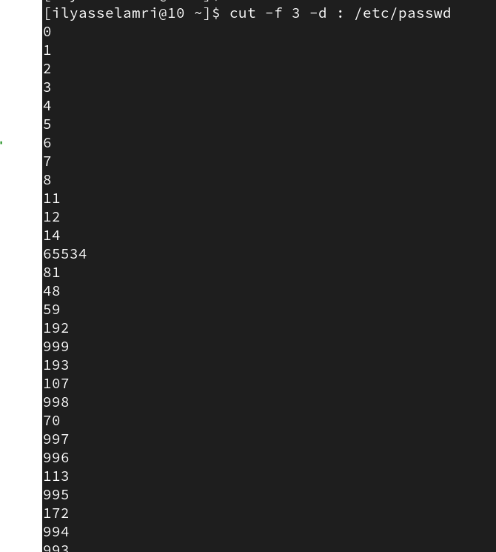

1. **[root@master ~]# cut -f 1 -d : /etc/passwd | sort**: This command extracts the first field (-f 1) from the **/etc/passwd** file and then sorts the output. The first field in **/etc/passwd** contains usernames.

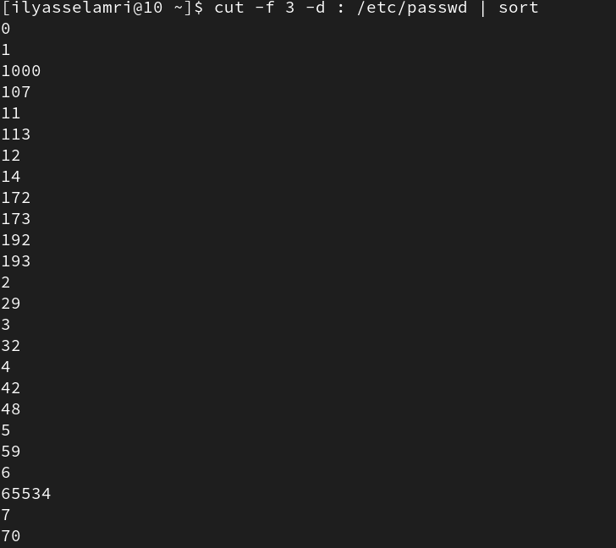

1. **[root@master ~]# cut -f 1 -d : /etc/passwd | sort | less**: This command is similar to the previous one, but it pipes the output to the **less** command, allowing you to scroll through the sorted list of usernames.

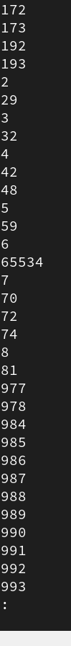

1. **[root@master ~]# echo hello world | tr a-z A-Z**: This command translates (tr) all lowercase letters from "a" to "z" to their corresponding uppercase letters from "A" to "Z". It converts the text "hello world" to "HELLO WORLD".

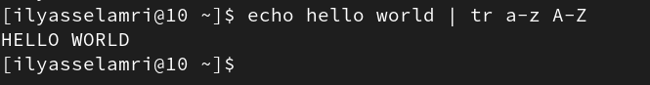

1. **[root@master ~]# echo hello world | tr [a-z] [A-Z]**: This command is another way to achieve the same result as the previous command. It translates lowercase letters to uppercase using character classes.



1. **[root@master ~]# echo hello world | tr [:lower:] [:upper:]**: This command also converts lowercase letters to uppercase using character classes but uses the character class **[:lower:]** for lowercase letters and **[:upper:]** for uppercase letters.

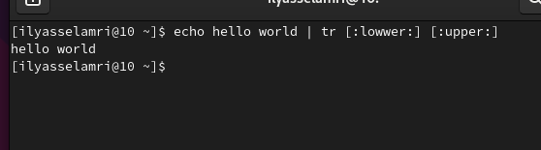

1. **[root@master ~]# sed 2q /etc/passwd**: This command uses **sed** to print the first two lines of the **/etc/passwd** file. The **2q** command tells **sed** to quit after reading the second line.

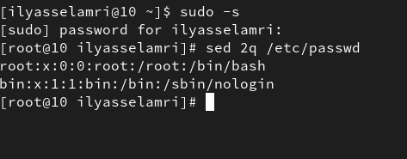

1. **[root@master ~]# sed -n /^root/p /etc/passwd**: This command uses **sed** to print lines from the **/etc/passwd** file that start with "root". The **-n** option suppresses the default output, and the **/^root/p** command prints lines that match the pattern "root".

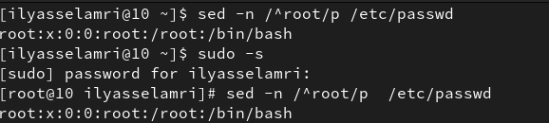

1. **[root@master ~]# sed -n 5p /etc/passwd**: This command uses **sed** to print the fifth line of the **/etc/passwd** file. The **5p** command tells **sed** to print only the line number 5.



1. **[root@master ~]# sed -i 's/simo/SIMO/g' file**: This command uses **sed** to replace all occurrences of "simo" with "SIMO" globally (**g**) in the file named "file". The **-i** option tells **sed** to edit the file in-place.



1. **[root@master ~]# ps aux | grep root | awk '{ print $2 }'**: This command lists all running processes (**ps aux**), filters the output to show only the lines containing the word "root" (**grep root**), and then uses **awk** to print the second field (column) from those

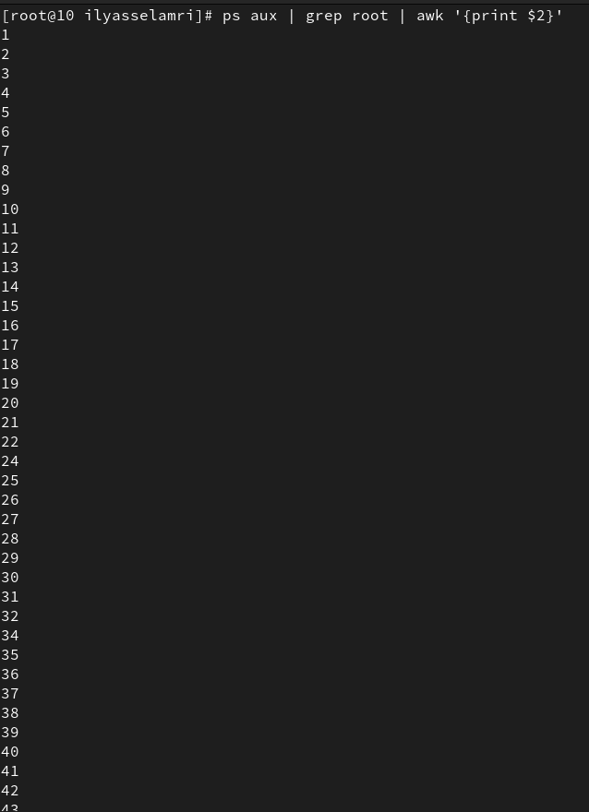

**13.head /etc/passwd | tail -1 :**

