|  |
| --- |
| PROJECT OUTLINE INCOMING MARIE SKLODOWSKA-CURIE FELLOWSHIPS |

The discovery of the first extrasolar X-ray source in the early 60’s quickly triggered the rise of High Energy Astrophysics and paved the way to the common acceptance of an exotic solution of General Relativity, the black hole. Within a decade, the X-ray emission was attributed to the conversion of gravitational potential energy into heat as a flow of matter got accreted onto a high compacity object such as a neutron star or a black hole - whose effective size is of the order of 10km. Binary systems where one of the two stars has collapsed into a compact body are ideal candidates to see this kind of phenomena occurs : as the mass of the remaining star is transferred to the compact remnant, temperature rises up to values responsible for X-ray emission. If the big picture has been widely accepted within the community, the specificities of the mass transfer remain in question, in particular when the star lies well within its sphere of gravitational influence called its Roche lobe. When the star evolves and fills its Roche lobe, a stream of gas forms and feed a large and permanent accretion disc around the compact object. The latter is well described by analytical models and has turned out to be an incredibly rich background on top of which can grow a wide spectrum of instabilities. However, when the stellar companion is a massive hot star, it usually underfills its Roche lobe. Mass accretion must then proceed through the intense stellar winds, a fraction of which being captured by the gravitational field of the compact object. In this configuration, a shock forms around the tiny accretor whose size is typically 10^5 times smaller than the distance to the shock front ; the very existence of a disc-like structure within the shocked region susceptible to account for the time variability is to be shown for such a low angular momentum flow.

**State of the art**

In the 2000’s, simulations giving birth to wind-capture discs have been observed for symbiotic binaries, a family of binary systems where the two bodies are of stellar size and where the stellar wind is much slower than for massive stars (see eg Abate+13). Since the accretor is much larger than in X-ray binaries, the scale discrepancy is small enough to grasp both the shock and the accretor within the same simulation space. Those simulations brought insightful comments concerning the long-puzzling formation of barium stars, the shaping of planetary nebulae and the evolutionary path to the progenitors of Type Ia supernovae.

Another way to avoid the scale discrepancy has been to consider a relative speed between the flow and the accreting body close enough from the speed of light to bring the front shock close from the surface (for a neutron star) or the event horizon (for a black hole) (Lora-Clavijo+13). The latter approach remains purely numerical as it still lacks corresponding realistic situations ; in X-ray binaries undergoing wind accretion for instance, the velocities are “only” of the order of 1000km/s. Truncated inner boundaries, hundreds of times larger than the actual size of the accretor, have though enabled to bypass the small scales and to focus on the shock formation (Blondin+12), in spite of the artifacts it introduces concerning the stability of the flow and the mass accretion rates measured (Ruffert94).

In parallel of those studies, analytical investigations have set constrains on the structure of a planar supersonic flow being gravitationally deflected by a point-mass and its characteristic quantities (Foglizzo97). With Fabien Casse, we have shown how those properties can be retrieved and quantified, provided the numerical setup is cautiously designed such as to resolve uniformly the 5 orders-of-magnitude in space at stake (El Mellah+15).

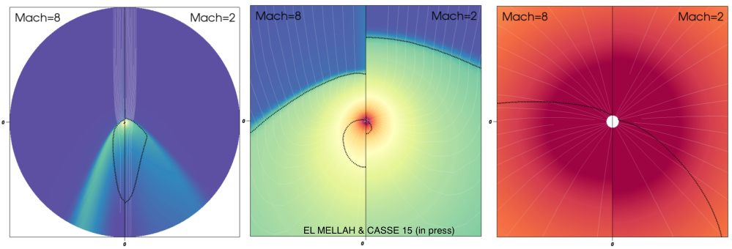*Fig. 1 : successive zoom in on the innermost parts of a planar flow (coming from the top) being deflected by a central accretor for different Mach numbers at infinity. In white are represented the streamlines while the the dotted black lines represent the Mach=1 surfaces.*

To be applied to X-ray binaries, this setup had to take into account the non-planar feeding of the flow. As an example, the Coriolis force, shears the streamlines as the flow travels from the hot star to the compact object. The launching of the radiatively-driven wind, totally different from the case of symbiotic binaries, had also to be accounted for. We designed a synthetic model of ballistic wind accretion at the orbital scale to identify the configurations susceptible to form a disc and obtained physically-motivated outer boundary conditions which pave the way to full 3D numerical simulations within the Roche lobe of the accretor (El Mellah+16, in prep). The coupling between the orbital, stellar, wind and accretion phenomena provides a consistent overlook of a broad range of systems under thorough observational monitoring : the Supergiant X-ray binaries, whose number of confirmed systems has been multiplied by 4 within the last decade. Unambiguous mass determinations of the neutron stars has been achieved in several of those systems (Falanga+15) and can be compared to the set of parameters we derived ; the maximum mass of a neutron star represents a burning question in fundamental Physics since it sets constrains on the still unknown equation-of-state of the exotic matter it is made of.

Other teams chose to put on the shelves more global approaches, either in terms of simulation space or in terms of multi-physics. In the first case, it implies the use of cartesian meshes with up to 19 levels of refinement to include the stellar companion within the simulation space of a hydrodynamics (HD) model and get small enough sizes for the accretor (Walder+14). Although the angular momentum is no longer guaranteed to be conserved, contrary to a spherical or a cylindrical geometry, it does pinpoint suggestive hints of disc formation in the few explored configurations. Including more physical effects such as the self-ionization of the flow by the X-ray emission from its innermost parts has also proven to be fruitful (Manousakis+15).

**Objectives of the research**

At the core of my research project for the next 3 years lies the question of the self-organizing phenomenon responsible for the X-ray variability of SgXB and SFXT L: how can we explain the log-normal distribution in time of the X-ray luminosity in those systems? The first axis of my approach focuses on the consistent coupling between different scales and physical environments while the second one examines in more details the stability of the shock cone.

Project#1 : A consistent journey to the eye of the storm

Due to the temperature radial profile and to the strong dependence of the black body flux on temperature, the X-ray emission is dominated by the innermost parts of the flow. The strong time variability we observe reflects strong disturbances in the vicinity of the accretor, either triggered locally or excited by propagating perturbations from larger scales (eg clumps in the stellar wind). To disentangle the two, we must equip ourselves with a framework to monitor the flux on different scales and with different numerical modules to represent the evolution of a radiatively-dominated flow, a bow shock, a force-free magnetosphere…

Ballistic at the orbital scale (El Mellah+16, in prep), the wind is shocked (El Mellah+15) and sheared as it enters the Roche lobe of the neutron star. Since the curvature radius of this shock is much larger than the shock scale for winds in SgXB, we expect the winding up of the flow to occur within the shocked region. It is then subjected to photo-ionization due to the X-ray emission from the innermost parts of the flow and is finally funneled into the magnetosphere. We have laid the foundations of a semi-analytical approach where all those steps are, for the first time, concatenated together so as to produce self-consistent scenarii for SgXB and trace back many parameters of the system such as the mass of the neutron star ; the maximum mass of a neutron star is a critical measure to rule out equation-of-states in those degenerated objects and finally determine their material content. The latter would be a major breakthrough in fundamental Physics

The possible magnetic gating undergone by the innermost parts of the flow (now a plasma due to photo-ionization) has never been explored with physical inputs accounting for the upper scales. Hence, it has produced fruitful results but ambiguous since the toy-models are separated from the large scale observables (such as the parameters of the stellar companion). Ultimately, this comprehensive sketch of wind accretion is prone to join the question of jet-launching conditions, a vastly explored and fertile ground of contemporary research with a wide range of applications (microquasars, active galactic nuclei, young stellar objects…).

Project#2 : Stability of the shock

In addition of the phenomenological roadmap I have started to draw, I want to focus on the fundamental Physics of one of the successive steps : the bow shock formed by the gravitational beaming of the flow. Two main instabilities are expected to play a role in this case.

As pinpointed by Thierry Foglizzo, Michel Tagger and collaborators in the 2000’s, a resonant cavity can form between the shock and the sonic surface, the latter being typically 100 to 10,000 times closer from the accretor. The numerical study of this configuration has revealed how important this mechanism can be, with a possible application to the case of core-collapse supernovae. We plan to export this study to an axisymmetric configuration and monitor the non-linear growth and saturation of this advective-acoustic cycle.

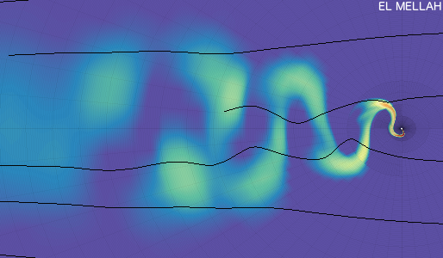

*Fig. 2 : logarithmic colormap of the density for a two-dimensional simulation with adaptive mesh refinment of a planar flow onto a point-mass. The flip-flop instability in the wake is clearly visible. In black are represented a few streamlines.*

Beyond this longitudinal instability, it has been suggested in the late 1980’s but never confirmed that those flows produce a transversally oscillating pattern in the wake of the accretor, like a fluttering flag in the wind : the flip-flop instability. Until now, the computational and algorithmic capacities were too limited to design numerical setups able to unambiguously conclude : is this reminiscence of the Von Kàrmàn vortex street real or just an artifact due to cylindrical grids, numerical schemes failing to conserve angular momentum or too large accretors? Unfolding the 2D axisymmetric relaxed flows we got in El Mellah+15 spares us the expensive necessity to wait for the flow to relax in full 3D, bringing a definitive answer within our scope.

In the future, as an extension of those two projects : Project#3 : The hybrid accretion regime of “wind Roche lobe overflow” (Cyg X-1, Cen X-3)

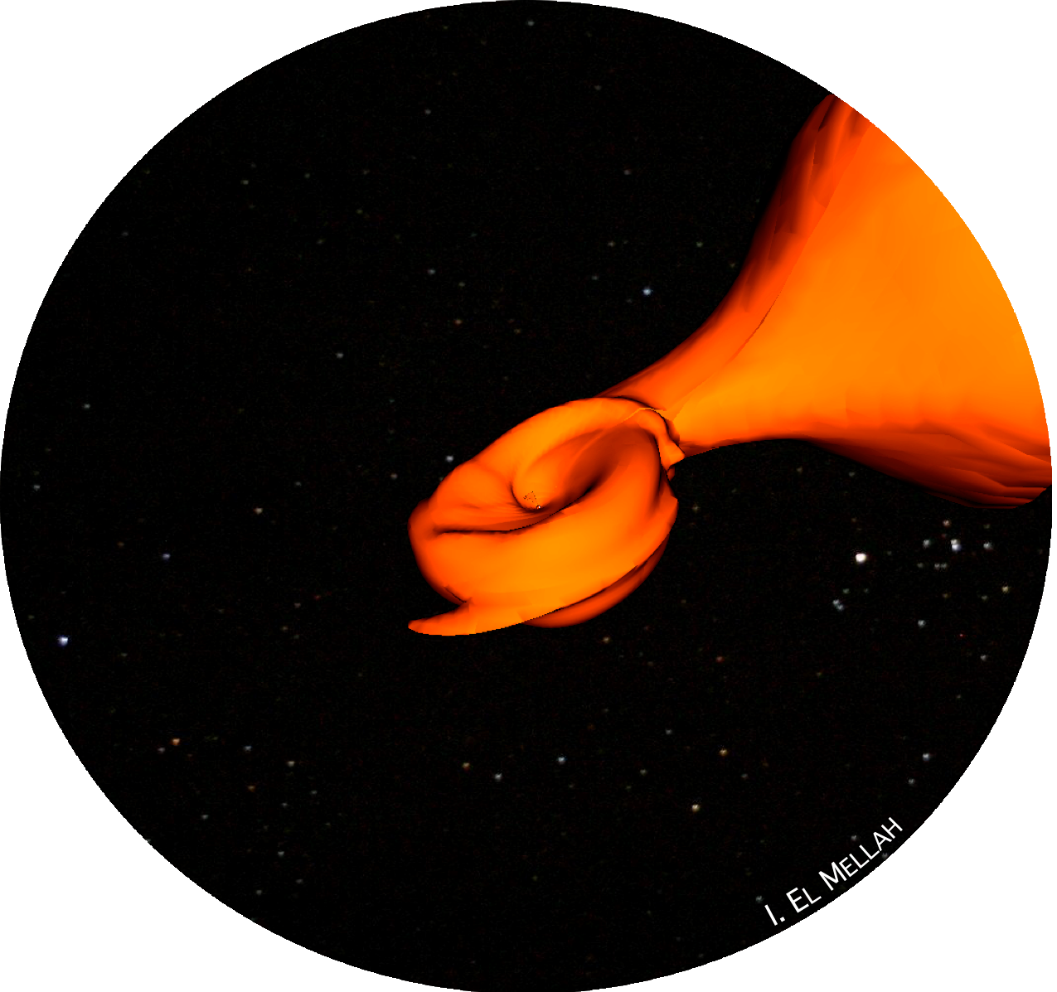

As shown by Mohamed+07, undeflowing stars can still transfer matter to their companion in a more efficient way than pure wind accretion. In the future, beyond those two projects, I would wish to study the interplay between the low velocity / high density stream of matter flowing from the star and the high velocity / low density diffuse wind.

*Fig. 3 : isodensity surface of a 3D flow being transferred from a stellar companion (upper right) to an accretor. The inner boundary of this suggestive spherical simulation is 1000 times smaller than the orbital separation between the two bodies*

**Methodology**

Project#1 : A consistent journey to the eye of the storm

The numerical case addressed in El Mellah+15 has served as a benchmark to motivate the orbital characterization of the structure of the wind (El Mellah+16, in prep). Now, we can gather the two : the (M)HD modules of MPI-AMRVAC with the properties of the flow at the outer boundary set by the ballistic large scale simulations. The estimated computing times are indicated in kilo hours on one CPU (khCPU). Given the excellent scalability of MPI-AMRVAC, most of the simulations will be run on typically 512 CPUs.

- - - - - - - -

WP 1.a. : The shock

1st step : 2D setup in the orbital plane of a spherical logarithmically stretched grid

- modification of the tensorial elements

- identification of a bow shock for adequate parameters

2nd step : Full 3D spherical stretched grid

- figure out a swindle for the polar singularity (eg angular stretching, truncation…)

- monitoring of the flow and matching with the case in the orbital plane (200khCPU)

3rd step : The disc within the shock (if it shows up)

- characterization of its structure (eg temperature and density profiles)

- produce light curves and spectra

4th step : Self-ionization (with A. J. Van Marle)

- use of the ray-tracing module developed by A. J. Van Marle for MPI-AMRVAC

- computation of the ionization levels (Ho+87)

- evaluation of the impact on the dynamics of the flow and comparison with theoretical expectations (see Manousakis+15) (250khCPU)

Once quantification of self-ionization has been included, it provides us with a robust quantification of the coupling between the plasma and the magnetic field and justify the use of the magnetoHD (MHD) modules in MPI-AMRVAC —> WP 1.c.

- - - - - - - -

WP 1.b. : A clumpy wind (if WP 1.a. finished within time - see the work plan in next section)

- bibliography on the observational characterization and theoretical models of clumpy winds in SgXB with L. Ducci

- rerun the numerical setup of WP 1.a. with time modulated outer boundary conditions to inject realistic overdensities (150khCPU)

- evaluate the implied time variability of X-ray emission and compare to observations

- - - - - - - -

WP 1.c. : The magnetosphere

- implement a static dipolar field as a first model for the influence of the neutron star (with Z. Meliani)

- control the divergence of the magnetic field with the constrained transport module developed by F. Casse for MPI-AMRVAC

- validate the compatibility between the MHD modules and the stretched grid on test-cases (50khCPU)

- turn on the magnetic resistivity

- observe the magnetic-dominated regime (eg verify the frozen-flux theorem) (300khCPU)

- produce light curves and spectra (with the cyclotron emission) and compare to observations

- - - - - - - -

In the future or if additional time left : the jets.

Project#2 : Stability of the shock

This project will address the following questions : which variability (time and amplitude) for axisymmetric and non-axisymmetric instabilities? Is flip-flop a numerical artifact? If no, is it strong enough to account for torque reversal? The novelty lies in the new grids designed so as to suit the numerical solvers and the parallel computing. Indeed, we need to capture the Physics between the shock and the sonic surface here.

- - - - - - - -

WP 2.a. : Axisymmetric stability (200khCPU)

- adapt the spherical model to axisymmetric geometry

- design a suitable grid to resolve the wavelengths responsible for the advective-acoustic instability

- adapt the high order accuracy schemes to the new grid

- measure the energy and entropy fluxes

- compute a quality factor and evaluate the leakage of the resonant cavity

- plot the spectrum : which growing mode?

- measure the saturation level of the instability

- compare to the model : was the adaptation relevant? If not, possible iteration loop here

- if level of saturation high enough, compare with observations (eg with the Guitare Nebula for an example of pinching modes)

- - - - - - - -

WP 2.b. : Three dimensional stability (400khCPU)

- adapt the axisymmetric two dimensional setup to 3D

- implement conservative scheme for angular momentum

- repeat stability analysis above for longitudinal but also transversal modes

- 2 cases : #1, if transverse modes saturate at low amplitude, I will focus on the thermodynamics, using the modules devoted to optically thin radiative cooling

#2, if they saturate high enough, measure the mass and angular momentum accretion rates. Compare to the observations of torque reversals for pulsars in SgXB

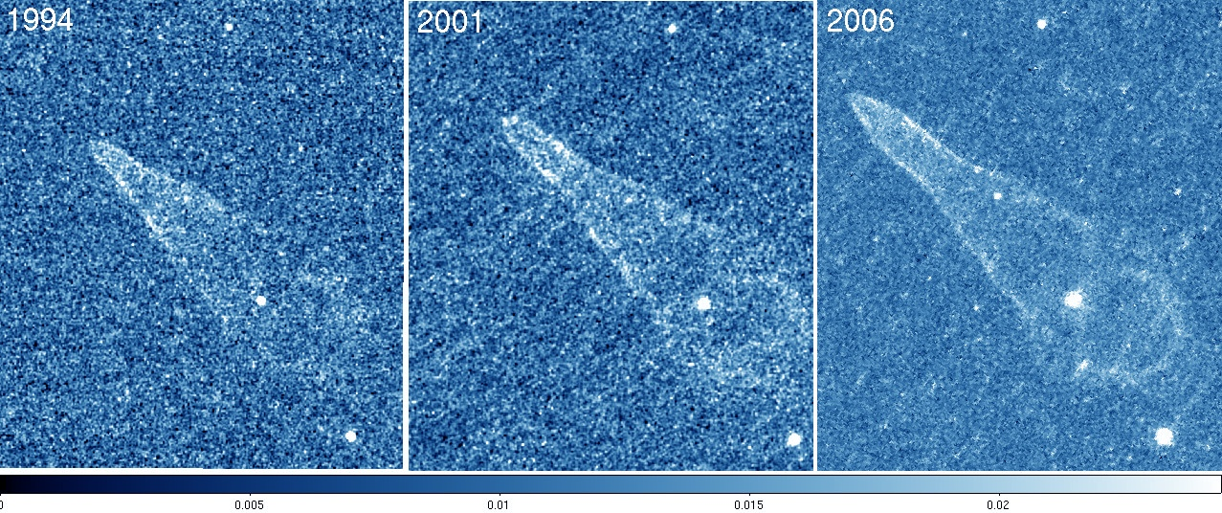

*Fig. 4 : Head of the Guitare Nebula imaged by the Hubble Space Telescope in 1994, in 2001 and in 2006. See Chatterjee+02. Is the variability tracing inhomogeneities in the interstellar medium or is the flow displaying axisymmetric instabilites?*

The computing tools

So as to carry on such time demanding numerical simulations, I need to be able to rely on national facilities such as the Flemish Supercomputing Centre and the French Centre Informatique National de l’Enseignement Supérieur (CINES). I have already successfully applied twice to the latter within the last 2 years, where I have been granted each time 300 kh CPU. At the European level, I plan to apply for computing time on the PRACE Tier 0 platform, already put to good use in the past by the KU Leuven Centre for mathematical Plasma Astrophysics. I anticipate a need for my work of 1.5 to 2MhCPU within the next 3 years.

The visualization tools

When it comes to full 3D (M)HD simulations, one has to worry about the output visualization prior to the runs to not be left with excessively huge data file to proceess. During my PhD, I have got familiar with sophisticated visualization tools such as VisIt or Paraview and I have paid specific attention to the display. More than once, this step brought to my attention unforeseen features which turned out to be fundamental albeit non trivial characteristics of the flow (eg this is first how I got a glimpse of the anchoring of the sonic surface in February 2015). The visualization is definitely, in my approach, an active part of the research workflow and not only for a posteriori communication of the results.

The non-linearity of the equations I have been working on, not only in HD but also in ballistic toy-models, brings up the question of the overview of the input parameters space, especially when the latter displays an essential intermediate dimensionality (typically less than 10 and more than 3). The inputs of a model rarely coincide with the observables we have access to ; thus, we need to spot the dependence strengths and the possible degeneracies before any conclusion can be drawn. A web application framework such as Spyre (Adam Hajari, 2015) provides a handy library to customize Python data visualization pipelines and set up sophisticated interactive interfaces. I have made an extensive use of the latter in my currently ongoing article (El Mellah+16, in prep) and do intend to keep making the most of it in my following work.

**Provide a work plan, i.e. the different work packages and a detailed timetable.**

WP 1.a. : **5 months** (3 for implementation and run and 2 for analysis of the results). Partner : A. J. Van Marle for the ray-tracing module he developed.

WP 1.b. : **3 months** (1 for bibliography, 1 for implementation and run and 1 for analysis). Partner : L. Ducci for his toy-model of clumpy wind.

WP 1.c. : **6 months** (4 for implementation and run and 2 for analysis). Partners : Z. Meliani for the numerical modeling of the neutron star magnetosphere. F. Casse for the constrained transport module he developed to guarantee divB=0.

WP 2.a. : **5 months** (1 for analytical adaptations, 2 for implementation and run and 2 for analysis). Partner : T. Foglizzo for the analytical adaptation of the advective-acoustic model to the axisymmetric configuration.

WP 2.b. : **5 months** (3 for implementation and run and 2 for analysis). Partner : T. Foglizzo for the physical interpretation of the results and the comparison with theoretical expectations.

We plan approximately to apply for one peer-reviewed article per work package. Each article being devoted **2 months** of exclusive work, we estimate at **2 years the work load for Project#1 and 1 to 1.5 year the work load for Project#2**.

**Enumerate the bibliographical references that are relevant for your research proposal.**

Abate, C.; Pols, O. R.; Izzard, R. G.; Mohamed, S. S.; de Mink, S. E. Wind Roche-lobe overflow: Application to carbon-enhanced metal-poor stars. Astronomy & Astrophysics, Volume 552 (2013)

Blondin, J. M.; Raymer, E. Hoyle-Lyttleton Accretion in Three Dimensions. The Astrophysical Journal, Volume 752, Issue 1, article id. 30, 6 pp. (2012)

Falanga, M.; Bozzo, E.; Lutovinov, A.; Bonnet-Bidaud, J. M.; Fetisova, Y.; Puls, J. Ephemeris, orbital decay, and masses of ten eclipsing high-mass X-ray binaries. A&A, Volume 577, (2015)

Ho, C. ; Arons, J. High-luminosity accretion in wind-driven binary X-ray sources. Astrophysical Journal, Part 1 (ISSN 0004-637X), vol. 316, May 1, 1987, p. 283-293 (1987)

Lora-Clavijo, F. D.; Guzmán, F. S. Axisymmetric Bondi-Hoyle accretion on to a Schwarzschild black hole: shock cone vibrations. MNRAS, Volume 429, Issue 4, p.3144-3154 (2013)

Mohamed, S.; Podsiadlowski, Ph. Wind Roche-Lobe Overflow: a New Mass-Transfer Mode for Wide Binaries. 15th European Workshop on White Dwarfs ASP Conference Series, Vol. 372,

Ruffert, M. Three-dimensional hydrodynamic Bondi-Hoyle accretion. 1: Code validation and stationary accretors. Astrophysical Journal, Part 1 (ISSN 0004-637X), vol. 427, no. 1, p. 342-350

Walter, R.; Lutovinov, A. A.; Bozzo, E.; Tsygankov, S. S. High-mass X-ray binaries in the Milky Way. A closer look with INTEGRAL. The Astronomy and Astrophysics Review, Volume 23, 99 pp. (2015)

**Please provide full bibliographic details of your five main publications and update all your scientific publications through the E-portal.**

Peer-reviewed articles

I. El Mellah and F. Casse. Numerical simulations of axisymmetric hydrodynamical Bondi–Hoyle accretion on to a compact object. Mon. Not. R. Astron. Soc., 454(3):2657–2667, oct 2015. Impact factor : 5.521

Roberto Sanchis-Ojeda, Saul Rappaport, Joshua N. Winn, Michael C. Kotson, Alan Levine, and Ileyk El Mellah. a Study of the Shortest- Period Planets Found With Kepler. Astrophys. J., 787(1):47, mar 2014. ISSN 0004-637X. doi: 10.1088/0004-637X/787/1/47. Impact factor : 5.993

S. Rappaport, K. Deck, a. Levine, T. Borkovits, J. Carter, I. El Mellah, R. Sanchis-Ojeda, B. Kalomeni, I. El Mellah, R. Sanchis- Ojeda, and B. Kalomeni. Triple-Star Candidates Among the Kepler Binaries. Astrophys. J., 768(v):33, feb 2013. ISSN 0004-637X. Impact factor : 5.993

S. Rappaport, a. Levine, E. Chiang, I. El Mellah, J. Jenkins, B. Kalomeni, E. S. Kite, M. Kotson, L. Nelson, L. Rousseau-Nepton, and K. Tran. Possible Disintegrating Short-Period Super-Mercury Orbiting Kic 12557548. Astrophys. J., 752(1):1, jan 2012. ISSN 0004-637X. doi: 10.1088/ 0004-637X/752/1/1. Impact factor : 5.993

Conference proceedings

I. El Mellah and F. Casse. Numerical simulations of axisymmetric Bondi- Hoyle accretion onto a compact object. SF2A-2015 Proc. Annu. Meet. French Soc. Astron. Astrophys. Eds. F. Martins, 2015.

In prep

I. El Mellah and F. Casse. A numerical investigation of wind accretion in persistent Supergiant X-ray Binaries. I – Structure of the flow at the orbital scale.

|  |
| --- |
| MARIE SKLODOWSKA-CURIE RELATED QUESTIONS |

**Outline how a two way transfer of knowledge will occur between you and the host institution, in view of their and your future development and past experience:**

*A. Explain how you will gain new knowledge and experience during the fellowship at the host institution(s). The text must also demonstrate how your proposed research and personal experience will contribute to your professional development as an independent/mature researcher.* *Hereby explain the expected impact of the planned research and training, and new competences acquired during the fellowship on the capacity to increase your career prospects after this fellowship finishes.*

*B. Outline the previously acquired knowledge and skills that you will transfer to the host institution.*

**Outline the quality of the supervision and the hosting arrangements.**

*Outline the nature and the quality of the hosting research group/environment as a whole, together with the measures taken to integrate you in the different areas of expertise, disciplines. Include the research infrastructure, international networking- and training opportunities that the host could offer. The text must show that you should be well integrated within the host institution(s) in order that all parties gain the maximum knowledge and skills from the fellowship.*

A postdoctoral stay as a Pegasus fellow at the KU Leuven Centre for mathematical Plasma Astrophysics (CmPA) will allow me to join and interact with the core developer team of the open source code effort MPI-AMRVAC (Porth et al, ApJS, 2014). This software is ideally suited for high performance computing, and has a build-in versatility in its applications: these range from polytropic hydrodynamics, over full Euler to Navier-Stokes descriptions of gas dynamics, can include gas-dust coupling, allow to employ single fluid MHD modeling (up to hall-MHD), and all of these can be run in either Newtonian up to special relativistic settings. This versatility has been key for my own PhD research, where I added functionality that was not available in the public release: radially stretched grids. During my latest visit in April 2016 to the CmPA, we transferred this functionality to the public release, and can now fully exploit this feature in block grid-adaptive fashion. As a postdoc, I plan to make further improvements to the discretization schemes that are absolutely vital for my application on X-ray binary physics, such as encoding angular momentum conservation at machine precision (currently handled to truncation level only), making python tools for post-processing large data volumes, working with state-of-the-art visualization tools, etc.

I plan to collaborate closely within the team of my host Prof. Rony Keppens. In this team, there is currently no focus on X-ray binary physics, but expertise is shared at the algorithmic level between solar physics research, Active Galactic Nuclei jet studies, pulsar wind nebulae, and particle acceleration scenarios in reconnecting current systems. The latter will be extremely useful to interact with, as we wish to quantify ultimately how intricate shock configurations perturbed by (magneto)hydrodynamic instabilities give rise to X-ray variability.

On the other hand, the courses I attended at the LOPHISS Master degree during my first year of PhD (10h/week of Philosophy and Sociology of Sciences, both validated) brought me an insightful perspective on the laying foundations of our scientific activity. With a particular emphasis on the question of the articulation between physical models and numerical simulations, my epistemological approach could serve the scientific purposes of the members of the Astrophysical-Plasma division and the Institute of Astronomy.

**Explain on how you will establish a solid communication and public engagement strategy of the research.**

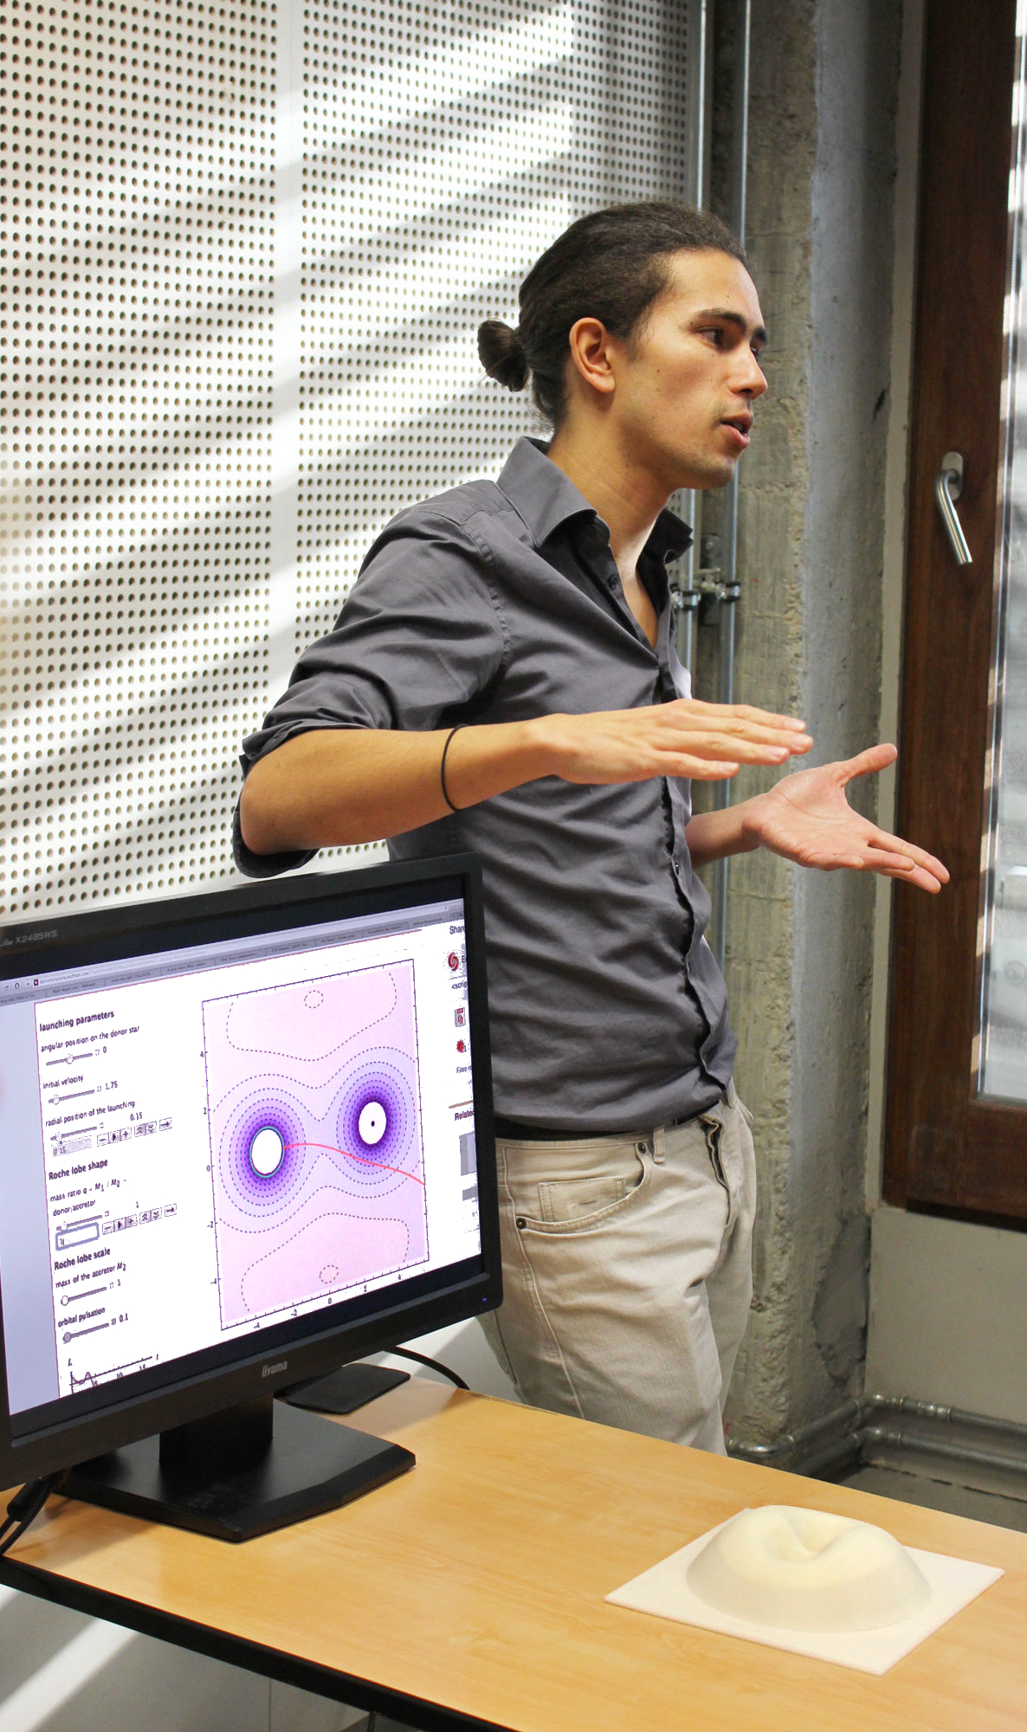

I have shown my sensibility to the question of scientific outreach all along my PhD and before (with the Agrégation). As an example, I developed a [Mathematica applet](http://demonstrations.wolfram.com/TrajectoryOfATestMassInARochePotential/) in association with 3D printed Roche potentials. I used this material at the Fête de la Science (Science Festival) of Paris 7 in October 2015 where I gave a presentation for high school and university students on the way a parallel can be drawn between the motion of a marble on a surface and the one of a test-mass in a 2D potential (more material on [my webpage](http://www.apc.univ-paris7.fr/~elmellah/index.html)).

In 2015, I have been one of the 7 organizing committee members for the Rencontres des Jeunes Physiciens (Meeting of the Young Physicist), an event sponsored by the Société Française de Physique and the main Physics institutions of Paris. The third edition of this yearly event took place on the 10th of November in the historical buildings of the Conservatoire National des Arts et Métiers and brought together several hundreds of PhD candidates from all fields of Physics. As a community manager, I was responsible of the [website design](http://rjp.sfp-paris.fr), the communication strategy, the broadcasting of the event and the a posteriori data processing. I was also involved in the fund raising (14.6 k€) with, among others, the Observatoire de Paris-Meudon, the Department of Physics of Paris 7 and the Collège des Ecoles Doctorales Sorbonne Paris Cité.

In the future, I look forward to participating into the organization of new events, including schools devoted to coding skills such as [the one organized in May 2016 in Les Houches](http://comp-phys-2016.sciencesconf.org). On a local scale, I think practical workshops on the model of the weekly meetings I participated to at the APC could be highly profitable. Indeed, if the scientific topics differ a lot from a person to another, we can easily find methodological grounds on which we can share concrete how-to-do knowledge and save much wasted time :

- data analysis statistical methods (eg introduction to wavelet analysis)

- visualization tools

- working environments (code editors, bibliographic tools, LateX tips…)

- mathematical tools for growth of instability analyzing (eg elements of perturbation theory)

- numerical schemes to solve partial and/or non-linear differential equations

Concerning my incoming participation to conferences and seminars, I plan to present my results on the two projects described in this application in local (eg the [yearly Journées de la Société Française de Physique](http://2016.sf2a.eu) and the [European Physical Society meetings on plasma physics](https://kuleuvencongres.be/eps2016)) and international meetings (eg the [IAU General Assembly in 2018](http://astronomy2018.univie.ac.at), the [COSPAR General Assembly in 2018](http://cospar2016.tubitak.gov.tr/en/) and the next [Texas symposium on Relativistic Astrophysics](https://indico.cern.ch/event/336103/)).