Identification of Operational Parameters in a Wuling Air EV Using CAN Bus Sniffing
Abstract

This study aimed to identify the operational parameters of a Wuling Air EV using a Controller Area Network (CAN Bus) sniffing approach. Limited accessibility to proprietary vehicle communication data motivated the development of an alternative approach for extracting operational information directly from the vehicle CAN Bus network. A data acquisition system was developed using an ESP32 microcontroller and an MCP2515 CAN controller module connected to the vehicle's OBD-II port. CAN Bus data were passively collected for approximately 49 minutes under various operating conditions and subsequently processed using Python for CAN ID identification, signal decoding, and data visualization. A total of 115 CAN IDs were successfully recorded, from which three key operational parameters were identified, namely Accelerator Pedal Position (APP), Motor RPM, and Battery Current. The analysis showed that increases in APP were generally accompanied by increases in Motor RPM and Battery Current, reflecting the driver's torque demand during vehicle acceleration. However, the relationships among these parameters were not always linear due to variations in driving conditions and the Vehicle Control Unit (VCU) control strategy in regulating the electric powertrain response. The results demonstrate that the proposed CAN Bus sniffing method can effectively identify vehicle operational parameters and perform CAN signal reverse engineering without requiring a CAN Database (DBC) file or proprietary manufacturer documentation. These findings demonstrate that the proposed low-cost CAN Bus sniffing platform provides an effective approach for reverse engineering proprietary CAN signals without requiring a CAN Database (DBC) file or manufacturer documentation, thereby supporting electric vehicle monitoring, diagnostics, and performance evaluation.
Keywords: CAN Bus, Electric Vehicle, Wuling Air EV, CAN Bus sniffing, ESP32, Operational Parameters.

INTRODUCTION
The rapid development of electric vehicles (EVs) has become an important part of the global transition toward sustainable transportation because of their high energy efficiency, low greenhouse gas emissions, and lower operating costs than conventional internal combustion engine vehicles [1], [2]. In Indonesia, the adoption of electric vehicles continues to grow, supported by advances in battery technology, electric powertrain systems, and government policies promoting transportation electrification as part of the national energy transition strategy [2]. Modern electric vehicles consist of multiple Electronic Control Units (ECUs) that communicate through the Controller Area Network (CAN Bus), enabling reliable real-time data exchange among vehicle subsystems. Through this communication network, operational parameters such as Accelerator Pedal Position (APP), Motor RPM, and Battery Current are continuously transmitted to support vehicle control, energy management, and performance monitoring [3], [4]. These parameters are valuable for evaluating vehicle performance and understanding the dynamic response of the electric powertrain to driver inputs.
Although CAN Bus provides access to a large amount of operational information, most CAN messages in commercial electric vehicles are proprietary, and their signal definitions are generally unavailable to the public. Consequently, extracting meaningful operational parameters requires reverse engineering techniques to identify CAN IDs, determine data-byte locations, and establish signal conversion methods [5]. Passive CAN Bus sniffing has become an effective approach because it enables data acquisition without transmitting additional messages to the network, thereby preserving normal vehicle communication [6], [7]. Previous studies have employed CAN Bus data acquired through the On-Board Diagnostics (OBD-II) interface and Battery Management Systems (BMS) for vehicle monitoring and diagnostic applications [8]. However, studies focusing on the direct identification of operational parameters through passive CAN Bus sniffing remain limited, particularly for commercial electric vehicles employing proprietary communication protocols. Furthermore, publicly available CAN Database (DBC) files for commercial electric vehicles are generally unavailable, creating challenges in decoding CAN messages without manufacturer documentation [4], [5].
Therefore, this study aims to identify the operational parameters of a Wuling Air EV using a passive CAN Bus sniffing approach. A low-cost data acquisition system based on an ESP32 microcontroller and an MCP2515 CAN controller module was developed to capture CAN traffic through the vehicle's OBD-II interface. The recorded data were processed using Python to identify CAN IDs, decode vehicle signals, and analyze the relationships among Accelerator Pedal Position (APP), Motor RPM, and Battery Current. The novelty of this study lies in the identification of operational parameters of a commercial Wuling Air EV through CAN Bus sniffing without relying on a CAN Database (DBC) file or proprietary manufacturer documentation. The proposed approach provides a practical, low-cost, and reproducible solution for CAN signal reverse engineering and demonstrates its potential for electric vehicle monitoring, diagnostics, and performance analysis.

MATERIALS AND METHODS
Experimental Setup
The experimental setup was developed to acquire and analyze operational data from an electric vehicle through the Controller Area Network (CAN) Bus communication system. The experiment was conducted on a Wuling Air EV by utilizing a passive CAN Bus sniffing approach to capture communication data between electronic control units (ECUs) without modifying or interfering with the original vehicle control system. CAN Bus sniffing is commonly applied for vehicle parameter identification and communication analysis because it enables observation of transmitted messages while maintaining the integrity of the vehicle network [9], [10], [7].
The CAN data acquisition system consisted of an ESP32 microcontroller, MCP2515 CAN transceiver module, and an OBD-II interface connected to the vehicle communication network. The MCP2515 module was used to receive CAN frames from the vehicle network, while the ESP32 served as a data acquisition controller for recording CAN messages. The collected CAN frames were transferred to a computer for further processing and decoding analysis. Figure 1. Developed CAN Bus sniffing system

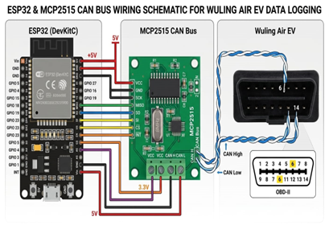 | 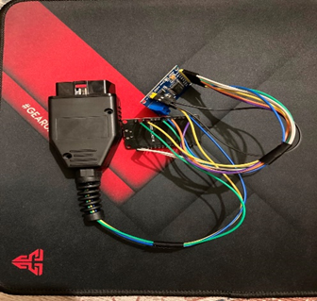
- Hardware wiring diagram | - Assembled prototype.

Figure 1 presents the developed CAN Bus sniffing system. Figure 1(a) illustrates the hardware wiring configuration between the OBD-II interface, MCP2515 CAN module, ESP32 microcontroller, and laptop, while Figure 1(b) shows the assembled prototype used during the vehicle testing. The developed system was designed as a non-intrusive monitoring device to acquire raw CAN messages from the Wuling Air EV without interfering with communication among the Electronic Control Units (ECUs).

Research Methodology
The research methodology was designed to identify and decode CAN Bus signals associated with electric vehicle operational parameters. The experimental procedure consisted of vehicle preparation, CAN Bus data acquisition, CAN message logging, data preprocessing, signal identification, parameter decoding, and operational parameter analysis. The overall research methodology is presented in Figure 2.

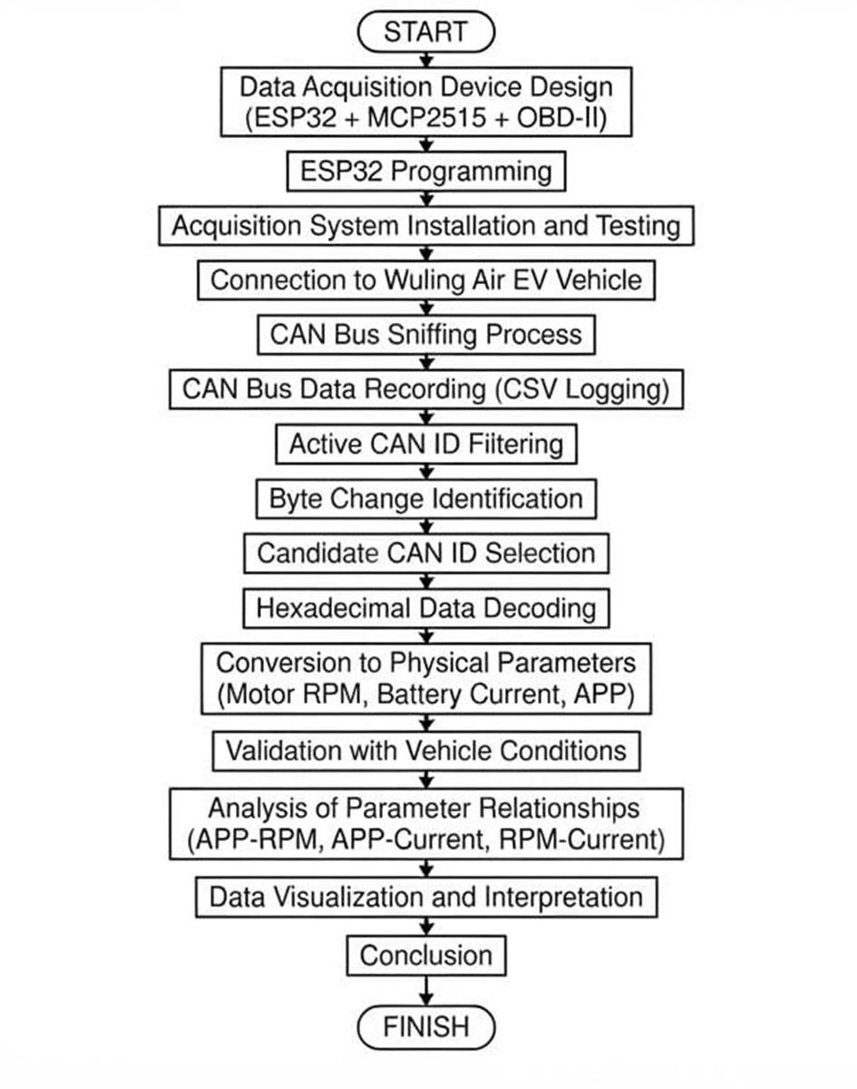
Figure 2. Overall research methodology.

Figure 2 illustrates the overall research methodology consisting of vehicle preparation, CAN Bus data acquisition, CAN message logging, data preprocessing, signal identification, parameter decoding, and operational parameter analysis. The CAN Bus data acquisition process was conducted during real driving conditions to obtain variations in vehicle operating states. The recorded CAN messages were stored in a comma-separated values (CSV) format containing timestamp, CAN identifier, data length code, and hexadecimal payload data.

Software Implementation
The software implementation was developed to process and analyze the recorded CAN Bus data. A Python-based processing system was developed using the Pandas and Matplotlib libraries for data manipulation, signal decoding, and visualization.

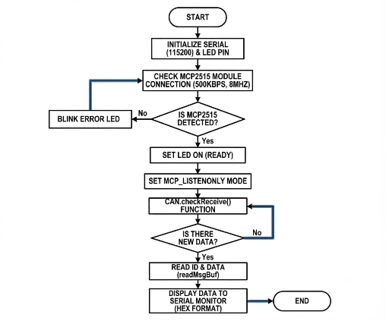
Figure 3. Software implementation flowchart.
Figure 3 shows the software implementation workflow consisting of CAN data importing, data preprocessing, CAN frame filtering, hexadecimal data conversion, parameter calculation, and graphical visualization. The preprocessing stage was performed to organize raw CAN messages based on CAN ID and data bytes. The identified CAN signals were subsequently converted from hexadecimal values into physical parameters such as Accelerator Pedal Position (APP), Motor RPM, & Battery Current. Python and Pandas were selected because they provide efficient tools for handling large datasets and numerical data processing, while Matplotlib was used for graphical visualization of vehicle operational parameters.

CAN Signal Decoding
CAN signal decoding was performed to identify the relationship between raw hexadecimal CAN data and physical vehicle parameters. The identification process was conducted by analyzing variations in CAN payload values during different vehicle operating conditions, including acceleration, deceleration, and constant-speed driving. The identified CAN messages and conversion methods are summarized in Table 1.
Table 1 summarizes the identified CAN IDs, corresponding data bytes, conversion equations, and descriptions used to obtain physical vehicle parameters

Parameter | CAN ID | Byte | Conversion Equation | Description
Motor RPM | 0x16E | B5 & B7 | Eq. (1) | Electric motor rotational speed
Battery Current | 0x16C | B5 & B6 | Eq. (2) – (3) | Battery charging/discharging current
Accelerator Pedal Position | 0x17D | B4 & B6 | Eq. (4) | Driver torque demand

The conversion equations used for decoding CAN signals are expressed as follows:

Motor RPM
(1)
$$RPM= \left(B5×16\right)+B7$$

where B5 and B7 denote the hexadecimal data bytes extracted from the CAN message payload, while RPM represents the rotational speed of the electric motor.

Raw
(2)
$$Raw=\left(B5×16\right)+B6$$

where Raw represents the decimal value obtained from the hexadecimal CAN payload before current conversion.

Battery Current
For Raw ≤ 32767
(3) $I =\frac{Raw}{100}$

For Raw > 32767 $I=\frac{Raw- 65536}{100}$
(4)
where I denotes the battery current expressed in amperes (A). The first equation is applied to positive current values, whereas the second equation is used to convert signed 16-bit values representing negative current during battery charging or regenerative braking.

Accelerator Pedal Position (APP)
(5)
$$APP=\frac{Raw}{Raw Max} x 100$$

where APP represents the accelerator pedal position expressed as a percentage of the driver's torque demand. The decoding equations were established through a CAN signal reverse engineering approach by correlating hexadecimal payload variations with actual vehicle operating conditions observed during the road test. This method enables the extraction of proprietary operational parameters from CAN Bus messages without requiring access to the manufacturer's communication database.

Data Processing and Analysis
The operational parameters were identified from the recorded CAN Bus messages obtained during real driving conditions. The acquired CAN data were stored in comma-separated values (CSV) format and subsequently analyzed offline using Python. The analysis process included filtering the identified CAN IDs, observing variations in hexadecimal payload values under different vehicle operating conditions, and validating the decoded parameters by comparing them with the corresponding information displayed on the vehicle instrument cluster. CAN IDs exhibiting consistent signal patterns and strong agreement with the vehicle operational parameters were selected for further analysis [11], [12].
The decoded parameters consisted of Motor RPM, Battery Current, and Accelerator Pedal Position (APP). These parameters were selected because they represent the interaction between driver input, electric motor response, and battery energy flow during vehicle operation. Time-series analysis was employed to evaluate the relationships among the identified parameters during acceleration, cruising, and deceleration. The correlation between APP, Motor RPM, and Battery Current was subsequently analyzed to characterize the operational behavior of the electric vehicle under real driving conditions [13], [14], [15].

RESULT AND DISCUSSION

Identification of CAN Bus Signals
The CAN Bus data acquisition process was conducted for approximately 49 minutes under various vehicle operating conditions, including vehicle idle, acceleration, cruising, and deceleration. During the experiment, communication data were continuously recorded through the OBD-II interface using the developed CAN Bus sniffing system. A total of 115 unique CAN IDs were recorded from the communication network of the Wuling Air EV, from which three key operational parameters, namely Accelerator Pedal Position (APP), Motor RPM, and Battery Current, were successfully identified . The recorded CAN messages were subsequently filtered and analyzed to identify operational parameters associated with the vehicle's powertrain performance.

Table 2. Identified operational parameters obtained from the CAN Bus communication network.
No | Parameter Operasional | CAN ID | Main Data Byte | Description
 | Accelerator Pedal Position (APP) | 0x17D | Byte 4 & Byte 6 | Driver torque demand
 | Motor RPM | 0x16E | Byte 5 & Byte 7 | Electric motor rotational speed
 | Battery Current | 0x16C | Byte 5 & Byte 6 | Battery charging/discharging current

The identification process was performed by observing variations in the hexadecimal payload values under different driving conditions and correlating these changes with the corresponding operational information displayed on the vehicle instrument cluster. CAN IDs exhibiting consistent signal variations and strong agreement with the observed vehicle behavior were selected as representative operational parameters for further analysis. This reverse engineering approach has been widely adopted to identify proprietary CAN Bus signals without requiring access to the manufacturer's communication database [16], [7], [17], [11].
The decoding process successfully identified three primary operational parameters, namely Accelerator Pedal Position (APP), Motor RPM, and Battery Current. These parameters were selected because they directly represent the interaction between driver input, electric motor response, and battery energy consumption during vehicle operation [13], [14], [15]. The identified CAN IDs and their corresponding data bytes are summarized in Table 2.

Following the filtering and decoding process, each identified parameter exhibited distinct signal characteristics corresponding to changes in vehicle operating conditions. The APP signal varied proportionally with accelerator pedal input, the Motor RPM signal reflected changes in the rotational speed of the traction motor, and the Battery Current signal represented the electrical energy flow between the battery pack and the electric drivetrain during acceleration and deceleration. These decoded parameters were subsequently utilized to analyze the operational characteristics of the Wuling Air EV under real driving conditions.
Relationship between APP and Motor RPM
The relationship between Accelerator Pedal Position (APP) and Motor RPM was analyzed to evaluate the response of the electric traction motor to variations in driver torque demand during real driving conditions. Since the complete CAN Bus dataset consisted of approximately 49 minutes of recorded vehicle operation, only a representative data segment is presented to facilitate a clearer interpretation of the relationship between the analyzed parameters. The selected segment represents typical vehicle operating conditions during acceleration and deceleration and serves as the basis for the subsequent discussion

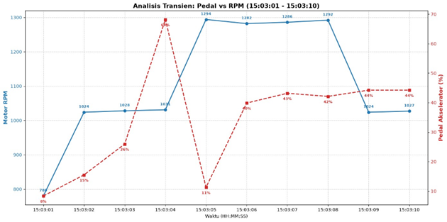
Figure 4. Relationship between Accelerator Pedal Position (APP) and Motor RPM during the road test.

Figure 4 illustrates the relationship between Accelerator Pedal Position (APP) and Motor RPM during the selected driving segment. Overall, the decoded CAN Bus data indicate that an increase in APP was generally followed by an increase in Motor RPM, demonstrating that the accelerator pedal position was interpreted by the Vehicle Control Unit (VCU) as a driver torque demand to regulate the rotational speed of the electric traction motor through the inverter control system. This behavior is consistent with the operating principle of electric vehicles, where APP serves as the primary input for determining the required motor torque [18], [19]. Although a positive correlation between APP and Motor RPM was observed throughout most of the driving cycle, the relationship was not strictly linear at every instant. Several transient responses were identified, indicating that the motor speed was influenced not only by driver input but also by the dynamic characteristics of the electric drivetrain and the torque control strategy implemented by the VCU [20], [21].
For example, during the interval between 15:03:04 and 15:03:05, the APP decreased from approximately 68% to 11%, whereas the Motor RPM increased from approximately 1031 rpm to 1294 rpm. This transient response indicates that the traction motor did not immediately reduce its rotational speed following the decrease in driver torque demand. The observed behavior can be attributed to the inertia of the vehicle drivetrain, where the kinetic energy accumulated during acceleration maintained the motor rotation despite the reduction in accelerator input. In addition, the VCU applies a progressive torque control strategy to ensure smooth acceleration and deceleration while minimizing drivetrain jerk [19], [20], [21].
A different operating characteristic was observed during the interval between 15:03:08 and 15:03:09, where the APP increased from 42% to 44%, while the Motor RPM decreased from approximately 1292 rpm to 1024 rpm. This behavior suggests that Motor RPM is influenced by multiple operating variables in addition to accelerator pedal position, including vehicle load, drivetrain dynamics, and torque management algorithms implemented by the VCU. Consequently, the electric motor response cannot always be interpreted as a direct linear function of APP because the control system continuously adjusts motor torque according to the instantaneous operating conditions to maintain vehicle stability and efficiency [18], [19], [20], [21]. Overall, the obtained results demonstrate that APP and Motor RPM exhibit a strong positive relationship during normal vehicle operation. However, transient deviations from this trend indicate that the dynamic behavior of the electric drivetrain is governed by both driver input and the electronic control strategy of the vehicle, highlighting the capability of the proposed CAN Bus decoding approach to capture real operational characteristics of the Wuling Air EV.

Relationship between APP and Battery Current
The relationship between Accelerator Pedal Position (APP) and Battery Current was analyzed to evaluate the influence of driver torque demand on the electrical energy supplied by the battery during vehicle operation. Similar to the previous analysis, a representative segment of the recorded CAN Bus dataset was selected to clearly illustrate the current response under different driving conditions.

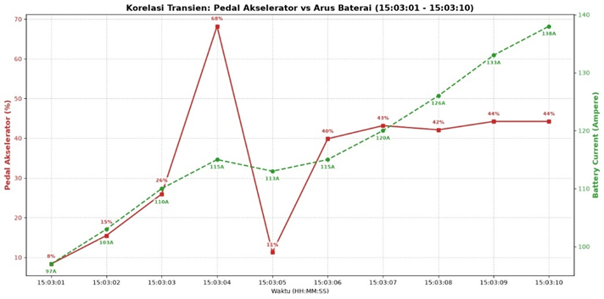

Figure 5. Relationship between Accelerator Pedal Position (APP) and Battery Current during the road test.
Figure 5 illustrates the relationship between Accelerator Pedal Position (APP) and Battery Current during the selected driving segment. In general, an increase in APP was accompanied by an increase in Battery Current, indicating that greater driver torque demand required a higher electrical power supply from the battery to the traction motor. In electric vehicles, the APP signal is processed by the Vehicle Control Unit (VCU) to determine the requested motor torque, which is subsequently delivered through inverter control by regulating the current supplied to the electric motor [18], [19], [22].
During the interval between 15:03:01 and 15:03:04, the APP increased from approximately 8% to 68%, while the Battery Current gradually increased from approximately 97 A to 115 A. This behavior demonstrates a positive correlation between accelerator pedal input and battery current demand, where higher driver torque requests require greater electrical energy to produce the desired motor output torque. Similar characteristics have been reported in previous studies on electric vehicle powertrain control, in which battery current increases proportionally with motor torque demand [21], [23].
A transient response was observed during the interval between 15:03:04 and 15:03:05, where the APP decreased significantly from 68% to 11%, whereas the Battery Current only decreased slightly from approximately 115 A to 113 A. This observation indicates that battery current does not immediately follow changes in accelerator pedal position. Instead, the electrical power demand is influenced by drivetrain dynamics, motor characteristics, and the torque management strategy implemented by the VCU to maintain stable and smooth vehicle operation [20], [24].
Following the transient condition, between 15:03:05 and 15:03:10, the APP gradually increased to approximately 44%, while the Battery Current increased from approximately 113 A to 138 A. The gradual increase in battery current indicates that the electric powertrain continuously adjusts the supplied current according to the required motor torque without introducing abrupt current fluctuations. Such controlled current regulation is essential for improving drivetrain stability, battery performance, and overall energy management efficiency in electric vehicles [22], [23], [24]. Overall, the obtained results demonstrate that Battery Current exhibits a strong positive relationship with Accelerator Pedal Position under normal operating conditions. However, the transient responses observed during rapid changes in accelerator input indicate that the electrical energy flow is governed not only by driver demand but also by the dynamic characteristics of the electric drivetrain and the vehicle energy management strategy. These findings confirm that the decoded CAN Bus signals are capable of accurately representing the electrical behavior of the Wuling Air EV during real driving conditions.

Relationship between Motor RPM and Battery Current
The relationship between Motor RPM and Battery Current was analyzed to evaluate the electrical power demand of the traction motor under different vehicle operating conditions. Since the complete CAN Bus dataset consisted of approximately 49 minutes of recorded vehicle operation, a representative data segment was selected to clearly illustrate the interaction between motor rotational speed and battery current during acceleration and transient driving conditions.

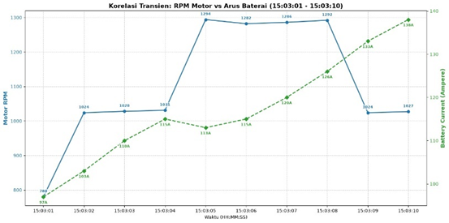

Figure 6. Relationship between Motor RPM and Battery Current during the road test.
Figure 6 illustrates the relationship between Motor RPM and Battery Current during the selected driving segment. In general, an increase in Motor RPM was accompanied by an increase in Battery Current, indicating that higher motor rotational speeds require greater electrical energy supplied by the battery pack. In battery electric vehicles, Battery Current represents the electrical energy delivered from the battery to the traction motor and is continuously regulated through the Battery Management System (BMS) and Energy Management System (EMS) to satisfy vehicle power demand while maintaining system efficiency [9], [25].
During the interval between 15:03:01 and 15:03:04, the Motor RPM increased from approximately 780 rpm to 1031 rpm, while the Battery Current increased from approximately 97 A to 115 A. This operating characteristic demonstrates a positive relationship between motor rotational speed and battery current, where greater electrical current is required to generate the motor torque needed for vehicle acceleration. Similar behavior has been reported in previous studies, where increases in traction motor speed are accompanied by higher battery current due to increased power demand from the electric drivetrain [26], [27].
A transient response was observed during the interval between 15:03:04 and 15:03:05, where the Motor RPM increased from approximately 1031 rpm to 1294 rpm, whereas the Battery Current slightly decreased from approximately 115 A to 113 A. This result indicates that the relationship between Motor RPM and Battery Current is not strictly proportional at every instant. The observed behavior suggests that battery current is influenced not only by motor rotational speed but also by the vehicle operating conditions, inverter control characteristics, and the energy management strategy implemented by the electric powertrain to optimize efficiency and maintain stable operation [9], [27].
Another transient operating characteristic was identified during the interval between 15:03:08 and 15:03:09, where the Motor RPM decreased from approximately 1292 rpm to 1024 rpm, while the Battery Current increased from approximately 126 A to 133 A. This behavior further confirms that Battery Current cannot be interpreted solely as a function of Motor RPM. Instead, the electrical current supplied by the battery is continuously adjusted according to the instantaneous power demand, vehicle load, and energy management strategy implemented by the control system. Consequently, the battery current reflects the actual electrical energy required by the propulsion system rather than motor speed alone [9], [25].
Overall, the obtained results demonstrate that Motor RPM and Battery Current exhibit a generally positive relationship during vehicle acceleration. Nevertheless, several transient responses indicate that the electrical behavior of the vehicle is governed by multiple operating variables, including drivetrain dynamics, power demand, and energy management strategies. These findings confirm that the decoded CAN Bus signals.

CONCLUSION
This study demonstrated that the proposed Controller Area Network (CAN) Bus sniffing method using an ESP32 microcontroller and an MCP2515 CAN module successfully acquired communication data from the Wuling Air EV through a passive monitoring approach without interfering with the vehicle control system. Approximately 49 minutes of driving data were recorded, resulting in 115 unique CAN IDs, which were subsequently processed using Python through filtering, decoding, data conversion, and visualization to identify operational vehicle parameters.

The proposed decoding approach successfully identified three key operational parameters, namely Accelerator Pedal Position (APP), Motor RPM, and Battery Current. The experimental results revealed that increases in APP were generally accompanied by increases in Motor RPM and Battery Current, indicating that the accelerator pedal input was translated by the Vehicle Control Unit (VCU) into motor torque demand. Nevertheless, several transient responses demonstrated that the relationships among these parameters were not strictly linear due to the influence of drivetrain dynamics, torque control strategies, and vehicle energy management.

Overall, the results confirm that a low-cost CAN Bus sniffing platform can be effectively utilized for reverse engineering proprietary CAN signals without requiring a manufacturer-provided CAN database (DBC). The proposed methodology provides a practical and systematic approach for monitoring and analyzing electric vehicle operational characteristics and may serve as a foundation for future research on real-time vehicle monitoring, diagnostics, and performance evaluation.

References
[1] A. Lazuardy, R. Nurcahyo, E. Kristiningrum, and A. Ma, “Technological , Environmental , Economic , and Regulation Barriers to Electric Vehicle Adoption : Evidence from Indonesia,” pp. 1–14, 2024.
[2] N. Amilia, Z. Palinrungi, I. Vanany, and M. Arief, “Designing an Optimized Electric Vehicle Charging Station Infrastructure for Urban Area : A Case study from Indonesia,” 2022.
[3] N. N. Pham, J. Leuchter, and K. L. Pham, “Battery Management System for Unmanned Electric Vehicles with CAN BUS and Internet of Things,” pp. 639–662, 2022.
[4] C. Ramai, V. Ramnarine, and S. Ramharack, “Framework for Building Low-Cost OBD-II Data-Logging Systems for Battery Electric Vehicles,” pp. 1209–1222, 2022.
[5] E. Levy, A. Shabtai, B. Groza, P. S. Murvay, and Y. Elovici, “CAN-LOC: Spoofing Detection and Physical Intrusion Localization on an In-Vehicle CAN Bus Based on Deep Features of Voltage Signals,” IEEE Trans. Inf. Forensics Secur., vol. 18, pp. 4800–4814, 2023, doi: 10.1109/TIFS.2023.3297444.
[6] Z. Bi, G. Xu, G. Xu, C. Wang, and S. Zhang, “Bit‐Level Automotive Controller Area Network Message Reverse Framework Based on Linear Regression,” Sensors, vol. 22, no. 3, 2022, doi: 10.3390/s22030981.
[7] X. Lin et al., “ByCAN: Reverse Engineering Controller Area Network (CAN) Messages From Bit to Byte Level,” IEEE Internet Things J., vol. 11, no. 21, pp. 35477–35491, 2024, doi: 10.1109/JIOT.2024.3435833.
[8] S. Akter, S. F. Wamba, and M. Mariani, “Alma Mater Studiorum Università di Bologna Archivio istituzionale della ricerca industrial Marketing Rights / License : The terms and conditions for the reuse of this version of the manuscript are specified in the,” no. March, 2025, doi: 10.1109/CCNC49033.2022.9700713.The.
[9] A. F. Challoob, N. A. Bin Rahmat, V. K. A/L Ramachandaramurthy, and A. J. Humaidi, “Energy and battery management systems for electrical vehicles: A comprehensive review & recommendations,” Energy Explor. Exploit., vol. 42, no. 1, pp. 341–372, 2024, doi: 10.1177/01445987231211943.
[10] S. El Afia, A. Cano, P. Arévalo, and F. Jurado, “Energy Sources and Battery Thermal Energy Management Technologies for Electrical Vehicles: A Technical Comprehensive Review,” Energies, vol. 17, no. 22, 2024, doi: 10.3390/en17225634.
[11] M. E. Verma, R. A. Bridges, J. J. Sosnowski, S. C. Hollifield, and M. D. Iannacone, “CAN-D: A Modular Four-Step Pipeline for Comprehensively Decoding Controller Area Network Data,” IEEE Trans. Veh. Technol., vol. 70, no. 10, pp. 9685–9700, 2021, doi: 10.1109/TVT.2021.3092354.
[12] R. Lutchen, A. Krätschmer, and H. C. Reuss, “AI-based classification of CAN measurements for network and ECU identification,” Automot. Engine Technol., vol. 7, no. 3–4, pp. 317–330, 2022, doi: 10.1007/s41104-022-00116-6.
[13] J. Caban, B. Šarkan, A. Małek, S. Dowkontt, and M. Loman, “Data-Driven Analysis of Electric Powertrain Energy Flow and Traction Battery Behavior in a Modern Battery Electric Vehicle Using Real-World OBD Data,” Electron., vol. 15, no. 10, pp. 1–28, 2026, doi: 10.3390/electronics15102018.
[14] S. Li, H. Zhang, N. Ding, M. Acquarone, F. Miretti, and D. A. Misul, “Associations of battery cell voltage consistency with driving behavior of real-world electric vehicles,” Green Energy Intell. Transp., vol. 4, no. 4, p. 100236, 2025, doi: 10.1016/j.geits.2024.100236.
[15] B. V. Malozyomov et al., “Determination of the Performance Characteristics of a Traction Battery in an Electric Vehicle,” World Electr. Veh. J., vol. 15, no. 2, 2024, doi: 10.3390/wevj15020064.
[16] P. Ngo, J. Sprinkle, and R. Bhadani, “CANClassify: Automated Decoding and Labeling of CAN Bus Signals,” J. Eng. Res. Sci., vol. 1, no. 10, pp. 5–12, 2022, doi: 10.55708/js0110002.
[17] X. Lin, B. Ma, X. Wang, Y. He, R. P. Liu, and W. Ni, “Multi-layer Reverse Engineering System for Vehicular Controller Area Network Messages,” 2022 IEEE 25th Int. Conf. Comput. Support. Coop. Work Des. CSCWD 2022, no. Can Id, pp. 1185–1190, 2022, doi: 10.1109/CSCWD54268.2022.9776214.
[18] Y. Li, H. Hong, and L. D’apolito, “Reliability control of electric racing car’s accelerator and brake pedals,” World Electr. Veh. J., vol. 12, no. 1, pp. 1–13, 2021, doi: 10.3390/WEVJ12010001.
[19] M. U. Cuma, Ç. D. Ünal, and M. M. Savrun, “Design and implementation of algorithms for one pedal driving in electric buses,” Eng. Sci. Technol. an Int. J., vol. 24, no. 1, pp. 138–144, 2021, doi: 10.1016/j.jestch.2020.12.014.
[20] H. Kim, “Personalization of electric vehicle accelerating behavior based on motor torque adjustment to improve individual driving satisfaction,” Sensors, vol. 21, no. 12, 2021, doi: 10.3390/s21123951.
[21] J. Wu, B. Wang, and X. Hong, “Driving Torque Control of Dual-Motor Powertrain for Electric Vehicles,” Actuators, vol. 11, no. 11, 2022, doi: 10.3390/act11110320.
[22] J. Yin and G. Cen, “Intelligent Motor Bearing Fault Diagnosis Using Channel Attention-Based CNN,” World Electr. Veh. J., vol. 13, no. 11, 2022, doi: 10.3390/wevj13110208.
[23] C. M. Coman, A. Florescu, and C. D. Oancea, “Assessment of energy use based on an implementation of iot, cloud systems, and artificial intelligence,” Energies, vol. 14, no. 11, pp. 1–21, 2021, doi: 10.3390/en14113202.
[24] K. He, H. Ding, N. Xu, and K. Guo, “Accelerated and Refined Lane-Level Route-Planning Method Based on a New Road Network Model for Autonomous Vehicle Navigation,” World Electr. Veh. J., vol. 14, no. 4, 2023, doi: 10.3390/wevj14040098.
[25] W. Liu, T. Placke, and K. T. Chau, “Overview of batteries and battery management for electric vehicles,” Energy Reports, vol. 8, pp. 4058–4084, 2022, doi: 10.1016/j.egyr.2022.03.016.
[26] F. Ju, N. Murgovski, W. Zhuang, and L. Wang, “Integrated Propulsion and Cabin-Cooling Management for Electric Vehicles,” Actuators, vol. 11, no. 12, pp. 1–21, 2022, doi: 10.3390/act11120356.
[27] E. Louback, A. Biswas, F. Machado, and A. Emadi, “A review of the design process of energy management systems for dual-motor battery electric vehicles,” Renew. Sustain. Energy Rev., vol. 193, no. December 2023, p. 114293, 2024, doi: 10.1016/j.rser.2024.114293.

