**Nama : Dimas Ilham M  
NIM : 18090122  
Kelas : 5B**

1. **Source Code**

Latihan1.php : application/controllers

Latihan2.php : application/controllers

Model_latihan1.php : application/models

view-latihan1.php : application/views

1. **URL**

http://localhost/pustaka_booking5B/index.php/latihan1

<http://localhost/pustaka_booking5B/index.php/latihan1/penjumlahan/2/6>

http://localhost/pustaka_booking5B/index.php/latihan2/penjumlahan/2/6

1. **Capture Hasil**

**Latihan1 :**

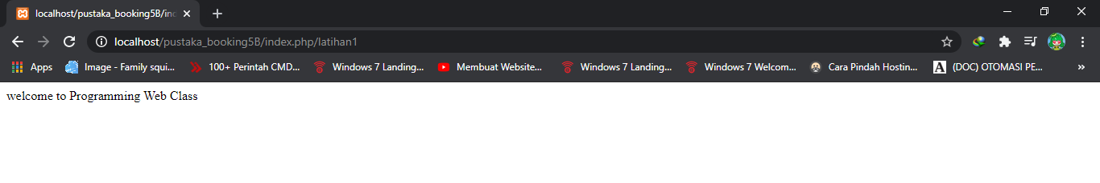

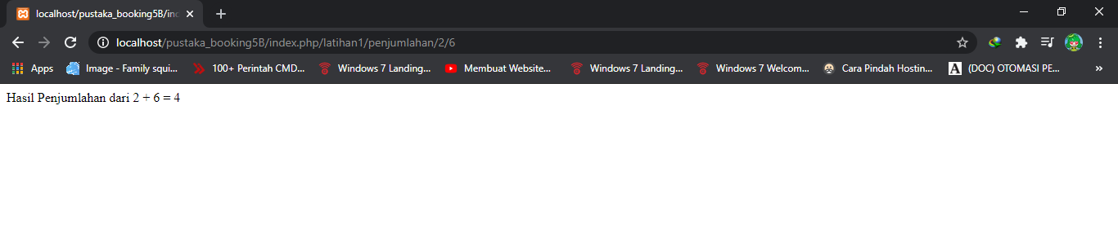

**Latihan2 :**

