**Nama : Dimas Ilham M  
NIM : 18090122  
Kelas : 5B**

1. **Source Code**

Matakuliah.php : application/controllers

form-matakuliah.php : application/views

data-matakuliah.php : application/views

config.php : application/config

autoload.php : application/config

routes.php : application/config

.htaccess : pustaka_booking5B/

1. **URL**

http://localhost/pustaka_booking5B/matakuliah

[http://localhost/pustaka_booking5B/](http://localhost/pustaka_booking5B/index.php/latihan1/penjumlahan/2/6)matakuliah/cetak

1. **Capture Hasil**

**Latihan1 :**

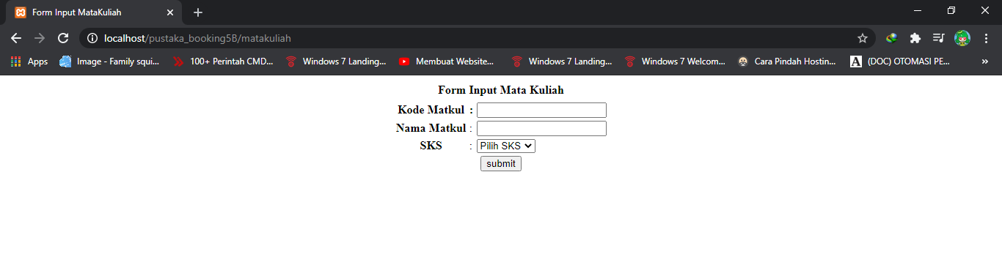

**Latihan2 :**

