**ASSIGMENT 3 – PROGRAMMING CONCEPT**

Aim: Understanding the functions, arrays and pointer.

1. Implement a recursive function that takes an integer argument (n) and prints the first n Fibonacci numbers.

# Sample output:



1. Implement a recursive function that takes a positive integer argument and returns the sum of the below sequence for the given argument

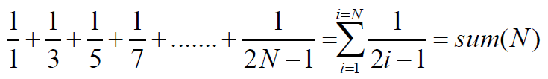

float sum(unsigned int N); // function prototype

# Sample output:



1. Write a main function that creates a two dimensional array (3x4) and then fillsthis array with the values from the user. Then,print the sum of the first values of every row of the array using the function below:

int sum (int a[][4], int rowSize);

//sum function returns the sum of the first values of every row of the given 2-D array

# Sample output:

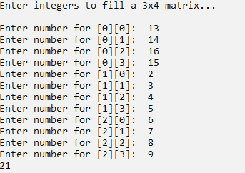

1. Write two functions in order to convert the temperature degrees in Celsius and Fahrenheit to each other. The functions, as declared below, should take the corresponding arguments as pointers to double variables:

void celsiusToFahrenheit (double* var); //argument “var” is given in Celcius

void fahrenheitToCelcius (double* var); //argument “var” is given in Fahrenheit

**Hint: Formulas to convert temperatures**:

c = (5/9)* (f - 32)

f = ((9/5)*c) + 32

=====================================================================