Irish Healthcare Waiting List Analysis
A Data-Driven Assessment of Outpatient Waiting Lists 2023–2025
Data Source: National Treatment Purchase Fund (NTPF) Open Data
Tools Used: PostgreSQL · Power Query · Microsoft Power BI
Prepared by: Ilham

1. Executive Summary
This report analyses three years of outpatient waiting list data published by the National Treatment Purchase Fund (NTPF) for Irish public hospitals. The dataset covers 36 monthly snapshots from January 2023 to December 2025, comprising over 2,920 records across 61 to 64 medical specialties and two patient groups: adults and children.
The analysis was conducted using PostgreSQL for data querying and Microsoft Power BI for visual reporting. The central question driving this project is: Is Ireland making real progress on its hospital waiting list crisis, and who is being left behind?

21M  Total Patient Records 2023–2025 | 51K  Reduction in 18+ Month Waiters | 17.36%  Avg % Waiting Over 12 Months

The findings show a clear improvement in the proportion of patients facing very long waits, particularly between 2023 and 2024. However, overall demand on the system is growing, progress stalled in 2025, and children are now proportionally worse off than adults for long waits. These mixed results suggest that while NTPF interventions have had a measurable impact, deeper structural challenges remain.

2. Background and Context
Ireland's hospital waiting list crisis has been a central issue in public health policy for over a decade. The National Treatment Purchase Fund (NTPF) is an independent public body responsible for publishing monthly waiting list data for all public hospitals in Ireland. Its data covers outpatient appointments (OP), inpatient and day case procedures (IPDC), and gastrointestinal endoscopy (GI Endoscopy).
This analysis focuses on outpatient waiting lists, which represent the largest category of waiting patients and the first point of contact between a patient and a hospital specialist. Patients are recorded in four-time bands: 0–6 months, 6–12 months, 12–18 months, and 18 months or more.
The Sláintecare reform programme, introduced in 2017, set maximum waiting time targets of 10 weeks for outpatient appointments and 12 weeks for inpatient and day case procedures. The Waiting List Action Plan (WLAP), launched in September 2021 and renewed annually, coordinates government efforts to reduce backlogs through outsourcing to private hospitals, insourcing initiatives, and additional funding.

3. Data and Methodology

3.1 Data Source
All data used in this report was sourced from the NTPF Open Data portal (ntpf.ie/waiting-list-data/open-data). Three annual files were downloaded covering outpatient waiting lists by specialty for 2023, 2024 and 2025.

Year | File | Rows | Months | Specialties
2023 | OpenData_OPNational02_2023 | 1,011 | 12 | 64
2024 | OpenData_OPNational02_2024 | 934 | 12 | 63
2025 | OpenData_OPNational02_2025 | 975 | 12 | 61
Combined | — | 2,920 | 36 | 58 consistent

3.2 Data Cleaning
The three files were combined and cleaned using Microsoft Power Query before being loaded into a PostgreSQL database. The following cleaning steps were applied:
- All three annual CSV files were combined into a single unified table
- Date column was converted from text format to a proper date data type
- Numeric columns containing comma-formatted values (e.g. “2,206”) were converted to whole numbers
- Year and month number columns were derived from the archive date
- A percentage over 12 months column was calculated: (wait_12_18m + wait_18m_plus) / total_waiting × 100
- No null values were found in any column across any of the three files

3.3 Analysis Approach
Five SQL queries were written in PostgreSQL to answer five specific business questions. Results were then visualised in a three-page Power BI dashboard. Each query was designed to move from broad overview to specific insight, building a connected narrative across the full dataset.

4. Key Findings

1 | Overall Demand Is Growing Despite Improvement in Long Waits  Total patient records across all three years exceeded 21 million. The overall number of patients on waiting lists grew from 7.1 million records in 2023 to 7.2 million in 2025. At the same time, the proportion waiting over 12 months fell from 22.93% in 2023 to 16.70% in 2025 a 6.23 percentage point improvement. This means the system is getting better at reducing the longest waits, but is seeing more patients overall. See Figure 1 for the full year-on-year trend across all three years

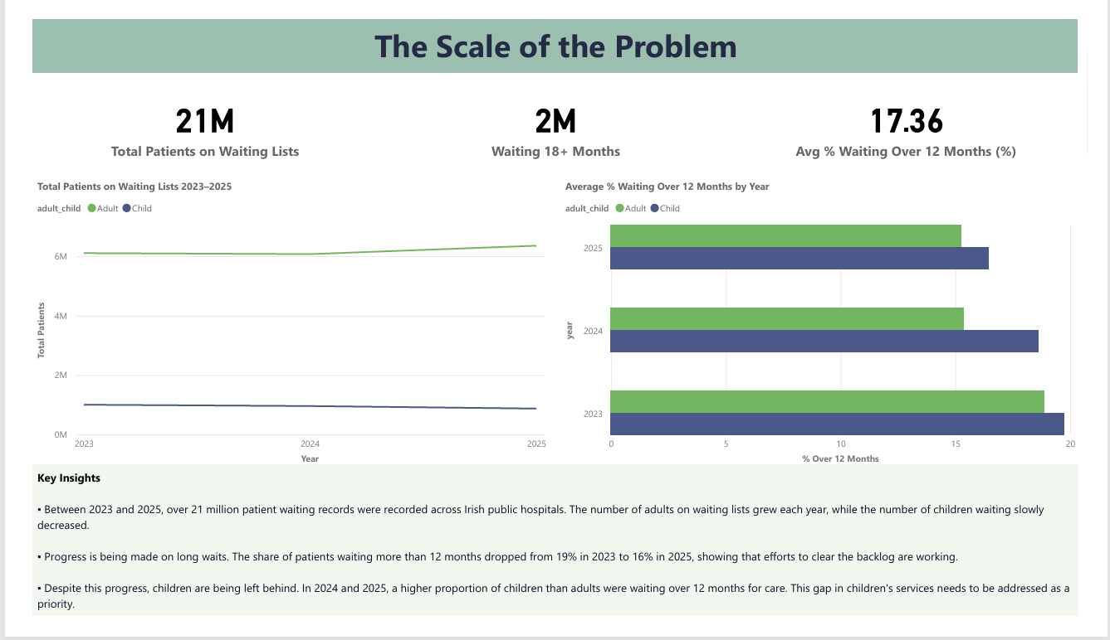
Figure 1: The Scale of the Problem Overall Waiting List Trends 2023–2025

2 | Orthopaedics, Dermatology and Cardiology Carry the Highest Volume  Among adult patients, Orthopaedics had the highest total waiting list volume with over 2.3 million patient records across the three years, followed by Dermatology at 1.84 million and Cardiology at 1.37 million. However, volume alone does not reflect severity. Neurology had 16.13% of its patients waiting 18 months or more, and Ophthalmology had 15.57% both significantly higher than Orthopaedics at 7.02%. Figure 2 shows the contrast between the highest-volume specialties and those with the most severe long-wait rates

3 | Children Are Being Left Behind  In 2023, adults had a higher proportion of 18+ month waiters than children (13.40% vs 11.28%). By 2025, this had reversed: 8.23% of children were waiting 18 months or more, compared to 7.32% of adults. Children are now proportionally worse off than adults for long waits. Eight of the fifteen specialties with the highest rates of patients waiting over 12 months are children’s services, including Rheumatology Child (49.75%), Paediatric Dermatology (31.99%), and Developmental Paediatrics (31.85%). Figure 2 also shows the Adults vs Children breakdown across the top specialties by 18+ month waiters.

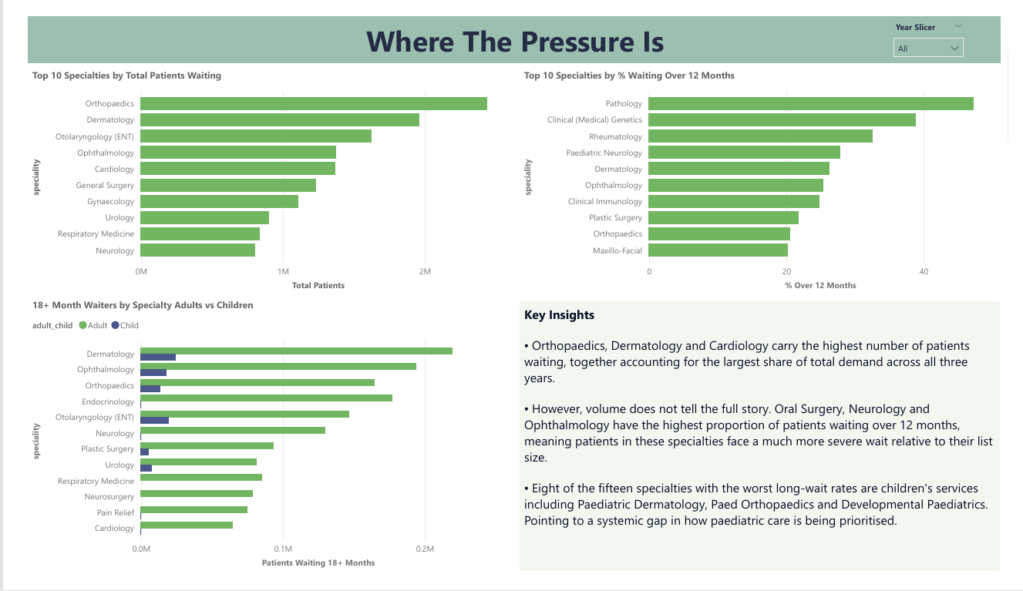
Figure 2: Where The Pressure Is Specialty and Patient Group Analysis

4 | The 18+ Month Backlog Fell by 55% Then Stalled  The number of patients waiting 18 months or more fell from a peak of 95,582 in January 2023 to 42,996 by December 2024 a reduction of over 55% in two years. This reflects the impact of NTPF outsourcing and insourcing programmes. However, throughout 2025, the number plateaued between 43,000 and 47,000 patients, with no further meaningful reduction. This suggests the most accessible gains have already been made. The monthly progression of this decline and the 2025 plateau are clearly visible in Figure 3.

5 | Oral Surgery and Clinical Genetics Face the Most Severe Backlogs  When looking at the proportion of patients waiting over 12 months, Oral Surgery (Adult) had the highest rate at 62.88%, meaning nearly two in three adult oral surgery patients had been waiting more than a year. Clinical (Medical) Genetics (Adult) was at 46.52% and Rheumatology (Child) at 49.75%. These are specialties where delayed treatment carries serious health consequences, including permanent joint damage in children and delayed cancer risk assessment in adults. Figure 3 further shows how the composition of the waiting list has shifted across the three years.

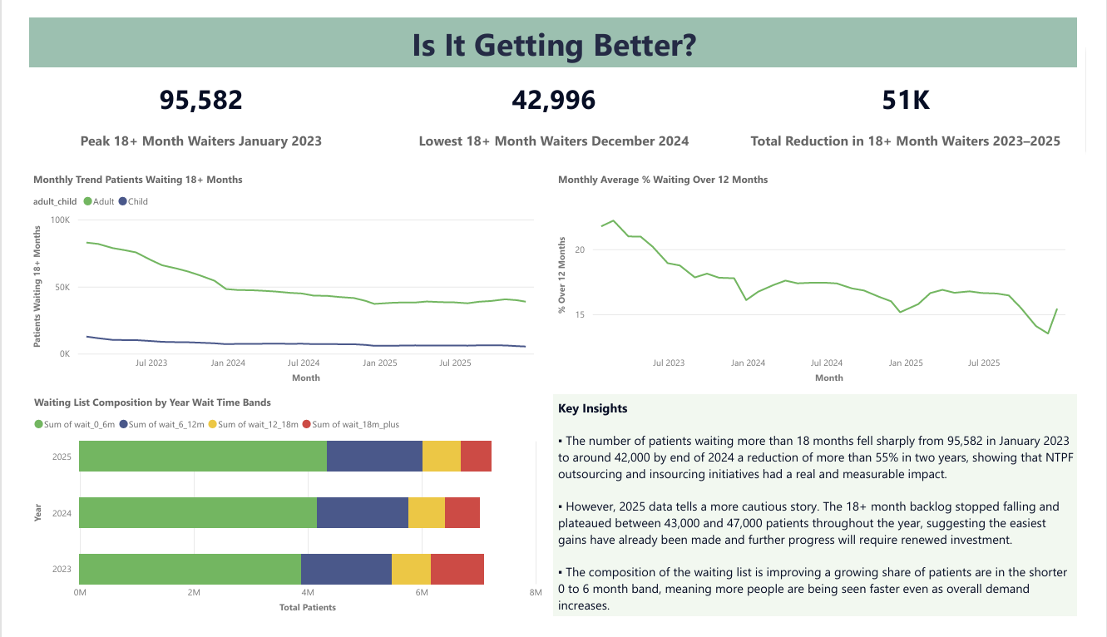
Figure 3: Is It Getting Better? Monthly Trend and Backlog Progression

5. Supporting Data

5.1 Year on Year Summary

Year | Total Patients | Waiting Over 12M | % Over 12 Months
2023 | 7,105,956 | 1,629,584 | 22.93%
2024 | 7,027,520 | 1,246,837 | 17.74%
2025 | 7,225,490 | 1,206,557 | 16.70%

5.2 Adults vs Children — 18+ Month Wait Rates

Group | 2023 (%) | 2024 (%) | 2025 (%) | Trend
Adult | 13.40% | 8.65% | 7.32% | ↓ Improving
Child | 11.28% | 8.87% | 8.23% | ↓ Improving Slowly

5.3 Top 10 Adult Specialties by Volume

Specialty | Total Patients | 18+ Month Waiters | % Waiting 18M+
Orthopaedics | 2,348,047 | 164,949 | 7.02%
Dermatology | 1,840,937 | 219,774 | 11.94%
Cardiology | 1,372,958 | 64,852 | 4.72%
Otolaryngology (ENT) | 1,314,920 | 146,870 | 11.17%
Ophthalmology | 1,247,272 | 194,262 | 15.57%
General Surgery | 1,190,039 | 25,905 | 2.18%
Gynaecology | 1,088,398 | 20,604 | 1.89%
Respiratory Medicine | 840,986 | 85,398 | 10.15%
Urology | 836,524 | 81,717 | 9.77%
Neurology | 808,470 | 130,409 | 16.13%

6. Recommendations
Based on the findings of this analysis, three recommendations are proposed for consideration by the HSE and the Department of Health.

Recommendation 1: Renew Investment in the 18+ Month Backlog
The plateau in 18+ month waiters throughout 2025 suggests that the current level of outsourcing and insourcing activity is insufficient to drive further reductions. The NTPF and HSE should review which specialties have responded well to outsourcing (such as Ophthalmology) and increase targeted investment in those that have not, particularly Neurology and Endocrinology.

Recommendation 2: Develop a Dedicated Paediatric Waiting List Strategy
Children are now proportionally worse off than adults for long waits, with eight of the fifteen most affected specialties being children’s services. A dedicated action plan for paediatric outpatient waiting lists should be developed, with specific targets for Rheumatology, Developmental Paediatrics, and Paediatric Dermatology where critical wait rates exceed 30%.

Recommendation 3: Focus on Severity, Not Just Volume
Current reporting and public discourse tends to focus on the total number of patients on waiting lists. This analysis shows that the severity of waits — the proportion waiting over 12 or 18 months — is a more meaningful indicator of patient harm. The NTPF and Department of Health should adopt severity-weighted metrics as primary performance indicators in the Waiting List Action Plan 2026.

7. Limitations
- This analysis covers outpatient waiting lists only. Inpatient, day case and GI endoscopy lists are not included and may tell a different story.
- A small number of specialties changed between years (64 in 2023, 61 in 2025), meaning some comparisons across the full three-year period are based on 58 consistent specialties only.
- The data does not include information on patient outcomes, clinical urgency, or the reason for each wait. Two patients in the same time band may have very different levels of need.
- NTPF spending and outsourcing volumes were not available in structured format and could not be incorporated into this analysis. Including this data in a future version would strengthen the ROI findings.
- This report is based on publicly available aggregate data. No individual patient data was accessed or used.

8. Conclusion
Ireland has made measurable progress in reducing its hospital waiting list backlog between 2023 and 2025. The number of patients waiting 18 months or more fell by more than 55% over two years, and the overall proportion of patients facing long waits has declined consistently. These are real improvements that reflect the impact of sustained government investment and NTPF initiatives.
However, this analysis reveals important gaps that require attention. Overall demand is growing. The 18+ month backlog has stopped falling. Children are now disproportionately affected, with higher long-wait rates than adults across multiple specialties. And the specialties with the most severe backlogs — Oral Surgery, Clinical Genetics, and Rheumatology — are those where delays carry the greatest risk of lasting harm.
Addressing these challenges will require a shift from volume-based targets to severity-based metrics, a dedicated strategy for paediatric services, and renewed investment in the specialties where progress has stalled. The data is clear: the easy gains have been made. The harder work is still ahead.

End of Report
Data Source: NTPF Open Data Portal | Analysis Period: January 2023 – December 2025

