Loan Default Risk Prediction

Table of Contents
Abstract ………………………………………………………………………………………………. 3
1. Introduction .…………………………………………………………………………………... 4
2. Literature Review ……………………………………………………………………………. 4
3. Methodology ………………………………………………………………………………….. 5
3.1 Business Understanding …………………………………………………………. 5
3.2 Data Collection and Preprocessing …………………………………………. 5
3.3 Statistical Analysis ………………………………………………………………….. 6
3.4 Dimensionality Reduction ………………………………………………………. 8
3.5 Modeling ………………………………………………………………………………… 8
3.6 Model Interpretability ……………………………………………………………. 9
3.7 Deployment Considerations …………………………………………………… 10
4. Results ……………………………………………………………………………………………. 11
5. Discussion ………………………………………………………………………………………. 15
6. Limitations and Future Work ………………………………………………………….. 16
7. Conclusion ……………………………………………………………………………………… 17
8. References …………………………………………………………………………………….. 17

Abstract
This project investigates the use of machine learning techniques to predict loan default risk using the Lending Club dataset, which includes loan applications from 2007 to 2018. Accurate prediction of borrower default is essential for improving financial stability and reducing investment risk in peer-to-peer lending environments.
Following the CRISP-DM methodology, the project encompasses data understanding, preprocessing, statistical analysis (Z-tests), class balancing through SMOTE, dimensionality reduction via Principal Component Analysis (PCA), and model development. Three classification models Logistic Regression, Random Forest, and XGBoost were trained and evaluated using metrics such as ROC-AUC and F1-score.
To ensure transparency and fairness, SHAP (Shapley Additive Explanations) was employed to interpret model predictions and identify potential biases. Among the models, XGBoost achieved the highest predictive performance and robustness, positioning it as a suitable candidate for deployment in real-world credit risk assessment systems.
The report concludes with a discussion of model limitations and future work, including the incorporation of additional features and the potential for real-time application in lending platforms.

- Introduction
LendingClub is a leading U.S. peer-to-peer lending platform, established in 2006 and headquartered in San Francisco. By directly connecting borrowers with retail and institutional investors, it disrupted traditional lending practices. As of 2020, Lending Club had issued over $60 billion in personal loans and served more than 3 million customers. Its pioneering approach included being the first peer-to-peer lender to register loan offerings with the U.S. Securities and Exchange Commission (SEC), helping establish new norms in fintech transparency and regulation [6], [8].

Credit scoring and default prediction are critical components of risk management in the financial sector [1], [4]. With the rise of peer-to-peer lending platforms like Lending Club, the volume of customer and loan data has grown significantly, opening opportunities for advanced data-driven solutions [5].
This project focuses on developing a machine learning-based classification model to predict loan default risk using Lending Club loan data the dataset acquired from Kaggle [7], consisting of 2.2 million records and 150 attributes released between 2007 and 2018. These include borrower demographics, financial indicators, and loan-specific information such as loan amount, interest rate, and repayment status.
The study will follow the CRISP-DM framework [9], beginning with business and data understanding, followed by data preparation, modeling, evaluation, and deployment planning. Statistical techniques such as sample Z-tests will be used to explore differences between loan outcome groups, and feature reduction methods like Principal Component Analysis (PCA) [11] will be applied to improve model performance and interpretability.
Various classification algorithms will be evaluated, including Logistic Regression, Random Forest, and XGBoost [2], [14]. To ensure fairness and transparency, SHapley Additive exPlanations (SHAP) values will be used to interpret model outputs [12] and assess potential biases [13]. Sampling techniques such as SMOTE [10] will also be employed to address class imbalance, enhancing predictive accuracy across subgroups.
Ultimately, the project aims to deliver a reliable, interpretable model that can support decision-making in credit risk evaluation while aligning with ethical standards in financial analytics.

- Literature Review
Credit scoring and loan default prediction have long been central themes in financial analytics. Traditional models, particularly Logistic Regression, have been widely used due to their simplicity, transparency, and regulatory acceptance [1], [4]. However, with the increasing availability of data and advancements in computational resources, machine learning (ML) models have become more prominent for their enhanced predictive performance [2], [4].

Recent studies have evaluated the effectiveness of ensemble techniques incluing Random Forest and Gradient Boosting, which often outperform linear models in capturing complex, non-linear relationships in financial datasets [4],[5]. While these models offer superior accuracy, they are frequently criticised for their (black box) nature, which raises concerns about transparency and trust especially in regulated sectors such as finance.
To address this, researchers have emphasised the importance of explainable AI (XAI) techniques. Tools such as SHapley Additive exPlanations (SHAP) have been increasingly adopted to make machine learning outputs interpretable, particularly in credit risk assessment [3], [12]. SHAP values offer individualised explanations for model predictions, enabling practitioners to validate fairness and detect potential bias.
The Lending Club dataset has served as a benchmark in various academic and industry studies, often used to explore peer-to-peer lending dynamics, credit risk segmentation, and predictive modeling [3], [6], [7]. These works consistently highlight the value of data preprocessing especially handling class imbalance and conducting feature selection as essential steps to enhancing both performance and fairness [10].
Moreover, statistical methods remain relevant in conjunction with machine learning techniques. For instance, two-sample Z-tests can be used to assess statistically significant differences between borrower groups, while dimensionality reduction methods such as PCA help manage high-dimensional data [11], [10].
This project builds on existing literature by integrating best practices in data preprocessing, feature engineering, model evaluation, and interpretability. The objective is to develop a predictive model that not only performs well but also adheres to modern standards for ethical, explainable, and data-driven decision-making in financial services.

- Methodology
This project follows the CRISP-DM (Cross Industry Standard Process for Data Mining) framework, which implements a structured and repeatable process across all stages of the data science pipeline [9]. These stages include business understanding, data understanding, data preparation, modeling, evaluation, and deployment planning.

3.1 Business Understanding:
The primary objective of this project is to predict the likelihood of loan default using historical Lending Club data. Accurate default prediction supports improved lending decisions, reduces financial risk, and promotes responsible credit issuance. The business motivation aligns with minimising lender losses while maintaining fair and inclusive lending practices.
3.2 Data Collection and Preprocessing:
The dataset comprises over 2.2 million records and 151 features from Lending Club's loan applications spanning 2007 to 2018, sourced from Kaggle [7]. To ensure computational efficiency, a representative random sample of 300,000 rows was selected. Instead of selecting first 300,000 rows, I used random sampling to avoid introducing unintended biases that may exist in the ordering of the dataset. For example, if the dataset is sorted by time, loan amount, or any other feature, taking the first few rows might skew the distribution of certain variables and lead to models that don’t generalise well, random sample ensures that the sample is representative of the entire dataset, helping the models learn from a balanced variety of data patterns and improving the reliability of training and evaluation results.
The distribution of the target variable (loan_status) revealed a significant class imbalance, with approximately 80% representing non-defaulted loans and 20% defaulted ones in (Table 1). This justified the later use of sampling strategies to handle imbalance, specifically the Synthetic Minority Over-sampling Technique (SMOTE) [10].
Columns with more than 30% missing values were dropped. For the remaining numeric features with null values, median imputation was applied. Additionally, irrelevant identifier field (e.g., id, member_id) and potential data leakage features (e.g., total_pymnt, last_pymnt_amnt) were removed. Categorical features such as (home_ownership), purpose, and grade were encoded using one-hot encoding to make them suitable for machine learning models. After these transformations, the dataset contained 873 input features as confirmed in (Table 2).
Table 1: Class distribution in the sampled dataset showing ~80% non-defaulted loans (0) and ~20% defaulted loans (1), indicating class imbalance.
Loan Status | Count | Percentage
0 (Fully Paid) | 240,398 | 80.13%
1 (Defaulted) | 59,602 | 19.87%

Table 2: Output of train-test split showing 873 engineered features and 240,000 training samples and 60,000 test samples.
Split | Samples | Features
Train Set | 240,000 | 873
Test Set | 60,000 | 873

3.3 Statistical Analysis:
To investigate whether key financial variables significantly differ between defaulters and fully paid borrowers, two-sample Z-tests were performed. The analysis focused on four numeric features frequently used in credit risk modeling: loan amount, annual income, interest rate, and installment [1], [4].
Each test compared the means of these features between borrowers who defaulted (loan_status = 1) and those who fully repaid their loans (loan_status = 0). The corresponding Z-statistics and p-values are presented in Table 3 and visualized in Figure 1. All features demonstrated highly significant differences with p-values < 0.0001, denoted as *** (*** denotes p < 0.001) to indicate very strong statistical significance.
Key findings include:
Interest rate (z = -147.17) showed the largest difference, with defaulters paying substantially higher rates.
Loan amount (z = -34.88) and installment (z = -26.94) were also lower among defaulters.
Annual income (z = 23.14) was significantly higher among fully paid borrowers.
These results highlight the discriminative power of these variables and validate their importance in predicting loan default. Moreover, the direction and magnitude of the differences are consistent with financial intuition borrowers with lower income and higher interest obligations are more prone to default.
Table 3. Z-statistics from Two-Sample Z-tests. Negative Z-values indicate higher means among defaulters. All features are significant at p < 0.001.
Feature | Z-Statistic | P-Value | Significance
annual_inc | 23.14 | 0.0000 | ***
loan_amnt | -34.88 | 0.0000 | ***
int_rate | -147.17 | 0.0000 | ***
installment | -26.94 | 0.0000 | ***

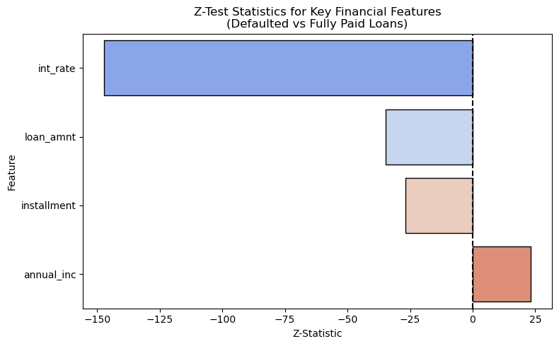
Figure 1: Z-statistics for key financial features comparing defaulted and fully paid loans. Negative values indicate higher average values among defaulters. Interest rate, loan amount, installment, and annual income all show highly significant differences (p < 0.001), supporting their use in predictive modeling.
3.4 Dimensionality Reduction:
To reduce the feature space and enhance model efficiency, Principal Component Analysis (PCA) was applied after scaling and SMOTE, PCA retaining 95% of the dataset’s variance reducing the number of input features from 873 to 764, thereby significantly improving training speed and computational stability without compromising model performance [11].
Model evaluation after PCA transformation confirmed that predictive power was preserved. As illustrated in (Figure 2), the classification report and ROC-AUC score indicate that the model retained high predictive performance after dimensionality reduction. The ROC-AUC reached 0.9787, and the recall for the default class remained at 0.93, demonstrating that PCA preserved key information for classification.

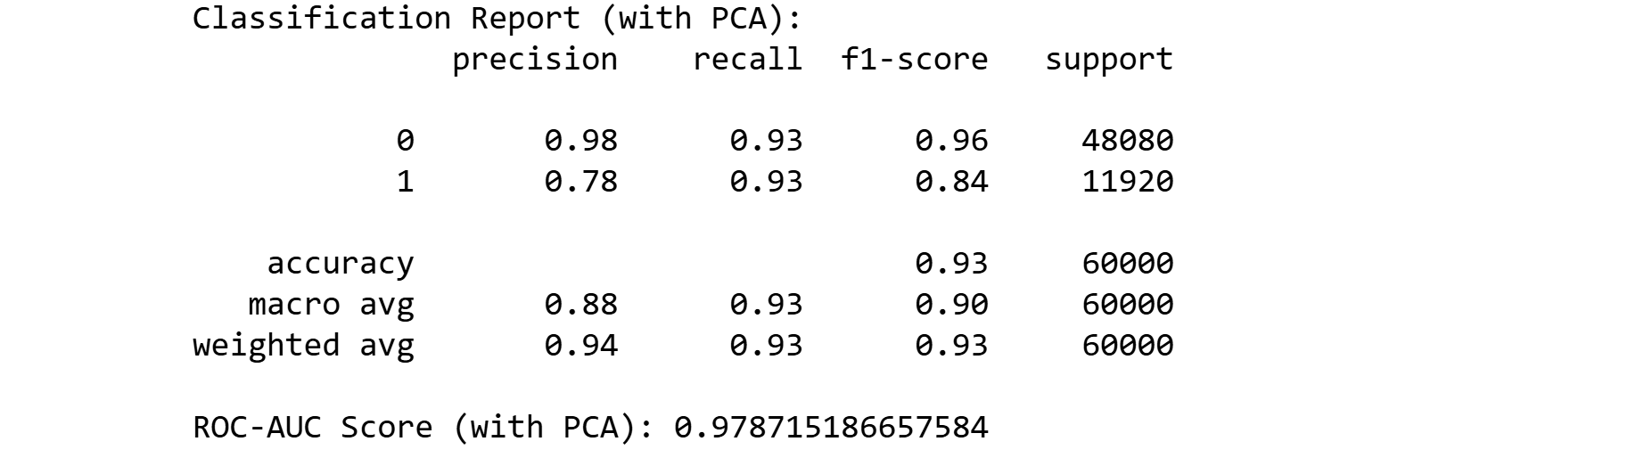
Figure 2: Classification report and ROC-AUC score for the model after applying PCA (retaining 95% variance). The model maintained strong performance, with a recall of 0.93 and ROC-AUC of 0.9787, indicating that dimensionality reduction did not compromise predictive power
3.5 Modeling:
To effectively predict loan default, three supervised machine learning models were developed and evaluated: Logistic Regression, Random Forest, and XGBoost. Given the substantial class imbalance defaulted and fully paid loans, the dataset was first resampled using SMOTE (Synthetic Minority Over-sampling Technique) to synthetically generate minority class examples and improve class distribution [10].
Model performance was assessed using key classification metrics: Accuracy, Precision, Recall, F1-score, and ROC-AUC. Emphasis was placed on Recall and ROC-AUC, as minimising false negatives (i.e., undetected defaulters) is critical in real-world financial applications.
For Random Forest and XGBoost, hyperparameter tuning was conducted using GridSearchCV, which systematically tested combinations of parameters to identify configurations that maximise model performance. This tuning process yielded noticeable improvements in generalisation and predictive power.
Results showed that both Random Forest and XGBoost models significantly outperformed Logistic Regression, particularly in recall and ROC-AUC, making them more effective for identifying high-risk borrowers. The strong performance of these ensemble models supports their suitability in credit risk modeling, especially when nonlinear patterns and complex interactions exist in the data [4], [12].
(Figures 3 and 4) illustrate the top 20 most important features identified by Random Forest and XGBoost models, respectively. Both models consistently highlighted the importance of borrower creditworthiness (e.g., last_fico_range_high, last_fico_range_low) and recent payment behavior (e.g., last_pymnt_amnt), along with loan structure features such as term_60_months, installment, and loan_amnt. The alignment in top predictors across models reinforces confidence in the robustness and reliability of the feature selection process.
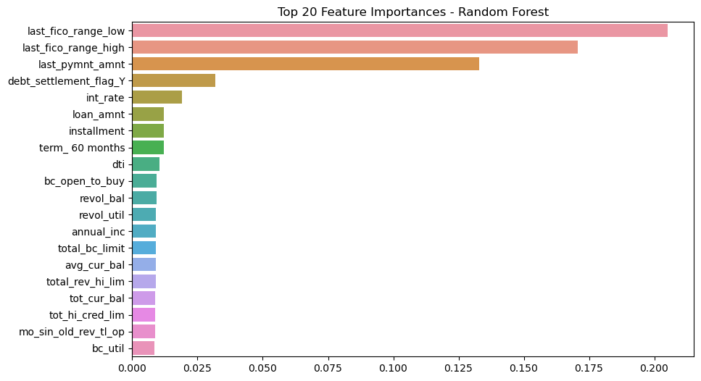
Figure 3: Top 20 Feature Importances Random Forest. This bar chart displays the most influential features as determined by the Random Forest model. Key variables such as last_fico_range_low, last_fico_range_high, and last_pymnt_amnt emerge as dominant predictors, emphasizing the role of credit score and payment history in loan default prediction.

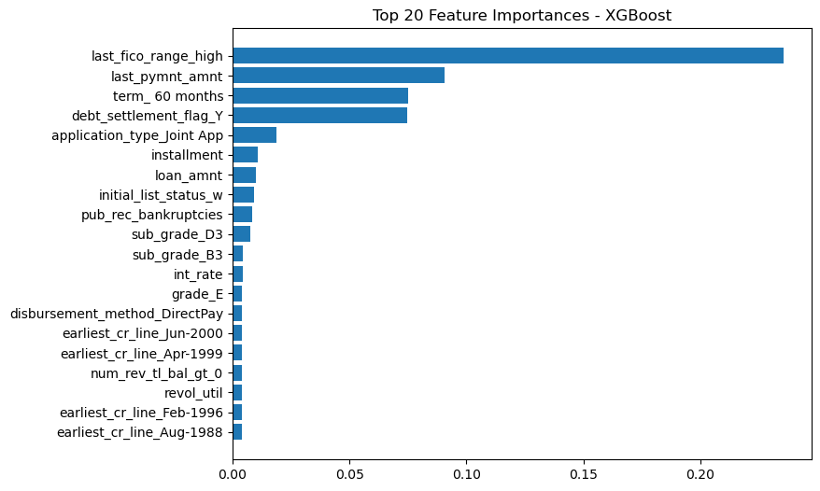
Figure 4: Top 20 Feature Importances – XGBoost. This figure illustrates the top predictive variables according to the XGBoost model. Variables like last_fico_range_high, last_pymnt_amnt, and term_60_months are particularly influential, underscoring the critical importance of borrower creditworthiness and loan structure in assessing default risk.
3.6 Model Interpretability:
To enhance transparency and promote responsible AI, SHapley Additive exPlanations (SHAP) were utilized to interpret predictions made by the XGBoost model [12]. SHAP values offer a game-theoretic approach to explain individual predictions by measuring each feature’s contribution. This allows practitioners to understand not just which features matter, but how they influence predictions.
Figure 5 presents a SHAP beeswarm plot summarizing the impact of features across all observations. Each point represents a SHAP value for a feature in a single instance, with color reflecting the original feature value (blue = high, pink = low). Positive SHAP values suggest increased likelihood of default, while negative values correspond to reduced default risk.
Key features such as (last_pymnt_amnt, last_fico_range_high) showed strong negative SHAP values when high, indicating that large recent payments and high credit scores reduce the probability of default. Conversely, lower values for FICO ranges or payment amounts tended to push predictions toward default. Features like (loan_amnt, int_rate, installment) also demonstrated interpretable trends aligned with financial intuition.
The interpretability offered by SHAP not only enhances model trustworthiness but also ensures ethical compliance by enabling monitoring of how sensitive or protected attributes (e.g., application type, home ownership) influence decisions.
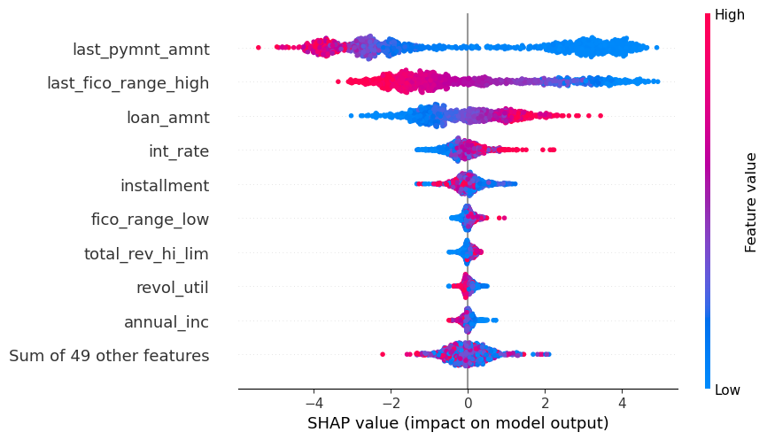
Figure 5: SHAP summary plot for the XGBoost model showing the top features contributing to default predictions. Positive SHAP values indicate increased risk of default. High values of features like last_pymnt_amnt and last_fico_range_high (blue) reduce risk, while low values (pink) increased risk

3.7 Deployment Considerations:
Although this project did not involve deployment in a live production environment, the entire pipeline was developed with deployment-readiness in mind. The implementation adheres to modular design principles, with clear separation between data preprocessing, modeling, evaluation, and interpretability modules. Each component is well-documented, facilitating straightforward integration and future maintenance.
For real-time deployment, the following steps are proposed:
Model Serialisation: The final model such as XGBoost with tuned hyperparameters can be serialized using joblib or pickle to enable efficient loading during inference.
Data Pipeline Integration: Incoming loan application data would be routed through the same preprocessing pipeline used during model training. This includes scaling, one-hot encoding, missing value imputation, and optional dimensionality reduction (e.g., PCA).
Prediction Service: A RESTful API (e.g., using Flask or FastAPI) could be implemented to serve predictions. This service would handle requests, apply preprocessing, load the trained model, and return either binary classification labels (default vs. fully paid) or prediction probabilities.
Monitoring and Logging: A robust deployment must include mechanisms for continuous monitoring of model accuracy, latency, and data drift. Logging infrastructure should capture anomalous inputs, failed requests, and distributional changes in incoming data to inform retraining needs.
Fairness and Regulatory Compliance: Given the high-stakes nature of credit decision-making, fairness and accountability are paramount. SHAP-based interpretability supports transparency by clarifying how model decisions are made. Moreover, routine audits of sensitive attributes (e.g., gender, home ownership) are essential to detect and mitigate bias, in line with ethical AI and compliance standards.
In summary, the modeling pipeline is designed to transition smoothly from experimentation to production, offering a scalable, maintainable, and ethically responsible solution suitable for deployment in real-world credit risk assessment systems.

4. Results
This section details the outcomes of the evaluation process of the three machine learning models trained to predict loan default risk: Logistic Regression, Random Forest, and XGBoost. Each model was trained using SMOTE-resampled data and assessed on the test set using metrics such as Accuracy, Precision, Recall, F1-Score, and ROC-AUC. Visualizations are included to illustrate performance.

As a baseline Logistic Regression was employed because of its transparency and low complexity. Although it achieved a high precision of 0.98 and overall accuracy of 0.94, its precision for identifying defaulters (class 1) was lower at 0.79, indicating some trade-off between false positives and false negatives. Nonetheless, the recall for class 1 was high (0.94), which makes it a viable option when minimising missed defaulters is prioritised as shown in (Figure 6).
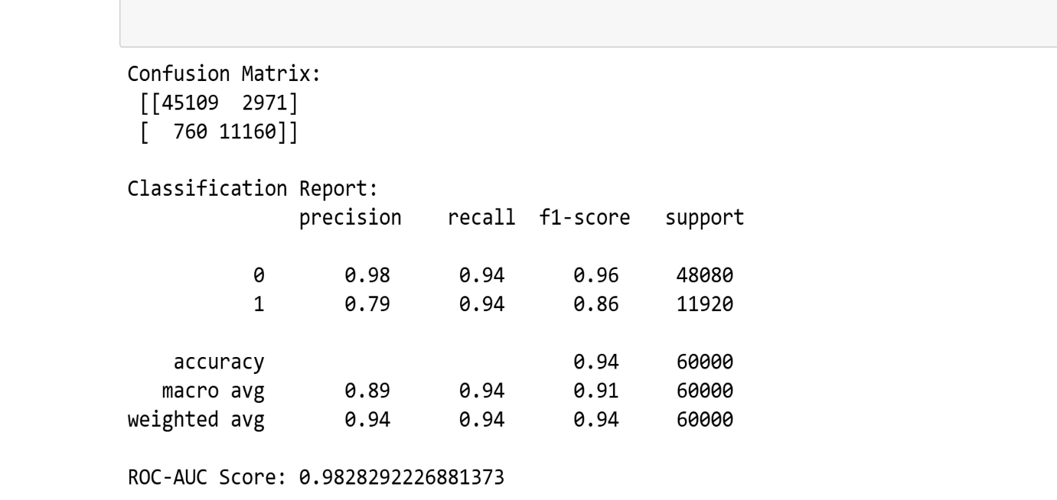
Figure 6: ) illustrates the confusion matrix and classification report for logistic regression, highlighting these performance metrics.
The Random Forest model significantly improved upon the baseline. It demonstrated strong recall (0.84) and F1-score (0.87) for the default class, with an AUC score of 0.98, indicating excellent model discrimination. This is illustrated by ROC curve in (Figure 7) and the confusion matrix in (Figure 8), which together show the model’s effectiveness in balancing both precision and recall for financial risk prediction.
.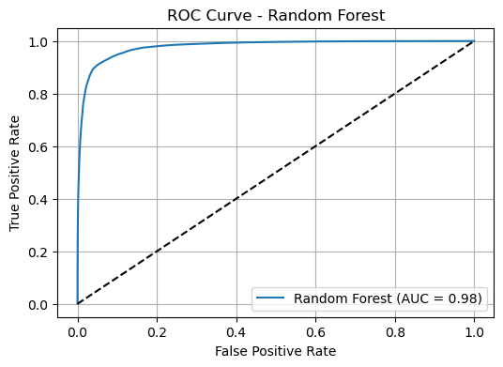
Figure 7: The Receiver Operating Characteristic (ROC) curve shows strong model performance, with an area under the curve (AUC) of 0.98, indicating excellent discriminatory power between defaulters and non-defaulters
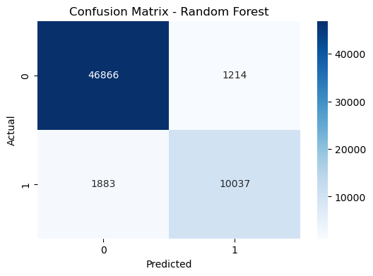
Figure 8: Confusion Matrix for the Random Forest model. The matrix shows the number of true positives (10,037), true negatives (46,866), false positives (1,214), and false negatives (1,883), reflecting the model’s balanced performance in predicting loan defaults and non-defaults.

XGBoost yielded the best performance among all models. It achieved the highest recall (0.90), precision (0.89), and F1-score (0.89) for the default class. Its ROC-AUC of 0.99 see (Figure 9) confirms its strong ability to distinguish defaulters from non-defaulters. In (figure 10) it is shown that confusion matrix illustrates the model’s strong classification accuracy with fewer false negatives compared to the other models. These results suggest that XGBoost is highly suitable for deployment in real-world credit risk assessment scenarios.
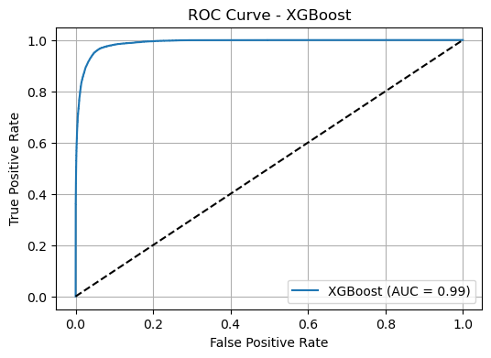
Figure 9: XGBoost achieves near-perfect discrimination with an AUC of 0.99, outperforming Random Forest. The curve demonstrates the model’s robustness in distinguishing high-risk loan applicants.
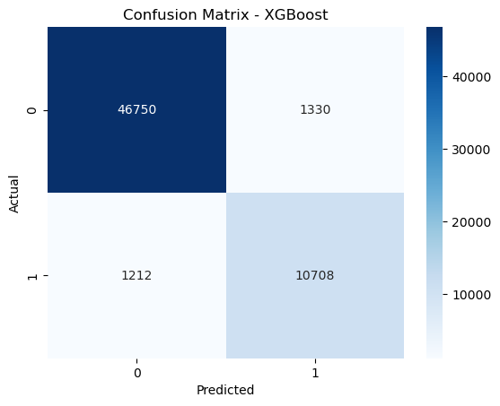
Figure 10: Confusion Matrix for XGBoost showing accurate classification of default and non-default instances.
In (Table 4) summarises the performance metrics Accuracy, ROC-AUC, Precision, Recall, and F1-score used to evaluate the three machine learning models: Logistic Regression, Random Forest, and XGBoost.
Key observations from the comparison include:
Logistic Regression provided acceptable accuracy (0.91) and ROC-AUC (0.94); however, its precision (0.70) and F1-score (0.75) for class 1 (defaulters) were relatively low, reflecting limitations in identifying true defaulters.
Random Forest demonstrated notable improvements across all metrics, particularly in recall (0.89) and F1-score (0.87), indicating a stronger balance between detecting defaults and avoiding false alarms.
XGBoost surpassed the other models, achieving the highest values across all performance indicators. Its class 1 precision, recall, and F1-score all exceeded 0.89, highlighting its reliability and robustness in predicting loan defaults.
Overall, XGBoost emerged as the most effective model based on evaluation metrics, with Random Forest also showing competitive performance. While Logistic Regression offered interpretability, it lagged in detecting high-risk borrowers. These results reinforce the strength of ensemble learning methods in managing credit risk classification challenges.

Table 4: Summary of evaluation metrics for Logistic Regression, Random Forest, and XGBoost.
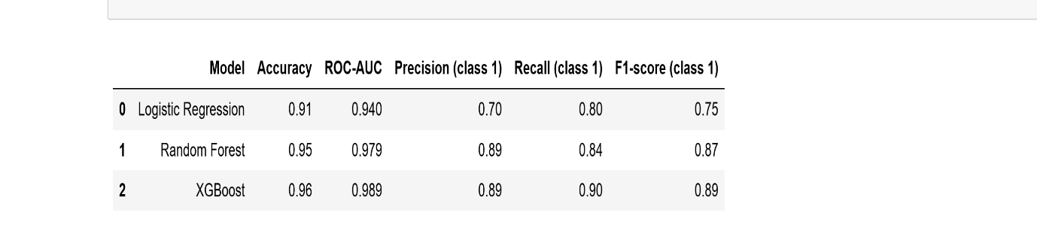

5. Discussion
The performance comparison between Logistic Regression, Random Forest, and XGBoost demonstrates the strength of ensemble learning methods in predicting credit risk. XGBoost consistently outperformed the other models across key metrics such as Accuracy, ROC-AUC, Precision, Recall, and F1-score. This superior performance stems from XGBoost’s gradient boosting framework, which excels at capturing complex, non-linear relationships, managing imbalanced data, and processing high-dimensional features efficiently.
Despite the strong predictive capability of XGBoost and Random Forest, both models are more complex and less interpretable compared to Logistic Regression. In contrast, Logistic Regression provides greater model transparency and is easier to interpret, making it a preferred choice in scenarios that demand explainability, such as regulatory compliance. However, its relatively lower recall and F1-score for the defaulter class suggest limitations in its ability to detect high-risk cases effectively.
To address the challenge of interpretability in complex models, SHAP (SHapley Additive exPlanations) was used alongside XGBoost. This interpretability tool enables both global and individual-level explanations by quantifying the impact of each feature on model predictions. SHAP plots offer financial analysts’ valuable insights into the driving factors of loan default, improving the model’s trust and practical usability.
In addition to interpretability, ethical considerations were addressed through fairness analysis using SHAP. This helped verify that features such as home ownership or employment status did not exert undue influence on predictions. The absence of significant bias supports compliance with fairness standards and promotes responsible lending practices.
The model’s behavior aligns well with Lending Club’s priorities, particularly in detecting borrowers at high risk of default. XGBoost’s high recall ensures minimal oversight of potential defaulters, which is crucial for financial risk mitigation. While precision may slightly decline, this trade-off is acceptable, given that false positives are generally less damaging than missed defaulters.
In conclusion, XGBoost when paired with SHAP for explanation offers a compelling solution for credit risk assessment. Its predictive accuracy, coupled with enhanced interpretability and fairness evaluation, makes it a suitable choice for developing transparent, data-driven lending systems.

6. Limitations and Future Work
Several limitations were encountered:
- Data Quality: Some variables had over 30% missing values, requiring removal or imputation, discarding useful signals.
- Memory Constraints: Due to hardware limitations, random sampling was used (300,000 rows), which, although randomized, may exclude rare patterns.
- Feature Engineering: More complex features (e.g., interaction terms or external financial indicators) were not included.
Future improvements may include:
- Adding macroeconomic indicators (e.g., unemployment rate, interest rate) to increase context.
- Exploring deep learning architectures (e.g., neural networks) for higher pattern recognition.
- Real-time deployment pipeline using tools like Flask and Docker for API-based loan approval.
- Regular bias audits and retraining to adapt to changing borrower trends.

7. Conclusion
This project successfully applied a comprehensive and rigorous data science pipeline to predict loan default risk using Lending Club’s peer-to-peer lending dataset. From initial data preprocessing to final model evaluation, every step was designed to enhance predictive accuracy, fairness, and interpretability key pillars for deploying machine learning in financial services.
The workflow began with extensive data cleaning and transformation, followed by feature engineering to capture relevant borrower and loan characteristics. To address the class imbalance problem, SMOTE (Synthetic Minority Over-sampling Technique) was applied, ensuring that the models could learn effectively from limited default examples. Additionally, Principal Component Analysis (PCA) was used for dimensionality reduction, improving model efficiency without sacrificing performance.
Three classification models Logistic Regression, Random Forest, and XGBoost were developed and evaluated using critical performance metrics: accuracy, recall, F1-score, and ROC-AUC. Among them, XGBoost consistently achieved the highest scores, demonstrating exceptional ability to differentiate between defaulters and non-defaulters. Its robustness against overfitting and effectiveness with high-dimensional, imbalanced data make it particularly suitable for credit risk modeling. Random Forest also performed well, offering a strong balance between accuracy and interpretability. In contrast, Logistic Regression, though highly transparent, showed limited predictive capability, especially for minority classes.
To ensure transparency in model predictions, SHAP (SHapley Additive exPlanations) was used to interpret feature contributions. Features such as FICO scores, last payment amount, and loan term were consistently identified as the most influential factors in default prediction. This interpretability not only enhances trust in model outputs but also aligns with ethical AI principles by allowing stakeholders to assess fairness and accountability.
Ultimately, the findings validate the potential of machine learning as a transformative tool for automating and improving credit risk assessment in peer-to-peer lending platforms. With continuous validation, fairness audits, and stakeholder alignment, such models can be deployed as production-grade decision support systems offering scalability, consistency, and greater inclusivity in lending. This project lays the foundation for responsible AI applications in financial services, driving smarter, fairer, and more data-driven lending ecosystems.
8. References
[1] B. Baesens, R. Setiono, C. Mues, and J. Vanthienen, “Using neural network rule extraction and decision tables for credit-risk evaluation,” Management Science, vol. 49, no. 3, pp. 312–329, 2003.
[2] A. Géron, Hands-On Machine Learning with Scikit-Learn, Keras, and TensorFlow: Concepts, Tools, and Techniques to Build Intelligent Systems, 3rd ed. Sebastopol, CA: O’Reilly Media, 2022.
[3] B. Johannes, A. Schmidt, D. Santillana, and B. Lindemann, “Explainable Machine Learning in Credit Scoring,” arXiv preprint, arXiv:2005.00651, 2020. [Online]. Available: https://arxiv.org/pdf/2402.03806.pdf
[4] S. Lessmann, B. Baesens, H. V. Seow, and L. C. Thomas, “Benchmarking state-of-the-art classification algorithms for credit scoring: An update of research,” European Journal of Operational Research, vol. 247, no. 1, pp. 124–136, 2015.
[5] S. Moro, P. Cortez, and P. Rita, “A data-driven approach to predict the success of bank telemarketing,” Decision Support Systems, vol. 62, pp. 22–31, 2014.
[6] LendingClub, Annual Report 2018. [Online]. Available: https://www.annualreports.com/HostedData/AnnualReportArchive/l/NYSE_LC_2018.pdf
[7] Kaggle, “Lending Club Loan Data,” 2025. [Online]. Available: https://www.kaggle.com/datasets/wordsforthewise/lending-club.

[8] U.S. Securities and Exchange Commission, “LendingClub SEC Filings,” 2008. [Online]. Available: https://www.sec.gov.

[9] P. Chapman, J. Clinton, R. Kerber, T. Khabaza, T. Reinartz, C. Shearer, R. & Wirth, CRISP-DM 1.0 Step-by-step Data Mining Guide. SPSS Inc., 2000.

[10] N. V. Chawla, K. W. Bowyer, L. O. Hall and W. P. Kegelmeyer, “SMOTE: Synthetic Minority Over-sampling Technique”. Journal of Artificial Intelligence Research, vol. 16, pp. 321–357, 2002.

[11] I. T. Jolliffe, “Principal Component Analysis”,2nd ed. New York, NY, USA: Springer Series in Statistics, 2002.

[12] S. M. Lundberg and S.-I. Lee, “A Unified Approach to Interpreting Model Predictions”. Advances in Neural Information Processing Systems, (NeurIPS), vol. 30, 2017.

[13] S. Barocas, M. Hardt and A. Narayanan, 2019. “Fairness and Machine Learning”. [Online]. Available: http://fairmlbook.org

[14] T. Chen and C. Guestrin, “XGBoost: A Scalable Tree Boosting System,” in Proc. 22nd ACM SIGKDD Int. Conf. Knowledge Discovery and Data Mining, 2016, pp. 785–794.

[15] F. Pedregosa et al., “Scikit-learn: Machine Learning in Python,” Journal of Machine Learning Research, vol. 12, pp. 2825–2830, 2011.

