UK Online Retail Sales Analysis
SQL Data Analysis & Power BI Business Intelligence Dashboard
Author: Ilham Oussanna
Tools Used: PostgreSQL, SQL, Power BI
Dataset: UK Online Retail Dataset (2010–2011)

1. Introduction
This project analyses transactional data from a UK-based online retail company between December 2010 and December 2011. The goal of the analysis is to understand business performance, identify customer purchasing patterns, evaluate product performance, and uncover geographic sales trends.
The project combines SQL-based data analysis with Power BI dashboards to transform raw transactional data into meaningful business insights.

2. Data Preparation
The dataset was first imported into PostgreSQL using a staging table where all fields were initially stored as text to prevent ingestion errors. A cleaned analytical view was then created to standardize data types and calculate revenue.
Cleaning steps included:
- Converting quantity and price to numeric types
- Converting invoice dates to timestamp
- Creating a calculated revenue column (quantity × unit_price)
- Removing cancelled orders and invalid transactions

3. Core Business KPIs
Key performance metrics were calculated using SQL aggregation queries after filtering out transactions with missing CustomerID values.
Metric | Value
Total Revenue | €8,911,407.90
Total Orders | 18,532
Active Customers | 4,338
Average Order Value (AOV) | €480.87

4. Sales Trend Analysis
Monthly sales analysis shows clear seasonal patterns. Revenue remained relatively stable during the first half of the year before accelerating significantly in Q4. November represents the peak month, likely driven by pre‑Christmas wholesale purchasing.

5. Customer Behaviour Analysis
Customer segmentation revealed strong repeat purchasing behaviour. Approximately 66% of customers are repeat buyers, indicating high retention. The distribution of order frequency shows that most customers place between two and six orders, while a smaller group of high‑frequency customers place many more.

6. Product Performance
Product analysis revealed that a relatively small number of items generate the majority of revenue. Some products achieve high revenue through high pricing while others generate revenue through high sales volume. This indicates opportunities for pricing optimization and product promotion.

7. Geographic Sales Analysis
The United Kingdom dominates both revenue and order volume. However, several international markets demonstrate higher average order values, including the Netherlands and Singapore. These regions may represent opportunities for international growth.

8. Power BI Dashboard Overview
The analysis results were visualized in Power BI using four dashboard pages:
- Executive Overview: high‑level KPIs and revenue trends
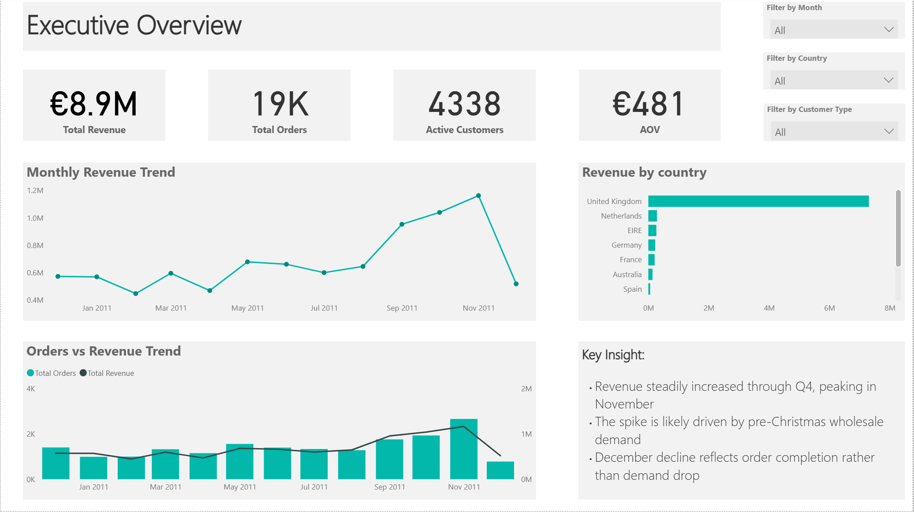
- Product Performance: top revenue products and sales distribution
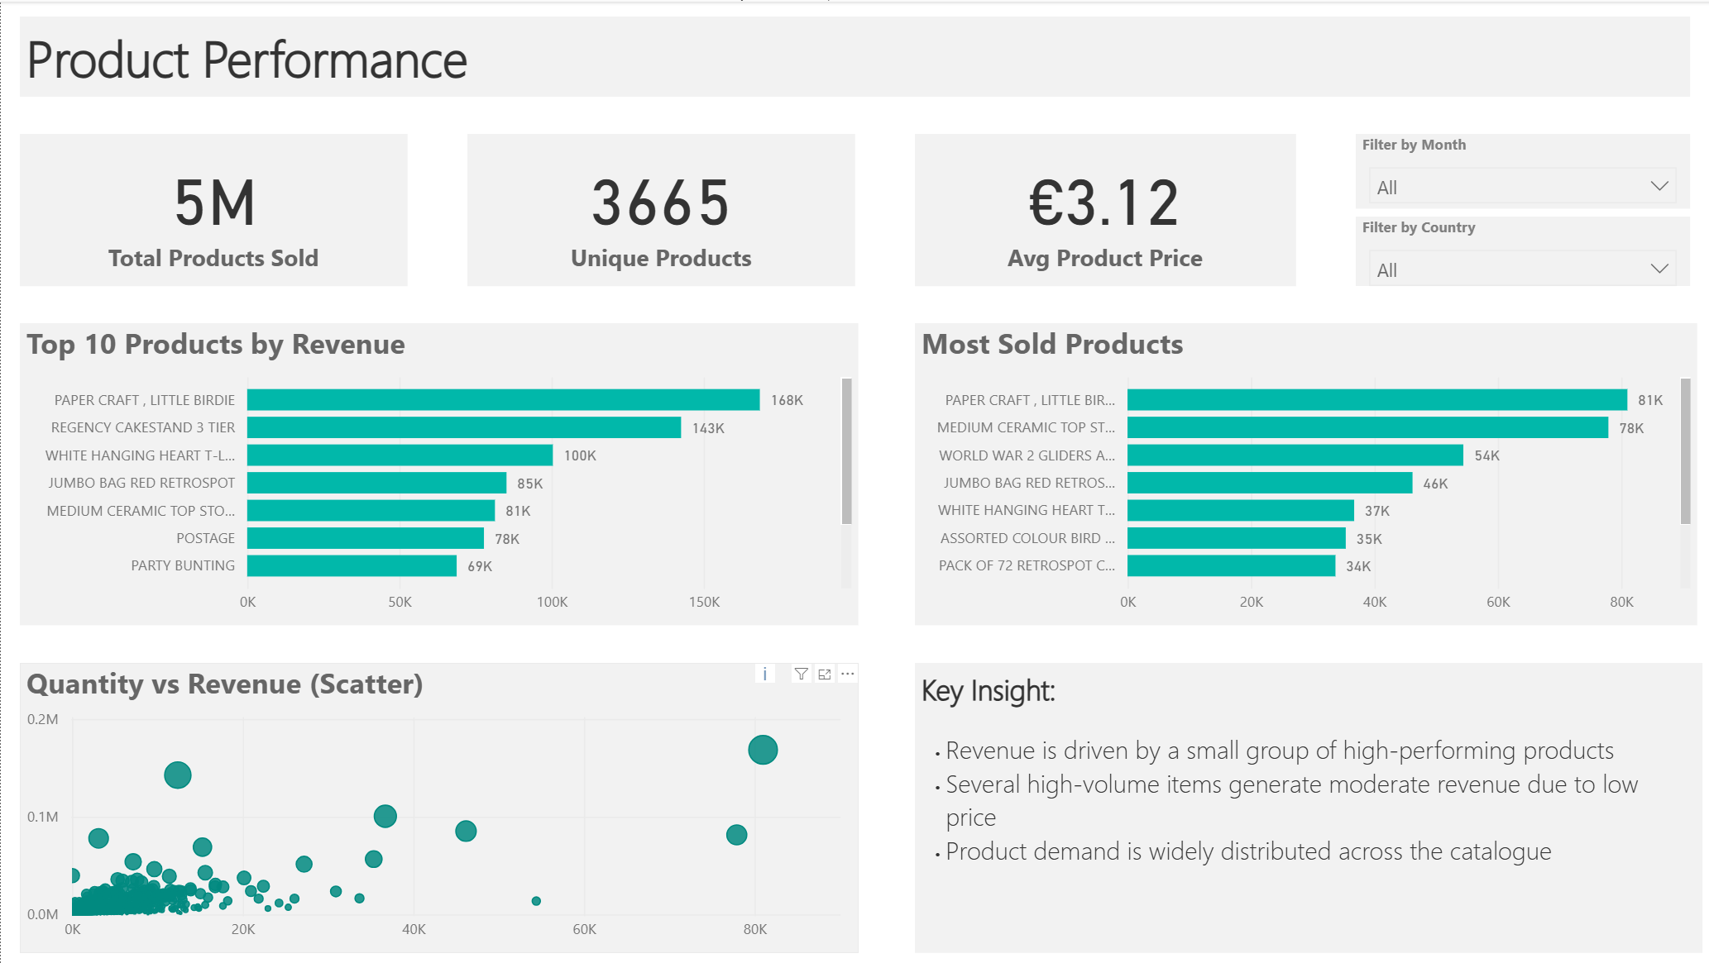
- Customer Behaviour: repeat rate and purchase frequency
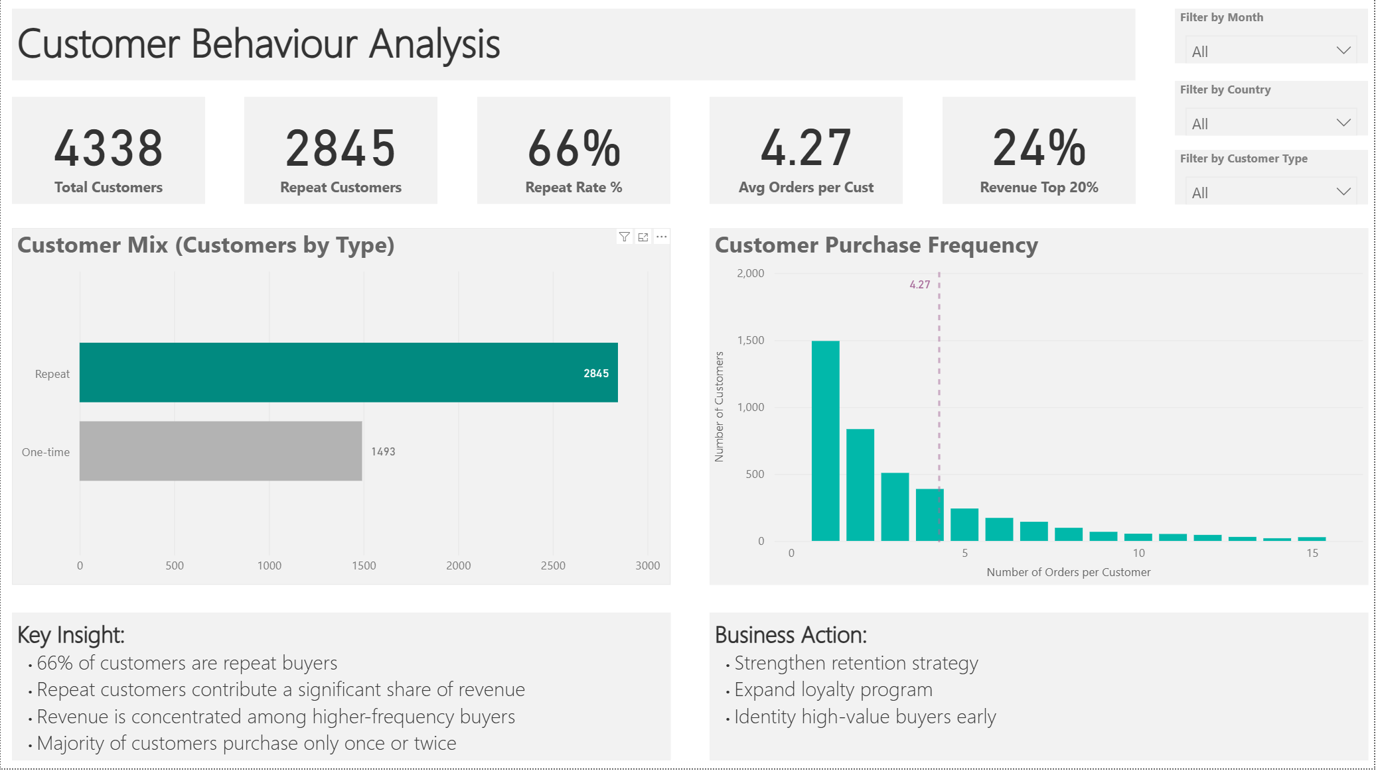
- Geographic Sales: country-level revenue and map visualisations
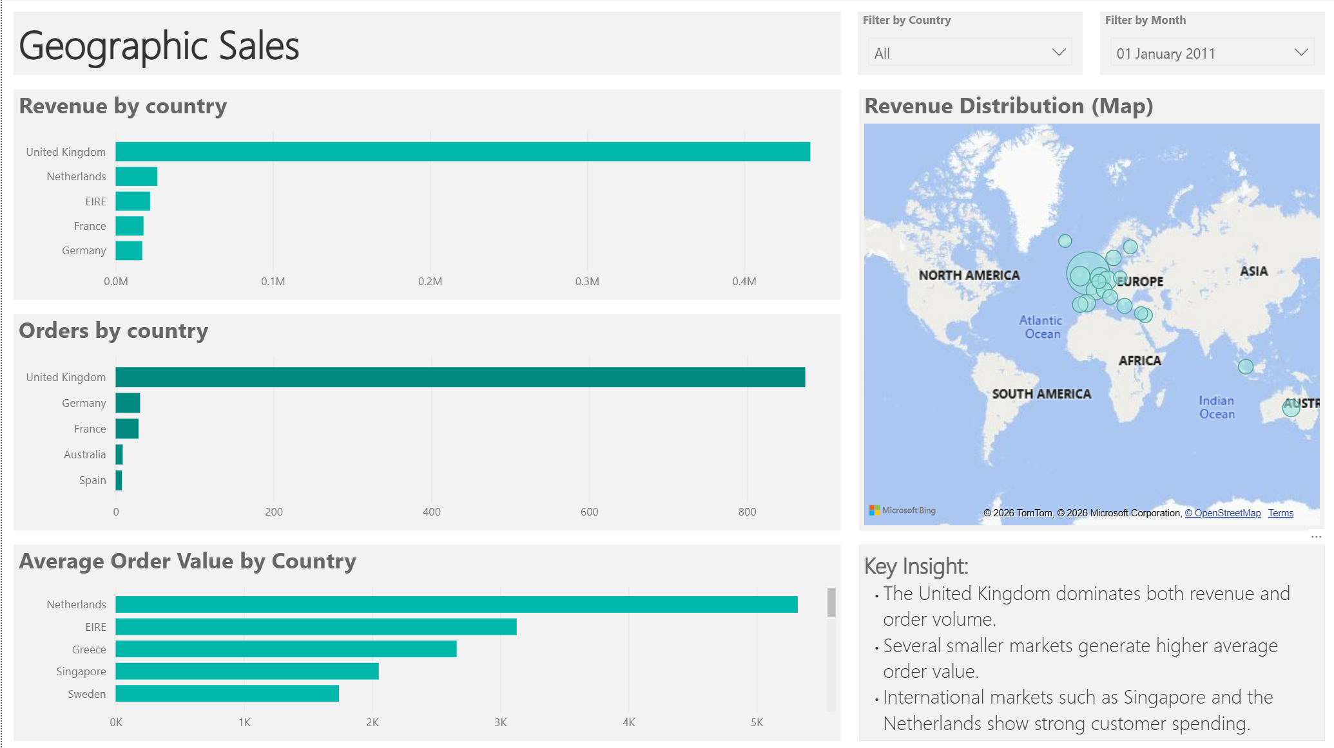

9. Key Business Insights
- Revenue growth is strongest during Q4
- A large share of revenue comes from repeat customers
- A small number of products drive a large share of total revenue
- International markets show strong spending potential

10. Business Recommendations
- Strengthen customer retention programs
- Focus marketing on high-performing products
- Expand marketing efforts in high-value international markets
- Prepare inventory and operations for seasonal demand spikes

11. Conclusion
This project demonstrates a full analytics workflow from SQL data preparation and business analysis to interactive Power BI dashboards. The insights produced can support data-driven decision making and strategic planning.

12. Appendix: Example SQL KPI Query
--1. Total Revenue
SELECT ROUND(
SUM(line_revenue)) AS total_revenue
FROM v_retail_clean
WHERE customer_id IS NOT NULL;
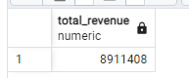
--2. Total Orders
SELECT
COUNT(DISTINCT invoice_no) AS total_orders
FROM v_retail_clean
WHERE customer_id IS NOT NULL;
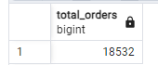
--3. Active Customers
SELECT
COUNT(DISTINCT customer_id) AS active_customers
FROM v_retail_clean
WHERE customer_id IS NOT NULL;
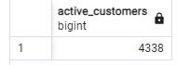
--4. Average Order Value (AOV)
SELECT ROUND(
SUM(line_revenue) / NULLIF(COUNT(DISTINCT invoice_no),0)) AS avg_order_value
FROM v_retail_clean
WHERE customer_id IS NOT NULL;
