Web Designing Assignment

**Module (HTML) -1**

**1.Are the HTML tags and elements the same things ?**

Ans- No, HTML tags and elements are not the same thing .they are closely related.

HTML Tags – it’s a keyword enclosed in angle brackets that defines a specific HTML element.

HTML Elements-Element is a component of an HTML document that tells a web browser how to structure and interpret a part of the HTML document.

**Example:**

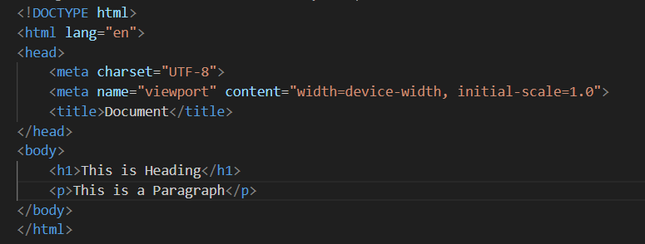

In this example:

~ <h1> and </h1> are the opening and closing tags.

~ The text “This is Heading” is the content of the heading element.

~ The entire unit ( <h1> This is Heading </h1> ) is the heading element.

~ <p> and </p> are tags for the paragraph elements.

~ “This is a Paragraph” is the content of the paragraph element.

~The entire unit ( <p> This is a Paragraph </p> ) is the paragraph element.

**2.What are tags and attributes in HTML?**

Ans- **Tags-** HTML tags are instructions used to define how content should be displayed on a Web page.

**Attributes-**Attributes are essentially additional pieces of information attached to HTML elements. Attributes provide ways to modify the element’s behavior or appearance on the Webpage.

**<img src=”Car_image.jpg” alt=”Car image”>**

**Example:**

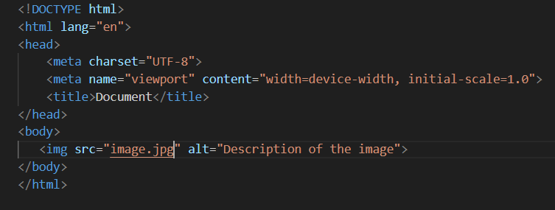

**~** <img> is the image tag

~ <img> tag has two attributes.

~ First one is src=”image.jpg”. This attribute specifies the source (source location) of the image.

~ Second one is alt=”Description of the image”. This attribute provides alternative text for the users who can’t see the image.

**3.What are void elements in HTML?**

Ans- In HTML, void elements are special type of element that only have an opening tag. Void elements cannot contain any text or other HTML elements within them.

Here are some examples of void elements:

**~** <br>

**~** <hr>

**~** <img>

**~** <link>

**~** <input>

**Example:**

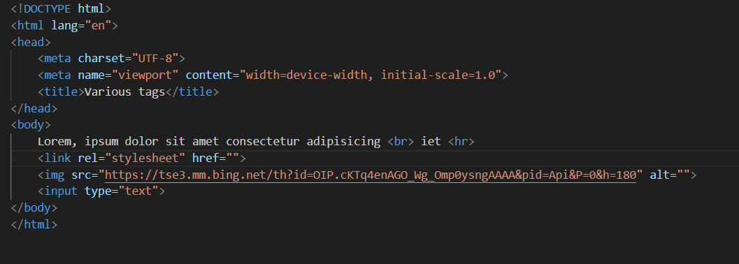

**Output:**

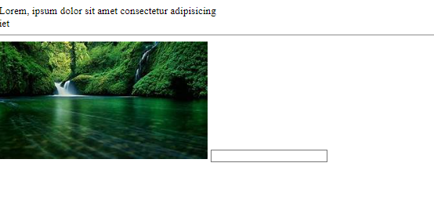

**4.What are HTML Entities?**

Ans- Entities are special codes used to represent characters that can’t be displayed directly.

By using entities, you ensure the characters are displayed correctly on the webpage.

An HTML entity consist of an ampersand (**&**),a name or number representing the character, and a semicolon (**:**)

**Description Entity Name**

Non-breaking space &nbsp;

Less than &lt;

Greater than &gt;

Copyright &copy;

Pound &pound;

Single question mark &apos;

**Example:**

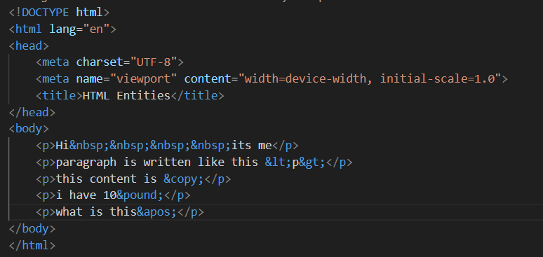

**Output:**

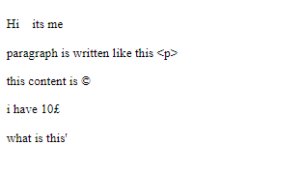

**5.What are different types of list in HTML?**

**Ans- There is three different types of list in HTML**

**(1)Ordered List (ol): This list displays elements in an ordered form either numerical or alphabetical.**

(2)Unordered List (ul): This list displays elements in form of disc, circle, square,none.

(3)Description List (dl): This Description lists are used to associate terms with their revelent description.

**Example:**

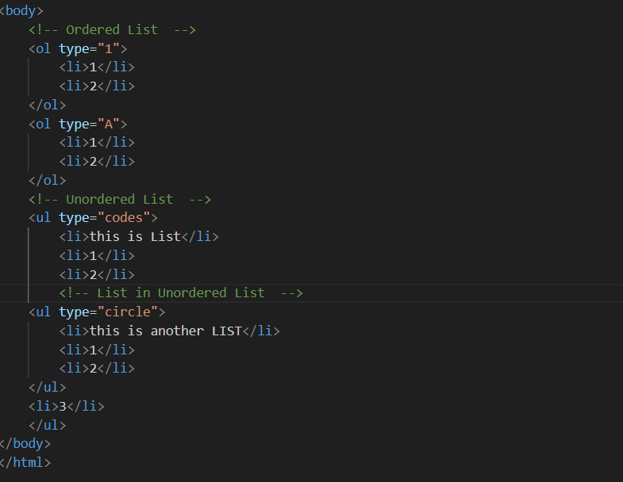

**Output:**

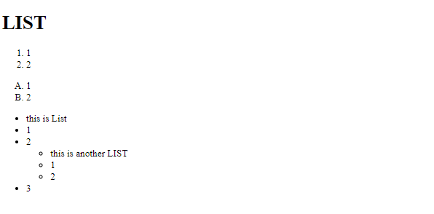

**6. What is the ‘class’ attribute in HTML?**

Ans- The class attribute in HTML is a versatile tool used to associate HTML celements with CSS styles. It essentially acts like a label that you can assign to elements to group them or target them for styling with CSS.

1. **Assigning the Class:**

~ The class attribute is added within the opening tag of an HTML element.It follows the format **class=”class_name”**.

~ You can assign onr or more class names (separated by space) to a single elements.

1. **Targeting the Class with CSS:**

~ In CSS stylesheet, you can use the class name prefixed with a dot **(.)** to define styles for elements with that particular class.

~ If an element has **class=”important”**, you can target it in yout CSS with a selector like **.important**.

**Example: HTML**

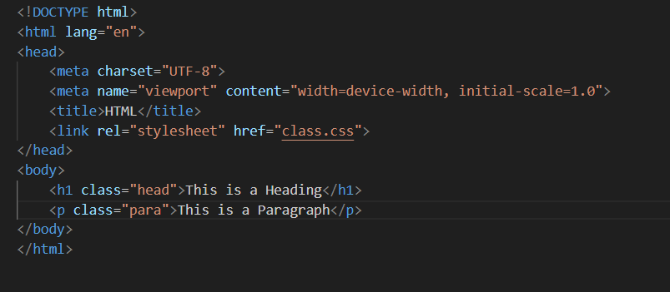

**CSS**

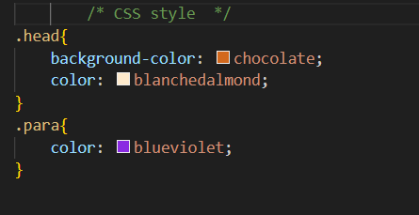

**Output:**

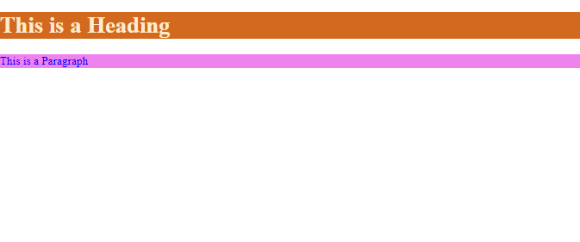

**7.What is the difference between the ‘id’ attribute and the ‘class’ attribute of HTML elements?**

Ans- The key difference between the **ID** and **Class** attributes in HTML lies in how they are used to identify elements and how many elements can share the same identifier.

**iD:** The **id** attribute assigns unique identifier to an element within a webpage.

There can only be one element with a specific **id** value on a single page.

**Class:** The **Class** attribute allows you to categorize elements. A single **Class** name can be assigned to multiple elements on the same page.

**Difference Between Class and ID –** A class name can be used by multiple HTML elements, while an id name must only be used by one HTML element within the page.

**Example:HTML**

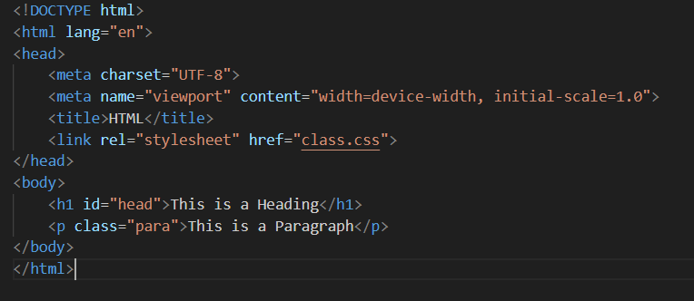

**CSS:**

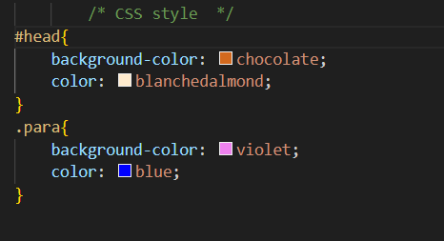

**Output:**

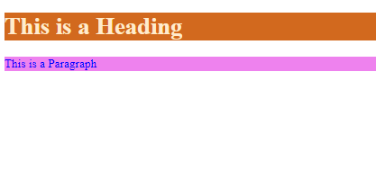

**8.What are the various formatting tags in HTML?**

Ans- Formatting tags in HTML are instruction that define the visual presentation of a specific piece of text within your webpage.

**Various Formatting Tags:**

**<b> -**Bold text.

**<strong> -** Important text.

**<i> -** Italic text.

**<em> -** Emphasized text.

**<mark> -** Marked text.

**<small> -** Smaller text.

**<del> -** Deleted text.

**<ins> -** Inserted text.

**Example:**

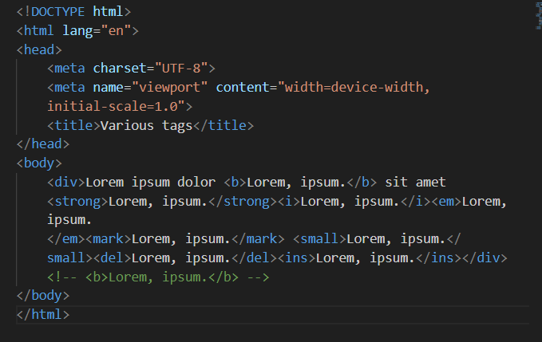

**Output:**

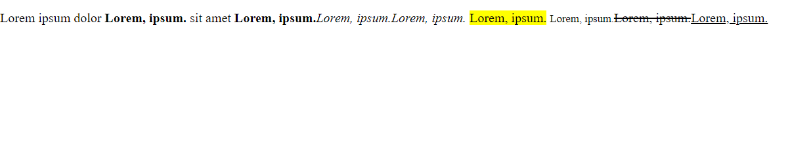

**9.How is Cell Padding different from Cell Spacing?**

Ans- CellPadding and CellSpacing are two different things. Cell Spacing refers to the distance between the cells in a grid layout and Cell Padding refers to the space around each cell.

**Feature Cellpadding Cellspacing**

**What it controls** Space between content Space between Cell

And border borders

**Affects Cell size** yes No

**Controlled by**  Cellpadding Cellspacing

**Attribute**

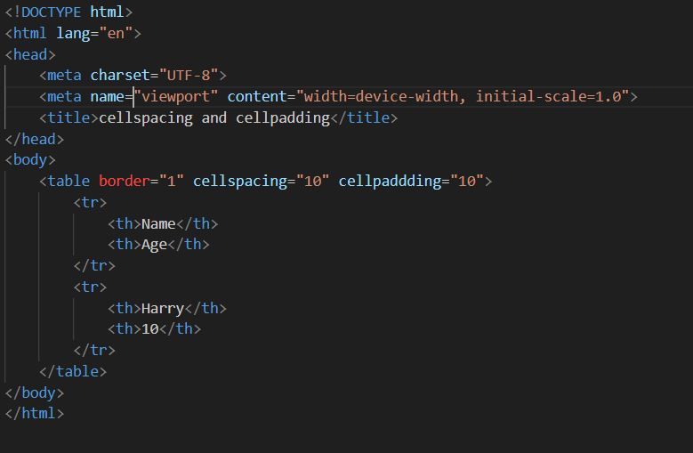**Example:**

**Output:**

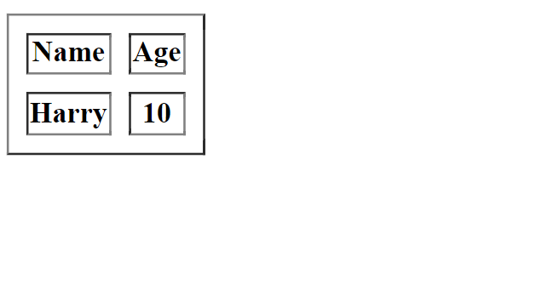

**10.How can we club two or more rows or columns into a single row or column in an HTML table?**

Ans- We can merge the rows or columns by using attributes within the table cell tags **( <td> or <th>)**.

**Merging Columns (Colspan):**

We can use **(Colspan)** attribute within a table data cell **(<td>)** to specify how many columns it should span horizontally.

Here’s the syntax: **<td colspan =”2”>1</td>**

**Example:**

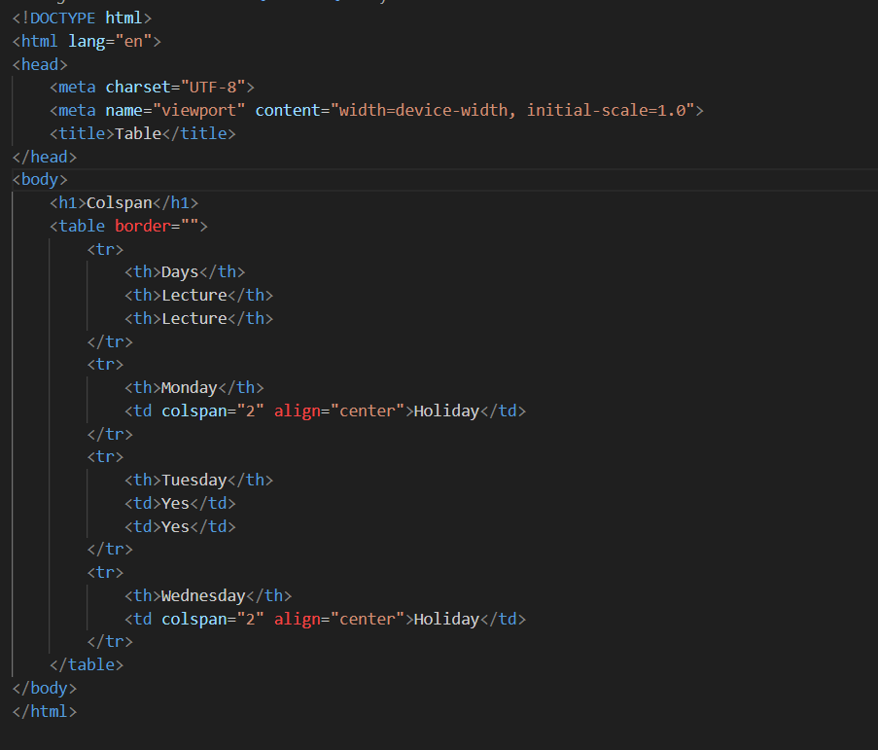

**Output:**

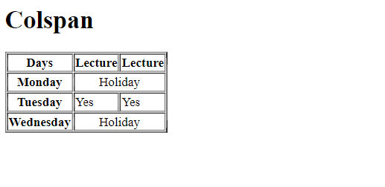

**Merging Rows (Rowspan):**

We can use **(Rowspan)** attribute within a table data cell **(<td>)** to specify how many

Rows it should span vertically.

Here’s the syntax: **<td rowspan=”2”>1</td>**

**Example:**

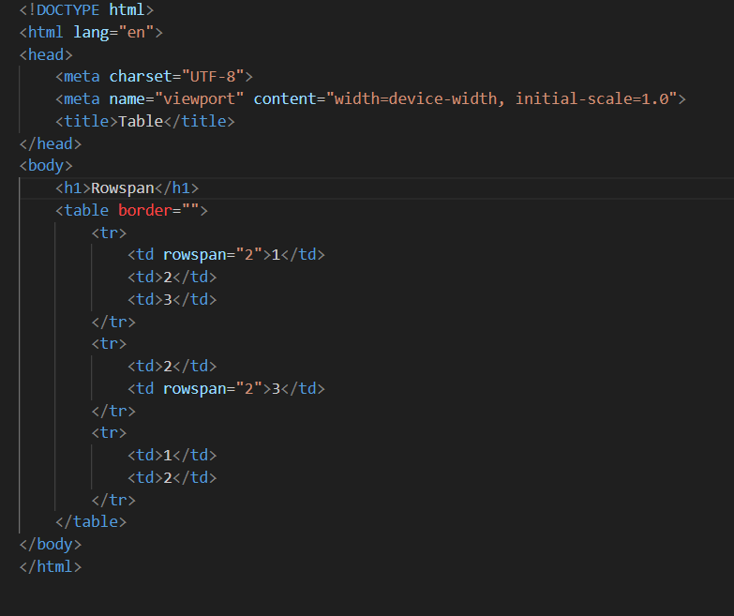

**Output:**

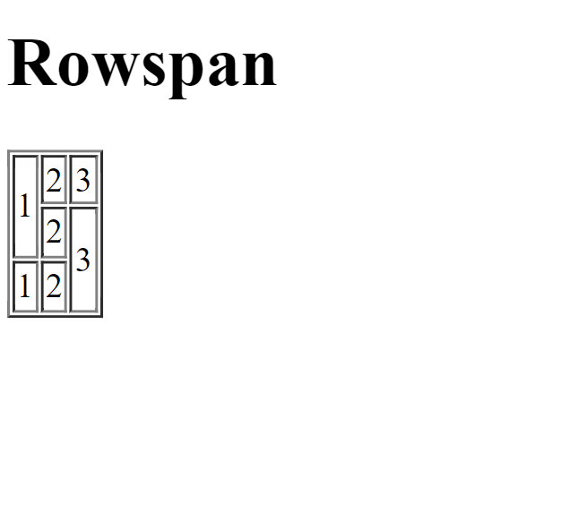

**11.What is the difference between a block-level element and inline element?**

Ans- The main difference between a block elements and inline elements in HTML is how they behave with respect to new lines and surrounding content.

**Block Elements:**

**~** Block element take up the entire space of their parent.

**~** Always start on a new line before and after the element.

**~** Expand horizontally to fill the available space from left to right.

**~** Can have top and bottom margins.

**~** Examples: **<P>**,  **<h1>** , **<div>** , **<Ul>** , **<Li>.**

**Example**

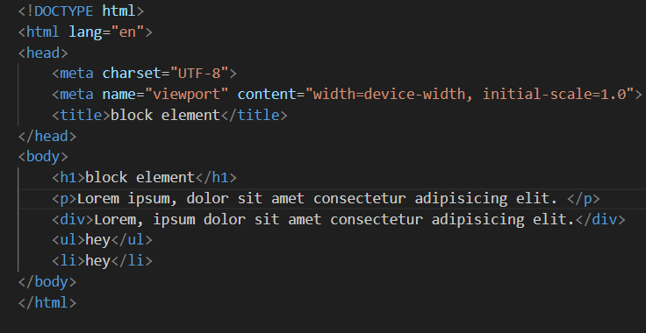

**Output:**

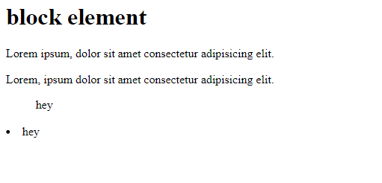

**Inline Elements:**

**~** Inline element take only their space.

**~** Don’t start on a new line. They flow in line with other content.

**~** Don’t have top and bottom margins by default (but can be styled with CSS).

**~** Examples: **<span> , <b> , <i> , <a>(anchor tag)** , **<em>**.

**Example:**

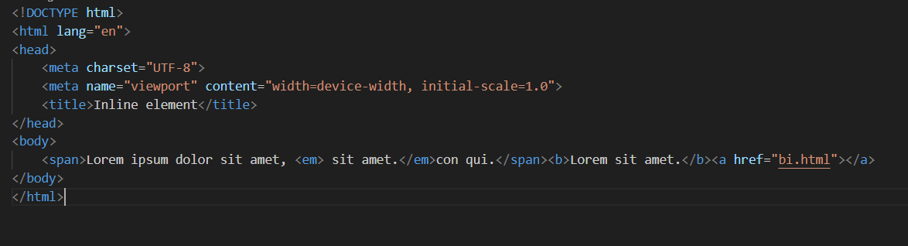

**Output:**

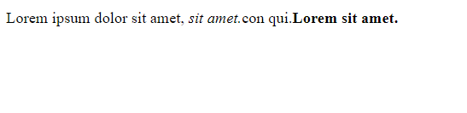

**12.How to create a Hyperlink in HTML?**

Ans- We can create hyperlink in HTML by using Anchor tag **(<a>).** This tagdefines the hyperlink element.

Within the Opening anchor tag, include the **“href”** attribute. This attribute specifies the destination URL of the link.

<a href=”URL_ here”></a>

**Example:**

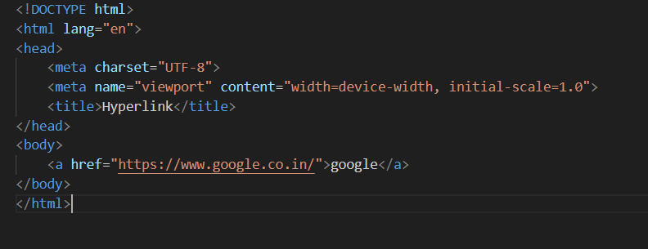

**Output:**

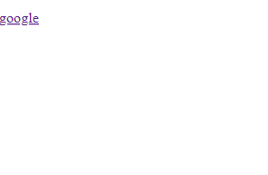

**12.What is the use of an iframe tag?**

Ans-The iframe tag in HTML is used to embed another HTML document within the current webpage.it essentially creates a mini window that displays content from an external sources or even another part of the same webpage.

You can embed elements like videos from YouTube, maps, social media feeds, or even entire web pages from other websites into your webpage using iframes.

Iframes are sometimes used to display advertisements on webpages.

**Examples:**

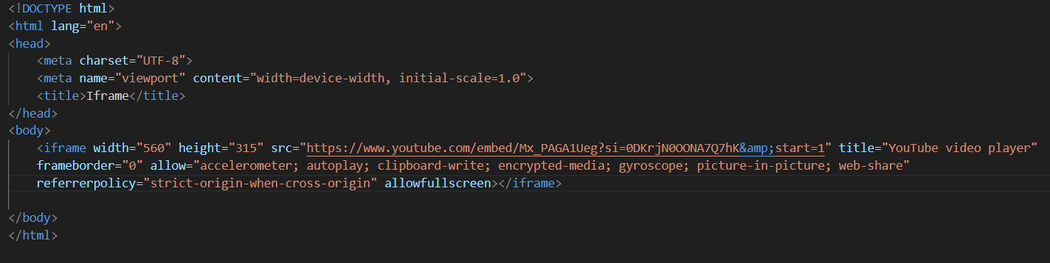

**Output:**



**13.What is the use of a span tag? Explain with Example?**

Ans-T he **<span>** in HTML is an inline element that acts as generic container for inline content. It’s essentially wrapper for a portion of text or other inline elements that you want to style or to apply specific attributes without affecting the overall document structure.

**Styling:** The most common use of a span tag is for applying CSS styles to a specific part of text.

**Grouping elements:** Span can be used to group inline elements together. This can be useful for applying styles or scripts to the group as a whole.

**Adding attributes:** You can use span to add attributes to a specific inline content, such as setting the language for a particular word or phrase.

**Example:**

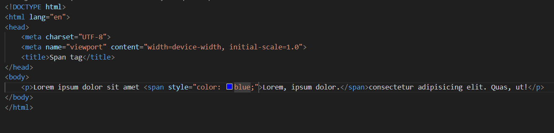

**Output:**

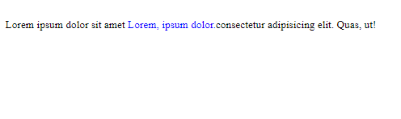

**14.How to insert a picture into a background image of a web page?**

Ans-We can insert a picture into a background image of a web page by using

**<body background =“image_ path”> .**

**~** First open the HTML file in the text editor.

**~** within the starting <body> tag in your HTML file, and type **<body background=”link_”>**.

**~** give the path of the image we want to add ,

**~** Save the HTML file and run the file.

**Example:**

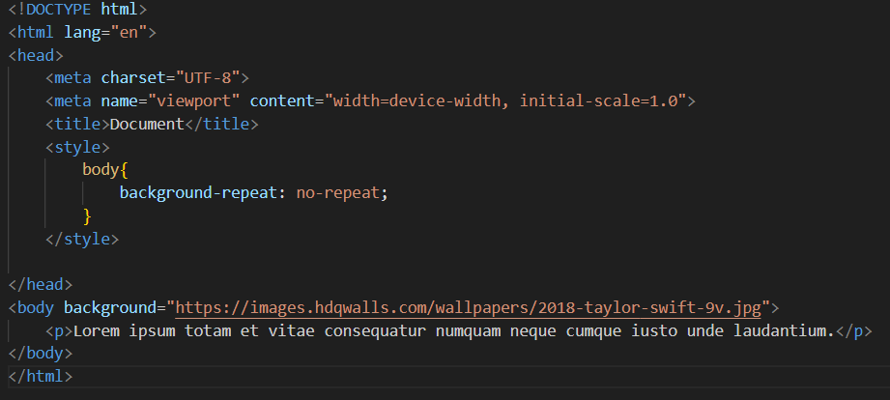

**Output:**



**15.How are active links different from normal links?**

Ans-Normal links and active links are two different states of the same hyperlink on a webpage.

**Normal Link:**

**~** This is the default state of a link.

~ it indicates a clickable element that, when clicked, will take you to another webpage, a different section of the current webpage.

~ Browsers typically display normal links with underlining and a specific colour.

~ You can customize the appearance of normal links using CSS.

**Active Link:**

**~**  This state is temporary and applies when the user interacts with a link.

**~ These are two main ways a link can become active.**

~ Clicking and holding the mouse button on the link.

~ Right-clicking on the link.

**~** Similar to normal links, you can also style active links using CSS.

**16.What are the different tags to separate sections of text?**

Ans- In HTML , Various tags are used for structing and separating text with specific tags:

**~ <br> :** This tag inserts a single line break. it’s useful for creating space between lines within a paragraph.

**~ <p> :** This tag defines a paragraph. It creates space before and after the text.

**~ <blockquote> :** This tag indicates a quoted passage. It typically indents the text and might use italics to visually distinguish it from the main content.

**~ Heading Tags( <h1> to <h6>):** These tags define headings of different sizes. They separate sections with a clear hierarchy and often use larger, bolder fonts.

**Example:**

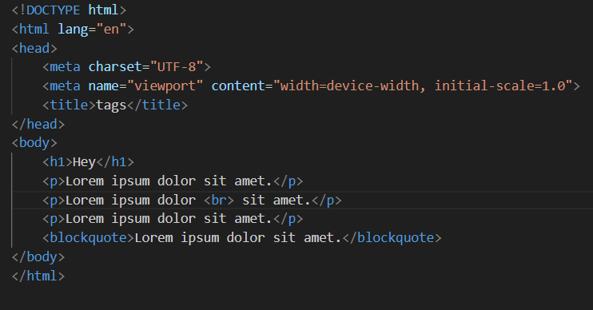

**Output:**

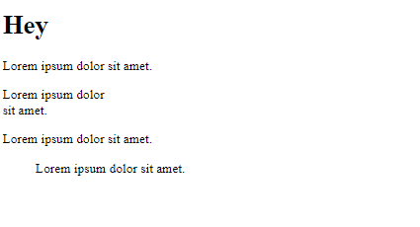

**17.What is SVG?**

Ans- SVG stands for scalable vector graphics. It’s a special kind of image format that’s used on the web and in other application.

~ SVG images are based on vectors.

~SVG images can be scaled to any size without losing quality.

**Benefits of SVG:**

**~ Scalable:** They can be resized without losing quality.

**~ Sharp:** They always look crisp, even on high-resolution displays.

**~ Flexible:** They can be animated and interacted.

**Example:**

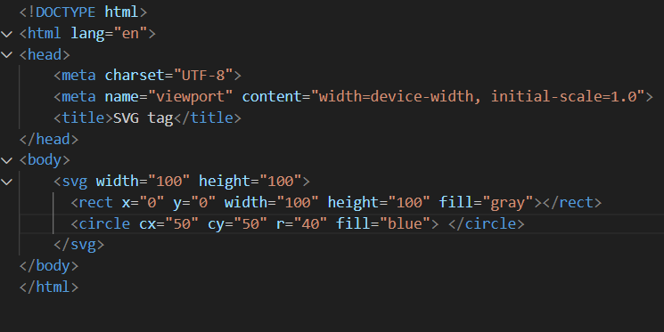

**Output:**



**18.What is difference between HTML and XHTML?**

Ans- HTML and XHTML are both markup languages used for creating web pages.

**Structure and Syntax:**

**HTML:** More lenient and forgiving in its syntax. Errors are often ignored by browsers , and the page will still render even if the code isn’t perfectly formatted. Doesn’t require all tags to be closed, and case sensitivity doesn’t matter.

**XHTML:** Stricter syntax based on XML rules. Requires proper closing of all tags, use lowercase for elements and attributes, and needs a DOCTYPE declaration at the beginning of the document. This makes XHTML code more reliable and easier for validation, but also less forgiving of errors.

**A table summarizing the key difference:**

|  |  |  |
| --- | --- | --- |
| **Features** | **HTML** | **XHTML** |
| Syntax | More lenient | Stricter, follows XML rules |
| Tags | Can be uppercase or lowercase | Must be lowercase |
| Closing Tags | Not always required for empty elements | Required for all elements, even empty ones |
| Doctype Declaration | Not mandatory | Mandatory |
| Underlying Technology | SGML | XML |
| Common Use Today | Yes | No |

**19.What are logical and physical tags in HTML?**

Ans- In HTML tags are used to define how content should be displayed or interpreted. These tags fall into two main categories. **Logical tags** and **Physical tags**.

**Logical Tags:**

**~ Purpose:** Define the meaning and structure of the content.

**~Focus:** These tags convey the meaning of the content to the browser and assistive technologies rather than how it should look.

**~Examples:** **<h1>**(heading) , **<strong>**(important text) , **<p>**(paragraph) ,**<circle>**(article content) , **<nav>**(navigation selection).

**Example:**

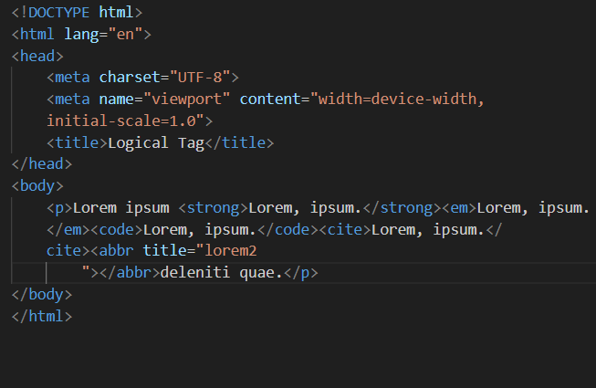

**Output:**

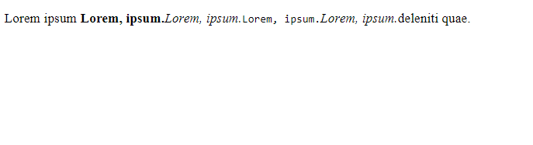

**Physical Tags:**

**~ Purpose:** Control the visual presentation of the content.

**~ Focus:** These tag dictate how the content should appear on the screen, such as bold, italics or font size.

**~ Examples:** **<b>**(bold) , **<i>**(italics) , **<font>**(font style) , **<center>**(center alignment).

**Example:**

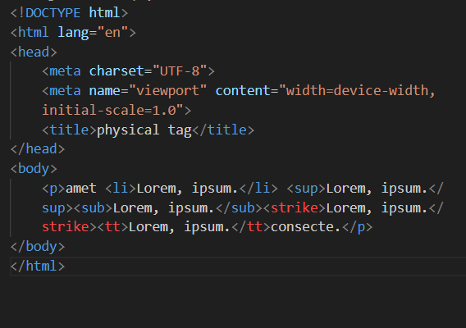

**Output:**

