Web Designing Assignment

**Bootstrap Basic & Amp; Advanced**

**1.What are the advantages of Bootstrap?**

**Ans-** Bootstrap is a popular front-end web development framework that offers serval advantages to developers:

~ Responsive design: Websites need to look good and function properly on all devices, easy to create responsive layouts that adapt to different screen sizes.

~ Ease of use: Bootstrap is known for its user-friendly approach. It provides pre-built components and styles, eliminating the need to write code from scratch for common elements like buttons, forms, and navigation menus. This saves developers time and effort, especially for beginners.

~ Consistency across browser: Ensuring a website displays consistently across different web browsers can be a challenge. Bootstrap helps with this by providing pre-tasted code that works across major browsers like chrome, Firefox, Safari, and Edge.

~ Customization: While Bootstrap offers pre-designed components, it’s not a one-size-fits-all solution. It allows for a high degree of customization. Developers can use Bootstrap’s built-in variable.

**2.What is a Bootstrap Container, and how does it work?**

**Ans-** Bootstrap containers are essential building blocks for creating responsive layouts. They define the maximum width of your content and provide consistent padding.

**Types of Containers**

Bootstrap offers three primary container types:

**1. Container:**

**~** This is the default container.

**~** It sets a fixed maximum width at each responsive breakpoint, ensuring your content is centered and has proper padding.

**~** Ideal for most standard web page layouts.

**2. Container-fluid:**

**~** This container spans the full width of the viewport at all breakpoints.

**~** Use it when you want your content to extend to the edge of the screen.

**3. Container-(breakpoint):**

**~** This is a responsive container introduced in Bootstrap 4.4.

**~** It sets the container to full width until the specified breakpoint is reached, then applies max-width for larger screens.

**~** Useful for creating more complex layouts with specific width requirements at different screen sizes.

**How Containers work:**

Containers are used to wrap your content and provide a structured layout. You can nest containers within each other, but this is generally not recommended for most layouts.

**3. What are the default bootstrap text settings?**

**Abs-** Bootstrap provides a solid foundation for typography, offering default styles for various text elements.

**Global Setting:**

**~ Font Family:** A browser-default font stack that ensures compatibility across different operating systems and devices.

**~ Font Size:** Typically 16px, respecting the browser’s default root font size for accessibility.

**~ Line Height:** A base line height for normal text, providing readability.

**~ Link Color:** A default color for links, often blue or a similar hue.

Underlines are usually applied on hover.

**Text Elements:**

Bootstrap styles various text elements like heading, paragraphs, lists, and more. The specific styles depend on the Bootstrap version you’re using.

**~ Headings:** Different font sizes and weights for <h1> to <h6> to create a hierarchy.

**~ Paragraphs:** Default styles for line height, margin. And spacing.

**~ Lists:** Styles for unordered , ordered, and description lists.

**~ Inline Elements:** Styles for elements like <strong> , <em> and <mark>.

**Text Utilities**

Bootstrap offers utility classes to quickly style text without writing custom CSS. These classes provide option for:

**~ Text color:** Various predefined colors.

**~ Font weight:** Bold. Light, etc.

**~ Text alignment:** Left, right, center, justified.

**~ Text decoration:** Underline, line-through, etc.

**~ Text transformation:** Uppercase. Lowercase, capitalize.

**4. What do you know about the Bootstrap Grid System?**

**Ans- Bootstrap Grid System: A Foundation for Responsive Layouts**

Bootstrap’s grid system is a powerful tool for creating responsive and flexible layouts for web pages. It’s built on a 12-column grid system that adapts to different screen sizes, ensuring your content looks great on everything from small smartphones to large desktops.

**How it Works**

The grid system uses a combination of containers, rows, and columns to structure content.

**~ Containers:** These define the overall width of your content and can be either fixed-width or full-width.

**~ Rows:** These are horizontal containers for your columns.

**~ Columns:** These are the building blocks of your layout, and you can combine them to create different column width and arrangements.

**Grid Breakpoints**

Bootstrap defines several breakpoints to target different screen sizes:

**~ xs:** Extra small (phones)

**~ sm**: small (phone in landscape)

**~ md:** Medium (tablets)

**~ lg:** Large (desktops)

**~ xl:** Extra large (large desktops)

**~ xxl:** Extra extra large (very large desktops)

You can use these breakpoints to create different layouts for different screen sizes.

**5. What is the difference between Bootstrap 4 and Bootstrap 5**

**Ans-** Bootstrap 4 and 5 are both popular front-end frameworks for building responsive websites, but they have significant differences.

**Core Differences**

**~ jQuery Dependency:** Bootstrap 4 relied heavily on jQuery for its JavaScript components. Bootstrap 5 has completely dropped jQuery, offering a more modern and lightweight approach.

**~ Browser Support:** Bootstrap 5 has dropped support for older browsers like internet Explorer 10 and 11, allowing for more efficient and modern code.

**~ Grid system:** While the basic structure remains similar, Bootstrap 5 has introduced enhancements to provide more flexibility.

**~ Utilities:** Bootstrap 5 offers a more robust and customizable utilities API, allowing developers to create their own utility classes.

**~ Components:** Both versions offer a rich set of components, but Bootstrap 5 has introduced new components and improved existing ones, such as accordions, cards, and navbars.

**~ Icons:** Bootstrap 5 includes its own set of SVG icons, eliminating the need for external libraries like Font Awesome.

**In Conclusion**, Bootstrap 5 represents a significant improvement over Bootstrap 4, offering a more modern, flexible, and customizable framework.

**6. What is a Button Group, and what is the class for a basic Button Group?**

**Ans- Button Group**

**A button group is a collection of buttons displayed together as a group:** This often used to present a set of related options or actions to the user.

**Basic Button Group Class**

In Bootstrap, the most common framework for building responsive web applications, the class for creating a basic button group is the core class that groups the buttons together.

**~** You can customize the appearance of the buttons using additional classes like **btn-secondary** , **btn-success** , etc.

**~** You can also control the size of the button group using classes like **btn-group-sm** , **btn-group-lg**.

**~** For more complex button groups with dropdown menus or toggles, Bootstrap provides additional classes and features.

**Example:**

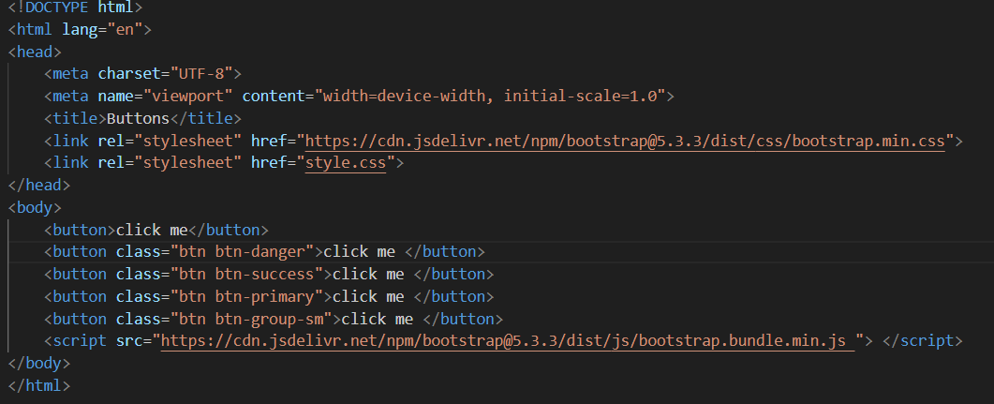

**Output:**

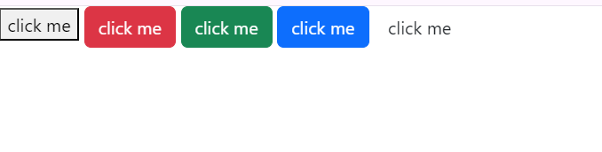

**7. How can you use Bootstrap to make thumbnails?**

**Ans-** Bootstrap provides a simple and efficient way to create thumbnails with its thumbnail class. This class adds basic styling to an image, including padding, a border, and a hover effect.

**Basic Thumbnail Structure**

Here’s a basic example of creating a thumbnail:

**EXAMPLE:**

This code will create a clickable thumbnail with an image.

**Customizing Thumbnails**

You can customize thumbnails by adding additional HTML elements and classes within the .thumbnail container.

**Responsive Thumbnails**

To make your thumbnails responsive, you can use bootstrap’s grid system.

**EXAMPLE:**

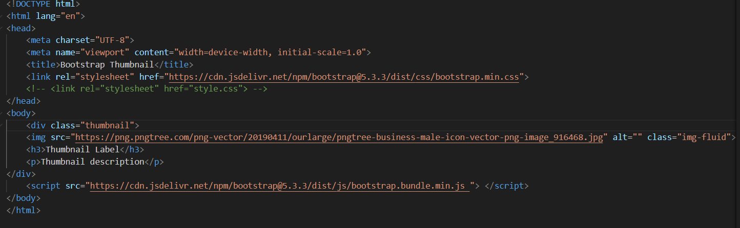

**OUTPUT:**

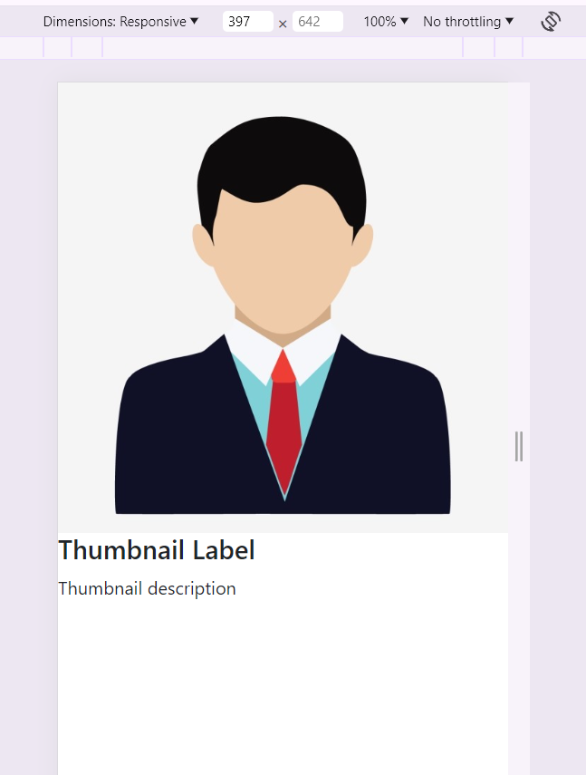

This code will create three thumbnails that will adjust their size based on the screen size.

**Additional Customization**

You can further customize the appearance of your thumbnails by using CSS to override Bootstrap’s default styles. For example, you can change the border color, padding, and hover effects.

**Note:** Bootstrap 4 has deprecated the .thumbnail class. Instead , you can use the .img-thumbnail class to apply a rounded border to an image.

Example using .img-thumbnail:

**Key Point**

**~** Use the .thumbnail class (or .img-thumbnail in Bootstrap 4) for basic styling.

**~** Add custom HTML elements within the .thumbnail container for additional content.

**~** Use Bootstrap’s grid system for responsive layouts.

**~** Customize the appearance using CSS.

**8. In Bootstrap 4, what is flexbox?**

**Ans- Flexbox** is a powerful CSS layout model that Bootstrap 4 extensively utilizes for creating responsive and flexible designs. It allows you to arrange items in a container efficiently, controlling their direction, alignment, order, and distribution.

**~ Flex Container:** The parent element that holds flex items. It’s created using the .d-flex class or its responsive variants.

**~ Flex Items:** The child elements within the flex container.

**Bootstrap’s Flexbox Utilities**

Bootstrap provides a set of utility classes to manipulate flex containers and items:

**~ Direction:** Controls the orientation of flex items.

**~ .flex-row:** Default horizontal direction.

**~ .flex-column:** Vertical direction.

**~ .flex-row-reverse:** Reverse horizontal direction.

**~ .flex-column-reverse:** Reverse vertical direction.

**~ Wrap:** Controls whether flex items wrap to the next line.

**~ .flex-wrap:** Wrap flex items.

**~ .flex-nowrap:** Prevent flex items from wrapping.

**~ .flex-wrap-reverse:** Wrap flex items in reverse order.

**~ Justify Content:** Aligns flex items within the main axis of the container.

**~ .justify-content-start:** Align items to the start.

**~ .justify-content-end:** Align items to the end.

**~ .justify-content-center:** Center items.

**~ .justify-content-between:** Distribute items evenly with space between them

**~ .justify-content-around:** Distribute items evenly with space around them.

**~ Align Self:** Aligns individual flex items within the container.

**~ .align-self-auto:** Default, let the browser decide.

**~ .align-self-start:** Align item to the start.

**~ .align-self-end:** Align item to the end.

**~ .align-self-center:** Center item.

**~ .align-self-baseline:** Align item based on its baseline.

**~ .align-self-stretch:** Stretch item to fill the container.

**9.How can one create an alert in Bootstrap?**

**Ans-**Bootstrap provides a simple and efficient way to create visually appealing alerts. These are used to display important messages to users.

**Basic Alert Structure**

To create a basic alert, you’ll use the **.alert** class along with a contextual class to define the alert type.

This will create a green alert box with the text “This is a success alert-check it out!”.

**Available Alert Types**

Bootstrap offers several contextual classes to style your alerts:

**~ .alert-success:** Green

**~ .alert-info:** Blue

**~ .alert-warning:** Yellow

**~ .alert-danger:** Red

**~ .alert-primary:** Blue(default)

**~ .alert-secondary:** Grey

**~ .alert-light:** Light grey

**~ .alert-dark:** Dark grey

**Dismissable Alerts**

You can make alerts dismissable by adding the **.alert-dismissable** class to the alert container and including a close button with the **data-dismiss=”alert”** attribute:

**Note:** To make the alert fade out when dismissed, you’ll need to include the fade and show classes as well.

**Customizing Alerts**

You can further customize alerts by adding additional content, such as links or other HTML elements, within the alert container.

**EXAMPLE:**

**HTML**

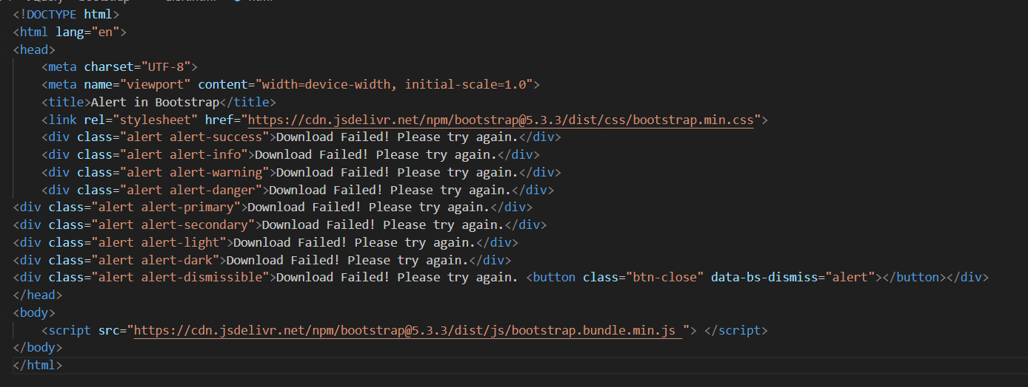

**OUTPUT:**

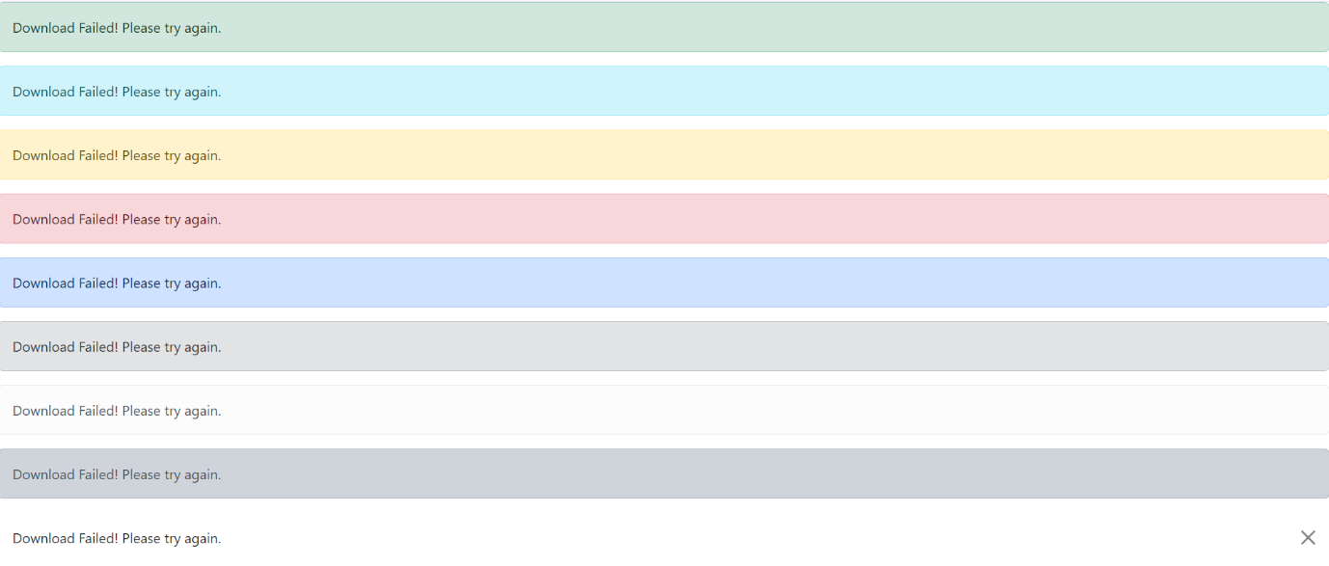

**Important Points**

**~** Always include the **role=”alert”** attribute for accessibility.

**~** The **data-bs-dismisss=”alert”** attribute triggers the JavaScript functionality to close the alert.

**~** For proper styling and behavior, make sure you’re including the necessary bootstrap CSS and JavaScript files.

**10. What is a bootstrap card and how would you create one?**

**Ans- Bootstrap Card: A Versatile Content Container**

A Bootstrap card is a flexible and customizable container designed to hold various types of content in a visually appealing and organized manner. It’s a building block for creating user interfaces, offering options for headers, footers, images, text, and more. Think of it as a versatile box that you can fill with different elements.

**Basic Structure of a Bootstrap Card:**

A card consists of several optional elements:

**~** **Card body:** Contains the main content of the card.

**~ Card header:** Displays a heading or title above the card content.

**~** **Card footer:** Provides additional information or actions at the bottom of the card.

**~ Card image:** Includes an image within the card, typically at the top.

**Creating a Basic Bootstrap Card:**

**HTML:**

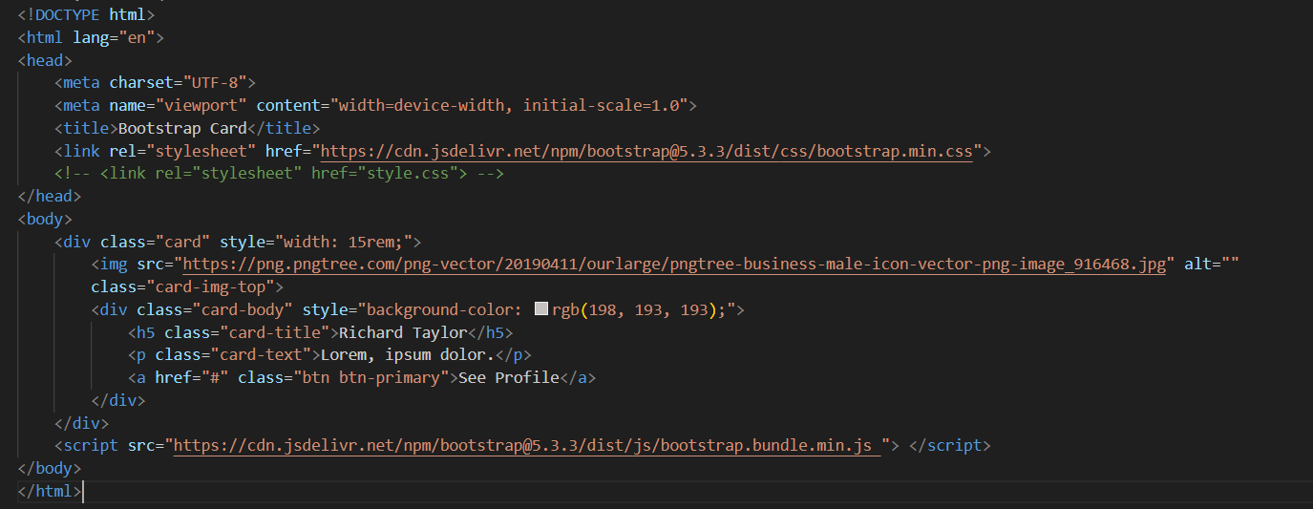

**OUTPUT:**

