Basic Questions

1. Query to Update Whose Salary=8500 To Salary=7000

A: We use the query: db.m1.updateMany({salary:8500},{$set:{salary:7000}})

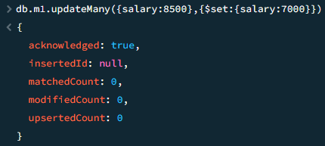> db.m1.updateMany({salary:8500},{$set:{salary:7000}})

2. Query to Update Location='Mumbai' Whose Firstname is Amitabh

A: We use the query: db.m1.updateMany({"firstname":"amitabh"},{$set:{location:"mumbai"}})

> db.m1.updateMany({"firstname":"amitabh"},{$set:{location:"mumbai"}})

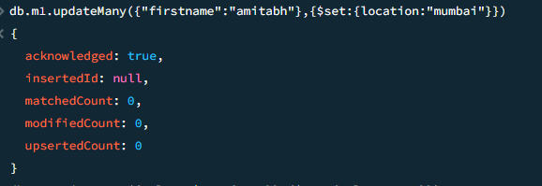

3. Query to set Salary = 5000 If Salary>=4500

A: We use the query: db.m1.updateMany({"firstname":"amitabh"},{$set:{location:"mumbai"}})

> db.m1.updateMany({"firstname":"amitabh"},{$set:{location:"mumbai"}})

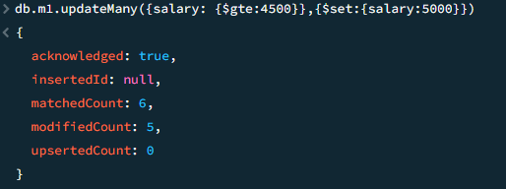

4. Query/Demonstrate Use of Updatemany to Update Multiple Fields

A: We use the query: db.m1.updateMany({}, {$set:{salary:8000}})

> db.m1.updateMany({}, {$set:{salary:8000}})

