Intermediate Questions

1. How To Use $Exists Operator to Check Whether Spice Cinnamon Exists In Document

Or Not And If Exists Fetches Only Those Records?

A: We use the command: db.spices.find({saffron: {$exists: true}})

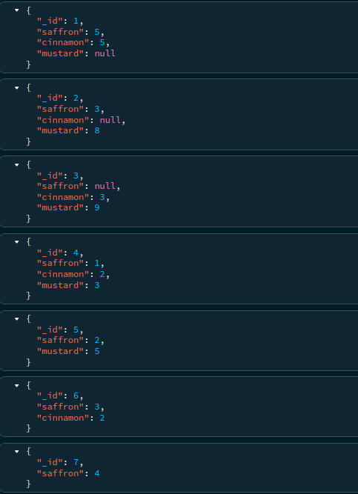> db.spices.find({saffron: {$exists: true}})

2. How To Use $Exists Operator to Check Whether Spice Cinnamon Exists In Document

Or Not And If Exists Fetches Only Those Record

A: We use the command: db.spices.find({cinnamon: {$exists: true}})

> db.spices.find({cinnamon: {$exists: true}})

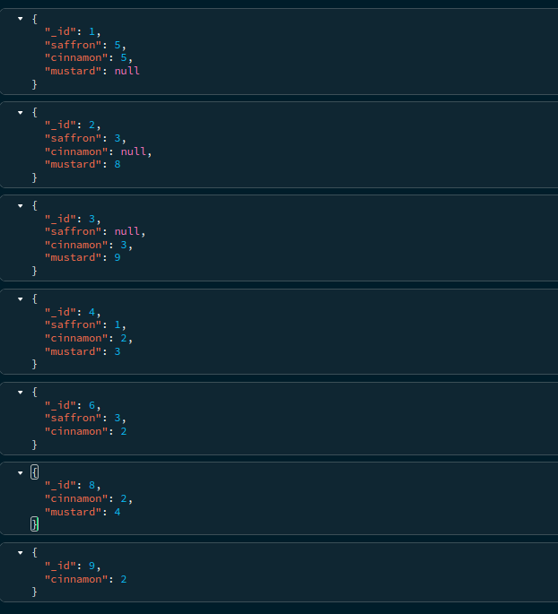

3. How to Use $exists Operator to check whether spice cinnamon does not exists in

document and fetches only those records which does not exists

A: We use the command: db.spices.find({cinnamon: {$exists: false}})

> db.spices.find({cinnamon: {$exists: false}})

