Introduction to Data Science and AI
Assignment 1
By
Ilia Todorov - FN: 2MI3400906
&
Georgi Karamishev

Table of Contents
Scatter plot of GDP per capita vs life expectancy (a.) 2
Combining the data 2
Data cleaning 2
The figures 3
Assumptions 5
Observations 5
Does every strong economy (normally indicated by GDP) have high life expectancy? (d.) 6
Definitions/Assumptions 6
Answer 6
Related to question d, what would happen if you use GDP per capita as an indicator of a strong economy? (e.) 7
Answer 7
Insight from comparing d and e 7
Work distribution 7

Scatter plot of GDP per capita vs life expectancy (a.)
We used three datasets from Our World in Data. Our program downloads them directly as CSV files, so anyone can re-run it and get the same data:
- Life expectancy at birth; indicator: life_expectancy_0
- GDP per capita (World Bank); indicator: ny_gdp_pcap_pp_kd
- GDP (World Bank), for d and e; indicator: same as above
We have chosen the World Bank GDP series measured in PPP-adjusted constant 2021 dollars because it accounts for both inflation and differences in price levels between countries.

Combining the data
- Join key: We joined the datasets on country code + year, not on country name. ISO codes are stable, while names can be spelled differently in different files.
- Inner join between life expectancy and GDP per capita: As a result, the plotted period is 1990–2023. Life expectancy goes back to 1543, but GDP per capita starts in 1990, and life expectancy stops in 2023.
- Left join for total GDP, so that we add the total GDP to our combined dataset.

Data cleaning
- Rows with missing or non-positive values removed.
- Aggregates removed. OWID marks regions and groups with codes starting with OWID_
- Kosovo kept as an exception. Kosovo has no ISO code, so OWID gives it OWID_KOS, but it is a country, not an aggregate.
- Dependent territories removed. They have their own ISO codes, so the aggregate filter keeps them, but they belong to another state. Small rich territories would otherwise crowd the top of the GDP per capita ranking and distort questions b–e. Kosovo and Palestine are kept as partially recognized states.

The figures
- Figure 1, all countries, 1990–2023. Each point is one country in one year. It shows the general pattern, but points from the same country are strongly correlated, and different decades get mixed together.
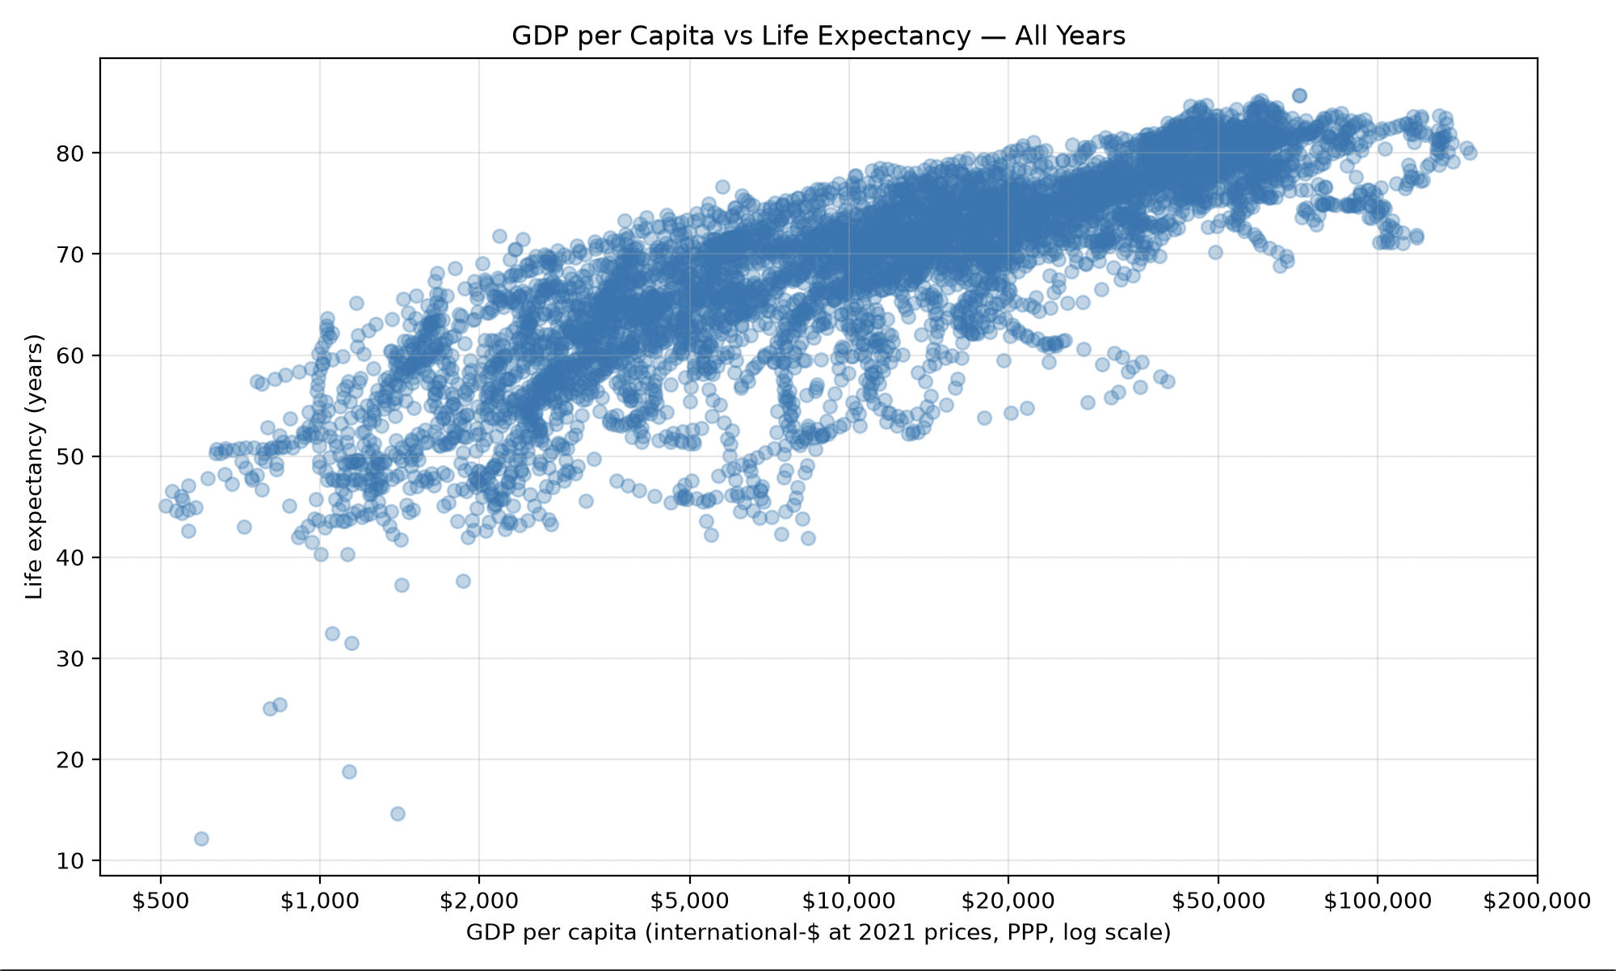

- Figure 2, all countries in 2023 (main figure). Each point is one country, all measured in the same year, so the countries are compared fairly. The red line is a smoothed average trend: We split GDP per capita into 20 equal-width bins on the log scale, averaged each bin, and applied a 5-bin rolling mean.
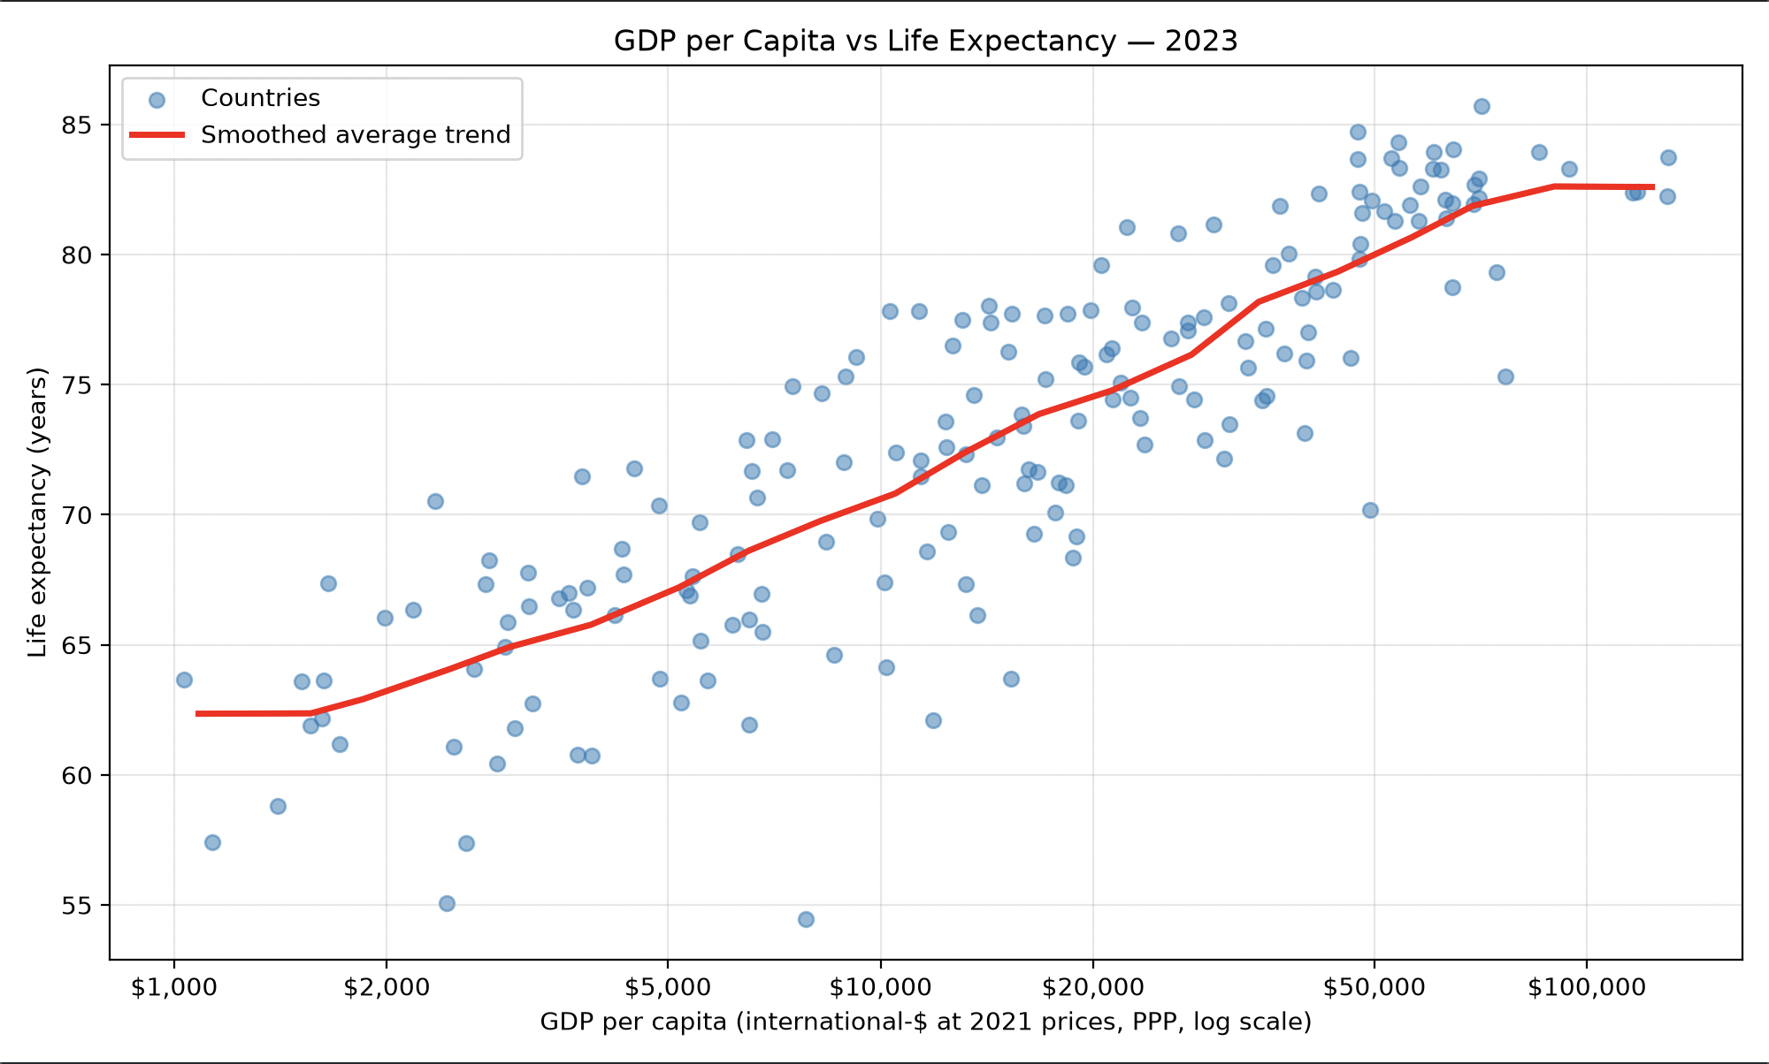

- Figure 3, Japan, 1990–2023. Looking at one country removes differences between countries (geography, climate, health system) and shows how income and life expectancy changed together over time. The points are joined in year order to show the path over time.
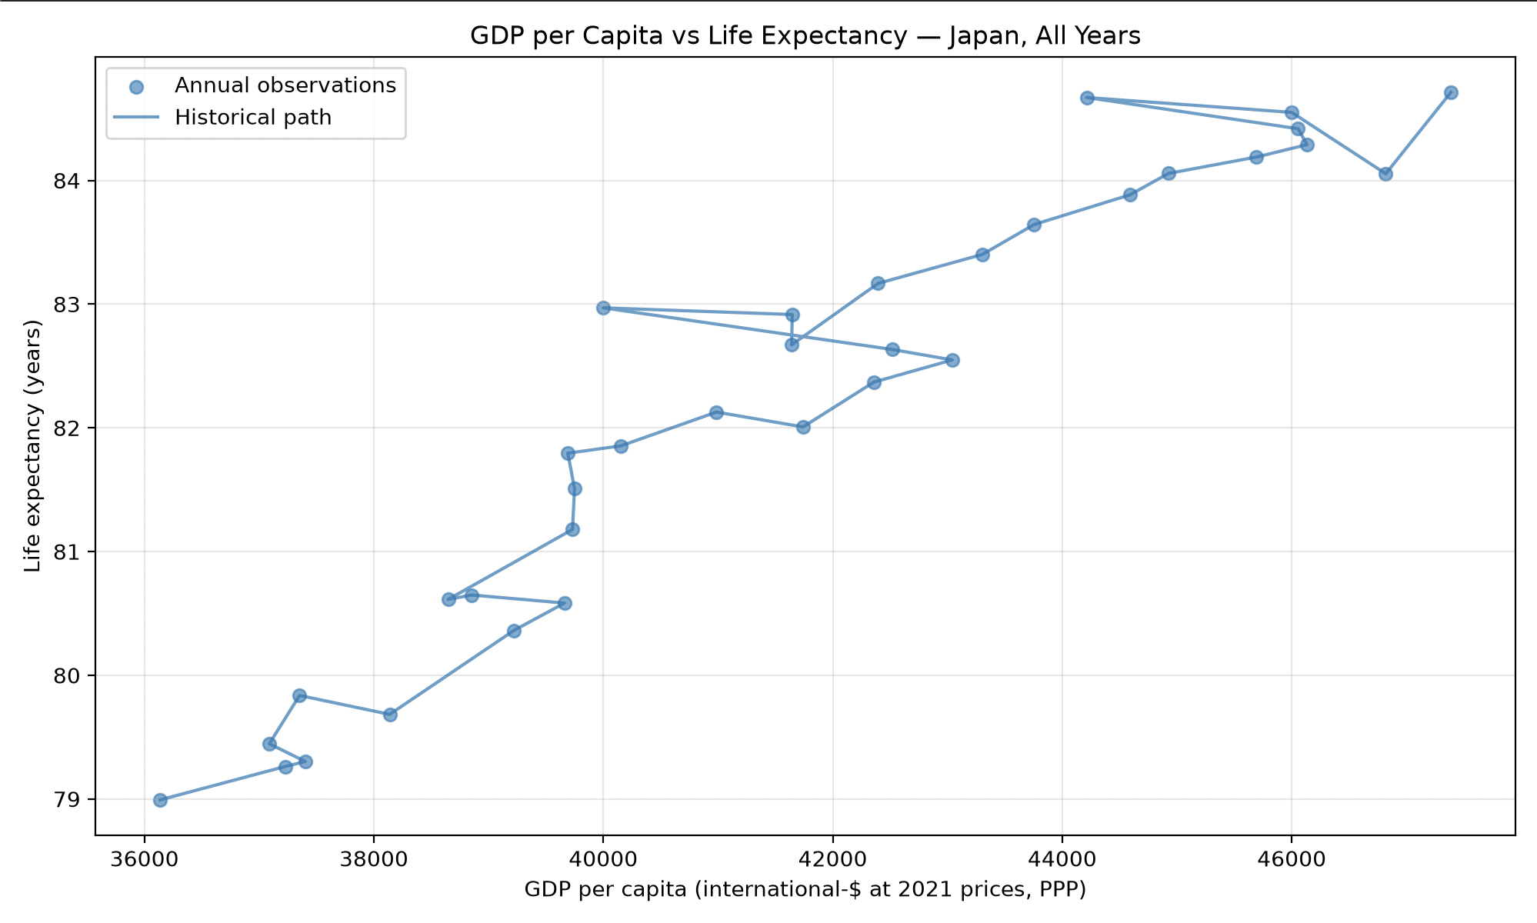

Assumptions
- OWID/World Bank figures are accurate and comparable between countries.
- PPP adjustment properly corrects for differences in price levels.
- Life expectancy at birth is a reasonable summary of a population's health.
- The relationship shown is a correlation, not causation. Things like education, healthcare spending and inequality affect both variables.

Observations
Life expectancy rises steeply with GDP per capita at low incomes and levels off at high incomes, at roughly 80–85 years above about $40,000. That is the classic "Preston curve". On the log scale, the relationship looks roughly linear, which supports using that scale.

Does every strong economy (normally indicated by GDP) have high life expectancy? (d.)

Definitions/Assumptions
A "strong economy" is one of the 15 largest economies by total GDP (PPP, 2023). "High" life expectancy means the upper quartile of countries in 2023, which is ≥ 78.3 years. We use the latest year so that countries are compared at the same point in time.

Answer
No. Only 8 of the top 15 are above the threshold: the US, Japan, Germany, France, the UK, Italy, South Korea and Canada. The other 7 are below it
Total GDP measures how big an economy is, and that depends heavily on population. China and India rank high mainly because they have so many people, not because each person is wealthy.
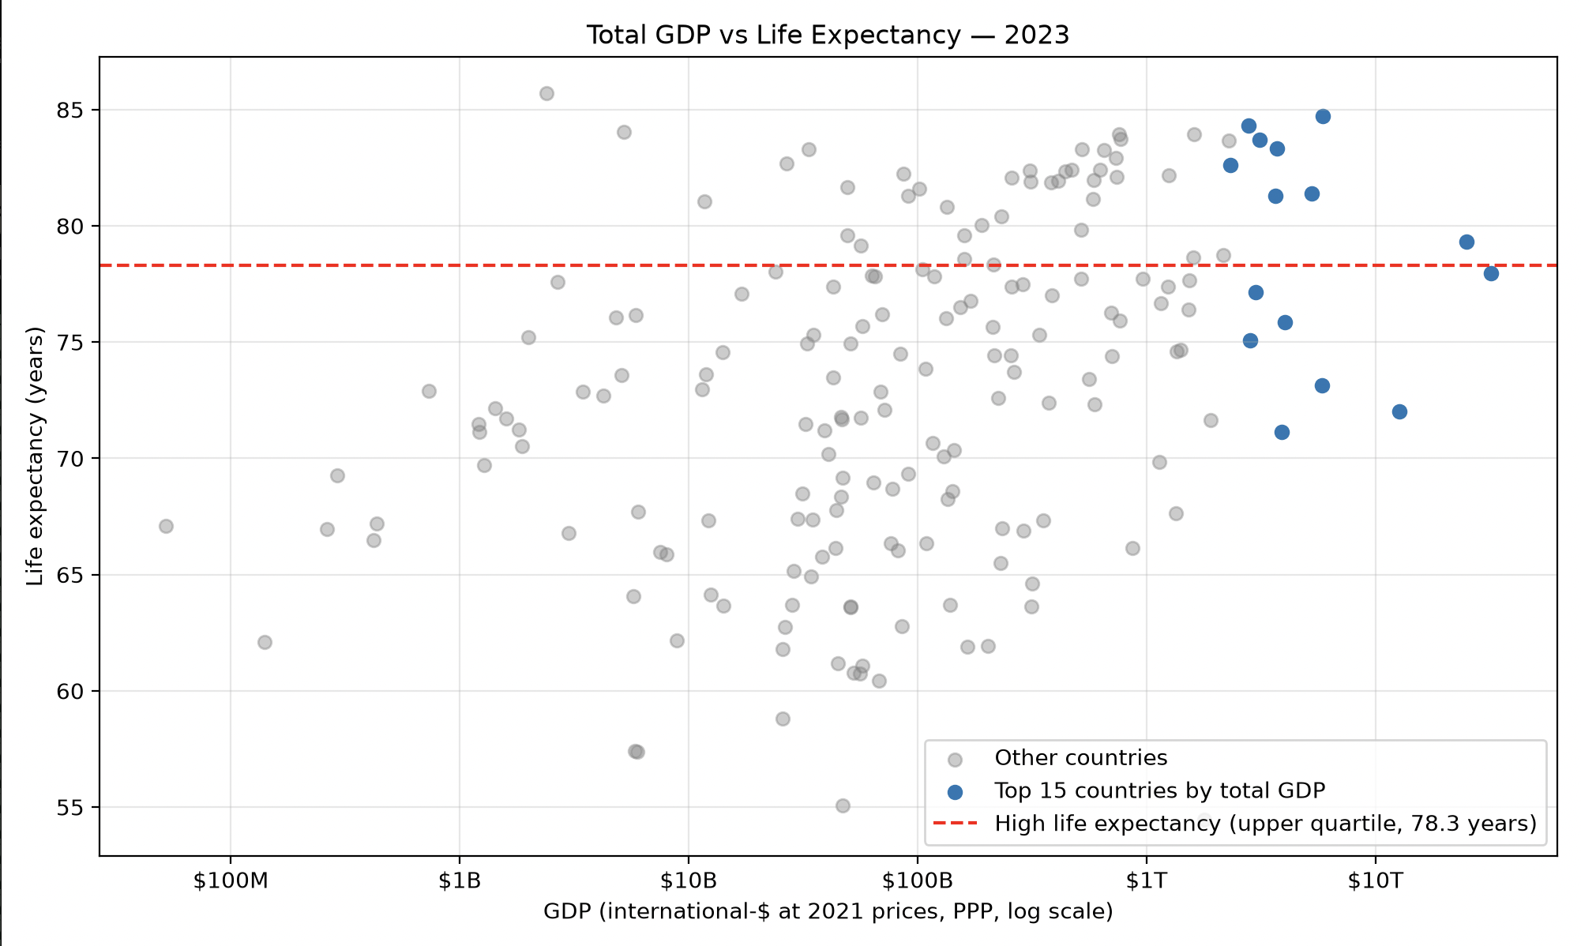

Related to question d, what would happen if you use GDP per capita as an indicator of a strong economy? (e.)

Answer
With the same threshold, 14 of the top 15 have high life expectancy. There is just one exception – Brunei, which is not annotated in the figure, but it is in the data itself.
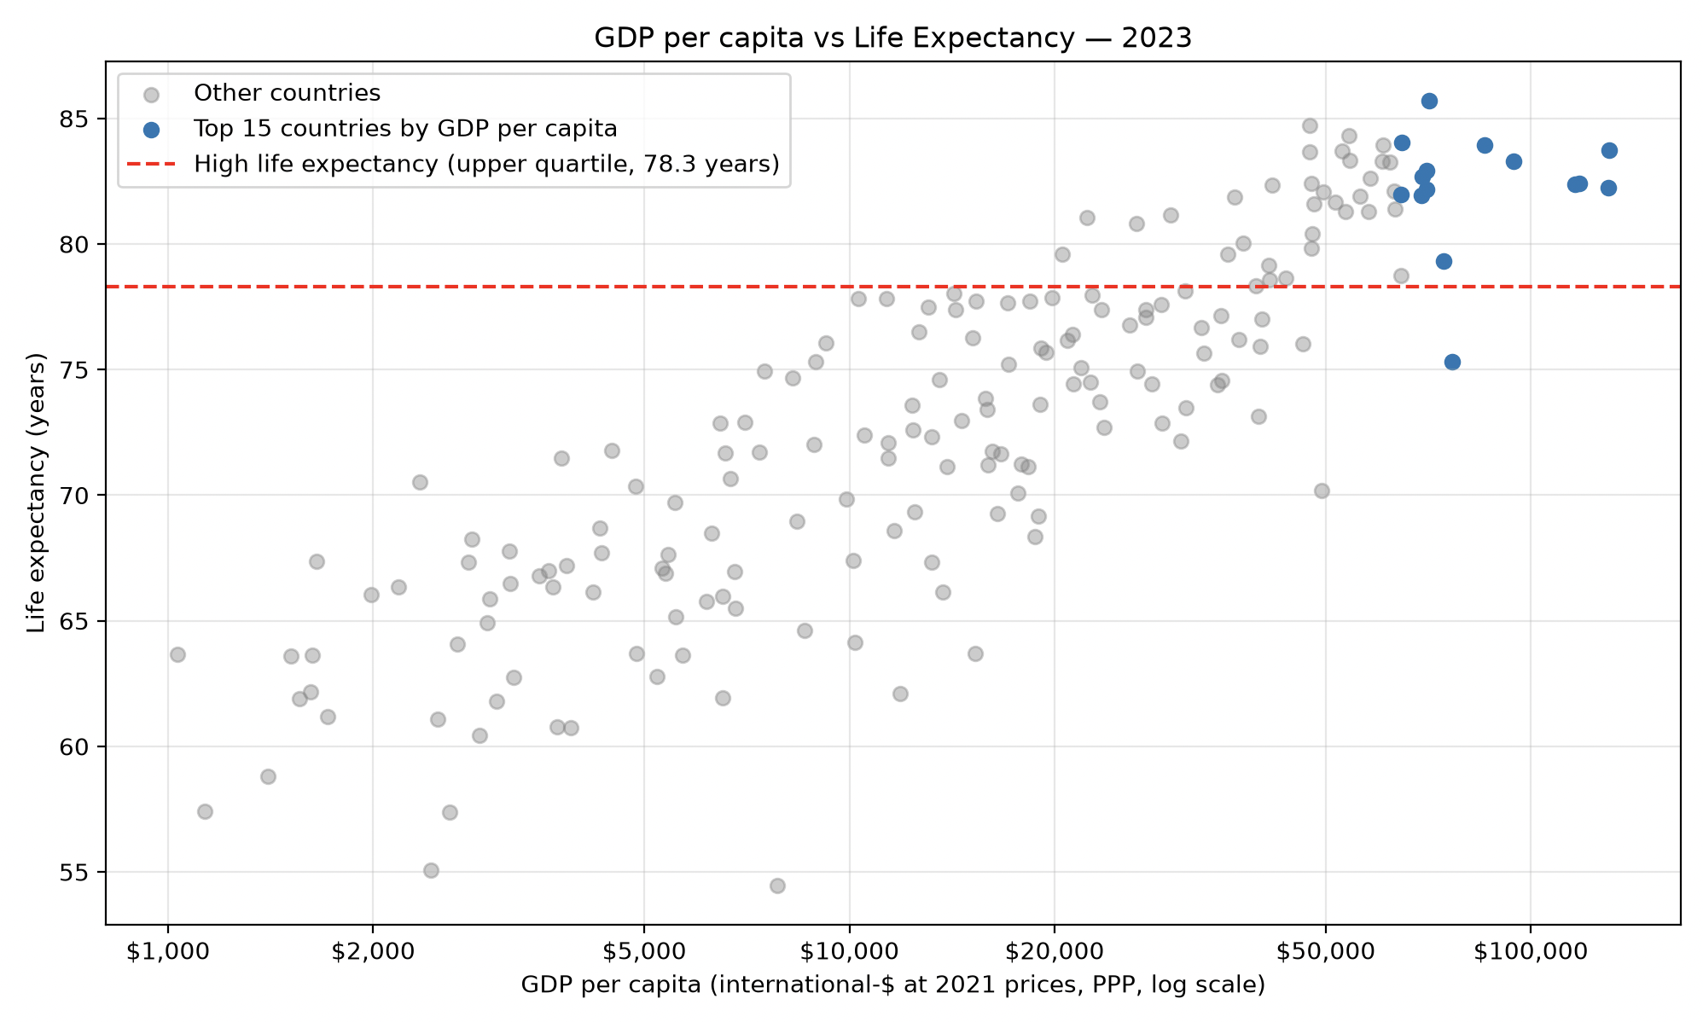

Insight from comparing d and e
Life expectancy depends on how much wealth there is per person, not on the total size of the economy. GDP per capita says much more about living standards, such as healthcare, nutrition and sanitation, so it predicts life expectancy far better.

Work distribution
Georgi - Initial data fetching and initial plots(a.), b., c., report (b., c.)
Ilia – Refactoring the code, d., e., report (a., d., e.)
GitHub repo: https://github.com/Ilia-tod29/Introduction_to_Data_Science_and_AI

