Introduction to Data Science and AI
Assignment 2
By
Ilia Todorov - FN: 2MI3400906
&
Georgi Karamishev - FN:2MI3200988

Work distribution
Georgi - Question 1, parts a to d (data cleaning, regression model, predictions, residual plot, code and report).
Ilia – Question 2,
GitHub repo: https://github.com/Ilia-tod29/Introduction_to_Data_Science_and_A

Table of Contents
Question 1a. Linear regression model and data cleaning………………………………………
Method …………………………………………………………………………………………………….
Data cleaning……………………………………………………………………………………………...
Figure 1: Raw data, outliers and the effect of cleaning………………………………...
Question 1b. Slope and intercept of the regression line……………………………………………..
Result and interpretation………………………………………………………………………….……..
Figure 2: Regression line and predictions………………………………………………………...
Question 1c. Predicted selling prices for 100, 150 and 200 m²………………………………………
Predictions………………………………………………………………………………………………...
Limitations for question 1c…………………………………………………………………..
Question 1d. Residual plot…………………………………………………………………………………….
Figure 3: Residual plot…………………………………………………………………………………….
Observations……………………………………………………………………………………………..
Conclusion Questuion 1 ……………………………………………………………………………………….
Appendix Questuion 1: Key parts of the Python code(assignment__2.py) ………
Question 2

Question 1a. Linear regression model and data cleaning
Find a linear regression model that relates the living area to the selling price. If you did any data cleaning step(s), describe what you did and explain why.

Method
Data: 56 villas sold in Landvetter, Sweden (hemnet.se, 2020-10-18). Variables used: Living_area (x, m²) and Selling_price (y, SEK).
A linear regression model describes the relationship between two quantities with a straight line. Here the line predicts the selling price of a house from its living area:
Selling price = intercept + slope × living area
The line was found with ordinary least squares, the standard method that chooses the line with the smallest total squared distance to the houses in the data.

Data cleaning
I did three checks.
- Missing values. The columns Rooms (2 missing), Land_size (1 missing) and Biarea (24 missing) have gaps. The model uses only living area and selling price, and neither has gaps, so no house was removed for this reason. Removing them would have thrown away good data for nothing.
- Duplicates. No two rows are identical. Houses 29 and 44 have the same area and price (135 m², 5,200,000 SEK) and could be one sale entered twice, but they differ in other columns, so I kept both. Their effect on the result is small.
- Unusual houses (outliers). I first fitted a line to all 56 houses and measured how far each house lies from it, in standard deviations. A standard deviation is the typical size of the distance from the line, so a house more than 3 standard deviations away is very unusual. Two houses were that far away, and I removed them:
  - House 41: 170 m², sold for only 1,775,000 SEK, with age 0 and no land size recorded. The price is far too low for such a house, so this is most likely a data error or a special sale.
  - House 46: 168 m², age 81, sold for 2,360,000 SEK. This sale is possible, but it is far below what similar houses cost.
The next most unusual house was only about 1.9 standard deviations away, so the line between "unusual" and "normal" is clear.
Why this matters. Two extreme houses can pull the line away from the typical house. With them included, each extra m² adds 19,370 SEK and the line explains 32% of the variation in price. Without them, each extra m² adds 23,598 SEK and the line explains 54%. Removing data is always a judgment call. My reasons are that both houses are far from all the others, and that one of them probably contains an error.
After cleaning, 54 houses remain.

Figure 1: Raw data, outliers and the effect of cleaning
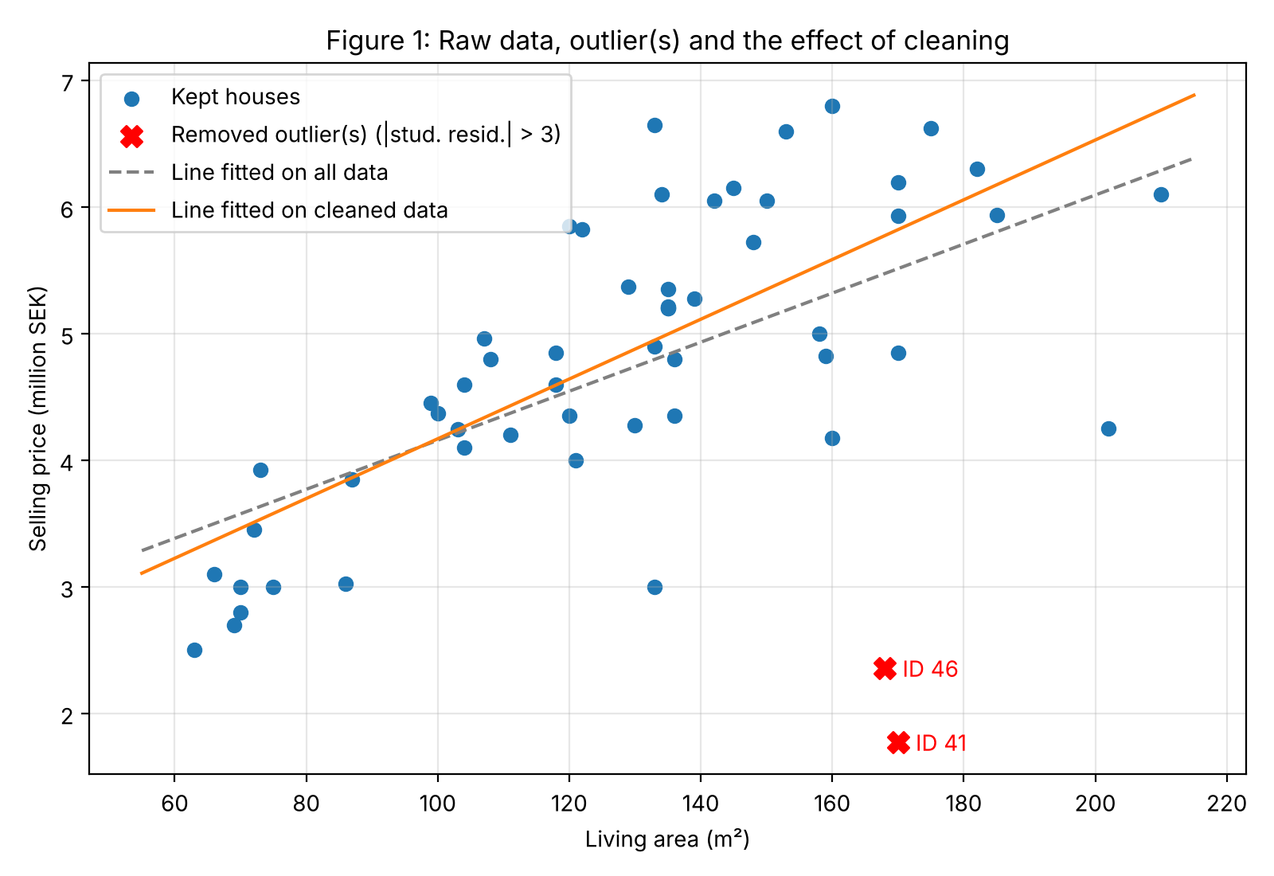
The figure shows all 56 houses as points. The two removed houses (ID 41 and ID 46) are marked in red. The grey dashed line was fitted to all the data and the orange line to the cleaned data. The two red houses lie far below other houses of similar size, and they pull the grey line down and make it flatter. The orange line follows the main group of houses better. This figure supports the decision to remove the two houses.

Question 1b. Slope and intercept of the regression line
What are the values of the slope and intercept of the regression line?

Result and interpretation
Selling price = 1,809,821 + 23,598 × living area (SEK)
- Slope: 23,598 SEK per m². This is how much the predicted price rises for each extra square metre of living area. Its 95% confidence interval runs from 17,539 to 29,657. This interval is the range in which the true value very likely lies. The p-value is 2.5e-10, which is the chance of seeing such a clear relationship by luck alone, so the relationship is real.
- Intercept: 1,809,821 SEK. This is where the line crosses the price axis, at a living area of 0 m². It has no practical meaning, because the smallest house in the data has 63 m². It is just the starting point that makes the line fit.
- R² = 0.54 (correlation 0.735). R² tells us what share of the differences in price the line explains. Living area explains about 54%. The remaining 46% comes from other things, such as the age of the house or the size of the plot.
- Typical error of the line: 786,958 SEK (residual standard error). A prediction is usually off by about that amount.

Figure 2: Regression line and predictions
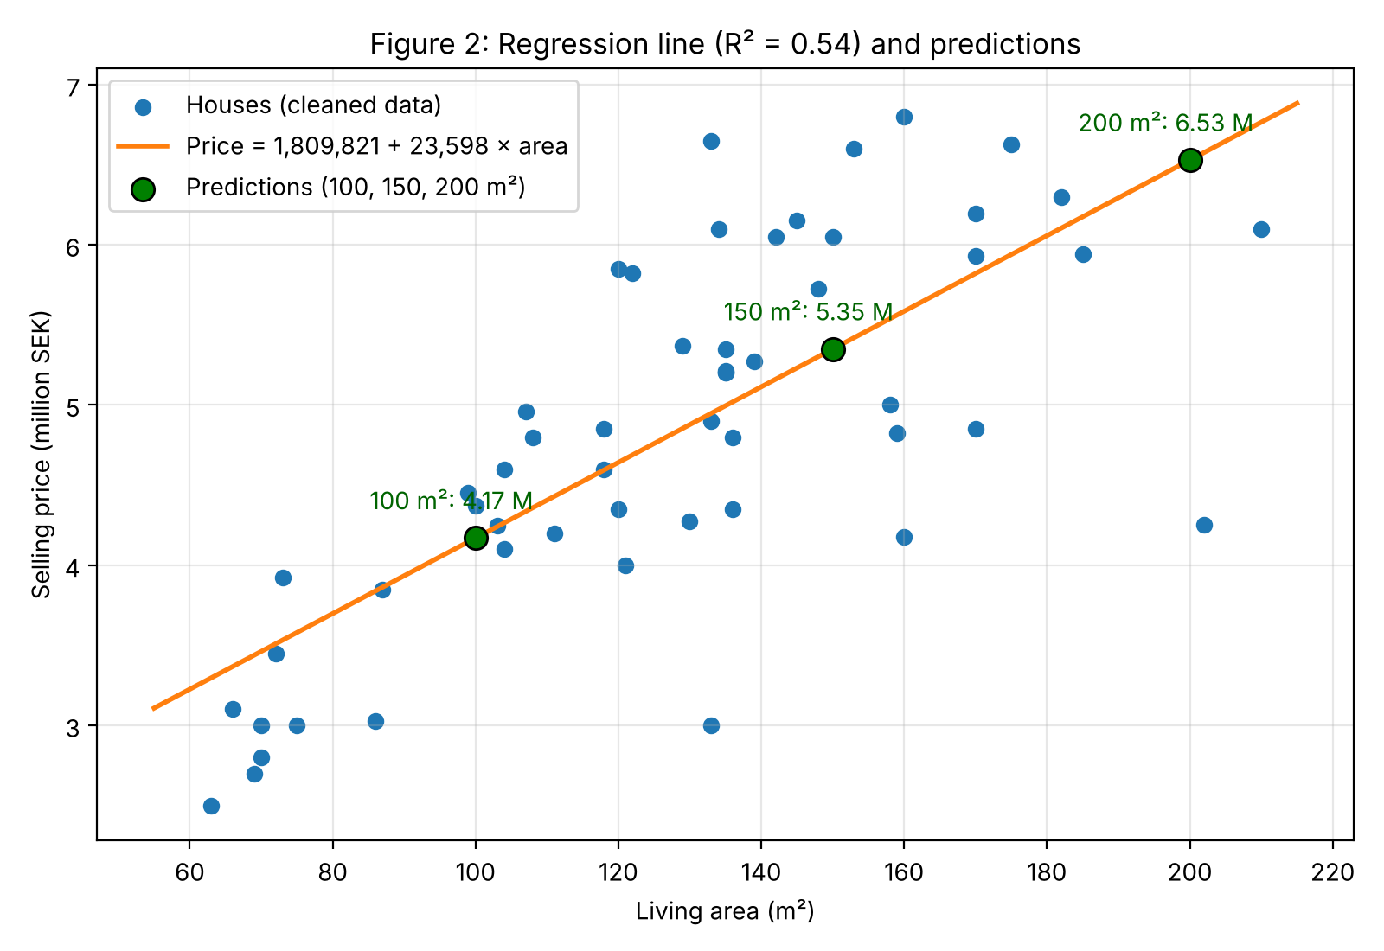
The figure shows the 54 cleaned houses, the fitted line, and the three predictions (100, 150 and 200 m²) as green points. The prices rise clearly with living area, but the houses are widely spread around the line. This matches R² = 0.54: living area matters a lot, but it is not the only factor.

Question 1c. Predicted selling prices for 100, 150 and 200 m²
Use this model to predict the selling prices of houses which have living area 100 m2, 150 m2 and 200 m2.

Predictions
The three predictions are the green points in Figure 2. For each one I also give a 95% prediction interval, which is the range in which the price of a single new house of that size would very likely fall.
Living area | Predicted price (SEK) | 95% prediction interval (SEK) | Similar houses in the data (within 10 m²)
100 m² | 4,169,601 | 2,567,411 to 5,771,790 | 7
150 m² | 5,349,490 | 3,749,806 to 6,949,174 | 9
200 m² | 6,529,380 | 4,875,745 to 8,183,016 | 2

Limitations for question 1c
All three sizes lie inside the range of the data (63 to 210 m²), so these are fair predictions and not guesses beyond what we observed. The intervals are wide, about 1.6 million SEK up or down, because houses of the same size sell for quite different prices. The predictions are therefore rough guides and not exact prices. The 200 m² prediction is the least reliable, because only 2 houses in the data are within 10 m² of it (there are 7 for 100 m² and 9 for 150 m²).

Question 1d. Residual plot
Draw a residual plot.
A residual is the difference between the real selling price of a house and the price the line predicts for it. A residual plot shows these differences against living area. It is a check on the model: if a straight line is a good choice, the points should scatter evenly around zero with no clear pattern.
Figure 3 is the residual plot. In short, the residuals are centred on zero and show no strong pattern, so a straight line is a reasonable model. There is one mild weakness, a slightly larger spread for big houses, which is described under Observations.

Figure 3: Residual plot
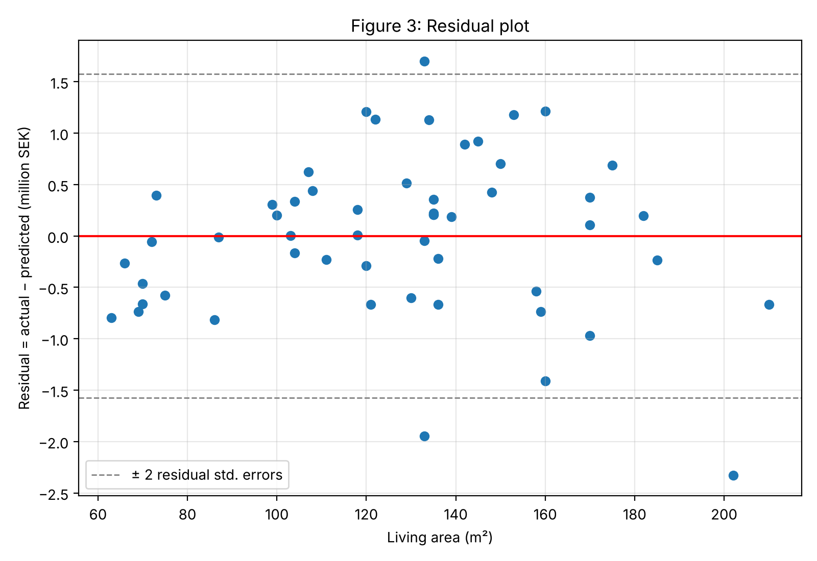
The horizontal axis is living area. The vertical axis is the residual (real price minus predicted price). The red line marks zero, which is a perfect prediction. The dashed lines mark 2 typical errors above and below zero (about 1.57 million SEK).

Observations
- The residuals are centred on zero and almost all lie between the dashed lines, so the line does not lean systematically too high or too low.
- The spread is somewhat larger for big houses. The typical distance from the line is 854,000 SEK for houses above the median size of 133 m², against 722,000 SEK for smaller ones. This is a mild effect.
- The largest errors are house 25 (202 m², age 54), which sold 2.33 million SEK below the prediction, house 10 (133 m², age 51), 1.95 million below, and house 6 (133 m², age 12), 1.70 million above.
- The residuals are related to age (correlation -0.35): older houses sell for less than their size alone would suggest. Age would be a natural extra variable in a better model.

Conclusion
Living area is a clear predictor of selling price: each extra m² adds about 23,600 SEK. The straight line explains about half of the differences in price. The residuals look acceptable (centred on zero, with only a mild increase in spread), but predictions remain uncertain, with a typical error of about 790,000 SEK. A better model could add variables such as the age of the house or the size of the plot.

Appendix: Key parts of the Python code (assignment__2.py)
The full script is submitted as a separate file, assignment__2.py. These are the steps that answer the question.
Cleaning and fitting the model (parts 1a and 1b). A first line is fitted to all houses, and houses more than 3 standard deviations from it are removed. The line is then fitted again to the cleaned data, and the slope and intercept are read from the model.
model_raw, fitted_raw, resid_raw = fit_line(x_all, y_all)
df["stud_resid_raw"] = studentized(x_all, resid_raw)
outlier_mask = np.abs(df["stud_resid_raw"]) > OUTLIER_THRESHOLD # threshold = 3
outliers = df[outlier_mask]
clean = df[~outlier_mask].copy()
model, fitted, resid = fit_line(x, y)
slope, intercept = model.coef_[0], model.intercept_
r2 = model.score(x.reshape(-1, 1), y)
Predictions (part 1c). For each living area the model gives the price, and the prediction interval is the price plus or minus t_crit * se_pred.
for a in NEW_AREAS: # [100, 150, 200]
p = model.predict(np.array([[a]]))[0]
se_pred = s * np.sqrt(1 + 1 / n + (a - x.mean()) ** 2 / sxx)

