Bricks Breaker RL Algorithm

RL area – area from the end of the bricks area till the paddle area.

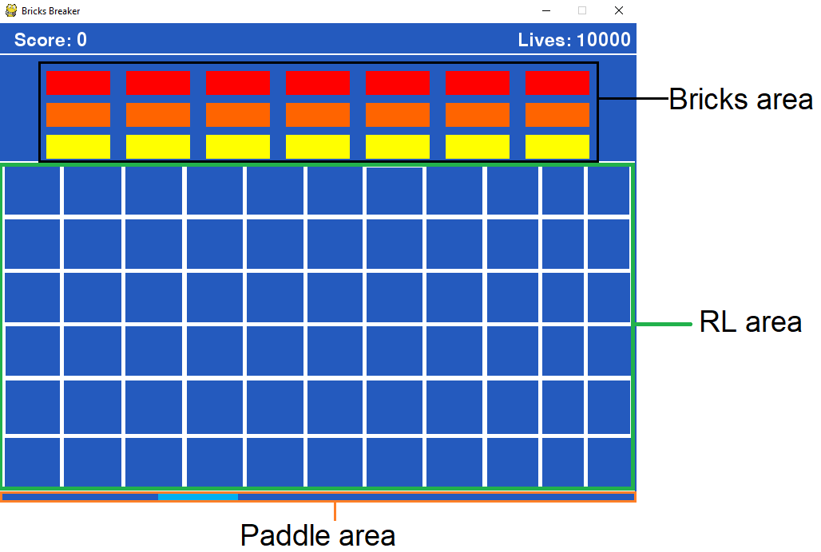

The RL area is divided into equal sub-areas (white rectangles in the images).
Each sub-area has an array of 180 elements. Each element matches the vector that
corresponds to the certain direction. The direction is measured in degrees – angle between
the vector and X-axis. Example:
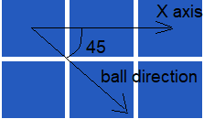

Each degree element has an array of 8 elements: number of possible states of the paddle.
State 0:
State 3:

State 7:

Data structure:
According to this description we create a RL table – two-dimensional array, that consists
of RL info sub areas. Each RL info object contains an array of 180 of RL states objects.
Each RL state object contains array of 8 states. Each state can have a value:
not tested, failure, success.

Algorithm description:
Create RL table according to the existing RL sub-areas, number of directions and
initialize all the states with NOT TESTED value.
Repeat till end of the game:
When the ball is found in the RL area and moves down:
Snap its location (RL sub-area) and the movement direction.
Select the paddle action (movement to some state):
Search in the RL table a relevant cell (due to the location and the direction)
and pass through all the states values.
If exists a state with SUCCESS value:
Choose this state.
Else:
If all the states have FAILURE values:
Initialize all the states with NOT TESTED value .
Choose any state with NOT TESTED value.
Wait for the ball collision with the paddle or with the bottom wall.
If the collision occurs:
If the collision occurs with the paddle:
Update the relevant paddle state for the appropriate direction (degree)
in the snapped RL sub-area with SUCCESS value in the RL table.
Else if collision with the bottom wall:
Update the relevant paddle state for the appropriate direction (degree)
in the snapped RL sub-area with FAILURE value the RL table.

