STM32 Peripheral Tester

Project Goal

The goal of this project is to verify the hardware correctness of the STM32F756ZG board peripherals using an automated client-server testing system.

The Linux server sends test commands over UDP/Ethernet, and the STM32 firmware receives these commands, runs the requested peripheral test, and sends the result back to the server.

Project Description
STM32 Hardware Tester is an automated hardware validation system for the STM32F756ZG Nucleo development board.
The project consists of two independent applications:
- STM32 firmware, running on the target board under FreeRTOS.
- Linux UDP server, responsible for generating test commands, collecting test results, and displaying execution statistics.
The server sends test commands over Ethernet using UDP. Each command specifies the peripheral to test, the number of iterations, and the test data size (when applicable). The STM32 firmware executes the requested test and returns a PASS or FAIL result to the server.
The project supports simultaneous execution of multiple peripheral tests, allowing different hardware modules to be tested independently and in parallel.

Development Environment
Hardware
- STM32 Nucleo-F756ZG development board
- STM32F756ZG microcontroller
- Ethernet connection between the board and Linux PC
Software
- STM32CubeIDE
- STM32CubeMX
- STM32 HAL
- FreeRTOS
- lwIP (UDP)
- GCC (Linux)
- Ubuntu Linux
Programming Languages
- C (STM32 firmware)
- C (Linux server)
Communication
- UDP over Ethernet

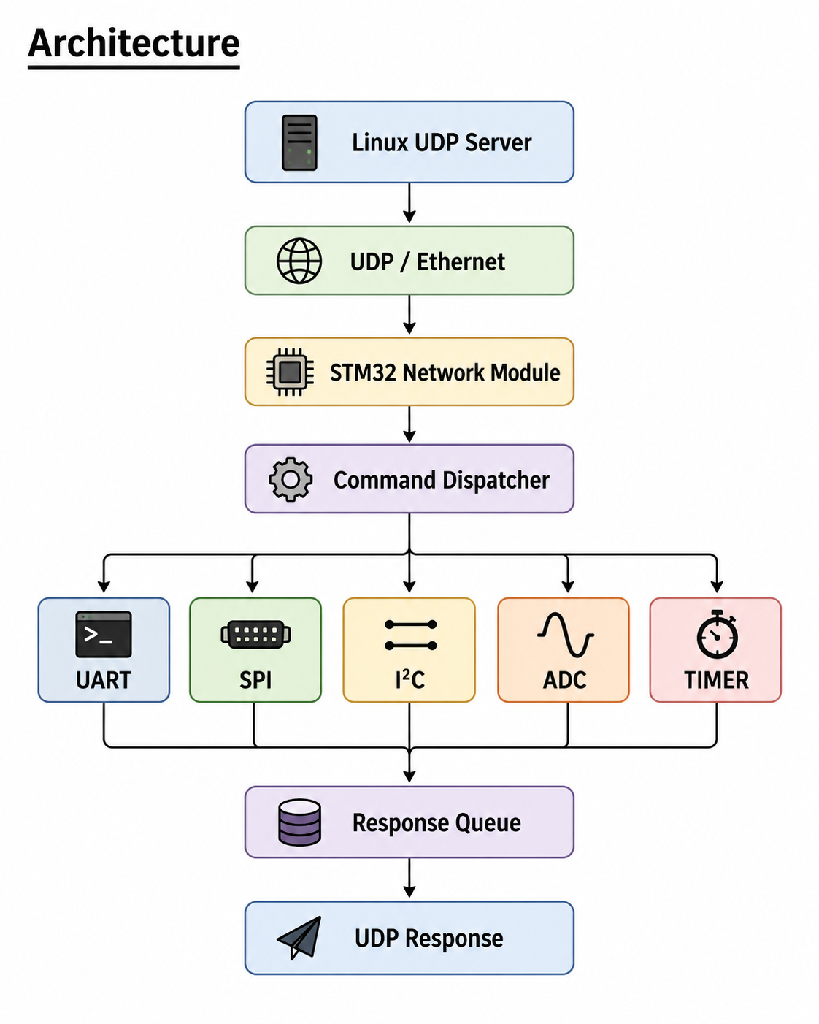
Architecture Modules
Linux UDP Server
Generates test commands, sends them to the STM32 board over UDP, receives test results, and displays execution statistics.
STM32 Network Module
Receives UDP packets from the server, validates incoming commands, and sends test results back to the server.
Command Dispatcher
Routes each received command to the appropriate peripheral test module based on the requested peripheral type.
Peripheral Test Modules
- UART – Verifies bidirectional UART communication by transmitting and receiving data patterns.
- SPI – Tests full-duplex SPI communication between the master and slave peripherals.
- I²C – Verifies data exchange between the I²C master and slave peripherals.
- ADC – Checks the ADC by comparing measured values with DAC-generated reference voltages.
- Timer – Measures timer accuracy by comparing the measured delay with the expected delay.
Response Queue
Collects completed test results from all peripheral test modules and transfers them to the network module for transmission.
UDP Response
Sends the final PASS or FAIL result, together with the test identifier, back to the Linux server.

Implemented Tests
The communication peripherals (UART, SPI and I²C) use the same testing methodology. Random data packets (1–255 bytes) are transmitted and verified using either Interrupt (IT) or DMA mode, selected at compile time. For packets longer than 100 bytes, CRC is used instead of byte-by-byte comparison to improve verification efficiency.
UART Test
Verifies bidirectional UART communication by transmitting random data between two UART peripherals and validating the received data.
SPI Test
Verifies full-duplex SPI communication by exchanging random data between the SPI master and SPI slave.
I²C Test
Verifies bidirectional I²C communication by transmitting random data from the master to the slave and back to the master.
ADC Test
Several predefined DAC output values are generated and measured by the ADC. The measured values are compared against the expected values using a configurable tolerance to verify correct analog operation.
Timer Test
A hardware timer generates a precisely timed delay. The measured delay is compared with the expected delay, and the test passes if the timing error remains within the configured tolerance.

Project Components
STM32PeripheralTester
Firmware project running on the STM32F756ZG board. Responsible for receiving UDP commands, executing peripheral tests, and transmitting the results.
STM32_Server
Linux application responsible for generating test commands, collecting responses, maintaining the result database, and displaying execution statistics.
Building and Running
STM32 Firmware
- Open the STM32PeripheralTester project in STM32CubeIDE.
- Build the project.
- Program the firmware to the STM32 Nucleo-F756ZG board.
Linux Server
- Open a terminal in the STM32_Server directory.
- Build the server:
make
- Run the server:
./stm32_server
STM32 Serial Output
The STM32 firmware prints runtime messages through the ST-LINK virtual COM port. These messages can be monitored using minicom:
minicom -D /dev/ttyACM0 -b 115200
The serial log shows network initialization, received commands, peripheral test execution, and UDP responses sent back to the Linux server.
Test Execution
- Connect the STM32 board to the Linux PC using an Ethernet cable.
- Start minicom to monitor STM32 runtime messages.
- Start the Linux server.
- The server automatically generates test commands and displays the test results in real time.
- The STM32 serial output shows received commands, executed tests, and generated responses.

Test Results
During execution, theLinux server displays each transmitted command together with its corresponding PASS or FAIL result. At the end of the test session, a summary is printed containing:
- Total number of executed tests
- Number of passed tests
- Number of failed tests
- Number of pending tests
- Overall success rate
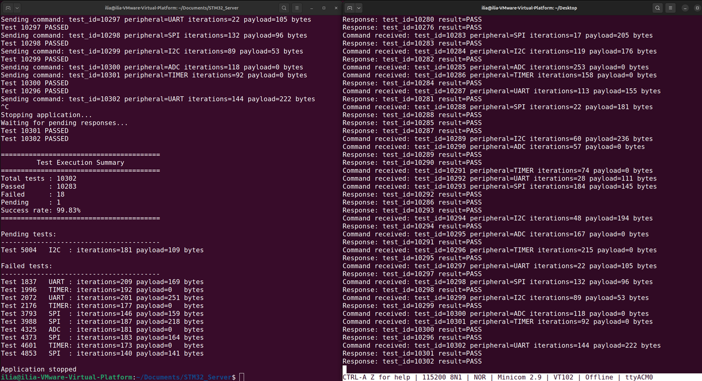
Figure 1. Real-time execution of parallel peripheral tests. The Linux server (left) generates UDP test commands and collects results, while the STM32 board (right) receives commands, executes peripheral tests, and returns PASS/FAIL responses.

