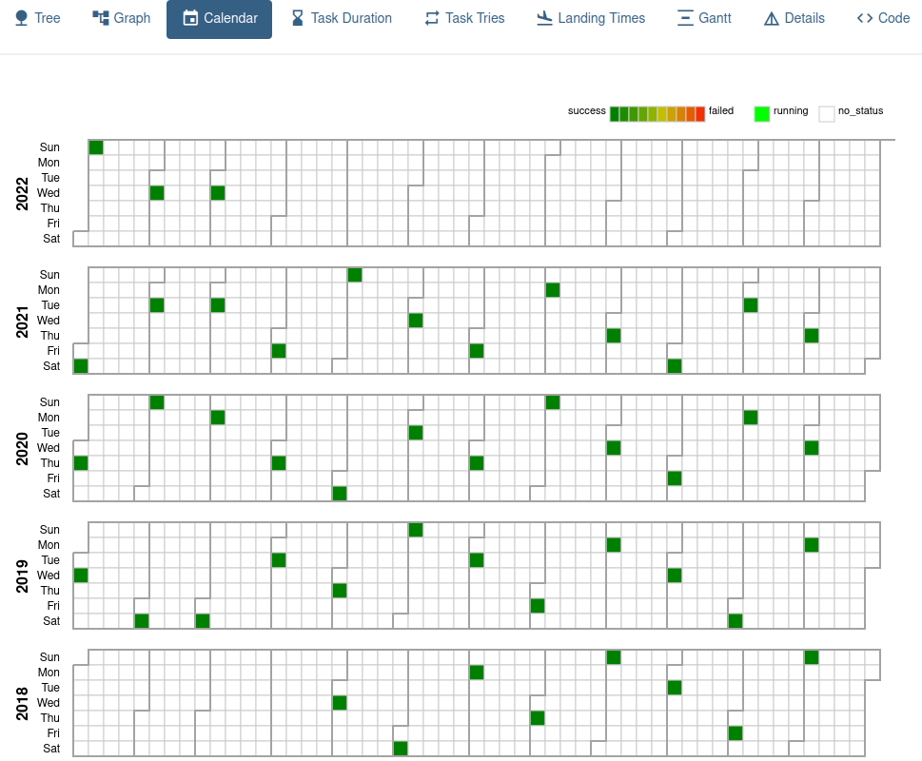
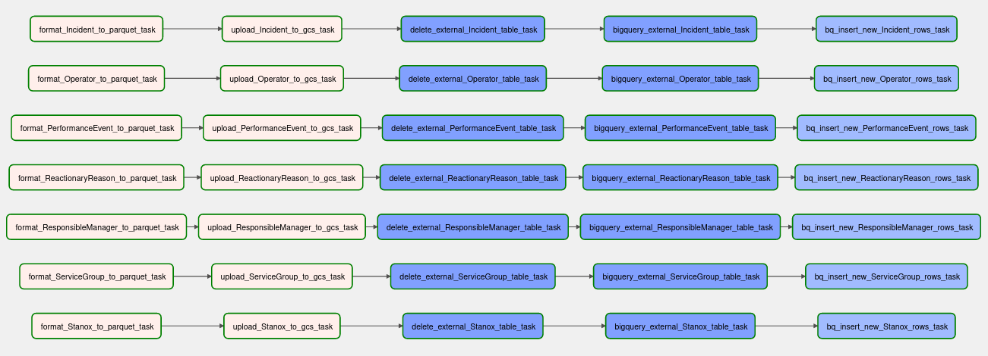
That satisfying moment when your pipelines run smoothly after days of debugging. It’s project time in the DataTalksClub’ DataEngineering Zoomcamp – we are instructed to find a data set of our choice and build an end-to-end analytical solution on it. I have decided to go with UK train delay data (link) because it covers several years and has many attributes to go with. I am doing data ingestion with Airflow into a datalake based on Google cloud storage.

