Library Project

*Documentation*

1. Meet the team Durian: (”{0} – {1} {2}”, TAid, FirstNameBg, SecondNameBg ):

*1) IlianaB - Илиана Бобева -Team Lead*

*2) pzubev - Петър Зубев*

*3) dani.ivanov.96 - Дани Иванов*

*4) Andro0 - Андрей Киров*

*5) loderunner - Никола Богомиров*

*6) nikistefanov - Николай Стефанов*

*7) messenger - Михаил Петров*

*8) D.Yanis - Димитър Янис*

1. Program description: Product deliverable is a an implmented logic and structure of an online Library API allowing users to read and comment on books, newspapers and magazies that are present in the library. The delivered product could be used out side of the box allowing for quick integration with WPF as UI.
2. RepositoryLocation: <https://github.com/IlianaB/TA-TeamWork-CSharpOOP>

All code under MIT licence.

1. Highlevel description of underlying logic and implementation: We have used the Factory method pattern as a creational pattern. The common interfaces implemented in the factory IProfilesFactory and IReadableItemsFactory require implementation of IProfile and IReadable interfaces respectively. The Profile class implements the IProfile interface. This class creates a user with properties Name, Password and Profile Type. Profile class is being inherited by the User and Admin classes. Moderator and Regular users are treated as subclasses of the User class. All users can keep statistics on their activities in the Library by adding or removing items in their custom lists Wish-to-read-list, currently-reading and read items. The items produced by our virtual Factory for our Libarary are of 3 types: Books, Magazines and Newspapers. Those items have some different set of properties but share a common genre from a predefined set listed in the Genres enumeration. The Datamanger class takes care of reading and writing inforation about users profiles, and the collection of readable items. All the informatio about user and readable items is to be stored in the DB folder in our project structure.

Users can comment on everything they read in the Library.

Some built-in extending fuctionalities are being predefined and implemented but not released to prodiction just as yet as they come at additional monetary cost for the customer paying for this project deliverable. Those fucntionalities are implemented with the Search and Rating Class.

1. Class diagram:

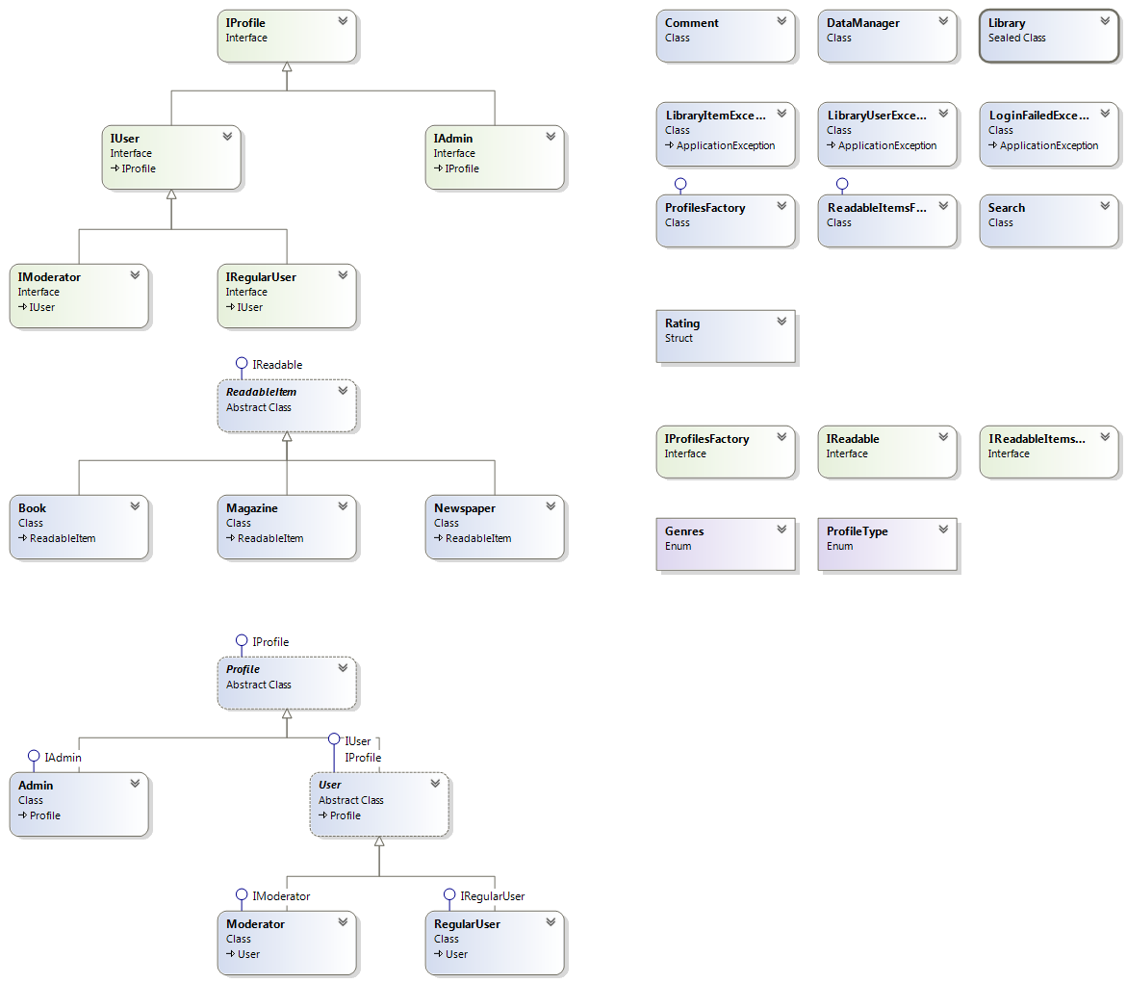

1. Requirements for the project vs. project implementation:

All requirments are being met incl. those for classes, interfaces enumerations, OOD design, enumerations, polymorphism, inheritance, abstraction, exception.