System Analysis
Gemini Prompt + JSON creation and detection
-Initialization of a session for each MCP server.
-Fixed Prompt that includes instructions on how to form a JSON object and how to reply, plus all the tools discovered from the initialization phase.
-conversation history(context_text) that includes the last 6 messages (3 responses), it resets every time.
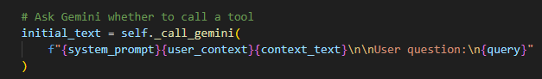-including the user question(query) and his data(user_context, depending on who is logged in) they all form together the initial text that Gemini will process.
-If llm decides to call a tool, it returns a message in JSON format as instructed in the system_prompt.
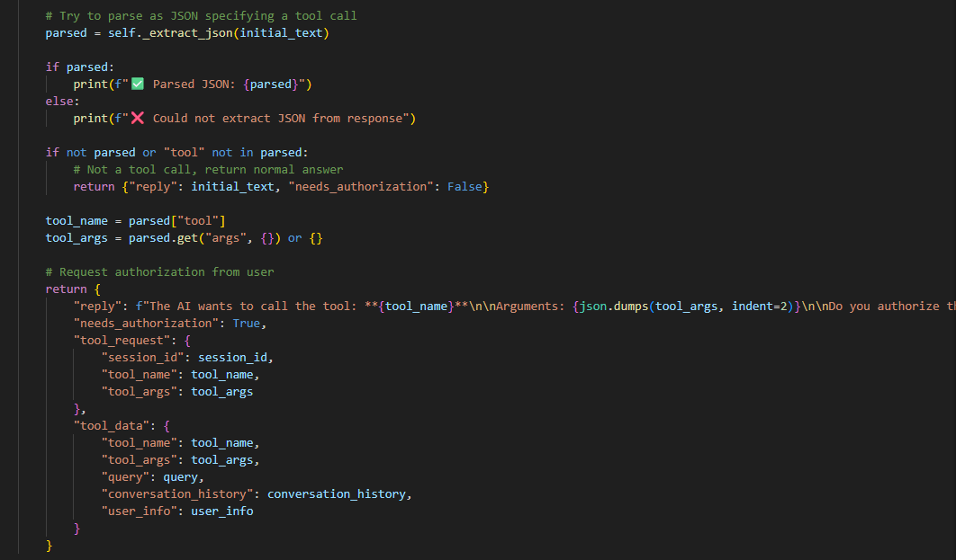
-Then there’s a check on whether the message is in a JSON form, if yes then we print an authorization that the user has to approve, else it’s a natural language response that we immediately print.
-If a tool was called and the JSON object was detected successfully we then proceed to search for the session that includes the requested tool in order to execute it.

Current Logic: No agent loop, meaning I’m mainly doing query -> LLM -> tool -> result. Only 1 tool call is possible per query.
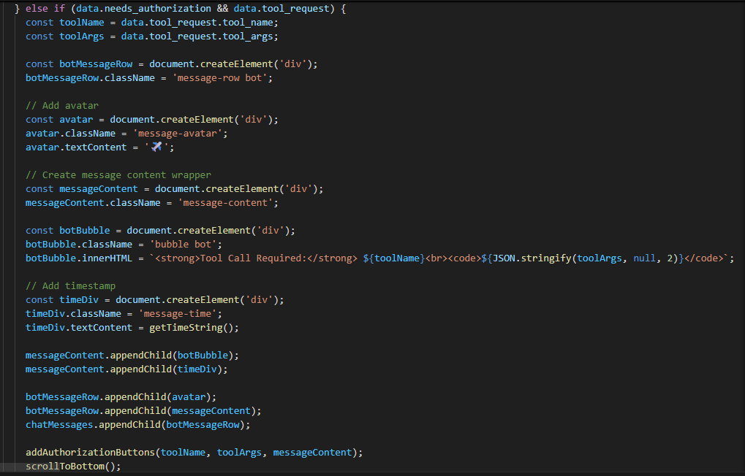
-If a tool call is detected then we set a needs_authorization variable to true which our frontend receives plus the tool name and arguments in order to create the authorization pop up for the user to approve or deny.

