## Koliesnikov Ilia Kyiv, Ukraine

## [ilakoles96@gmail.com](mailto:bukovskii111@gmail.com)

## +38 063 2865495

**City resume**: [my-web](https://my-resume-cite-klw3haws9-illiasargument.vercel.app/)[1]

**Frontend developer**

## OBJECTIVE:

I am currently looking for opportunities to make use of my experience at premium level IT companies and would therefore be extremely interested in any potential vacancies that might arise. Want to continue my development in the field of front-end or back-end developing, improve and upgrade technical skills.

**QUALIFICATIONS:**

Good knowledge of JavaScript and JavaScript frameworks such as React.

I am also hardworking, efficient, flexible and can work under pressure.

I easily make new acquaintances, I am sociable, I appreciate straightforwardness, openness and a sense of humor. I quickly adapt to new conditions, I complete the assigned tasks on time and as productively as possible.

I want to become a pro in my craft, I easily learn new things that have become my lifestyle. I'm ready for anything and if I have to work without sleep and head over heels in water, I can easily cope.

**TECHNOLOGY:**

HTML, HTML5, CSS, CSS3, Sass, JavaScript, React JS, Redux, Babel, ES6, Webpack, Git, REST, web -development, JSON, API, firebase, gulp, figma.

## EDUCATION/DEGREES:

National Technical University of Uktaine Kyiv Politechnic Institute

Enrgy managment and engineering of heat and power systems.

2011 – 2016

Passed 8 month **UDEMI course** (html, css), (JavaScript, React & Redux)

Passed 3 month **Coursehounter** **course** (React, React/Redux) in 2021

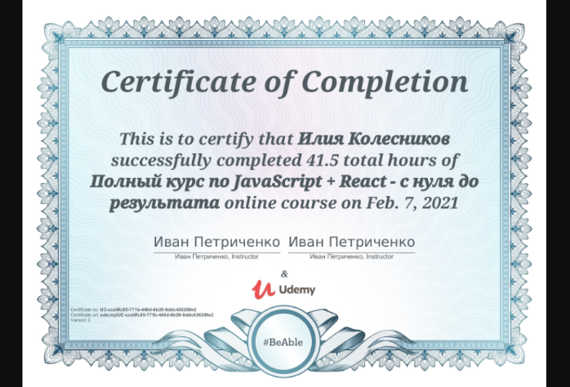

**LANGUAGE**: English - lower-intermediate (courses), Ukrainian - native, Russian - fluent.

1.