**Лабораторная работа №3 Приложение - Контейнер единиц измерения**

Наша цель: разработать мобильное приложение, которое поможет конвертировать заданные числа в определённый формат расстояния.

1. **Интерфейс**

**Ссылка на видео** <https://youtu.be/1endDcsEWW4>

На рисунке 1 продемонстрирован интерфейс нашего приложения

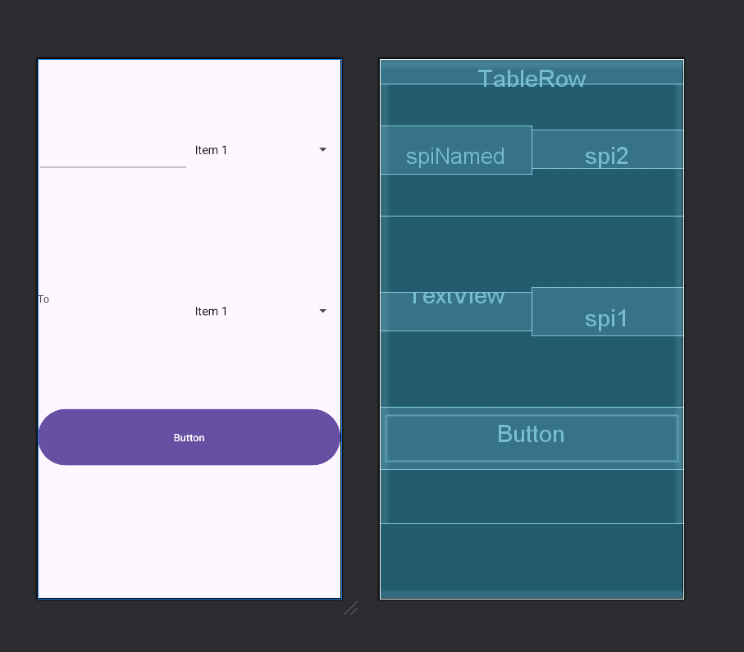

*Рисунок 1*

XAML код данного приложения

<?xml version="1.0" encoding="utf-8"?>  
<LinearLayout xmlns:android="http://schemas.android.com/apk/res/android"  
 xmlns:app="http://schemas.android.com/apk/res-auto"  
 xmlns:tools="http://schemas.android.com/tools"  
 android:id="@+id/main"  
 android:layout_width="match_parent"  
 android:layout_height="match_parent"  
 android:orientation="vertical"  
 tools:context=".MainActivity">  
  
 <TableRow  
 android:layout_width="match_parent"  
 android:layout_height="33dp" />  
  
 <LinearLayout  
 android:layout_width="match_parent"  
 android:layout_height="179dp"  
 android:gravity="center"  
 android:orientation="horizontal">  
  
 <EditText  
 android:id="@+id/spiNamed"  
 android:layout_width="match_parent"  
 android:layout_height="66dp"  
 android:layout_weight="1"  
 android:ems="10"  
 android:inputType="text" />  
  
 <Spinner  
 android:id="@+id/spi2"  
 android:layout_width="match_parent"  
 android:layout_height="52dp"  
 android:layout_weight="1" />  
  
 </LinearLayout>  
  
 <LinearLayout  
 android:layout_width="match_parent"  
 android:layout_height="259dp"  
 android:gravity="center"  
 android:orientation="horizontal">  
  
 <TextView  
 android:id="@+id/txte"  
 android:layout_width="match_parent"  
 android:layout_height="52dp"  
 android:layout_weight="1"  
 android:text="To" />  
  
 <Spinner  
 android:id="@+id/spi1"  
 android:layout_width="match_parent"  
 android:layout_height="66dp"  
 android:layout_weight="1" />  
  
 </LinearLayout>  
  
 <LinearLayout  
 android:layout_width="match_parent"  
 android:layout_height="158dp"  
 android:orientation="horizontal">  
  
 <Button  
 android:id="@+id/butf03"  
 android:layout_width="match_parent"  
 android:layout_height="84dp"  
 android:layout_weight="1"  
 android:text="Button"  
 android:onClick="on_convert"/>  
 </LinearLayout>  
</LinearLayout>

**2. Программнный код**

Здесь представлен в своём первоначальном виде программный код нашего приложения.

package com.example.lab03;  
  
import android.os.Bundle;  
import android.view.View;  
import android.widget.ArrayAdapter;  
import android.widget.EditText;  
import android.widget.Spinner;  
import android.widget.TextView;  
  
import androidx.appcompat.app.AppCompatActivity;  
  
  
public class MainActivity extends AppCompatActivity {  
  
 @Override  
 protected void onCreate(Bundle savedInstanceState) {  
 super.onCreate(savedInstanceState);  
 setContentView(R.layout.*activity_main*);  
  
 spFrom = findViewById(R.id.*spi1*);  
 spTo = findViewById(R.id.*spi2*);  
 etFrom = findViewById(R.id.*spiNamed*);  
 tvTo = findViewById(R.id.*txte*);  
  
 ArrayAdapter<String> adp =new <String> ArrayAdapter(this, android.R.layout.*simple_list_item_1*);  
  
 adp.add("mm");  
 adp.add("cm");  
 adp.add("m");  
 adp.add("km");  
  
 spFrom.setAdapter(adp);  
 spTo.setAdapter(adp);  
 }  
 Spinner spFrom;  
 Spinner spTo;  
 EditText etFrom;  
 TextView tvTo;  
  
  
 public void on_convert(View v)  
 {  
 float from = Float.*parseFloat*(etFrom.getText().toString());  
  
 String aFrom = (String) spFrom.getSelectedItem();  
 String aTo = (String) spTo.getSelectedItem();  
  
 float to = 0.0f;  
  
 if (aFrom.equals("mm"))  
 {  
 if (aTo.equals("mm")) to = from * 1.0f;  
 if (aTo.equals("cm")) to = from * 0.1f;  
 if (aTo.equals("m")) to = from * 0.001f;  
 if (aTo.equals("km")) to = from * 0.000001f;  
  
 tvTo.setText(String.*valueOf*(to));  
  
  
 }  
  
 if (aFrom.equals("cm"))  
 {  
 if (aTo.equals("mm")) to = from / 0.1f;  
 if (aTo.equals("cm")) to = from * 1.0f;  
 if (aTo.equals("m")) to = from * 0.01f;  
 if (aTo.equals("km")) to = from * 0.00001f;  
  
 tvTo.setText(String.*valueOf*(to));  
  
  
 }  
  
 if (aFrom.equals("m"))  
 {  
 if (aTo.equals("mm")) to = from / 0.001f;  
 if (aTo.equals("cm")) to = from / 0.01f;  
 if (aTo.equals("m")) to = from * 1.0f;  
 if (aTo.equals("km")) to = from * 0.001f;  
  
 tvTo.setText(String.*valueOf*(to));  
  
  
 }  
  
 if (aFrom.equals("km"))  
 {  
 if (aTo.equals("mm")) to = from / 0.000001f;  
 if (aTo.equals("cm")) to = from / 0.00001f;  
 if (aTo.equals("m")) to = from / 0.001f;  
 if (aTo.equals("km")) to = from * 1.0f;  
  
 tvTo.setText(String.*valueOf*(to));  
  
  
 }  
 }  
 }