Azure Container Registry + Web App
Easy Step-by-Step Lab Manual
Create an ACR → Import a Container Image → Configure ACR Access → Create a Linux Web App

Lab goal
By the end of this lab, you will have an Azure Container Registry containing the az204:ecom image and a Linux Azure Web App configured to run that image.

What you will create
Resource | Value used in this lab | Purpose
Resource Group | ResourceGroup1 | Holds the lab resources
Container Registry | acr65006303 | Stores container images
Login server | acr65006303.azurecr.io | Address used to access the registry
ACR SKU | Basic | Registry pricing tier required by the lab policy
Web App | app-docprocessor-65006303 | Runs the container
App Service Plan | plan-docprocessor-65006303 | Provides compute for the Web App
Plan SKU | Basic B1 | Compute tier used by the lab policy
Container image | az204:ecom | Image imported into ACR
Container port | 80 | Port exposed by the container

Important naming rule
The lab policy shown in the earlier screenshots expects ACR names beginning with 'acr' and App Service Plan names beginning with 'plan-docprocessor-'. If Azure creates a default plan such as ASP-ResourceGroup1-xxxx, do not use it; create a new plan with the required name.

Part 1 – Create the Azure Container Registry (ACR)
The Container Registry is the place where the container image will be stored. In this lab we use ResourceGroup1, West US 2, and the Basic pricing plan.
Step 1: Open Create container registry
In the Azure portal, open Container registries and select Create. On the Basics tab, select the subscription used by your lab and choose ResourceGroup1.
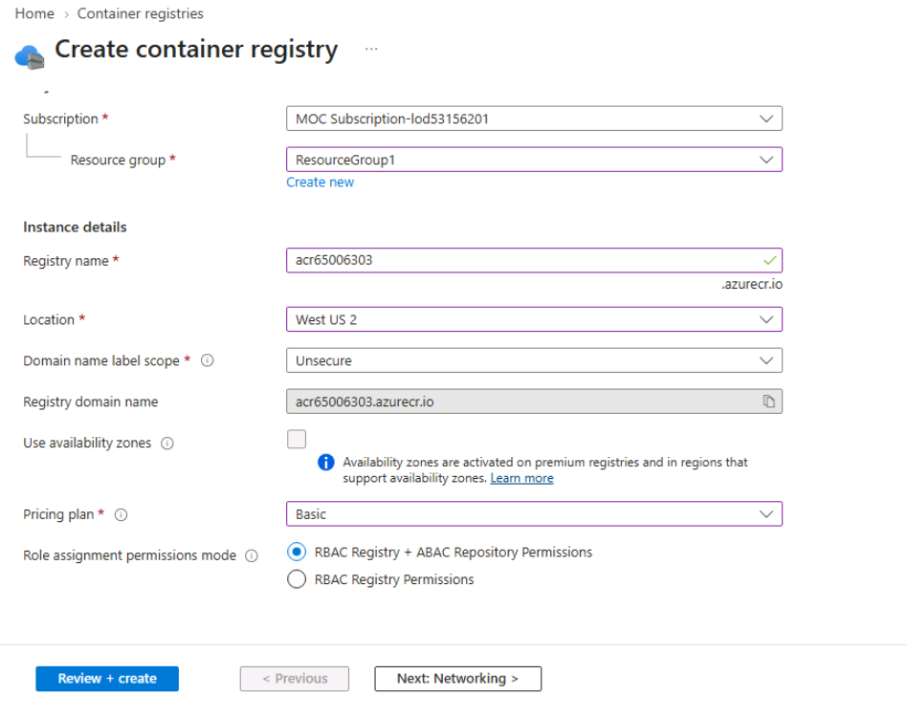
Figure – Open Create container registry
Step 2: Enter the ACR basic settings
Use the following values: Registry name = acr65006303, Location = West US 2, Domain name label scope = Unsecure, and Pricing plan = Basic. Leave Availability zones disabled.
Figure – Enter the ACR basic settings

ACR settings to verify
Setting | Value
Subscription | Your lab subscription
Resource group | ResourceGroup1
Registry name | acr65006303
Location | West US 2
Domain name label scope | Unsecure
Availability zones | Disabled
Pricing plan | Basic
Role assignment mode | RBAC Registry + ABAC Repository Permissions
Step 3: Review and create
Select Review + create. Wait for Validation passed. Then select Create. After deployment finishes, open the new registry.
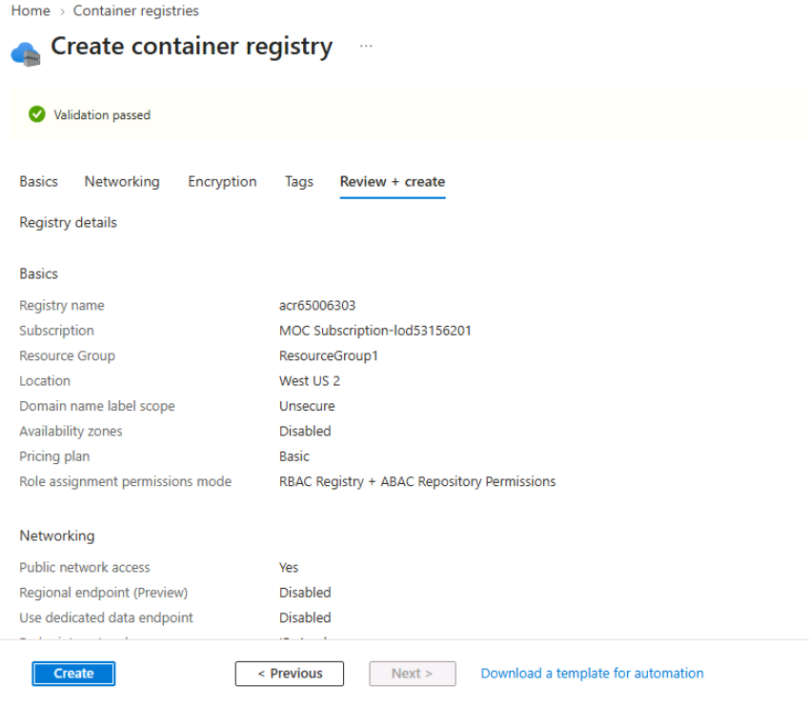
Figure – Review and create

Part 2 – Enable the ACR Admin User
The Admin user provides username/password credentials that can be used by a Web App or other client when the lab requires admin credentials.
Step 4: Open Access keys
Inside acr65006303, select Access keys under Settings. Turn on Admin user. Confirm that the Login server is acr65006303.azurecr.io.
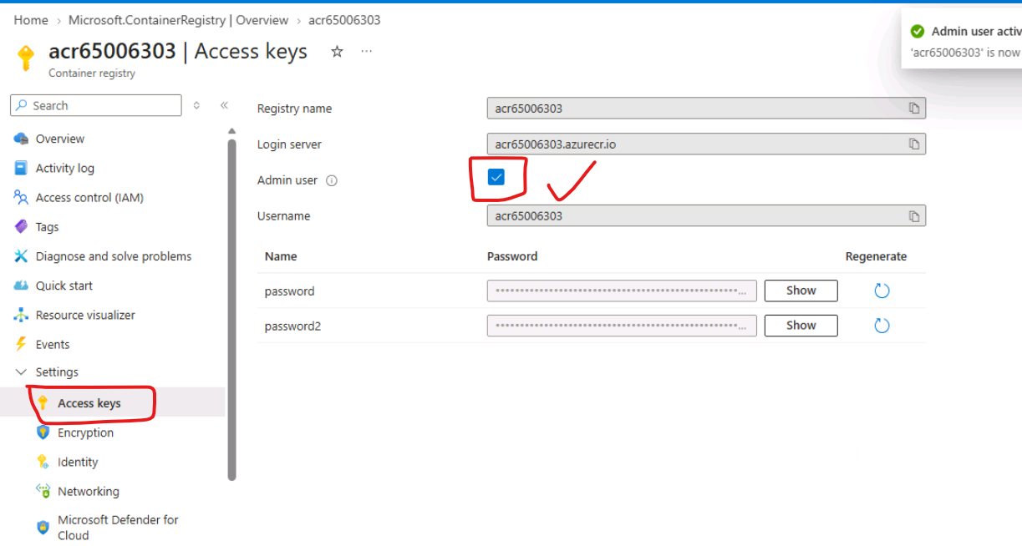
Figure – Open Access keys
Security note
Do not paste the ACR password into the lab document or chat. Treat it like a password and use it only where the Azure portal asks for credentials.

Part 3 – Import the Container Image into ACR
Instead of downloading the image locally and pushing it, Azure ACR can import an image directly from Docker Hub into the registry.
Step 5: Run the ACR import command
Open Azure Cloud Shell or a terminal where Azure CLI is logged in. Run the following command. This imports the Docker Hub image into ACR and stores it as az204:ecom.
Figure – Run the ACR import command
az acr import --name acr65006303 --source docker.io/bipeen2001/az204:ecom --image az204:ecom

After the command completes without an error, the image should be available in the registry as:
acr65006303.azurecr.io/az204:ecom

Part 4 – Configure ACR Role Assignment Mode
The lab changes the registry authentication/authorization mode to RBAC + ABAC Repository Permissions.
Step 6: Update the ACR role-assignment mode
Run this Azure CLI command. It changes the registry to RBAC + ABAC Repository Permissions.
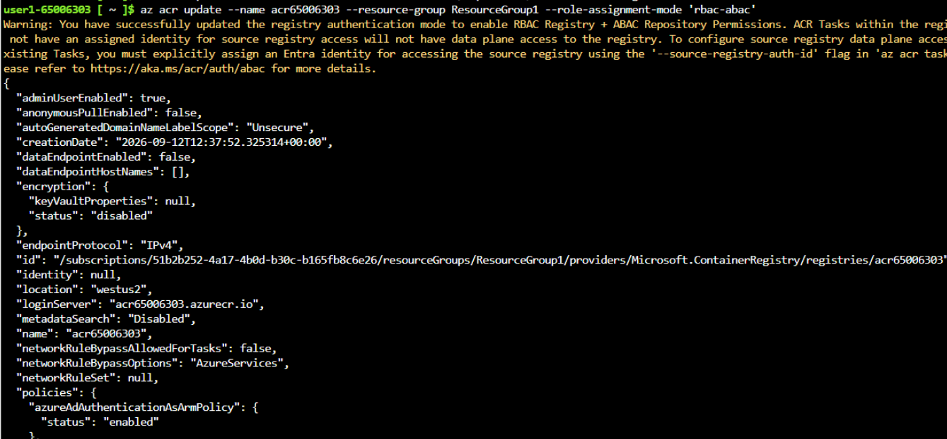
Figure – Update the ACR role-assignment mode
az acr update --name acr65006303 --resource-group ResourceGroup1 --role-assignment-mode 'rbac-abac'

Step 7: Verify the registry properties
In the ACR portal, open Properties and check the Role assignment permissions mode. The registry should show the RBAC/ABAC mode required by your lab. If your portal displays RBAC Registry Permissions instead, verify the setting before continuing.
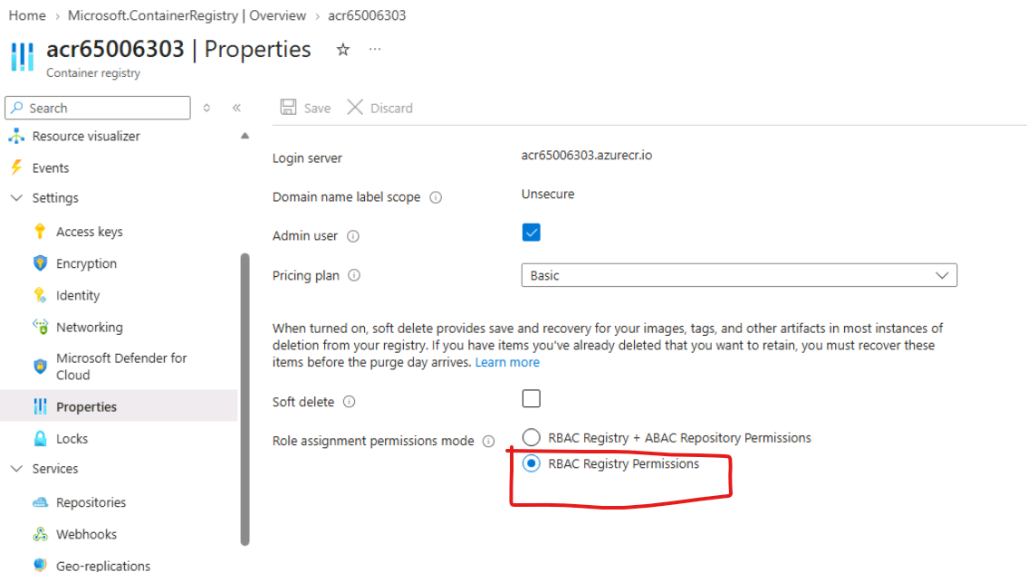
Figure – Verify the registry properties
If repository access is denied
If the Repositories page says that you do not have permission to list repositories, the issue is an RBAC/data-plane permission issue. The ACR itself may still be working correctly. Check the role assignments for your user before changing the registry again.

Part 5 – Create the Linux Web App
The Web App will run the container image stored in ACR. The lab policy requires a specially named App Service Plan, so pay close attention to the plan name.
Step 8: Start Create Web App
Open App Services and select Create → Web App. On Basics, choose the lab subscription and ResourceGroup1. Set Name to app-docprocessor-65006303. Select Container and Linux, and choose West US 2.
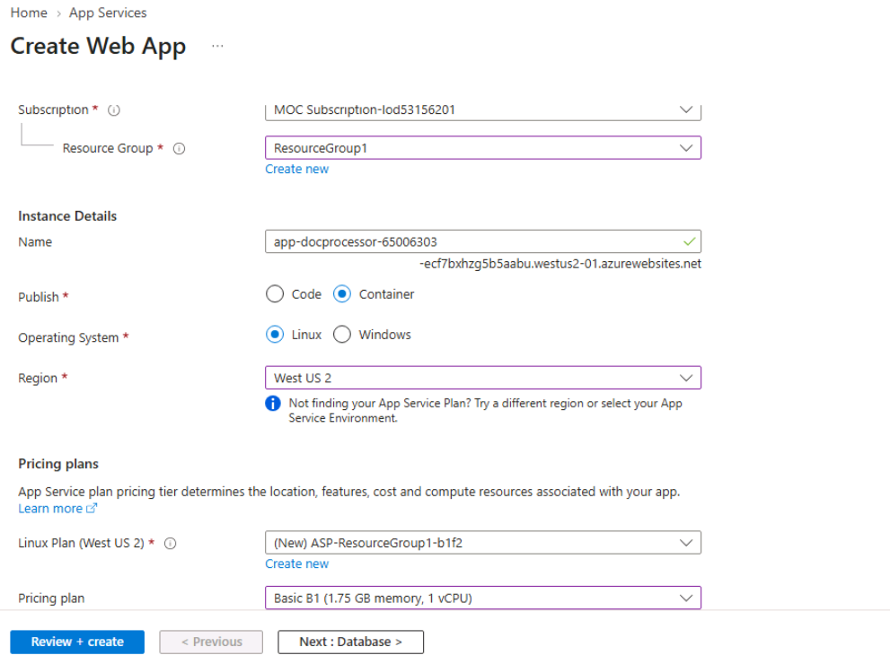
Figure – Start Create Web App

Create the correct App Service Plan
This is the most important policy-related step. The screenshot shows Azure proposing a default plan named ASP-ResourceGroup1-b1f2. That default name was rejected by the lab policy. Select Create new and use the required plan name.
App Service Plan name: plan-docprocessor-65006303
Pricing plan: Basic B1

Why this matters
The lab policy shown earlier allows App Service Plans whose name matches plan-docprocessor-........, uses B1, has capacity no greater than 1, and is in a non-global region. A default ASP-ResourceGroup1-xxxx plan can therefore fail policy validation.

Step 9: Configure the container
Open the Container tab. Select Azure Container Registry as the image source, choose registry acr65006303, select Admin credentials for authentication, then choose image az204 and tag ecom. Keep the port as 80. Leave Startup Command blank unless your application specifically requires one.
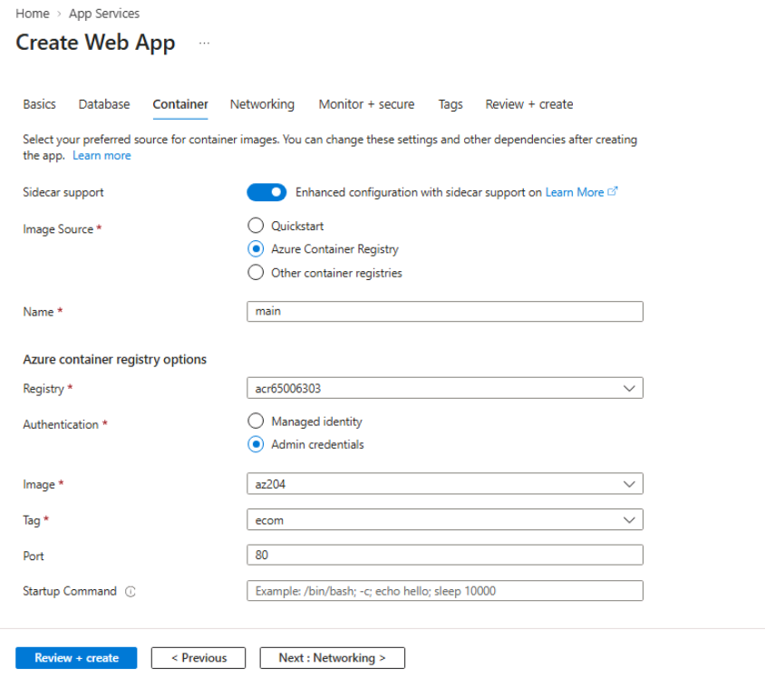
Figure – Configure the container

Container settings
Setting | Value
Image source | Azure Container Registry
Registry | acr65006303
Authentication | Admin credentials
Image | az204
Tag | ecom
Port | 80
Startup command | Leave blank unless required

Part 6 – Review and Create
Step 10: Review the Web App configuration
Select Review + create. Check the Web App name, App Service Plan name, B1 pricing plan, ACR name, image, tag, and port before selecting Create.
Figure – Review the Web App configuration

Final checklist
- ☐ Resource Group = ResourceGroup1
- ☐ ACR = acr65006303
- ☐ ACR location = West US 2
- ☐ ACR pricing = Basic
- ☐ ACR admin user enabled
- ☐ Image imported as az204:ecom
- ☐ App Service Plan name begins with plan-docprocessor-
- ☐ App Service Plan = Basic B1
- ☐ Web App = app-docprocessor-65006303
- ☐ Container source = Azure Container Registry
- ☐ Image = az204
- ☐ Tag = ecom
- ☐ Port = 80

Troubleshooting – Common Lab Errors
Validation failed when creating ACR — Check ResourceGroup1, ACR name beginning with acr, Basic SKU, and a real region such as West US 2. The screenshots show these values passing validation.
Resource 'ASP-ResourceGroup1-xxxx' was disallowed by policy — The App Service Plan name does not match the lab policy. Select Create new and use plan-docprocessor-65006303 with Basic B1.
You do not have permissions to list repositories — Check ACR role assignments. This is a permissions issue, not necessarily an image or registry creation problem.
Container image not visible in Web App — Confirm that the image was imported as az204:ecom and that the Web App Container tab selects registry acr65006303, image az204, and tag ecom.

Quick command reference
# Import image into ACR
az acr import --name acr65006303 --source docker.io/bipeen2001/az204:ecom --image az204:ecom
# Change ACR role assignment mode
az acr update --name acr65006303 --resource-group ResourceGroup1 --role-assignment-mode 'rbac-abac'
# Check ACR role-assignment mode
az acr show --name acr65006303 --resource-group ResourceGroup1 --query roleAssignmentMode -o tsv

Important note about the supplied script
This manual follows the values visible in the screenshots and the lab policy discussed in the session: Basic B1, plan-docprocessor-..., and image az204:ecom. If you are also running an earlier automation script, compare its generated plan SKU and image/tag with these lab-policy values before using it. Do not mix the script's values with the portal values without checking the policy.

End of Lab

