MICROSOFT AZURE HANDS-ON TRAINING LAB
MODULE 09
Process Messages with Azure Service Bus

Table of Contents
Lab Objective 4
What You Will Build 5
Current Lab vs. Future Extension 5
Architecture / Workflow 6
Why Use Azure Service Bus? 6
Prerequisites 8
Azure Resources Required 8
Lab Environment 9
Table of Contents 10
Step-by-Step Exercise 12
Step 1 — Install Python 12
Step 2 — Install Visual Studio Code and Create the Project Folder 12
Step 3 — Create a Python Virtual Environment 12
Step 4 — Create requirements.txt 13
Step 5 — Install the Python Packages 14
Step 6 — Open the Azure Portal and Search for Service Bus 14
Step 7 — Create the Service Bus Namespace 15
Step 8 — Create the AI Inference Queue 17
Step 9 — Get the Connection String 19
Step 10 — Create the .env File 20
Step 11 — Build the Flask Application (app.py) 21
The services/service_bus.py File 24
Step 12 — Build the Web Interface 27
Step 13 — Run the Flask Application 59
Test the Solution 61
Verify the Message in Azure Service Bus 63
Step 14 — Open Service Bus Explorer 63
Understand What Happened 64
What This Proves 64
“What should I see?” — Quick Reference 64
Troubleshooting 65
Lab Summary 66
Next Step / Extension 66

HANDS-ON LAB MANUAL
Build a simple AI Service Desk messaging workflow
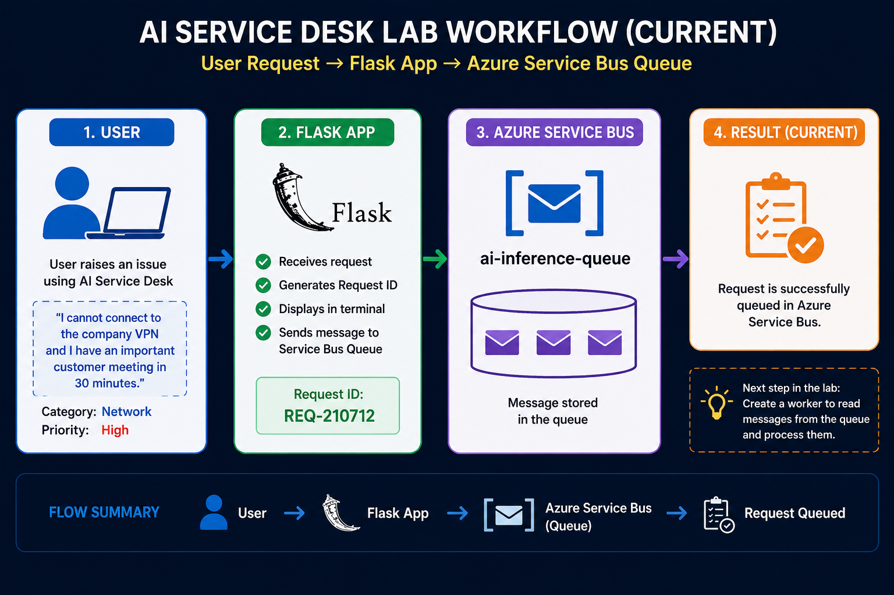
Technologies | Level | Environment
Azure Service Bus • Python Flask • Queue-based messaging | Beginner | Azure Portal + VS Code + Python

AI Service Desk • Decoupling Applications with Queue-Based Messaging

Lab Objective
AI applications often need to process requests asynchronously. Instead of sending an AI request directly to a processing component, an application can place the request into an Azure Service Bus queue.
In this lab, you will build a small Python Flask application that simulates an AI support-ticket workflow — the AI Service Desk. A user submits an issue, and the application sends that request into an Azure Service Bus queue.
By the end of this lab, you will be able to:
- Create an Azure Service Bus namespace
- Create a queue for AI inference requests
- Configure a Python Flask application
- Send an AI request from the web interface
- Send the request to Azure Service Bus
- Verify that the message reaches the queue
- Understand how a queue decouples the application from message processing

What You Will Build
The AI Service Desk lets a user describe a problem in plain language. The Flask web application receives that request and sends it into an Azure Service Bus queue, where it waits to be processed.
Figure 1 – The current lab workflow: a user request flows from the AI Service Desk through Flask into the Azure Service Bus queue.
⚠️ IMPORTANT
This lab implements the flow only up to the queue. The worker that reads and processes messages is a future exercise — it is not built in this lab.

Current Lab vs. Future Extension
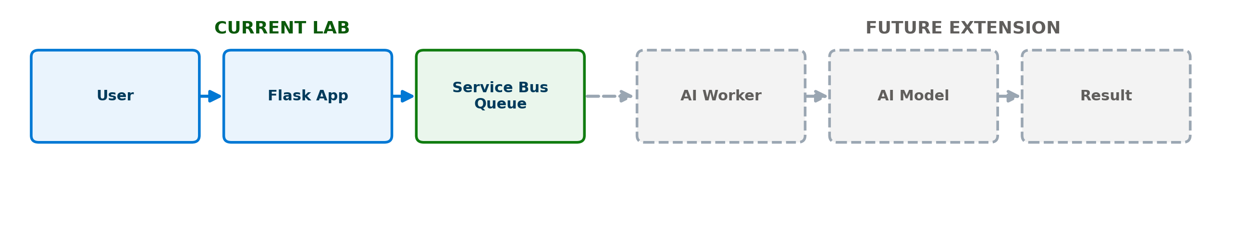
Figure 2 – What this lab builds (solid) compared to what comes next (dashed).
Scope | Flow
CURRENT LAB | User → Flask → Azure Service Bus Queue
FUTURE EXTENSION | Service Bus Queue → AI Worker → AI Model → Result

Architecture / Workflow
The diagram below shows the complete message flow this lab is part of — from the user's request all the way to a processed result. Steps 1–3 are what you build in this lab. Steps 4–5 (the AI Worker and the processed result) are a future extension.
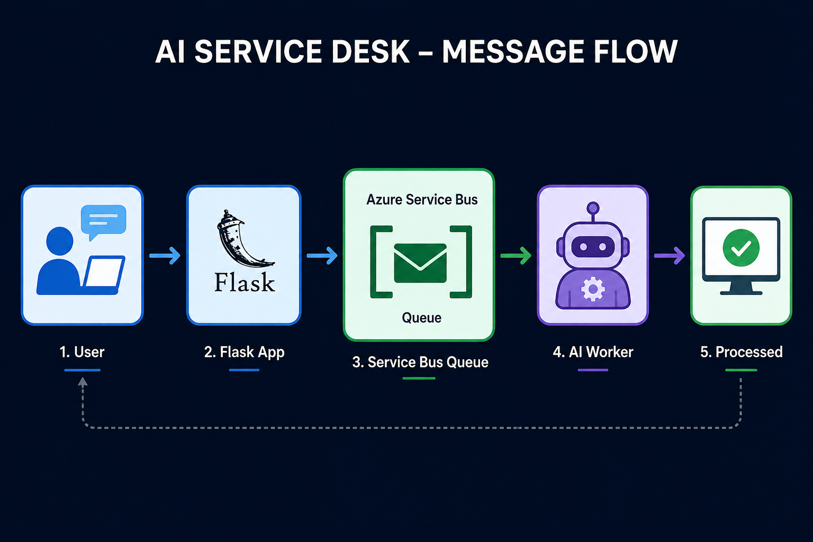
Figure 3 – AI Service Desk message flow, end to end.

Why Use Azure Service Bus?
Without a queue, the application would need to call the AI worker directly — which means the application depends on the worker being available right now. With Azure Service Bus, the application simply places the request in a queue and moves on. The queue holds the request safely until a worker is ready to process it.
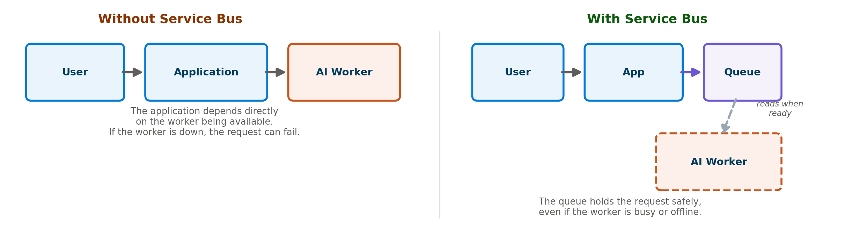
Figure 4 – Without Service Bus, the application depends directly on the worker. With Service Bus, the queue decouples them.
This provides:
- Decoupling — the web application and the AI worker don't need to run at the same time.
- Reliable message delivery — the message waits safely in the queue.
- Independent scaling — the application and the worker can scale separately.
- Better failure handling — if the worker is temporarily down, requests aren't lost.

Prerequisites
Before starting, make sure you have:
- An Azure subscription
- Azure Portal access
- Python installed (3.10 or later)
- Visual Studio Code (or another code editor)
- An Azure Service Bus namespace (created during this lab)
- Internet connectivity
- The provided Flask application files

Python packages used in this lab:
Package | Purpose
Flask | Simple web application
azure-servicebus | Communicate with Azure Service Bus
python-dotenv | Read configuration from .env

Azure Resources Required
Resource | Purpose | Name Used in This Lab
Azure Service Bus Namespace | Messaging infrastructure | ai200-sb-<unique>
Queue | Stores AI inference requests | ai-inference-queue
Flask Application | Accepts user requests and sends messages | app.py

💡 NOTE
Resource group used in this lab: rg-ai200-servicebus. Region: your selected Azure region. Pricing tier: Basic.

Lab Environment
This lab uses the following tools:
Tool | What It's For
Azure Portal | Create the Service Bus namespace and queue.
Visual Studio Code | Write and run the Python Flask application.
Python 3.10+ | Run the Flask application and send messages to Service Bus.
Terminal (VS Code) | Create a virtual environment, install packages, and run the app.

Project structure you will build:
ai-service-desk-ServiceBus/
│
├── app.py
├── .env
│
├── services/
│ └── service_bus.py
│
├── templates/
│ └── index.html
│
└── static/
├── css/
│ └── style.css
├── js/
│ └── app.js
└── images/
└── developer.png

Table of Contents
The list below updates automatically from the section headings in this document. In Microsoft Word, right-click anywhere in the list and select “Update Field” (or press F9) to refresh page numbers.
Lab Objective 1
What You Will Build 1
Current Lab vs. Future Extension 1
Architecture / Workflow 1
Why Use Azure Service Bus? 1
Prerequisites 1
Azure Resources Required 1
Lab Environment 1
Table of Contents 1
Step-by-Step Exercise 1
Step 1 — Install Python 1
Step 2 — Install Visual Studio Code and Create the Project Folder 1
Step 3 — Create a Python Virtual Environment 1
Step 4 — Create requirements.txt 1
Step 5 — Install the Python Packages 1
Step 6 — Open the Azure Portal and Search for Service Bus 1
Step 7 — Create the Service Bus Namespace 1
Step 8 — Create the AI Inference Queue 1
Step 9 — Get the Connection String 1
Step 10 — Create the .env File 1
Step 11 — Build the Flask Application (app.py) 1
The services/service_bus.py File 1
Step 12 — Build the Web Interface 1
Step 13 — Run the Flask Application 1
Test the Solution 1
Verify the Message in Azure Service Bus 1
Step 14 — Open Service Bus Explorer 1
Understand What Happened 1
What This Proves 1
“What should I see?” — Quick Reference 1
Troubleshooting 1
Lab Summary 1
Next Step / Extension 1

Step-by-Step Exercise
Follow each step in order. Every step tells you what you're doing, why it matters, exactly what to do, and what you should see when you're done.

Step 1 — Install Python
Objective: Make sure Python is installed and ready to use.
Instructions:
1. Install Python 3.10 or later.
2. Verify the installation by running the command below in a terminal.
python --version
Expected Result:
You should see something similar to:
Python 3.x.x

Step 2 — Install Visual Studio Code and Create the Project Folder
Objective: Set up your code editor and a working folder for the lab.
Instructions:
1. Install Visual Studio Code if it is not already installed.
2. Create a folder for the lab, for example: C:\AI200\ServiceBusLab
3. Open this folder in Visual Studio Code.
Expected Result: Visual Studio Code opens with your empty lab folder ready to use.

Step 3 — Create a Python Virtual Environment
Objective: Create an isolated Python environment for this project's packages.
Instructions:
Open the VS Code terminal and run:
py -m venv labenv
Screenshot:
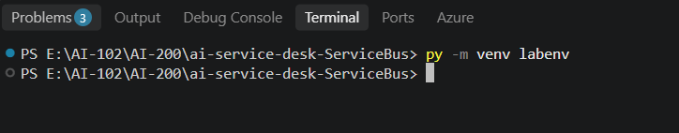
Figure 5 – Creating the virtual environment.
Activate it (Windows):
.\labenv\Scripts\Activate.ps1
Screenshot:
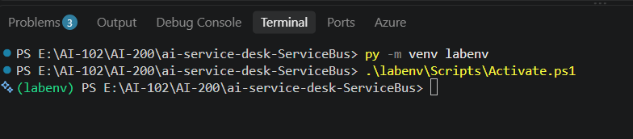
Figure 6 – Activating the virtual environment.
Expected Result: Your terminal prompt now shows (labenv) at the beginning of the line, confirming the virtual environment is active.

Step 4 — Create requirements.txt
Objective: List the Python packages this project needs.
Instructions:
1. In your project folder, create a file named requirements.txt.
2. Add the following lines and save the file.
Flask
azure-servicebus
python-dotenv

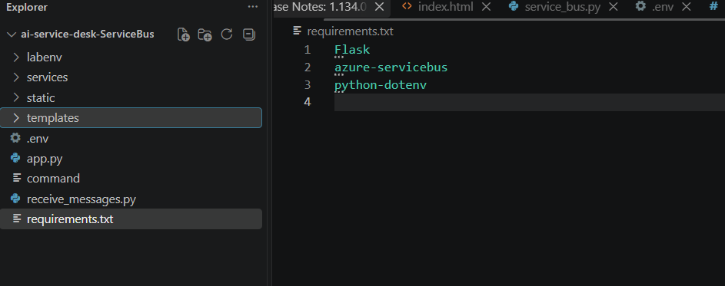
What these packages are for:
Package | Purpose
Flask | Simple web application
azure-servicebus | Communicate with Azure Service Bus
python-dotenv | Read configuration from .env

Step 5 — Install the Python Packages
Objective: Install Flask, azure-servicebus, and python-dotenv into your virtual environment.
Instructions:
Run:
pip install -r requirements.txt
Screenshot:
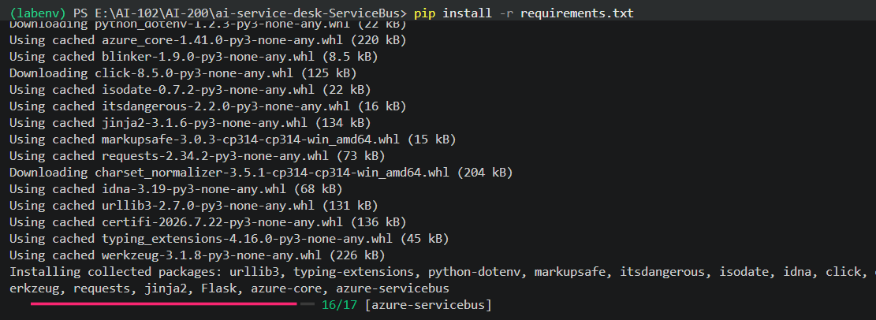
Figure 7 – Installing the required Python packages.
Expected Result: pip finishes without errors, and Flask, azure-servicebus, and python-dotenv are installed.

Step 6 — Open the Azure Portal and Search for Service Bus
Objective: Find the Service Bus service in the Azure Portal.
Instructions:
1. Open the Azure Portal.
2. In the search bar, search for: Service Bus
3. Select Create → Service Bus.
Screenshot:
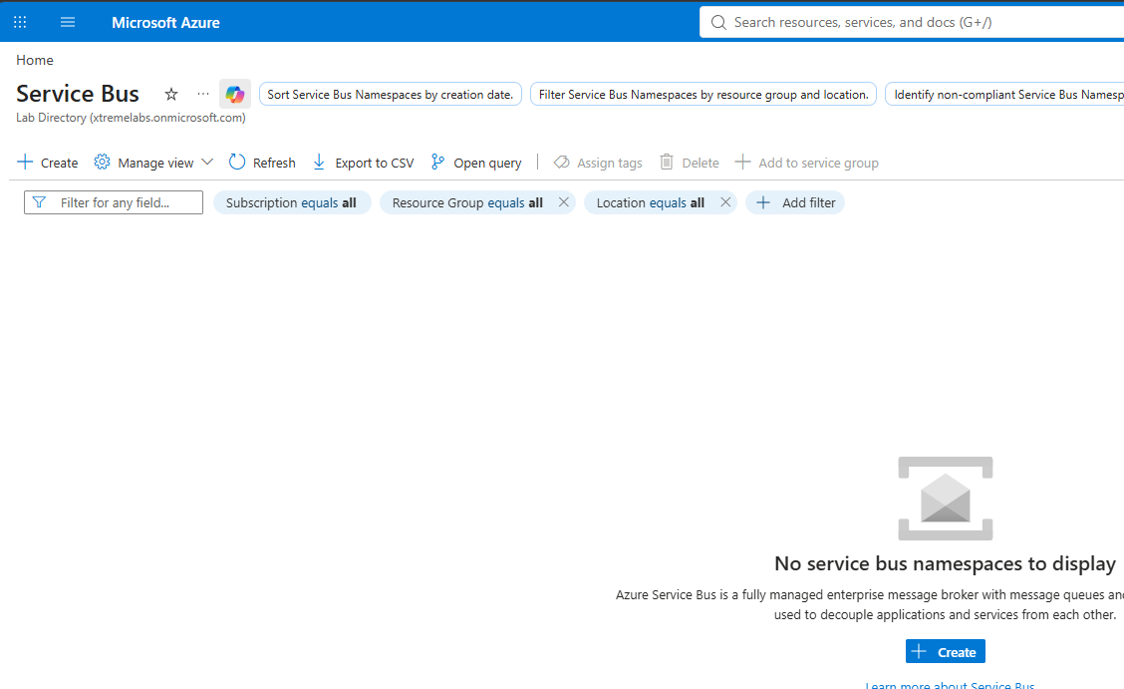
Figure 8 – Searching for Service Bus in the Azure Portal.
Expected Result: You see the Service Bus overview page with a Create option.

Step 7 — Create the Service Bus Namespace
Objective: Create the namespace that will host your queue.
Instructions:
Use the following settings:
Setting | Value
Subscription | Your subscription
Resource group | rg-ai200-servicebus
Namespace name | ai200-sb-<unique>
Region | Your selected Azure region
Pricing tier | Basic

1. Select Review + create.
2. Select Create.
3. Wait for deployment to complete.
Screenshot:
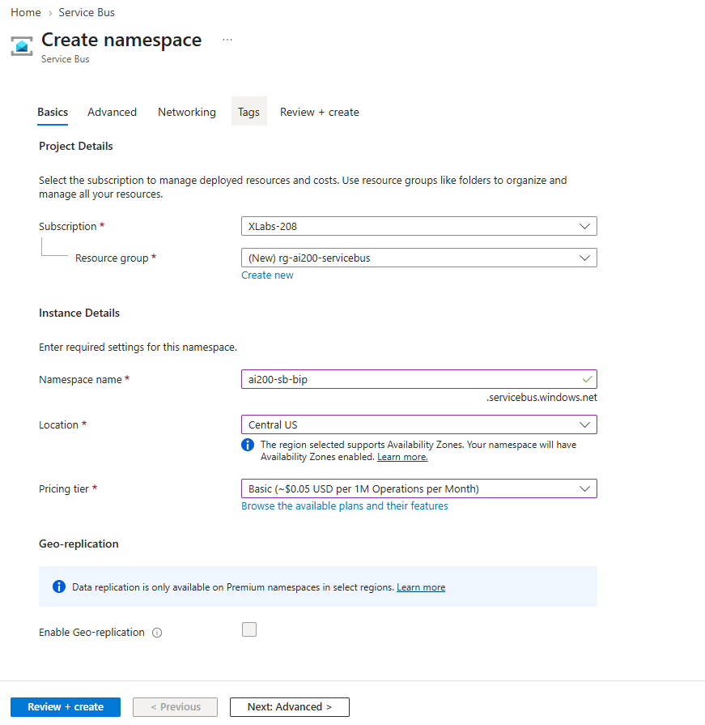
Figure 9 – Review + create — confirming the namespace settings before creating it.
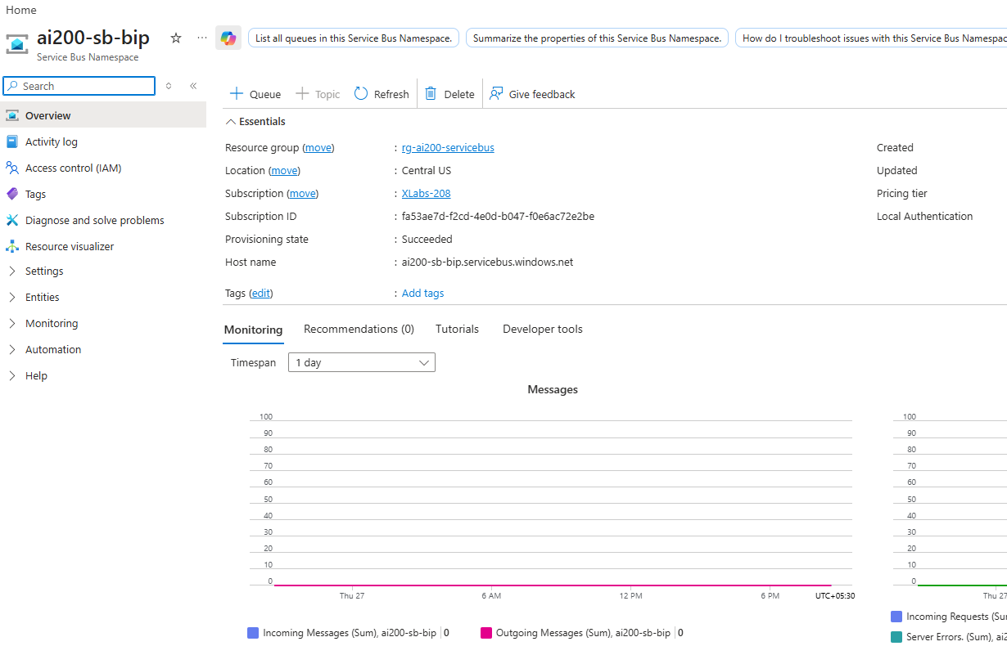
Figure 10 – The new Service Bus namespace after deployment completes.
Expected Result: Your Service Bus namespace is deployed and ready to use.

Step 8 — Create the AI Inference Queue
Objective: Create the queue that will store AI inference requests.
Instructions:
1. Open your Service Bus namespace.
2. Select Entities → Queues → + Queue.
Screenshot:
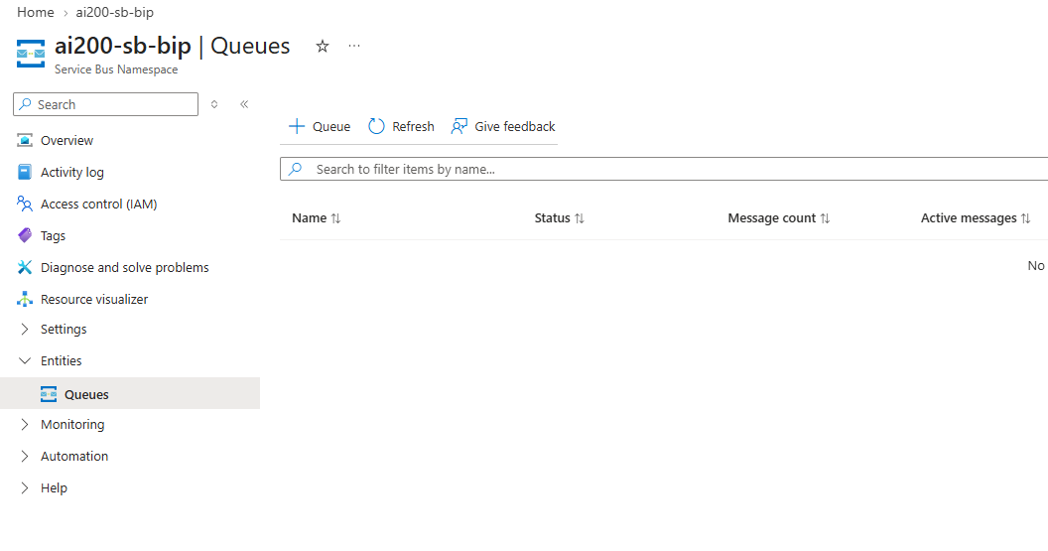
Figure 11 – Creating a new queue in the Service Bus namespace.
1. Enter the queue name: inference-requests
2. Select Create.
⚠️ IMPORTANT
Use the queue name exactly as configured in Azure. It must match the SERVICE_BUS_QUEUE_NAME value you'll set in your .env file later in this lab.

Screenshot:
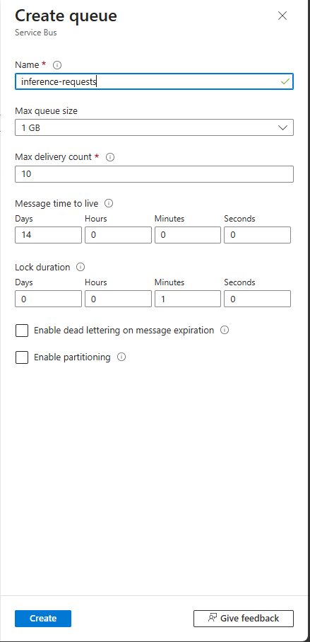
Figure 12 – The Create queue panel (enter your own queue name here).
You now have:
Service Bus Namespace
│
└── inference-requests
Screenshot:
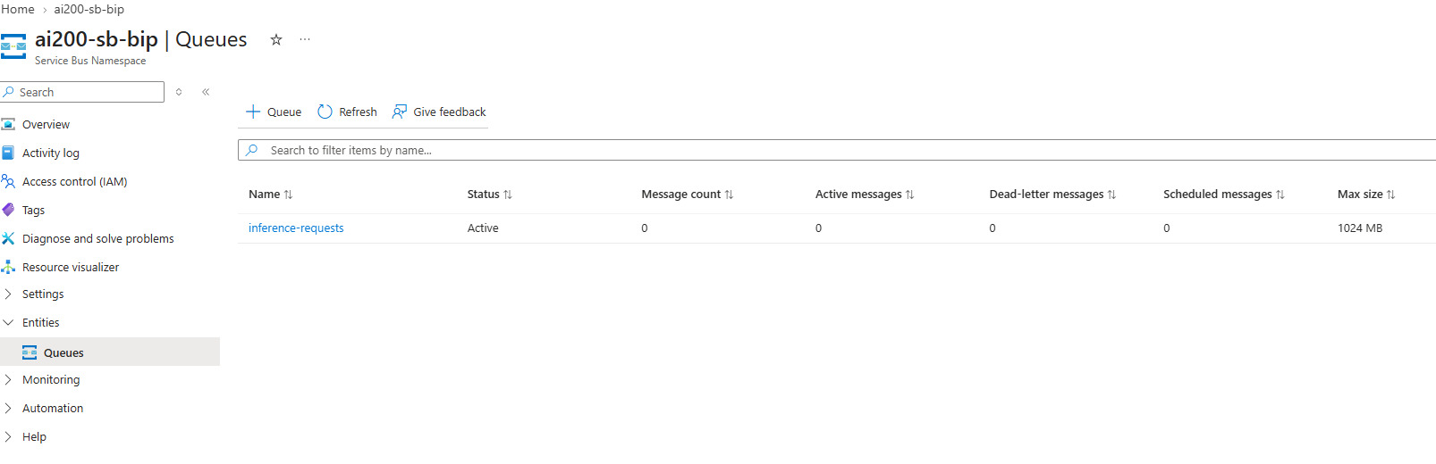
Figure 13 – The queue listed inside the Service Bus namespace.
Expected Result: Your queue appears in the Queues list with a status of Active.

Step 9 — Get the Connection String
Objective: Get the connection string your Flask application will use to reach Service Bus.
Instructions:
1. Inside the Service Bus namespace, select Settings → Shared access policies.
2. Select RootManageSharedAccessKey.
3. Copy the Primary Connection String.
Screenshot:
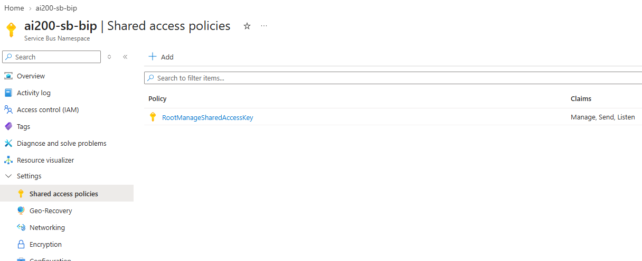
Figure 14 – Shared access policies for the namespace.
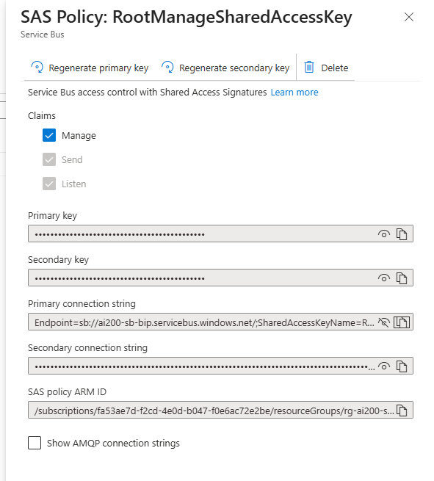
Figure 15 – Copying the Primary Connection String.
⚠️ IMPORTANT
Treat your connection string like a password. Never commit it to source control or share it publicly.

Expected Result: You have a connection string that starts with Endpoint=sb://... copied to your clipboard.

Step 10 — Create the .env File
Objective: Store your Service Bus configuration so the Flask app can read it.
Instructions:
1. In VS Code, create a file named .env in the project root.
2. Add the following, replacing the placeholder with your actual connection string.
SERVICE_BUS_CONNECTION_STRING="PASTE-YOUR-CONNECTION-STRING-HERE"
SERVICE_BUS_QUEUE_NAME="ai-inference-queue"
Screenshot:
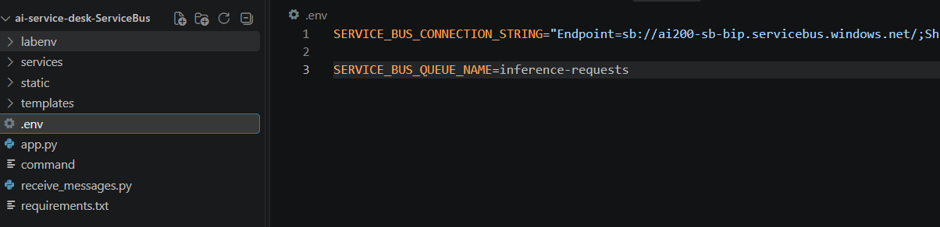
Figure 16 – The .env file with the Service Bus connection string and queue name.
Expected Result: Your .env file contains your real connection string and the exact queue name you created in Step 8.
💡 NOTE
python-dotenv reads this file automatically, so your code never has to hard-code secrets.

Step 11 — Build the Flask Application (app.py)
Objective: Create the Flask application that serves the web page and sends requests to Service Bus.
Instructions:
Create app.py in your project root and paste the following complete code:
from flask import Flask, render_template, request, jsonify
from datetime import datetime

# Azure Service Bus
from services.service_bus import send_message

app = Flask(__name__)

# --------------------------------------------------
# Home Page
# --------------------------------------------------
@app.route("/")
def dashboard():
return render_template("index.html")

# --------------------------------------------------
# Submit AI Request
# --------------------------------------------------
@app.route("/api/submit", methods=["POST"])
def submit_request():
data = request.get_json()
issue = data.get("issue", "")
category = data.get("category", "General")
priority = data.get("priority", "Medium")

# Basic validation
if not issue.strip():
return jsonify({
"success": False,
"message": "Please describe your issue."
}), 400

# Create Request ID
request_id = "REQ-" + datetime.now().strftime("%H%M%S")

# Display request in terminal
print("\n===================================")
print("AI INFERENCE REQUEST")
print("===================================")
print("Request ID :", request_id)
print("Issue :", issue)
print("Category :", category)
print("Priority :", priority)
print("===================================")

# Send request to Azure Service Bus
try:
send_message(
request_id=request_id,
issue=issue,
category=category,
priority=priority
)
print("Status : Message sent to Service Bus")
print("===================================\n")
return jsonify({
"success": True,
"requestId": request_id,
"message": "AI request sent to Azure Service Bus.",
"status": "Queued"
})
except Exception as e:
print("\nERROR: Unable to send message")
print(e)
print("===================================\n")
return jsonify({
"success": False,
"message": "Unable to send request to Azure Service Bus.",
"error": str(e)
}), 500

# --------------------------------------------------
# Run Flask Application
# --------------------------------------------------
if __name__ == "__main__":
app.run(
host="127.0.0.1",
port=8000,
debug=True
)
💡 NOTE
submit_request() does three things: it validates the issue text, creates a Request ID, and calls send_message() to hand the request to Azure Service Bus.

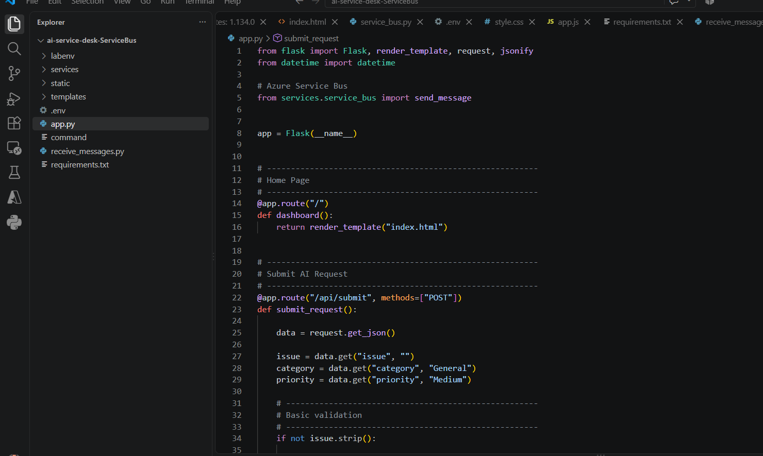

The services/service_bus.py File
app.py imports a send_message() function from services/service_bus.py. This file is responsible for actually connecting to Azure Service Bus and sending the message.
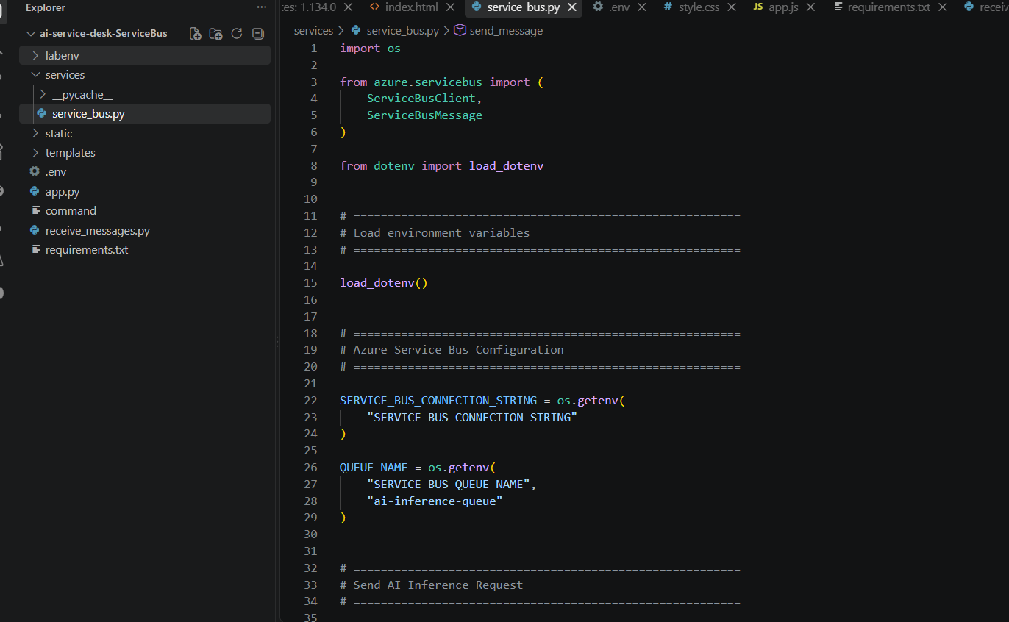
import os

from azure.servicebus import (
ServiceBusClient,
ServiceBusMessage
)

from dotenv import load_dotenv

# =========================================================
# Load environment variables
# =========================================================

load_dotenv()

# =========================================================
# Azure Service Bus Configuration
# =========================================================

SERVICE_BUS_CONNECTION_STRING = os.getenv(
"SERVICE_BUS_CONNECTION_STRING"
)

QUEUE_NAME = os.getenv(
"SERVICE_BUS_QUEUE_NAME",
"ai-inference-queue"
)

# =========================================================
# Send AI Inference Request
# =========================================================

def send_message(
request_id,
issue,
category,
priority
):

# Create the message body

message_body = {

"requestId": request_id,

"issue": issue,

"category": category,

"priority": priority

}

# Convert dictionary to JSON

import json

message_json = json.dumps(
message_body
)

# Create Service Bus client

with ServiceBusClient.from_connection_string(
conn_str=SERVICE_BUS_CONNECTION_STRING
) as client:

# Create queue sender

with client.get_queue_sender(
queue_name=QUEUE_NAME
) as sender:

# Create Service Bus message

message = ServiceBusMessage(
message_json
)

# Send message

sender.send_messages(
message
)

print(
f"Message sent successfully: {request_id}"
)

return True

Step 12 — Build the Web Interface
Objective: Create the page the user fills in to submit an AI request.
Instructions:
- Create templates/index.html — the AI Service Desk page (form fields, sidebar, activity feed).
S
<!DOCTYPE html>
<html lang="en">
<head>
<meta charset="UTF-8">
<meta name="viewport" content="width=device-width, initial-scale=1.0">

<title>AI Service Desk</title>
<link rel="stylesheet" href="{{ url_for('static', filename='css/style.css') }}">
</head>

<body>

<!-- =====================================================
HEADER
===================================================== -->

<header>

<div class="logo-area">

<div class="logo">
🤖
</div>

<div class="brand">
<h1>
ENTERPRISE
<span>AI SERVICE DESK</span>
</h1>

<p>
AI Inference Request Portal
</p>
</div>

</div>

<div class="profile">

<img
class="developer-photo"
src="{{ url_for('static', filename='images/developer.png') }}"
alt="Bipeen Sinha"
>

<div class="profile-text">
<strong>Bipeen Sinha</strong>
<small>AI/ML Architect</small>
</div>

</div>

</header>

<div class="layout">

<!-- =====================================================
SIDEBAR
===================================================== -->

<aside class="sidebar">

<div class="menu-item active">
🏠 &nbsp; Dashboard
</div>

<div class="menu-item">
💬 &nbsp; New Request
</div>

<div class="menu-item">
📋 &nbsp; My Requests
</div>

<div class="menu-item">
⚡ &nbsp; Activity
</div>

<div class="menu-item">
📚 &nbsp; Knowledge Base
</div>

<div class="menu-item">
📊 &nbsp; Reports
</div>

<div class="menu-item">
⚙️ &nbsp; Settings
</div>

<div class="ai-card">

<div class="ai-circle">
AI
</div>

<h3>AI Powered</h3>

<p>Smarter Support</p>
<p>Faster Resolution</p>
<p>Better Experience</p>

</div>

</aside>

<!-- =====================================================
MAIN CONTENT
===================================================== -->

<main class="main">

<div class="top-status">

<div class="online">
<span class="online-dot"></span>
System Online
</div>

</div>

<div class="content">

<!-- =====================================================
LEFT SIDE
===================================================== -->

<div>

<!-- REQUEST FORM -->

<section class="card">

<h2>Create AI Inference Request</h2>

<p class="subtitle">
Describe your issue or question
</p>

<label for="issue">
Describe your issue *
</label>

<textarea
id="issue"
placeholder="Example: My laptop battery is draining very quickly."
></textarea>

<div class="form-row">

<div>

<label for="category">
Category
</label>

<select id="category">

<option>Hardware</option>
<option>Network</option>
<option>Identity</option>
<option>Software</option>

</select>

</div>

<div>

<label for="priority">
Priority
</label>

<select id="priority">

<option>High</option>
<option>Medium</option>
<option>Low</option>

</select>

</div>

</div>

<div class="submit-area">

<button id="submitButton" onclick="submitRequest()">
➤ Submit Request
</button>

</div>

<div id="message"></div>

</section>

<!-- WORKFLOW -->

<section class="card">

<h2>AI Agent Workflow</h2>

<p class="subtitle">
Real-time status of your request
</p>

<div class="workflow">

<div class="step active" id="step1">

<div class="step-number">1</div>

<div class="step-icon">
📤
</div>

<h3>Request Received</h3>

<p>
Request submitted
</p>

<span class="status" id="status1">
Waiting
</span>

</div>

<div class="step" id="step2">

<div class="step-number">2</div>

<div class="step-icon">
📋
</div>

<h3>Queued in Service Bus</h3>

<p>
Request added to queue
</p>

<span class="status" id="status2">
Waiting
</span>

</div>

<div class="step" id="step3">

<div class="step-number">3</div>

<div class="step-icon">
⚙️
</div>

<h3>AI Processing</h3>

<p>
AI analyzes request
</p>

<span class="status" id="status3">
Waiting
</span>

</div>

<div class="step" id="step4">

<div class="step-number">4</div>

<div class="step-icon">
✓
</div>

<h3>Resolution Ready</h3>

<p>
Result available
</p>

<span class="status" id="status4">
Waiting
</span>

</div>

</div>

</section>

</div>

<!-- =====================================================
ACTIVITY FEED
===================================================== -->

<section class="card activity">

<h2>Activity Feed</h2>

<p class="subtitle">
Live activity
</p>

<div id="activityFeed">

<div class="activity-item">

<div class="activity-icon">
ℹ️
</div>

<div class="activity-text">

<strong>System Ready</strong>

<p>
Waiting for an AI request
</p>

<time>
Now
</time>

</div>

</div>

</div>

</section>

</div>

</div>

</main>

<!-- =====================================================
JAVASCRIPT
===================================================== -->

<script src="{{ url_for('static', filename='js/app.js') }}"></script>

</body>
</html>

- Create static/css/style.css — the page styling.
S
/* =========================================================
AI SERVICE DESK
Enterprise Dark Dashboard
========================================================= */

* {
box-sizing: border-box;
margin: 0;
padding: 0;
}

body {
font-family: Arial, Helvetica, sans-serif;
background: #03132d;
color: white;
min-height: 100vh;
}

/* =========================================================
HEADER
========================================================= */

header {
height: 90px;
background: #041a38;
border-bottom: 1px solid #123b6b;

display: flex;
align-items: center;
justify-content: space-between;

padding: 0 35px;
}

.logo-area {
display: flex;
align-items: center;
gap: 18px;
}

.logo {
width: 55px;
height: 55px;

border-radius: 15px;
background: #087cf0;

display: flex;
align-items: center;
justify-content: center;

font-size: 28px;
}

.brand h1 {
font-size: 25px;
color: #ffffff;
}

.brand h1 span {
color: #19a7ff;
}

.brand p {
color: #8ca8c8;
font-size: 12px;
margin-top: 4px;
}

/* =========================================================
PROFILE
========================================================= */

.profile {
display: flex;
align-items: center;
gap: 12px;
}

.avatar {
width: 48px;
height: 48px;

border-radius: 50%;

background: linear-gradient(
135deg,
#08a9ff,
#713cff
);

display: flex;
align-items: center;
justify-content: center;

font-weight: bold;
}

.profile-text strong {
display: block;
}

.profile-text small {
color: #8ca8c8;
}

/* =========================================================
MAIN LAYOUT
========================================================= */

.layout {
display: flex;
min-height: calc(100vh - 90px);
}

/* =========================================================
SIDEBAR
========================================================= */

.sidebar {
width: 210px;

background: #021127;

padding: 25px 15px;

border-right: 1px solid #10335b;
}

.menu-item {
padding: 14px 15px;

margin-bottom: 8px;

border-radius: 9px;

color: #a9bfd8;

cursor: pointer;
}

.menu-item:hover,
.menu-item.active {
background: #073365;
color: white;
}

/* =========================================================
AI CARD
========================================================= */

.ai-card {
margin-top: 40px;

padding: 20px;

border: 1px solid #164678;

border-radius: 14px;

text-align: center;

background: #041b39;
}

.ai-circle {
width: 55px;
height: 55px;

border-radius: 50%;

background: #063d77;

margin: auto;

display: flex;
align-items: center;
justify-content: center;

font-size: 22px;

color: #18a8ff;
}

.ai-card h3 {
margin-top: 12px;
color: #16a9ff;
}

.ai-card p {
font-size: 12px;

color: #91a9c5;

margin-top: 6px;
}

/* =========================================================
MAIN CONTENT
========================================================= */

.main {
flex: 1;

padding: 28px;
}

.top-status {
display: flex;
justify-content: flex-end;

margin-bottom: 15px;
}

.online {
background: #06332f;

border: 1px solid #087d6d;

padding: 8px 15px;

border-radius: 20px;

color: #35e6b3;

font-size: 12px;
}

.online-dot {
display: inline-block;

width: 8px;
height: 8px;

background: #19dc9b;

border-radius: 50%;

margin-right: 6px;
}

/* =========================================================
CONTENT GRID
========================================================= */

.content {
display: grid;

grid-template-columns: 1fr 330px;

gap: 22px;
}

/* =========================================================
CARD
========================================================= */

.card {
background: #041a38;

border: 1px solid #123d6c;

border-radius: 14px;

padding: 22px;

margin-bottom: 20px;
}

.card h2 {
font-size: 20px;

margin-bottom: 7px;
}

.subtitle {
color: #8fa9c6;

font-size: 13px;

margin-bottom: 20px;
}

/* =========================================================
FORM
========================================================= */

label {
display: block;

font-size: 13px;

margin-bottom: 8px;
}

textarea,
select,
input {
width: 100%;

background: #02132b;

border: 1px solid #18528a;

border-radius: 8px;

padding: 13px;

color: white;

outline: none;
}

textarea {
height: 90px;

resize: none;
}

textarea:focus,
select:focus,
input:focus {
border-color: #13a8ff;
}

.form-row {
display: grid;

grid-template-columns: 1fr 1fr;

gap: 18px;

margin-top: 18px;
}

/* =========================================================
SUBMIT BUTTON
========================================================= */

.submit-area {
text-align: right;

margin-top: 18px;
}

button {
border: none;

background: linear-gradient(
135deg,
#087cff,
#168eff
);

color: white;

padding: 13px 28px;

border-radius: 8px;

cursor: pointer;

font-weight: bold;

font-size: 14px;
}

button:hover {
background: #159cff;
}

button:disabled {
background: #35516e;

cursor: not-allowed;
}

/* =========================================================
AI AGENT WORKFLOW
========================================================= */

.workflow {
display: grid;

grid-template-columns:
repeat(4, 1fr);

gap: 12px;
}

.step {
background: #061d3b;

border: 1px solid #173e68;

border-radius: 12px;

padding: 18px 10px;

text-align: center;
}

.step.active {
border-color: #7d3cff;

box-shadow:
0 0 15px
rgba(125, 60, 255, 0.3);
}

.step.completed {
border-color: #08b989;
}

.step-number {
width: 30px;
height: 30px;

border-radius: 50%;

background: #12365e;

margin: auto auto 12px;

display: flex;
align-items: center;
justify-content: center;
}

.step-icon {
font-size: 25px;

margin-bottom: 10px;
}

.step h3 {
font-size: 13px;
}

.step p {
color: #829bb7;

font-size: 11px;

margin-top: 7px;

min-height: 28px;
}

/* =========================================================
STATUS BADGES
========================================================= */

.status {
display: inline-block;

margin-top: 12px;

padding: 5px 10px;

border-radius: 15px;

font-size: 10px;

background: #182c45;

color: #9bb1ca;
}

.status.processing {
background: #093e73;

color: #31b8ff;
}

.status.done {
background: #073e35;

color: #31e3ae;
}

/* =========================================================
ACTIVITY FEED
========================================================= */

.activity {
height: 100%;
}

.activity-item {
display: flex;

gap: 12px;

padding: 17px 0;

border-bottom: 1px solid #123354;
}

.activity-icon {
width: 32px;
height: 32px;

min-width: 32px;

border-radius: 50%;

background: #073c70;

display: flex;
align-items: center;
justify-content: center;
}

.activity-text strong {
display: block;

font-size: 13px;
}

.activity-text p {
color: #829ab5;

font-size: 11px;

margin-top: 5px;
}

.activity-text time {
color: #55718e;

font-size: 10px;

display: block;

margin-top: 5px;
}

/* =========================================================
SUCCESS / ERROR MESSAGE
========================================================= */

#message {
display: none;

margin-top: 15px;

padding: 12px;

border-radius: 8px;

background: #073e35;

color: #3be0ae;

font-size: 13px;
}

/* =========================================================
RESPONSIVE DESIGN
========================================================= */

@media (max-width: 1000px) {

.sidebar {
width: 170px;
}

.content {
grid-template-columns: 1fr;
}

.activity {
height: auto;
}
}

@media (max-width: 700px) {

.sidebar {
display: none;
}

.workflow {
grid-template-columns: 1fr 1fr;
}

.form-row {
grid-template-columns: 1fr;
}

header {
padding: 0 15px;
}

.profile-text {
display: none;
}
}

/* ================= DEVELOPER PROFILE ================= */

.developer-photo {
width: 58px;
height: 58px;
border-radius: 50%;
object-fit: cover;
object-position: center top;
border: 2px solid #19a7ff;
box-shadow: 0 0 14px rgba(25, 167, 255, 0.35);
}

.profile-text strong {
color: #ffffff;
font-size: 14px;
}

.profile-text small {
display: block;
color: #19a7ff;
font-size: 11px;
margin-top: 3px;
font-weight: 600;
}

@media (max-width: 700px) {
.developer-photo {
width: 46px;
height: 46px;
}
}

- Create static/js/app.js — the logic that submits the form to Flask.
S
// =========================================================
// AI SERVICE DESK
// Frontend JavaScript
// =========================================================

// =========================================================
// SUBMIT AI INFERENCE REQUEST
// =========================================================

function submitRequest() {

const issue =
document.getElementById("issue").value;

const category =
document.getElementById("category").value;

const priority =
document.getElementById("priority").value;

const button =
document.getElementById("submitButton");

const message =
document.getElementById("message");

// -----------------------------------------------------
// Validate user input
// -----------------------------------------------------

if (issue.trim() === "") {

message.style.display = "block";

message.style.background = "#4b1e2b";

message.style.color = "#ff8095";

message.innerText =
"Please describe your issue.";

return;
}

// -----------------------------------------------------
// Disable button while request is being submitted
// -----------------------------------------------------

button.disabled = true;

button.innerText =
"Submitting...";

// -----------------------------------------------------
// Send request to Flask
// -----------------------------------------------------

fetch("/api/submit", {

method: "POST",

headers: {
"Content-Type": "application/json"
},

body: JSON.stringify({

issue: issue,

category: category,

priority: priority

})

})

// -----------------------------------------------------
// Read Flask response
// -----------------------------------------------------

.then(response => {

if (!response.ok) {
throw new Error(
"Request failed"
);
}

return response.json();

})

// -----------------------------------------------------
// Process response
// -----------------------------------------------------

.then(data => {

if (data.success) {

message.style.display = "block";

message.style.background =
"#073e35";

message.style.color =
"#3be0ae";

message.innerText =
"✓ Request " +
data.requestId +
" submitted successfully!";

// Update the demo workflow

updateWorkflow();

// Add activity message

addActivity(
"📤",
"Request Submitted",
"New AI inference request received"
);

}

})

// -----------------------------------------------------
// Handle errors
// -----------------------------------------------------

.catch(error => {

console.error(error);

message.style.display = "block";

message.style.background =
"#4b1e2b";

message.style.color =
"#ff8095";

message.innerText =
"Unable to submit request.";

})

// -----------------------------------------------------
// Enable button again
// -----------------------------------------------------

.finally(() => {

button.disabled = false;

button.innerText =
"➤ Submit Request";

});

}

// =========================================================
// UPDATE AI AGENT WORKFLOW
// =========================================================

function updateWorkflow() {

// -----------------------------------------------------
// STEP 1
// Request Received
// -----------------------------------------------------

setStep(
"step1",
"status1",
"Completed",
"done"
);

// -----------------------------------------------------
// STEP 2
// Service Bus Queue
// -----------------------------------------------------

setTimeout(() => {

setStep(
"step2",
"status2",
"In Progress",
"processing"
);

addActivity(
"📋",
"Queued in Service Bus",
"Request added to inference queue"
);

}, 1000);

// -----------------------------------------------------
// STEP 3
// AI Processing
// -----------------------------------------------------

setTimeout(() => {

setStep(
"step2",
"status2",
"Completed",
"done"
);

setStep(
"step3",
"status3",
"In Progress",
"processing"
);

addActivity(
"⚙️",
"AI Processing Started",
"AI inference is processing the request"
);

}, 2500);

// -----------------------------------------------------
// STEP 4
// Resolution Ready
// -----------------------------------------------------

setTimeout(() => {

setStep(
"step3",
"status3",
"Completed",
"done"
);

setStep(
"step4",
"status4",
"Completed",
"done"
);

addActivity(
"✓",
"Resolution Ready",
"AI processing completed"
);

}, 4500);

}

// =========================================================
// UPDATE INDIVIDUAL WORKFLOW STEP
// =========================================================

function setStep(
stepId,
statusId,
text,
className
) {

const step =
document.getElementById(stepId);

const status =
document.getElementById(statusId);

// Remove previous state

step.classList.remove(
"active",
"completed"
);

// Update status badge

status.className =
"status " + className;

status.innerText =
text;

// Apply new state

if (className === "done") {

step.classList.add(
"completed"
);

}
else {

step.classList.add(
"active"
);

}

}

// =========================================================
// ADD ACTIVITY FEED MESSAGE
// =========================================================

function addActivity(
icon,
title,
description
) {

const feed =
document.getElementById(
"activityFeed"
);

const item =
document.createElement("div");

item.className =
"activity-item";

// Current time

const time =
new Date().toLocaleTimeString();

// Create activity HTML

item.innerHTML = `

<div class="activity-icon">
${icon}
</div>

<div class="activity-text">

<strong>
${title}
</strong>

<p>
${description}
</p>

<time>
${time}
</time>

</div>

`;

// Add newest activity at the top

feed.prepend(item);

}

4. Add your logo and profile images to static/images/.
The important part of index.html for this lab is the request form: a textarea for the issue, and dropdowns for category and priority.
<textarea id="issue" placeholder="Describe your issue or question"></textarea>

<select id="category">
<option>Network</option>
<option>Hardware</option>
<option>Identity</option>
<option>Software</option>
</select>

<select id="priority">
<option>Low</option>
<option>Medium</option>
<option>High</option>
</select>

<button id="submitButton" onclick="submitRequest()">Submit Request</button>
💡 NOTE
The rest of index.html (header, sidebar, Activity Feed) is starter UI styling and isn't specific to Service Bus — it's provided so the lab looks like a real application.

app.js reads those three fields and sends them to Flask's /api/submit endpoint:
function submitRequest() {
const issue = document.getElementById("issue").value;
const category = document.getElementById("category").value;
const priority = document.getElementById("priority").value;

fetch("/api/submit", {
method: "POST",
headers: { "Content-Type": "application/json" },
body: JSON.stringify({ issue, category, priority })
})
.then(res => res.json())
.then(data => {
// Show the result (Request ID, success message) to the user
});
}
Screenshot:
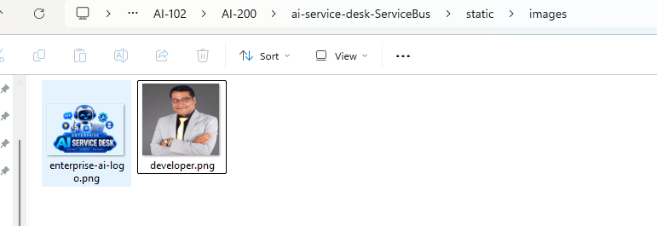
Figure 17 – The logo and profile image used in the interface.
Expected Result: Your project has a working templates/index.html, static/css/style.css, and static/js/app.js.

Step 13 — Run the Flask Application
Objective: Start the Flask application and open it in a browser.
Instructions:
In the terminal, run:
py app.py
Screenshot:
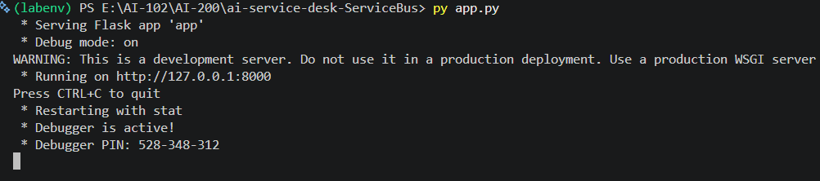
Figure 18 – Flask starting up.
Expected Result: You should see something similar to:
Running on http://127.0.0.1:8000
Open that address in your browser:
http://127.0.0.1:8000
Screenshot:
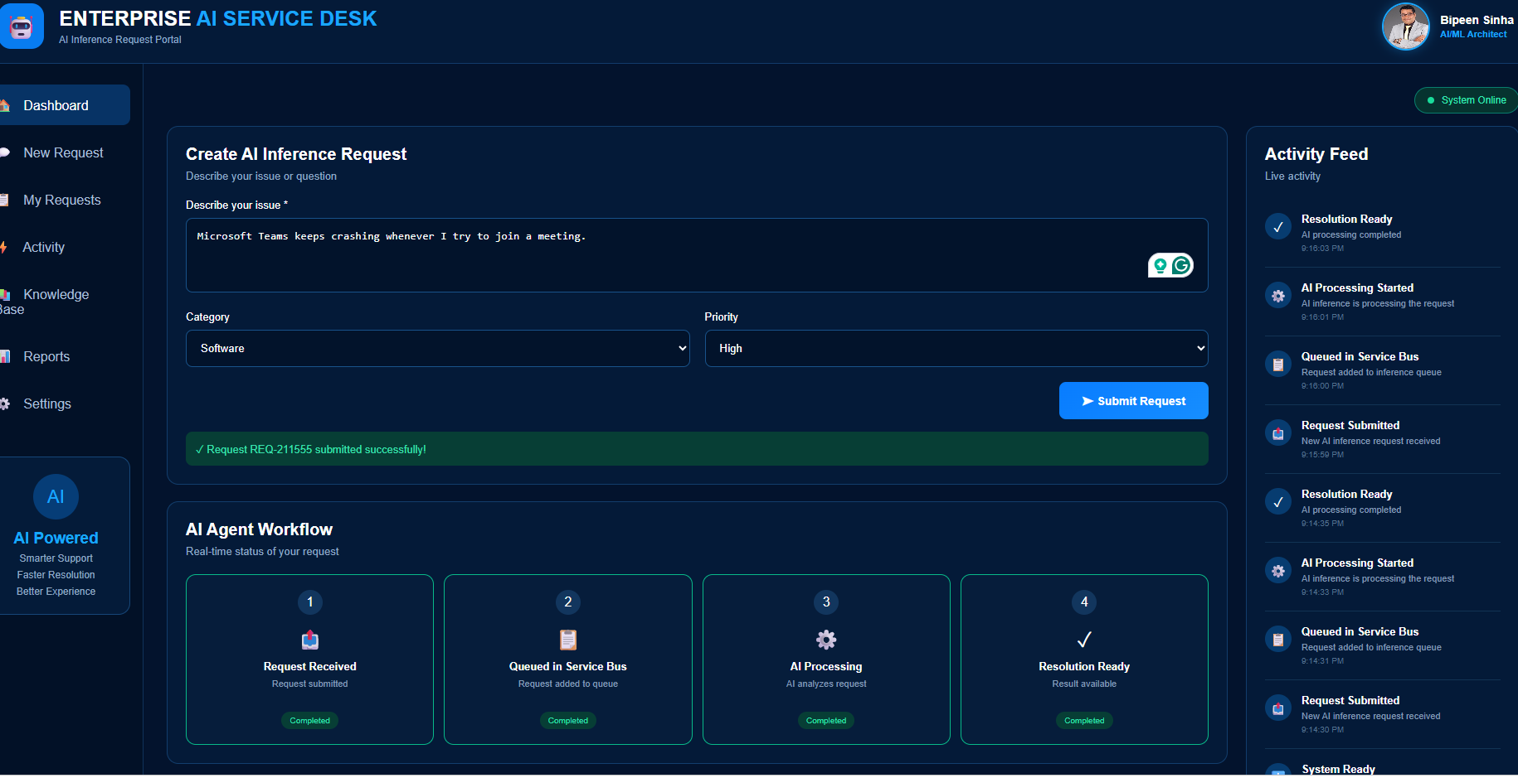
Figure 19 – The AI Service Desk dashboard running in the browser.
✅ EXPECTED RESULT
The AI Service Desk dashboard loads, showing the Create AI Inference Request form.

Test the Solution
With the Flask application running, submit a test request through the AI Service Desk dashboard.
Test message:
Field | Value
Issue | I cannot connect to the company VPN and I have an important customer meeting in 30 minutes.
Category | Network
Priority | High

Expected flow:
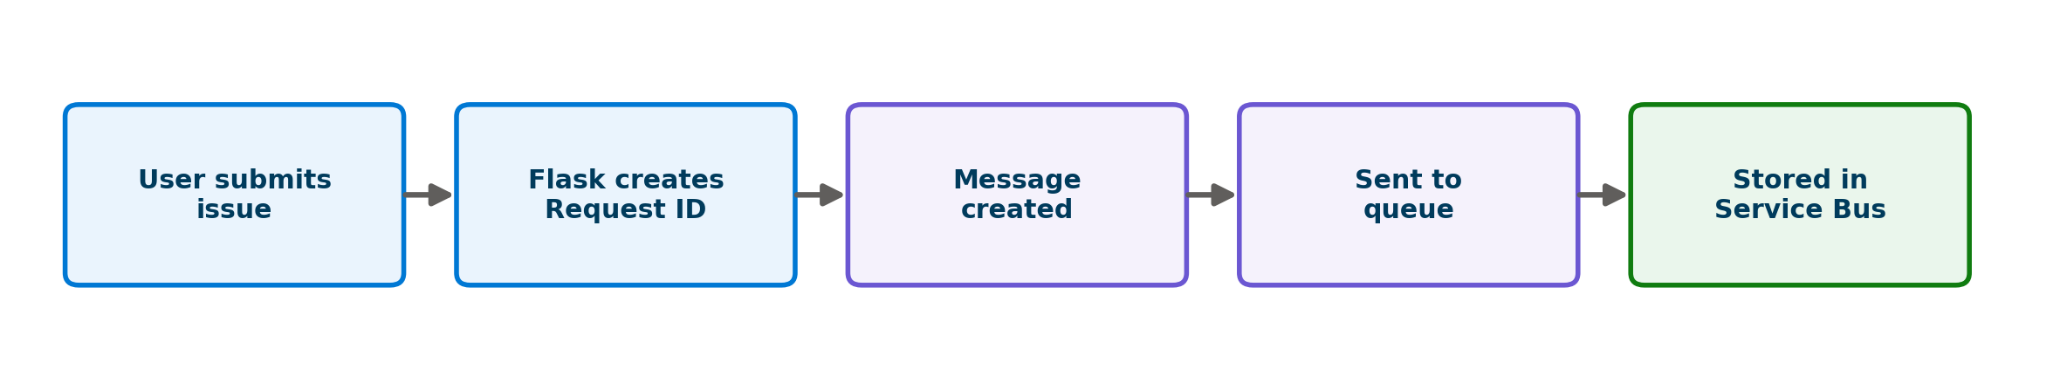
Figure 20 – What happens after you select Submit Request.
Steps:
1. Enter the issue text, category, and priority shown above.
2. Select Submit Request.
Screenshot:
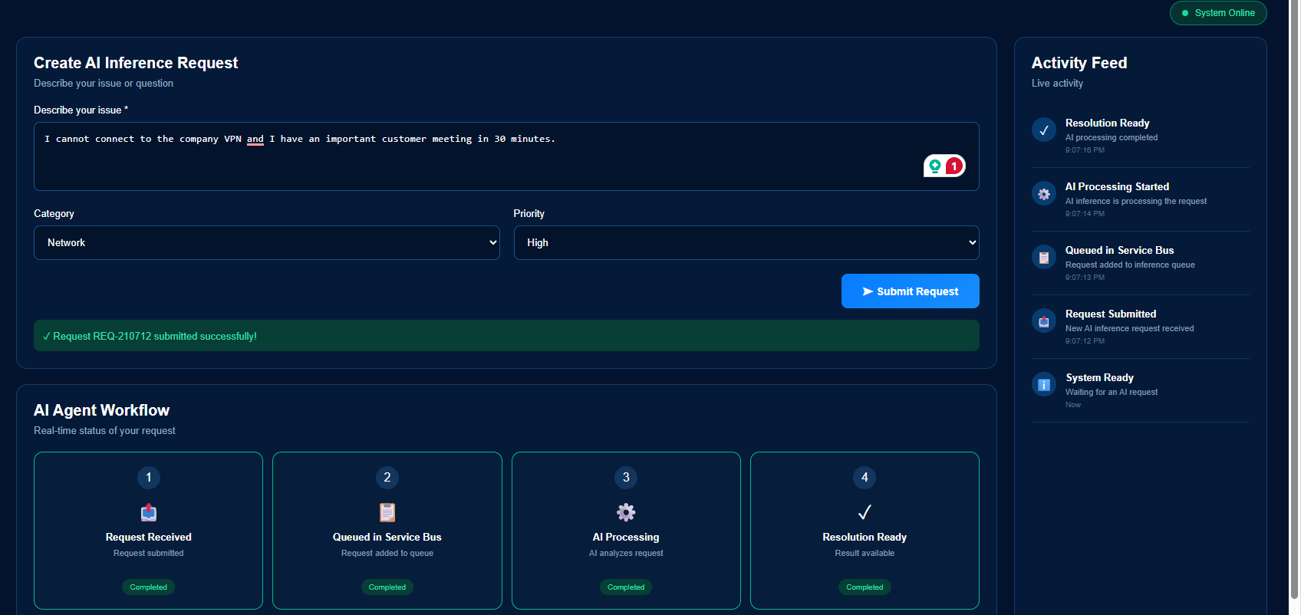
Figure 21 – Submitting the VPN issue as a Network / High priority request.
✅ EXPECTED RESULT
A green confirmation banner appears: “Request REQ-210712 submitted successfully!”
The AI Agent Workflow panel shows “Queued in Service Bus” as completed.

💡 NOTE
The request ID (e.g. REQ-210712) is generated from the current time, so yours will be different — that's expected.

Verify the Message in Azure Service Bus

Step 14 — Open Service Bus Explorer
Objective: Confirm your request actually reached the Azure Service Bus queue.
Instructions:
1. In the Azure Portal, go to: Service Bus → Queues → ai-inference-queue
2. Select Service Bus Explorer.
Screenshot:
[Add screenshot: Service Bus Explorer showing the queued message. This screenshot was not included in the provided reference material.]
🔍 VERIFY
The queue's Active messages count should be at least 1.
Opening the message in Service Bus Explorer should show the Request ID, issue text, category, and priority you submitted.

This demonstrates:
Flask Application
│
▼
AI Request
│
▼
Service Bus Queue

Understand What Happened
Here's the full picture of what you just built, in plain terms:
1. The user entered an issue in the AI Service Desk web page.
2. Flask received the request through the /api/submit endpoint.
3. The application created a unique Request ID.
4. The application created a Service Bus message from the request details.
5. The message was sent to the ai-inference-queue queue.
6. Azure Service Bus stored the message.
7. A future worker can retrieve and process it.
Figure 22 – The message lifecycle, end to end.

What This Proves
The web application successfully sent the request to Azure Service Bus. The request now exists independently of the Flask application — it will stay safely in the queue whether or not the application (or a future worker) is running at any given moment.

“What should I see?” — Quick Reference
Field | Expected Value
Request ID | REQ-XXXXXX (generated from the current time)
Category | Network
Priority | High
Queue | The Azure Service Bus queue (ai-inference-queue) should contain the submitted message.

Troubleshooting
Problem | Possible Cause | Solution
Message not appearing in the queue | Wrong queue or namespace name in .env | Verify SERVICE_BUS_QUEUE_NAME matches the queue name you created in Azure exactly
Application error on startup | Missing Python package | Run pip install -r requirements.txt again
Connection failure to Service Bus | Incorrect or expired connection string | Copy the Primary Connection String again from Shared access policies
Flask page not loading | Application not running | Run py app.py and check the terminal for errors

Lab Summary
At this point, the AI Service Desk has successfully separated request submission from request processing.
User Request
│
▼
Flask Application
│
▼
Azure Service Bus Queue
│
▼
Message Waiting for Processing
The next step is to create a worker that reads messages from the queue and performs the AI operation.

Next Step / Extension
🚀 NEXT STEP
The next lab in this series builds the AI Worker: a Python script that listens to ai-inference-queue, receives messages using Peek-Lock, and processes each AI request.

From there, the full pipeline will extend to:
- Completing successfully processed messages
- Sending invalid messages to a Dead-Letter Queue
- Publishing AI results to a topic
- Routing results to High and Normal priority subscriptions

For now, your AI Service Desk can reliably accept requests and hand them off to Azure Service Bus — the foundation every later exercise builds on.

import os
import json

from dotenv import load_dotenv

from azure.servicebus import ServiceBusClient

# ---------------------------------------------------------
# Load environment variables
# ---------------------------------------------------------

load_dotenv()

# ---------------------------------------------------------
# Azure Service Bus Configuration
# ---------------------------------------------------------

CONNECTION_STRING = os.getenv(
"SERVICE_BUS_CONNECTION_STRING"
)

QUEUE_NAME = os.getenv(
"SERVICE_BUS_QUEUE_NAME",
"ai-inference-queue"
)

# ---------------------------------------------------------
# Receive Messages
# ---------------------------------------------------------

def receive_messages():

print("\n===================================")
print("AI WORKER STARTED")
print("===================================")
print("Listening to queue:", QUEUE_NAME)
print("Waiting for messages...\n")

with ServiceBusClient.from_connection_string(
conn_str=CONNECTION_STRING
) as client:

with client.get_queue_receiver(
queue_name=QUEUE_NAME,
max_wait_time=10
) as receiver:

for message in receiver:

print("-----------------------------------")
print("MESSAGE RECEIVED")
print("-----------------------------------")

# Convert message to text

message_text = str(message)

# Convert JSON text to Python object

data = json.loads(message_text)

print("Request ID :", data["requestId"])
print("Issue :", data["issue"])
print("Category :", data["category"])
print("Priority :", data["priority"])

# -----------------------------------------
# Simulate AI processing
# -----------------------------------------

print("\nAI Worker is processing request...")

# -----------------------------------------
# Complete message
# -----------------------------------------

receiver.complete_message(message)

print("Message completed successfully.")
print("-----------------------------------\n")

if __name__ == "__main__":

receive_messages()

