MICROSOFT AZURE AI-200 CERTIFICATION
MODULE 4
Develop AI Solutions with Azure Cosmos DB for NoSQL

HANDS-ON LAB MANUAL
Building an AI Support Agent with Vector Search in Azure Cosmos DB
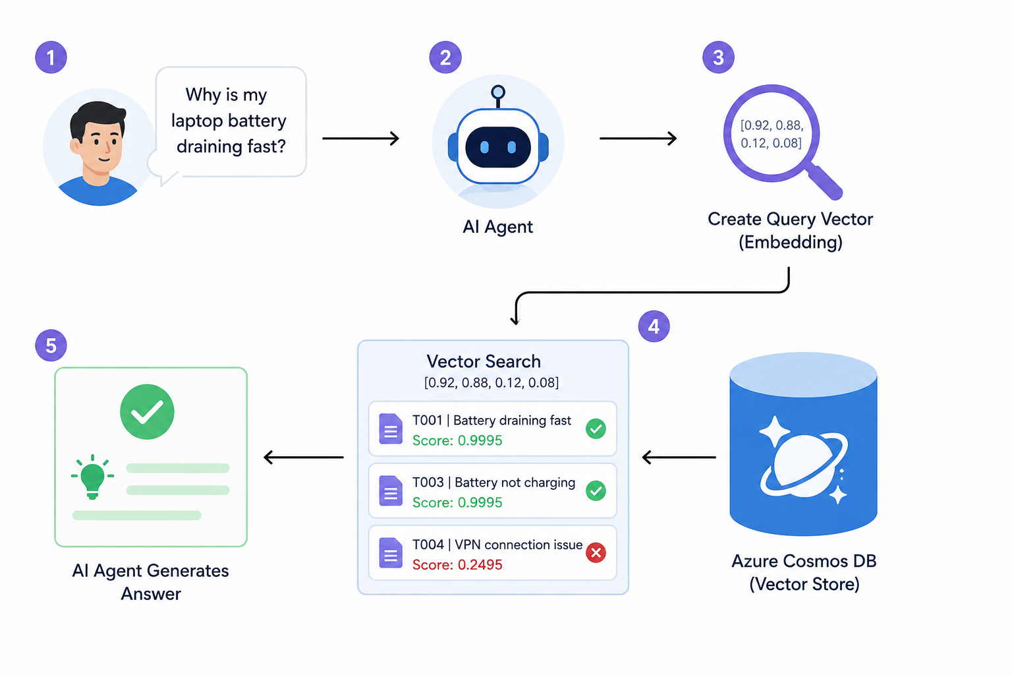
Lab Focus | Level | Estimated Duration | Environment
Cosmos DB queries → Vector search → AI agent | Beginner | 60–90 minutes | Azure Portal (no code required)

Certification Training Series • AI-200: Designing and Implementing an AI Solution

Objective
This lab introduces the core AI-200 skills for working with Azure Cosmos DB for NoSQL. You will build a small IT Support Ticket database entirely in the Azure Portal, query it with familiar NoSQL statements, then extend it with vector embeddings so an AI agent can retrieve tickets by meaning rather than by exact wording.
By the end of this lab, you will be able to:
- Create an Azure Cosmos DB for NoSQL account
- Create a database and container
- Add sample support-ticket documents
- Run basic NoSQL queries
- Understand embeddings and vectors
- Perform a simple vector search using VectorDistance()
- Filter vector-search results using a similarity threshold
- Understand how an AI agent can use Azure Cosmos DB as a vector store

TRAINER TIP
This lab is designed to run live in the Azure Portal with no local tools, SDKs, or code editors required. Every step uses Data Explorer.

Prerequisites
Keep this short — students only need the following before starting:
- An active Azure subscription
- Access to the Azure Portal (portal.azure.com)
- Basic understanding of JSON
- Basic understanding of Azure AI concepts

NOTE
Azure pricing and free-tier options can change. For a classroom lab, verify current pricing and free-tier eligibility in the Azure Portal before the session.

Table of Contents
The list below updates automatically from the section headings in this document. In Microsoft Word, right-click anywhere in the list and select “Update Field” (or press F9) to refresh page numbers.

Index of Key Terms
Use this quick-reference glossary while working through the lab and while reviewing for the AI-200 exam.
Term | Definition
Azure Cosmos DB | Microsoft's globally distributed, multi-model database service. This lab uses the NoSQL API.
NoSQL | A database approach that stores data as flexible documents (here, JSON) instead of fixed rows and columns.
Container | The Cosmos DB equivalent of a table — a collection that stores items (documents) and defines the partition key and indexing policy.
Partition Key | A JSON property (e.g. /customerId) used to distribute and route data across physical partitions for scalability and targeted queries.
Embedding | A numeric vector that represents the meaning of a piece of text, generated by an AI model.
Vector | An ordered array of numbers (e.g. [0.95, 0.90, 0.10, 0.05]) representing a point in multi-dimensional space, used to capture semantic meaning.
Vector Search | A search method that finds items whose vectors are mathematically closest to a query vector, i.e. semantically similar content.
VectorDistance() | A built-in Cosmos DB NoSQL function that calculates the similarity/distance between two vectors.
Similarity Score | A numeric value produced by VectorDistance() indicating how close two vectors are; higher generally means more similar.
AI Agent | An application that uses an LLM plus external data (such as a vector store) to answer questions or take actions.
Query | A request written in Cosmos DB's SQL-like language (e.g. SELECT * FROM c WHERE ...) used to retrieve documents.
RU/s | Request Units per second — the currency Cosmos DB uses to measure the cost of database operations such as reads, writes, and queries.

1. Lab Scenario
Imagine you are building an IT Support AI Agent. A user types a question such as:
USER QUESTION
“My laptop battery is dying very quickly. Are there any similar support tickets?”

To answer this well, the AI agent needs a data store that can do two things: find tickets that match exact criteria (like status or priority), and find tickets that are similar in meaning, even when the wording is different. Azure Cosmos DB for NoSQL can do both — which is exactly what this lab demonstrates.

How the AI Agent Uses Cosmos DB
The diagram below shows the end-to-end flow you will recreate conceptually in this lab: the user's question is converted into a query vector (an embedding), Cosmos DB performs a vector search over stored ticket embeddings, and the closest matches are used to generate the agent's answer.
Figure 1 – How an AI agent uses Azure Cosmos DB as a vector store to answer a user question.

Two Ways to Query the Same Data
Azure Cosmos DB for NoSQL supports both retrieval styles side by side, on the same container:
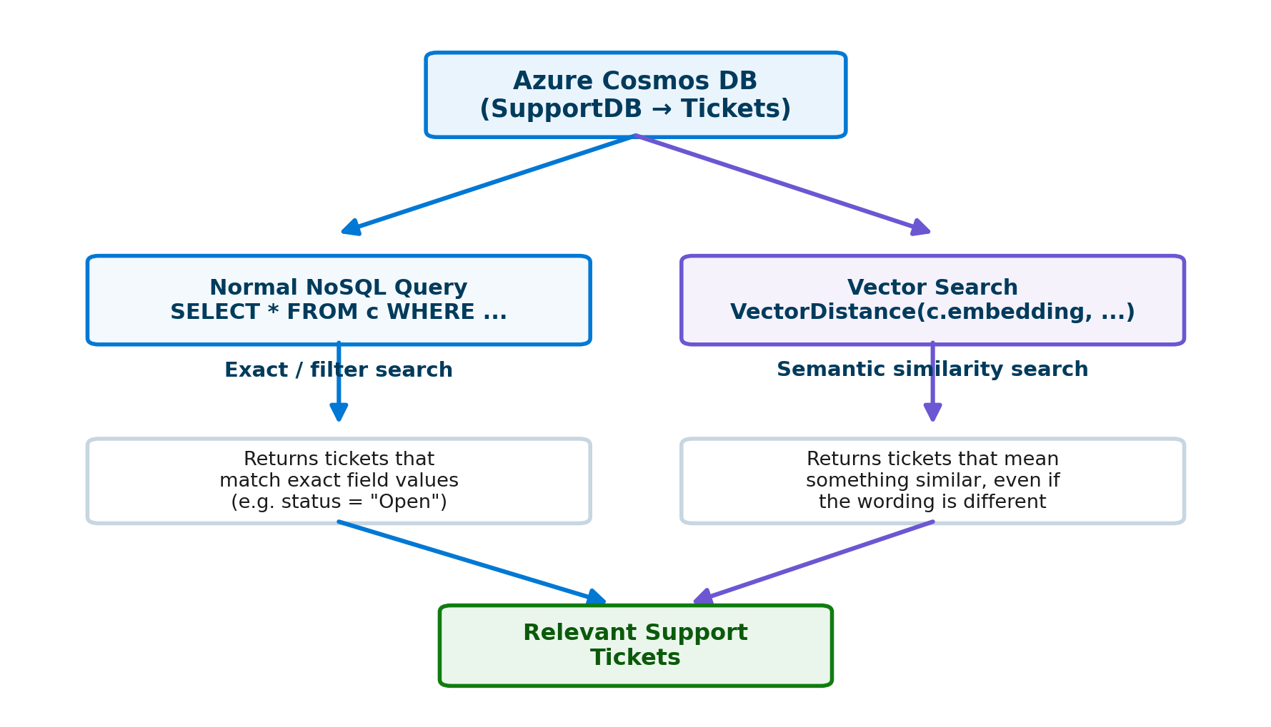
Figure 2 – Normal NoSQL queries return exact matches; vector search returns semantically similar matches.

2. What You Will Build
By the end of this lab you will have created the following structure inside Azure Cosmos DB:
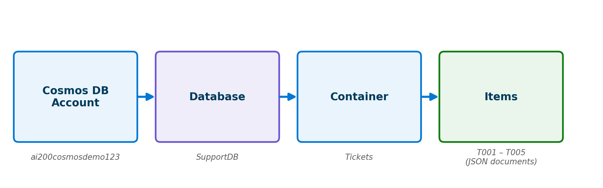
Figure 3 – Cosmos DB account → database → container → items hierarchy for this lab.
Level | Name Used in This Lab
Cosmos DB Account | ai200cosmosdemo<unique>
Database | SupportDB
Container | Tickets
Items (documents) | T001, T002, T003, T004, T005

Part A — Create an Azure Cosmos DB Account
In this part you will create the Cosmos DB account that will host your support-ticket database.

Step 1 — Open the Azure Portal
1. Sign in to the Azure Portal.
2. In the top search bar, type: Azure Cosmos DB
3. Select Azure Cosmos DB from the results.
4. Select + Create.
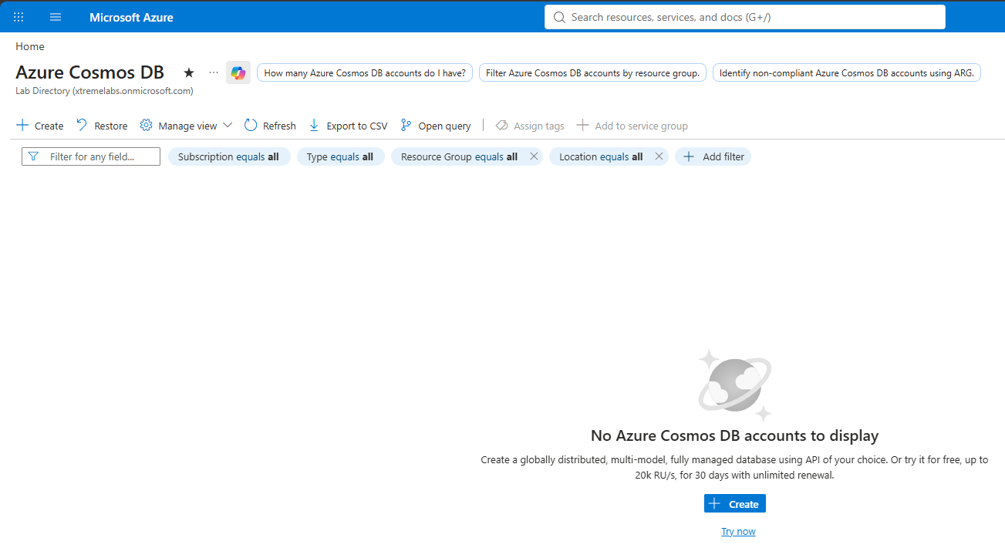
Figure 4 – The Azure Cosmos DB resource page in the Azure Portal.

Step 2 — Select the API
Azure Cosmos DB supports several APIs. For this lab, select:
AI-200 EXAM TIP
Azure Cosmos DB for NoSQL
The NoSQL API works with JSON documents and SQL-like queries. Whenever an AI-200 question says “Azure Cosmos DB for NoSQL”, think: JSON documents, NoSQL queries, containers, partition keys, indexing, and vector search.

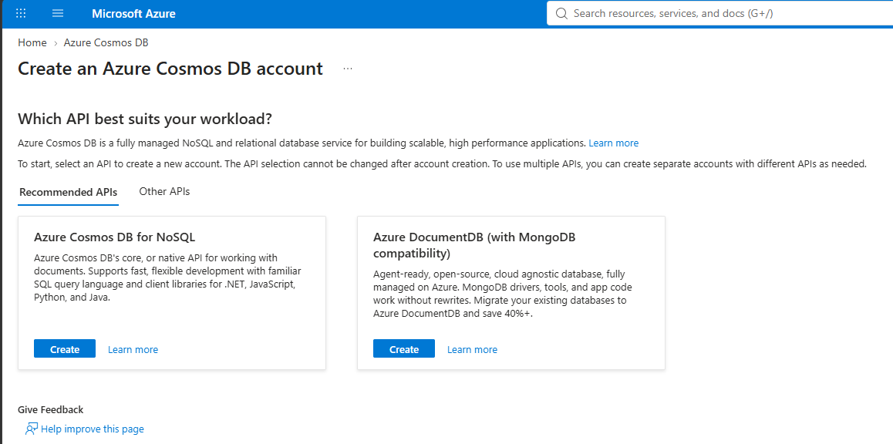
Figure 5 – Choosing the NoSQL API when creating the Cosmos DB account.

Step 3 — Configure the Account
On the Create Azure Cosmos DB for NoSQL account page, configure the basic settings using values similar to the table below.
Setting | Example Value
Subscription | Your Azure subscription
Resource Group | rg-ai200-cosmos-lab
Account Name | ai200-cosmos-<unique> (must be globally unique)
Location | Choose a nearby Azure region
Capacity mode | Use the option appropriate for your lab/subscription
Apply Free Tier Discount | Enable if available and appropriate

Example account name: ai200cosmosdemo123
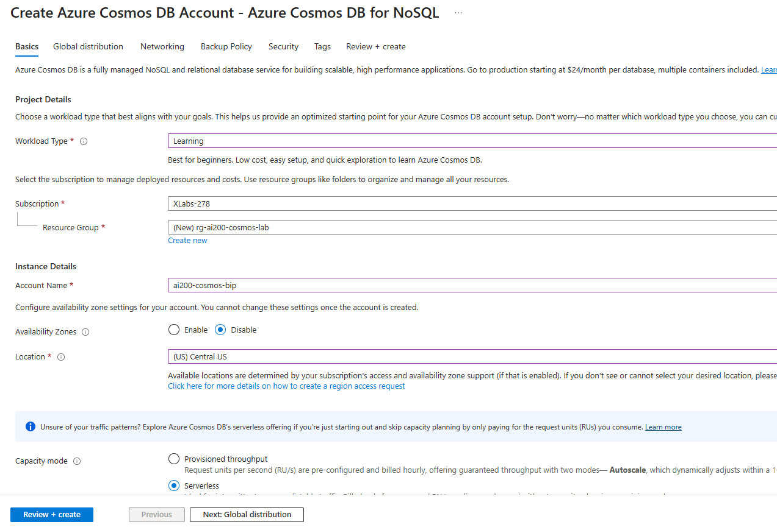
Figure 6 – Configuring the new Cosmos DB account.

Step 4 — Create the Account
1. Select Review + create.
2. Select Create.
3. Wait for deployment to finish.
4. Select Go to resource.
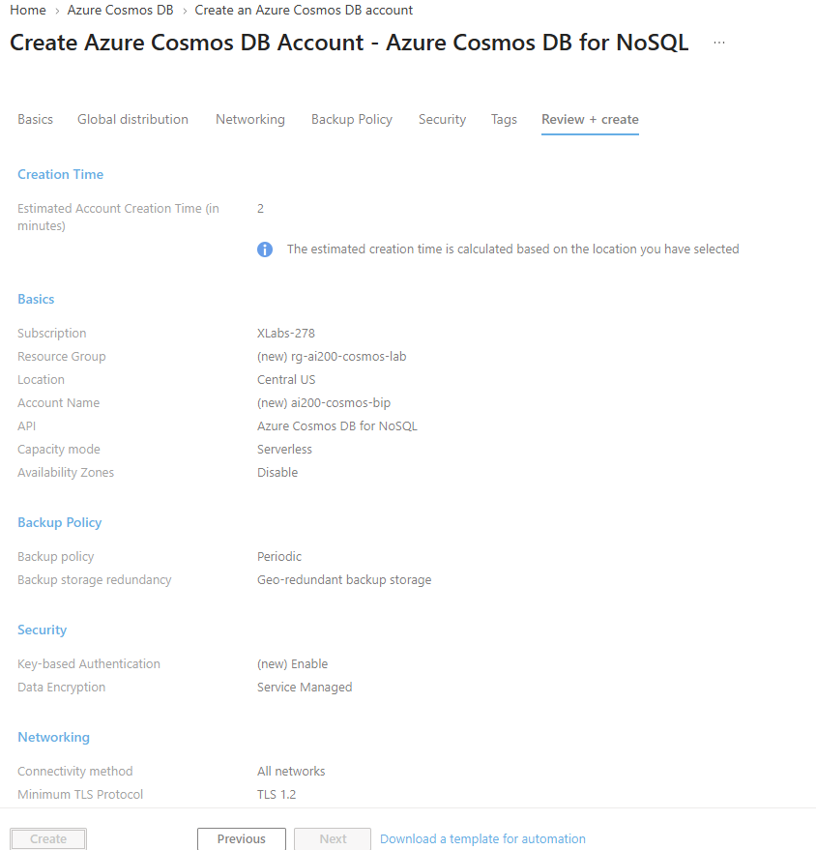
Figure 7 – Deployment in progress.
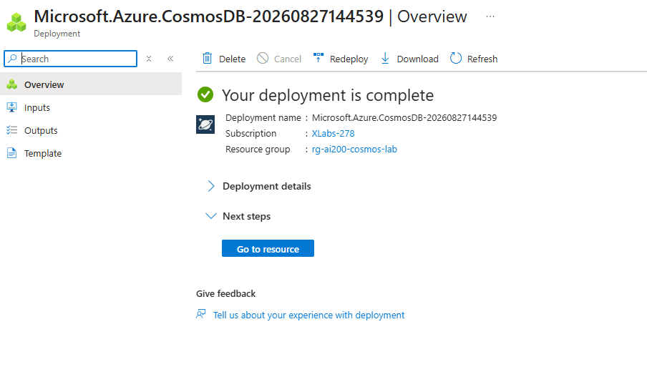
Figure 8 – Deployment complete — select Go to resource.

Part B — Create a Database and Container
Now you will create the logical structure Cosmos DB uses to organize your data: a database, and a container inside it.

Step 1 — Open Data Explorer
Inside your Cosmos DB account, select Data Explorer. This lets you work with your database directly from the Azure Portal, without any external tools.
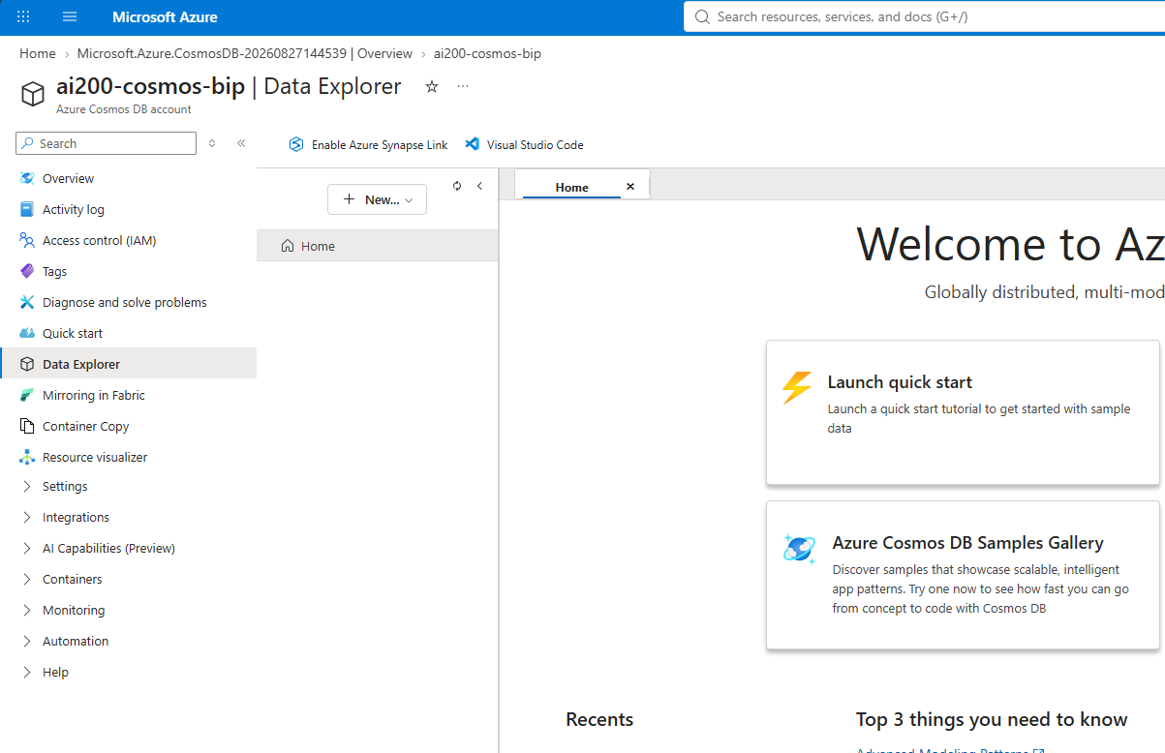
Figure 9 – Data Explorer inside the Cosmos DB account.

Step 2 — Create the Database and Container
1. Select New Container.
2. Depending on the current Portal experience, you may see options to create a database and container together.
Database ID: SupportDB
Container ID: Tickets
Partition key: /customerId
AI-200 EXAM TIP
The partition key is one of the most frequently tested Cosmos DB concepts. It determines how Cosmos DB distributes data across physical partitions and enables efficient, targeted queries.

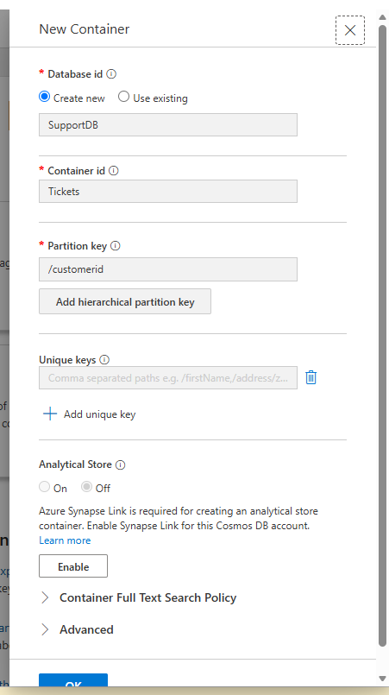
Figure 10 – Creating the SupportDB database and Tickets container with partition key /customerId.
After creating the container, you should see a structure similar to:
SupportDB
└── Tickets
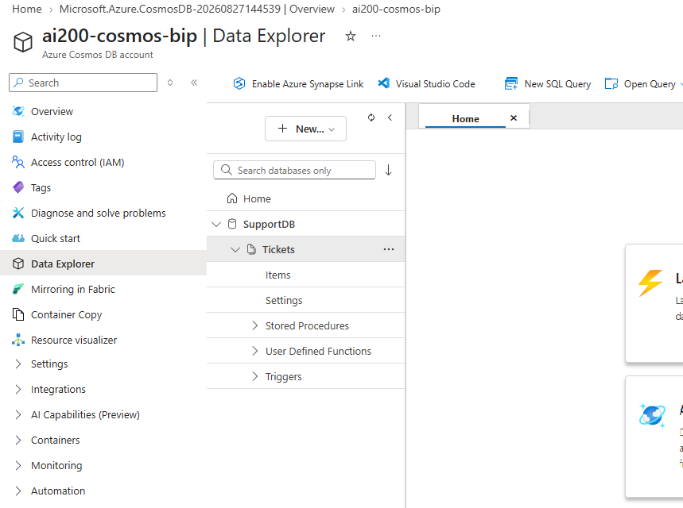
Figure 11 – The SupportDB database and Tickets container in Data Explorer.

Part C — Add Documents to the Container
You will now manually create five support-ticket documents. Open Data Explorer → SupportDB → Tickets → Items, then select New Item for each ticket below.
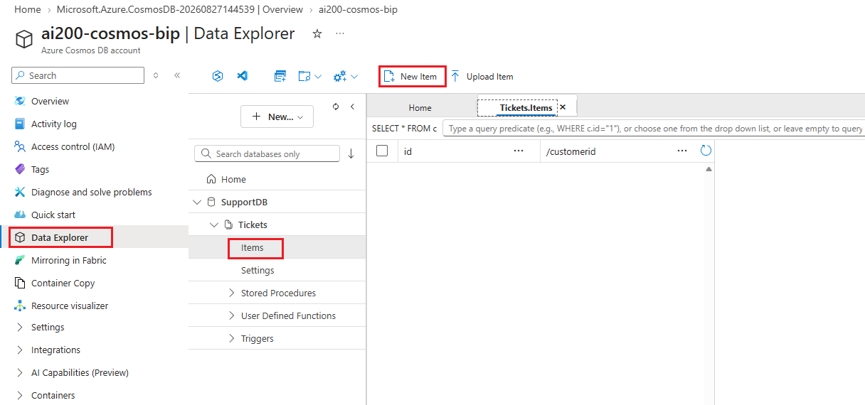
Figure 12 – Selecting New Item to add a document to the Tickets container.

Step 1 — Add Ticket 1
Paste the following JSON and select Save:
{
"id": "T001",
"customerId": "C001",
"customer": "Omer",
"issue": "Laptop battery is draining quickly",
"category": "Laptop",
"status": "Open",
"priority": "High"
}
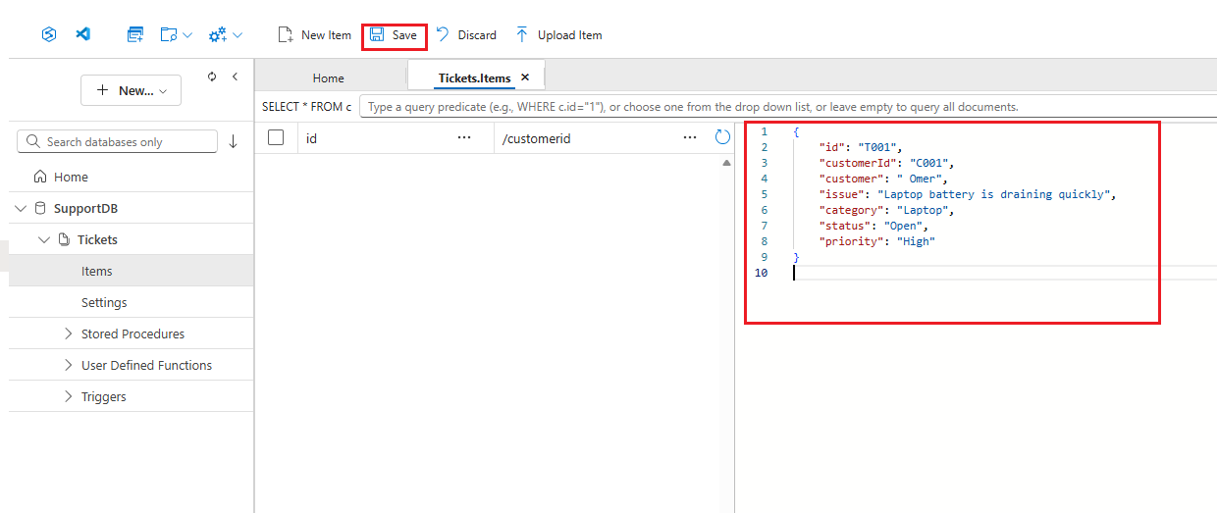
Figure 13 – Ticket T001 saved in the Tickets container.

Step 2 — Add Ticket 2
{
"id": "T002",
"customerId": "C002",
"customer": "Arnab",
"issue": "Unable to connect to office Wi-Fi",
"category": "Network",
"status": "Open",
"priority": "Medium"
}
Save it.

Step 3 — Add Ticket 3
{
"id": "T003",
"customerId": "C003",
"customer": "Hidde",
"issue": "Laptop battery is not charging",
"category": "Laptop",
"status": "Open",
"priority": "High"
}
Save it.

Step 4 — Add Ticket 4
{
"id": "T004",
"customerId": "C004",
"customer": "Denis",
"issue": "VPN connection keeps failing",
"category": "Network",
"status": "Closed",
"priority": "High"
}
Save it.

Step 5 — Add Ticket 5
{
"id": "T005",
"customerId": "C005",
"customer": "Ilie",
"issue": "Forgot corporate password",
"category": "Identity",
"status": "Open",
"priority": "Medium"
}
Save it.

Step 6 — Verify Your Data
You should now have five items in the Tickets container:
Ticket ID | Customer
T001 | Omer
T002 | Arnab
T003 | Hidde
T004 | Denis
T005 | Ilie

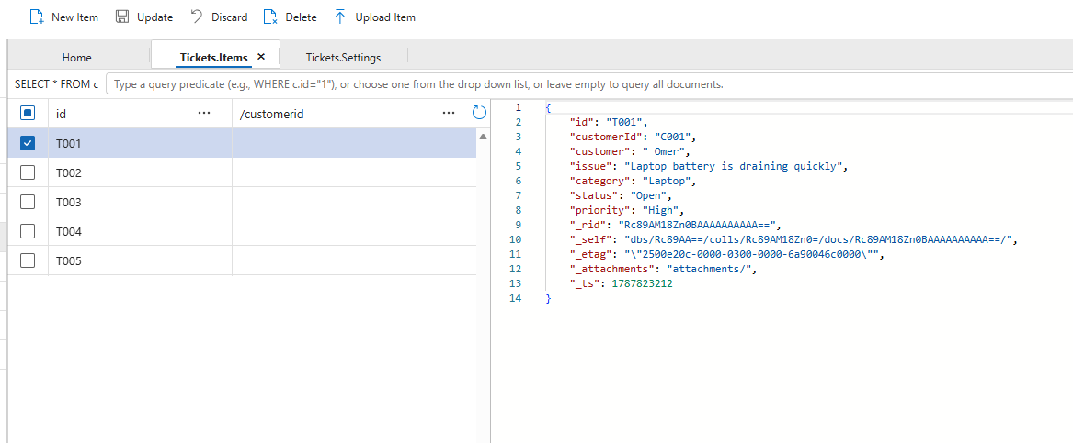
Figure 14 – All five ticket documents visible in Data Explorer.
The database is now ready to query.

Part D — Build Queries for Azure Cosmos DB for NoSQL
This is the first major AI-200 skill area: building queries for Azure Cosmos DB for NoSQL. Open Data Explorer → Tickets → Items and open the query editor (New SQL Query).
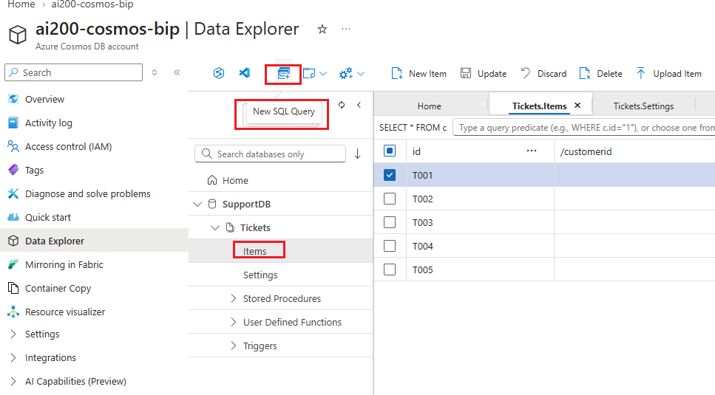
Figure 15 – The query editor in Data Explorer.

Query 1 — Retrieve Everything
SELECT *
FROM c

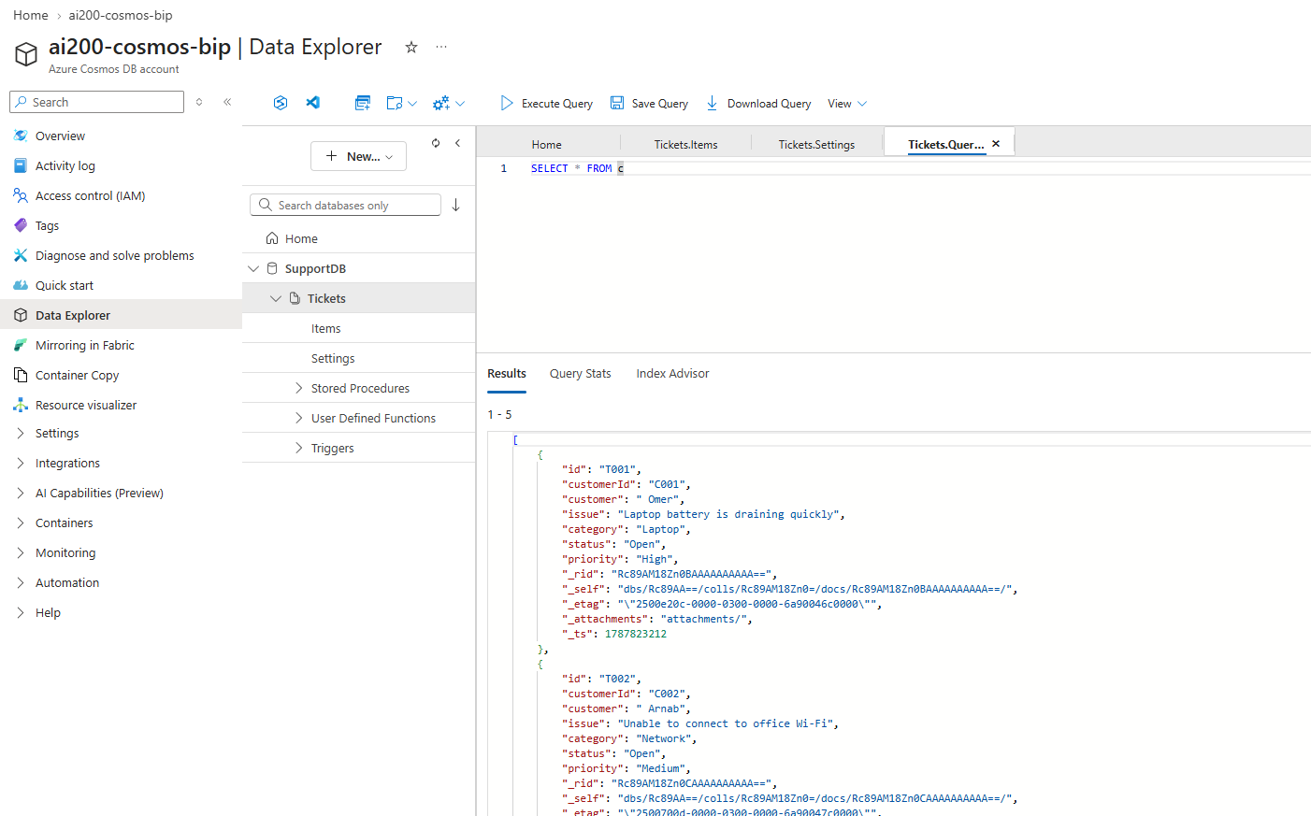
Figure 16 – Query 1 results — all five ticket documents.
WHAT DOES c MEAN?
c is simply the alias representing each document (item) in the container. Think of FROM c as “read documents from the container.” Unlike a relational database, which works in rows and columns, Cosmos DB for NoSQL works naturally with JSON documents — for example { "customer": "Ravi", "issue": "Laptop battery is draining quickly" }.

Query 2 — Find Open Tickets
SELECT *
FROM c
WHERE c.status = "Open"

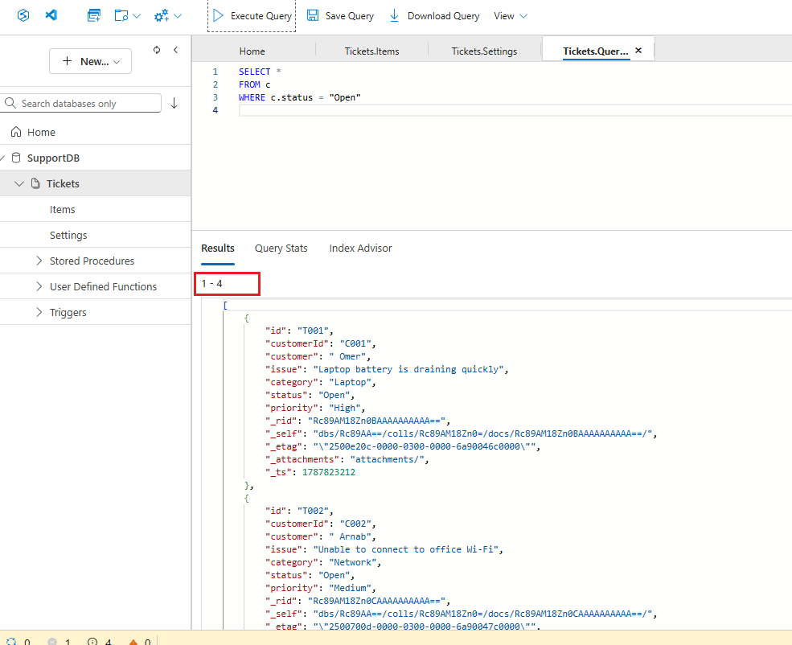
Figure 17 – Query 2 results — open tickets only.

Query 3 — Find High-Priority Tickets
SELECT *
FROM c
WHERE c.priority = "High"

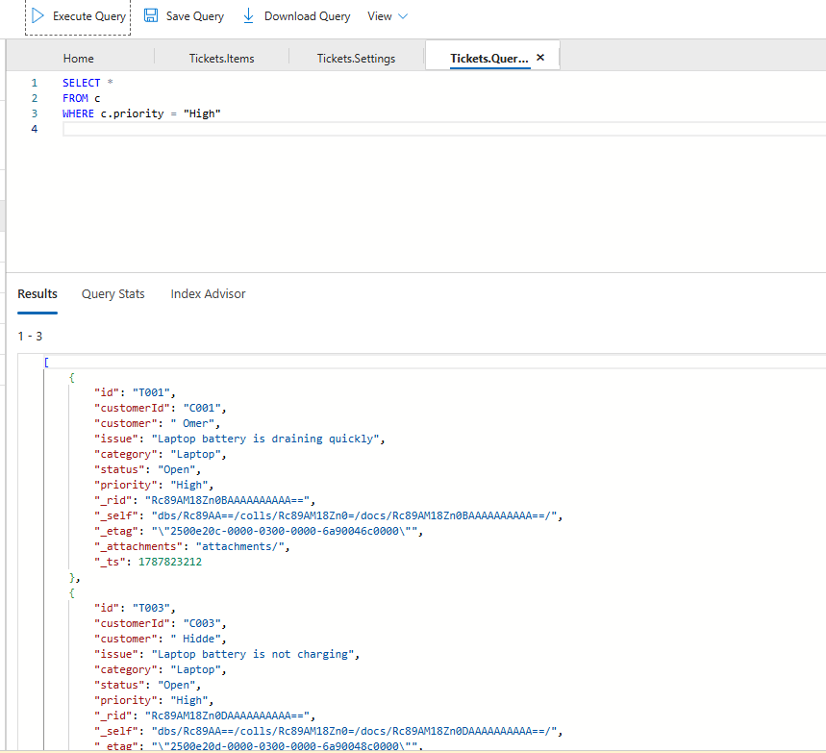
Figure 18 – Query 3 results — high-priority tickets.

Query 4 — Combine Conditions
SELECT *
FROM c
WHERE c.status = "Open"
AND c.priority = "High"

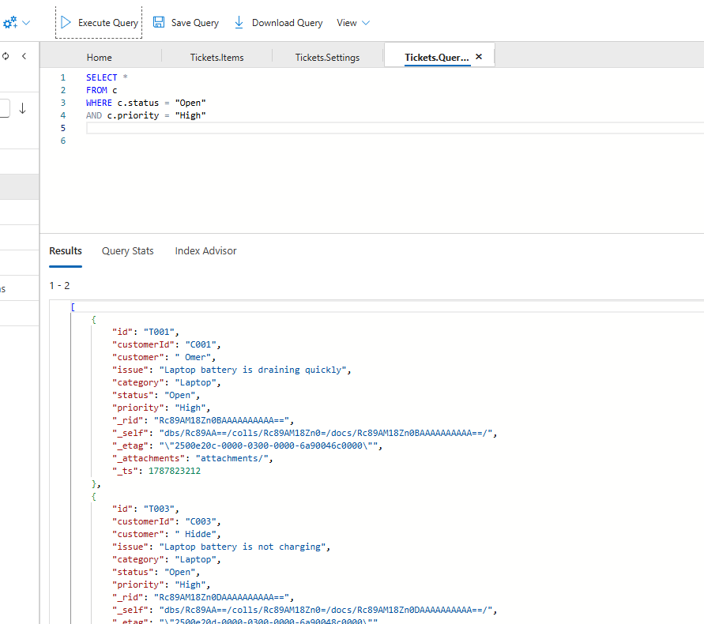
Figure 19 – Query 4 results — open AND high-priority tickets.

Query 5 — Filter by Category
SELECT *
FROM c
WHERE c.category = "Laptop"

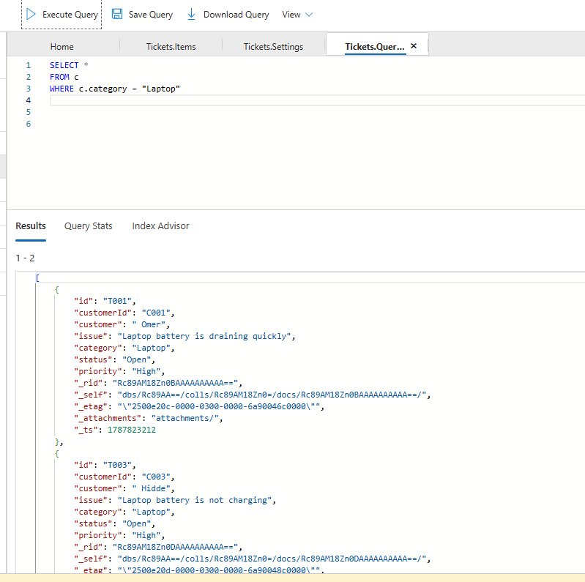
Figure 20 – Query 5 results — Laptop category tickets.

Query 6 — Select Only Required Fields
SELECT
c.customer,
c.issue,
c.priority
FROM c
WHERE c.status = "Open"
Instead of returning the entire document, this query returns only customer, issue, and priority.
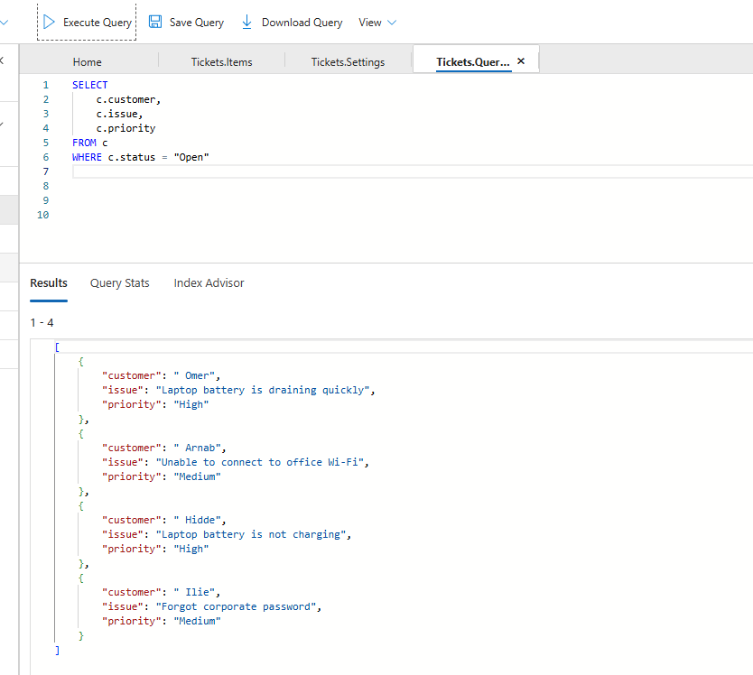
Figure 21 – Query 6 results — projecting only selected fields.
WHY IS THIS USEFUL?
Imagine a document has 30 properties but your application only needs customer, issue, and priority. Projecting only the fields you need reduces unnecessary data transfer, response size, processing, and query cost (RU/s).

Query 7 — Use TOP
Suppose you only need the first three results:
SELECT TOP 3
c.customer,
c.issue,
c.priority
FROM c
WHERE c.status = "Open"
This limits the number of documents returned.
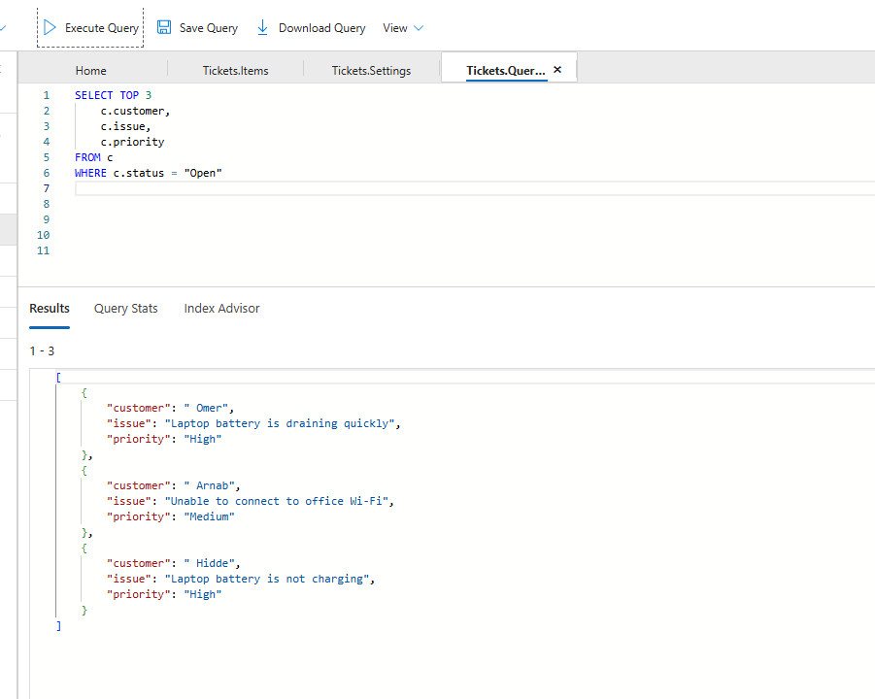
Figure 22 – Query 7 results — TOP 3 open tickets.

Query 8 — Sort Results
SELECT
c.customer,
c.issue,
c.priority
FROM c
WHERE c.status = "Open"
ORDER BY c.priority
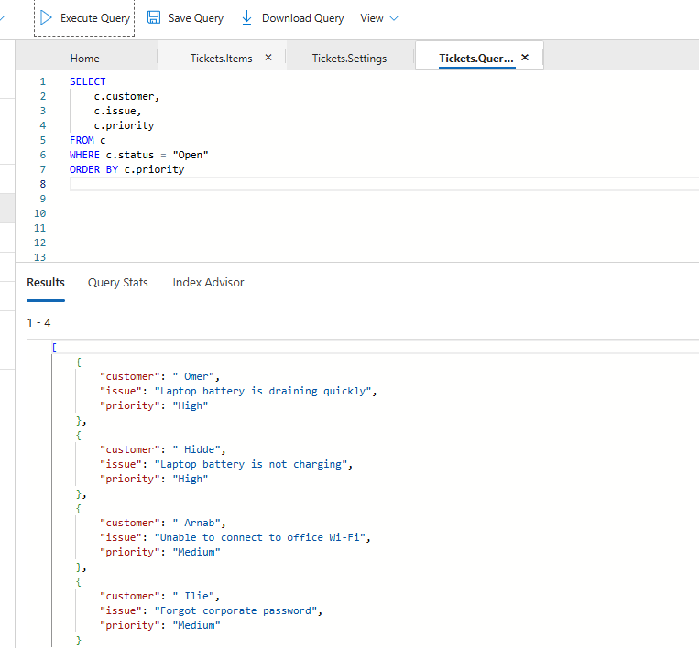
Figure 23 – Query 8 results — sorted by priority.
Cosmos DB for NoSQL supports SQL-like operations such as filtering (WHERE), projection (SELECT), limiting (TOP), and sorting (ORDER BY).

Part E — Understand Partition-Aware Queries

SELECT *
FROM c
WHERE c.customerId = "C001"
When a query includes the partition-key value, Cosmos DB can route the request to a targeted partition rather than searching across every partition unnecessarily.

Compare Two Queries

Query A — No Partition Key
SELECT *
FROM c
WHERE c.status = "Open"
This query does not reference the partition key, so Cosmos DB may need to check every partition.
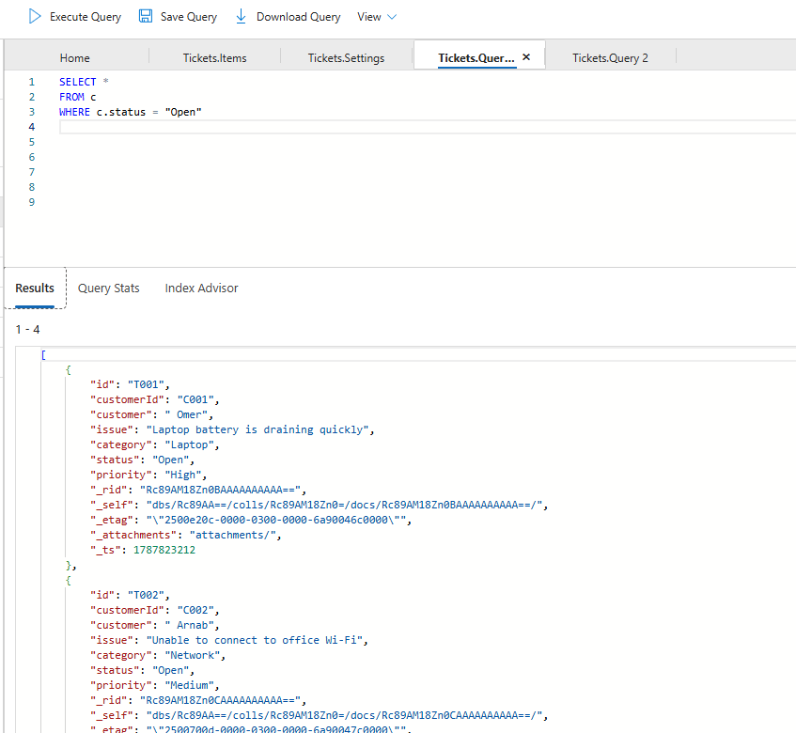
Figure 24 – Query A — no partition key specified.

Query B — Includes the Partition Key
SELECT *
FROM c
WHERE c.customerId = "C001"
AND c.status = "Open"
This query includes customerId, which is the partition key.
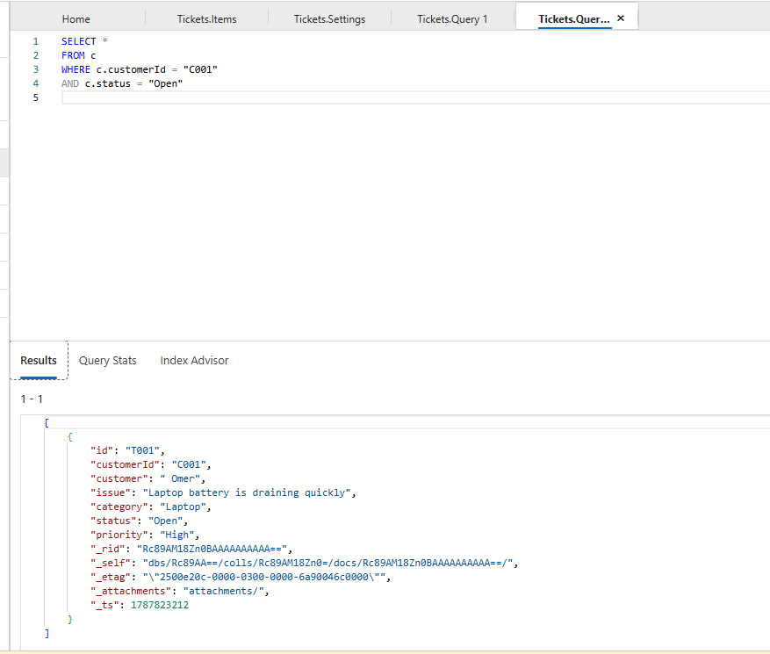
Figure 25 – Query B — partition key included for a targeted query.
AI-200 EXAM TIP
Partition key in query → potentially targeted partition → less unnecessary work. When a question asks “How can you improve query efficiency when retrieving data for a specific customer?”, look for an answer involving the partition key.

Part F — Query Performance and Indexing
This is the third AI-200 skill area: optimize query performance for Azure Cosmos DB for NoSQL. By default, Cosmos DB automatically indexes properties according to its indexing policy, so you generally do not need to manually create an index before querying a property.

Why Indexing Matters
With five documents, searching is trivial. But imagine five million documents — scanning every one for every query would be inefficient. An index helps Cosmos DB locate relevant data quickly, the same way a book index helps a reader jump straight to a page.
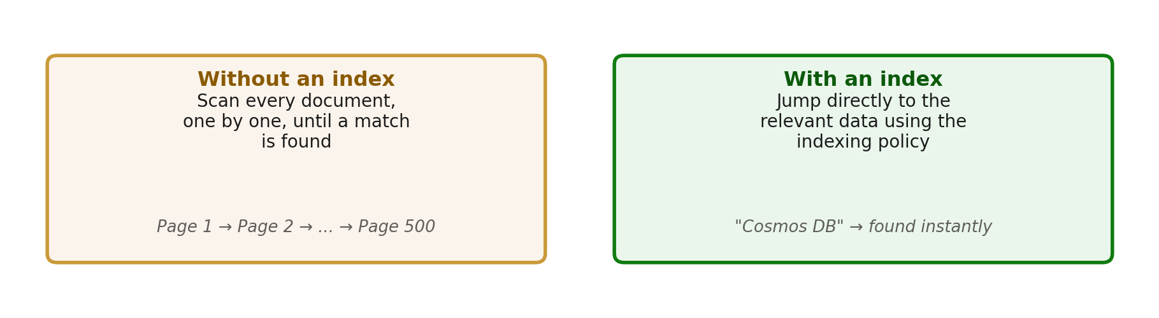
Figure 26 – Searching without an index vs. searching with an index.

Step 1 — Inspect the Indexing Policy
In the Azure Portal, open your container's Settings and locate the Indexing Policy. The exact Portal layout can change over time, so the wording or location may differ slightly. Look for concepts such as included paths, excluded paths, and indexing mode.
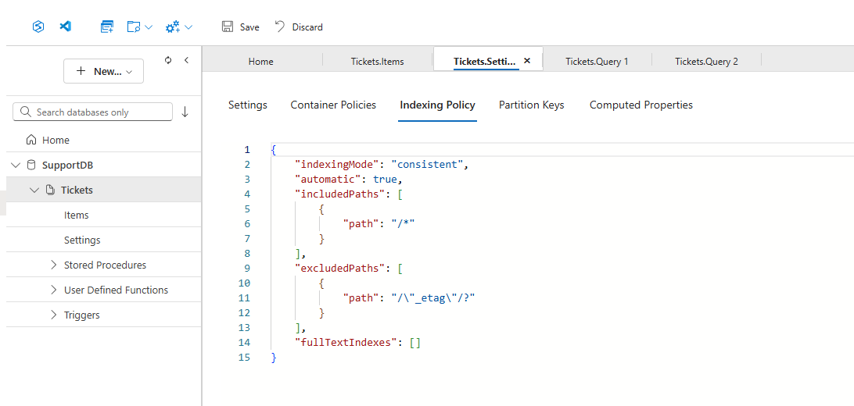
Figure 27 – The container's indexing policy in the Azure Portal.
NOTE
For this small lab, you do not need to change the indexing policy. The goal is simply to understand that Cosmos DB automatically indexes data according to the container's indexing policy.

When Would You Change Indexing?
In a large production system, you might identify a property that is never queried and exclude it from indexing to reduce indexing overhead and storage. Be careful, though: don't blindly exclude properties from indexing — if the application later queries that property, performance or query behavior may be affected depending on the configuration.

Part G — Implement Vector Search
Now you will add a numeric embedding field to each ticket and use it to perform a semantic similarity search.

A Quick Note on Embeddings
An embedding is a numeric vector produced by an AI model that represents the meaning of a piece of text. Real-world embeddings from Azure OpenAI typically have hundreds or thousands of dimensions. For this classroom exercise we use simple 4-dimensional vectors so the JSON stays easy to read. Cosmos DB's flat vector index supports up to 505 dimensions, so this small example uses the same mechanics as a production embedding, just at a much smaller scale.
IMPORTANT
The vector values used in this lab (e.g. [0.95, 0.90, 0.10, 0.05]) are teaching vectors chosen by hand to demonstrate the concept clearly. They are not generated by a real embedding model.

Step 1 — Update Ticket 1
Replace your existing Ticket 1 with the version below (adds the embedding field), then select Update:
{
"id": "T001",
"customerId": "C001",
"customer": "Omer",
"issue": "Laptop battery is draining quickly",
"category": "Laptop",
"status": "Open",
"priority": "High",
"embedding": [0.95, 0.90, 0.10, 0.05]
}
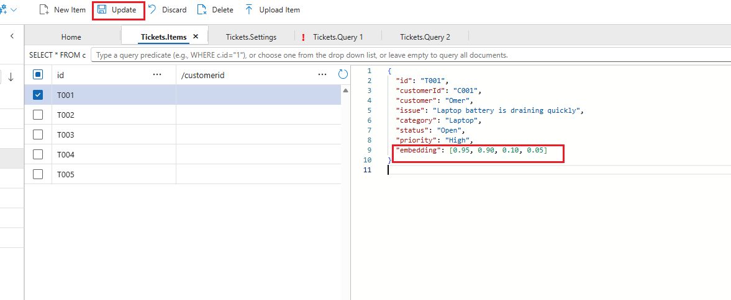
Figure 28 – Editing Ticket T001 to add the embedding field.
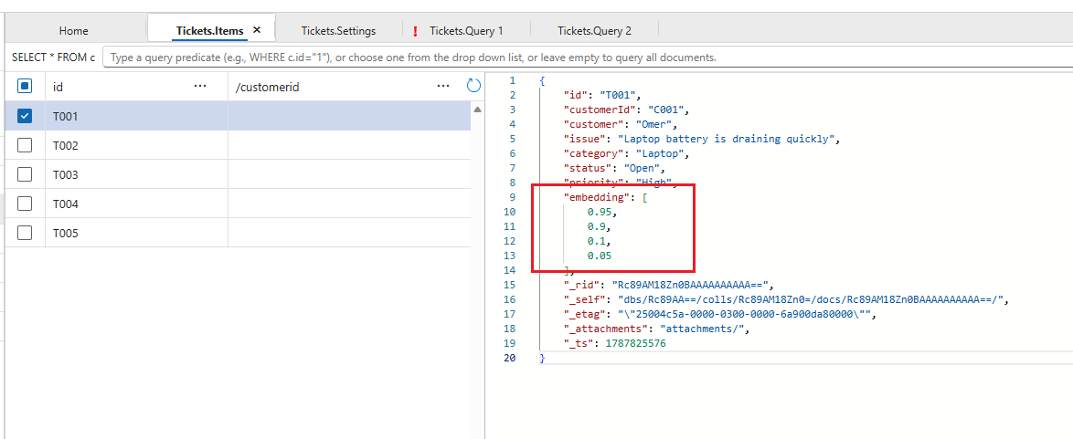
Figure 29 – Ticket T001 updated and saved with its embedding.

Step 2 — Update Ticket 2
{
"id": "T002",
"customerId": "C002",
"customer": "Arnab",
"issue": "Unable to connect to office Wi-Fi",
"category": "Network",
"status": "Open",
"priority": "Medium",
"embedding": [0.10, 0.15, 0.90, 0.85]
}
Select Update.
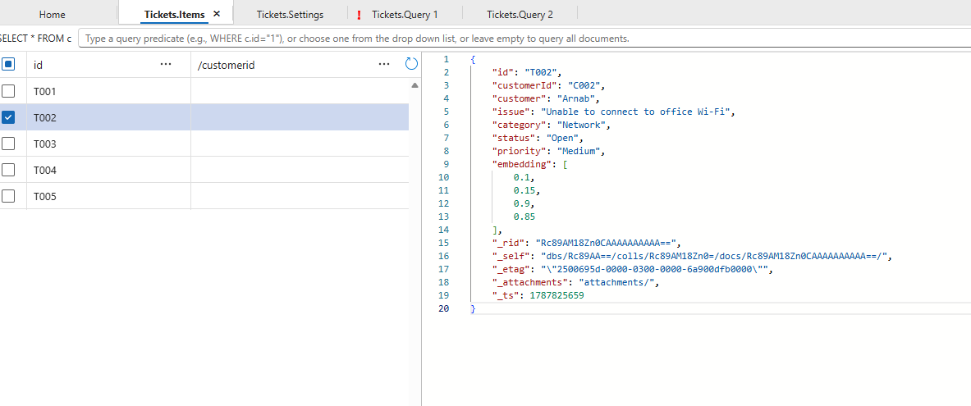
Figure 30 – Ticket T002 updated with its embedding.

Step 3 — Update Ticket 3
{
"id": "T003",
"customerId": "C003",
"customer": "Hidde",
"issue": "Laptop battery is not charging",
"category": "Laptop",
"status": "Open",
"priority": "High",
"embedding": [0.90, 0.85, 0.15, 0.10]
}
Select Update.

Step 4 — Update Ticket 4
{
"id": "T004",
"customerId": "C004",
"customer": "Denis",
"issue": "VPN connection keeps failing",
"category": "Network",
"status": "Closed",
"priority": "High",
"embedding": [0.15, 0.10, 0.85, 0.90]
}
Select Update.

Step 5 — Update Ticket 5
{
"id": "T005",
"customerId": "C005",
"customer": "Ilie",
"issue": "Forgot corporate password",
"category": "Identity",
"status": "Open",
"priority": "Medium",
"embedding": [0.05, 0.10, 0.20, 0.95]
}
Select Update.

What Did We Just Do?
Ticket | Issue | Vector
T001 | Laptop battery is draining quickly | [0.95, 0.90, 0.10, 0.05]
T002 | Unable to connect to office Wi-Fi | [0.10, 0.15, 0.90, 0.85]
T003 | Laptop battery is not charging | [0.90, 0.85, 0.15, 0.10]
T004 | VPN connection keeps failing | [0.15, 0.10, 0.85, 0.90]
T005 | Forgot corporate password | [0.05, 0.10, 0.20, 0.95]

Notice that T001 and T003 have very similar vectors — that is intentional for this lab. We are effectively telling Cosmos DB: “these two tickets are semantically similar.”

Step 6 — Create the Query Vector
Now imagine the user asks: “My laptop battery dies very fast.” For this simple lab, we represent that question with the teaching vector:
[0.92, 0.88, 0.12, 0.08]
This is deliberately close to T001 [0.95, 0.90, 0.10, 0.05] and T003 [0.90, 0.85, 0.15, 0.10].

Step 7 — Run the Vector Search — VectorDistance()
In Data Explorer → New SQL Query, run:
SELECT TOP 3
c.id,
c.customer,
c.issue,
VectorDistance(c.embedding, [0.92, 0.88, 0.12, 0.08]) AS vectorDistance
FROM c
ORDER BY VectorDistance(c.embedding, [0.92, 0.88, 0.12, 0.08])
Cosmos DB's VectorDistance() function compares the query vector with the vectors stored in each document and orders the results by similarity.
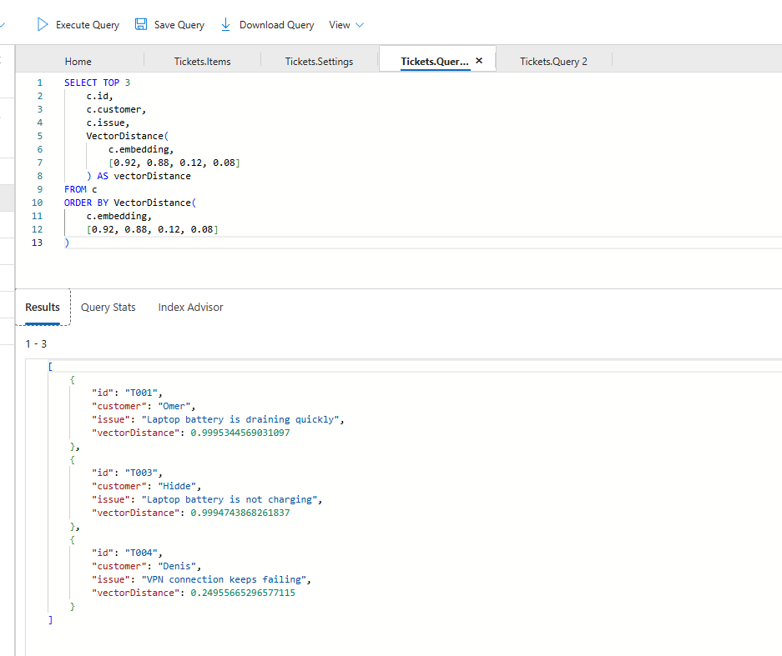
Figure 31 – Vector search results ordered by VectorDistance().

Rank | Ticket | Issue | Distance
1 | T001 | Laptop battery is draining quickly | ~0.9995
2 | T003 | Laptop battery is not charging | ~0.9995
3 | T004 | VPN connection keeps failing | ~0.2496

This confirms Cosmos DB is successfully calculating vector distance and ordering documents by similarity — T001 and T003 are identified as the closest vectors to the query vector.

Step 8 — Run the Vector Search with a Similarity Threshold
SELECT TOP 3
c.id,
c.customer,
c.issue,
VectorDistance(c.embedding, [0.92, 0.88, 0.12, 0.08]) AS similarityScore
FROM c
WHERE VectorDistance(c.embedding, [0.92, 0.88, 0.12, 0.08]) >= 0.8
ORDER BY VectorDistance(c.embedding, [0.92, 0.88, 0.12, 0.08])
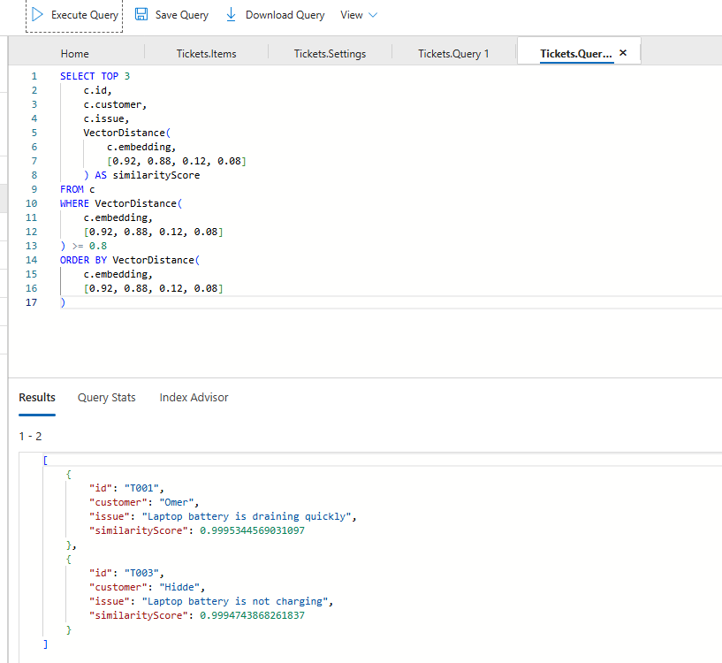
Figure 32 – Vector search filtered by a similarity threshold of 0.8.

Ticket | Issue | Score | Result
T001 | Laptop battery is draining quickly | ~0.9995 | ✅ Include
T003 | Laptop battery is not charging | ~0.9995 | ✅ Include
T004 | VPN connection keeps failing | ~0.2495 | ❌ Exclude

This is a great classroom talking point: vector search finds semantically similar content, and a similarity threshold lets you reject results that aren't relevant enough.

Part H — Final AI-200 Mapping and Wrap-Up
Map everything you did in this lab back to the certification objectives:
AI-200 Objective | What We Did
Build queries for Azure Cosmos DB for NoSQL | SELECT, WHERE, AND, TOP, ORDER BY
Work with JSON documents | Created support-ticket documents
Understand partitioning | /customerId as the partition key
Optimize queries | Targeted queries and field projection
Understand indexing | Reviewed the container's indexing policy
Implement vector search | Embeddings + vector field + vector index
Perform similarity search | VectorDistance()
Combine filtering + vector search | Metadata filters + semantic search
Build AI applications | Connected Cosmos DB to an AI-agent scenario

Final Exam Cheat Sheet
Concept | Think
Cosmos DB hierarchy | Account → Database → Container → Items → JSON data
Query (SELECT / WHERE) | Exact / filter search
Partition key (/customerId) | Data distribution + efficient targeted access
Index | Efficient querying
Vector | Text → Embedding → Numbers → semantic similarity
Vector search (VectorDistance) | “Find things that mean something similar”
AI Agent | User → Agent → Embedding → Cosmos DB Vector Search → Relevant data → LLM → Answer

One Final Mental Model
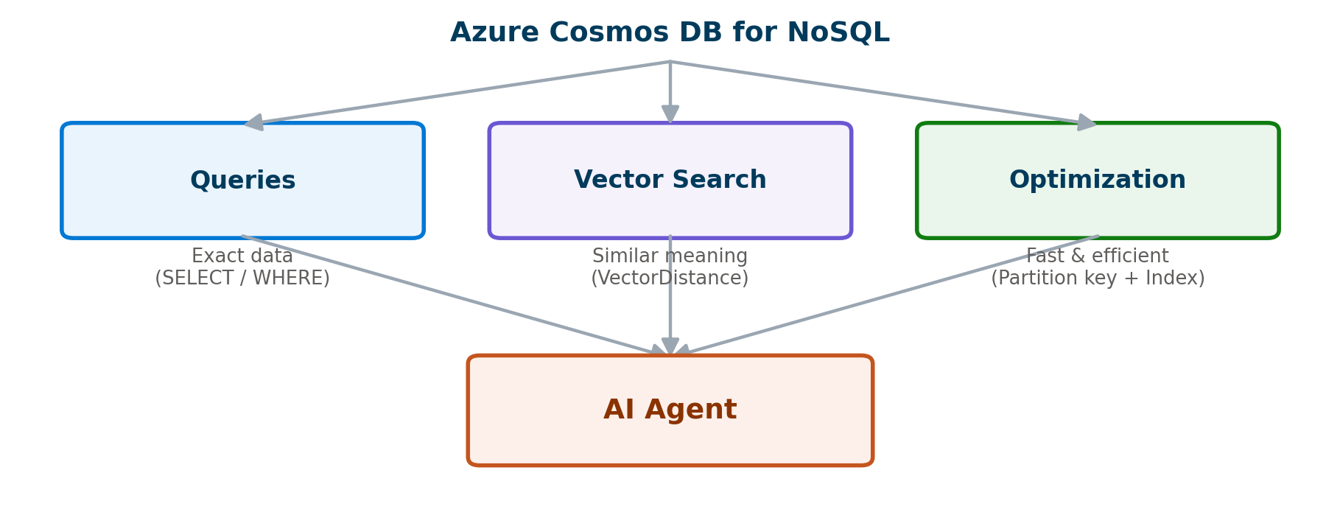
Figure 33 – Queries, vector search, and optimization all feed the AI agent.

Trainer Wrap-Up
SAY THIS TO CLOSE THE DEMO
“Azure Cosmos DB for NoSQL gives our AI solution a scalable JSON data store. Traditional NoSQL queries help the agent retrieve exact information, while vector search allows the agent to retrieve information based on semantic similarity. Partitioning, indexing, and efficient query design help us keep the solution performant and cost-effective.”

That is the core of Module 4.

