MICROSOFT AZURE AI-200 CERTIFICATION
MODULE 5 LAB
Develop AI Solutions with Azure Database for PostgreSQL

HANDS-ON LAB MANUAL
Build → Query → Vector Search → Optimize
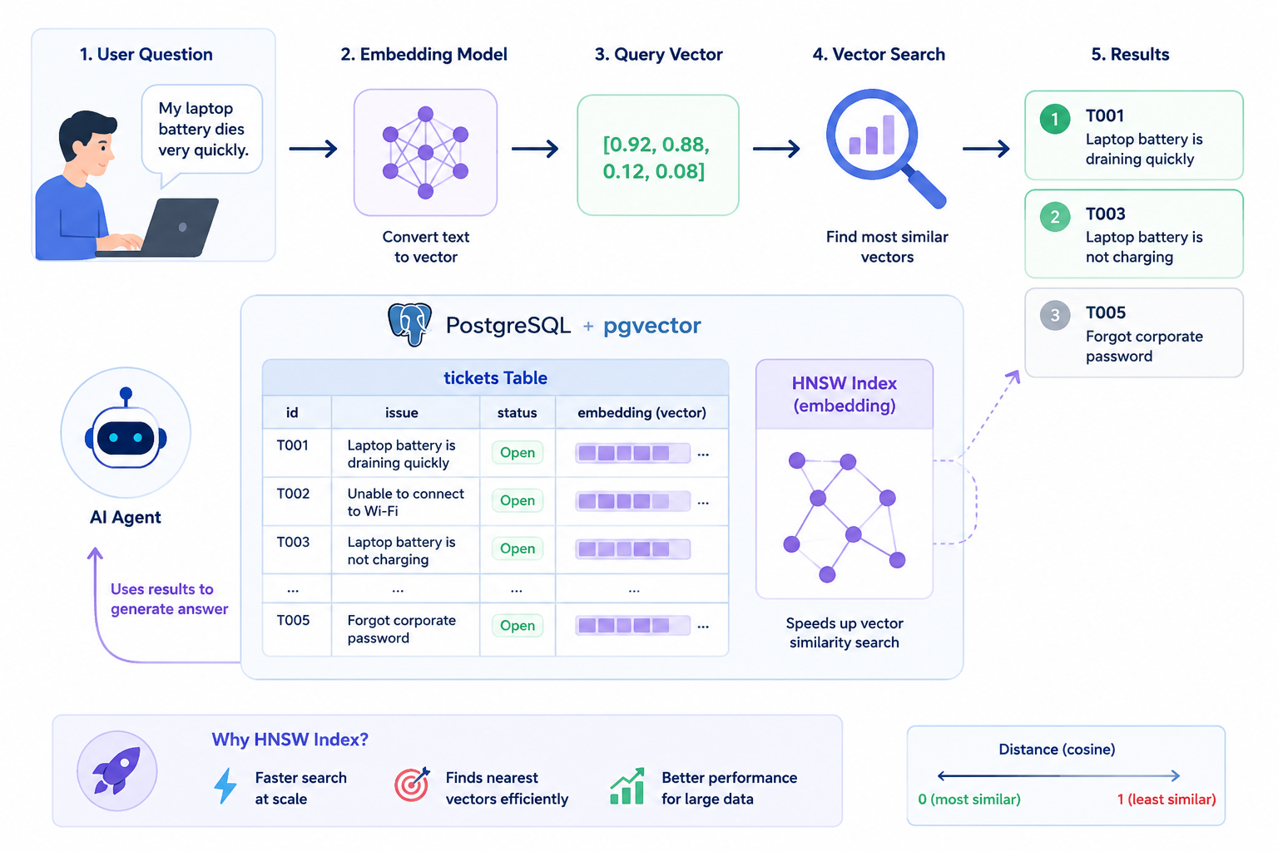
Lab Focus | Level | Estimated Duration | Environment
PostgreSQL + pgvector → vector search → HNSW | Beginner | 60–90 minutes | Azure Portal + Cloud Shell (psql)

Certification Training Series • AI-200: Designing and Implementing an AI Solution

Table of Contents
The list below updates automatically from the section headings in this document. In Microsoft Word, right-click anywhere in the list and select “Update Field” (or press F9) to refresh page numbers.

Lab Overview
In Module 4, you used Azure Cosmos DB for NoSQL to store support tickets and perform vector search. In this lab, you will do the same thing using a different Azure database: Azure Database for PostgreSQL.
PostgreSQL is one of the most popular relational databases in the world. With the pgvector extension, PostgreSQL can also store embeddings and perform vector search — which makes it a great option for AI solutions that already use PostgreSQL for regular application data.
NOTE
This lab uses the same support-ticket scenario as Module 4 so you can focus on what's different: how PostgreSQL and pgvector do the same job.

Learning Objectives
By the end of this lab, you will be able to:
- Create an Azure Database for PostgreSQL flexible server
- Connect to PostgreSQL using Azure Cloud Shell and psql
- Create a database and a table
- Insert sample support-ticket data, including embeddings
- Run traditional SQL queries
- Enable the pgvector extension for vector search
- Perform a vector similarity search
- Combine SQL filtering with vector search
- Create an HNSW index to optimize vector search
- Understand how an AI agent can use PostgreSQL as a vector store

TRAINER TIP
This lab is designed to run live using the Azure Portal and Azure Cloud Shell. No local tools or installation are required.

Scenario
A company stores IT support tickets in Azure Database for PostgreSQL. An employee asks the IT AI agent a question:
USER QUESTION
“My laptop battery dies very quickly.”

The AI agent converts that question into an embedding, then searches PostgreSQL for similar support tickets — even if the wording is completely different from what's stored in the database.
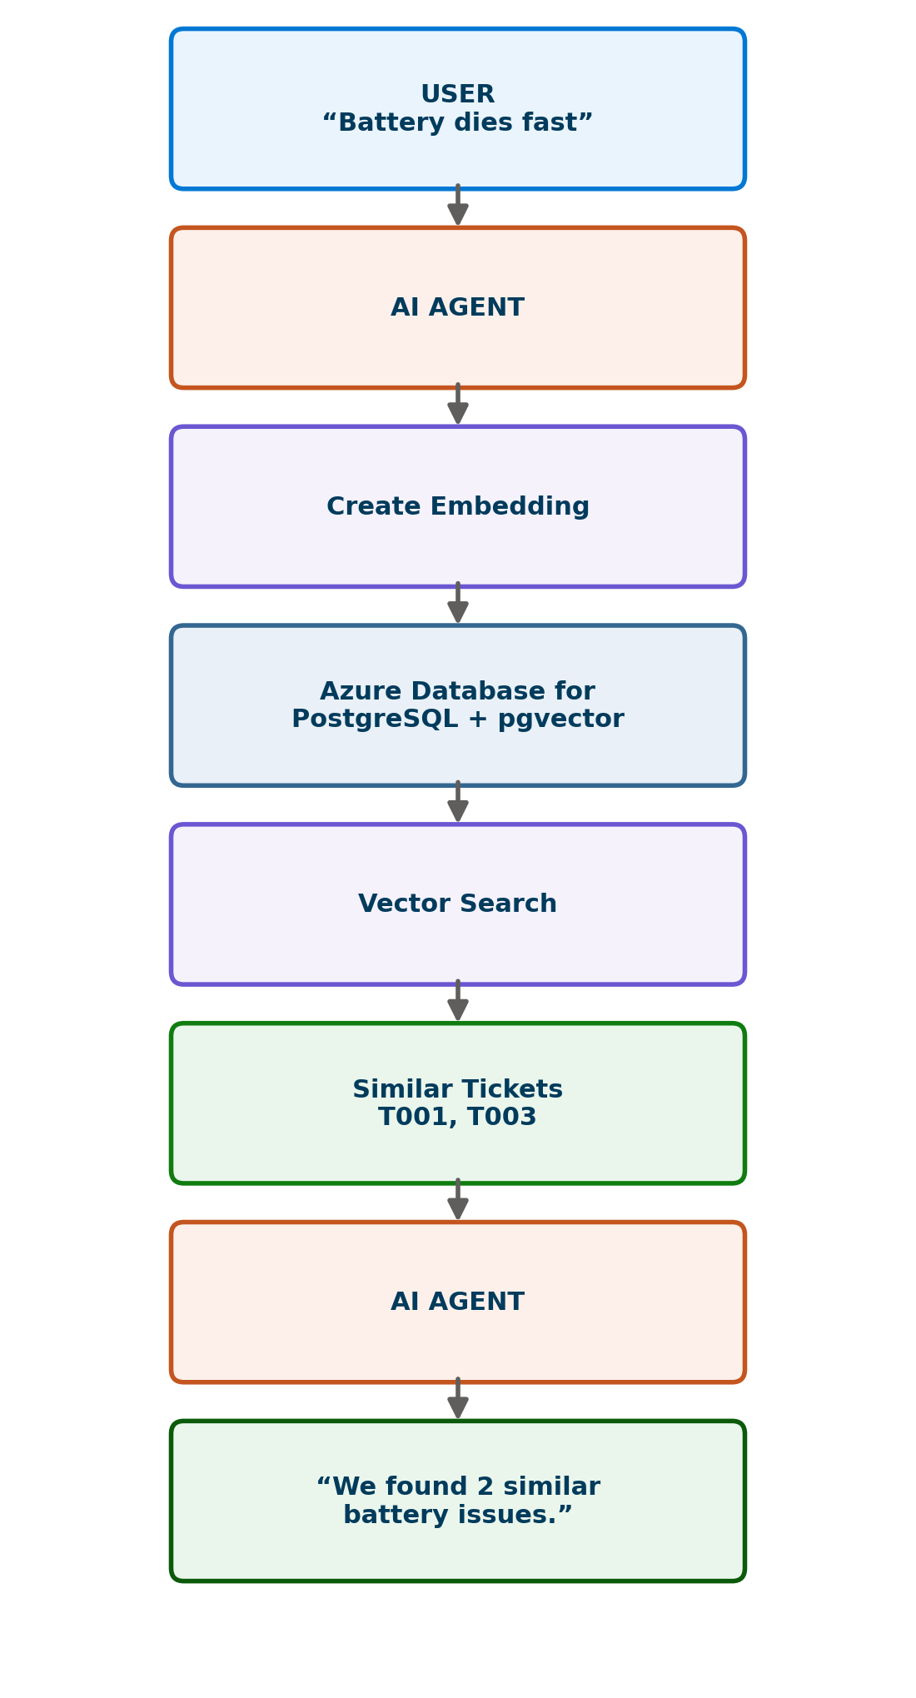
Figure 1 – How the AI agent uses PostgreSQL + pgvector to answer the user's question.

Architecture
The diagram below shows the full flow this lab demonstrates: a user question becomes an embedding, the embedding becomes a query vector, PostgreSQL with pgvector performs the vector search, and the closest matching tickets are returned to the AI agent.
Figure 2 – From user question to AI agent response, powered by PostgreSQL + pgvector.
The flow, step by step:
- User Question — the employee describes their problem in plain language.
- Embedding — an AI embedding model converts the question into numbers.
- Query Vector — those numbers form a vector that represents the meaning of the question.
- PostgreSQL + pgvector — the vector is compared against the embeddings stored in the tickets table.
- Vector Search — PostgreSQL finds the closest matching vectors.
- Similar Tickets — the AI agent uses these results to ground its answer.

Prerequisites
Keep this short — you only need the following before starting:
- An active Azure subscription
- Access to the Azure Portal (portal.azure.com)
- Basic understanding of SQL
- Basic understanding of Azure AI concepts

NOTE
Azure pricing and free-tier options can change. Verify current pricing in the Azure Portal before your session.

Lab Environment
This lab uses two tools, both built into the Azure Portal — no local installation is required:
Tool | What It's For
Azure Portal | Create the PostgreSQL server and configure the vector extension.
Azure Cloud Shell (Bash) + psql | Connect to PostgreSQL and run SQL commands.

What you will build:
Item | Name Used in This Lab
Server | ai200-postgres-<unique>
Database | itsupport
Table | tickets
Rows (documents) | T001, T002, T003, T004, T005
Index | tickets_embedding_idx (HNSW)

Create Azure Database for PostgreSQL
In this section you will create the Azure Database for PostgreSQL flexible server that will host your support-ticket database.

Step 1 — Open the Azure Portal
🎯 Objective: Find the Azure Database for PostgreSQL service in the Azure Portal.
💡 Why? This is the Azure resource that hosts your PostgreSQL server.
🛠️ Do This
1. Sign in to the Azure Portal.
2. Select Create a resource.
3. Search for: Azure Database for PostgreSQL flexible server
📸 Screenshot
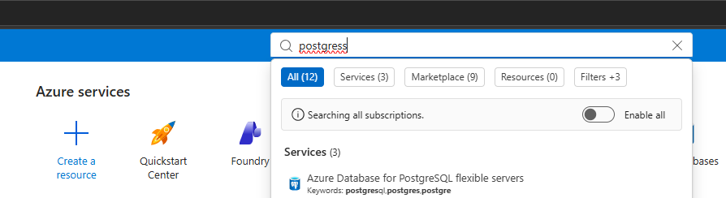
Figure 3 – Searching for Azure Database for PostgreSQL flexible servers.
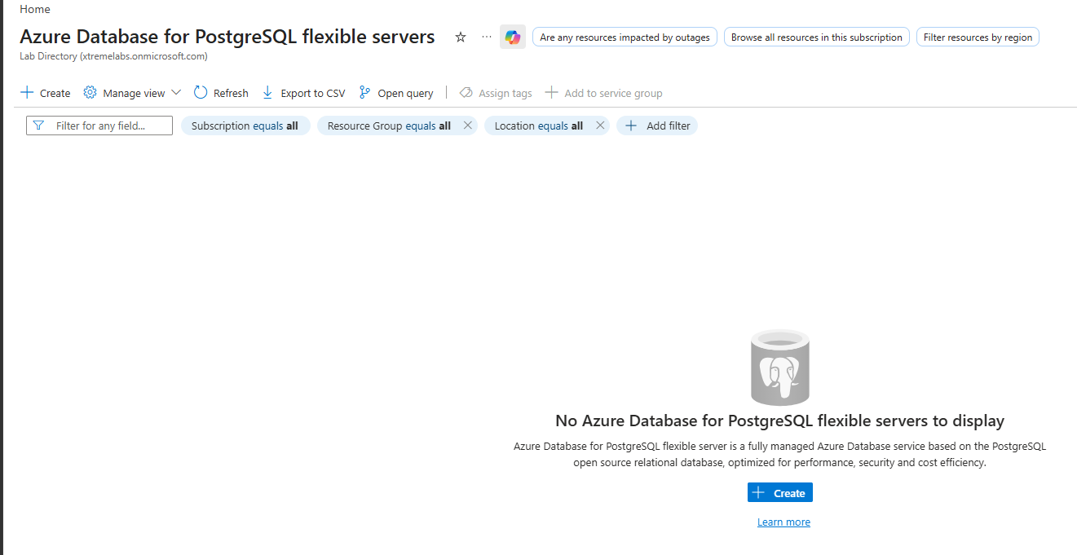
Figure 4 – The Azure Database for PostgreSQL flexible servers overview page.
✅ Expected Result
You see the Azure Database for PostgreSQL flexible servers page, with a Create button.

Step 2 — Create the Server
🎯 Objective: Configure and create your PostgreSQL flexible server using simple classroom settings.
💡 Why? The server is the container that will host your itsupport database.
🛠️ Do This
On the Basics tab, use the following settings:
Setting | Value
Subscription | Your subscription
Resource group | rg-ai200-lab
Server name | ai200-postgres-<unique>
Region | Your preferred region
PostgreSQL version | Current supported version
Workload type | Development
Compute | Smallest suitable option

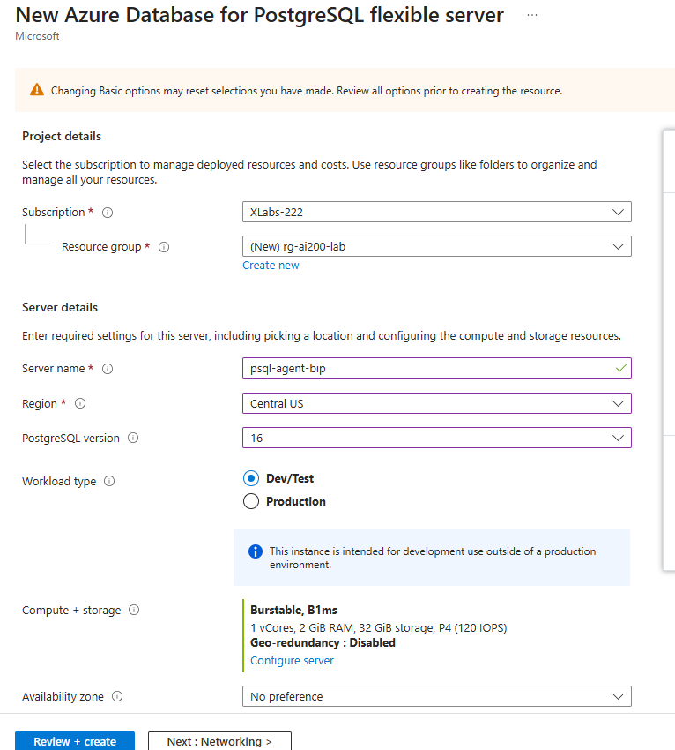
Figure 5 – Basic server settings.
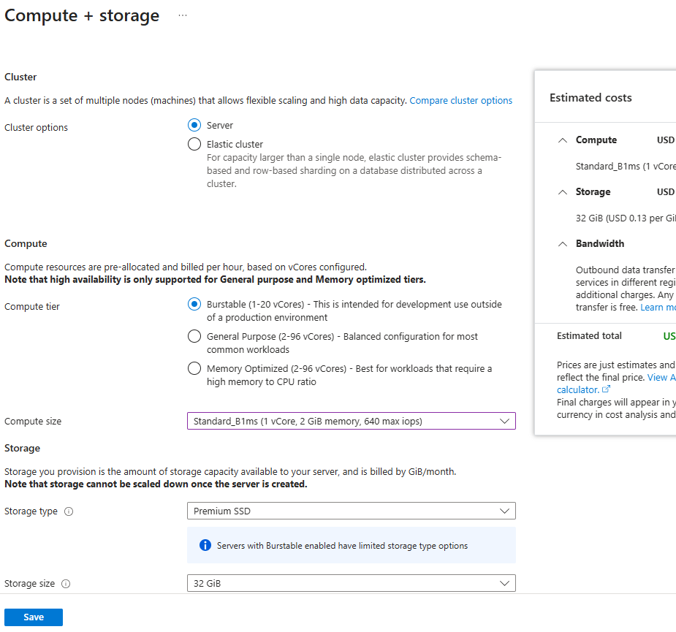
Figure 6 – Compute and storage settings.
Create an administrator account:
Username: pgadmin
Set a password and save it somewhere safe — you will need it to connect.
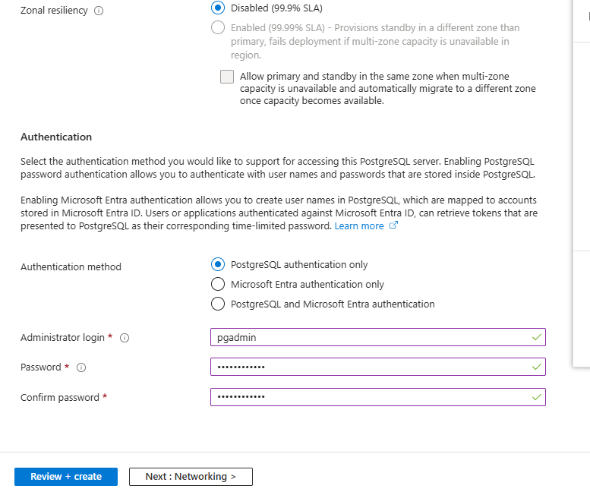
Figure 7 – Setting the PostgreSQL administrator account.
IMPORTANT
Write down your password now. You will need it in the next section to connect to PostgreSQL.

Finish creating the server:
1. Select Review + create.
2. Select Create.
3. Wait for deployment to finish.
📸 Screenshot
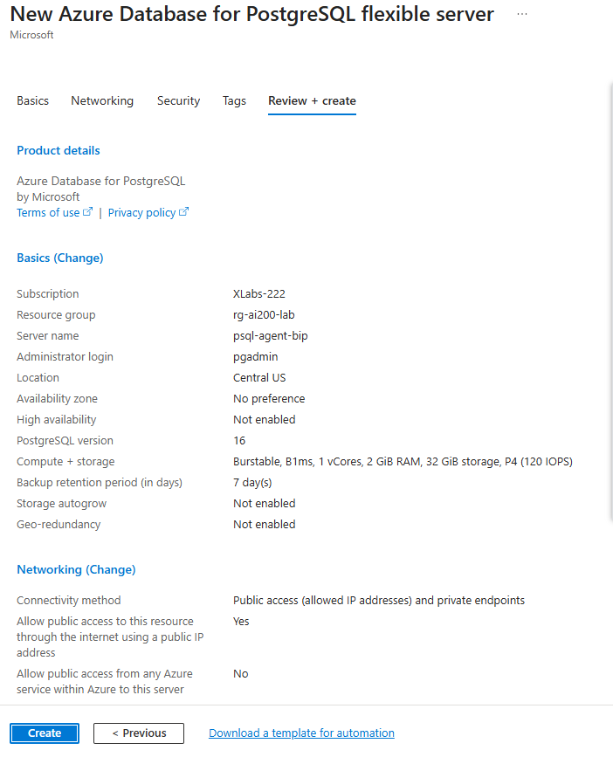
Figure 8 – Review + create summary.
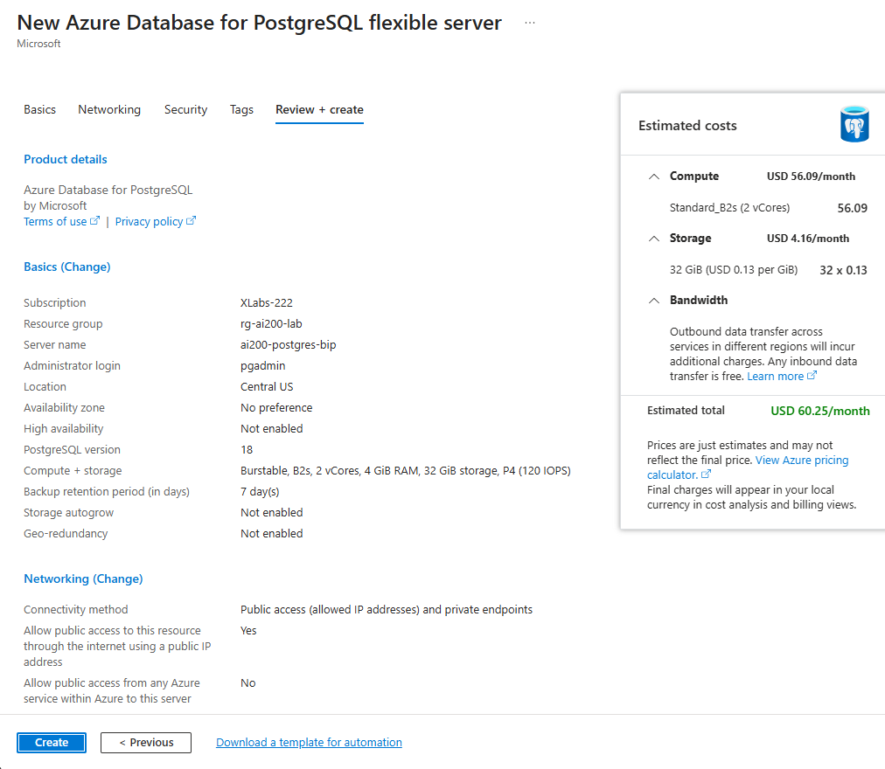
Figure 9 – Deployment in progress.
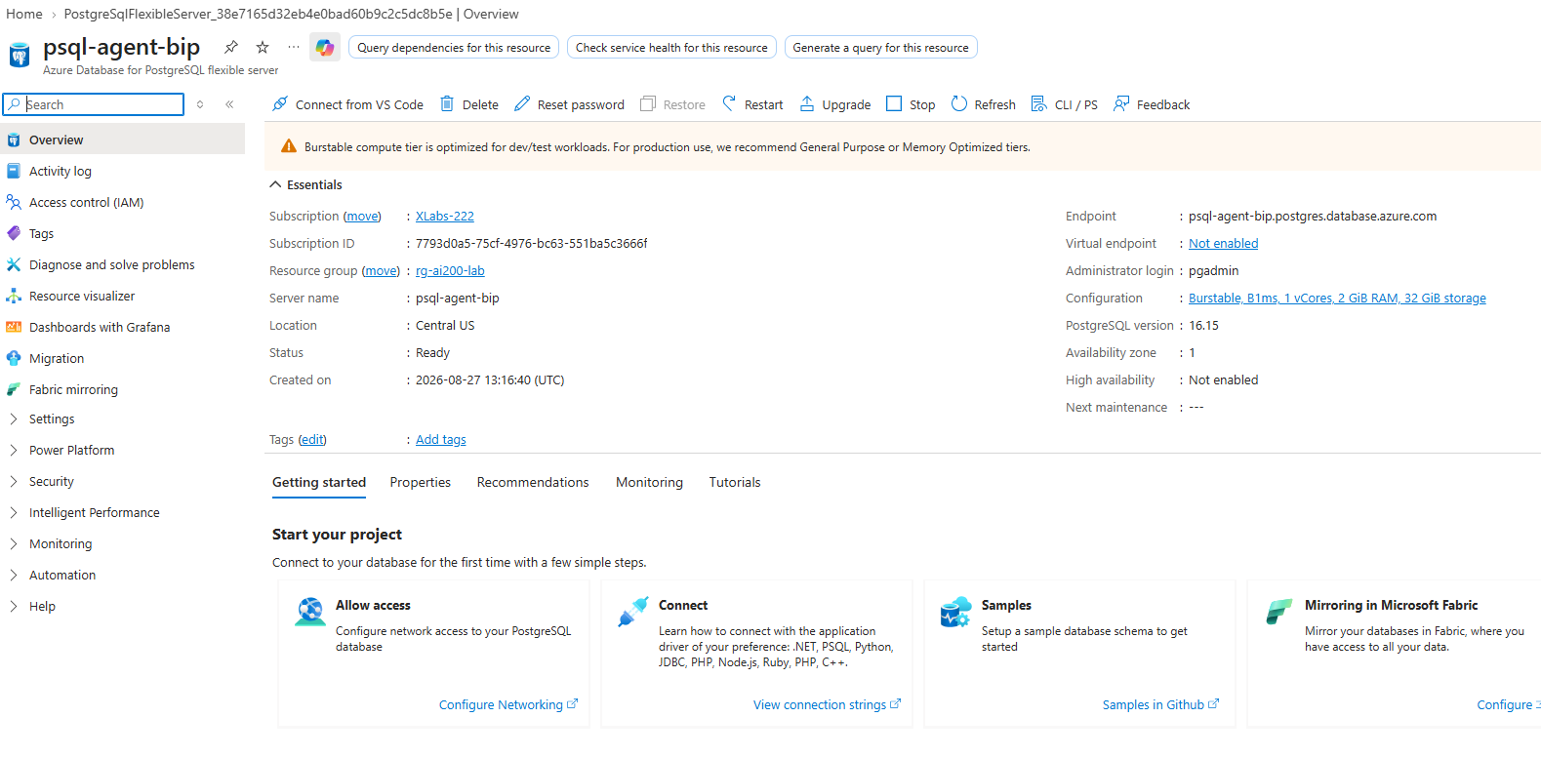
Figure 10 – Deployment complete.
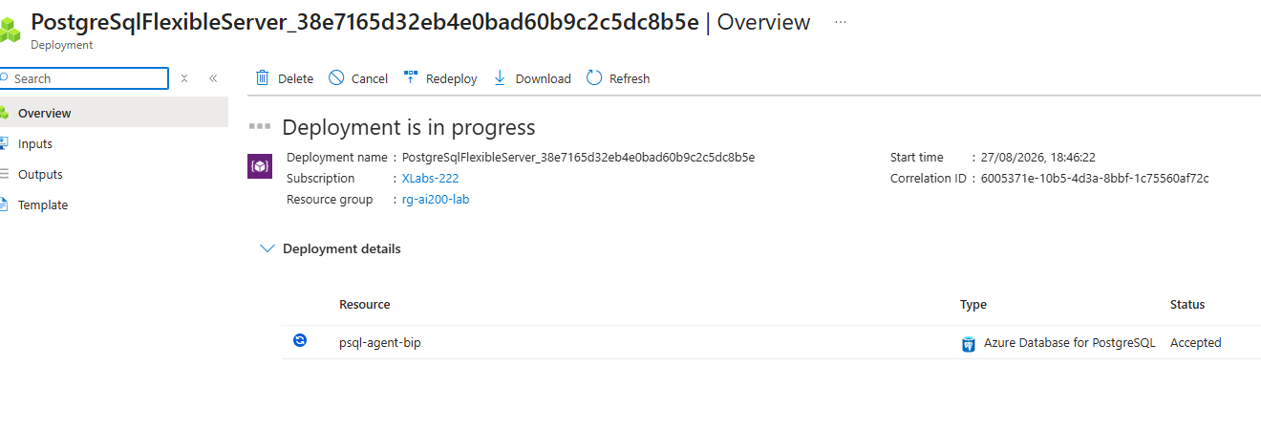
Figure 11 – The new PostgreSQL flexible server resource.
✅ Expected Result
Your new PostgreSQL flexible server is deployed and ready to use.

Connect to PostgreSQL
For this classroom lab, you will connect using Azure Cloud Shell and the psql command-line tool. Both are built into the Azure Portal — nothing to install.

Step 3 — Connect Using Cloud Shell + psql
🎯 Objective: Open a SQL session against your new PostgreSQL server.
💡 Why? You need an active connection before you can run any SQL commands.
🛠️ Do This
1. In the Azure Portal, open Cloud Shell and select Bash.
2. Run the psql command below, replacing <SERVER_NAME> with your own server name.
psql "host=<SERVER_NAME>.postgres.database.azure.com port=5432 dbname=postgres user=pgadmin sslmode=require"
Enter your password when prompted.
📸 Screenshot
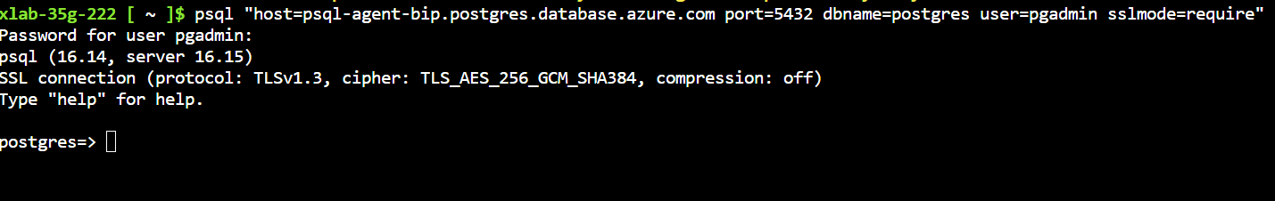
Figure 12 – Connecting to PostgreSQL with psql in Cloud Shell.
✅ Expected Result
You should see a prompt similar to:

postgres=>
📝 Instructor Note
This confirms you are connected to PostgreSQL and ready to run SQL commands for the rest of the lab.

Create Database and Table
Now that you're connected to PostgreSQL, you will create a dedicated database, enable vector search, and create the table that will hold your support tickets.

Step 4 — Create the itsupport Database
🎯 Objective: Create a new database to keep this lab's data separate from the default postgres database.
💡 Why? Using a dedicated database keeps your lab data organized, just like a container in Cosmos DB.
🛠️ Do This
Run:
CREATE DATABASE itsupport;
📸 Screenshot
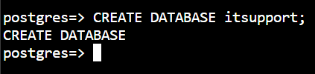
Figure 13 – Creating the itsupport database.
Then connect to it:
\c itsupport
📸 Screenshot
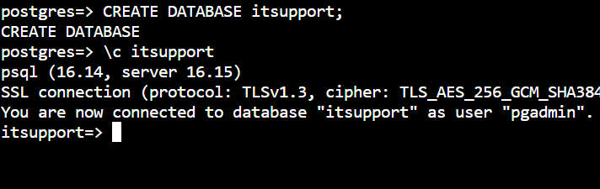
Figure 14 – Connecting to the itsupport database.
✅ Expected Result
You should see:

You are now connected to database "itsupport".

Enable Vector Search (pgvector)
WHAT IS PGVECTOR?
pgvector allows PostgreSQL to store and search numerical representations of text called embeddings. It adds a new data type (vector) and new operators for comparing vectors — which is exactly what you need for AI-powered search.


Figure 15 – Text becomes an embedding, then a vector, then something PostgreSQL can search by similarity.
Azure Database for PostgreSQL uses the PostgreSQL vector extension for pgvector. Before you can create the extension, Azure requires it to be added to the server's allow list.

Step 5 — Allow the Vector Extension
🎯 Objective: Add vector to the server's list of allowed extensions in the Azure Portal.
💡 Why? Azure Database for PostgreSQL only allows extensions that have been explicitly enabled at the server level.
🛠️ Do This
1. In the Azure Portal, open your PostgreSQL Flexible Server.
2. Go to Settings → Parameters.
3. Search for: azure.extensions
📸 Screenshot
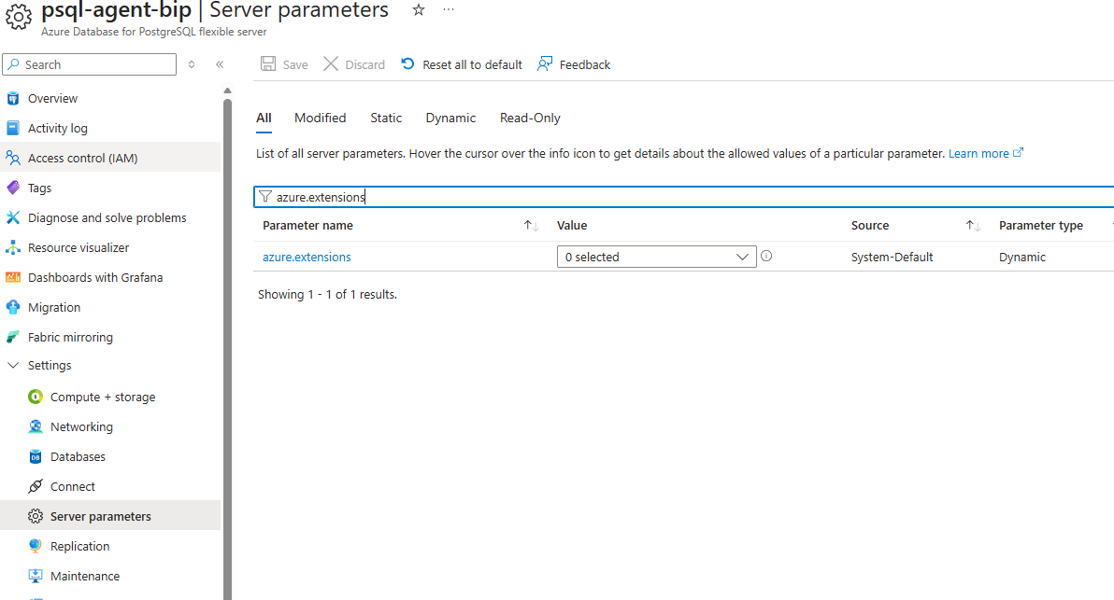
Figure 16 – The server's Parameters page, searching for azure.extensions.
1. In the value list, add: VECTOR
2. Select Save.
📸 Screenshot
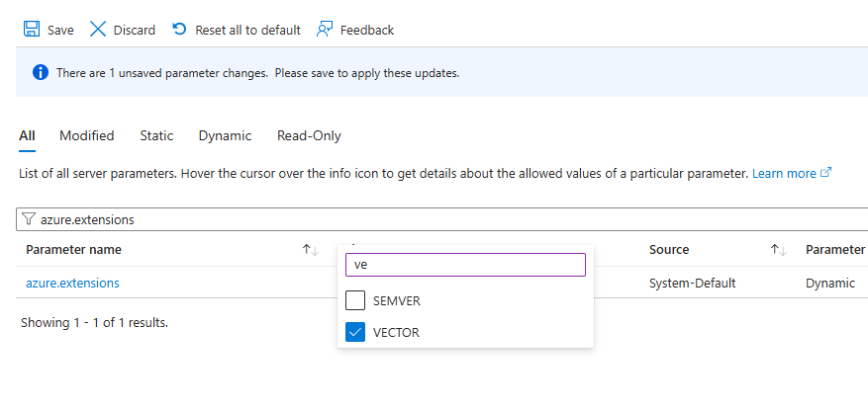
Figure 17 – Adding VECTOR to the azure.extensions parameter.
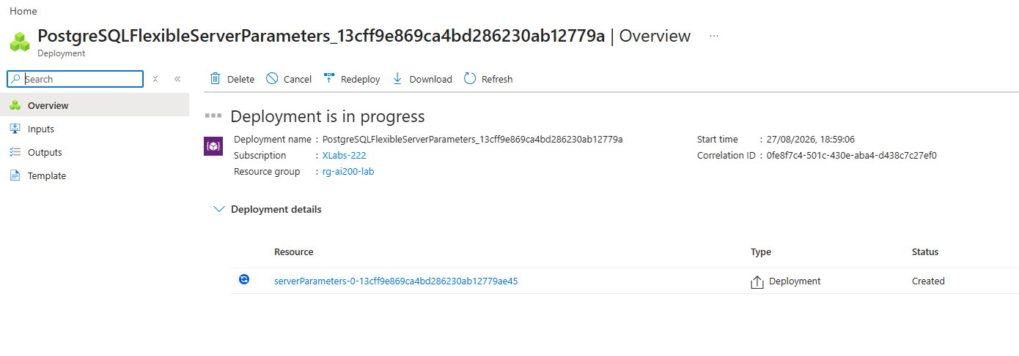
Figure 18 – Saving the updated server parameters.
✅ Expected Result
The parameter change is saved and deployed to the server.

Step 6 — Install the Extension
🎯 Objective: Turn on pgvector inside the itsupport database.
💡 Why? Allow-listing the extension in Azure is not enough — it must also be created inside the database you want to use it in.
🛠️ Do This
Back in your psql session, run:
CREATE EXTENSION vector;
📸 Screenshot
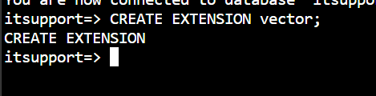
Figure 19 – Creating the vector extension.
Verify it was installed:
\dx
📸 Screenshot
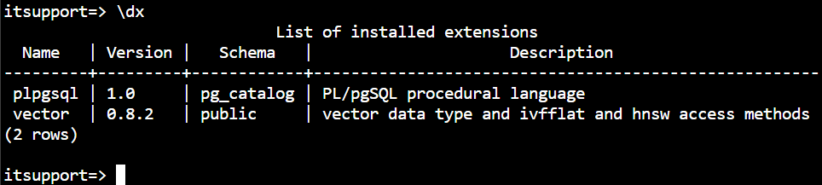
Figure 20 – Confirming the vector extension is installed.
✅ Expected Result
You should see vector listed among the installed extensions.

📝 Instructor Note
Vector search is now enabled. From this point on, the itsupport database can store embeddings using the vector data type.

Create the Support Ticket Table

Step 7 — Create the tickets Table
🎯 Objective: Create a table that stores both regular ticket fields and an embedding column.
💡 Why? This single table will support both traditional SQL queries and vector search — the same way a Cosmos DB container did in Module 4.
🛠️ Do This
Run:
CREATE TABLE tickets (
id VARCHAR(10) PRIMARY KEY,
customer VARCHAR(50),
issue TEXT,
category VARCHAR(30),
status VARCHAR(20),
priority VARCHAR(20),
embedding VECTOR(4)
);
📸 Screenshot
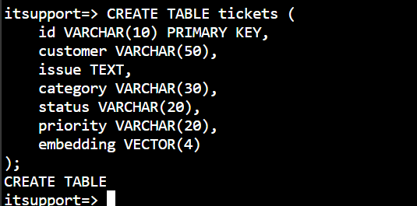
Figure 21 – Creating the tickets table.
✅ Expected Result
You should see:

CREATE TABLE
WHY VECTOR(4)?
For this classroom demonstration, we use only 4 dimensions so the vectors stay easy to read and understand.
In a real AI application, the dimension must match the embedding model you actually use — real embedding models typically produce hundreds or thousands of dimensions.

Insert Support Tickets (with Embeddings)
You will now insert five support tickets. Each ticket includes a small 4-number embedding, so it can be used for both traditional queries and vector search.
WHAT IS AN EMBEDDING?
An embedding is a list of numbers that represents the meaning of a piece of text. Tickets about similar problems (like two different laptop battery issues) end up with similar numbers.

Step 8 — Insert Ticket 1
🎯 Objective: Add the first support ticket, including its embedding.
💡 Why? This is the ticket the AI agent should find when a user asks about a laptop battery issue.
🛠️ Do This
INSERT INTO tickets
(id, customer, issue, category, status, priority, embedding)
VALUES
(
'T001',
'Omer',
'Laptop battery is draining quickly',
'Laptop',
'Open',
'High',
'[0.92,0.88,0.12,0.08]'
);
📸 Screenshot
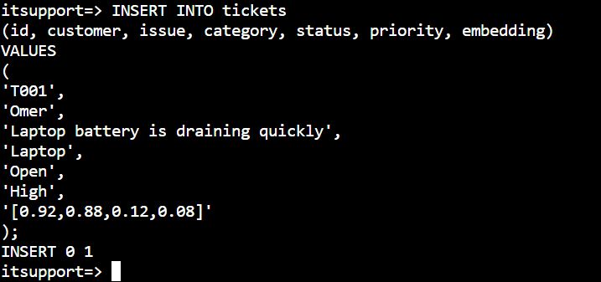
Figure 22 – Inserting ticket T001.
✅ Expected Result
INSERT 0 1

Step 9 — Insert Ticket 2
🛠️ Do This
INSERT INTO tickets
(id, customer, issue, category, status, priority, embedding)
VALUES
(
'T002',
'Arnab',
'Unable to connect to office Wi-Fi',
'Network',
'Open',
'Medium',
'[0.10,0.15,0.90,0.85]'
);
📸 Screenshot
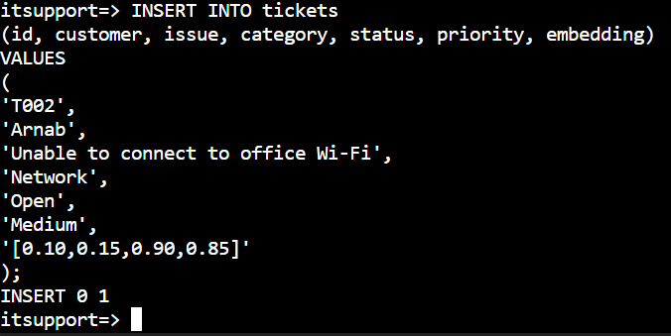
Figure 23 – Inserting ticket T002.

Step 10 — Insert Ticket 3
🛠️ Do This
INSERT INTO tickets
(id, customer, issue, category, status, priority, embedding)
VALUES
(
'T003',
'Hidde',
'Laptop battery is not charging',
'Laptop',
'Open',
'High',
'[0.91,0.87,0.15,0.10]'
);
📸 Screenshot
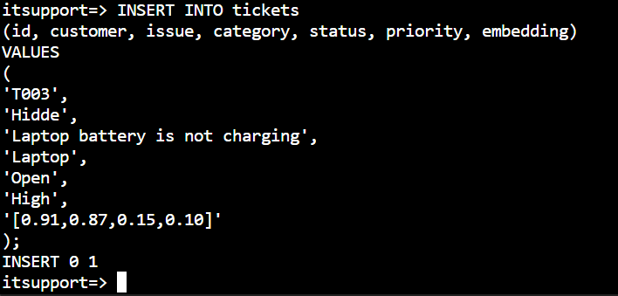
Figure 24 – Inserting ticket T003.
📝 Instructor Note
Notice that T001 and T003 have very similar embeddings. That's intentional — they describe similar laptop battery problems.

Step 11 — Insert Ticket 4
🛠️ Do This
INSERT INTO tickets
(id, customer, issue, category, status, priority, embedding)
VALUES
(
'T004',
'Denis',
'VPN connection keeps failing',
'Network',
'Closed',
'High',
'[0.20,0.10,0.90,0.80]'
);
📸 Screenshot
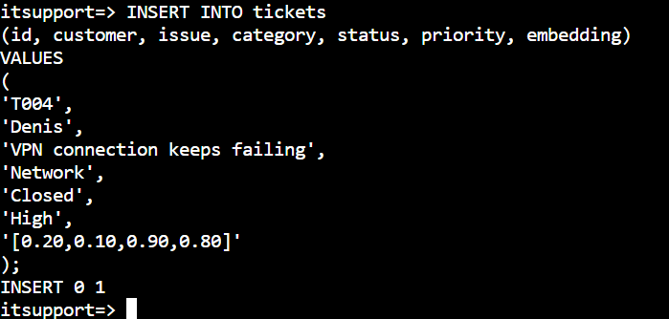
Figure 25 – Inserting ticket T004.

Step 12 — Insert Ticket 5
🛠️ Do This
INSERT INTO tickets
(id, customer, issue, category, status, priority, embedding)
VALUES
(
'T005',
'Ilie',
'Forgot corporate password',
'Identity',
'Open',
'Medium',
'[0.05,0.10,0.20,0.95]'
);
📸 Screenshot
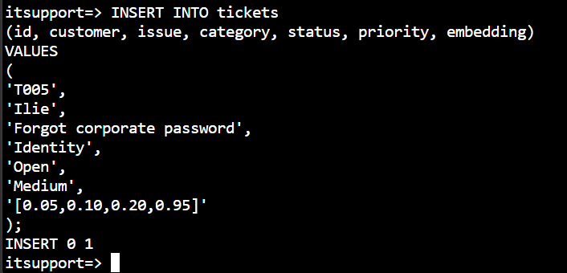
Figure 26 – Inserting ticket T005.

Summary of the tickets you just inserted:
ID | Customer | Issue | Category | Status | Priority
T001 | Omer | Laptop battery is draining quickly | Laptop | Open | High
T002 | Arnab | Unable to connect to office Wi-Fi | Network | Open | Medium
T003 | Hidde | Laptop battery is not charging | Laptop | Open | High
T004 | Denis | VPN connection keeps failing | Network | Closed | High
T005 | Ilie | Forgot corporate password | Identity | Open | Medium

Run Traditional SQL Queries
Before introducing vector search, let's demonstrate normal SQL against the tickets table. This is the same kind of query you would run against any PostgreSQL database.

Figure 27 – Traditional SQL reads the stored columns and returns matching rows.

Step 13 — View All Tickets
🎯 Objective: Retrieve every row from the tickets table.
💡 Why? This confirms all five tickets were inserted correctly.
🛠️ Do This
SELECT *
FROM tickets;
📸 Screenshot
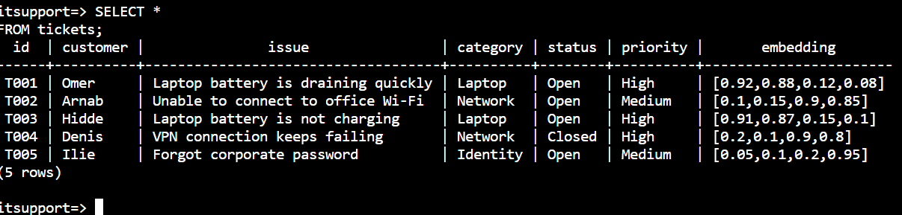
Figure 28 – SELECT * FROM tickets results.
✅ Expected Result
All five tickets (T001–T005) are returned, including their embedding column.

📝 Instructor Note
This is traditional database searching. PostgreSQL looks at the stored columns and returns matching rows — no AI involved yet.

Step 14 — Filter Tickets by Category
🎯 Objective: Retrieve only the tickets in the Laptop category.
💡 Why? This shows how PostgreSQL filters data using an exact match on a column value.
🛠️ Do This
SELECT id, customer, issue
FROM tickets
WHERE category = 'Laptop';
📸 Screenshot
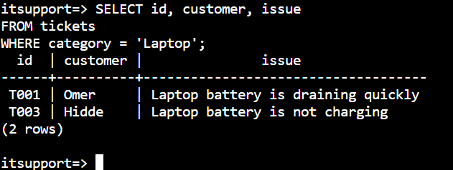
Figure 29 – Filtering tickets where category = 'Laptop'.
✅ Expected Result
T001 Omer Laptop battery is draining quickly
T003 Hidde Laptop battery is not charging

📝 Instructor Note
This demonstrates traditional SQL filtering — an exact match on the category column.

Traditional SQL vs. Vector Search
Traditional SQL and vector search solve different problems. PostgreSQL with pgvector can do both, on the very same table.
Traditional SQL | Vector Search
Searches structured data | Searches semantic meaning
Uses SQL conditions | Uses vector similarity
Example: WHERE category = 'Laptop' | Example: vector distance (<=>)
Exact / attribute-based | Meaning / similarity-based

Perform Vector Search
Now let's introduce the AI scenario from the beginning of this lab. The user asks:
USER QUESTION
“My laptop battery dies very fast.”

An AI embedding model would normally convert that question into a vector automatically. For this classroom demo, we represent that question with the same illustrative query vector used in Module 4:
[0.92, 0.88, 0.12, 0.08]
IMPORTANT
This is an illustrative vector chosen by hand to demonstrate the concept clearly — not an embedding actually generated by an AI model.


Figure 30 – The user's question becomes an embedding, then a query vector, then a vector search.
Flow:
- User Question
- Embedding Model
- Query Vector
- PostgreSQL
- Find Similar Vectors

Step 15 — Run the Vector Search Query
🎯 Objective: Find the tickets whose embeddings are closest to the query vector.
💡 Why? This is how the AI agent finds semantically similar tickets, even when the exact words don't match.
🛠️ Do This
Run:
SELECT
id,
customer,
issue,
embedding <=> '[0.92,0.88,0.12,0.08]'::vector
AS distance
FROM tickets
ORDER BY
embedding <=> '[0.92,0.88,0.12,0.08]'::vector
LIMIT 3;
WHAT DOES <=> MEAN?
The <=> operator performs cosine distance with pgvector. The smaller the distance, the more similar the two vectors are.
LIMIT 3 simply returns the 3 closest results.

📸 Screenshot
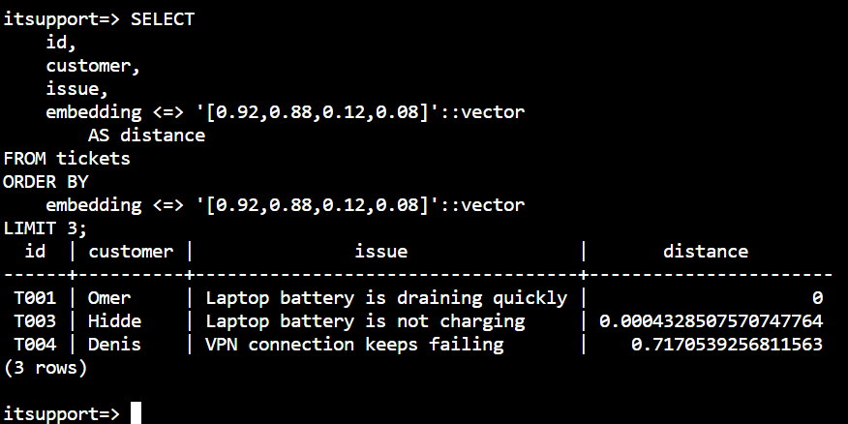
Figure 31 – Vector search results ordered by distance.
Expected result:
ID | Customer | Issue | Distance
T001 | Omer | Laptop battery is draining quickly | 0 (exact match)
T003 | Hidde | Laptop battery is not charging | 0.00043 (very close)
T004 | Denis | VPN connection keeps failing | 0.717 (far away)

📝 Instructor Note
T001 and T003 are closest to the query vector because they represent similar laptop/battery problems. T004 (a VPN issue) is much farther away, even though it's still a Network-related ticket.

Combine SQL Filtering with Vector Search
Real AI agents rarely use vector search alone. Suppose the AI agent should only return tickets that are still Open — closed tickets aren't useful to a user right now.

Step 16 — Filter by Status AND Search by Similarity
🎯 Objective: Combine a normal SQL condition (WHERE status = 'Open') with vector similarity ordering.
💡 Why? This shows that PostgreSQL can do both traditional SQL and AI vector search in the very same query.
🛠️ Do This
Run:
SELECT
id,
customer,
issue,
status,
embedding <=> '[0.92,0.88,0.12,0.08]'::vector
AS distance
FROM tickets
WHERE status = 'Open'
ORDER BY
embedding <=> '[0.92,0.88,0.12,0.08]'::vector
LIMIT 3;
📸 Screenshot
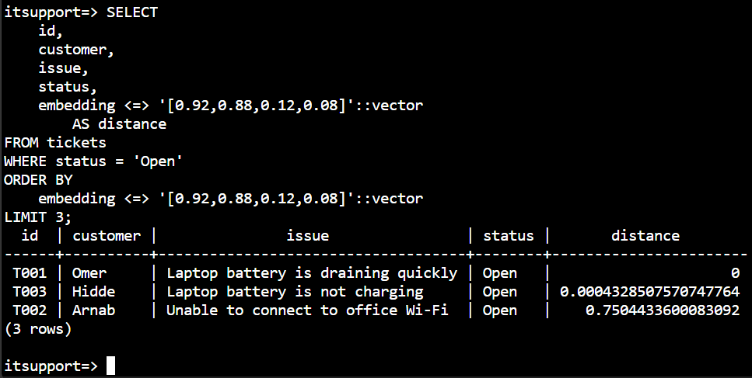
Figure 32 – Vector search combined with a WHERE status = 'Open' filter.
Expected result:
ID | Customer | Issue | Status | Distance
T001 | Omer | Laptop battery is draining quickly | Open | 0
T003 | Hidde | Laptop battery is not charging | Open | 0.00043
T002 | Arnab | Unable to connect to office Wi-Fi | Open | 0.750

Notice that T004 (VPN issue) is now excluded automatically — not because it's dissimilar, but because it's Closed.
Figure 33 – User question → vector search → similarity ranking → WHERE status = 'Open' → relevant open tickets.
AI-200 EXAM TIP
This is a great AI-200 example because PostgreSQL is doing both traditional SQL (WHERE status = 'Open') and AI vector search (ORDER BY embedding <=> ...) in the same query.

Create HNSW Index
WHAT IS HNSW?
HNSW is an index that helps PostgreSQL perform vector similarity searches more efficiently, especially as the amount of vector data grows.

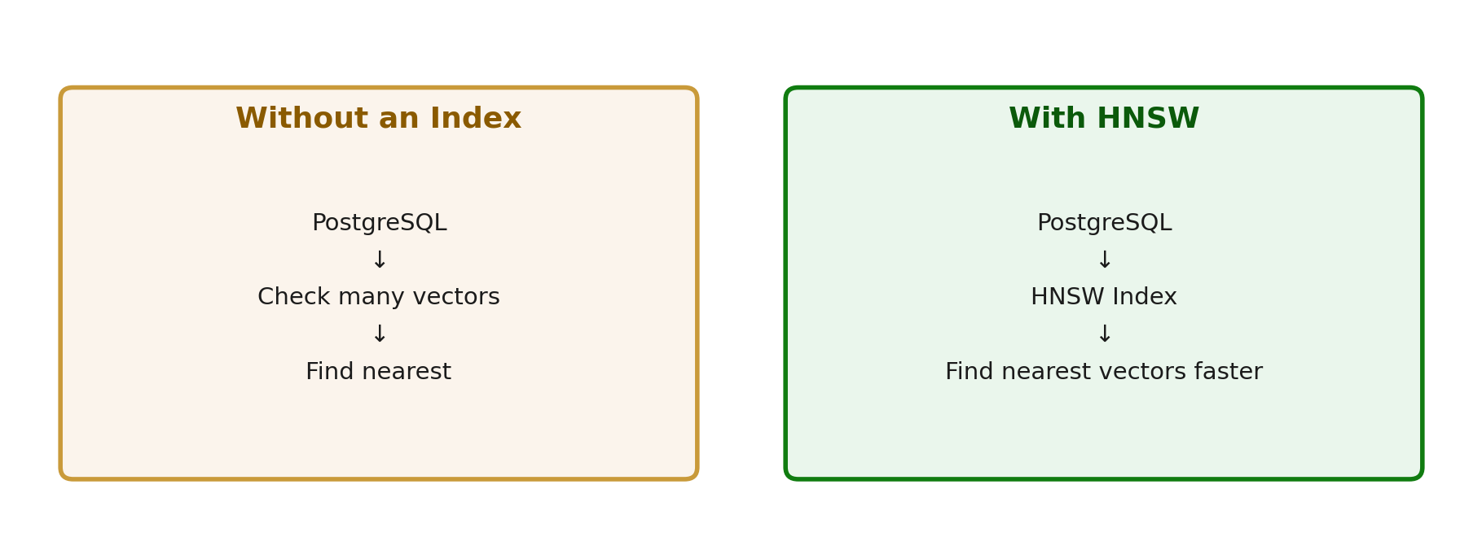
Figure 34 – Without an index, PostgreSQL checks many vectors one by one. With HNSW, it can find the nearest vectors faster.

Step 17 — Create the HNSW Index
🎯 Objective: Create an HNSW index on the embedding column.
💡 Why? As a table grows to thousands or millions of rows, an index helps PostgreSQL find similar vectors much faster.
🛠️ Do This
Run:
CREATE INDEX tickets_embedding_idx
ON tickets
USING hnsw (embedding vector_cosine_ops);
📸 Screenshot
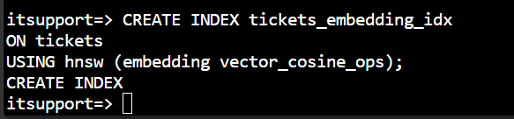
Figure 35 – Creating the HNSW index on the embedding column.
✅ Expected Result
CREATE INDEX

📝 Instructor Note
vector_cosine_ops tells PostgreSQL to build the index for cosine distance — the same distance measure used by the <=> operator.
Because this lab contains only a few records, PostgreSQL may not visibly use the HNSW index in the execution plan. The purpose of this step is to understand how vector search can be optimized for larger datasets.

Test the Optimized Search

Step 18 — Confirm the Index Exists
🎯 Objective: Verify that the HNSW index was created successfully.
💡 Why? It's good practice to confirm an index exists before relying on it.
🛠️ Do This
SELECT indexname
FROM pg_indexes
WHERE tablename = 'tickets';
📸 Screenshot
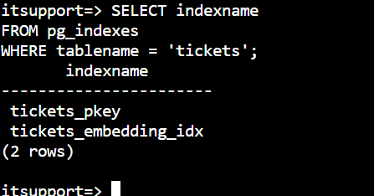
Figure 36 – Confirming the tickets_embedding_idx index exists.
✅ Expected Result
tickets_pkey
tickets_embedding_idx

Step 19 — Run the Vector Search Again
🎯 Objective: Re-run the same combined query from the previous section, now that the index exists.
💡 Why? This lets you compare behavior with and without the index in place.
🛠️ Do This
SELECT
id,
customer,
issue,
status,
embedding <=> '[0.92,0.88,0.12,0.08]'::vector AS distance
FROM tickets
WHERE status = 'Open'
ORDER BY embedding <=> '[0.92,0.88,0.12,0.08]'::vector
LIMIT 3;
📸 Screenshot
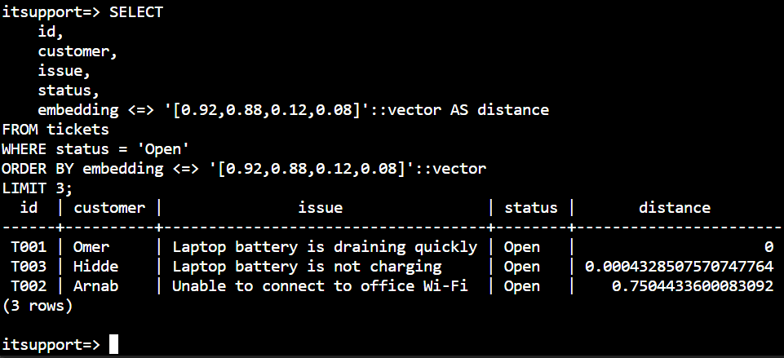
Figure 37 – Running the same vector search query after creating the index.
✅ Expected Result
You get the same three results as before: T001, T003, and T002 — T001 and T003 are closest to the query vector because they represent similar laptop/battery problems.

Step 20 — See the Query Execution Plan
🎯 Objective: Use EXPLAIN to see how PostgreSQL actually executes the query.
💡 Why? This shows whether PostgreSQL chose to use the HNSW index or scan the table directly.
🛠️ Do This
EXPLAIN
SELECT
id,
customer,
issue
FROM tickets
WHERE status = 'Open'
ORDER BY embedding <=> '[0.92,0.88,0.12,0.08]'::vector
LIMIT 3;
📸 Screenshot
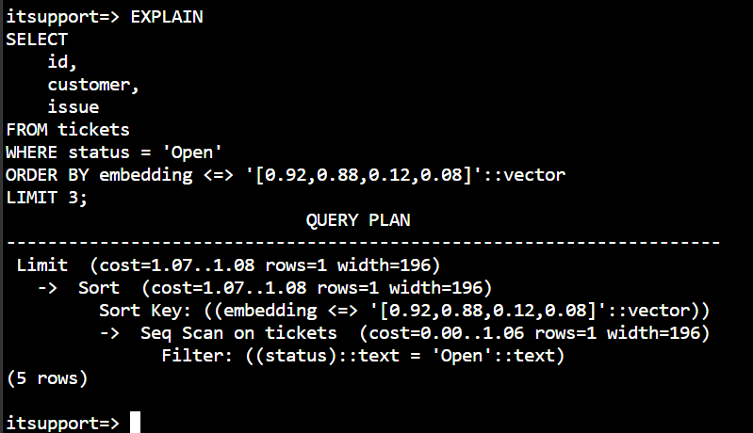
Figure 38 – The query execution plan (query planner output).
⚠️ Now Understand This!
We created the HNSW index, but we may not see PostgreSQL using it, because our demonstration table contains only five records. With a very small table, a sequential scan (Seq Scan) can actually be faster than using an index.

📝 Instructor Note
That's actually a great optimization lesson: PostgreSQL's query planner automatically chooses the fastest strategy for the amount of data it has — indexes help most as data grows into thousands or millions of rows.

AI Agent Use Case
This is the final concept to tie everything together: how PostgreSQL, pgvector, vector search, and HNSW all support a real AI agent.
Figure 39 – The full path from a user's question to the AI agent's grounded answer.
The database provides relevant information to the AI agent so that the agent can generate a more grounded response — instead of guessing, it answers based on real, similar support tickets.
TRAINER TIP
This connects PostgreSQL → pgvector → vector search → AI agent very cleanly. Azure Database for PostgreSQL can act as a vector database for AI agents and semantic retrieval, right alongside your regular application data.

Lab Summary
Here is the entire lab in eight steps:
Step | Activity
1 | Create PostgreSQL Flexible Server
2 | Create itsupport database
3 | Enable vector extension
4 | Create tickets table
5 | Insert 5 support tickets
6 | Run normal SQL query
7 | Run vector similarity search
8 | Create HNSW index

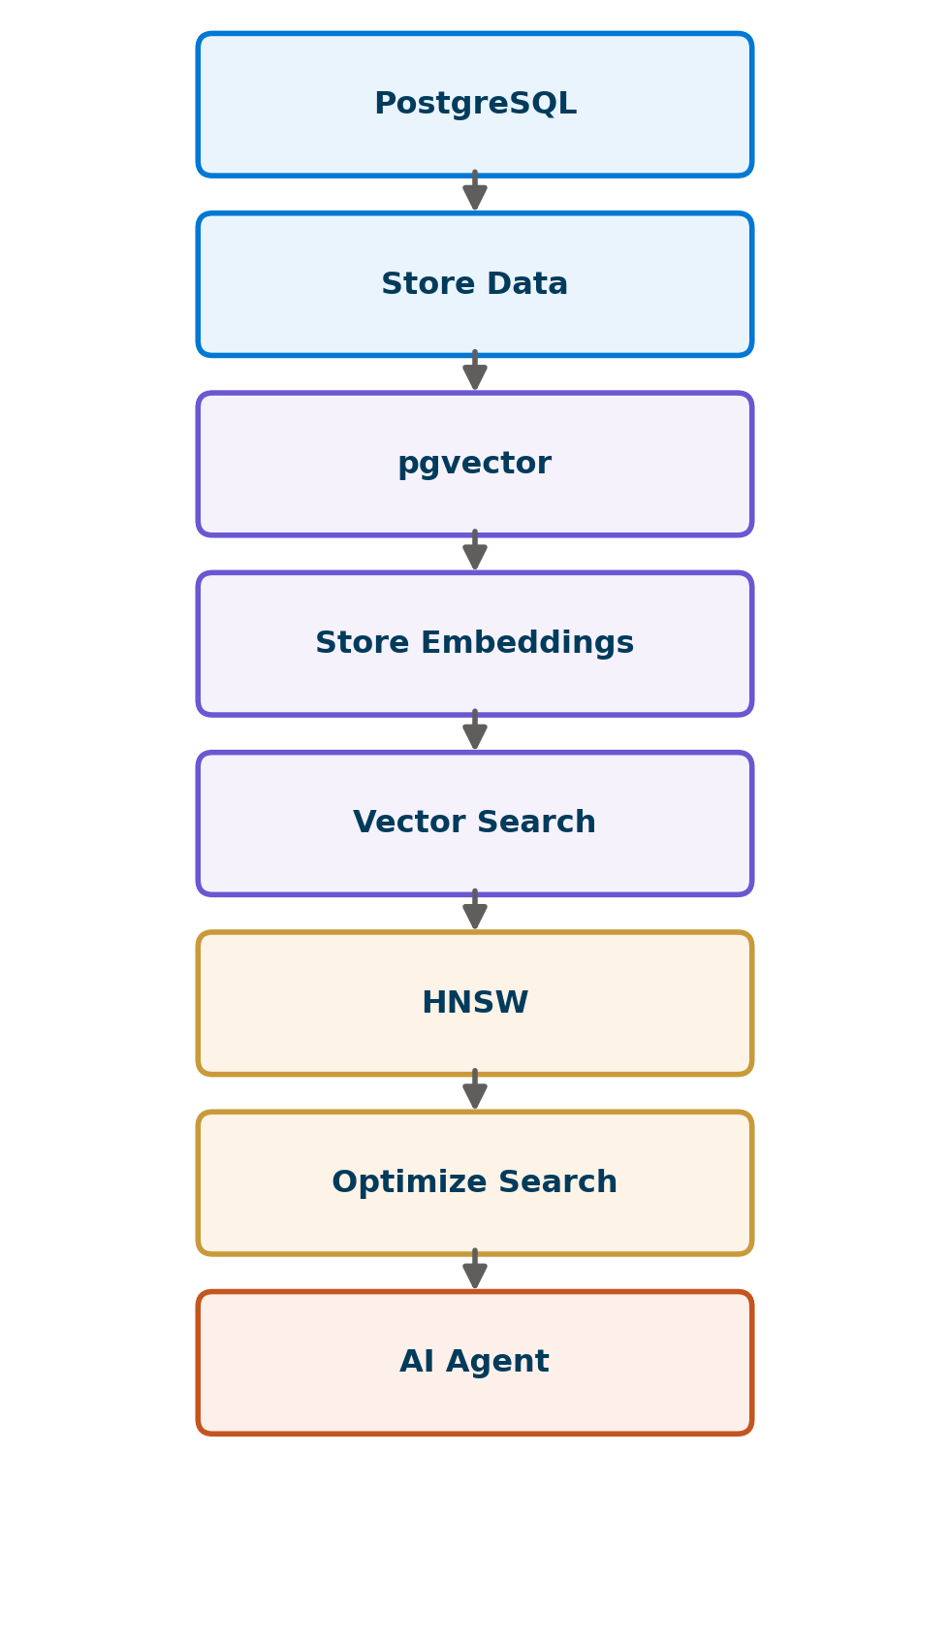
Figure 40 – PostgreSQL stores data, pgvector stores embeddings, vector search finds similar meaning, HNSW optimizes the search, and the AI agent uses it all.
You leave this lab with this understanding:
Concept | What It Does
PostgreSQL | Stores normal business data
pgvector | Stores embeddings
Vector search | Finds semantically similar data
HNSW | Makes vector search more efficient
AI Agent | Uses those results to ground its answer

Knowledge Check
Try to answer these questions yourself before checking the answers below.
1. What is Azure Database for PostgreSQL?
2. What is pgvector used for?
3. What is an embedding?
4. Why do we use vector search?
5. Why do we create an HNSW index?

Answers
1. A managed PostgreSQL database service in Azure — a relational database that can also store and search embeddings using the pgvector extension.
2. pgvector lets PostgreSQL store embeddings (as the vector data type) and search them by similarity, using operators like <=>.
3. An embedding is a list of numbers that represents the meaning of a piece of text, generated by an AI model.
4. Vector search finds data that is similar in meaning, even when the exact wording is different — something traditional SQL WHERE conditions can't do.
5. An HNSW index helps PostgreSQL perform vector similarity searches more efficiently as the amount of vector data grows.

Key AI-200 Takeaways

🎓 AI-200 Exam Connection
Map the activities from this lab back to the Module 5 objectives:
Lab Activity | AI-200 Concept
Create PostgreSQL database | Azure Database for PostgreSQL
Run SQL queries | Query PostgreSQL
Store embeddings | Vector data
Vector similarity search | Vector search
HNSW index | Vector search optimization
AI agent retrieval | AI solution integration

5 Key Takeaways
- Azure Database for PostgreSQL is a fully managed relational database that can also power AI solutions with pgvector.
- pgvector adds a vector data type and similarity operators (like <=>) directly inside PostgreSQL.
- Vector search finds data by meaning, while traditional SQL finds data by exact attributes — and PostgreSQL can combine both in one query.
- An HNSW index optimizes vector search as data grows, even if its benefit isn't visible on a small demo table.
- An AI agent becomes more useful — and more accurate — when it grounds its answers in real data retrieved through vector search.

