HANDS-ON LAB — MODULE 01
Perform Data Operations in Azure Managed Redis
In-Memory Data Store | Microsoft Entra Authentication | Python + redis-py
Enterprise AI Service Desk Curriculum
Azure Subscription | Python 3.12 | VS Code | Azure CLI
Project: AI200-Redis-Lab

Steps of Execution
This lab walks through storing, reading, updating, expiring, and deleting data in Azure Managed Redis from a Python console application, following the sequence below:
- Review the lab objective, architecture, and prerequisites for performing data operations in Azure Managed Redis.
- Create an Azure Managed Redis resource in the Azure Portal and configure Microsoft Entra authentication.
- Locate the Redis hostname and set up a Python 3.12 project with a virtual environment.
- Install redis-py, azure-identity, and redis-entraid, and configure the Redis connection using DefaultAzureCredential.
- Run the interactive console application and confirm it connects successfully (PING: True).
- Create, read, and update a support ticket stored as a Redis hash.
- Configure and observe a TTL (Time To Live), then delete the key and verify it no longer exists.

Introduction
Azure Managed Redis is a fully managed, high-performance in-memory data store. “In-memory” means data lives in RAM instead of on disk, so reads and writes are extremely fast — ideal for data that applications need instantly.
Applications use Redis for things like caching, session data, temporary state, and fast lookups — anywhere speed matters more than long-term storage. A common pattern is to store a single record as a Redis hash: one key that holds several named fields, similar to a small row in a table.
This lab also introduces TTL (Time To Live). A TTL tells Redis to automatically delete a key after a set number of seconds — perfect for temporary or cache data that shouldn't live forever.
Your Python application talks to Azure Managed Redis using the redis-py library over a secure TLS connection, authenticating with your own Azure identity through Microsoft Entra ID — no password is ever stored in the code.
In this lab, you create an Azure Managed Redis resource and build a simple, interactive Python console application. You will store a support ticket as a Redis hash, read it back, update a field, configure a TTL, delete the key, and verify the deletion — all while choosing each operation from a menu at runtime.

What You Will Build
You will build an interactive Python console application (app.py) that connects to an Azure Managed Redis resource and lets you choose data operations from a menu instead of running a fixed script. Each “ticket” is stored as a Redis hash under a key such as ai200:ticket:T1001.
Azure
│
▼
Azure Managed Redis
│
│ TLS / Port 10000
▼
Python App (redis-py)
│
├── CREATE
├── READ
├── UPDATE
├── TTL
└── DELETE

Architecture Diagram
The lab follows one consistent, simple flow from start to finish:
Python Application
↓
Azure Managed Redis
↓
Redis Hash
↓
Create / Store
Read
Update
TTL
Delete
Verify
NOTE
Every operation in this lab authenticates the same way — Microsoft Entra ID via DefaultAzureCredential — and talks to the same Redis hash. Once you understand one operation, the rest follow the same pattern.

Tasks Performed in This Exercise
- Create an Azure Managed Redis resource
- Configure Microsoft Entra authentication
- Obtain the Redis hostname
- Create a Python project
- Create a Python 3.12 virtual environment
- Install required Python packages
- Configure the Redis connection
- Run the Python console application
- Create/store a Redis hash
- Read the Redis hash
- Update a field in the hash
- Configure and check TTL
- Delete the Redis key
- Verify that the key no longer exists

Estimated duration: 25–30 minutes

Prerequisites
Requirement | Purpose
Azure subscription | Create Azure Managed Redis
Azure Portal | Create/configure Redis
Azure CLI | Microsoft Entra authentication
Python 3.12 | Run the application
VS Code | Develop/run the application

Step-by-Step Lab
Follow each step in order. Every step tells you what to do, the exact command or code to run, what you should see, and a short explanation of what happened.

Step 1 — Create Azure Managed Redis
Purpose
Create the Azure Managed Redis resource that will store your application's data.
What to do
Open the Azure Portal and search for:
Azure Managed Redis
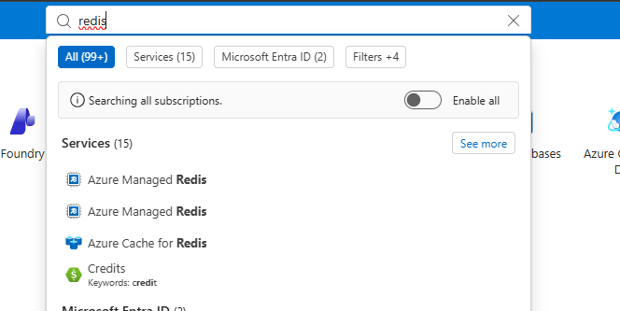
Figure 1 — Searching for Redis in the Azure Portal. Notice both Azure Managed Redis and the older Azure Cache for Redis appear.
IMPORTANT
Select Azure Managed Redis, not the older Azure Cache for Redis resource. This lab uses the current Microsoft service, which uses port 10000 instead of the older port 6380.
Open the Azure Managed Redis blade and select Create:
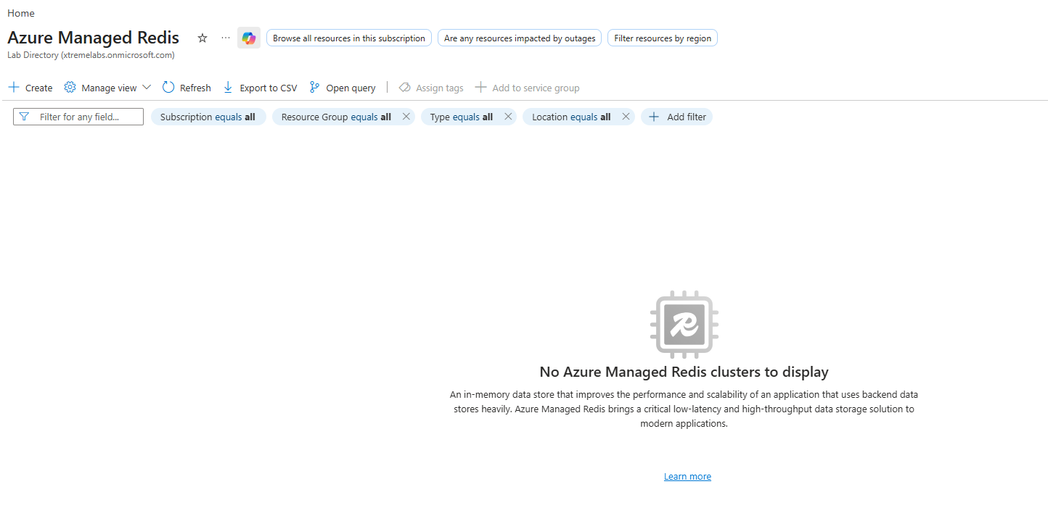
Figure 2 — Azure Managed Redis blade with no clusters yet — select Create
On the Basics tab, fill in the project and instance details:
Field | Value
Resource group | rg-ai200-redis
Name | ai200-redis-<unique>
Region | Central US
Data tier | In-memory (Recommended)
Use a unique resource name — Redis hostnames must be unique across Azure, so add a few characters or numbers if your first choice is taken.
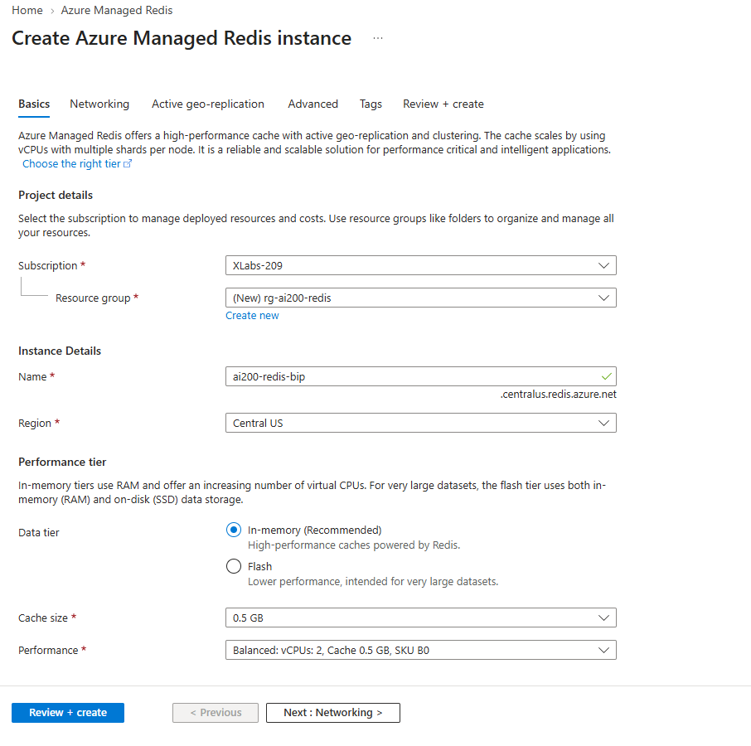
Figure 3 — Basics tab: resource name ai200-redis-bip, region Central US, In-memory performance tier
On the Review + create tab, confirm your settings and select Create:
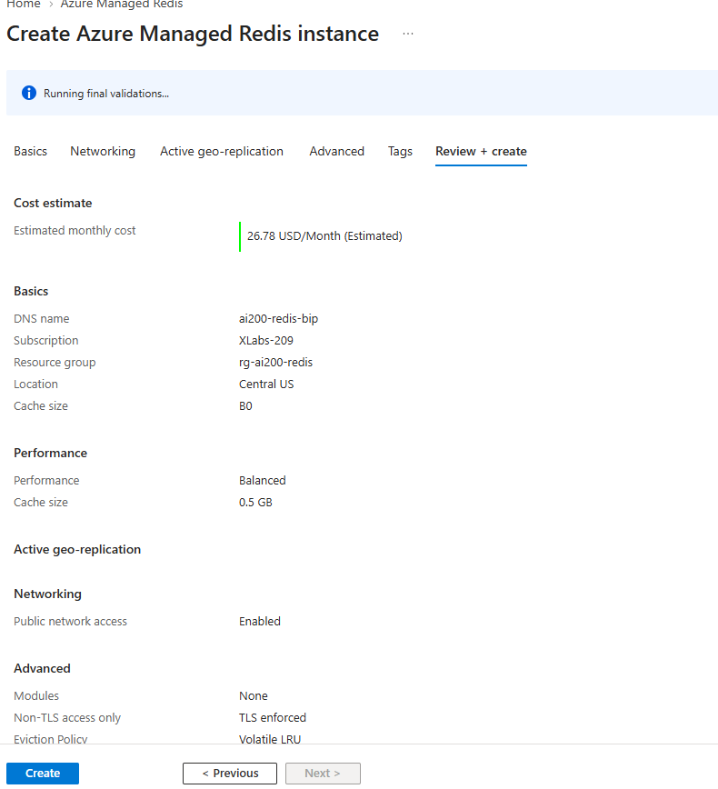
Figure 4 — Review + create: confirming the DNS name, resource group, and region before deployment
On the Networking tab (part of the same wizard), this classroom lab uses a public endpoint for simplicity:
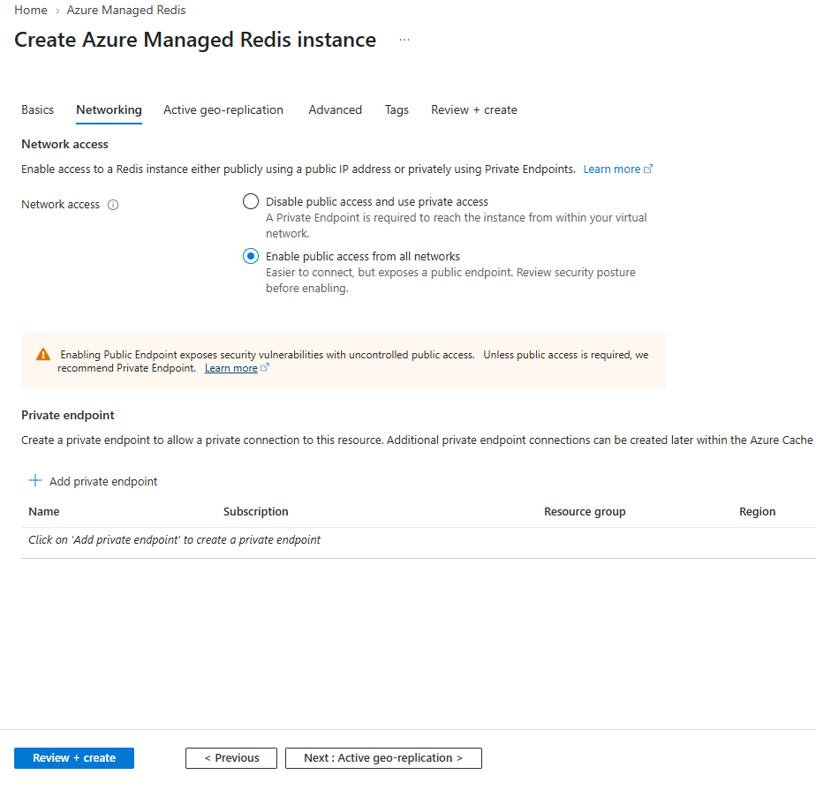
Figure 5 — Networking tab: Enable public access from all networks (simplest option for a classroom lab)
NOTE
A private endpoint is more secure and is recommended for production workloads. This lab uses a public endpoint only to keep the classroom setup simple.
EXPECTED RESULT
The Azure Managed Redis resource is deployed successfully inside the rg-ai200-redis resource group.

Step 2 — Configure Authentication
Purpose
Grant your own Azure user permission to access the Redis resource using Microsoft Entra ID — instead of using a Redis access key.
NOTE
Why Microsoft Entra authentication instead of a password? A Redis access key is a long-lived secret that has to be stored somewhere and rotated manually. Microsoft Entra authentication uses your existing Azure identity, so there is no password to store, copy, or accidentally leak in source code.
What to do
- Open the Azure Managed Redis resource.
- Select Authentication.
- Open the Microsoft Entra Authentication section.
- Select User or service principal.
- Select + Select member.
- Select your Azure user, then select Assign.
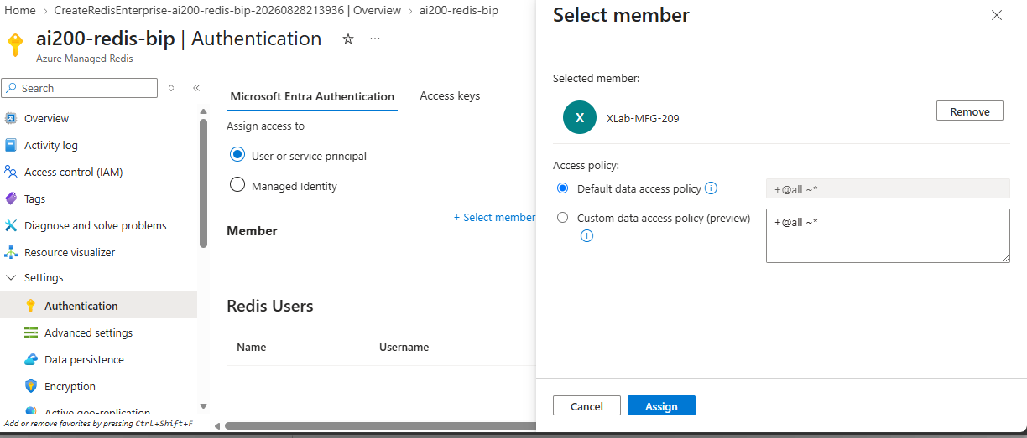
Figure 6 — Assigning your Azure user under Microsoft Entra Authentication
Once assigned, your user appears in the Redis Users list:
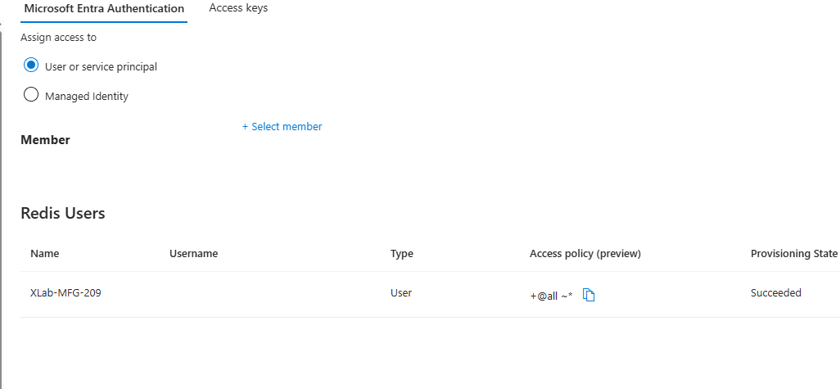
Figure 7 — Redis Users list showing the assigned user with a data access policy
IMPORTANT
Never place an actual Redis password, access key, client secret, or other credential in the lab document or in your source code. This lab only ever uses your Azure identity.
EXPECTED RESULT
Your Azure user appears under Redis Users with the default data access policy.

Step 3 — Get the Redis Hostname
Purpose
Find the hostname your Python application will use to connect to Redis.
What to do
Open your Redis resource and find the Endpoint value on the Overview page. It will look similar to:
ai200-redis-xxxxx.redis.azure.net:10000
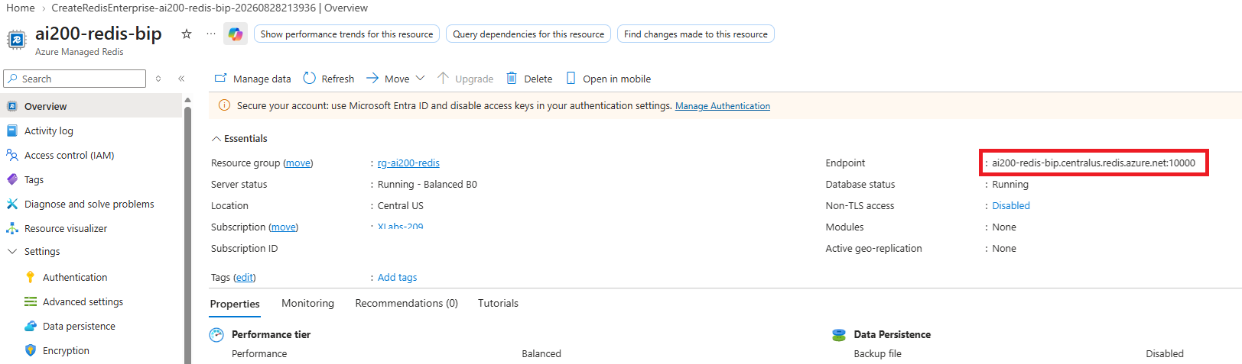
Figure 8 — The Redis endpoint on the Overview page (hostname and port 10000)
NOTE
The number after the colon (10000) is the port. You will use the hostname and the port 10000 separately in the Python connection code — you don't need the colon or the trailing digits together.
Copy the hostname portion (before the colon). You will use it in the Python application.
EXPECTED RESULT
You have copied a hostname similar to ai200-redis-bip.centralus.redis.azure.net.

Step 4 — Create the Python Project
Purpose
Set up a clean project folder for the application.
What to do
mkdir AI200-Redis-Lab
cd AI200-Redis-Lab
code .
You will build the following structure:
AI200-Redis-Lab
│
├── labenv
│
├── app.py
│
└── requirements.txt

Step 5 — Create the Virtual Environment
Purpose
Isolate this lab's Python packages using a Python 3.12 virtual environment.
What to do
py -3.12 -m venv labenv
.\labenv\Scripts\Activate.ps1
Verify the Python version:
python --version
Expected result
Python 3.12.x
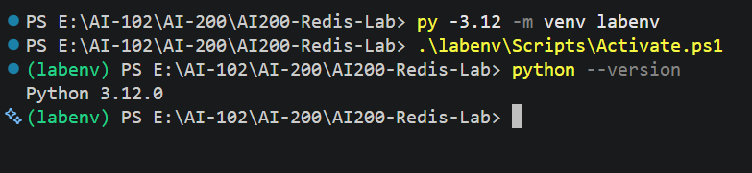
Figure 9 — Creating and activating labenv, then confirming Python 3.12

Step 6 — Install Dependencies
Purpose
Install the packages the application needs to talk to Redis and authenticate with Azure.
What to do
Create requirements.txt and add:
requirements.txt
redis
azure-identity
redis-entraid
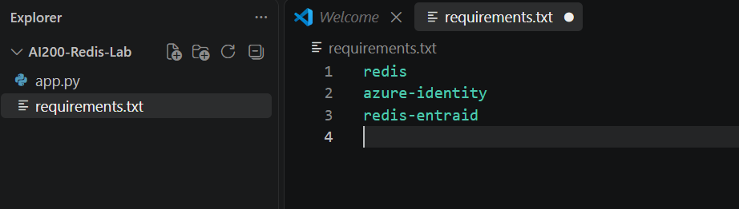
Figure 10 — requirements.txt with the three required packages
Package | Used for
redis | The redis-py client library — lets Python talk to Redis (hashes, TTL, etc.)
azure-identity | Provides DefaultAzureCredential to authenticate with your Azure identity
redis-entraid | Bridges Azure Identity and redis-py so Redis connections can use a Microsoft Entra token instead of a password
Install the packages:
pip install -r requirements.txt
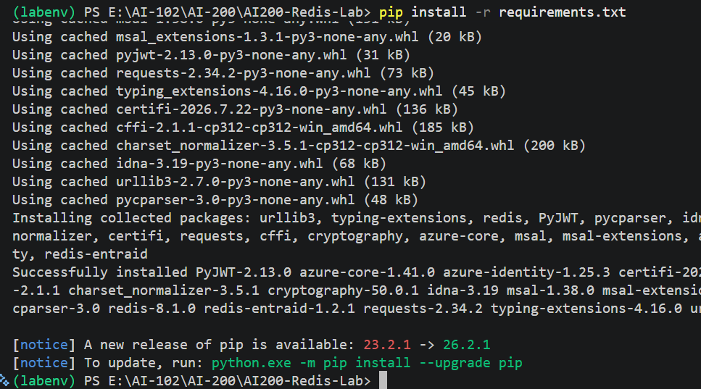
Figure 11 — Successful installation of redis, azure-identity, and redis-entraid

Step 7 — Configure the Redis Connection
Purpose
Understand the connection pattern before writing the full application: TLS, port 10000, and a Microsoft Entra credential provider — no password.
from azure.identity import DefaultAzureCredential
from redis_entraid.cred_provider import (
create_from_default_azure_credential
)

REDIS_HOST = "ai200-redis-xxxxx.redis.azure.net"
REDIS_PORT = 10000

credential = DefaultAzureCredential()

credential_provider = create_from_default_azure_credential(
("https://redis.azure.com/.default",),
)

r = redis.Redis(
host=REDIS_HOST,
port=REDIS_PORT,
ssl=True,
decode_responses=True,
credential_provider=credential_provider,
)
NOTE
REDIS_HOST above is a placeholder. Replace it with the hostname you copied in Step 3 — for example ai200-redis-bip.centralus.redis.azure.net.
create_from_default_azure_credential wraps DefaultAzureCredential so redis-py can request a Microsoft Entra token scoped to Redis (https://redis.azure.com/.default) instead of using a password.

Step 8 — Create app.py
Purpose
Write the full interactive application: connect to Redis, then let the student choose operations from a menu at runtime.
What to do
Create app.py and add the following code:
app.py
import redis
from azure.identity import DefaultAzureCredential
from redis_entraid.cred_provider import (
create_from_default_azure_credential
)

# =========================================================
# Configuration
# =========================================================
# Replace with your Azure Managed Redis hostname (Step 3)
REDIS_HOST = "ai200-redis-xxxxx.redis.azure.net"
REDIS_PORT = 10000

# =========================================================
# Microsoft Entra Authentication
# =========================================================
credential = DefaultAzureCredential()

credential_provider = create_from_default_azure_credential(
("https://redis.azure.com/.default",),
)

r = redis.Redis(
host=REDIS_HOST,
port=REDIS_PORT,
ssl=True,
decode_responses=True,
credential_provider=credential_provider,
)

# =========================================================
# Test Connection
# =========================================================
print("=" * 60)
print(" AZURE MANAGED REDIS - DATA OPERATIONS LAB")
print("=" * 60)
print("\nTesting Redis connection...")
print("PING:", r.ping())

# =========================================================
# Main Menu
# =========================================================
while True:
print("\n")
print("-" * 60)
print("Redis Operations")
print("-" * 60)
print("1. Create / Store Ticket")
print("2. Read Ticket")
print("3. Update Ticket")
print("4. Set TTL")
print("5. Check TTL")
print("6. Delete Ticket")
print("7. Check if Ticket Exists")
print("8. Exit")

choice = input("\nSelect an option: ").strip()

# ======================================================
# CREATE (uses r.hset to store a Redis hash)
# ======================================================
if choice == "1":
ticket_id = input("Enter ticket ID (example T1001): ").strip()
category = input("Enter category: ").strip()
priority = input("Enter priority: ").strip()
status = input("Enter status: ").strip()

key = f"ai200:ticket:{ticket_id}"

r.hset(
key,
mapping={
"ticket_id": ticket_id,
"category": category,
"priority": priority,
"status": status
}
)

print("\nTicket stored successfully.")
print("Redis Key:", key)

# ======================================================
# READ (uses r.hgetall to read every field in the hash)
# ======================================================
elif choice == "2":
ticket_id = input("Enter ticket ID: ").strip()
key = f"ai200:ticket:{ticket_id}"

ticket = r.hgetall(key)

if ticket:
print("\nTicket information:")
print(ticket)
else:
print("\nTicket not found.")

# ======================================================
# UPDATE (uses r.hset to update one field in the hash)
# ======================================================
elif choice == "3":
ticket_id = input("Enter ticket ID: ").strip()
key = f"ai200:ticket:{ticket_id}"

if not r.exists(key):
print("\nTicket does not exist.")
continue

print("\nWhat do you want to update?")
print("1. Category")
print("2. Priority")
print("3. Status")
field_choice = input("Select field: ").strip()

if field_choice == "1":
value = input("Enter new category: ").strip()
r.hset(key, "category", value)
elif field_choice == "2":
value = input("Enter new priority: ").strip()
r.hset(key, "priority", value)
elif field_choice == "3":
value = input("Enter new status: ").strip()
r.hset(key, "status", value)
else:
print("Invalid option.")
continue

print("\nTicket updated successfully.")
print("Updated ticket:", r.hgetall(key))

# ======================================================
# SET TTL (uses r.expire to set automatic expiration)
# ======================================================
elif choice == "4":
ticket_id = input("Enter ticket ID: ").strip()
key = f"ai200:ticket:{ticket_id}"

if not r.exists(key):
print("\nTicket does not exist.")
continue

seconds = int(input("Enter TTL in seconds: "))
r.expire(key, seconds)
print(f"\nExpiration set to {seconds} seconds.")

# ======================================================
# CHECK TTL (uses r.ttl to read remaining lifetime)
# ======================================================
elif choice == "5":
ticket_id = input("Enter ticket ID: ").strip()
key = f"ai200:ticket:{ticket_id}"

ttl = r.ttl(key)

if ttl == -2:
print("\nTicket does not exist.")
elif ttl == -1:
print("\nTicket exists but has no expiration.")
else:
print(f"\nRemaining TTL: {ttl} seconds")

# ======================================================
# DELETE (uses r.delete to remove the key)
# ======================================================
elif choice == "6":
ticket_id = input("Enter ticket ID: ").strip()
key = f"ai200:ticket:{ticket_id}"

if not r.exists(key):
print("\nTicket does not exist.")
continue

try:
result = r.delete(key)
if result == 1:
print("\nTicket deleted successfully.")
else:
print("\nTicket was not deleted.")
except Exception as e:
print("\nDelete operation failed.")
print("Error:", e)

# ======================================================
# EXISTS (uses r.exists to verify deletion / expiration)
# ======================================================
elif choice == "7":
ticket_id = input("Enter ticket ID: ").strip()
key = f"ai200:ticket:{ticket_id}"

exists = r.exists(key)
print("\nTicket exists:", bool(exists))

# ======================================================
# EXIT
# ======================================================
elif choice == "8":
print("\nExiting Redis lab...")
break

else:
print("\nInvalid option. Please try again.")

print("\n" + "=" * 60)
print("LAB COMPLETED")
print("=" * 60)
NOTE
The application is interactive on purpose — you choose each operation from the menu during the lab instead of running a fixed sequence. This lets you repeat, skip, or replay any operation as many times as you like.

Step 9 — Run the Application
Purpose
Authenticate to Azure and start the interactive application.
What to do
Make sure Azure CLI authentication is active:
az login
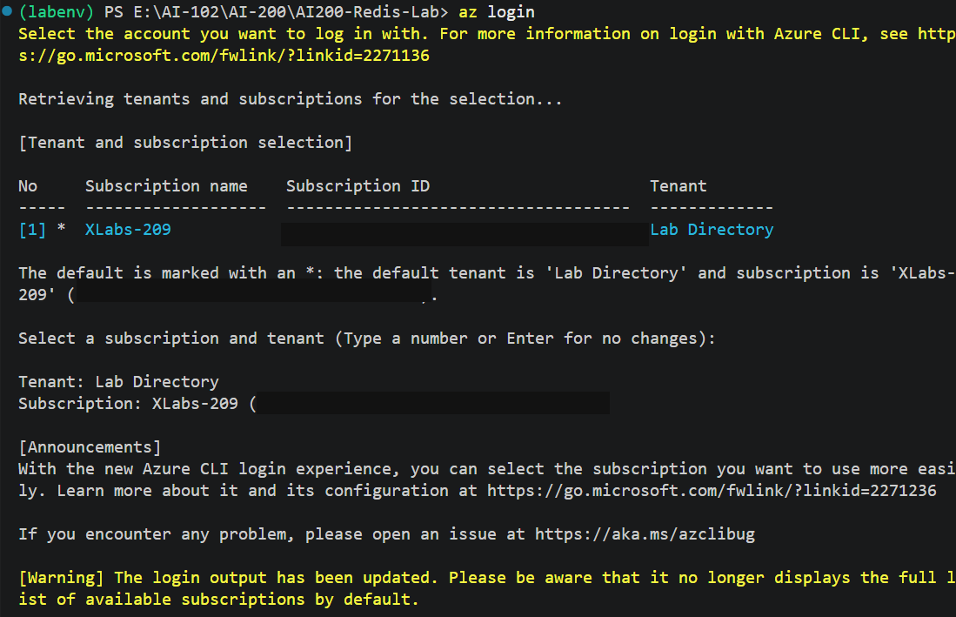
Figure 12 — az login: tenant and subscription selection (subscription ID masked)
NOTE
az login is required because DefaultAzureCredential looks for a signed-in identity during local development. It checks several sources in order (environment variables, Managed Identity, Visual Studio, Azure CLI, and others) and uses the first one it finds — in this lab, that's your Azure CLI login.
Then run:
py app.py
Expected result
PING: True
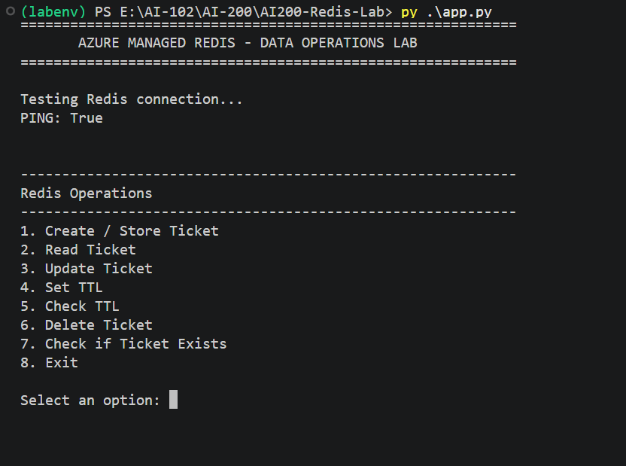
Figure 13 — app.py output: successful PING and the Redis Operations menu
EXPECTED RESULT
The application prints PING: True and then displays the Redis Operations menu, ready for input.

Step 10 — Create / Store Data
Purpose
Store your first support ticket as a Redis hash.
What to do
Choose option 1 and enter:
Select an option: 1
Enter ticket ID (example T1001): T1001
Enter category: Network
Enter priority: High
Enter status: Open
Expected result
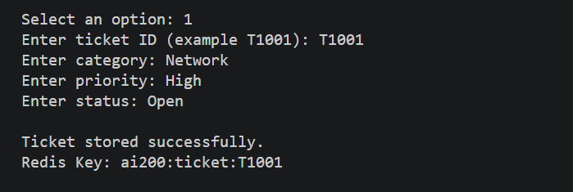
Figure 14 — Ticket T1001 stored successfully under key ai200:ticket:T1001
NOTE
r.hset() stored four fields — ticket_id, category, priority, and status — under one Redis key: ai200:ticket:T1001. That's what makes it a hash rather than a single value.

Step 11 — Read Data
Purpose
Retrieve every field of the ticket you just stored.
What to do
Choose option 2 and enter the ticket ID:
Select an option: 2
Enter ticket ID: T1001
Expected result
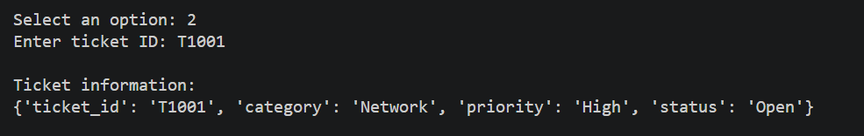
Figure 15 — r.hgetall() returns all four fields for T1001
EXPECTED RESULT
{'ticket_id': 'T1001', 'category': 'Network', 'priority': 'High', 'status': 'Open'}

Step 12 — Update Data
Purpose
Change a single field in the hash without touching the others.
What to do
Choose option 3, select the Status field, and change it:
Select an option: 3
Enter ticket ID: T1001
Select field: 3
Enter new status: In Progress
Expected result
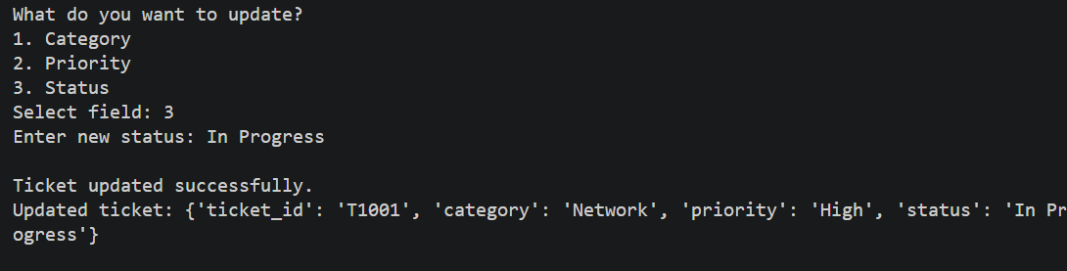
Figure 16 — Ticket updated successfully; status changed to In Progress
Read the ticket again (option 2) to confirm the change:
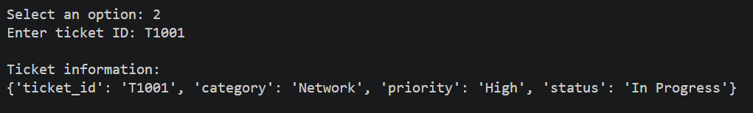
Figure 17 — Reading T1001 again shows status: In Progress, while the other fields are unchanged
NOTE
r.hset(key, "status", value) updates only the status field. The category and priority fields are untouched — this is the advantage of a hash over overwriting a whole record.

Step 13 — Configure TTL
Purpose
Set an automatic expiration on the ticket key and watch it count down — without waiting 5 minutes.
What to do
Choose option 4 and enter a short TTL so you can observe it during class:
Select an option: 4
Enter ticket ID: T1001
Enter TTL in seconds: 30
Expected result
Expiration set to 30 seconds.
Now choose option 5 to check the remaining time:
Select an option: 5
Enter ticket ID: T1001
EXPECTED RESULT
Remaining TTL: 29 seconds
TTL counts down automatically — check again a few seconds later and the number will be lower.
NOTE
r.expire(key, seconds) tells Redis to delete the key automatically once the timer reaches zero. r.ttl(key) simply reads the remaining time — it does not reset or extend it.
TTL is especially useful for session data, temporary AI results, one-time tokens, cache entries, and temporary support-ticket state — anything that should clean itself up automatically.

Step 14 — Delete Data
Purpose
Remove a Redis key immediately, without waiting for a TTL to expire.
What to do
Create a second ticket, then delete it:
Select an option: 1
Enter ticket ID (example T1001): T1002
Enter category: Software
Enter priority: Medium
Enter status: Open
Select an option: 6
Enter ticket ID: T1002
Expected result
Ticket deleted successfully.

Step 15 — Verify Deletion
Purpose
Confirm the key is really gone — either because you deleted it, or because its TTL expired.
What to do
Choose option 7 for the ticket you just deleted:
Select an option: 7
Enter ticket ID: T1002
EXPECTED RESULT
Ticket exists: False
If you still have the T1001 TTL running from Step 13, wait for it to reach 0 and check again:
Select an option: 7
Enter ticket ID: T1001
EXPECTED RESULT
Ticket exists: False — Redis removed the key automatically when the TTL reached zero.

Understand the Redis Hash
This is the key concept of the lab. A single Redis key can hold multiple named fields — that structure is called a hash.
ai200:ticket:T1001
│
├── ticket_id → T1001
├── category → Network
├── priority → High
└── status → In Progress
All of the operations you performed map directly onto a small set of Redis commands:
HSET
↓
Store/update hash fields

HGETALL
↓
Read all hash fields

EXPIRE
↓
Set automatic expiration

TTL
↓
Check remaining lifetime

DEL
↓
Remove the key

A more realistic AI example
Now connect the lab to an AI Service Desk scenario. Imagine the AI application receives:
"I cannot connect to the company VPN."
The application creates ai200:ticket:REQ-1001 with ticket_id, category, priority, and a status of Processing. An AI worker could later update status to Resolved and add a resolution field — all using the same HSET pattern you used in this lab.
User
│
▼
AI Service Desk
│
▼
Azure Managed Redis
│
├── Ticket data
├── Processing status
├── AI result
└── TTL
That's a much more meaningful picture of why Redis is useful in an AI application: fast, temporary, structured state that the application can read and update in milliseconds.

Troubleshooting
1. Python version problem
Make sure Python 3.12 is being used. Run python --version inside the activated labenv and confirm it reports 3.12.x.
2. Authentication failure
Run az login again.
Confirm the signed-in account has been added under Microsoft Entra Authentication on the Redis resource (Step 2).
3. Connection failure
Verify the Redis hostname exactly matches the Endpoint value from Step 3.
Verify the port is 10000.
Verify ssl=True (TLS) is set in the connection code.
4. Permission / access issue
Check the Microsoft Entra Authentication section on the Redis resource and confirm your user is listed under Redis Users with an access policy assigned.
5. ModuleNotFoundError
Activate the virtual environment: .\labenv\Scripts\Activate.ps1
Then reinstall dependencies: pip install -r requirements.txt

Cleanup
If the Redis resource is no longer required, delete the Azure Managed Redis resource and its associated resource group to avoid unnecessary Azure charges.

Knowledge Check
- What is Azure Managed Redis?
- Why is port 10000 used in this lab?
- What is a Redis hash?
- What does TTL mean?
- What happens when a Redis key is deleted or expires?

Knowledge Check – Answers
1. What is Azure Managed Redis?
A fully managed, high-performance in-memory data store that applications use for caching, session data, temporary data, and fast lookups.
2. Why is port 10000 used in this lab?
Azure Managed Redis (the current service used in this lab) uses port 10000, unlike the older Azure Cache for Redis, which commonly used port 6380.
3. What is a Redis hash?
A data structure that stores multiple named fields under a single Redis key — similar to a small row with several columns.
4. What does TTL mean?
Time To Live — the number of seconds Redis will keep a key before automatically deleting it.
5. What happens when a Redis key is deleted or expires?
The key and all of its data are removed. r.exists() then returns False, and r.hgetall() returns an empty result.

