HANDS-ON LAB — MODULE 01
Manage Secrets with Azure Key Vault
Securing AI Application Credentials | Azure CLI | Python SDK
Enterprise AI Service Desk Curriculum
Azure Subscription | Python 3.12 | VS Code | Azure CLI
Project: AI200-KeyVault-Lab

Steps of Execution
This lab walks through storing and retrieving AI application secrets using Azure Key Vault and Python, following the sequence below:
- Review the lab objective, architecture, and prerequisites for managing AI application secrets with Azure Key Vault.
- Create an Azure Key Vault with RBAC authorization enabled, using both the Azure Portal and the Azure CLI.
- Store three sample AI application secrets in the vault and verify them without exposing their values.
- Build a Python project with a virtual environment and the Azure Identity and Key Vault SDKs.
- Write app.py to authenticate with DefaultAzureCredential and retrieve secrets from Key Vault at runtime.
- Run the application and confirm it retrieves secrets securely without hard-coding any values.
- Demonstrate secret versioning, metadata inspection, and simple in-memory caching.
- Connect the pattern back to a real AI application scenario and validate the completed lab.

Introduction
AI applications frequently need sensitive information such as API keys, database passwords, connection strings, and service credentials.
Instead of storing these values directly in Python code or configuration files, Azure Key Vault provides a secure, centralized location for storing and retrieving secrets.
In this lab, you will create an Azure Key Vault, store sample AI application secrets, and build a simple Python application that retrieves those secrets securely. You will also demonstrate secret versioning and metadata inspection.

Objective
By the end of this lab, you will be able to:
- Create and configure an Azure Key Vault with RBAC authorization
- Store secrets that an AI application would need at runtime
- Connect a Python application to Key Vault using the Azure SDK
- Retrieve secrets securely using DefaultAzureCredential
- Inspect secret metadata without exposing secret values
- Create and manage secret versions
- Apply a simple caching pattern to reduce Key Vault calls

Lab Architecture / Lab Flow
The lab follows a simple, repeatable pattern used throughout enterprise AI applications: the application never stores the secret itself — it asks Key Vault for it at runtime.
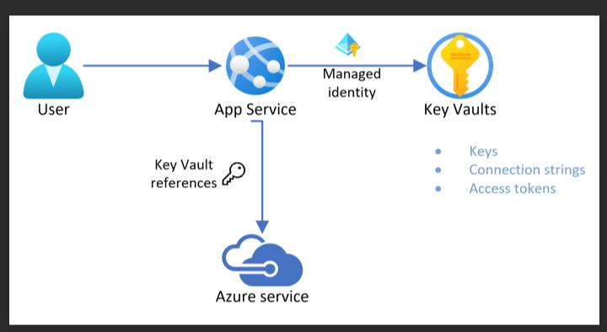
Figure 1 — Lab architecture: the application authenticates and requests secrets from Azure Key Vault instead of storing them
AI Application
│
│ Request secret
▼
Azure Key Vault
│
┌────┴────┐
▼ ▼
API Key Database
Password

What You Will Build
You will build a small Python console application (app.py) that connects to an Azure Key Vault named ai200-kv-bip. The application authenticates with your Azure identity, lists the available secrets, retrieves the AI-API-Key secret, displays its version and creation date, and demonstrates a simple in-memory cache — all without ever hard-coding a secret value in the source code.

Tasks Performed
- Create an Azure Key Vault
- Configure RBAC access
- Store sample secrets
- Create a Python application
- Connect Python to Key Vault
- Retrieve a secret
- List secret metadata without exposing values
- Create a new secret version
- Demonstrate simple secret caching

Prerequisites
Requirement | Purpose
Azure subscription | Create the Key Vault
Azure Portal | Configure the Key Vault
Python 3.10+ (3.12 used in this lab) | Run the application
VS Code | Write the Python code
Azure CLI | Authenticate locally and manage the vault

Azure's current Key Vault Python quickstart supports Python 3.7+ and uses Azure CLI authentication with DefaultAzureCredential.

Estimated Time
20–25 minutes

Step-by-Step Lab
Follow each step in order. Every step tells you what to do, the exact command or code to run, what you should see, and a short explanation of what happened behind the scenes.

Step 1 — Create the Key Vault
Purpose
Create the Azure Key Vault that will securely store your AI application's secrets. Key Vault names must be globally unique across Azure.
What to do
Choose a unique vault name, for example ai200-kv-bip. If that name is already taken, add a few numbers to the end. Run the following Azure CLI command:
az keyvault create `
--name ai200-kv-bip `
--resource-group rg-ai200-lab `
--location centralus `
--enable-rbac-authorization true
You can also create the vault from the Azure Portal to see each configuration option. Search for “key vault” in the portal search bar:
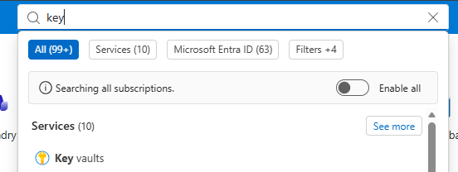
Figure 2 — Searching for Key Vault in the Azure Portal
Open the Key Vaults blade and select Create:
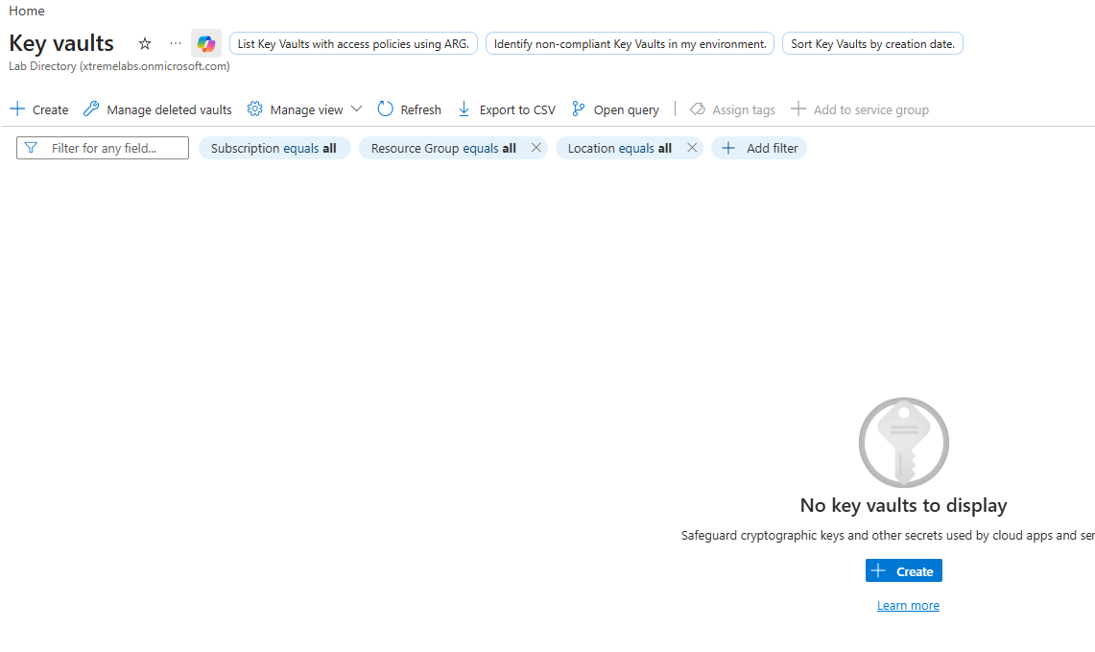
Figure 3 — Key Vaults blade with no vaults yet — select Create
On the Basics tab, set the subscription, resource group, vault name, region, and pricing tier:
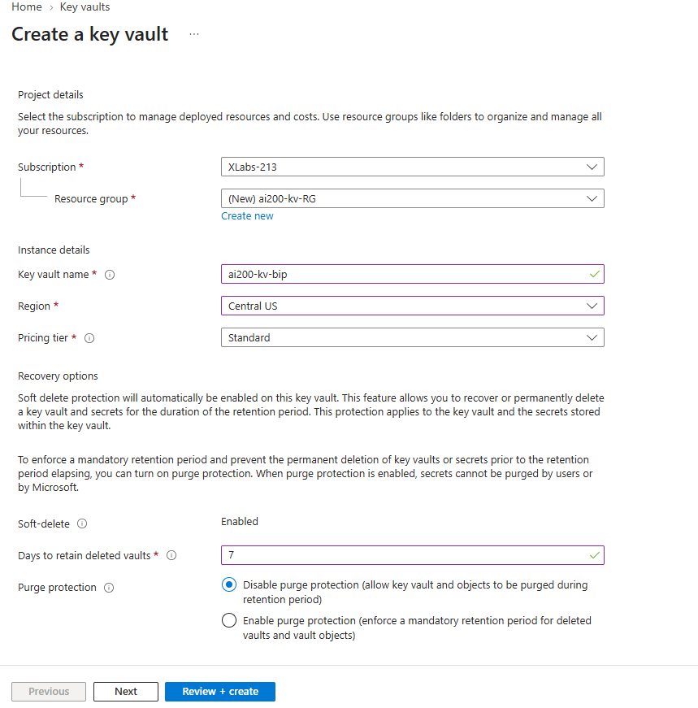
Figure 4 — Basics tab: vault name ai200-kv-bip, region Central US
On the Access configuration tab, choose Azure role-based access control (RBAC) — this matches the --enable-rbac-authorization true flag used in the CLI command above:
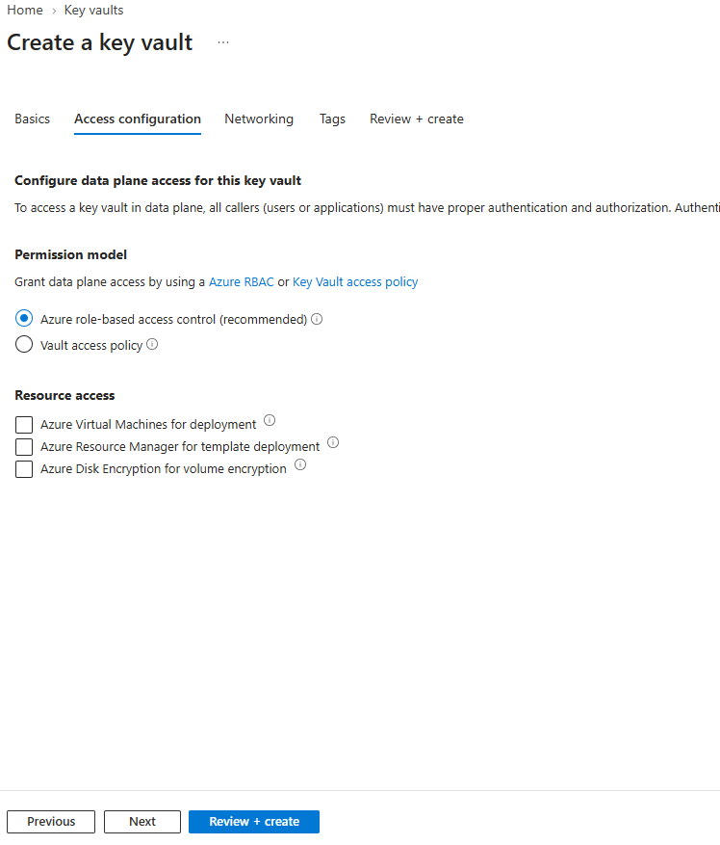
Figure 5 — Access configuration: Azure role-based access control selected (recommended)
For comparison, the alternative permission model is Vault access policy, shown below. This lab uses RBAC, but you may see this option in the portal:
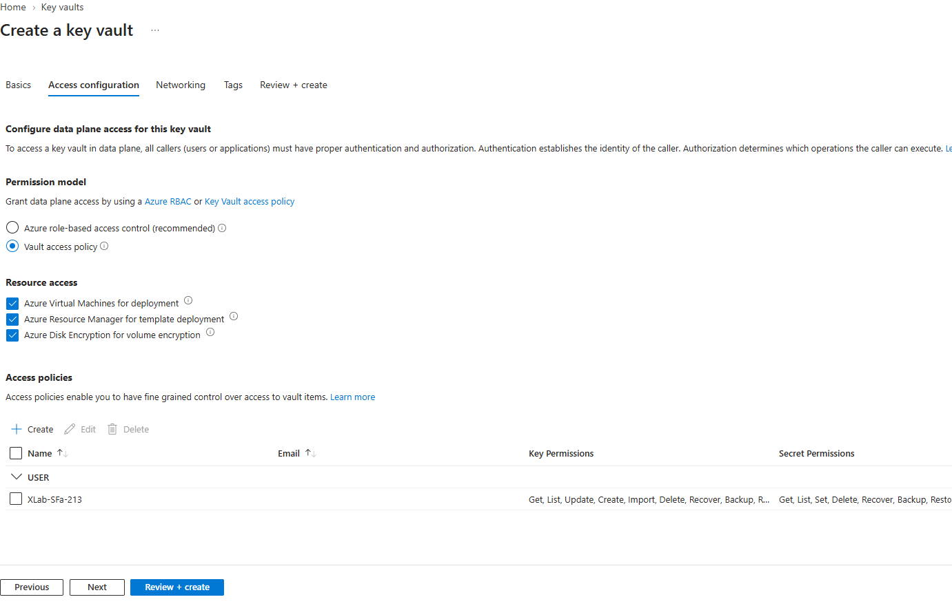
Figure 6 — Access configuration: the alternative Vault access policy model (not used in this lab)
Review the summary and select Create:
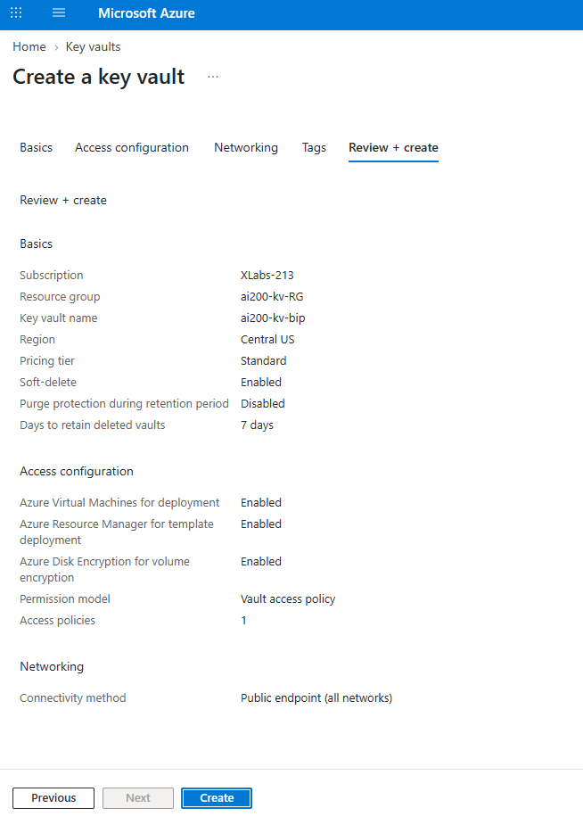
Figure 7 — Review + create: confirming vault name, region, and RBAC permission model
Wait for the deployment to complete:
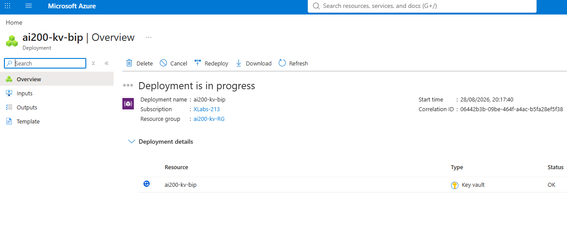
Figure 8 — Deployment succeeded: the ai200-kv-bip Key Vault resource has been created
What to verify:
• The Key Vault name matches what you typed (e.g. ai200-kv-bip)
• The resource group and region are correct
• Azure role-based access control (RBAC) is selected as the permission model
Expected result
The Key Vault resource ai200-kv-bip is created inside the rg-ai200-lab resource group with RBAC authorization enabled.
What just happened?
You created a secure, centrally managed vault for storing secrets.
RBAC authorization means access to the vault's data (its keys and secrets) is controlled through Azure role assignments, the same way access to other Azure resources is controlled.
No secrets exist yet — you only created the empty container that will hold them.

Step 2 — Create Sample Secrets
Purpose
Simulate the secrets that a real AI application might need: an API key, a database password, and a service connection string.

Secret 1 — AI API Key
az keyvault secret set `
--vault-name ai200-kv-bip `
--name AI-API-Key `
--value "demo-ai-api-key-12345"
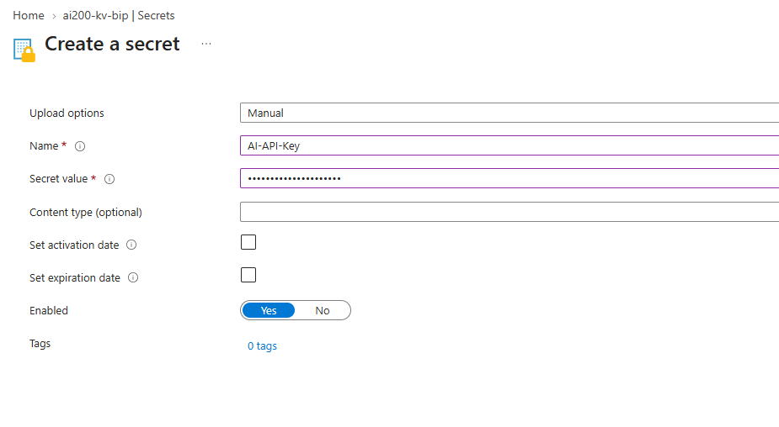
Figure 9 — Creating the AI-API-Key secret in the Azure Portal (value masked)

Secret 2 — Database Password
az keyvault secret set `
--vault-name ai200-kv-bip `
--name Database-Password `
--value "DemoDbPassword@123"
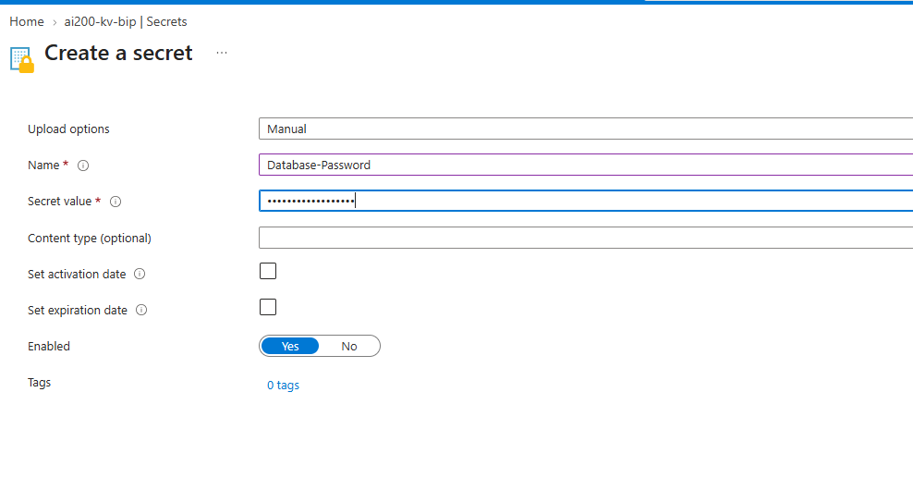
Figure 10 — Creating the Database-Password secret (value masked)

Secret 3 — Service Connection
az keyvault secret set `
--vault-name ai200-kv-bip `
--name AI-Service-Connection `
--value https://demo-ai-service.example.com
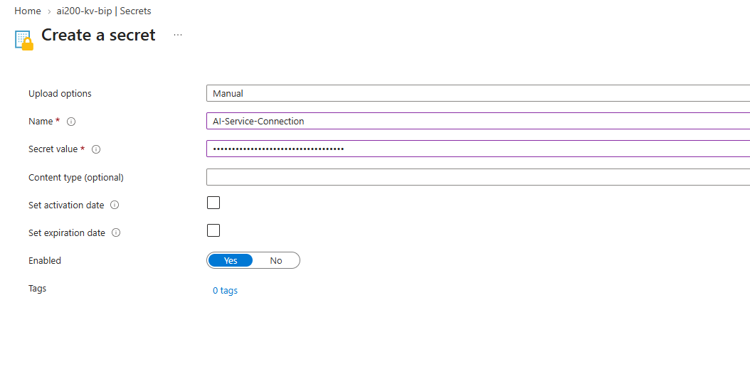
Figure 11 — Creating the AI-Service-Connection secret (value masked)
What to verify:
• Each secret name matches exactly: AI-API-Key, Database-Password, AI-Service-Connection
• The Secret value field is filled in (the portal automatically masks it)
• Enabled is set to Yes for each secret
Expected result
Three secrets now exist inside the ai200-kv-bip vault.

Step 3 — Verify the Secrets
Purpose
Confirm that all three secrets were created — without displaying their values.
What to do
List the secrets:
az keyvault secret list `
--vault-name ai200-kv-bip `
--query "[].name" `
-o table
What you should see
AI-API-Key
Database-Password
AI-Service-Connection
Important security point
We are listing the secret names, not the secret values. That's intentional.

Step 4 — Create the Python Project
Purpose
Set up a clean project folder for the application that will connect to Key Vault.
What to do
Create a new folder and open it in VS Code:
mkdir AI200-KeyVault-Lab
cd AI200-KeyVault-Lab
code .
You will build the following structure:
AI200-KeyVault-Lab
│
├── labenv
│
├── app.py
│
└── requirements.txt

Step 5 — Create Python Virtual Environment
Purpose
Isolate this lab's Python packages from the rest of your system using a virtual environment.
What to do
Create the environment using Python 3.12, then activate it:
py -3.12 -m venv labenv
.\labenv\Scripts\Activate.ps1
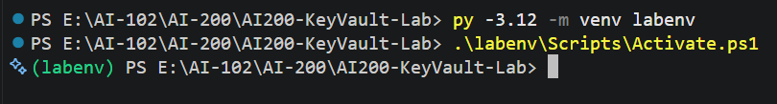
Figure 12 — Creating and activating the labenv virtual environment
Verify the Python version:
python --version
Expected result
Python 3.12.x
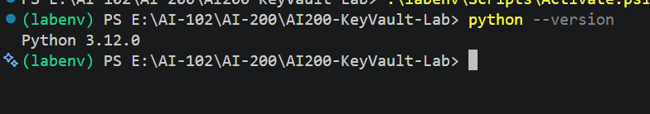
Figure 13 — Confirming Python 3.12 is active inside labenv

Step 6 — Install Azure Libraries
Purpose
Install the Azure SDK packages the application needs to authenticate and talk to Key Vault.
What to do
Create requirements.txt and add:
requirements.txt
azure-identity
azure-keyvault-secrets
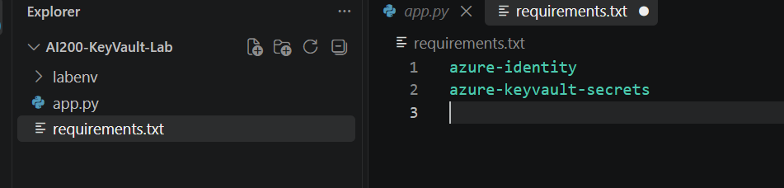
Figure 14 — requirements.txt with the two required Azure SDK packages
Install the packages:
pip install -r requirements.txt
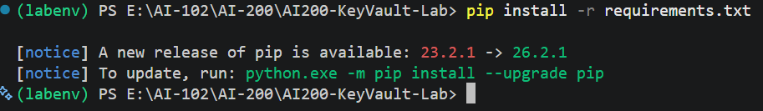
Figure 15 — Successful installation of azure-identity and azure-keyvault-secrets
What just happened?
azure-identity provides DefaultAzureCredential, which handles authentication to Azure.
azure-keyvault-secrets provides SecretClient, the object your Python code uses to talk to Key Vault.

Step 7 — Configure the Key Vault Name
Purpose
Keep the vault name out of the source code. For this classroom lab, we'll use an environment variable rather than hard-coding the vault name into the application.
What to do
In PowerShell, set the environment variable:
$env:KEY_VAULT_NAME="ai200-kv-bip"
Verify it:
echo $env:KEY_VAULT_NAME
Expected result
ai200-kv-bip
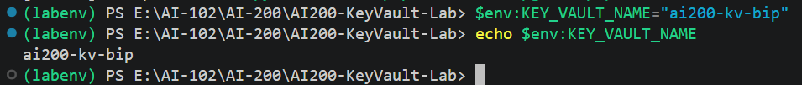
Figure 16 — KEY_VAULT_NAME environment variable set and verified

Step 8 — Create app.py
Purpose
Write the Python application that authenticates to Azure, retrieves secrets, inspects metadata, and demonstrates caching.
What to do
Create app.py and add the following code:
app.py
import os
import time
from azure.identity import DefaultAzureCredential
from azure.keyvault.secrets import SecretClient

# =========================================================
# Configuration
# =========================================================
KEY_VAULT_NAME = os.environ["KEY_VAULT_NAME"]
KEY_VAULT_URL = (
f"https://{KEY_VAULT_NAME}.vault.azure.net/"
)

# =========================================================
# Azure Authentication
# =========================================================
credential = DefaultAzureCredential()
client = SecretClient(
vault_url=KEY_VAULT_URL,
credential=credential
)

# =========================================================
# Retrieve Secret
# =========================================================
def get_secret(secret_name):
print(f"\nRetrieving secret: {secret_name}")
secret = client.get_secret(secret_name)
print("Secret retrieved successfully.")
return secret.value

# =========================================================
# List Secret Metadata
# =========================================================
def list_secrets():
print("\nAvailable secrets:")
for secret in client.list_properties_of_secrets():
print(
f"- {secret.name}"
f" | Enabled: {secret.enabled}"
)

# =========================================================
# Secret Version
# =========================================================
def show_secret_version(secret_name):
secret = client.get_secret(secret_name)
print("\nSecret information")
print("-------------------")
print("Name :", secret.name)
print("Version:", secret.properties.version)
print("Created:", secret.properties.created_on)

# =========================================================
# Simple Cache
# =========================================================
cache = {}
CACHE_SECONDS = 60

def get_secret_cached(secret_name):
current_time = time.time()
if secret_name in cache:
cached_value, timestamp = cache[secret_name]
if current_time - timestamp < CACHE_SECONDS:
print("Returning secret from cache.")
return cached_value

print("Retrieving secret from Key Vault.")
value = get_secret(secret_name)
cache[secret_name] = (
value,
current_time
)
return value

# =========================================================
# Main
# =========================================================
if __name__ == "__main__":
print("=" * 50)
print("AI SERVICE DESK - KEY VAULT DEMO")
print("=" * 50)

# 1. List metadata
list_secrets()

# 2. Retrieve API key
api_key = get_secret("AI-API-Key")
print("\nAPI key retrieved.")
print("Value is intentionally NOT displayed.")

# 3. Show version
show_secret_version("AI-API-Key")

# 4. Demonstrate cache
print("\nTesting cache...")
get_secret_cached("AI-API-Key")
get_secret_cached("AI-API-Key")

print("\nDemo completed.")
What just happened?
DefaultAzureCredential automatically finds a way to authenticate — using your Azure CLI login during local development, and a managed identity later when deployed to Azure.
SecretClient is the object the rest of the application uses to talk to Key Vault.
The API key value is deliberately never printed to the console — only its metadata (name, version, creation date) is shown.

Step 9 — Run the Application
Purpose
Authenticate to Azure and run the application end to end.
What to do
Make sure you are logged into Azure:
az login
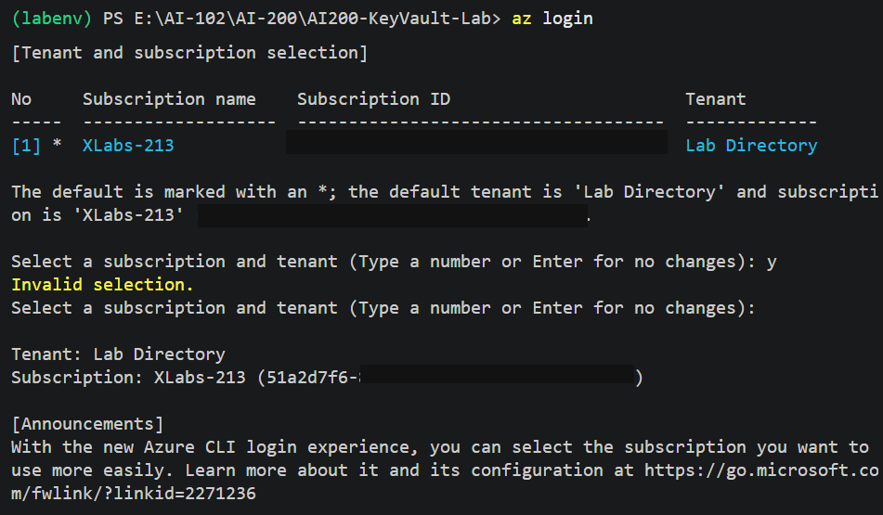
Figure 17 — az login: tenant and subscription selection (subscription ID masked)
Then run the application:
py app.py
Expected result
==================================================
AI SERVICE DESK - KEY VAULT DEMO
==================================================

Available secrets:
- AI-API-Key | Enabled: True
- Database-Password | Enabled: True
- AI-Service-Connection | Enabled: True

Retrieving secret: AI-API-Key
Secret retrieved successfully.

API key retrieved.
Value is intentionally NOT displayed.

Secret information
-------------------
Name : AI-API-Key
Version: xxxxxxxxxxxxxxxxxxxxx
Created: 2026-08-28 ...

Testing cache...
Retrieving secret from Key Vault.
Returning secret from cache.

Demo completed.
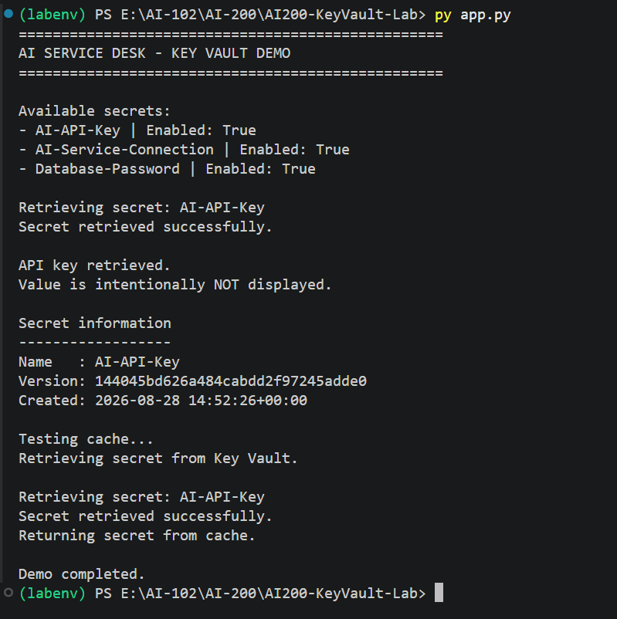
Figure 18 — app.py output: secrets listed, API key retrieved, version shown, cache demonstrated
What just happened?
The application authenticated to Azure and requested the secret from Key Vault.
The secret value was returned to the application without ever being stored directly in the source code.
Microsoft recommends DefaultAzureCredential because the same authentication approach works locally with Azure CLI credentials, and later with a managed identity when the application is deployed to Azure.

Step 10 — Demonstrate Secret Versioning
Purpose
See how Key Vault keeps a history of secret values, and how the application always retrieves the current version by default.
Currently:
AI-API-Key
│
└── Version 1
What to do
Rotate the secret by setting a new value:
az keyvault secret set `
--vault-name ai200-kv-bip `
--name AI-API-Key `
--value "demo-ai-api-key-67890"
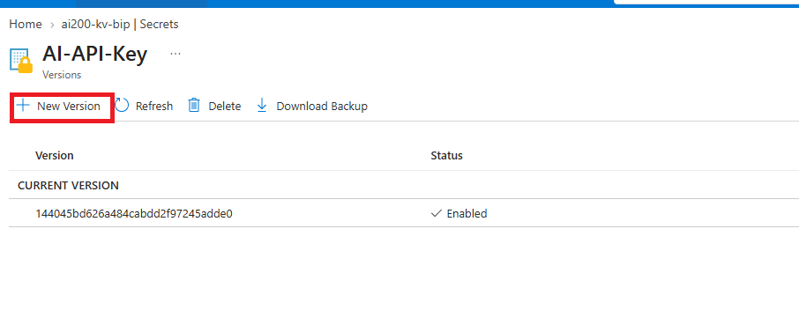
Figure 19 — AI-API-Key version history before rotation (one current version)
You have now created another version:
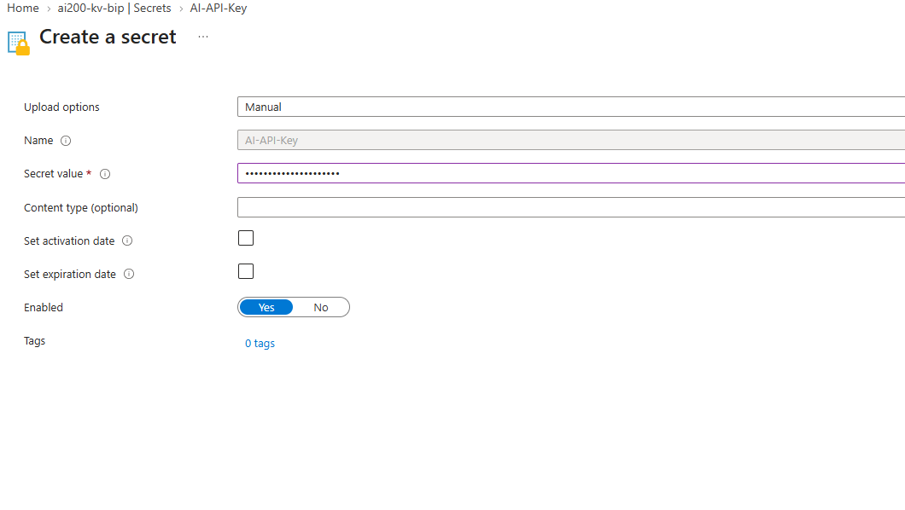
Figure 20 — Creating a new version of AI-API-Key (value masked)
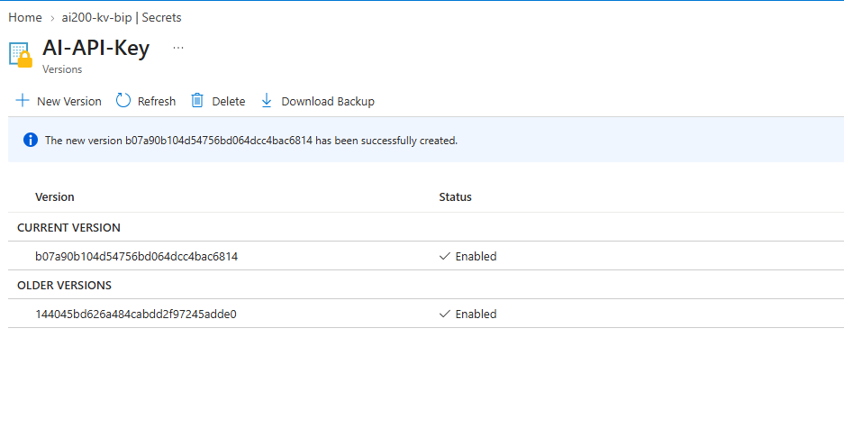
Figure 21 — AI-API-Key now has a current version and an older version
Conceptually:
AI-API-Key
│
├── Version 1
│ demo-ai-api-key-12345
│
└── Version 2
demo-ai-api-key-67890
Run the application again:
python app.py
Expected result
The application retrieves the current version by default — note the new version identifier and timestamp:
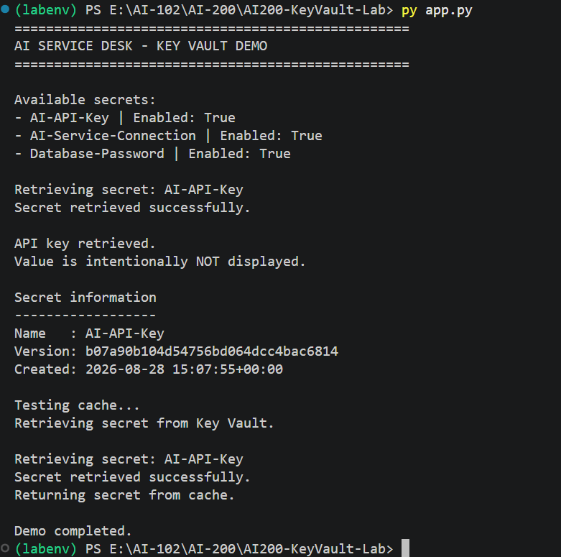
Figure 22 — app.py automatically retrieving the new current version of AI-API-Key
What just happened?
Key Vault never overwrites a secret — it creates a new version and marks it current.
Older versions remain available (for rollback or auditing) unless explicitly deleted.
Because the application code asks for the secret by name only, it automatically receives the latest version without any code changes.

Step 11 — Demonstrate Metadata Without Exposing Secrets
Purpose
Show that you can inspect useful information about secrets without ever printing their values — an important application-security pattern.
What to do
az keyvault secret list `
--vault-name ai200-kv-bip `
-o table
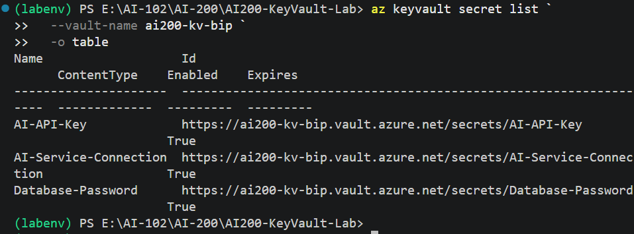
Figure 23 — Secret list showing name, ID, and enabled status — no values displayed
Notice that you can inspect information about the secrets without printing their actual values.
Application
│
├── Secret name → OK
├── Version → OK
├── Created date → OK
│
└── Secret value → Keep protected

Step 12 — Demonstrate the Cache
Purpose
Reduce unnecessary calls to Key Vault by caching a secret in memory for a short period.
What to do
Our application defines a 60-second cache window:
CACHE_SECONDS = 60
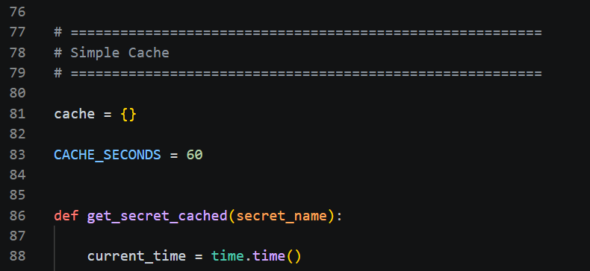
Figure 24 — The get_secret_cached() function in app.py
The first request goes to Key Vault:
Application
↓
Key Vault
↓
Secret
↓
Cache
The second request within 60 seconds is served from the cache instead:
Application
↓
Cache
↓
Secret
This reduces unnecessary calls to Key Vault.
Important lesson
Do not print or log the secret value while demonstrating caching — only log that a cache hit or miss occurred.

Step 13 — Connect This to an AI Application
Purpose
Tie the pattern back to a real AI course scenario so the security lesson is memorable.
Imagine your AI Service Desk application needs an API key for an AI service.
Instead of:
AI_API_KEY = "my-secret-api-key"
we use:
AI Service Desk
↓
Azure Key Vault
↓
AI-API-Key
↓
AI Service
So the application code contains no actual API key.

Real-world pattern
User
│
▼
AI Service Desk
│
│ needs AI credential
▼
Azure Key Vault
│
│ securely retrieves secret
▼
AI Model / Service
That's the security story you want to remember: the application asks for what it needs, and never stores the secret itself.

Final Lab Validation
Use this table to confirm every part of the lab is complete.
Test | Expected Result
Key Vault created | ✅
RBAC enabled | ✅
Secrets created | ✅
Python SDK installed | ✅
DefaultAzureCredential works | ✅
Python connects to Key Vault | ✅
Secret retrieved | ✅
Secret value not hard-coded | ✅
Secret metadata displayed | ✅
Secret version created | ✅
Cache demonstrated | ✅

Cleanup
When the lab is finished, you can remove everything by deleting the resource group:
az group delete `
--name rg-ai200-lab `
--yes
That removes the Key Vault and the other resources created in this lab.

