Azure Container Registry (ACR) + AKS
Step-by-Step Lab Manual: Deploy Two Container Images to AKS
This lab demonstrates how to import two container images into Azure Container Registry (ACR), connect ACR to an existing Azure Kubernetes Service (AKS) cluster, deploy each image as a Kubernetes Deployment, expose it through an Azure LoadBalancer, and access the application from a browser.

Lab Environment
Azure Container Registry | acrb4da9b2d
ACR Login Server | acrb4da9b2d.azurecr.io
AKS Cluster | aks-b4da9b2d
Resource Group | ResourceGroup1
Image 1 | az204:reconx
Image 2 | az204:ecom
Source Docker Hub | bipeen2001/az204

What You Will Build
The overall flow is:
Docker Hub image → ACR → AKS → Kubernetes Deployment → Pod → LoadBalancer → Browser
- ACR stores the container images.
- AKS runs the containers as Kubernetes Pods.
- A Deployment maintains the desired number of Pods.
- A LoadBalancer Service gives the application a public IP.
- The Service targetPort must match the port used by the application inside the container.

LAB 1 — Deploy the ReconX Application
In this lab, the ReconX Spring Boot application is imported into ACR and deployed to AKS. The supplied application logs show that ReconX listens on TCP port 8081, so the Kubernetes Service must use targetPort 8081.

Step 1 — Confirm the Existing ACR and AKS
The screenshots show an existing ACR named acrb4da9b2d and an existing AKS cluster named aks-b4da9b2d. We will reuse both resources instead of creating new ones.
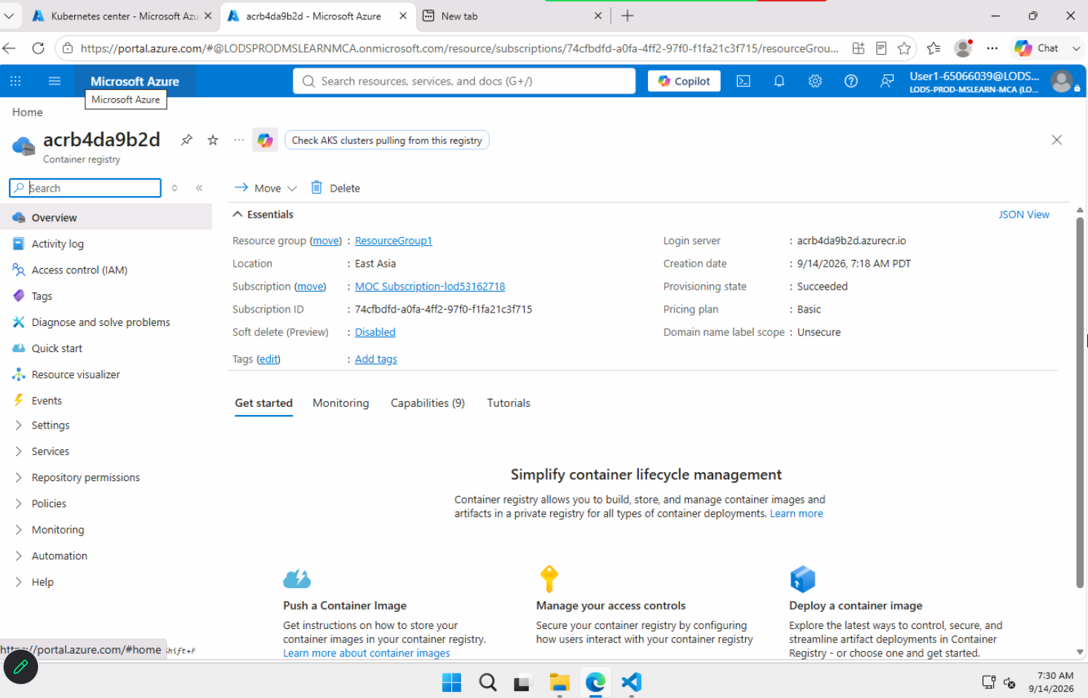
Figure 1 — Existing Azure Container Registry
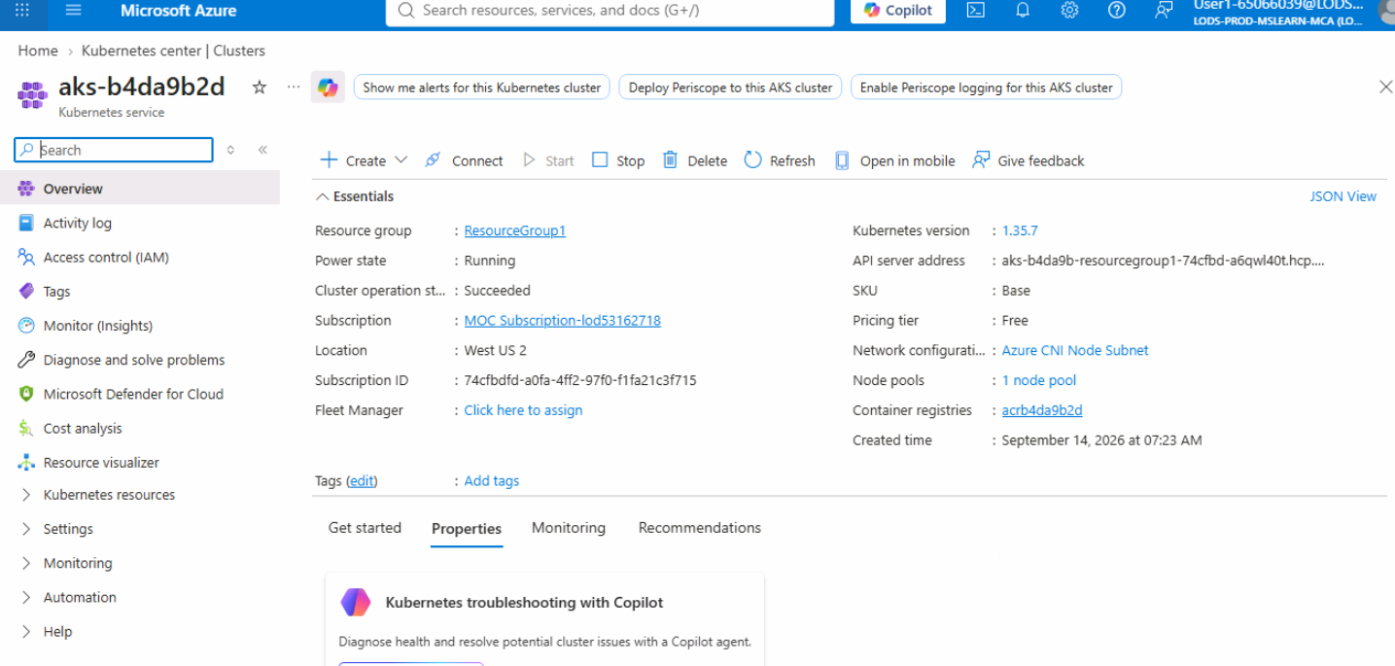
Figure 2 — Existing AKS cluster

Step 2 — Open Cloud Shell and Connect to AKS
Azure Cloud Shell provides the Azure CLI and kubectl. Set the subscription and download the AKS credentials so kubectl commands operate on the correct cluster.
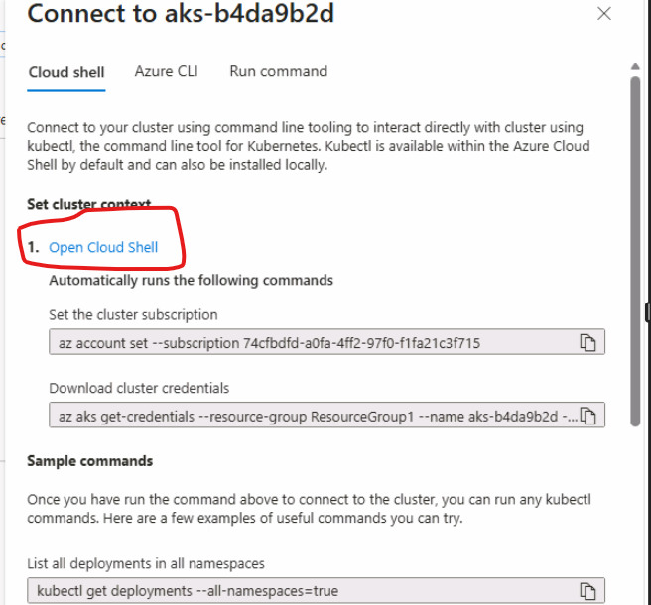
Figure 3 — Open Cloud Shell from the AKS Connect page
az account set --subscription 74cfbdfd-a0fa-4ff2-97f0-f1fa21c3f715
az aks get-credentials --resource-group ResourceGroup1 --name aks-b4da9b2d --overwrite-existing
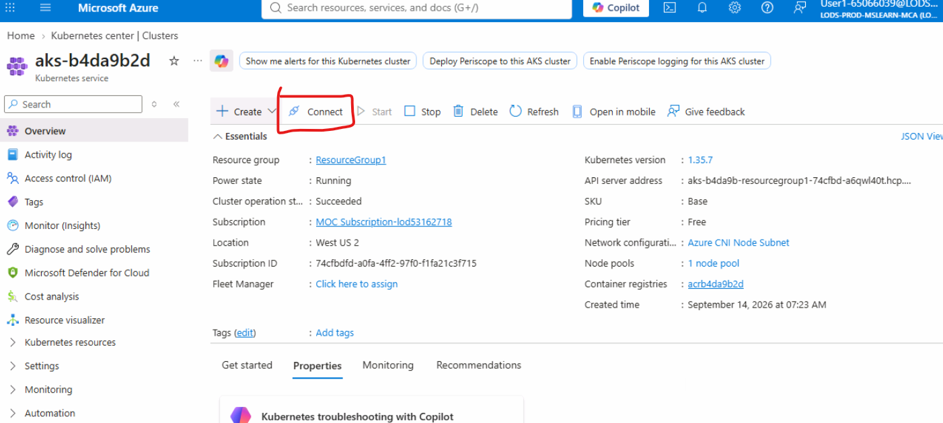
Figure 4 — AKS credentials connected for kubectl

Step 3 — Import ReconX Image into ACR
ACR can import an image directly from Docker Hub. This avoids manually pulling and pushing the image with Docker. The image is stored in ACR as repository az204 with tag reconx.
Figure 5 — Import the ReconX image into ACR
az acr import --name acrb4da9b2d --source docker.io/bipeen2001/az204:reconx --image az204:reconx
The resulting image reference is:
acrb4da9b2d.azurecr.io/az204:reconx

Step 4 — Attach ACR to AKS
This grants the AKS kubelet identity permission to pull images from the ACR. If the ACR is already attached to the AKS cluster, this step does not need to be repeated for the second image.
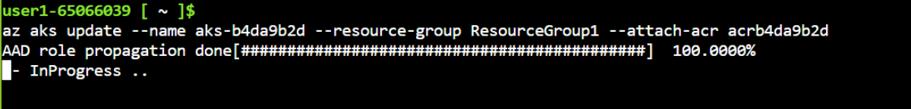
Figure 6 — Attach the ACR to AKS
az aks update --name aks-b4da9b2d --resource-group ResourceGroup1 --attach-acr acrb4da9b2d
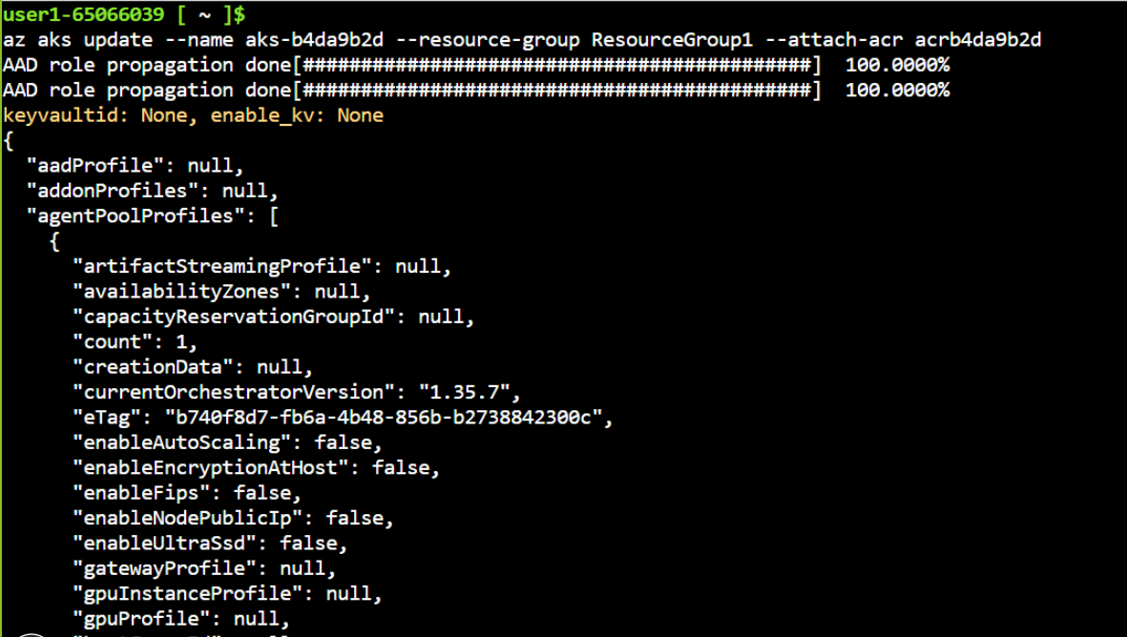
Figure 7 — Successful ACR attachment / role propagation

Step 5 — Create the ReconX Deployment
The Deployment tells Kubernetes which image to run. Kubernetes creates a Pod from the Deployment.
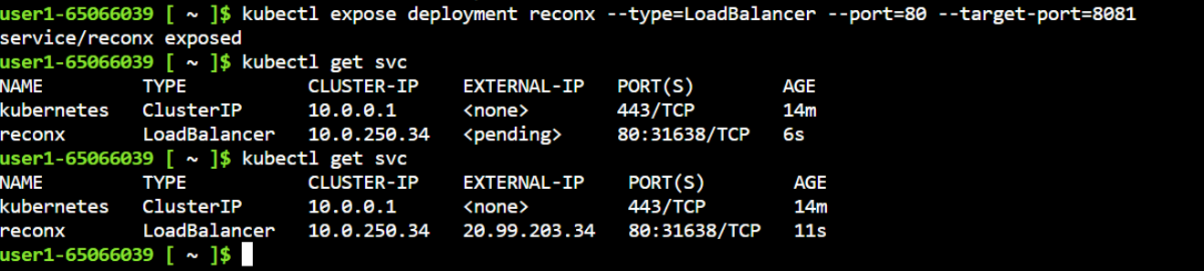
Figure 8 — Create the ReconX Deployment
kubectl create deployment reconx --image=acrb4da9b2d.azurecr.io/az204:reconx

Step 6 — Expose ReconX Through an Azure LoadBalancer
ReconX listens on port 8081 inside the container. Therefore, expose port 80 externally and forward the traffic to targetPort 8081 inside the Pod.
Figure 9 — Expose ReconX on port 80 and target port 8081
kubectl expose deployment reconx --type=LoadBalancer --port=80 --target-port=8081
After Azure assigns a public IP, retrieve it with:
kubectl get svc reconx

Step 7 — Open the ReconX Website
Open the EXTERNAL-IP shown for the reconx Service using HTTP. The screenshot demonstrates the ReconX dashboard successfully running from AKS.
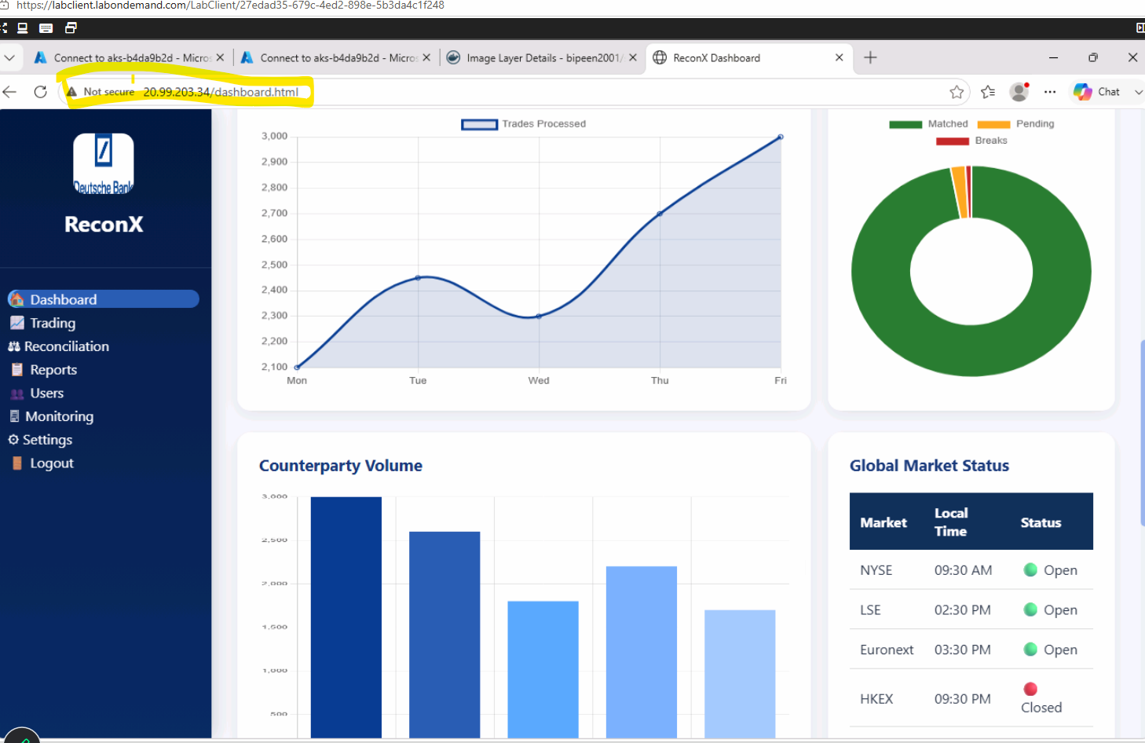
Figure 10 — ReconX application running through the AKS LoadBalancer

Step 8 — Optional: Scale ReconX
A Deployment can run multiple Pods. This improves availability and demonstrates Kubernetes scaling.
kubectl scale deployment reconx --replicas=3
kubectl get pods

ReconX — Kubernetes YAML
Instead of kubectl create/expose commands, the same application can be deployed using one YAML file.
apiVersion: apps/v1
kind: Deployment
metadata:
name: reconx
spec:
replicas: 1
selector:
matchLabels:
app: reconx
template:
metadata:
labels:
app: reconx
spec:
containers:
- name: reconx
image: acrb4da9b2d.azurecr.io/az204:reconx
ports:
- containerPort: 8081
---
apiVersion: v1
kind: Service
metadata:
name: reconx
spec:
type: LoadBalancer
selector:
app: reconx
ports:
- port: 80
targetPort: 8081
protocol: TCP
kubectl apply -f reconx.yaml
kubectl get pods
kubectl get svc reconx

LAB 2 — Deploy the E-Commerce Application
This lab repeats the same ACR-to-AKS process with the e-commerce image. The important difference is the application port. The e-commerce container in the supplied lab is exposed through port 80.

Step 1 — Import the E-Commerce Image into ACR
Import the Docker Hub e-commerce image into the same ACR using a different tag: az204:ecom.
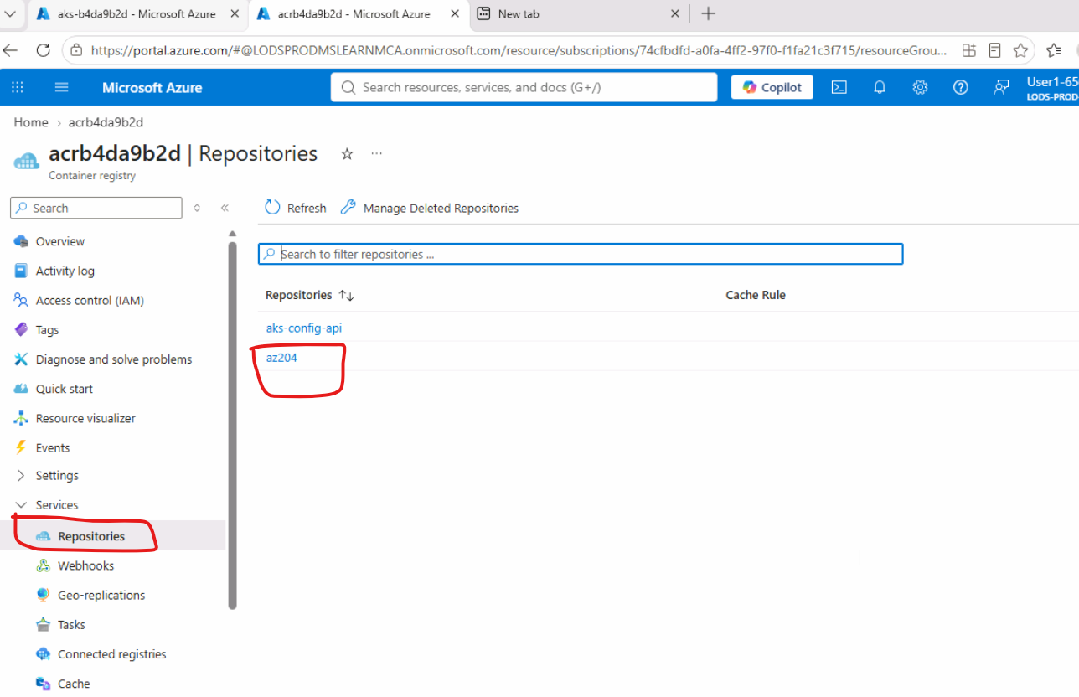
Figure 12 — Import the E-Commerce image into ACR
az acr import --name acrb4da9b2d --source docker.io/bipeen2001/az204:ecom --image az204:ecom
Figure 13 — Image imported into the ACR repository
The image reference used by AKS is:
acrb4da9b2d.azurecr.io/az204:ecom

Step 2 — Use the Existing ACR-to-AKS Connection
Because the ReconX lab already attached acrb4da9b2d to aks-b4da9b2d, the same permission applies to the e-commerce image in the same registry. You do not need to attach the registry again.
If starting this lab independently, use:
az aks update --name aks-b4da9b2d --resource-group ResourceGroup1 --attach-acr acrb4da9b2d

Step 3 — Create the E-Commerce Deployment
Create a Kubernetes Deployment using the e-commerce image stored in ACR.
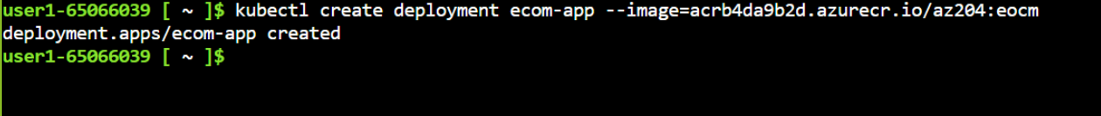
Figure 14 — Deployment created from the ACR image
kubectl create deployment ecom-app --image=acrb4da9b2d.azurecr.io/az204:ecom

Step 4 — Expose the E-Commerce Application
The e-commerce application uses port 80, so both the external Service port and targetPort are 80.
kubectl expose deployment ecom-app --type=LoadBalancer --port=80 --target-port=80
kubectl get svc ecom-app

Step 5 — Open the E-Commerce Website
Copy the EXTERNAL-IP from the ecom-app Service and open it in a browser using HTTP.
Example:
http://<EXTERNAL-IP>
The supplied screenshot shows the Sample E-Commerce Store successfully running from AKS.
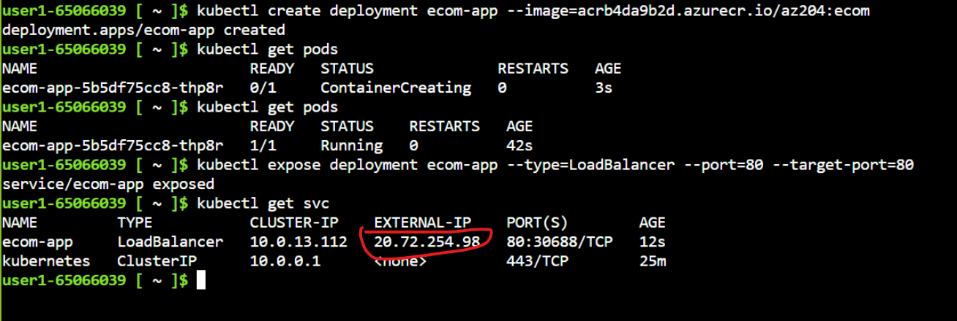
Figure 15 — E-Commerce Pod / Deployment creation

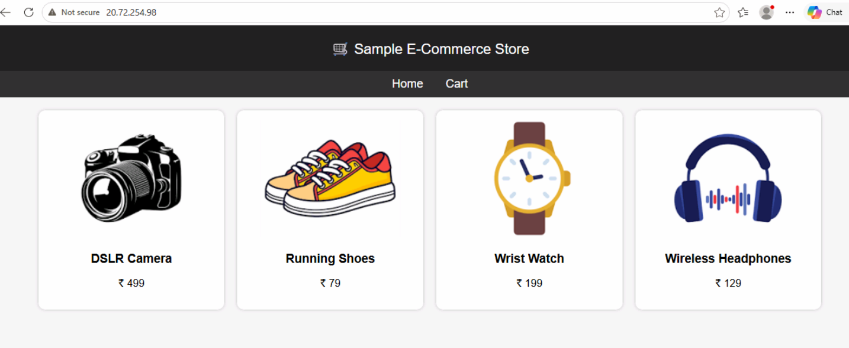

Step 6 — Optional: Scale the E-Commerce Application
kubectl scale deployment ecom-app --replicas=3
kubectl get pods

E-Commerce — Kubernetes YAML
apiVersion: apps/v1
kind: Deployment
metadata:
name: ecom-app
spec:
replicas: 1
selector:
matchLabels:
app: ecom-app
template:
metadata:
labels:
app: ecom-app
spec:
containers:
- name: ecom
image: acrb4da9b2d.azurecr.io/az204:ecom
ports:
- containerPort: 80
---
apiVersion: v1
kind: Service
metadata:
name: ecom-app
spec:
type: LoadBalancer
selector:
app: ecom-app
ports:
- port: 80
targetPort: 80
protocol: TCP
kubectl apply -f ecom.yaml
kubectl get pods
kubectl get svc ecom-app

Key Difference Between the Two Applications
Item | ReconX | E-Commerce | Why it matters
ACR image | az204:reconx | az204:ecom | Different image tags identify the applications.
AKS Deployment | reconx | ecom-app | Kubernetes object names are different.
Application port | 8081 | 80 | The Service must forward to the port used by the application.
Service port | 80 | 80 | Users access both applications through HTTP port 80.
targetPort | 8081 | 80 | This is the critical difference.

Port Mapping — Easy Explanation
ReconX:
Browser → LoadBalancer :80 → Pod :8081 → Spring Boot/Tomcat
E-Commerce:
Browser → LoadBalancer :80 → Pod :80 → Web application

Useful Kubernetes Commands
Purpose | Command
Show Deployments | kubectl get deployments
Show Pods | kubectl get pods
Show Services | kubectl get svc
Show Pod details | kubectl describe pod <POD-NAME>
View application logs | kubectl logs deployment/reconx
View e-commerce logs | kubectl logs deployment/ecom-app
Scale ReconX | kubectl scale deployment reconx --replicas=3
Scale E-Commerce | kubectl scale deployment ecom-app --replicas=3
Delete ReconX | kubectl delete deployment reconx service reconx
Delete E-Commerce | kubectl delete deployment ecom-app service ecom-app

Troubleshooting Guide
If the Pod shows ErrImagePull or ImagePullBackOff:
- Confirm the image name and tag exactly match the ACR image.
- Confirm the ACR is attached to AKS with --attach-acr.
- Check the Pod events with kubectl describe pod <POD-NAME>.
If the Pod is Running but the website does not open:
- Check the application logs with kubectl logs deployment/<deployment-name>.
- Check which port the application actually listens on.
- Make the Service targetPort match that application port.
- Use the Service EXTERNAL-IP, not the ClusterIP.
- If HTTPS has not been configured, use http:// rather than https://.

Cleanup
To remove the two lab applications while keeping the AKS cluster and ACR:
kubectl delete deployment reconx service reconx
kubectl delete deployment ecom-app service ecom-app
Do not delete the AKS cluster or ACR if you intend to continue the lab. Also avoid deleting the system Kubernetes service named 'kubernetes'.

Lab Completion Checklist
- ACR contains az204:reconx.
- ACR contains az204:ecom.
- AKS is connected to ACR.
- ReconX Deployment is Running.
- ReconX Service uses targetPort 8081.
- E-Commerce Deployment is Running.
- E-Commerce Service uses targetPort 80.
- Both applications can be opened using their LoadBalancer EXTERNAL-IP.
- Optional: each Deployment can be scaled to 3 replicas.

