AI-200 HANDS-ON LAB
Deploy a GenAI Application to AKS using Azure Container Registry
GitHub → ACR Build → ACR → AKS → LoadBalancer → Browser

1. Objective
Build a Docker image for the Vodafone AI Assistant directly from GitHub using Azure Container Registry (ACR), store the image in ACR, attach ACR to an existing Azure Kubernetes Service (AKS) cluster, deploy the image to AKS, expose the application through a Kubernetes LoadBalancer, and validate the GenAI application from a browser.

2. Lab Context
The application is a Flask-based Vodafone AI Assistant that uses Azure OpenAI. The source code is maintained in GitHub. ACR performs the container build in Azure, so Docker does not need to be installed locally. AKS then pulls the private image from ACR and runs it as a Kubernetes workload.
Security note: Never commit real Azure OpenAI keys to a public GitHub repository. Any credential visible in a public repository or screenshot should be rotated.

3. Resources
Resource | Value
GitHub repository | bipeensinha/AI-200-GenAI-AKS
Branch | master
Resource Group | ResourceGroup1
ACR | acrdb799d0c
ACR login server | acrdb799d0c.azurecr.io
Image | genai-api:v1
AKS cluster | aks-db799d0c
Application/container port | 5000
External service port | 80

4. End-to-End Workflow
1. Verify the GitHub repository and Dockerfile.
2. Verify the existing ACR.
3. Confirm Azure OpenAI configuration.
4. Build genai-api:v1 directly from GitHub in ACR.
5. Verify the image in ACR.
6. Connect to the existing AKS cluster.
7. Attach ACR to AKS.
8. Deploy genai-api:v1 to AKS.
9. Expose the deployment: Service port 80 → container port 5000.
10. Test the application using the AKS public IP.
Workflow: GitHub → ACR Build → ACR Image → Attach ACR → AKS Pod → LoadBalancer → Browser

Step 1 — Verify the GitHub Repository
Open https://github.com/bipeensinha/AI-200-GenAI-AKS and verify the master branch contains the application source, Dockerfile, and requirements.txt.
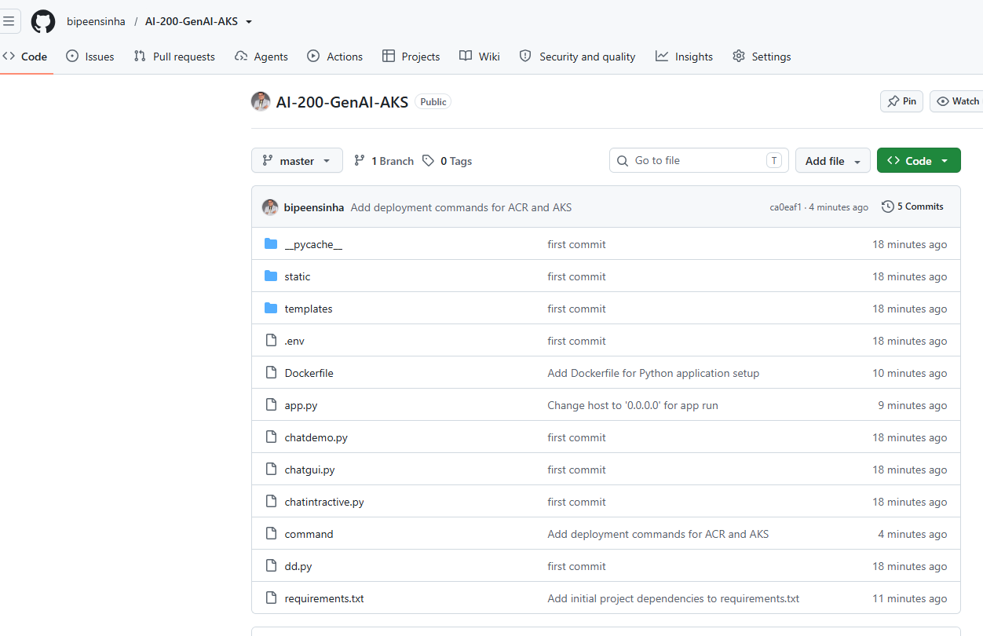
Step 1 - Verify the GitHub Repository

Step 2 — Verify the Existing ACR
Confirm that the existing registry is acrdb799d0c.
az acr show --name acrdb799d0c --resource-group ResourceGroup1 --query loginServer --output tsv
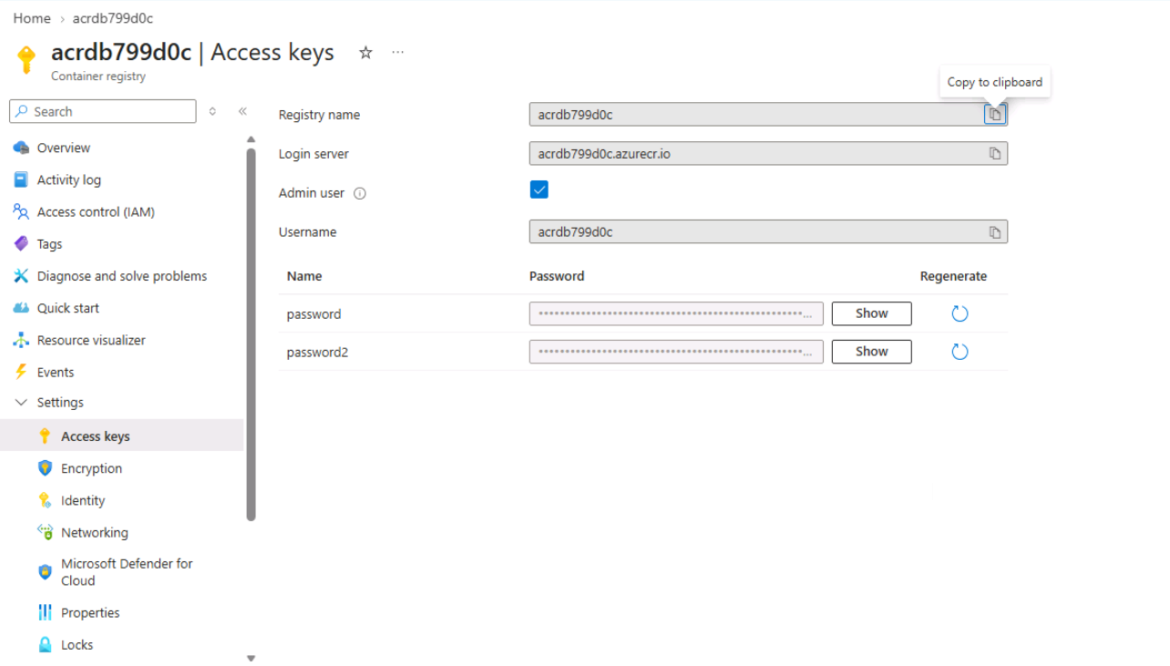
Step 2 - Verify the Existing ACR

Step 3 — Confirm Azure OpenAI Configuration
The application requires Azure OpenAI endpoint and key settings. Keep secrets out of GitHub; for AKS use Kubernetes Secrets or Key Vault.
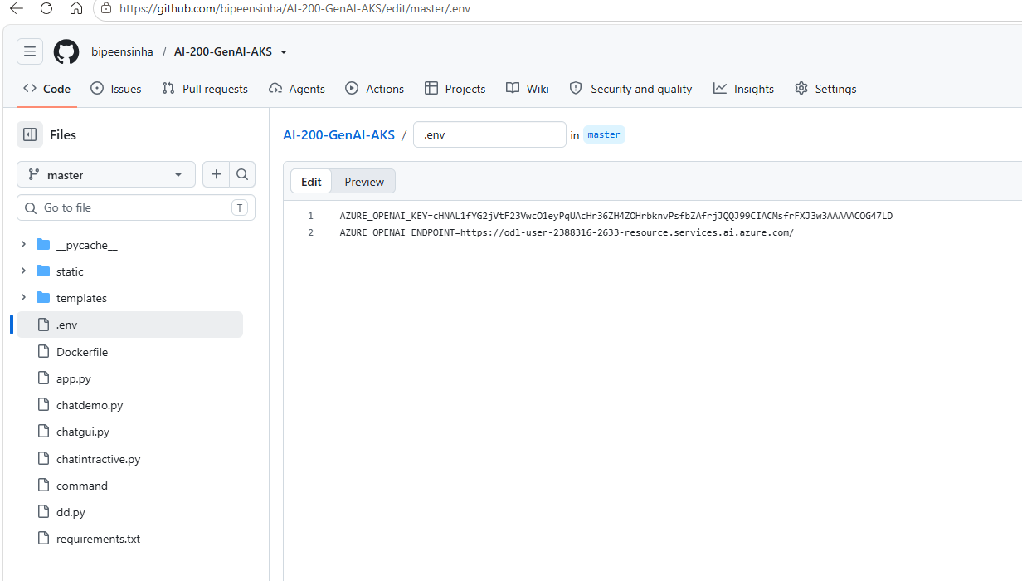
Step 3 - Confirm Azure OpenAI Configuration

Step 4 — Build the Image in ACR from GitHub
ACR downloads the repository, reads the Dockerfile, builds the container, and pushes the image to the registry.
az acr build --registry acrdb799d0c --image genai-api:v1 https://github.com/bipeensinha/AI-200-GenAI-AKS.git#master
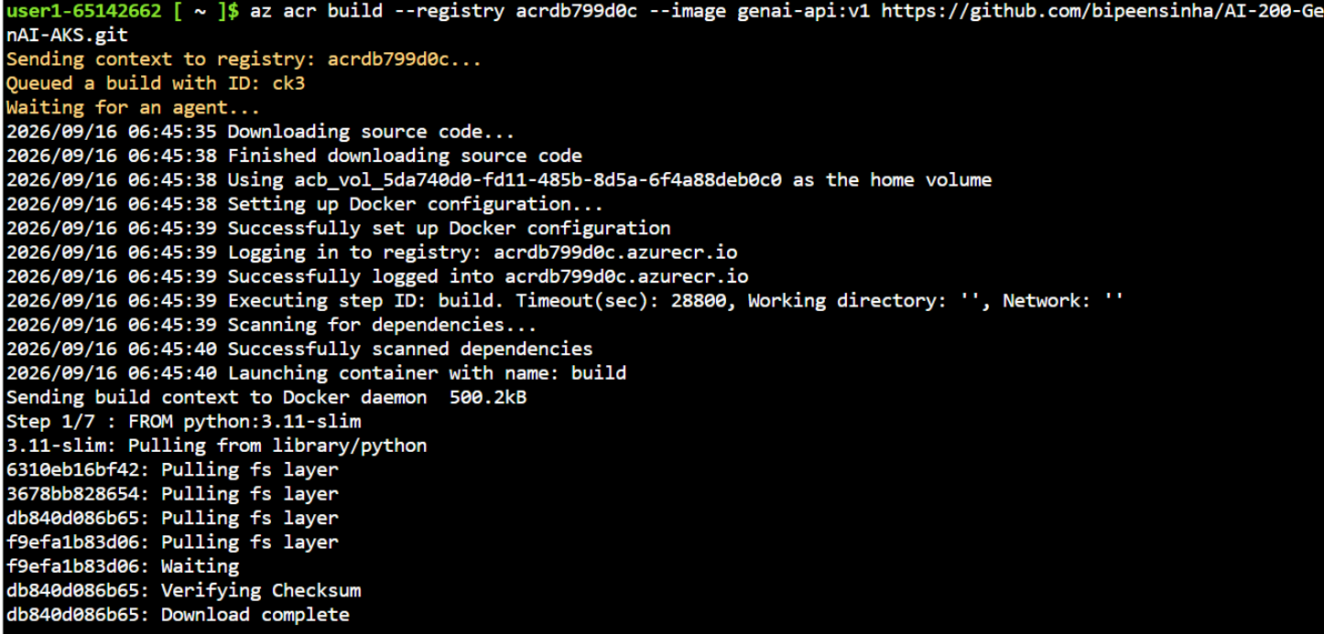
Step 4 - Build the Image in ACR from GitHub

Step 5 — Verify the Image in ACR
Confirm that the genai-api repository exists and then verify tag v1.
az acr repository list --name acrdb799d0c --output table
az acr repository show-tags --name acrdb799d0c --repository genai-api --output table
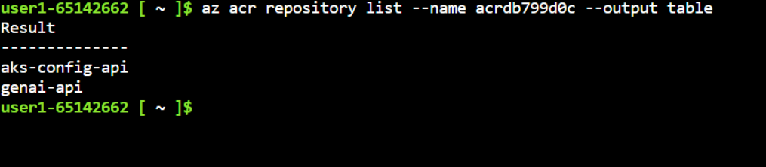
Step 5 - Verify the Image in ACR

Step 6 — Open the AKS Connect View
In Azure portal, open aks-db799d0c and select Connect. Choose Cloud Shell.
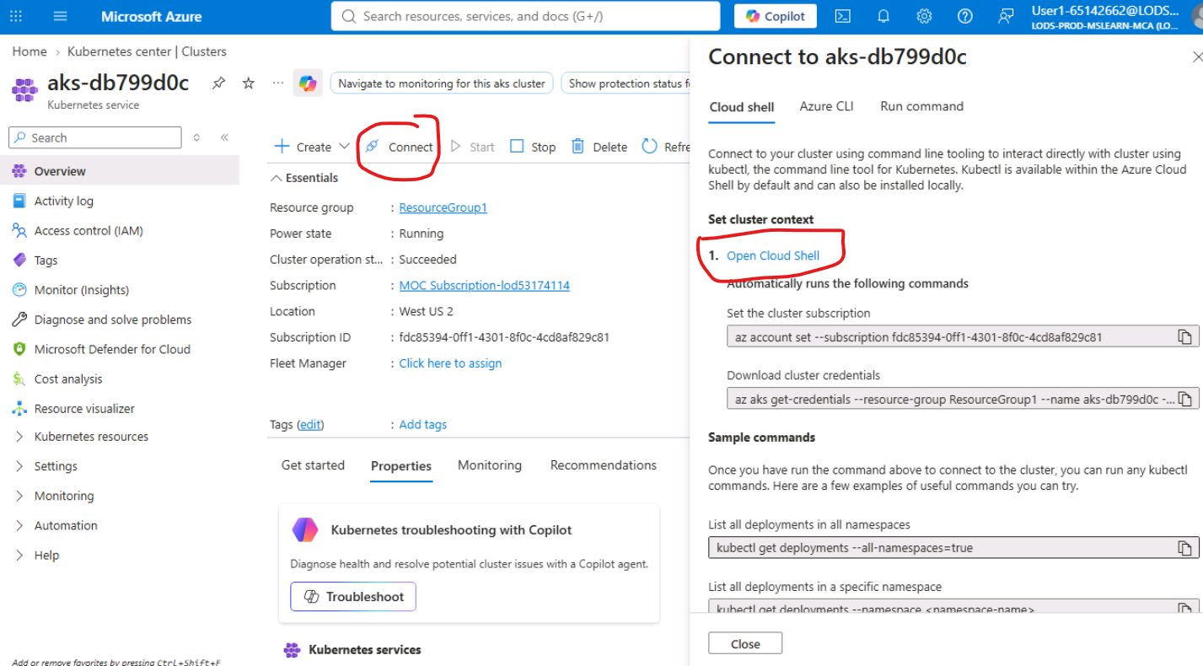
Step 6 - Open the AKS Connect View

Step 7 — Connect to AKS
Set the correct subscription, download AKS credentials, and verify that the nodes are Ready.
az account set --subscription fdc85394-0ff1-4301-8f0c-4cd8af829c81
az aks get-credentials --resource-group ResourceGroup1 --name aks-db799d0c --overwrite-existing
kubectl get nodes
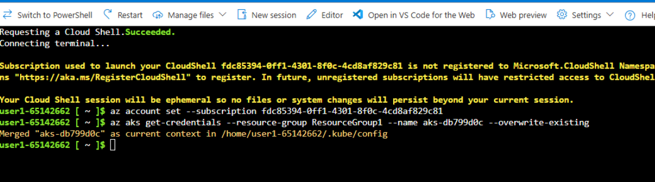
Step 7 - Connect to AKS

Step 8 — Attach ACR to AKS
This is essential: it grants AKS permission to pull the private image from ACR.
az aks update --name aks-db799d0c --resource-group ResourceGroup1 --attach-acr acrdb799d0c
Step 8 - Attach ACR to AKS

Step 9 — Deploy the GenAI Image
Create a Kubernetes Deployment using the ACR image. Then verify the pod reaches READY 1/1 and STATUS Running.
kubectl create deployment genai-api --image=acrdb799d0c.azurecr.io/genai-api:v1
kubectl get deployments
kubectl get pods
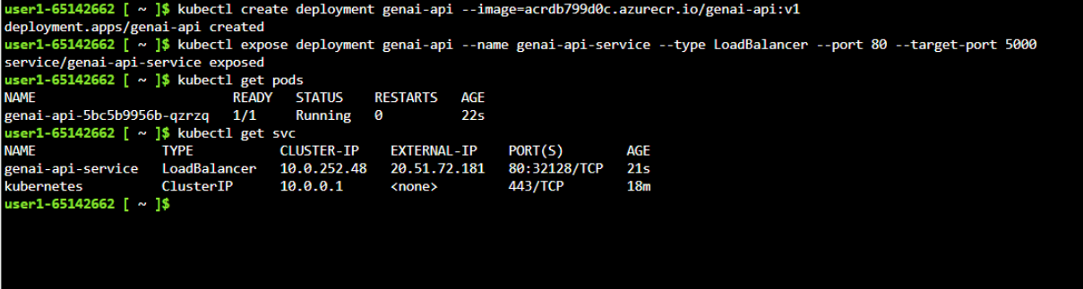
Step 9 - Deploy the GenAI Image

Step 10 — Expose the Application
Expose the deployment through a LoadBalancer. Port 80 is the external service port; target-port 5000 is the application port inside the container.
kubectl expose deployment genai-api --name genai-api-service --type LoadBalancer --port 80 --target-port 5000
kubectl get svc
Step 10 - Expose the Application

Step 11 — Test the Application
Copy the EXTERNAL-IP from kubectl get svc and open it in a browser using http://<EXTERNAL-IP>. Do not add :5000; Kubernetes maps external port 80 to container port 5000.
kubectl get svc genai-api-service
# Browser: http://<EXTERNAL-IP>
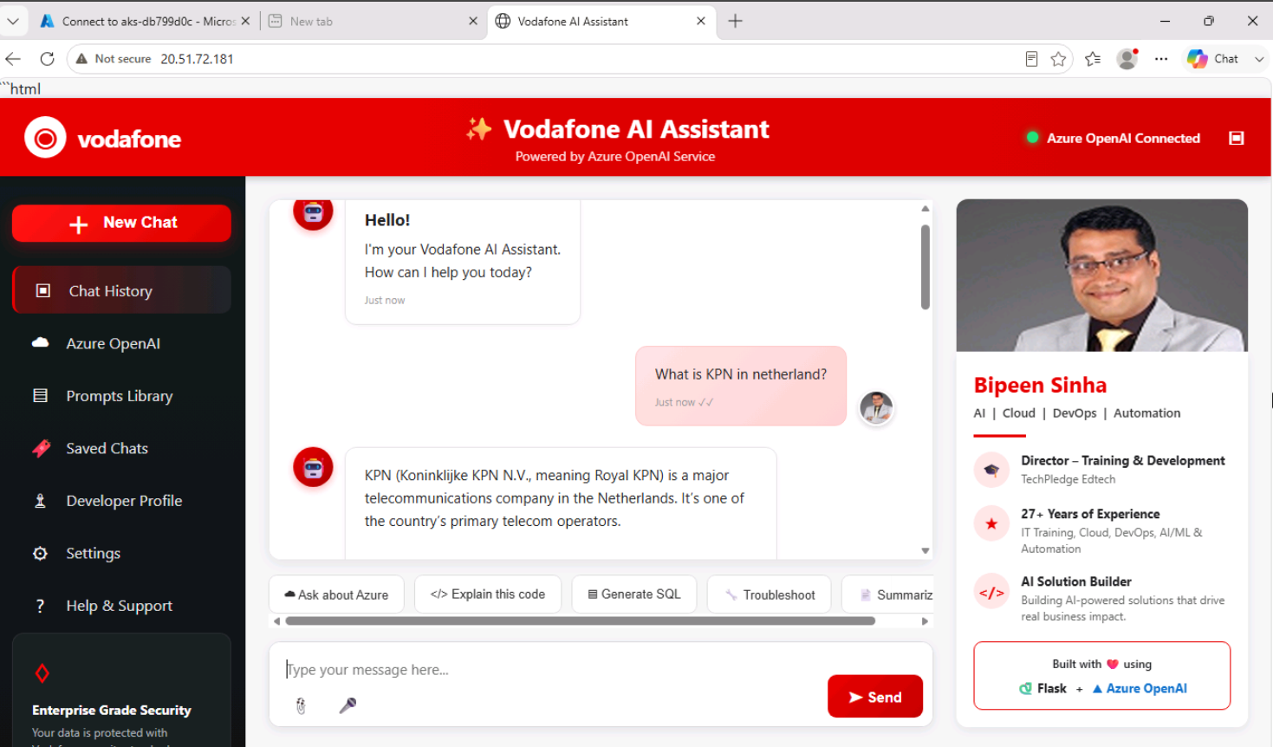
Step 11 - Test the Application

5. Port Mapping
Layer | Port | Purpose
Browser / LoadBalancer | 80 | External HTTP access
Kubernetes Service | 80 | Receives external traffic
Container / Flask | 5000 | Application listens here
Traffic flow: Browser :80 → LoadBalancer Service :80 → Pod :5000 → Flask/GenAI application.

6. Verification Checklist
☐ GitHub repository contains Dockerfile and requirements.txt
☐ ACR contains genai-api
☐ ACR contains tag v1
☐ AKS credentials are configured
☐ ACR is attached to AKS
☐ genai-api pod is Running
☐ LoadBalancer has an EXTERNAL-IP
☐ Application opens in a browser
☐ A test prompt receives a response

7. Troubleshooting
Problem | Check | Command
ImagePullBackOff | ACR attachment and image name | kubectl describe pod <pod-name>
Pod not running | Application logs | kubectl logs deployment/genai-api
EXTERNAL-IP pending | LoadBalancer provisioning | kubectl get svc -w
Connection refused | App listening on 0.0.0.0:5000 | kubectl logs deployment/genai-api
Azure OpenAI error | Endpoint/key/configuration | kubectl logs deployment/genai-api

8. Optional CI/CD Extension
After the manual deployment works, configure an ACR Task to build a new image automatically when code is committed to GitHub.
az acr task create --name genai-api-build --registry acrdb799d0c --context https://github.com/bipeensinha/AI-200-GenAI-AKS.git#master --file Dockerfile --image genai-api:v2 --commit-trigger-enabled true --base-image-trigger-enabled false --git-access-token "<YOUR-GITHUB-TOKEN>"
ACR Tasks automate the build/push portion. Updating AKS automatically is a separate deployment/CD step.

9. Lab Outcome
You have built a GenAI container image from GitHub in ACR, authorized AKS to pull it, deployed it as a Kubernetes workload, exposed it through a LoadBalancer, and validated the running Vodafone AI Assistant.

