AI-200 LAB MANUAL

Deploy an ML Model to AKS
Using Azure Container Registry
GitHub → ACR Build → AKS → Public Load Balancer

Lab environment used in the screenshots
Resource Group: ResourceGroup1 | ACR: acr4b8d3897 | AKS: aks-4b8d3897 | Image: ml-api:v1 | Container port: 5000

Purpose: Build a container image from the GitHub ML application, store it in Azure Container Registry (ACR), allow AKS to pull the image, deploy it as a Kubernetes Deployment, and expose the Flask API through an Azure Load Balancer.

Learning Objectives
- Understand the relationship between source code, Docker image, ACR, and AKS.
- Build a Docker image in Azure directly from a GitHub repository using az acr build.
- Verify that the image and tag exist in ACR.
- Attach ACR to AKS so the cluster can pull private images without using ACR admin credentials.
- Deploy the ML application to AKS and expose port 5000 through a public LoadBalancer.
- Test the deployed application using the public IP address.

Lab Architecture
GitHub | ACR Build | ACR | AKS Pod | Internet
GitHub source code → ACR builds Docker image → ACR stores image → AKS runs container → LoadBalancer exposes application
Important concept
ACR stores the container image; AKS runs the container image. The Dockerfile defines how the application becomes a container image. The Kubernetes LoadBalancer service provides the public endpoint.

Prerequisites
- Azure subscription with permission to create/update ACR and AKS resources.
- Azure Cloud Shell or a terminal with Azure CLI and kubectl installed.
- GitHub repository: bipeensinha/AI-200-AKS.
- A Dockerfile at the root of the GitHub repository.
- An existing ACR named acr4b8d3897 and AKS cluster named aks-4b8d3897.

Part 1 — Prepare the Application for Container Build
Dockerfile requirement: For this ACR build workflow, the repository should contain a Dockerfile at its root. ACR reads the Dockerfile and uses it to build the image.
FROM python:3.11-slim
WORKDIR /app
COPY requirements.txt .
RUN pip install --no-cache-dir -r requirements.txt
COPY . .
EXPOSE 5000
CMD ["gunicorn", "--bind", "0.0.0.0:5000", "--timeout", "600", "app:app"]
Expected repository structure
AI-200-AKS/
├── Dockerfile
├── app.py
├── requirements.txt
├── local_model.pkl
├── templates/
└── static/

Part 2 — Verify the Existing Azure Container Registry

Step 1: Open the Existing ACR
What to do: In the Azure portal, open the Container Registry named acr4b8d3897. Confirm that the provisioning state is Succeeded and note the login server.
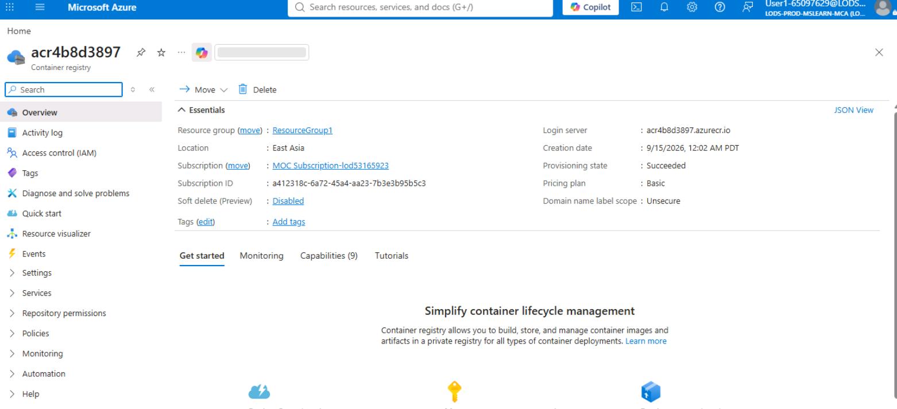
Figure 1 — Existing ACR: acr4b8d3897 and login server acr4b8d3897.azurecr.io

Step 2: Review ACR Access Keys
What to do: The screenshot shows the ACR Access keys page with Admin user enabled. For this lab, do not use these credentials for AKS image pulls; attaching ACR to AKS is the preferred method.
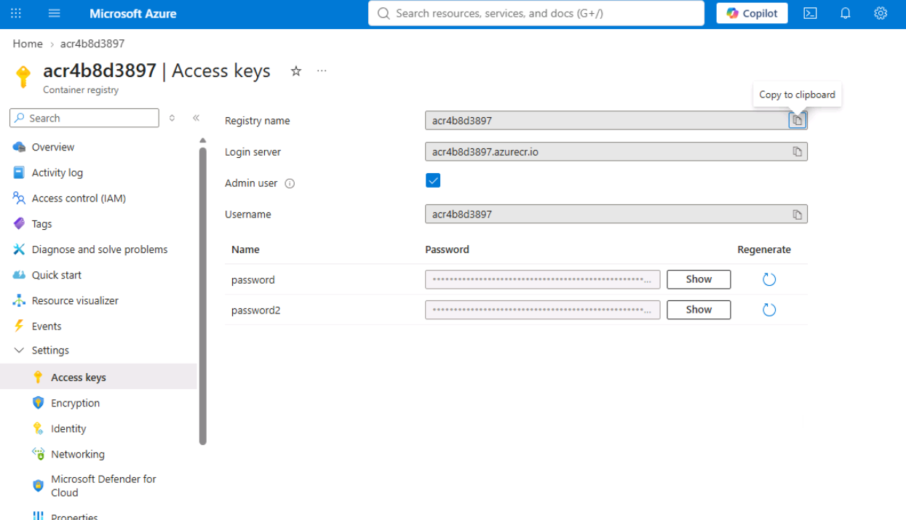
Figure 2 — ACR Access keys page (shown for awareness/validation)
Security note
Avoid putting ACR admin passwords in scripts, Kubernetes YAML, or GitHub repositories. For AKS, use az aks update --attach-acr so AKS receives permission to pull from ACR.

Part 3 — Build the Container Image from GitHub

Step 3: Build the Image in ACR from GitHub
What to do: Run the command from Azure Cloud Shell. ACR downloads the GitHub source, reads the Dockerfile, builds the image in Azure, and stores the resulting image in ACR. Your local machine does not need to build the image.
Command:
az acr build --registry acr4b8d3897 --image ml-api:v1 https://github.com/bipeensinha/AI-200-AKS.git
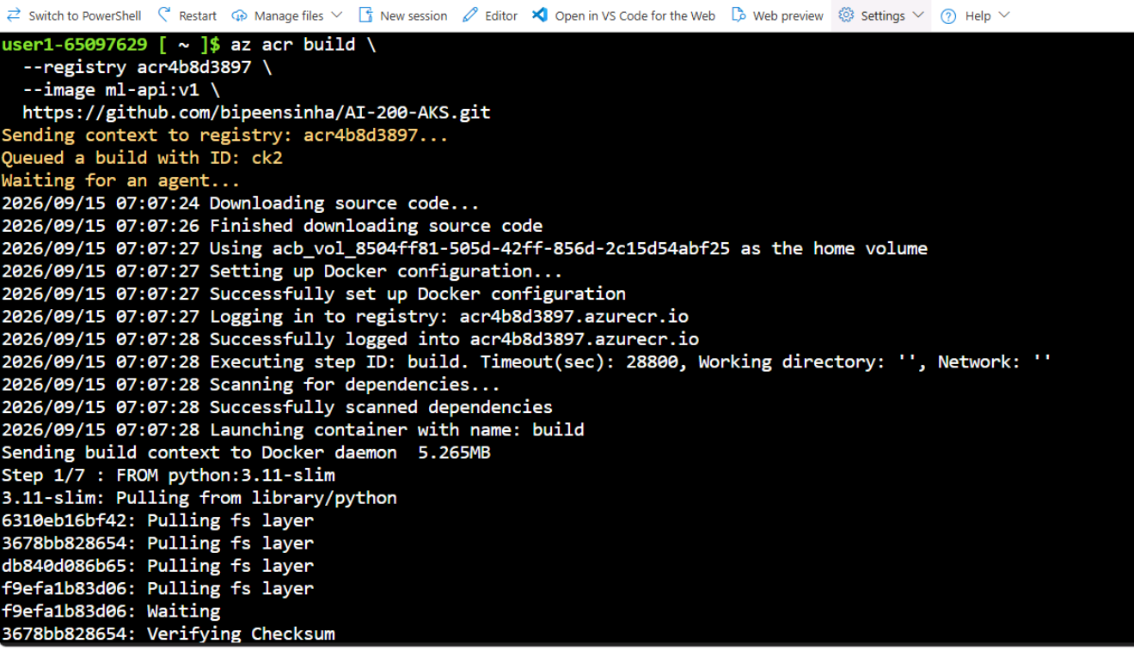
Figure 3 — ACR Task building the Docker image from the GitHub repository

Step 4: Verify the Image Repository
What to do: After the build succeeds, open Repositories in the ACR portal. The ml-api repository should appear.
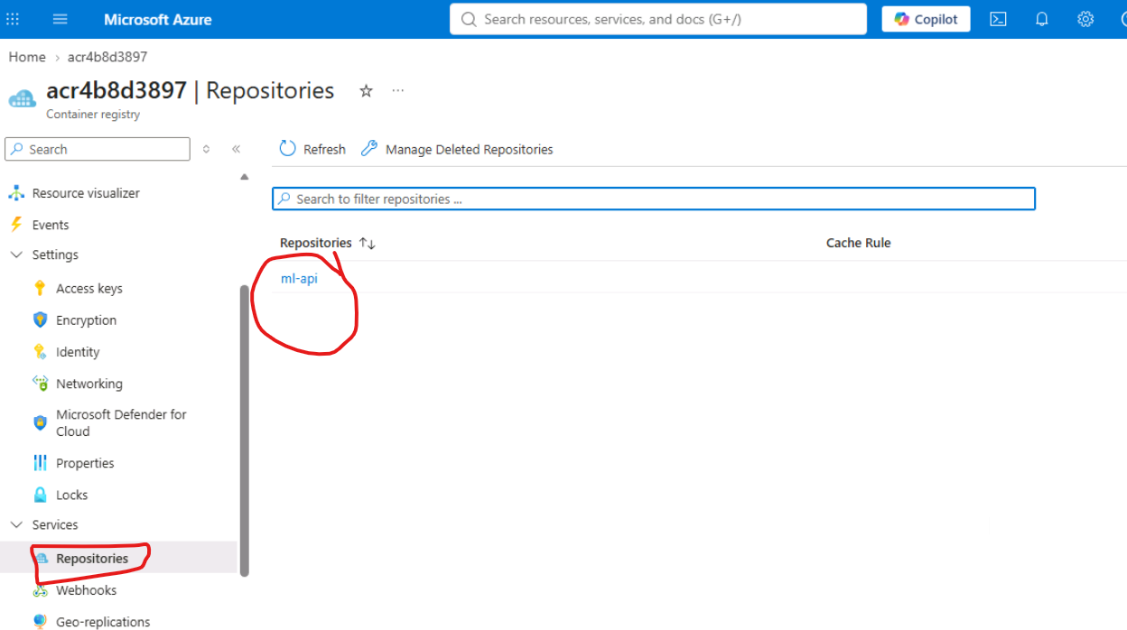
Figure 4 — ACR Repositories showing the ml-api image repository
az acr repository list --name acr4b8d3897 --output table
az acr repository show-tags --name acr4b8d3897 --repository ml-api --output table
Expected result
Repository: ml-api
Tag: v1
Full image name: acr4b8d3897.azurecr.io/ml-api:v1

Part 4 — Connect to the Existing AKS Cluster

Step 5: Open the Existing AKS Cluster
What to do: In the Azure portal, open aks-4b8d3897. Confirm that the resource group is ResourceGroup1 and the cluster is running.
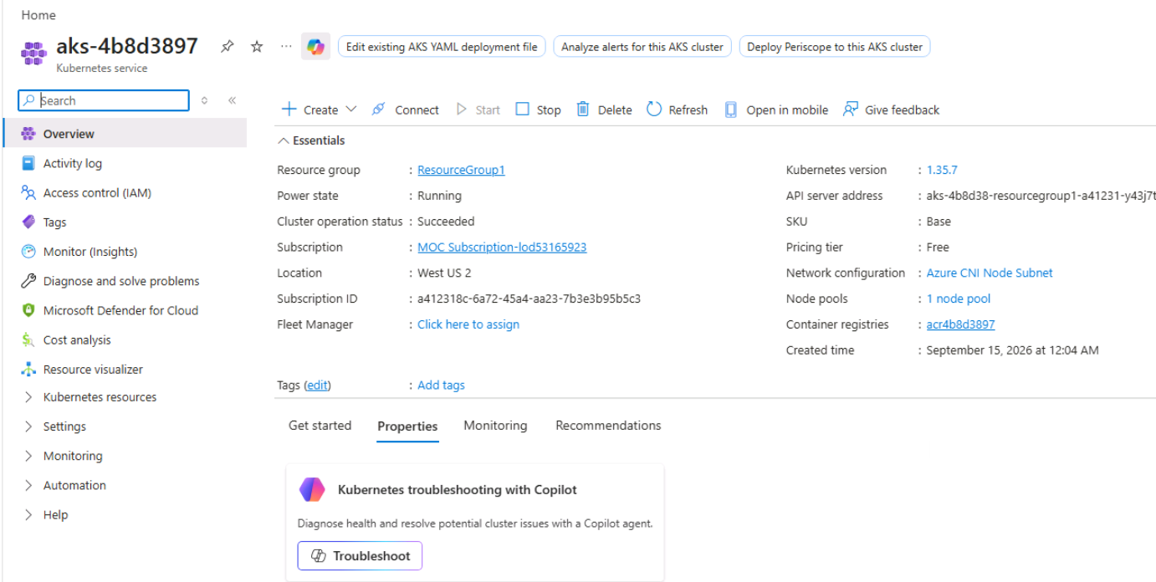
Figure 5 — Existing AKS cluster aks-4b8d3897

Step 6: Open the AKS Connect Panel
What to do: Select Connect on the AKS overview page and choose Open Cloud Shell. Azure provides the commands needed to set the subscription and download cluster credentials.
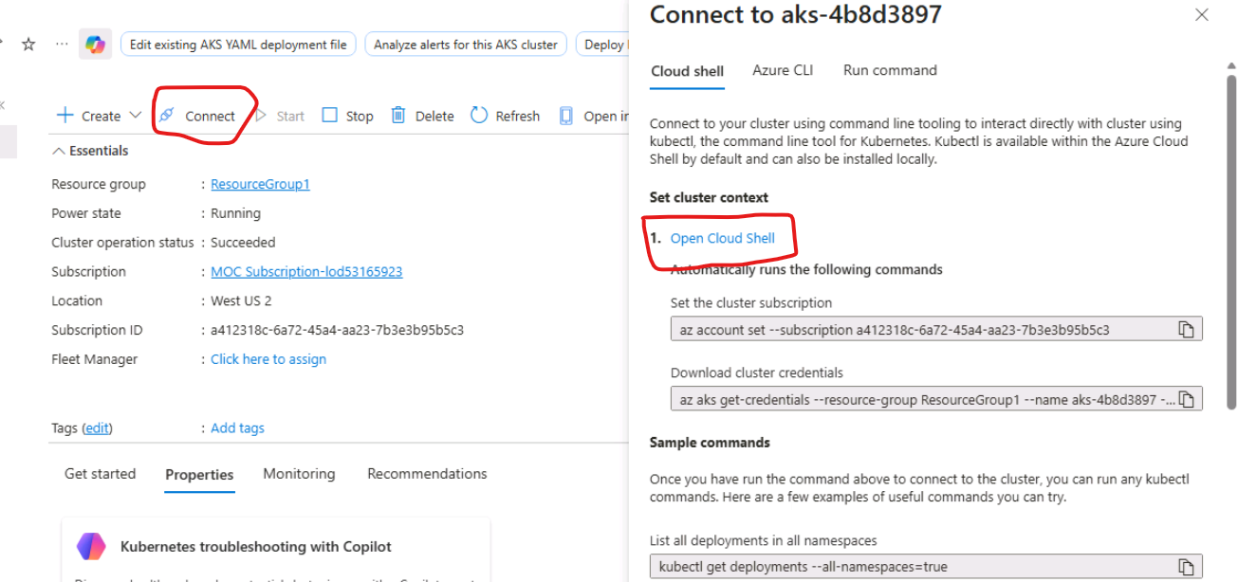
Figure 6 — AKS Connect panel showing Cloud Shell and credential commands

Step 7: Set the Azure Subscription
What to do: Use the subscription shown in your own Azure portal. The screenshot is from the lab environment; do not copy an unrelated subscription ID.
Command:
az account set --subscription <SUBSCRIPTION-ID>
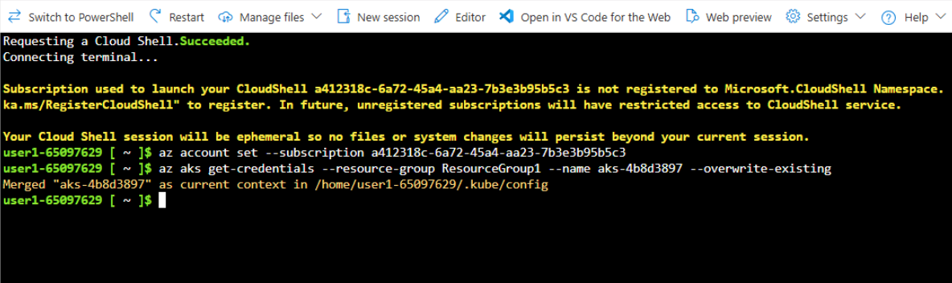
Figure 7 — Azure Cloud Shell connected to the AKS environment

Step 8: Download AKS Credentials
What to do: Download the Kubernetes credentials so kubectl can communicate with aks-4b8d3897.
Command:
az aks get-credentials --resource-group ResourceGroup1 --name aks-4b8d3897 --overwrite-existing
kubectl get nodes
Checkpoint
kubectl get nodes should return the nodes in aks-4b8d3897. If it does, your Cloud Shell is connected to the cluster.

Part 5 — Attach ACR to AKS

Step 9: Attach ACR to AKS
What to do: Grant the AKS cluster permission to pull images from acr4b8d3897. This is the key integration between the registry and the Kubernetes cluster.
Command:
az aks update --name aks-4b8d3897 --resource-group ResourceGroup1 --attach-acr acr4b8d3897
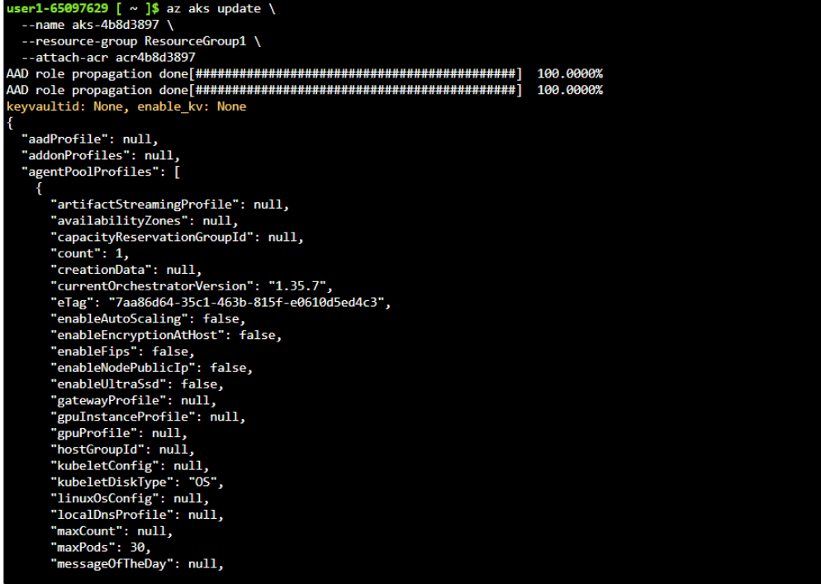
Figure 8 — Successful ACR attachment to the AKS cluster
What this command does
It creates/uses the appropriate Azure role assignment so the AKS kubelet identity can pull private container images from ACR. You do not need to put the ACR admin password into the Kubernetes deployment.

Part 6 — Deploy the ML Container to AKS

Step 10: Create the Kubernetes Deployment
What to do: Create a Deployment named ml-api using the v1 image stored in ACR. The image is pulled from acr4b8d3897.azurecr.io.
Command:
kubectl create deployment ml-api --image=acr4b8d3897.azurecr.io/ml-api:v1
Figure 9 — Kubernetes Deployment created from the ACR image
kubectl get deployment ml-api
kubectl get pods
Expected Pod state
The Pod should eventually show READY 1/1 and STATUS Running. If the Pod shows ImagePullBackOff, verify the ACR attachment and the image name/tag.

Part 7 — Expose the ML API

Step 11: Expose the Deployment with a LoadBalancer
What to do: The Flask/Gunicorn application listens inside the container on port 5000. Expose it externally on port 80 using a Kubernetes LoadBalancer service.
Command:
kubectl expose deployment ml-api --name ml-api-service --type LoadBalancer --port 80 --target-port 5000
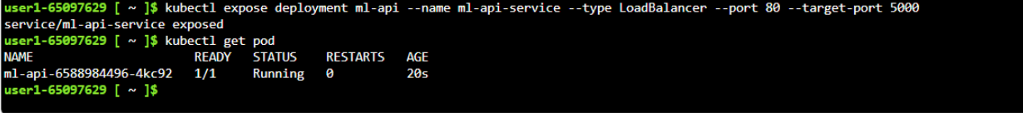
Figure 10 — LoadBalancer service created for the ML API
kubectl get svc ml-api-service
Port mapping
Internet port 80 → Azure Load Balancer → Kubernetes Service port 80 → Pod target port 5000 → Flask/Gunicorn application.

Step 12: Get the Public IP Address
What to do: Wait until EXTERNAL-IP changes from <pending> to a public IP address.
Command:
kubectl get svc ml-api-service
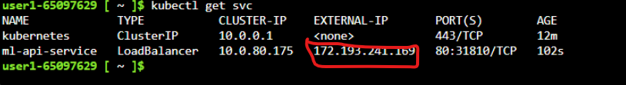
Figure 11 — Service output showing the public EXTERNAL-IP
kubectl get service ml-api-service -o jsonpath='{.status.loadBalancer.ingress[0].ip}'

Part 8 — Test the Deployed Application

Step 13: Open the ML Application
What to do: Copy the public IP returned by the LoadBalancer and open it in a browser using http://<EXTERNAL-IP>. The screenshot shows the deployed Vodafone Billing Predictor application.
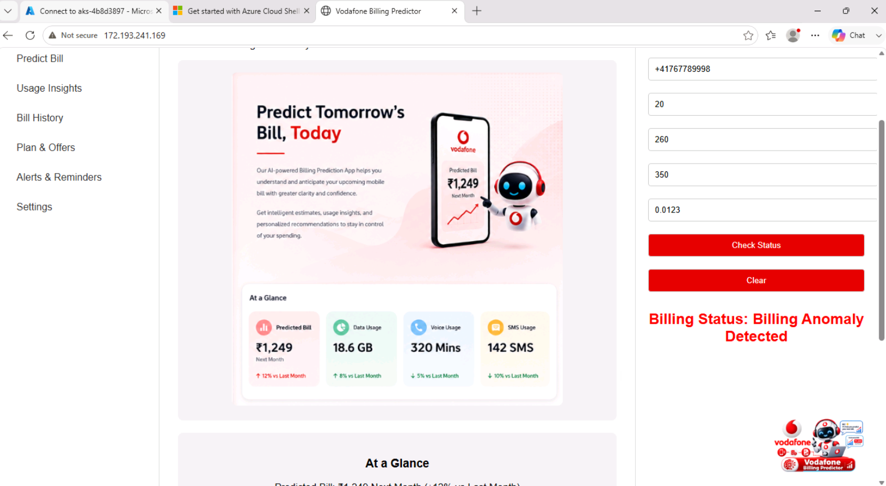
Figure 12 — ML application successfully accessible through the AKS public IP
curl http://<EXTERNAL-IP>
Expected result
The browser should display the ML application. You can enter the required input values and test the prediction/API functionality.

Troubleshooting Guide
Problem | Check | Useful command
ImagePullBackOff | AKS cannot pull the ACR image. | kubectl describe pod <POD-NAME>
Pod not Running | Check container logs. | kubectl logs <POD-NAME>
EXTERNAL-IP <pending> | Azure LoadBalancer is still provisioning. | kubectl get svc ml-api-service
Application not responding | Verify the application listens on 0.0.0.0:5000. | kubectl logs <POD-NAME>
Wrong image version | Check the image configured in Deployment. | kubectl get deployment ml-api -o jsonpath="{.spec.template.spec.containers[0].image}"

Useful Verification Commands
kubectl get nodes
kubectl get deployments
kubectl get pods
kubectl get svc
kubectl describe deployment ml-api
kubectl logs deployment/ml-api
az acr repository list --name acr4b8d3897 --output table
az acr repository show-tags --name acr4b8d3897 --repository ml-api --output table

Optional Extension — Build Version 2 Automatically
Next lab step: Use an ACR Task to automatically build a new image when code is committed to GitHub. This introduces the CI portion of the workflow.
az acr task create --name ml-api-build --registry acr4b8d3897 --context https://github.com/bipeensinha/AI-200-AKS.git#main --file Dockerfile --image ml-api:v2 --commit-trigger-enabled true --base-image-trigger-enabled false --git-access-token "<GITHUB-PAT>"
CI/CD concept
GitHub commit → ACR Task → Docker build → ACR ml-api:v2 → deployment update in AKS. For production, use secure federated identity/OIDC or managed deployment tooling rather than storing long-lived credentials.

Lab Completion Checklist
☐ GitHub repository contains a Dockerfile.
☐ ACR acr4b8d3897 contains repository ml-api.
☐ Image tag v1 exists in ACR.
☐ AKS aks-4b8d3897 is connected through kubectl.
☐ ACR is attached to AKS.
☐ Deployment ml-api is Running.
☐ Service ml-api-service is type LoadBalancer.
☐ EXTERNAL-IP is available.
☐ ML application opens successfully in the browser.

Final Architecture — What You Built
End-to-end flow
GitHub (source code) → Dockerfile → ACR Build → ACR (ml-api:v1) → AKS Deployment → Pod → LoadBalancer Service → Public IP → ML Web Application

