Dear Team Redbull,

Let me ask you for an instance of your imagination. What you see is not simply a paper bull — much rather a visual representation of my persona. The animal as such symbolises strength, grit, and perseverance, all of which are wired in my DNA. There is far more to interpret from my artwork. Berlin, New York, Copenhagen, and Innsbruck are places that have scaffolded my international background. As a dual citizen, culture has always been an integral part of my life, as well as a timeless case of adventure and confrontation. In light thereof, I studied Business, Language, and Culture to further indulge into what we, as people, make meaning of. I understand the power of culture in a business-context and am determined to work for Redbull as it embraces culture in a fashion unmatched by any other company. This is where sport comes into play. I am an athlete and my passion for sports is contagious — an ice hockey match, a yoga pose, a marathon, or a long swim will all thrill me differently. However, my own experiences as a soccer player leave me biased in claiming that soccer brings me ultimate bliss, which is why I am particularly intrigued by Redbull’s football clubs and what their futures bring. The idea of being part of Redbull’s three-sixty-degree mentality by contributing to the reinvention of media and marketing conventions excites me. I draw inspiration from visuals, crafts, and music, all of which incite my own creativity and desire to make art. To me, art also transcends in the digital world. Programming applications and websites has taught me new ways of thinking and working creatively, fostering my digital mindset.

To

Redbull

January 10th 2021

Am Brunnen 1, 5220 Fuschl am See, Austria

Dianastr. 20 14482 PotsdaM +49 176 77141216 [sMTWD14@gmail.com](mailto:sMTWD14@gmail.com)

I believe that all three Redbull Graduate Programs *(Sports Marketing & Media Graduate Program, Brand Marketing Graduate Program, and Digital Marketing Graduate Program)* will enable me to combine my passion for sports, arts, and technology with my career like no other programs out there.

Collaboration with developers, the management of projects, event coordination, and the many teams I have played for, have shaped me into a strong team player, listener, communicator, and allowed me to develop a dexterity to adapt to change. Curiosity, spirit, and goal-oriented are characteristics, which will enable me to contribute quickly and proactively in a new business culture demanding open-mindedness, tenacity, and teamwork. A strong commitment to excel, coupled with self-discipline and enthusiasm, is a mindset I bring to the table.

Lastly, I would like to share that I imagine the whitespace left on the sides of the bull as placeholders for what awaits me at Redbull — a new beginning. Thank you for your time and consideration, I am looking forward to hearing from you!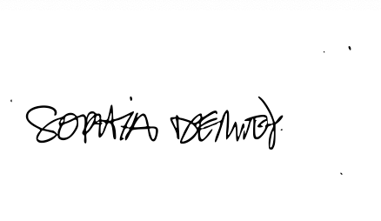

Sincerely,