Error 1
Error name | User Input wrong
Screenshot of error | 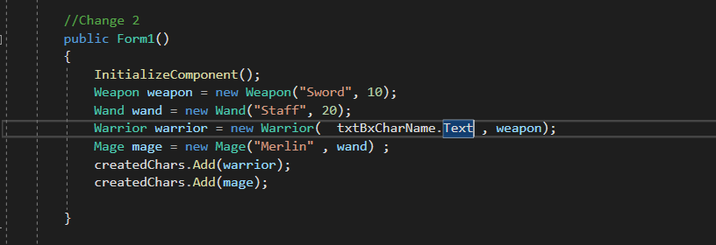
Error Description | The code was suppost to add random characters off the strat of the code but I Misunderstood and made it for the usere to input on start
Error Code | Warrior warrior = new Warrior (txtBxCharName.text , weapon);
How the error was fixed | Warrior warrior = new Warrior (“Name”, weapon);

Error 2
Error name | Cannot convert INT to String
Screenshot of error | 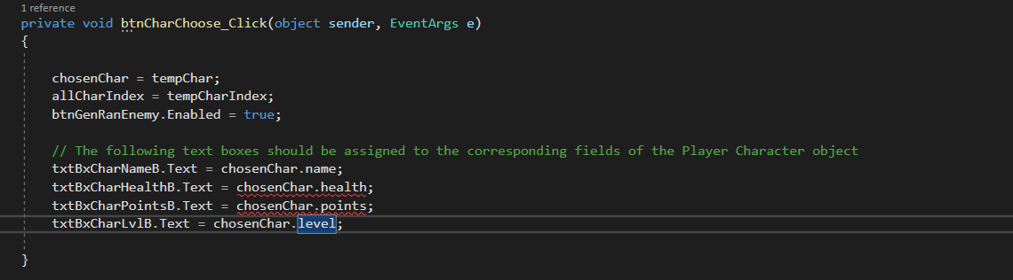
Error Description | HP , Points and level were a variable int and the chosenChar needs a string
Error Code | txtBxCharHealth.text = chosenChar.health;
How the error was fixed | txtBxCharHealth.text = chosenChar.health.ToString();

Error 3
Error name | Exception Thrown
Screenshot of error | 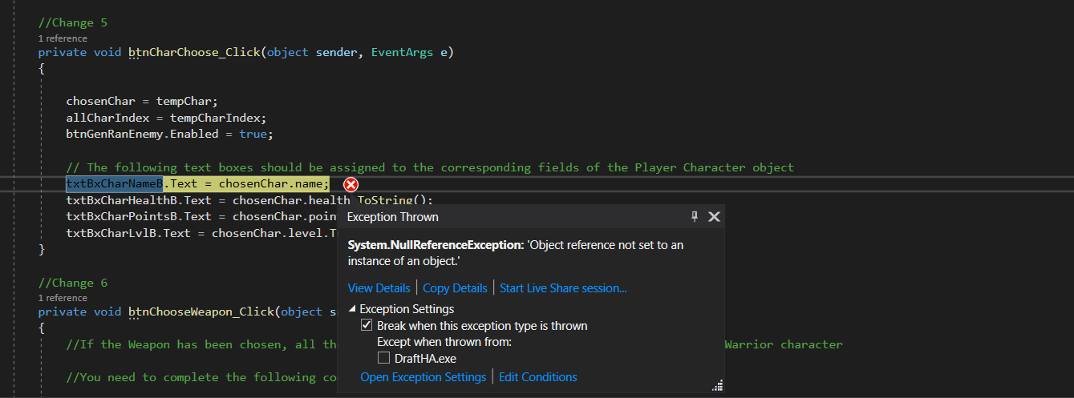
Error Description | The reference was not set to an object
Error Code | chosenChar = tempChar;
How the error was fixed | Character chosenChar = createdChars[TempCharIndex];

Error 4
Error name | Exception Thrown
Screenshot of error | 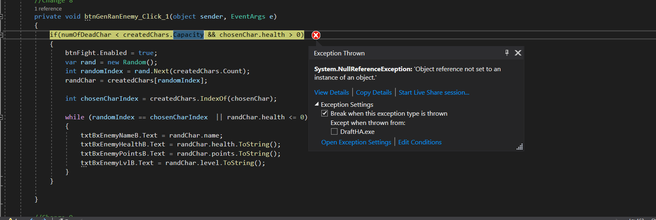
Error Description | The instance of the object was Null
Error Code | The whole code
How the error was fixed | The file has gotten corrupt and deleted all the classes , so I created a new project and and classes and copied all the code from there into the new project

Error 5
Error name | Exeption unhandled
Screenshot of error | 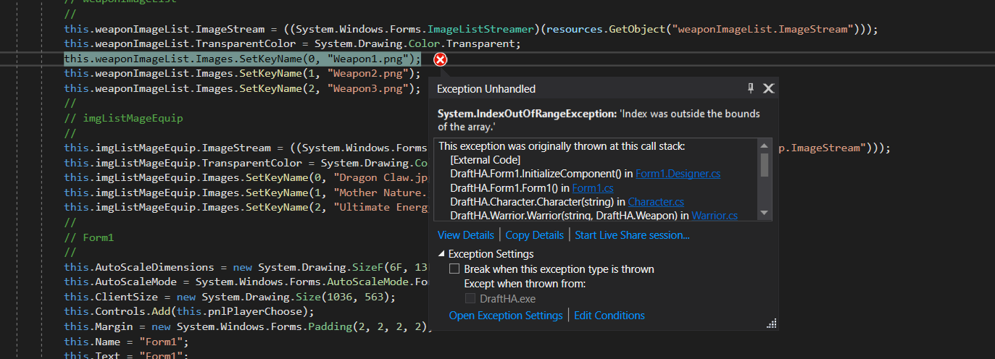
Error Description | The index was out of bounds
Error Code | Class Character : Form 1
How the error was fixed | The :Form 1 should have not been included Class Character{} <- good code

Error 6
Error name | Error CSO103;
Screenshot of error | 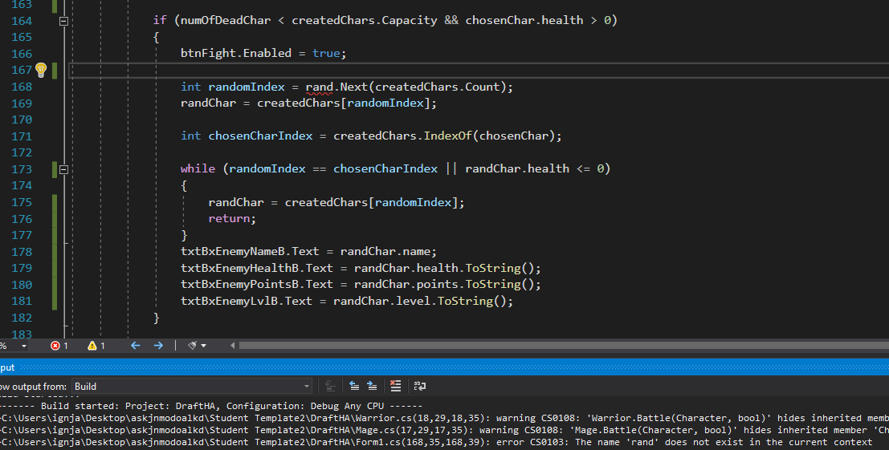
Error Description | The rand name did not exist in the current context
Error Code | int randomIndex = rand.Next(createdChars.Count);
How the error was fixed | var rand = new Random();

Error 7
Error name | Error CS0120
Screenshot of error | 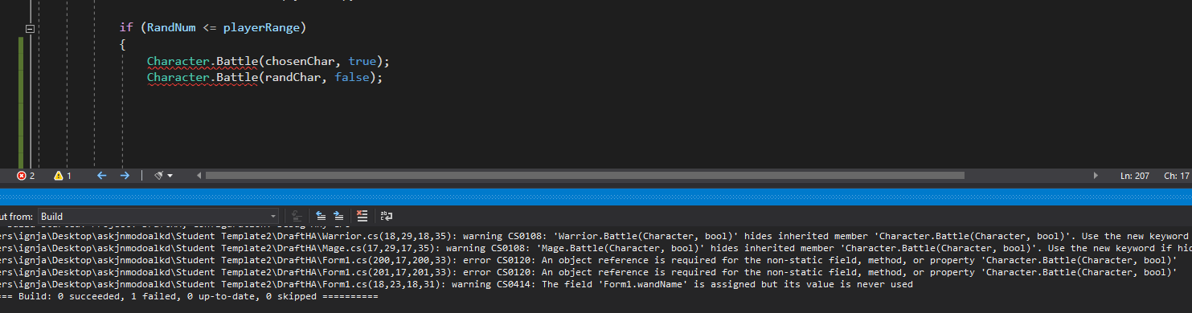
Error Description | Not the correct way to call a function from annother class
Error Code | Character.battle(TempChar, false);
How the error was fixed | randChar.Battle(randChar , false);

Application Design

Character
Name
Health
Points
Level
wins

Mage
Wand

Mage()
Battle()

Warrior
Weapon
Warrior()
Battle()

Wand
Name
HitPoints
PowerLevel
CurrentStamina

Wand()

Weapon
Name
Damage
HitPoints
Weapon()

Testing the final Application

Test Case Number | Desc | Test Data | Expected  Outcome | Actual Outcome | Pass / Fail
1 | Check if 2 characters are added at start when refresh button is clicked | No characters show on start | On click of the refresh button 2 characters show | On click of the refresh button 2 characters show | Pass
2 | Add 2 characters on start up of the application to the list | All the required fields were added | The 2 characters were added to the list | The 2 characters were added to the list | Pass
3 | If the characters health is < = 0 the button choose character is disabled | Button not clickable when character has health else not clickable | Button not clickable when character has 0 health | Button not clickable when character has 0 health | Pass
4 | If the characters health is <= 0  Fight button disabled | Button not clickable when character has health else not clickable | Button not clickable when character has 0 health | Button not clickable when character has 0 health | Pass
5 | When fight button is clicked the health is reduced | When the battle is won the health is reduced. | Health reduced when battle lost | Health reduced when battle lost | Pass
6 | If the enemy index is the same as character index it generates a new enemy | Enemy index is changed if it is the same as the character and returned. | Enemies are not repeated. | Enemies are not repeated. | Pass
7 | Random number is generated depending on the enemy and character level and stored in a variable | Created a new random class , and different variables to store the information | Enemy and player levels is multiplied by 20 , added together and a random number that is in that parameter is picked | Enemy and player levels is multiplied by 20 , added together and a random number that is in that parameter is picked | Pass
8 | If user wins he gains points else his health is reduced depending on the enemies level | If won points are added  Point += opponent.level * 5  else health is deducted depending on the enemie level  health -= opponent.level * 5; | User wins , points are added , user loses health is deducted | User wins , points are added , user loses health is deducted | Pass
9 | There are 2 classes mage and warrior the Weapons and wands will be added to the character Depending on the class of the character. | Weapons are added to the warrior  Wands are added to the Mage | When the user picks a class the right weapon is displayed | When the user picks a class the right weapon is displayed | Pass
10 | The user can Name their character what ever they would like , and when the user clicks the refresh button they will show up. | Uses the input from the text box and displays it as the name | The user inputted name is saved , After the click of the refresh button the name they have assigned is shown | The user inputted name is saved , After the click of the refresh button the name they have assigned is shown | PaSS

