

DOKUMENTACIJA

**Web Programiranje PHP 1**

Dinamički web sajt

https://ilijaroyalcars.000webhostapp.com/index.php

Ilija Antanasijević

48/21

Internet tehnologije – Web programiranje PHP 1

Sadrzaj

1.Uvod 3

1.1 Korišćeni alati 3

1.2 Opis funkcionalnosti 3

1.3 Template 4

2. Organizacija 5

2.1 Schema / Sitemap 5

2.2 Slike sa opisom funckionalnosti 6

3.Kodovi 10

3.1 HTML 10

3.2 CSS 17

3.3 Javascript 51

# 1.Uvod

## Korišćeni alati

Za izradu sajta su korišćeni: HTML, CSS, JavaScript, jQuery

Radno okruženje: Visual studio code

Napravljen robots.txt

Napravljen sitemap.xml

## Opis funkcionalnosti

Nasumično popunjavanje X/OX tabele

Dinamički napravljena tabela X/OX

Dinamički ispisan nav meni

Animirani sadržaj se aktivira ulaskom u vidno polje

Sekcija autor prekriva stranu i onemogućuje scroll

Slajder koji se aktivira pritiskom na strelicu

Dinamički napravlje slajder

Filtriranje sekcije ‘Cenovnik’

Dinamičko ispisivanje pića

Prilikom prelaska na sekciju forme iskače pop-up

Odbrojavanje od odredjenog datuma

Omogućen izlazak klikom van regiona

Prilikom ulaska u tekstualno polje forme, menja se boja

Validacija forme i ispisivanje eventualnih grešaka

Poruka o uspešnom popunjavanju forme

Resetovanje forme

Brojač koji kreće od 0

‘Back to top’ strelica koja se pojavljuje na odredjenoj rezoluciji

Na manjim rezolucijama ‘hamburger menu’

Korišćen jQuery za sekciju: autor, slajder, navMenu, tajmer, scroll delay

Korišćen jQuery plug-in za automatsko zatamnjenje pozadine

Dinamički ispisan Footer

## Template

Za ovaj sajt nije korišćen template

# 2. Organizacija

## 2.1 Schema / Sitemap

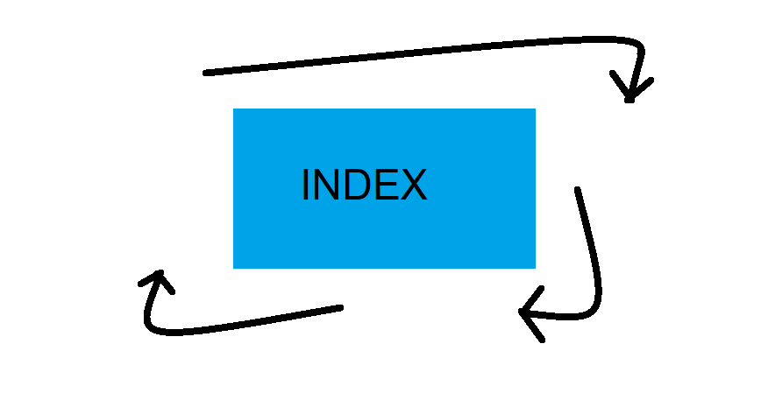

<urlset *xmlns*="http://www.sitemaps.org/schemas/sitemap/0.9">

<url>

<loc>https://ilijaweb.netlify.app/</loc>

<lastmod>2022-12-14</lastmod>

<changefreq>daily</changefreq>

<priority>1</priority>

</url>

## 2.2 Slike sa opisom funckionalnosti

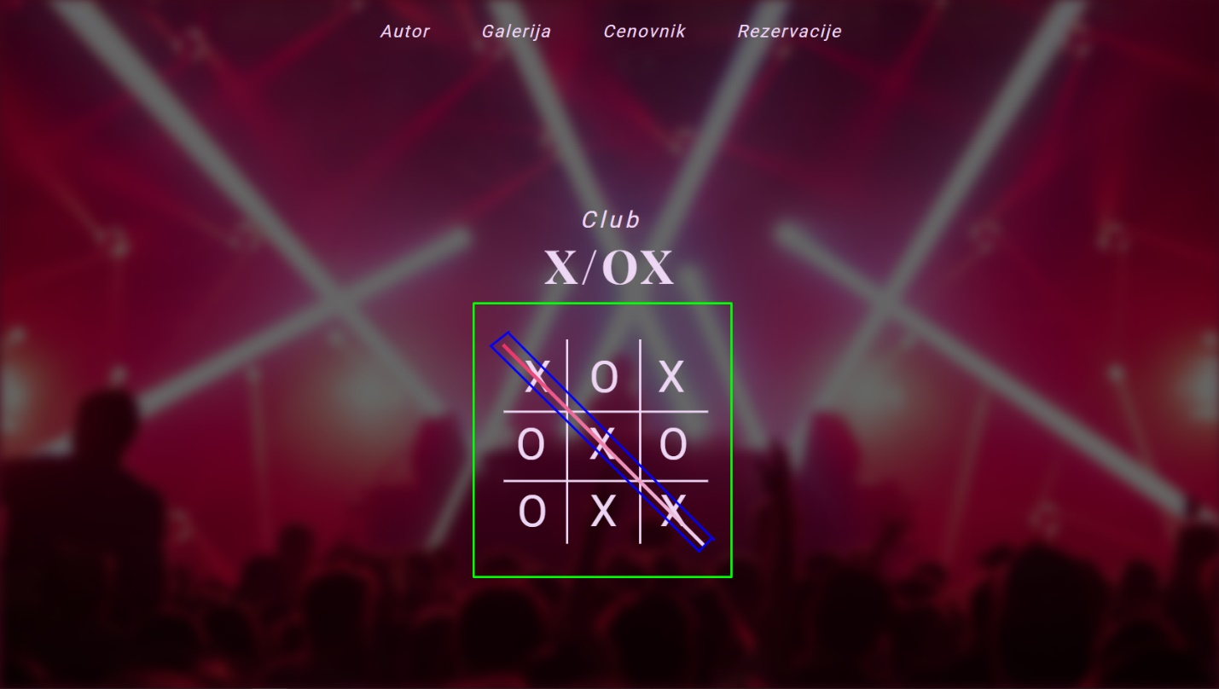Kada se uđe na sajt tabela je inicijalno prazna, popunjava se i za to vreme je onemogućen skrol, kada se popuni tabela prikaže se linija

Kada se pritisne na ‘Autor’ otvara se stranica o autoru koja se pojavljue sa leve strane, napravljen je pomocu metode animate() koja ima svojstvo toggle

Galerija koja je rađena u JavaScriptu i klikom na strelicu menja url slike

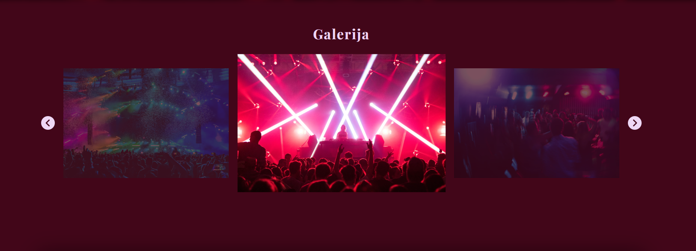

Strelica koja se pojavljuje ako se predje vise od 1000px stranice, koja ima metode fadeIn() i fadeout()



Cenovnik koje je radjen sa eventListener-om – click , kada se klikne na odredjeno dugme promeni vrstu pića

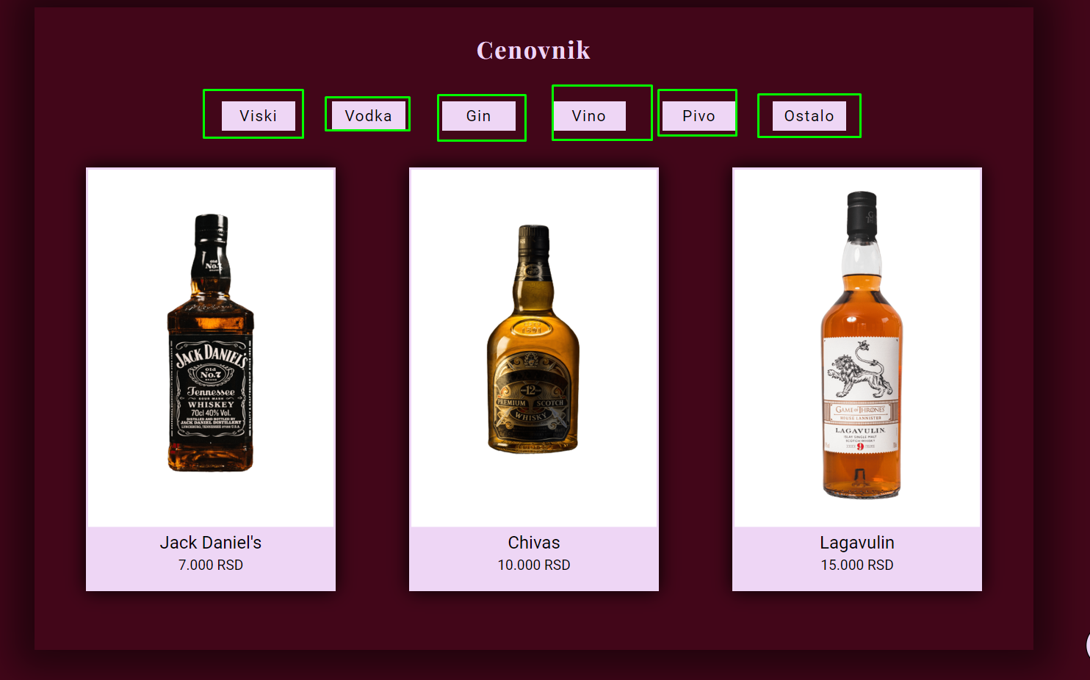

U označenim poljima brojevi se pune od 0 kada se dodje do tog dela sajta.

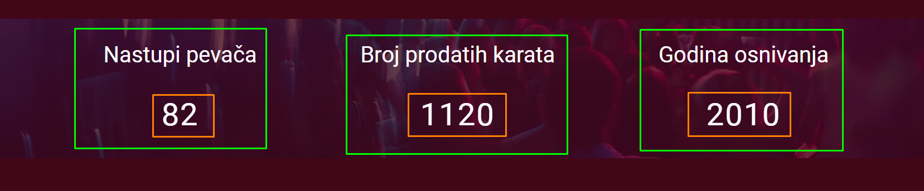

Kada se dodje do sekcije „Rezervacije“ izlazi pop-up koji broji vreme od 30-12-2022 , pozadina se boji tamnom bojom uz pomoć plug-ina dimBackground() / undim() . Isključuje se pritiskom na X u gornjem desnom uglu ili van celog bloka.

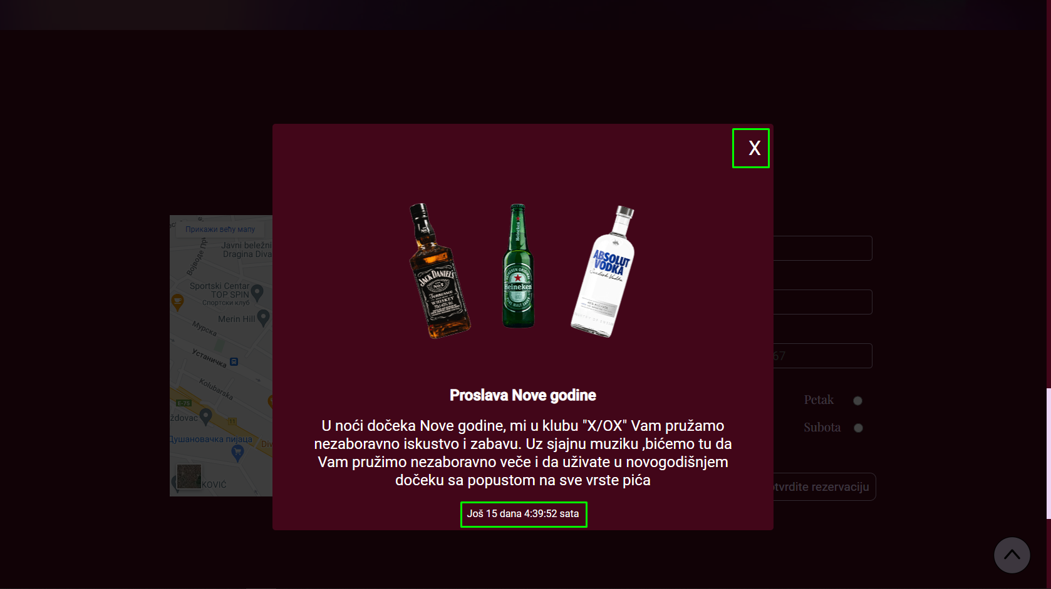

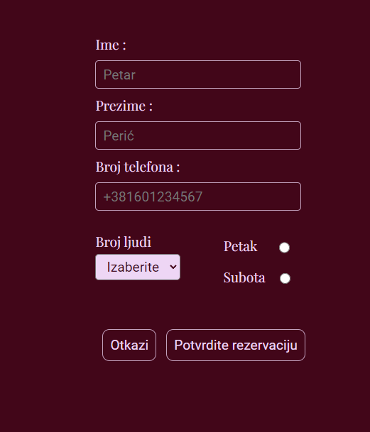Forma je skroz funckionalna i sva polja se ispituju kada se klikne na dugme ‘Potvrdite registraciju’, u slučaju da nije ispravno popunjena izaćiće greška.Pritiskom na dugme ‘Otkazi‘ brisu se sve unete vredosti.

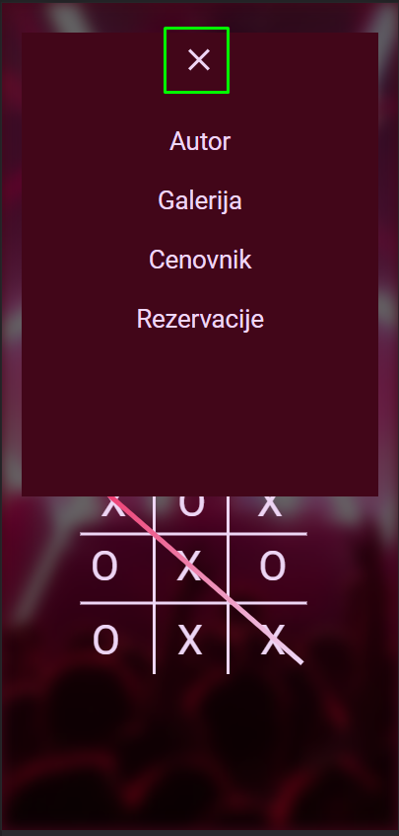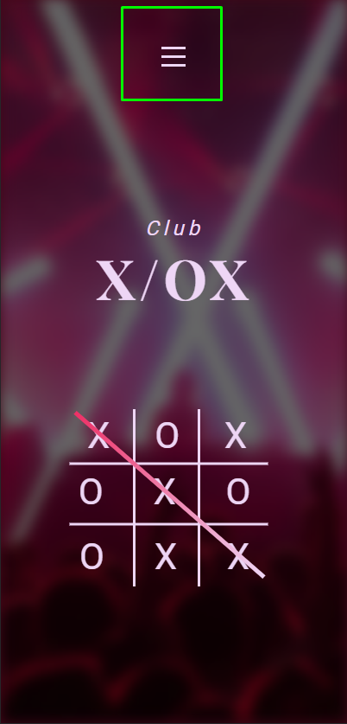

Na rezoluciji manjoj od 480px pojavljuje se „hamburger“ koji kada se otvori metodom toggle() otvori meni i metodom() animate sa tranzicijom pretvori u X, gde se i zatvara meni

# 3.Kodovi

## 3.1 HTML

<!DOCTYPE *html*>

<html *lang*="sr">

<head>

  <meta *charset*="UTF-8" />

  <meta *http-equiv*="X-UA-Compatible" *content*="IE=edge" />

  <meta *name*="viewport" *content*="width=device-width, initial-scale=1.0" />

*<!--Description/Keywords-->*

  <meta *name*="description" *content*="Club X/OX je noćni klub koji radi vikendom. Petak : 23:00h - 05:00h

  i Subota : 22:00h - 06:00h. Dodjite da se svi dobro provedemo. Vidimo se" />

  <meta *name*="keywords" *content*="Nocni klub, X/OX,Beograd">

*<!-- Css Template -->*

  <link *rel*="stylesheet" *href*="assets/css/style.css" *type*="text/css" />

  <title>Club X/OX</title>

*<!-- Google Fonts -->*

  <link *rel*="preconnect" *href*="https://fonts.googleapis.com" />

  <link *rel*="preconnect" *href*="https://fonts.gstatic.com" *crossorigin* />

  <link *href*="https://fonts.googleapis.com/css2?family=Roboto:wght@100;300;400;500&display=swap" *rel*="stylesheet" />

  <link *rel*="preconnect" *href*="https://fonts.googleapis.com" />

  <link *rel*="preconnect" *href*="https://fonts.gstatic.com" *crossorigin* />

  <link *href*="https://fonts.googleapis.com/css2?family=Playfair+Display:ital,wght@0,400;0,700;1,500;1,700&display=swap"

*rel*="stylesheet" />

*<!--Ico file-->*

  <link *rel*="shortcut icon" *href*="assets/img/logo.ico" *type*="image/x-icon" />

</head>

<body>

  <section *id*="author">

    <div *id*="close">X</div>

    <div *id*="authorSection">

      <div *id*="img">

        <img *src*="assets/img/Me1.png" *alt*="MyPhoto" />

      </div>

      <div *id*="authorContent">

        <p>Zovem se Ilija Antanasijević, imam 19 godina i trenutno sam student Visoke ICT škole, smer Internet

          Tehnologije.

          Živim u Paraćinu gde sam pohađao Mašinsko-elektrotehničku školu, smer elektrotehničar multimedije gde su i

          počela moja interesovanja za Web programiranje.</p>

        <p>48/21</p>

      </div>

    </div>

  </section>

*<!-- Header -->*

  <header *class*="header">

    <nav>

      <ul *id*="navMenu">

      </ul>

      <div *id*="hamb">

        <div *id*="open">

          <span></span>

          <span *id*="mid-line"></span>

          <span></span>

        </div>

        <div *id*="contentHamb">

          <ul>

*<!--Dinamicki ispisan hamb-->*

          </ul>

        </div>

      </div>

    </nav>

    <div *class*="background-img">

      <div *class*="overlay"></div>

    </div>

    <div *class*="hero-center">

      <div *class*="hero-text">

        <span *class*="clubText">Club</span>

        <h1 *class*="mainText"><a *href*="index.html">X/OX</a></h1>

      </div>

      <div *class*="hero-table">

        <div *class*="hor-line"></div>

        <div *class*="ver-line"></div>

*<!-- Table Content JS-->*

        <div *class*="table-add">

          <div *class*="first-row"></div>

          <div *class*="second-row"></div>

          <div *class*="third-row"></div>

        </div>

        <div *class*="connect-table"></div>

      </div>

    </div>

  </header>

*<!--Gallery Section -->*

  <section *id*="Gallery">

    <h2 *class*="title">Galerija</h2>

    <div *class*="allSlide">

      <div *class*="slideArrow">

        <img *src*="assets/img/arrow.png" *alt*="leftArrow" />

      </div>

      <div *id*="slider"></div>

      <div *class*="slideArrow">

        <img *src*="assets/img/arrow.png" *alt*="leftArrow" />

      </div>

    </div>

  </section>

*<!-- Price List -->*

  <section *id*="price">

    <div *class*="container">

      <div *id*="priceList">

        <h2 *class*="title">Cenovnik</h2>

        <form *action*="#">

          <div *id*="listDrinks">

          </div>

        </form>

        <div *id*="priceImg">

        </div>

      </div>

    </div>

  </section>

*<!-- Background About -->*

  <div *id*="secAbout">

    <div *id*="about">

      <div *class*="overlay">

        <div *id*="aboutContent">

          <div *id*="firstContent">

            <p>Nastupi pevača</p>

            <span *id*="perfSinger">82</span>

          </div>

          <div *id*="secondContent">

            <p>Broj prodatih karata</p>

            <span *id*="tickets">1120</span>

          </div>

          <div *id*="thirdContent">

            <p>Godina osnivanja</p>

            <span *id*="year" *class*="counter">2010</span>

          </div>

        </div>

      </div>

    </div>

  </div>

*<!-- Contact -->*

  <section *id*="secTimer">

    <div *id*="tajmer">

      <div *id*="exit">X</div>

      <img *src*="assets/img/promotion.webp" *alt*="promotion" />

      <h2>Proslava Nove godine</h2>

      <h3>U noći dočeka Nove godine, mi u klubu "X/OX" Vam pružamo nezaboravno iskustvo i zabavu. Uz sjajnu muziku

        ,bićemo tu da Vam pružimo nezaboravno veče i da uživate u novogodišnjem dočeku sa popustom na sve vrste pića

      </h3>

      <p *id*="timerText"></p>

    </div>

  </section>

  <div *id*="sectionContact">

    <div *class*="container">

      <h2 *class*="title">Rezervacije</h2>

      <div *id*="contact">

        <div *id*="img">

          <iframe

*src*="https://www.google.com/maps/embed?pb=!1m18!1m12!1m3!1d2831.679946189842!2d20.48251661492388!3d44.78732988637304!2m3!1f0!2f0!3f0!3m2!1i1024!2i768!4f13.1!3m3!1m2!1s0x475a74efffffffff%3A0x30eb97ff3c110512!2sBEOGARD!5e0!3m2!1ssr!2srs!4v1638640918587!5m2!1ssr!2srs"

*width*="600" *height*="450" *style*="border:0" *loading*="lazy" *allowfullscreen*="" *class*="iframeMain">

          </iframe>

          <iframe

*src*="https://www.google.com/maps/embed?pb=!1m18!1m12!1m3!1d2831.679946189842!2d20.48251661492388!3d44.78732988637304!2m3!1f0!2f0!3f0!3m2!1i1024!2i768!4f13.1!3m3!1m2!1s0x475a74efffffffff%3A0x30eb97ff3c110512!2sBEOGARD!5e0!3m2!1ssr!2srs!4v1638640918587!5m2!1ssr!2srs"

*width*="400" *height*="400" *style*="border:0" *loading*="lazy" *allowfullscreen*="" *class*="iFrame">

          </iframe>

          <iframe

*src*="https://www.google.com/maps/embed?pb=!1m18!1m12!1m3!1d2831.679946189842!2d20.48251661492388!3d44.78732988637304!2m3!1f0!2f0!3f0!3m2!1i1024!2i768!4f13.1!3m3!1m2!1s0x475a74efffffffff%3A0x30eb97ff3c110512!2sBEOGARD!5e0!3m2!1ssr!2srs!4v1638640918587!5m2!1ssr!2srs"

*width*="350" *height*="350" *style*="border:0" *loading*="lazy" *allowfullscreen*="" *class*="iFrameSmall">

          </iframe>

        </div>

        <div *id*="form">

          <form *method*="post" *id*="forma-1" *action*="contact.php">

            <div *id*="formInput">

              <div *class*="formArea">

                <label *for*="ime">Ime :</label>

                <input *type*="text" *id*="ime" *name*="name" *required* *placeholder*="Petar" />

                <span *id*="nameErr">Neispravno ime. Primer: Petar</span>

              </div>

              <div *class*="formArea">

                <label *for*="prezime">Prezime :</label>

                <input *type*="text" *id*="prezime" *name*="lastname" *required* *placeholder*="Perić" />

                <span *id*="lastnameErr">Neispravno prezime. Primer: Perić</span>

              </div>

              <div *class*="formArea">

                <label *for*="telefon">Broj telefona :</label>

                <input *type*="text" *id*="telefon" *name*="phone" *placeholder*="+381601234567" *required* />

                <span *id*="phoneErr">Neispravan format telefona.<br>Primer: +381601234567</span>

              </div>

            </div>

            <div *id*="formCheck">

              <div *id*="ppl">

                <label *for*="numberPpl">Broj ljudi</label>

                <select *name*="numberPpl" *id*="numberPpl">

                </select>

                <span *id*="pplErr">Morate izabrati broj ljudi.</span>

              </div>

              <div *id*="day">

                <div *id*="firstCheck">

                  <label *for*="rb1">Petak</label>

                  <input *type*="radio" *name*="rbDay" *id*="rb1" *class*="chBoxColor" />

                </div>

                <div *id*="secondCheck">

                  <label *for*="rb2">Subota</label>

                  <input *type*="radio" *name*="rbDay" *id*="rb2" *class*="chBoxColor" />

                </div>

                <span *id*="dayErr">Morate izabrati jedan od ponudjenih dana</span>

              </div>

            </div>

            <div *id*="formButtons">

              <input *type*="button" *id*="reset" *name*="reset" *value*="Otkaži" />

              <input *type*="button" *id*="submit" *name*="submit" *value*="Potvrdite rezervaciju" />

            </div>

          </form>

          <p *id*="okText"></p>

        </div>

      </div>

    </div>

  </div>

  <footer>

    <div *id*="footer">

      <div *id*="aboutFooter">

        <h3>Radno vreme: </h3>

        <p><i *class*="fa-solid fa-clock"></i>Petak : 23:00h - 05:00h</p>

        <p><i *class*="fa-solid fa-clock"></i>Subota : 22:00h - 06:00h</p>

        <a *href*="tel:0112345678"><i *class*="fa-solid fa-phone"></i>011/2345678</a>

        <p><i *class*="fa-solid fa-location-dot"></i>Zdravka Celara 16</p>

        <p><i *class*="fa-solid fa-house"></i>Beograd, Srbija</p>

      </div>

      <div *id*="footerContent">

        <span *class*="clubText">Club</span>

        <h2 *class*="mainText"><a *href*="index.html">X/OX</a></h2>

        <h3>Noćni klub "X/OX" je mesto gde možete uživati u najboljoj zabavi. U nasem klubu ćete pronaci sve što Vam je

          potrebno za nezaboravno veče: od sjajne muzike do finih koktela i atraktivnih ljudi. Naš tim profesionalaca će

          se pobrinuti da se osećate kao kod kuće i da uživate u svim atrakcijama koje nudimo.

        </h3>

      </div>

      <div *id*="footerLinks">

        <ul *id*="footerLinksUl">

        </ul>

      </div>

    </div>

    <div *id*="endFooter">

      <span>&#169; 2022 <a *href*="https://ilija-portfolio.netlify.app/" *target*="_blank">Ilija</a></span>

      <div *id*="footerInfo">

        <a *href*="assets/dokumentacija.pdf" *target*="_blank">DOKUMENTACIJA</a>

        <a *href*="sitemap.xml" *target*="_blank">Sitemap</a>

      </div>

    </div>

  </footer>

  <div *id*="arrow"></div>

  <script *src*="https://ajax.googleapis.com/ajax/libs/jquery/3.6.1/jquery.min.js"></script>

  <script *type*="text/javascript"

*src*="https://andywer.github.io/jquery-dim-background/jquery.dim-background.min.js"></script>

  <script *type*="text/javascript" *src*="assets/js/main.js"></script>

</body>

</html>

## 3.2 CSS

* {

  font-family: 'Roboto', sans-serif;

  margin: 0px;

  padding: 0px;

  box-sizing: border-box;

}

html {

  scroll-behavior: smooth;

  overflow-y: hidden;

}

*:root* {

  --lightColor: #EED6F5;

  --primaryPink: #ee3066;

  --bgColor: #420619;

  --PlayFairFont: 'Playfair Display', serif;

}

*/* Basic */*

body {

  background-color: var(--bgColor);

}

*.container* {

  max-width: 1400px;

  margin: 0px auto;

  padding: 0px 20px;

}

*#arrow* {

  position: fixed;

  width: 60px;

  height: 60px;

  border-radius: 50%;

  background-color: var(--lightColor);

  bottom: 25px;

  right: 25px;

  cursor: pointer;

  background-image: url('../img/arrowUp.png');

  border: none;

  background-position: center;

  display: none;

}

*#secTimer* {

  display: flex;

  justify-content: center;

}

*#tajmer* {

  position: absolute;

  width: 800px;

  height: 650px;

  background-color: var(--bgColor);

  border-radius: 5px;

  display: none;

}

*#tajmer* img {

  margin: 0px auto;

  transform: translateX(35%);

  margin-top: 100px;

}

*#tajmer* *#exit* {

  float: right;

  margin: 20px;

  font-size: 2rem;

  cursor: pointer;

  color: white;

}

*#tajmer* h2 {

  text-align: center;

  color: white;

  margin: 20px 0px;

}

*#tajmer* h3 {

  text-align: center;

  font-size: 1.5rem;

  color: white;

  width: 85%;

  margin: 0px auto;

  font-weight: normal;

}

*#tajmer* *#timerText* {

  color: white;

  text-align: center;

  padding: 30px 0px 10px;

}

*/*ScrollBar*/*

*::-webkit-scrollbar* {

  width: 8px;

}

*::-webkit-scrollbar-thumb* {

  background-color: var(--lightColor);

}

*::-webkit-scrollbar-thumb:hover* {

  background-color: #f7ddff;

}

*/* Nav Menu */*

nav {

  width: 100%;

  position: absolute;

  z-index: 999;

  left: 50%;

  transform: translateX(-50%);

  top: 30px;

}

nav *#navMenu* {

  list-style: none;

  display: flex;

  align-items: center;

  justify-content: center;

}

nav *#navMenu* a {

  text-decoration: none;

  color: var(--lightColor);

  font-size: 1.5rem;

  font-style: italic;

  letter-spacing: 2px;

  margin-right: 70px;

}

nav *#navMenu* li*:last-child* a {

  margin-right: 0px;

}

*#author* {

  height: 100vh;

  position: absolute;

  width: 100%;

  background-color: var(--bgColor);

  z-index: 9999;

  color: var(--lightColor);

  display: none;

}

*#authorSection* {

  display: flex;

  flex-direction: column;

  align-items: center;

}

*#authorSection* *#img* {

  margin: 50px 0px 100px;

}

*#authorSection* *#img* img {

  width: 80%;

}

*#authorSection* *#authorContent* p {

  font-size: 2rem;

  text-align: center;

  padding: 0px 500px;

  font-family: var(--PlayFairFont);

}

*#authorSection* *#authorContent* p*:last-child* {

  margin-top: 20px;

  font-size: 3rem;

}

*#close* {

  float: right;

  font-size: 3rem;

  transform: translateX(-50px);

  margin-top: 20px;

  cursor: pointer;

}

*/* Hero Section */*

*.overlay* {

  width: 100%;

  height: 100vh;

  background: rgba(0, 0, 0, 0.6);

}

*.background-img* {

  background-image: url(*../img/hero.webp*);

  height: inherit;

  width: 100%;

  background-size: cover;

  background-repeat: no-repeat;

  background-position: center;

  object-fit: cover;

  filter: blur(7.5px);

}

*/* Hero section text */*

*.hero-center* {

  position: absolute;

  width: 100%;

  margin: 0px auto;

  top: 30%;

}

*.hero-text* {

  text-align: center;

}

*.clubText* {

  color: var(--lightColor);

  font-size: 2rem;

  font-style: italic;

  letter-spacing: 5px;

}

*.mainText* a {

  color: var(--lightColor);

  font-size: 4rem;

  font-family: var(--PlayFairFont);

  letter-spacing: 5px;

  text-decoration: none;

}

*#hamb* *#open* {

  display: none;

  margin-left: -30px;

}

*#hamb* *#open* span {

  width: 28px;

  height: 3px;

  background-color: var(--lightColor);

  margin: 6px 0px;

}

*#hamb* *#contentHamb* {

  display: none;

  background-color: var(--bgColor);

  margin-top: 50px;

  width: 90%;

  margin: 0px auto;

*/* height: 44%; */*

  height: 470px;

}

*#hamb* *#contentHamb* ul {

  display: flex;

  flex-direction: column;

  justify-content: center;

  align-items: center;

  list-style-type: none;

*/* margin-left: 25px; */*

  padding-top: 80px;

}

*#hamb* *#contentHamb* ul li {

  margin: 15px 0px;

}

*#hamb* *#contentHamb* ul li a {

  text-decoration: none;

  color: var(--lightColor);

  font-size: 1.6rem;

}

*/* Hero section tic tac toe table */*

*.hero-table* {

  position: relative;

}

*.hero-table* *.hor-line* {

  position: relative;

  margin: 0px auto;

  width: 3px;

  height: 280px;

  transform: translate(-60px, 60px);

  background-color: var(--lightColor);

}

*.hero-table* *.hor-line::after* {

  content: "";

  position: absolute;

  width: 3px;

  height: inherit;

  transform: translateX(100px);

  background-color: var(--lightColor);

}

*.hero-table* *.ver-line* {

  position: absolute;

  top: 23%;

  left: 49.5%;

  width: 3px;

  height: 280px;

  transform: rotate(90deg);

  background-color: var(--lightColor);

}

*.hero-table* *.ver-line::after* {

  content: "";

  position: absolute;

  width: 3px;

  height: inherit;

  left: 5%;

  transform: translateX(-95px);

  background-color: var(--lightColor);

}

*/* X/O in table */*

*.table-add* {

  transform: translateY(-20px);

  color: var(--lightColor);

  text-align: center;

  font-size: 3.75rem;

}

*.table-add* *.first-row* {

  position: relative;

  transform: translateY(-185px);

  letter-spacing: 17px;

}

*.table-add* *.second-row* {

  position: relative;

  transform: translateY(-165px);

  letter-spacing: 23px;

}

*.table-add* *.third-row* {

  letter-spacing: 23px;

  transform: translateY(-145px);

}

*.table-add* *#second-O*,

*.table-add* *#fifth-X*,

*.table-add* *#eight-X* {

  margin: 0px 35px;

}

*.connect-table* {

  position: absolute;

  left: 49.3%;

  bottom: 96px;

  width: 5px;

  height: 390px;

  transform: rotate(315deg);

  background-image: linear-gradient(var(--primaryPink), var(--lightColor));

  opacity: 1;

  animation: connectTable 3s linear forwards;

  display: none;

}

*.tableAnimation* {

  animation: showTable 1s linear forwards;

  opacity: 0;

}

*.tableAnimation1* {

  animation: showTable 1s linear forwards;

  animation-delay: 0.25s;

  opacity: 0;

}

*.tableAnimation2* {

  animation: showTable 1s linear forwards;

  animation-delay: 0.5s;

  opacity: 0;

}

*.tableAnimation3* {

  animation: showTable 1s linear forwards;

  animation-delay: 0.75s;

  opacity: 0;

}

*.tableAnimation4* {

  animation: showTable 1s linear forwards;

  animation-delay: 1s;

  opacity: 0;

}

*.tableAnimation5* {

  animation: showTable 1s linear forwards;

  animation-delay: 1.25s;

  opacity: 0;

}

*.tableAnimation6* {

  animation: showTable 1s linear forwards;

  animation-delay: 1.5s;

  opacity: 0;

}

*.tableAnimation7* {

  animation: showTable 1s linear forwards;

  animation-delay: 1.75s;

  opacity: 0;

}

*.tableAnimation8* {

  animation: showTable 1s linear forwards;

  animation-delay: 2s;

  opacity: 0;

}

@keyframes *showTable* {

  0% {

    opacity: 0;

  }

  100% {

    opacity: 1;

  }

}

*/* Galllery Section */*

*#Gallery* {

  margin-bottom: 100px;

}

*.allSlide* {

  display: flex;

  align-items: center;

  justify-content: center;

}

*#slider* {

  display: flex;

  justify-content: space-around;

  align-items: center;

  width: 80%;

}

*#slider* *.imgBox* {

  width: 400px;

}

*#slider* img {

  width: 100%;

}

*#slider* *.imgBox:nth-child*(odd) {

  opacity: 0.3;

  margin: 0px 20px;

}

*#slider* *.imgBox:nth-child*(2) {

  margin: 0px 50px;

  padding: 0px 20px;

}

*.slideArrow* {

  cursor: pointer;

}

*.slideArrow:first-child* {

  transform: rotateY(180deg);

}

*/************************/*

*.title* {

  text-align: center;

  color: var(--lightColor);

  font-family: var(--PlayFairFont);

  font-size: 2rem;

  letter-spacing: 2px;

}

*#Gallery* h2 {

  margin: 60px 0px 60px;

}

*/* Section PriceList */*

*#priceList* {

  margin-top: 200px;

  width: 100%;

  box-shadow: 0px 0px 50px 28px rgb(0, 0, 0, 50%);

  padding-top: 35px;

  padding-bottom: 30px;

  margin-bottom: 200px;

}

*#priceList* *#listDrinks* {

  margin-top: 50px;

  display: flex;

  justify-content: center;

}

*#priceList* *#listDrinks* input {

  cursor: pointer;

  width: 100px;

  margin-left: 50px;

  height: 40px;

  font-size: 1.3rem;

  font-family: var(--robo);

  border: none;

  background-color: var(--lightColor);

  letter-spacing: 1.5px;

}

*#priceList* *#listDrinks* input*:first-child* {

  margin-left: 0px;

}

*#priceList* *#priceImg* {

  display: flex;

  justify-content: center;

  flex-wrap: wrap;

}

*#priceList* *#priceImg* *.priceBorder* {

  width: 25%;

  margin: 50px;

  padding-top: 3px;

  text-align: center;

  background-color: var(--lightColor);

*/* border: 1px solid var(--lightColor);*

*box-shadow: 0px 0px 25px 0px;*

*border-radius: 25px 25px 0px 0px; */*

  box-shadow: 0px 0px 25px 0px;

}

*#priceList* *#priceImg* *.priceBorder:first-child* {

  margin-left: 0px;

}

*#priceList* *#priceImg* *.priceBorder:nth-child*(3) {

  margin-right: 0px;

}

*#priceList* *#priceImg* img {

  width: 98%;

  height: 85%;

  display: block;

  margin: 0px auto;

}

*#priceList* *#priceImg* *.priceBorder* p {

  font-size: 1.5rem;

  margin: 5px 0px;

}

*#priceList* *#priceImg* *.priceBorder* span {

  font-size: 1.2rem;

}

*/*About Club*/*

*#secAbout* {

  margin-bottom: 150px;

}

*#about* {

  width: 100%;

  height: 250px;

  background-image: url(*../img/sectionBackground.webp*);

  background-position: revert;

  background-size: cover;

  background-attachment: fixed;

}

*#about* *.overlay* {

  background-color: rgba(66, 6, 25, 0.8);

  height: inherit;

}

*#secAbout* *#aboutContent* {

  display: flex;

  justify-content: space-evenly;

  font-size: 2.5rem;

  text-align: center;

  color: white;

}

*#secAbout* *#aboutContent* p {

  margin-bottom: 50px;

  margin-top: 40px;

}

*#secAbout* *#aboutContent* span {

  font-size: 3.5rem;

  letter-spacing: 2px;

}

*#secAbout* *#secondContent* {

  align-items: center;

}

*#secAbout* *#thirdContent* {

  align-self: center;

}

*/****************** Contact ****************/*

*#contact* {

  display: flex;

  justify-content: space-around;

  align-items: center;

  margin-bottom: 200px;

}

*#sectionContact* *.title* {

  margin-bottom: 100px;

}

*#contact* *#img* {

  width: 600px;

}

*#contact* *.iFrame* {

  display: none;

}

*#contact* *.iFrameSmall* {

  display: none;

}

*/* #contact #form {*

*margin: 0px auto;*

*} */*

*#contact* *#form* span {

  display: none;

  margin-top: 5px;

  font-size: 0.9rem;

}

*#contact* *.formArea*,

*#contact* *#ppl*,

*#contact* *#day* {

  display: flex;

  flex-direction: column;

  color: #EED6F5;

}

*#contact* *.formArea* {

  margin-bottom: 10px;

}

*#formCheck* *#ppl* *#pplErr* {

  width: 50%;

}

*#contact* *#day* {

  margin-left: 30px;

}

*#contact* *#day* *#dayErr* {

  width: 150px;

}

*#contact* *#ppl* *#pplErr* {

  width: 150px;

}

*#contact* *#formInput* *.formArea* input[*type*='text'] {

  background: none;

  width: 290px;

  height: 40px;

  border: 1px solid rgb(238, 214, 245, 0.75);

  border-radius: 5px;

  color: var(--lightColor);

  font-size: 1.2rem;

  padding: 0px 10px;

}

*#contact* *#formInput* *.formArea* *.textInput* {

  background-color: var(--lightColor);

  color: black;

  outline: none;

}

*.prikazi* {

  border: 1px solid red !important;

}

*#contact* *#formInput* span {

  margin-bottom: 20px;

  width: 290px;

}

*#contact* *#formInput* *.formArea* label {

  font-size: 1.2rem;

  font-family: var(--PlayFairFont);

  margin-bottom: 10px;

}

*#contact* *#formCheck* {

  display: flex;

  justify-content: flex-start;

  align-items: flex-start;

  margin-bottom: 50px;

  margin-top: 30px;

}

*#contact* *#formCheck* select {

  width: 120px;

  font-size: 1.2rem;

  text-align: center;

  border-radius: 5px;

  background-color: var(--lightColor);

  color: var(--bgColor);

  padding: 5px 0px;

  cursor: pointer;

}

*#contact* *#formCheck* label {

  font-size: 1.2rem;

  font-family: var(--PlayFairFont);

  margin-bottom: 5px;

}

*#contact* *#formButtons* input[*type*='button'] {

  font-size: 1.2rem;

  background: none;

  color: var(--lightColor);

  padding: 10px 10px;

  border: 1px solid rgb(238, 214, 245, 0.75);

  border-radius: 10px;

  cursor: pointer;

  margin-left: 10px;

}

*#formCheck* *#firstCheck*,

*#formCheck* *#secondCheck* {

  display: flex;

  justify-content: space-around;

}

*#formCheck* *#firstCheck* label,

*#formCheck* *#secondCheck* label {

  margin-right: 20px;

  line-height: 2;

}

*#formCheck* *#day* input[*type*='radio'] {

  width: 15px;

}

*#formCheck* *#day* *#rb1* {

  margin-left: 10px;

}

*#formCheck* *#day* input[*type*='radio']*.chBoxColor* {

  accent-color: var(--primaryPink);

  border: none;

}

*#okText* {

  color: var(--lightColor);

  margin-top: 20px;

  font-size: 1.2rem;

  display: none;

}

*.success* {

  display: block !important;

}

*.notOk* {

  display: none;

}

*/* JS Class */*

*.textInput* {

  background-color: var(--lightColor) !important;

  color: #000 !important;

  outline: none !important;

}

*#contact* *#form* *.errorMess* {

  display: block;

}

*/* Footer */*

*#footer* {

  display: flex;

  justify-content: space-evenly;

  align-items: center;

  flex-wrap: wrap;

  border-top: 1px solid var(--lightColor);

  padding-top: 80px;

  color: var(--lightColor);

}

footer *#footerContent* {

  text-align: center;

  width: 30%;

}

footer *#footerContent* h3 {

  margin-top: 20px;

  letter-spacing: 1.2px;

  line-height: 1.1;

  font-family: var(--PlayFairFont);

  font-weight: lighter;

}

footer *#aboutFooter* {

  display: flex;

  flex-direction: column;

  width: 30%;

  line-height: 1.5;

  font-size: 1.5rem;

  font-family: var(--PlayFairFont);

  letter-spacing: 1.2px;

  padding-left: 100px;

}

footer *#aboutFooter* i {

  font-size: 1rem;

  margin-right: 10px;

  transform: translateY(-2px);

}

footer *#aboutFooter* a {

  text-decoration: none;

  color: var(--lightColor);

  margin-top: 20px;

}

footer *#footerLinks* {

  width: 30%;

  display: flex;

  justify-content: center;

}

footer *#footerLinks* ul {

  list-style: none;

  text-align: center;

}

footer *#footerLinks* ul li a {

  text-decoration: none;

  font-size: 1.5rem;

  color: var(--lightColor);

  text-align: center;

  line-height: 2;

}

footer *#endFooter* {

  display: flex;

  justify-content: space-evenly;

  align-items: center;

  width: 100%;

  height: 25px;

  background-color: var(--lightColor);

  margin-top: 80px;

}

footer *#endFooter* *#footerInfo* a*:first-child* {

  margin-right: 15px;

}

footer *#endFooter* a,

footer *#endFooter* span {

  text-decoration: none;

  color: var(--bgColor);

  font-size: 1.2rem;

}

*/**************************RESPONSIVE*********************/*

@media screen and (max-width: 1440px) {

*#slider* {

    width: 100%;

  }

*#slider* img*:nth-child*(2) {

    margin: 0px 30px;

    padding: 0px 10px;

  }

*#slider* img*:nth-child*(odd) {

    margin: 0px 10px;

  }

*.slideArrow:nth-child*(3) {

    transform: translateX(-60px);

  }

*.slideArrow:nth-child*(1) {

    z-index: 999;

    transform: translateX(60px) rotateY(180deg);

  }

*#slider* *.imgBox:nth-child*(1) {

    margin-left: 0px;

  }

}

@media screen and (max-width: 1335px) {

*#about* {

    height: 200px;

  }

*#secAbout* *#aboutContent* {

    font-size: 2rem;

  }

*#secAbout* *#aboutContent* span {

    font-size: 2.5rem;

  }

*/* Contact */*

*#contact* {

    justify-content: space-evenly;

    flex-wrap: wrap-reverse;

  }

*#contact* *#img* {

    margin-right: 0px;

  }

*#contact* *#form* {

    margin: 0px;

  }

*#contact* *#formButtons* {

    margin-bottom: 50px;

  }

*#sectionContact* *.title* {

    margin-bottom: 50px;

  }

*/* Footer */*

  footer *#aboutFooter* {

    padding-left: 0px;

  }

  footer *#footerLinks* {

    justify-content: flex-end;

    transform: translateX(-50px);

  }

*#authorSection* *#img* {

    margin: 50px 0px 80px;

  }

*#authorSection* *#authorContent* p {

    padding: 0px 100px;

  }

}

@media screen and (max-width: 1150px) {

*/* PriceList */*

*#priceList* *#listDrinks* input {

    margin-left: 30px;

    font-size: 1.2rem;

    width: 90px;

  }

*#priceList* *#priceImg* *.priceBorder* {

    margin-right: 20px;

  }

*/* Footer */*

  footer *#footerLinks* {

    justify-content: flex-end;

    transform: translateX(-80px);

  }

  footer *#aboutFooter* {

    font-size: 1.3rem;

  }

*/* #slider .imgBox:nth-child(2) {*

*margin: 0px 10px;*

*} */*

*#tajmer* {

    width: 700px;

    z-index: 1;

  }

*#tajmer* img {

    transform: translateX(25%);

  }

*#authorSection* *#img* {

    margin: 50px 0px 60px;

  }

*#authorSection* *#img* img {

    transform: translateX(30px);

  }

*#authorSection* *#authorContent* p {

    padding: 0px 20px;

    font-size: 1.8rem;

  }

}

@media screen and (max-width: 880px) {

*#slider* {

    width: auto;

    margin-top: 30px;

  }

*#slider* *.imgBox:nth-child*(odd) {

    display: none;

  }

*.slideArrow:nth-child*(3) {

    transform: translateX(-45px);

  }

*.slideArrow:nth-child*(1) {

    z-index: 999;

    transform: translateX(45px) rotateY(180deg);

  }

*#slider* *.imgBox:nth-child*(2) img {

    margin: 0px;

    padding: 0px;

  }

}

@media screen and (max-width: 769px) {

  nav *#navMenu* a {

    margin-right: 50px;

    font-size: 1.4rem;

  }

*.clubText* {

    font-size: 1.8rem;

  }

*.hero-text* h1 {

    font-size: 3.8rem;

  }

*/*Table */*

*.table-add* {

    font-size: 3.4em;

  }

*.hero-table* *.ver-line* {

    top: 22%;

  }

*.connect-table* {

    left: 48.3%;

    bottom: 85px;

  }

*/* priceList */*

*#priceList* {

    margin-bottom: 150px;

  }

*#priceList* *#listDrinks* input {

    width: 70px;

    font-size: 1.1rem;

    height: 35px;

  }

*#priceList* *#priceImg* *.priceBorder* {

    width: 35%;

    margin-left: 40px;

  }

*#priceList* *#priceImg* *.priceBorder:first-child* {

    margin-left: 40px;

  }

*#priceList* *#priceImg* *.priceBorder* p {

    font-size: 1.3rem;

  }

*#priceList* *#priceImg* *.priceBorder* span {

    font-size: 1rem

  }

  ;

*/* About BG */*

*#secAbout* {

    margin-bottom: 100px;

  }

*#secAbout* *#aboutContent* p {

    margin-top: 20px;

    margin-bottom: 30px;

  }

*#secAbout* *#aboutContent* {

    font-size: 1.8rem;

  }

*#secAbout* *#aboutContent* span {

    font-size: 2.2rem;

  }

*#secAbout* *#firstContent*,

*#secAbout* *#secondContent*,

*#secAbout* *#thirdContent* {

    width: 33%;

  }

*#tajmer* {

    width: 560px;

  }

*#tajmer* img {

    transform: translateX(10%);

  }

*/* Footer */*

*#footer* {

    flex-wrap: wrap;

    flex-direction: row;

  }

*#footer* *#footerContent* {

    order: -1;

    flex: 1 0 100%;

    width: 80%;

  }

*#footer* *#footerContent* h3 {

    width: 80%;

    margin: 10px auto 30px auto;

  }

  footer *#aboutFooter* {

    width: 37%;

  }

  footer *#footerLinks* ul {

    text-align: right;

  }

  footer *#footerLinks* {

    transform: translateX(0);

  }

*#authorSection* *#img* img {

    width: 70%;

  }

*#authorSection* *#authorContent* p {

    padding: 0px 20px;

    font-size: 1.6rem;

  }

}

@media screen and (max-width: 575px) {

  nav *#navMenu* a {

    margin-right: 30px;

    font-size: 1.25rem;

  }

*.table-add* {

    font-size: 2.6em;

    transform: translateY(150px);

  }

*.table-add* *.first-row* {

    transform: translateY(-240px);

  }

*.table-add* *.second-row* {

    transform: translateY(-225px);

  }

*.table-add* *.third-row* {

    transform: translateY(-200px);

  }

*.hero-table* *.hor-line* {

    height: 205px;

    transform: translate(-47px, 110px);

  }

*.hero-table* *.hor-line::after* {

    transform: translateX(75px);

  }

*.hero-table* *.ver-line* {

    height: 230px;

    top: 36%;

    left: 48%;

  }

*.hero-table* *.ver-line::after* {

    transform: translateX(-70px);

  }

*.connect-table* {

    left: 48%;

    bottom: 1px;

    height: 290px;

    transform: rotate(311deg);

  }

*.title* {

    font-size: 1.8rem;

  }

*#about* {

    display: none;

  }

*#contact* *.iframeMain* {

    display: none;

  }

*#contact* *.iFrame* {

    display: block;

  }

*#contact* *#img* {

    width: 400px;

  }

*/* PriceList */*

*#priceList* *#listDrinks* {

    display: grid;

    grid-template-columns: auto auto auto;

    row-gap: 20px;

    justify-content: center;

  }

*#priceList* *#listDrinks* input {

    margin-left: 10px;

    width: 80px;

    font-size: 1.3rem;

  }

*#priceList* *#listDrinks* input*:first-child* {

    margin-left: 10px;

  }

*#tajmer* {

    width: 90%;

    z-index: 1;

    height: fit-content;

  }

*#tajmer* img {

    transform: translateX(0%);

    margin-top: 10px;

    width: 100%;

  }

*#tajmer* p {

    font-size: 1.3rem;

  }

*#tajmer* *#timerText* {

    margin-bottom: 20px;

  }

*/* Footer */*

  footer *#footerLinks* {

    width: 0%;

  }

  footer *#footerLinks* ul li a {

    font-size: 1.2rem;

  }

  footer *#aboutFooter* {

    width: 70%;

    font-size: 1rem;

  }

  footer *#aboutFooter* i {

    font-size: 0.8rem;

  }

  footer *#footerContent* h3 {

    font-size: 1.1rem;

    letter-spacing: 1.05px;

  }

  footer *#endFooter* a,

  footer *#endFooter* span {

    font-size: 1rem;

  }

}

@media screen and (max-width: 485px) {

*#arrow* {

    width: 40px;

    height: 40px;

    display: block;

    border: 1px solid black;

  }

  nav *#navMenu* {

    display: none;

  }

*#hamb* *#open* {

    display: block;

  }

*#open* {

    cursor: pointer;

    text-align: center;

  }

*#open* span {

    position: absolute;

  }

*#open* span*:nth-child*(1) {

    top: 20px;

  }

*#open* span*:nth-child*(2) {

    top: 30px;

  }

*#open* span*:nth-child*(3) {

    top: 40px;

  }

*.slideArrow* img {

    width: 20px;

  }

*.clubText* {

    font-size: 1.5rem;

  }

*.mainText* {

    font-size: 3rem;

  }

*#tajmer* p {

    font-size: 1.2rem;

  }

*/* Contact */*

*#contact* *.iFrame* {

    display: none;

  }

*#contact* *.iFrameSmall* {

    display: block;

  }

*#contact* *#img* {

    width: 350px;

  }

*#contact* *#formInput* *.formArea* input[*type*='text'] {

    font-size: 1rem;

  }

*#contact* *#formButtons* input[*type*='button'] {

    font-size: 1rem;

    padding: 10px 7px;

  }

*#contact* *#formButtons* {

    display: flex;

    justify-content: center;

  }

*#contact* *#formCheck* select {

    font-size: 1rem;

  }

*/* priceList */*

*#priceList* *#priceImg* *.priceBorder* {

    width: 80%;

    margin-left: 0px;

    margin-right: 0px;

  }

*#priceList* *#priceImg* *.priceBorder:first-child* {

    margin-left: 0px;

  }

*#priceList* *#priceImg* *.priceBorder:last-child* {

    margin-right: 0px;

  }

*#slider* {

    width: 100%;

  }

*#slider* *.imgBox* {

    width: 100%;

  }

*#authorSection* *#authorContent* p {

    padding: 0px 10px;

    font-size: 1.5rem;

  }

}

@media screen and (max-width: 400px) {

*.slideArrow:nth-child*(3) {

    transform: translateX(-65px);

  }

*.slideArrow:nth-child*(1) {

    transform: translateX(65px) rotateY(180deg);

  }

*#tajmer* p {

    font-size: 1.05rem;

  }

*#footer* {

    flex-direction: column;

    justify-content: center;

    padding-top: 30px;

  }

  footer *#aboutFooter* {

    width: auto;

    text-align: center;

    margin-bottom: 20px;

  }

  footer *#footerLinks* {

    width: auto;

  }

  footer *#footerLinks* ul {

    text-align: center;

  }

}

## 3.3 Javascript

*var* tmp = "";

*//Nav menu - Dinamicki ispis*

*let* navMenu = document.getElementById('navMenu');

*var* navHref = ["#author", "#Gallery", "#price", "#sectionContact"];

*var* navText = ["Autor", "Galerija", "Cenovnik", "Rezervacije"];

for (*let* i in navHref) {

    tmp += `<li><a href ='${navHref[i]}'>${navText[i]}</a></li>`;

}

navMenu.innerHTML = tmp;

tmp = "";

*//Hamburger*

*let* hamb = document.querySelector("#contentHamb ul");

for (*let* i in navText) {

    tmp += `<li><a href ='${navHref[i]}'>${navText[i]}</a></li>`;

}

hamb.innerHTML = tmp;

tmp = "";

*// Table Content X/O*

*let* firstRow = document.querySelector('.first-row');

*let* secondRow = document.querySelector('.second-row');

*let* thirdRow = document.querySelector('.third-row');

*let* animation = document.querySelector('.tableAnimation');

*var* tableSpan = new Array('first-', 'second-', 'third-', 'fourth-', 'fifth-', 'sixth-', 'seventh-', 'eight-', 'ninth-');

*var* tableContent = ['X', 'O'];

*var* counter = 0;

for (*let* i = 0; i < tableSpan.length; i++) {

    counterFnc(i);

    tmp += `<span id="${tableSpan[i]}${tableContent[counter]}">${tableContent[counter]}</span>`;

    if (i == 2) {

        firstRow.innerHTML = tmp;

        tmp = "";

    }

    if (i == 5) {

        secondRow.innerHTML = tmp;

        tmp = "";

    }

}

thirdRow.innerHTML = tmp;

*//Table Animation*

*let* random = [];

while (random.length < 9) {

*let* numberArr = Math.floor(Math.random() * 9); *// 0-8*

    if (random.indexOf(numberArr) == -1) random.push(numberArr)

}

for (*var* i = 0; i < tableSpan.length; i++) {

    counterFnc(i);

*var* tableId = document.getElementById(`${tableSpan[i]}${tableContent[counter]}`);

    switch (random[i]) {

        case 0: tableId.classList.add(`tableAnimation`); break;

        case 1: tableId.classList.add(`tableAnimation1`); break;

        case 2: tableId.classList.add(`tableAnimation2`); break;

        case 3: tableId.classList.add(`tableAnimation3`); break;

        case 4: tableId.classList.add(`tableAnimation4`); break;

        case 5: tableId.classList.add(`tableAnimation5`); break;

        case 6: tableId.classList.add(`tableAnimation6`); break;

        case 7: tableId.classList.add(`tableAnimation7`); break;

        case 8: tableId.classList.add(`tableAnimation8`); break;

    }

}

*function* counterFnc(*i*) {

    switch (i) {

        case 1:

        case 5:

        case 3:

        case 6:

            counter = 1; break;

        case 0:

        case 4:

        case 2:

        case 7:

        case 8:

            counter = 0; break;

    }

}

*//PriceList Dynamically*

tmp = ""

*let* btnDrinks = document.querySelector("#listDrinks");

*let* btnValue = ['Viski', 'Vodka', 'Gin', 'Vino', 'Pivo', 'Ostalo'];

*let* btnId = ['whiskey', 'vodka', 'gin', 'rak', 'beer', 'other']

for (*let* i in btnValue) {

    tmp += `<input type="button" value = "${btnValue[i]}" id="${btnId[i]}"/>`;

}

btnDrinks.innerHTML = tmp;

tmp = "";

*//********************PRICE LIST************************************ */*

*let* priceImg = document.querySelector("#priceImg");

*let* baseUrl = 'assets/img/'

*let* priceBorderClass = 'priceBorder';

*let* imgUrl = ['jackDanielsPS.webp', 'chivasPS.webp', 'randomWhiskeyPS.webp'];

*let* imgAlt = [`JackDaniel's`, `Chivas`, 'Lagavulin 16YO']

*let* drink = [`Jack Daniel's`, `Chivas`, 'Lagavulin'];

*let* price = ['7.000 RSD', '10.000 RSD', '15.000 RSD'];

for (*let* i in imgUrl) {

    tmp += `<div class = "${priceBorderClass}">

            <img src= "${baseUrl}${imgUrl[i]}" alt = "${imgAlt[i]}">

            <p>${drink[i]}</p><span>${price[i]}</span></div>`

}

priceImg.innerHTML = tmp;

tmp = "";

*let* viskiId = document.querySelector("#whiskey");

*let* vodkaId = document.querySelector('#vodka');

*let* ginId = document.querySelector("#gin");

*let* rakId = document.querySelector("#rak");

*let* BeerID = document.querySelector("#beer");

*let* Other = document.querySelector("#other");

*/*Vodka Info*/*

*let* imgUrlVodka = ['vodkaPS.webp', 'vodka1PS.webp', 'vodka2PS.webp'];

*let* imgAltVodka = [`absolutVodka`, 'hendrix', 'Chivas']

*let* drinkVodka = [`Absolut Vodka`, 'Hendrix', 'Oginski Vodka'];

*let* priceVodka = ['8.500 RSD', '6.000 RSD', '15.000 RSD'];

*/*Gin Info*/*

*let* imgUrlGin = ['gin1PS.webp', 'gin2PS.webp', 'gin3.webp'];

*let* imgAltGin = [`tuckombilGin`, 'gin47', 'BränneriGin']

*let* drinkGin = [`Tuckombil Dry Gin`, 'Monkey 47 Gin', 'Bränneri'];

*let* priceGin = ['4.000 RSD', '12000 RSD', '19.000 RSD'];

*/*Wine info*/*

*let* imgUrlRak = ['vine1PS.webp', 'vine2PS.webp', 'vine3PS.webp', 'vine4PS.webp', 'vine5PS.webp'];

*let* imgAltRak = [`RasteauWine`, 'modaWine', 'broadLeafWine', 'lasperdicesWine', 'TaylorsWine']

*let* drinkRak = [`Rasteau Wine`, 'Talamonti Moda', 'Broadleaf', 'Las Perdices', 'Taylors'];

*let* priceRak = ['4.000 RSD', '3.000 RSD', '5.000 RSD', '3.500', '5.000'];

*/*beer Info*/*

*let* imgUrlBeer = ['beer1PS.webp', 'beer2PS.webp', 'beer3PS.webp'];

*let* imgAltBeer = [`HeinekenBeer`, 'modeloBeer', 'budLightBeer']

*let* drinkBeer = [`Heineken`, 'Modelo', 'Bud Light'];

*let* priceBeer = ['300 RSD', '350 RSD', '500 RSD'];

*/* Other Info */*

*let* imgUrlOther = ['coctail1PS.webp', 'schweepsPS.webp', 'redbullPS.webp', 'lemonadePS.webp', 'cocePS.webp', 'orangePS.webp'];

*let* imgAltOther = [`Coctail`, 'schweppesJuice', 'redBull', 'Lemonade', 'CocaCola', 'orangeJuice']

*let* drinkOther = [`Blue Lagoon`, 'Schweppes', 'Red Bull', 'Limunada', 'Coca Cola', 'Cedjena narandža'];

*let* priceOther = ['1.100 RSD', '400 RSD', '600 RSD', '500 RSD', '400 RSD', '700 RSD'];

filter(viskiId, imgUrl, imgAlt, drink, price);

filter(vodkaId, imgUrlVodka, imgAltVodka, drinkVodka, priceVodka);

filter(ginId, imgUrlGin, imgAltGin, drinkGin, priceGin);

filter(rakId, imgUrlRak, imgAltRak, drinkRak, priceRak);

filter(BeerID, imgUrlBeer, imgAltBeer, drinkBeer, priceBeer);

filter(Other, imgUrlOther, imgAltOther, drinkOther, priceOther);

*function* filter(*Id*, *img*, *alt*, *drink*, *price*) {

    Id.addEventListener("click", *function* () {

        filterDrinks(img, alt, drink, price)

    })

}

*function* filterDrinks(*imgurl*, *imgalt*, *drinkName*, *price*) {

    tmp = "";

    for (*let* i in imgurl) {

        tmp += `<div class = "${priceBorderClass}">

                <img src= "${baseUrl}${imgurl[i]}" alt = "${imgalt[i]}">

                <p>${drinkName[i]}</p><span>${price[i]}</span></div>`

    }

    priceImg.innerHTML = tmp;

}

*//*******************END PRICE LIST********************************* */*

*/******************************Gallery*******************************/*

*var* slider = document.getElementById('slider');

*var* baseSliderUrl = 'assets/img/';

*var* images = ['slider.webp', 'hero.webp', 'sectionBackground.webp'];

*var* showImages = ['dj2.webp', 'galleryPhoto1.webp', 'galleryPhoto2.webp', "galleryPhoto3.webp", 'dj.webp', 'galleryPhoto5.webp', 'galleryPhoto4.webp', 'galleryPhoto6.webp', 'slider.webp', 'hero.webp', 'sectionBackground.webp'];

*var* createImg, createDiv;

for (*let* i = 0; i < images.length; i++) {

    createDiv = document.createElement('div');

    createDiv.setAttribute('class', 'imgBox');

    createImg = document.createElement('img');

    createImg.setAttribute('src', `${baseSliderUrl}${images[i]}`);

    createImg.setAttribute('alt', 'slika');

    createDiv.appendChild(createImg);

    slider.appendChild(createDiv);

}

*//About Content*

*/*********************Counter *****************/*

*let* countBool = false;

window.addEventListener('scroll', () => {

*let* div = document.getElementById("secAbout");

*let* postion = div.getBoundingClientRect();

*let* x = postion.top;

    if (x <= (window.innerHeight) && !countBool) {

        countBool = true;

*let* count = document.querySelectorAll('#secAbout span');

*let* niz = [0, 0, 0];

*let* duration = [0, 0, 0];

*let* pomNiz = [0, 0, 0];

        for (*let* i = 0; i < count.length; i++) {

            niz[i] = parseInt(count[i].textContent);

*let* m = niz[i] / 3;

            duration[i] = 800 / m;

            console.log(duration[i]);

        }

        for (*let* i = 0; i < count.length; i++) {

            increase(niz[i], pomNiz[i], i, duration[i]);

        }

*function* increase(*x*, *y*, *i*, *duration*) {

*let* j;

            j = setInterval(() => {

                if (y < x) {

                    if (count[i].textContent == 2010) {

                        y = 900;

                        count[i].textContent = y;

                    }

                    else {

                        y++;

                        count[i].textContent = y;

                    }

                }

            }, duration);

            if (y == x) clearInterval(j);

        }

    }

})

*//********************END COUNTER*********************************** */*

*/***********************FORM*******************************/*

*let* ddlValue = ['0', '2', '3', '4', '5', '6', '7', 'more']

*let* ddlText = ['Izaberite', '2', '3', '4', '5', '6', '7', '8+']

*let* ddl = document.querySelector("#numberPpl");

for (*let* i in ddlValue) {

    tmp += `<option value = "${ddlValue[i]}">${ddlText[i]}</option>`

}

ddl.innerHTML = tmp;

tmp = "";

*/*Check Form */*

*var* ime = document.querySelector('#ime');

*var* prezime = document.querySelector('#prezime');

*var* tel = document.querySelector('#telefon');

*var* ppl = document.querySelector("#numberPpl");

*var* rb = document.getElementsByName('rbDay');

*var* btnSubmit = document.getElementById("submit");

*var* success = document.getElementById("okText");

textChange(ime);

textChange(prezime);

textChange(telefon);

*function* textChange(*obj*) {

    obj.addEventListener("focus", *function* () {

        obj.classList.add("textInput");

    })

    obj.addEventListener("blur", *function* () {

        obj.classList.remove("textInput");

    })

}

*var* reName = /^[A-Zčćžšđ][a-zčćžšđ]{2,19}(\s[A-Zčćžšđ][a-zčćžšđ]{2,19})?$/;

*var* reLname = /^[A-Zčćžšđ][a-zčćžšđ]{3,20}(\s[A-Zčćžšđ][a-zčćžšđ]{3,20})?$/;

*var* reNumber = /^\+3816[\d]{6,9}$/

addEventListener('keypress', *function* () {

    if (event.keyCode == 13) {

        formCheck();

    }

})

btnSubmit.addEventListener("click", formCheck)

*function* formCheck() {

*let* brojGresaka = 0;

*let* rbText = "";

*let* pplValue = ppl.options[ppl.options.selectedIndex].value;

*let* pplText = ppl.options[ppl.options.selectedIndex].text;

    if (!(rb[0].checked || rb[1].checked)) {

        document.getElementById("dayErr").classList.add('errorMess');

        brojGresaka++;

    }

    else {

        document.getElementById("dayErr").classList.remove(`errorMess`);

    }

    if (!reName.test(ime.value)) {

        document.querySelector('#nameErr').classList.add(`errorMess`);

        brojGresaka++;

        ime.classList.add('prikazi');

    }

    else {

        document.querySelector('#nameErr').classList.remove(`errorMess`);

        ime.classList.remove('prikazi');

    }

    if (!reLname.test(prezime.value)) {

        document.querySelector('#lastnameErr').classList.add(`errorMess`);

        brojGresaka++;

        prezime.classList.add('prikazi');

    }

    else {

        document.querySelector('#lastnameErr').classList.remove(`errorMess`);

        prezime.classList.remove('prikazi');

    }

    if (!reNumber.test(tel.value)) {

        document.querySelector('#phoneErr').classList.add(`errorMess`);

        brojGresaka++;

        tel.classList.add('prikazi');

    }

    else {

        document.querySelector('#phoneErr').classList.remove(`errorMess`);

        tel.classList.remove('prikazi');

    }

    if (pplValue == 0) {

        document.querySelector("#pplErr").classList.add('errorMess');

        brojGresaka++;

    }

    else {

        document.querySelector("#pplErr").classList.remove('errorMess');

    }

    if (rb[0].checked) {

        rbText = 'Petak';

    }

    else if (rb[1].checked) {

        rbText = 'Subota';

    }

    console.log(brojGresaka);

    if (brojGresaka == 0) {

        success.classList.add('success');

        success.innerHTML = `Uspešno ste rezervisali vaše mesto:<br/> ${rbText} za

        ${pplText} osobe. Vidimo se`;

    }

    else {

        success.classList.remove('success');

    }

}

*var* btnReset = document.getElementById("reset");

btnReset.addEventListener("click", *function* () {

    ime.value = "";

    prezime.value = "";

    tel.value = "";

    ime.classList.remove('prikazi');

    prezime.classList.remove('prikazi');

    tel.classList.remove('prikazi');

    document.querySelector('#nameErr').classList.remove(`errorMess`);

    document.querySelector('#lastnameErr').classList.remove(`errorMess`);

    document.querySelector('#phoneErr').classList.remove(`errorMess`);

    rb[0].checked = false;

    rb[1].checked = false;

    document.getElementById("dayErr").classList.remove('errorMess');

    document.querySelector("#pplErr").classList.remove('errorMess');

    ppl.value = 0;

    success.classList.remove('success');

})

*/****************END FORM********************************/*

*let* navHrefFooter = ["#", "#Gallery", "#price", "#sectionContact"];

*var* navTextFooter = ["Početna", "Galerija", "Cenovnik", "Rezervacije"];

*//Nav menu - Footer*

*let* navFooter = document.querySelector("#footerLinksUl");

for (*let* i in navHref) {

    tmp += `<li><a href ='${navHrefFooter[i]}'</a>${navTextFooter[i]}</li>`;

}

navFooter.innerHTML = tmp;

*/******************Date Count************************/*

*let* dateCount = new Date("December 30,2022 05:00:00");

*var* second = 1000;

*var* min = second * 60;

*var* hour = min * 60;

*var* day = hour * 24;

*var* timeLeft;

*var* timerText = document.getElementById("timerText");

*/*****************jQuery**********************************/*

$(document).ready(*function* () {

*//Hamburger*

*let* click = 0;

    $('#open').click(*function* () {

        if (click % 2 == 0) { *//X*

            $('#open span:eq(1)').fadeTo('slow', 0);

            $('#open span:eq(0)').css({

                transform: 'rotateZ(45deg)',

                transition: "0.5s ease-in-out"

            })

            $('#open span:eq(2)').css({

                transform: 'rotateZ(-45deg)',

                transition: "0.5s ease-in-out",

                top: 20

            })

        }

        else {

            $('#open span:eq(1)').fadeTo('slow', 1);

            $('#open span:eq(0)').css({

                transform: 'rotateZ(0deg)'

            })

            $('#open span:eq(2)').css({

                transform: 'rotateZ(0deg)',

                top: 40

            })

        }

        $('#contentHamb').slideToggle(200);

        click++;

    });

*/****Connect table*** */*

    $('.connect-table').animate({

        opacity: 'show'

    }, 5000);

*/*Scroll Delay */*

    $(*function* () {

        setTimeout(*function* () {

            $('html, body').css({

                'overflow': 'auto'

            })

        }, 2000);

    });

*/*********** Show arrow*************/*

    $(document).scroll(*function* () {

*var* scroll = window.scrollY;

        if (scroll > 1000) {

            $('#arrow').fadeIn(600);

        }

        else {

            $('#arrow').fadeOut(600);

        }

    })

*/***********Scroll to top********** */*

    $('#arrow').click(*function* () {

        window.scrollTo({

            top: 0,

            behavior: 'smooth'

        });

    })

*/************Timer*********/*

*var* scrolled = false;

*let* open = true;

    $('#sectionContact').mouseenter(*function* () {

        if (!scrolled) {

            prikazi();

        }

        scrolled = true;

    })

*//Timer Function*

*function* prikazi() {

        $('#tajmer').show('slow');

        $('#tajmer').dimBackground();

*var* countDate = setInterval(*function* () {

*let* dateNow = new Date();

            timeLeft = dateCount - dateNow;

            if (timeLeft < 0) {

                clearTimeout(countDate);

            }

*var* $days, $hours, $min, $sec;

            $days = Math.floor(timeLeft / day);

            $hours = Math.floor(((timeLeft % day) / hour))

            $min = Math.floor(((timeLeft % hour) / min))

            $sec = Math.floor(((timeLeft % min) / second))

            timerText.textContent = `Još ${$days} dana ${$hours}:${$min}:${$sec} sata`;

        }, 1000)

    }

*//Close timer*

    $('#exit').click(*function* () {

        $('#tajmer').hide();

        $('#tajmer').undim();

        open = false;

    })

    $(window).click(*function* () {

        if (open) {

            $('#tajmer').hide();

            $('#tajmer').undim();

        }

        open = false;

    })

*/*******Scroll to top Footer Link *****/*

    $('#footerLinksUl li a:first').click(*function* (*e*) {

        e.preventDefault();

        window.scrollTo({

            top: 0,

            behavior: 'smooth'

        });

    })

*/***********Show Author***********/*

*var* a = $(`nav #navMenu li a`);

*var* $h = $(`nav #contentHamb ul li a`);

    $(a[0]).click(*function* () {

        $('#author').animate({

            width: "toggle"

        });

        $('html, body').css({

            overflow: 'hidden',

        });

    });

    $('#close').click(*function* () {

        $('#author').hide(300);

        $('html, body').css({

            overflow: 'auto'

        });

    })

    $($h[0]).click(*function* () {

        $('#author').animate({

            width: "toggle"

        });

        $('html, body').css({

            overflow: 'hidden',

        });

    });

    $('#close').click(*function* () {

        $('#author').hide(300);

        $('html, body').css({

            overflow: 'auto'

        });

    })

*/************Gallery**********/*

*var* par = par2 = 0;

    $('#slider .imgBox img:eq(1)').css({

        transform: "scale(1.4)"

    })

*//Right Arrow*

    $('.slideArrow:eq(1)').click(*function* () {

        slide();

        par++;

    })

*//Left arrow*

    $('.slideArrow:eq(0)').click(*function* () {

        slideBack();

        par2++;

    })

*// slideShow();*

*// function slideShow() {*

*//     slide();*

*//     par++;*

*//     setTimeout(slideShow, 4000);*

*// }*

*function* slideBack() {

        if (par2 == showImages.length) {

            par2 = 0;

        }

*var* help;

*var* first = $('#slider img:eq(0)').attr('src');

*var* second = $('#slider img:eq(1)').attr('src');

*var* third = $('#slider img:eq(2)').attr('src');

        console.log(showImages[par2])

        help = second;

        first = second;

        second = third;

        third = help;

*var* url = baseSliderUrl + showImages[par2];

        $('#slider img:eq(2)').attr('src', url);

        $('#slider img:eq(1)').attr('src', second);

        $('#slider img:eq(0)').attr('src', third);

    }

*function* slide() {

        if (par == showImages.length) {

            par = 0;

        }

*var* help;

*var* first = $('#slider img:eq(0)').attr('src');

*var* second = $('#slider img:eq(1)').attr('src');

*var* third = $('#slider img:eq(2)').attr('src');

        help = second;

        second = first;

        third = help;

*var* url = baseSliderUrl + showImages[par];

        $('#slider img:eq(0)').attr('src', url);

        $('#slider img:eq(1)').attr('src', second);

        $('#slider img:eq(2)').attr('src', third);

    }

});