Database & Interfaces (COMP1044)
Group 16
Name: | Student ID:
Ian Yap Yu Sheng | 20723833
Yee Grace Shuang | 20716333
Yang Shunxi | 20706107

Github link: https://github.com/IlikehWBSamsters/Database-Assignment

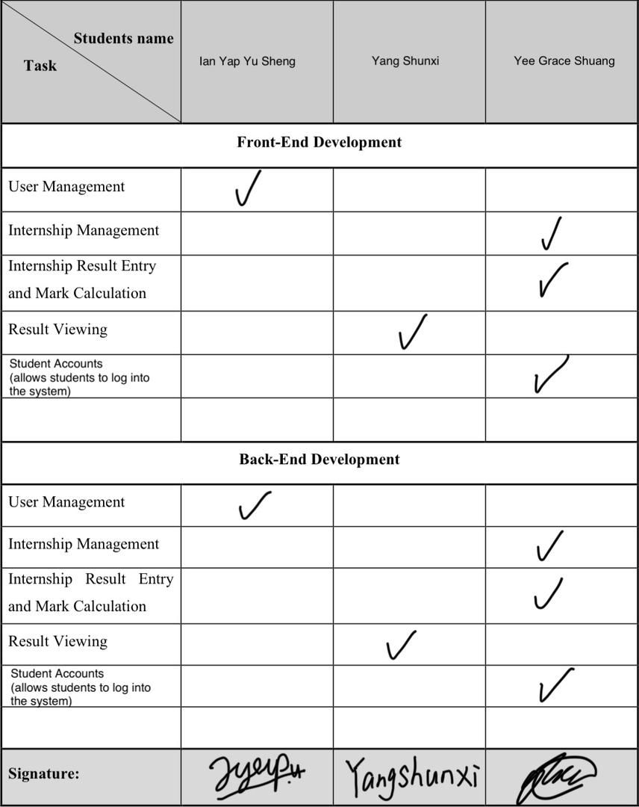

Report on Work Breakdown Structure
Throughout the development of the Internship Management System, there were numerous disputes and moments of confusion due to the lack of a medium that allowed constant updates of the code. Consequently, it led to major breakdowns in communication.
It was challenging to properly gauge the scope and the requirements of the system. The consideration of additional features to be implemented further added to the weight of each decision. This is the reason we have decided to delegate the task of a specific component’s front-end and back-end to each team member. This is to prevent future confusion and conflicts that may transpire when the workflow fluctuates due to the varying ideologies, approaches and competency of each member.
The following paragraphs outline every member’s contribution throughout the entire development phase:
ERD
During the drafting of the ER diagram, Ian Yap Yu Sheng provided the initial draft of the ER diagram. Then, Yee Grace Shuang aided in seeking overlooked or incorrect aspects of the ERD. Yang Shunxi was then tasked to draw the ERD based on every new information gained. However, due to the constant mistakes in the ERD from Yang Shunxi, Ian Yap Yu Sheng stepped up to take over Shunxi’s duty of drafting the ERD. As more details were inquired, Ian Yap Yu Sheng progressively reviews the ERD to fit the requirements better, with discussions being held together with Grace.

Database
Yang Shunxi was also tasked in delivering the database due to his initial responsibility of the ERD. However, as mentioned in the ERD section above, Ian Yap Yu Sheng took over his responsibility. So, the task of delivering the database now falls into Ian Yap’s hands as well as supplying the essential sample data, which laid the foundation to development and testing of the Internship system.

User Management
Additionally, Ian Yap also oversaw the development of one of the core components of the system, user management. Ian Yap did majority of the front-end and back-end of the component. This includes user login page and several admin-specific functionalities, such as the ability to add new student and staff accounts, alongside the feature to modify and delete existing accounts.
Yee Grace Shuang aided Ian Yap by looking for mistakes in the code and designing of certain aspects of the webpage. Furthermore, Ian Yap also created the login and change password system and further helped in checking Grace’s codes for mistakes. He also helped perform rigorous testing to ensure full functionality of the system.

Internship Result Entry & Mark Calculation
Yee Grace Shuang was responsible of the development of this core component. Ian Yap aided her in the conceptual HTML and CSS appearance for the Internship Result Entry page. Grace refined Ian’s work for the Internship Result Entry page appearance to suit practicality, such as changing certain input fields into data lists to implement the search function and readjusting the sizes of some elements. Additionally, she also created the navigation bar, home page for each role, along with the front-end and back-end code for the assessors and students to view their own profile information.

Internship Management
Yee Grace Shuang oversaw the front-end and back-end development for the Internship Management page using Ian’s earlier conceptual HTML and CSS appearance for the Internship Result Entry page as the base.

Result Viewing
Yang Shunxi was tasked with the development of the result viewing component. However, due to his lack of full understanding of the task, he could only deliver a conceptual version of the component. Consequently, Yee Grace Shuang had to take over this task too. Using Shunxi’s conceptual design, Grace overhauled the entire front-end of the Result Viewing page for staff and supervisors, coding in the back-end PHP to match the database. She was also responsible for the creation of the second Result Viewing page for students, which showed the detailed score breakdown for a specific student and included the lecturer and supervisor feedback.

Student Accounts (additional feature)
Grace was also responsible for the implementation of the student accounts feature that allows students to log into the system and view their internship profiles and their internship results.

