Министерство науки и высшего образования Российской Федерации
Федеральное государственное автономное образовательное учреждение высшего образования
«Пермский национальный исследовательский политехнический университет»

Электротехнический факультет
Выпускающая кафедра: Информационные технологии и автоматизированные системы (ИТАС)
Направление подготовки: 09.03.04 Программная инженерия

ОТЧЕТ
Лабораторная работа №1
«Задача коммивояжера.»
По дисциплине «Основы алгоритмизации и программирования»
Вариант 9

Выполнил: студент группы РИС-25-2Б
Ильинов Фёдор Михайлович
Принял: Доц. Полякова О. А.

Пермь 2026
ПОСТАНОВКА ЗАДАЧИ
Задача коммивояжера формулируется следующим образом: дан полный взвешенный граф, где вершины представляют города, а веса рёбер — расстояния (или стоимость проезда) между ними. Требуется найти гамильтонов цикл минимального веса, то есть маршрут, проходящий через каждую вершину ровно один раз и возвращающийся в исходную.
Входными данными программы является матрица смежности, содержащая веса рёбер. Если ребро отсутствует, используется значение бесконечности (или достаточно большое число).
Метод ветвей и границ.
Суть метода заключается в последовательном разбиении множества допустимых решений на подмножества (ветвление) и вычислении для каждого подмножества оценки снизу (границы).
В данной реализации алгоритм работает по следующему принципу:
Ветвление: на каждом шаге алгоритм пытается добавить в текущий путь следующую вершину.
Оценка: вычисляется нижняя оценка стоимости маршрута. В данной работе используется эвристическая оценка: к текущей стоимости пройденного пути прибавляется произведение количества оставшихся вершин на минимальный вес ребра во всём графе.
Отсечение: если вычисленная нижняя оценка превышает стоимость уже найденного лучшего решения (верхнюю границу), данная ветвь поиска прекращается, так как она не может привести к оптимальному решению.
Рекурсия: Процесс повторяется до тех пор, пока не будет построен полный маршрут или не будут отсечены все неперспективные ветви.

Вариант 9
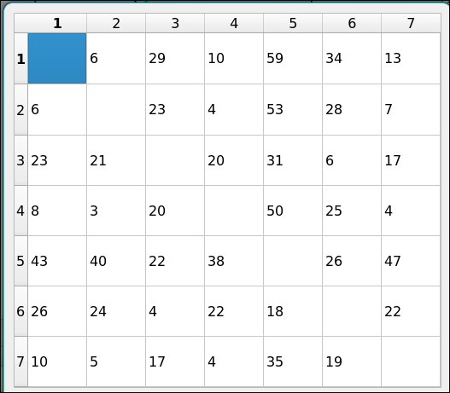
АНАЛИЗ.
Graph, UiVertex, UiEdge, MatrixEditor — см. работу “Графы”
GraphWorker — отрисовщик шагов алгоритма.
MainWindow — кнопки: Edit Matrix, Generate Random/Tree, Run BnB, Zoom In/Out, Reset, Next Step. Next Step запускает QTimer с interval=0, который вызывает сигнал step_next() пока шаги не кончатся.

UML-ДИАГРАММА
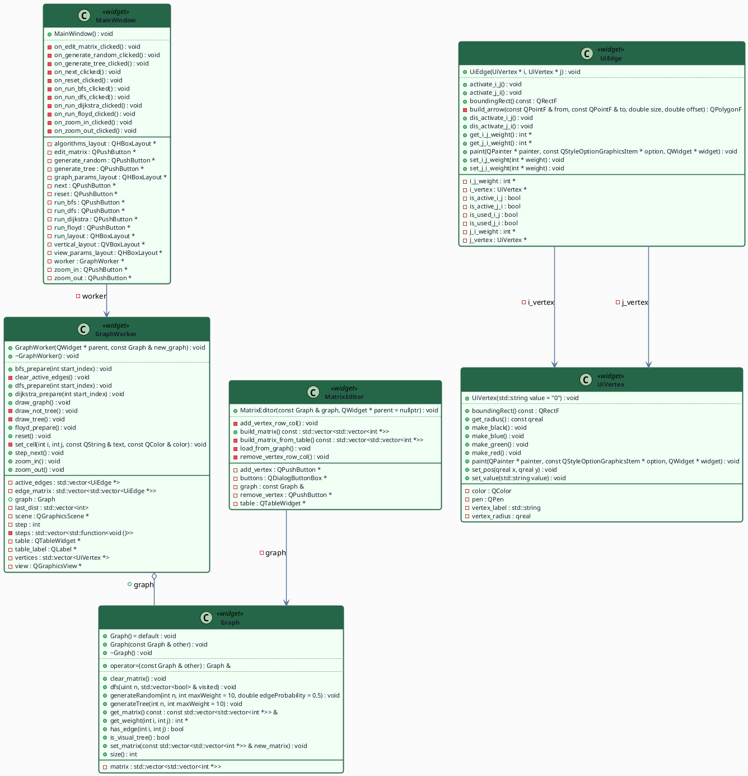
КОД UiVertex.h
//
// Created by localuser on 5/12/26.
//
#ifndef QTGRAPHVISUALIZATION_UIVERTEX_H
#define QTGRAPHVISUALIZATION_UIVERTEX_H
#include <QGraphicsScene>
#include <QGraphicsItem>
#include <QPainter>
class UiVertex : public QGraphicsItem {
std::string vertex_label = "0";
qreal vertex_radius = 30;
QColor color = Qt::black;
QPen pen = QPen(Qt::black, 3);
public:
UiVertex(std::string value = "0");
void set_pos(qreal x, qreal y);
void set_value(std::string value);
const qreal get_radius();
void make_red();
void make_green();
void make_blue();
void make_black();
QRectF boundingRect() const override;
void paint(QPainter *painter,
const QStyleOptionGraphicsItem *option,
QWidget *widget) override;
};
#endif //QTGRAPHVISUALIZATION_UIVERTEX_H

КОД UiVertex.cpp
//
// Created by localuser on 5/12/26.
//
#include "UiVertex.h"
UiVertex::UiVertex(std::string value) {
vertex_label = value;
}
QRectF UiVertex::boundingRect() const {
return QRectF(-vertex_radius, -vertex_radius,
vertex_radius * 2,
vertex_radius * 2);
}
void UiVertex::paint(QPainter *painter,
const QStyleOptionGraphicsItem *,
QWidget *) {
painter->setPen(pen);
painter->setBrush(Qt::white);
painter->drawEllipse(boundingRect());
painter->setPen(Qt::black);
painter->drawText(boundingRect(),
Qt::AlignCenter,
QString::fromStdString(vertex_label));
}
void UiVertex::set_pos(qreal x, qreal y) {
setPos(x, y);
}
void UiVertex::set_value(std::string value) {
vertex_label = value;
update();
}
const qreal UiVertex::get_radius() {
return vertex_radius;
}
void UiVertex::make_red() {
pen = QPen(Qt::red, 5);
update();
}
void UiVertex::make_blue() {
pen = QPen(Qt::blue, 5);
update();
}
void UiVertex::make_green() {
pen = QPen(Qt::green, 3 );
update();
}
void UiVertex::make_black() {
pen = QPen(Qt::black, 3);
update();
}

КОД UiEdge.h
#ifndef QTGRAPHVISUALIZATION_UIEDGE_H
#define QTGRAPHVISUALIZATION_UIEDGE_H
#include <QGraphicsItem>
#include "UiVertex.h"
class UiEdge : public QGraphicsItem {
UiVertex *i_vertex;
UiVertex *j_vertex;
int* i_j_weight = nullptr;
int* j_i_weight = nullptr;
bool is_active_i_j = false;
bool is_active_j_i = false;
bool is_used_i_j = false;
bool is_used_j_i = false;
QPolygonF build_arrow(const QPointF &from, const QPointF &to, double size, double offset);
public:
enum class DirColor { None, Included, Excluded, Current };
UiEdge(UiVertex *i, UiVertex *j);
QRectF boundingRect() const override;
void paint(QPainter *painter,
const QStyleOptionGraphicsItem *option,
QWidget *widget) override;
void set_i_j_weight(int* weight);
void set_j_i_weight(int* weight);
void activate_i_j();
void dis_activate_i_j();
void activate_j_i();
void dis_activate_j_i();
void reset_colors();
void set_i_j_color(DirColor c);
void set_j_i_color(DirColor c);
int* get_i_j_weight();;
int* get_j_i_weight();;
private:
DirColor i_j_color = DirColor::None;
DirColor j_i_color = DirColor::None;
};
#endif
КОД UiEdge.cpp
#include "UiEdge.h"
#include "UiVertex.h"
UiEdge::UiEdge(UiVertex *i, UiVertex *j) {
i_vertex = i;
j_vertex = j;
}
QRectF UiEdge::boundingRect() const {
auto aleft = std::min(i_vertex->pos().x(), j_vertex->pos().x()) - i_vertex->get_radius();
auto atop = std::min(i_vertex->pos().y(), j_vertex->pos().y()) - i_vertex->get_radius();
auto awidth = abs(i_vertex->pos().x() - j_vertex->pos().x()) + 2 * i_vertex->get_radius();
auto aheight = abs(i_vertex->pos().y() - j_vertex->pos().y()) + 2 * i_vertex->get_radius();
return QRectF(aleft, atop, awidth, aheight);
}
static QColor color_for_dir(UiEdge::DirColor c) {
switch (c) {
case UiEdge::DirColor::Included: return Qt::green;
case UiEdge::DirColor::Excluded: return Qt::blue;
case UiEdge::DirColor::Current: return Qt::red;
default: return Qt::black;
}
}
void UiEdge::paint(QPainter *painter,
const QStyleOptionGraphicsItem *,
QWidget *) {
if (i_vertex->pos() == j_vertex->pos()) return;
DirColor effective = DirColor::None;
if (i_j_color == DirColor::Current || j_i_color == DirColor::Current)
effective = DirColor::Current;
else if (i_j_color == DirColor::Included || j_i_color == DirColor::Included)
effective = DirColor::Included;
else if (i_j_color == DirColor::Excluded || j_i_color == DirColor::Excluded)
effective = DirColor::Excluded;
QColor line_color = Qt::black;
int line_width = 3;
if (effective == DirColor::Current || is_active_i_j || is_active_j_i) {
line_color = Qt::red;
line_width = 5;
} else if (effective == DirColor::Included) {
line_color = Qt::green;
line_width = 5;
} else if (effective == DirColor::Excluded) {
line_color = Qt::blue;
line_width = 3;
}
painter->setPen(QPen(line_color, line_width));
painter->drawLine(i_vertex->pos(), j_vertex->pos());
auto pen_for_dir = [&](DirColor c, bool active) {
if (active) return QPen(Qt::red, 5);
return QPen(color_for_dir(c), 3);
};
if (i_j_weight != nullptr) {
QPolygonF arrow = build_arrow(i_vertex->pos(), j_vertex->pos(),
i_vertex->get_radius() * 2, i_vertex->get_radius());
painter->setPen(pen_for_dir(i_j_color, is_active_i_j));
painter->setBrush(QBrush(Qt::white));
painter->drawPolygon(arrow);
QPointF centroid = (arrow[0] + arrow[1] + arrow[2]) / 3.0;
painter->setPen(QPen(Qt::black));
QString text = QString::number(*this->i_j_weight);
if (*i_j_weight == INT_MAX) text = "+inf";
if (*i_j_weight == INT_MIN) text = "-inf";
painter->drawText((int)(centroid.x() - 20), (int)(centroid.y() - 10),
40, 20, Qt::AlignCenter, text);
}
if (j_i_weight != nullptr) {
QPolygonF arrow = build_arrow(j_vertex->pos(), i_vertex->pos(),
i_vertex->get_radius() * 2, i_vertex->get_radius());
painter->setPen(pen_for_dir(j_i_color, is_active_j_i));
painter->setBrush(QBrush(Qt::white));
painter->drawPolygon(arrow);
QPointF centroid = (arrow[0] + arrow[1] + arrow[2]) / 3.0;
painter->setPen(QPen(Qt::black));
QString text = QString::number(*this->j_i_weight);
if (*j_i_weight == INT_MAX) text = "+inf";
if (*j_i_weight == INT_MIN) text = "-inf";
painter->drawText((int)(centroid.x() - 20), (int)(centroid.y() - 10),
40, 20, Qt::AlignCenter, text);
}
}
QPolygonF UiEdge::build_arrow(const QPointF &from, const QPointF &to,
double size, double offset) {
QPointF dir = to - from;
double len = std::sqrt(dir.x() * dir.x() + dir.y() * dir.y());
if (len == 0) return QPolygonF();
QPointF unit = dir / len;
QPointF perp(-unit.y(), unit.x());
double height = size * std::sqrt(3.0) / 2.0;
QPointF tip = to - unit * offset;
QPointF base1 = tip - unit * height + perp * (size / 2.0);
QPointF base2 = tip - unit * height - perp * (size / 2.0);
QPolygonF pol;
pol.resize(3);
pol[0] = tip;
pol[1] = base1;
pol[2] = base2;
return pol;
}
void UiEdge::set_i_j_weight(int *weight) { i_j_weight = weight; update(); }
void UiEdge::set_j_i_weight(int *weight) { j_i_weight = weight; update(); }
void UiEdge::activate_i_j() { is_active_i_j = true; update(); }
void UiEdge::dis_activate_i_j() { is_active_i_j = false; update(); }
void UiEdge::activate_j_i() { is_active_j_i = true; update(); }
void UiEdge::dis_activate_j_i() { is_active_j_i = false; update(); }
void UiEdge::reset_colors() { i_j_color = DirColor::None; j_i_color = DirColor::None; update(); }
void UiEdge::set_i_j_color(DirColor c) { i_j_color = c; update(); }
void UiEdge::set_j_i_color(DirColor c) { j_i_color = c; update(); }
int *UiEdge::get_i_j_weight() { return i_j_weight; }
int *UiEdge::get_j_i_weight() { return j_i_weight; }

КОД MatrixEditor.h
//
// Created by localuser on 5/13/26.
//
#ifndef QTGRAPHVISUALIZATION_MATRIXEDITOR_H
#define QTGRAPHVISUALIZATION_MATRIXEDITOR_H
#include <QDialog>
#include <QTableWidget>
#include <QDialogButtonBox>
#include <QPushButton>
#include "Graph.h"
class MatrixEditor : public QDialog {
Q_OBJECT
const Graph &graph;
QTableWidget *table;
QPushButton *add_vertex;
QPushButton *remove_vertex;
QDialogButtonBox *buttons;
void load_from_graph();
void add_vertex_row_col();
void remove_vertex_row_col();
std::vector<std::vector<int *> > build_matrix_from_table() const;
public:
MatrixEditor(const Graph &graph, QWidget *parent = nullptr);
std::vector<std::vector<int *> > build_matrix() const;
};
#endif //QTGRAPHVISUALIZATION_MATRIXEDITOR_H

КОД MainWindow.h
#ifndef QTGRAPHVISUALIZATION_MAINWINDOW_H
#define QTGRAPHVISUALIZATION_MAINWINDOW_H
#include <QHBoxLayout>
#include <QGraphicsView>
#include <QGraphicsScene>
#include <QPushButton>
#include <QDialog>
#include <QSpinBox>
#include <QDialogButtonBox>
#include <QTimer>
#include "GraphWorker.h"
#include "MatrixEditor.h"
class MainWindow : public QWidget {
Q_OBJECT
QVBoxLayout *vertical_layout;
QHBoxLayout *graph_params_layout;
QHBoxLayout *run_layout;
QPushButton *edit_matrix;
QPushButton *generate_random;
QPushButton *generate_tree;
QPushButton *run_bnb;
QPushButton *reset;
QPushButton *next;
QPushButton *zoom_in;
QPushButton *zoom_out;
GraphWorker *worker;
QTimer *anim_timer = nullptr;
public:
MainWindow();
private slots:
void on_edit_matrix_clicked();
void on_generate_random_clicked();
void on_generate_tree_clicked();
void on_run_bnb_clicked();
void on_reset_clicked();
void on_next_clicked();
void on_zoom_in_clicked();
void on_zoom_out_clicked();
};
#endif
КОД MainWindow.cpp
#include "MainWindow.h"
#include "UiEdge.h"
#include <chrono>
#include <thread>
MainWindow::MainWindow() : QWidget(nullptr) {
vertical_layout = new QVBoxLayout(this);
Graph graph;
worker = new GraphWorker(this);
worker->graph = graph;
worker->draw_graph();
graph_params_layout = new QHBoxLayout;
edit_matrix = new QPushButton("Edit matrix", this);
generate_random = new QPushButton("Generate random graph", this);
generate_tree = new QPushButton("Generate tree", this);
graph_params_layout->addWidget(edit_matrix);
graph_params_layout->addWidget(generate_random);
graph_params_layout->addWidget(generate_tree);
vertical_layout->addLayout(graph_params_layout);
vertical_layout->addWidget(worker);
run_layout = new QHBoxLayout;
run_bnb = new QPushButton("Run BnB", this);
zoom_in = new QPushButton("Zoom In", this);
zoom_out = new QPushButton("Zoom Out", this);
reset = new QPushButton("Reset", this);
next = new QPushButton("Next Step", this);
run_layout->addWidget(run_bnb);
run_layout->addWidget(zoom_in);
run_layout->addWidget(zoom_out);
run_layout->addWidget(reset);
run_layout->addWidget(next);
vertical_layout->addLayout(run_layout);
connect(edit_matrix, &QPushButton::clicked, this, &MainWindow::on_edit_matrix_clicked);
connect(generate_random, &QPushButton::clicked, this, &MainWindow::on_generate_random_clicked);
connect(generate_tree, &QPushButton::clicked, this, &MainWindow::on_generate_tree_clicked);
connect(run_bnb, &QPushButton::clicked, this, &MainWindow::on_run_bnb_clicked);
connect(zoom_in, &QPushButton::clicked, this, &MainWindow::on_zoom_in_clicked);
connect(zoom_out, &QPushButton::clicked, this, &MainWindow::on_zoom_out_clicked);
connect(next, &QPushButton::clicked, this, &MainWindow::on_next_clicked);
connect(reset, &QPushButton::clicked, this, &MainWindow::on_reset_clicked);
}
void MainWindow::on_edit_matrix_clicked() {
MatrixEditor editor(worker->graph, this);
if (editor.exec() == QDialog::Accepted) {
worker->graph.set_matrix(editor.build_matrix());
worker->draw_graph();
}
}
void MainWindow::on_generate_random_clicked() {
QDialog dialog(this);
dialog.setWindowTitle("Vertices amount");
auto *layout = new QVBoxLayout(&dialog);
auto *spin = new QSpinBox(&dialog);
spin->setRange(1, 10);
spin->setValue(4);
auto *buttons = new QDialogButtonBox(QDialogButtonBox::Ok | QDialogButtonBox::Cancel, &dialog);
layout->addWidget(spin);
layout->addWidget(buttons);
connect(buttons, &QDialogButtonBox::accepted, &dialog, &QDialog::accept);
connect(buttons, &QDialogButtonBox::rejected, &dialog, &QDialog::reject);
if (dialog.exec() != QDialog::Accepted) return;
worker->graph.generateRandom(spin->value(), 10, 1.0);
worker->draw_graph();
}
void MainWindow::on_generate_tree_clicked() {
QDialog dialog(this);
dialog.setWindowTitle("Vertices amount");
auto *layout = new QVBoxLayout(&dialog);
auto *spin = new QSpinBox(&dialog);
spin->setRange(1, 10);
spin->setValue(4);
auto *buttons = new QDialogButtonBox(QDialogButtonBox::Ok | QDialogButtonBox::Cancel, &dialog);
layout->addWidget(spin);
layout->addWidget(buttons);
connect(buttons, &QDialogButtonBox::accepted, &dialog, &QDialog::accept);
connect(buttons, &QDialogButtonBox::rejected, &dialog, &QDialog::reject);
if (dialog.exec() != QDialog::Accepted) return;
worker->graph.generateTree(spin->value(), 10);
worker->draw_graph();
}
void MainWindow::on_run_bnb_clicked() {
int n = worker->graph.size();
if (n == 0) return;
worker->reset();
worker->bnb_prepare();
}
void MainWindow::on_reset_clicked() {
worker->reset();
}
void MainWindow::on_next_clicked() {
if (anim_timer && anim_timer->isActive()) return;
if (!worker->has_next()) return;
if (!anim_timer) {
anim_timer = new QTimer(this);
connect(anim_timer, &QTimer::timeout, this, [this]() {
worker->step_next();
if (!worker->has_next())
anim_timer->stop();
});
}
anim_timer->start(0);
}
void MainWindow::on_zoom_in_clicked() {
worker->zoom_in();
}
void MainWindow::on_zoom_out_clicked() {
worker->zoom_out();
}

КОД main.cpp
#include <QApplication>
#include <QPushButton>
#include "MainWindow.h"
int main(int argc, char* argv[]) {
QApplication a(argc, argv);
MainWindow window;
window.show();
return QApplication::exec();
}
КОД GraphWorker.h
#include "MainWindow.h"
#include "UiEdge.h"
#include <chrono>
#include <thread>
MainWindow::MainWindow() : QWidget(nullptr) {
vertical_layout = new QVBoxLayout(this);
Graph graph;
worker = new GraphWorker(this);
worker->graph = graph;
worker->draw_graph();
graph_params_layout = new QHBoxLayout;
edit_matrix = new QPushButton("Edit matrix", this);
generate_random = new QPushButton("Generate random graph", this);
generate_tree = new QPushButton("Generate tree", this);
graph_params_layout->addWidget(edit_matrix);
graph_params_layout->addWidget(generate_random);
graph_params_layout->addWidget(generate_tree);
vertical_layout->addLayout(graph_params_layout);
vertical_layout->addWidget(worker);
run_layout = new QHBoxLayout;
run_bnb = new QPushButton("Run BnB", this);
zoom_in = new QPushButton("Zoom In", this);
zoom_out = new QPushButton("Zoom Out", this);
reset = new QPushButton("Reset", this);
next = new QPushButton("Next Step", this);
run_layout->addWidget(run_bnb);
run_layout->addWidget(zoom_in);
run_layout->addWidget(zoom_out);
run_layout->addWidget(reset);
run_layout->addWidget(next);
vertical_layout->addLayout(run_layout);
connect(edit_matrix, &QPushButton::clicked, this, &MainWindow::on_edit_matrix_clicked);
connect(generate_random, &QPushButton::clicked, this, &MainWindow::on_generate_random_clicked);
connect(generate_tree, &QPushButton::clicked, this, &MainWindow::on_generate_tree_clicked);
connect(run_bnb, &QPushButton::clicked, this, &MainWindow::on_run_bnb_clicked);
connect(zoom_in, &QPushButton::clicked, this, &MainWindow::on_zoom_in_clicked);
connect(zoom_out, &QPushButton::clicked, this, &MainWindow::on_zoom_out_clicked);
connect(next, &QPushButton::clicked, this, &MainWindow::on_next_clicked);
connect(reset, &QPushButton::clicked, this, &MainWindow::on_reset_clicked);
}
void MainWindow::on_edit_matrix_clicked() {
MatrixEditor editor(worker->graph, this);
if (editor.exec() == QDialog::Accepted) {
worker->graph.set_matrix(editor.build_matrix());
worker->draw_graph();
}
}
void MainWindow::on_generate_random_clicked() {
QDialog dialog(this);
dialog.setWindowTitle("Vertices amount");
auto *layout = new QVBoxLayout(&dialog);
auto *spin = new QSpinBox(&dialog);
spin->setRange(1, 10);
spin->setValue(4);
auto *buttons = new QDialogButtonBox(QDialogButtonBox::Ok | QDialogButtonBox::Cancel, &dialog);
layout->addWidget(spin);
layout->addWidget(buttons);
connect(buttons, &QDialogButtonBox::accepted, &dialog, &QDialog::accept);
connect(buttons, &QDialogButtonBox::rejected, &dialog, &QDialog::reject);
if (dialog.exec() != QDialog::Accepted) return;
worker->graph.generateRandom(spin->value(), 10, 1.0);
worker->draw_graph();
}
void MainWindow::on_generate_tree_clicked() {
QDialog dialog(this);
dialog.setWindowTitle("Vertices amount");
auto *layout = new QVBoxLayout(&dialog);
auto *spin = new QSpinBox(&dialog);
spin->setRange(1, 10);
spin->setValue(4);
auto *buttons = new QDialogButtonBox(QDialogButtonBox::Ok | QDialogButtonBox::Cancel, &dialog);
layout->addWidget(spin);
layout->addWidget(buttons);
connect(buttons, &QDialogButtonBox::accepted, &dialog, &QDialog::accept);
connect(buttons, &QDialogButtonBox::rejected, &dialog, &QDialog::reject);
if (dialog.exec() != QDialog::Accepted) return;
worker->graph.generateTree(spin->value(), 10);
worker->draw_graph();
}
void MainWindow::on_run_bnb_clicked() {
int n = worker->graph.size();
if (n == 0) return;
worker->reset();
worker->bnb_prepare();
}
void MainWindow::on_reset_clicked() {
worker->reset();
}
void MainWindow::on_next_clicked() {
if (anim_timer && anim_timer->isActive()) return;
if (!worker->has_next()) return;
if (!anim_timer) {
anim_timer = new QTimer(this);
connect(anim_timer, &QTimer::timeout, this, [this]() {
worker->step_next();
if (!worker->has_next())
anim_timer->stop();
});
}
anim_timer->start(0);
}
void MainWindow::on_zoom_in_clicked() {
worker->zoom_in();
}
void MainWindow::on_zoom_out_clicked() {
worker->zoom_out();
}
КОД GraphWorker.cpp
#include "GraphWorker.h"
#include <QGraphicsView>
#include <QVBoxLayout>
#include <cmath>
#include <queue>
#include <algorithm>
#include <climits>
static const int BNB_INF = 1e9;
GraphWorker::GraphWorker(QWidget *parent) : QWidget(parent) {
table = new QTableWidget(this);
table->hide();
table->setMaximumHeight(200);
table_label = new QLabel(this);
table_label->hide();
scene = new QGraphicsScene(this);
view = new QGraphicsView(scene, this);
view->setRenderHint(QPainter::Antialiasing);
view->setSizePolicy(QSizePolicy::Expanding, QSizePolicy::Expanding);
view->setTransformationAnchor(QGraphicsView::AnchorUnderMouse);
view->setInteractive(true);
view->setDragMode(QGraphicsView::ScrollHandDrag);
auto *layout = new QVBoxLayout(this);
layout->setContentsMargins(0, 0, 0, 0);
layout->addWidget(view);
layout->addWidget(table_label);
layout->addWidget(table);
setLayout(layout);
setSizePolicy(QSizePolicy::Expanding, QSizePolicy::Expanding);
}
GraphWorker::~GraphWorker() {
for (auto *v : vertices) delete v;
for (auto v : edge_matrix)
for (auto e : v)
if (e) delete e;
}
void GraphWorker::draw_not_tree() {
scene->clear();
vertices.clear();
edge_matrix.clear();
int n = graph.size();
if (n == 0) return;
const double radius_val = 500.0;
const double step_angle = 2.0 * M_PI / n;
QPointF center = view->mapToScene(view->viewport()->rect().center());
for (int i = 0; i < n; i++) {
double angle = step_angle * i;
double x = center.x() + radius_val * std::cos(angle);
double y = center.y() + radius_val * std::sin(angle);
auto *v = new UiVertex(std::to_string(i + 1));
v->set_pos(x, y);
vertices.push_back(v);
}
edge_matrix.assign(n, std::vector<UiEdge *>(n, nullptr));
for (int i = 0; i < n; i++) {
for (int j = i + 1; j < n; j++) {
if (graph.has_edge(i, j) || graph.has_edge(j, i)) {
auto *e = new UiEdge(vertices[i], vertices[j]);
if (graph.has_edge(i, j)) {
e->set_i_j_weight(graph.get_weight(i, j));
edge_matrix[i][j] = e;
}
if (graph.has_edge(j, i)) {
e->set_j_i_weight(graph.get_weight(j, i));
edge_matrix[j][i] = e;
}
}
}
}
for (auto v : edge_matrix)
for (auto ui_edge : v)
if (ui_edge)
scene->addItem(ui_edge);
for (auto v : vertices)
scene->addItem(v);
}
void GraphWorker::draw_graph() {
draw_not_tree();
}
void GraphWorker::zoom_in() {
view->setTransformationAnchor(QGraphicsView::AnchorViewCenter);
view->scale(1.2, 1.2);
}
void GraphWorker::zoom_out() {
view->setTransformationAnchor(QGraphicsView::AnchorViewCenter);
view->scale(1.0 / 1.2, 1.0 / 1.2);
}
void GraphWorker::set_cell(int i, int j, const QString &text, const QColor &color) {
auto *item = table->item(i, j);
if (!item) {
item = new QTableWidgetItem();
table->setItem(i, j, item);
}
item->setText(text);
item->setBackground(color);
item->setTextAlignment(Qt::AlignCenter);
}
void GraphWorker::clear_edge_highlights() {
for (auto v : edge_matrix)
for (auto e : v)
if (e) {
e->reset_colors();
e->update();
}
}
void GraphWorker::step_next() {
if (step >= static_cast<int>(steps.size())) return;
steps[step]();
step++;
}
void GraphWorker::reset() {
steps.clear();
step = 0;
clear_edge_highlights();
for (int i = 0; i < static_cast<int>(vertices.size()); i++) {
vertices[i]->make_black();
vertices[i]->set_value(std::to_string(i + 1));
vertices[i]->update();
}
for (auto v : edge_matrix)
for (auto e : v)
if (e) {
e->dis_activate_i_j();
e->dis_activate_j_i();
e->update();
}
table->hide();
table_label->hide();
}
void GraphWorker::bnb_prepare() {
steps.clear();
step = 0;
int n = graph.size();
if (n == 0) return;
// Build cost matrix from graph
std::vector<std::vector<int>> mat(n, std::vector<int>(n, BNB_INF));
for (int i = 0; i < n; i++)
for (int j = 0; j < n; j++)
if (i != j && graph.has_edge(i, j))
mat[i][j] = *graph.get_weight(i, j);
// Setup table
table->show();
table_label->show();
table->setRowCount(n);
table->setColumnCount(n);
for (int i = 0; i < n; i++) {
table->setHorizontalHeaderItem(i, new QTableWidgetItem(QString::number(i + 1)));
table->setVerticalHeaderItem(i, new QTableWidgetItem(QString::number(i + 1)));
table->setColumnWidth(i, 50);
table->setRowHeight(i, 30);
}
// Helper: convert working m×m matrix to full n×n display matrix
auto build_full = [n](const std::vector<std::vector<int>> &small,
const std::vector<int> &rows,
const std::vector<int> &cols) {
std::vector<std::vector<int>> full(n, std::vector<int>(n, BNB_INF));
for (size_t i = 0; i < small.size() && i < rows.size(); i++)
for (size_t j = 0; j < small[i].size() && j < cols.size(); j++)
if (rows[i] < n && cols[j] < n)
full[rows[i]][cols[j]] = small[i][j];
return full;
};
// Helper: push a visualization step
auto push_step = [this, n](const std::vector<std::vector<int>> &matrix,
int bound, int best,
const std::vector<std::pair<int, int>> &included,
const std::vector<std::pair<int, int>> &excluded,
int branch_i, int branch_j,
const std::string &msg) {
steps.push_back([this, n, matrix, bound, best, included, excluded, branch_i, branch_j, msg]() {
for (int i = 0; i < n; i++)
for (int j = 0; j < n; j++) {
QString val;
QColor bg = Qt::white;
if (matrix[i][j] >= BNB_INF / 2)
val = "inf";
else
val = QString::number(matrix[i][j]);
set_cell(i, j, val, bg);
}
QString label = QString::fromStdString(msg);
if (bound < BNB_INF / 2)
label += QString(" LB: %1").arg(bound);
if (best < BNB_INF / 2)
label += QString(" Best: %1").arg(best);
table_label->setText(label);
clear_edge_highlights();
auto color_arrow = [](UiEdge *e, int from, int to, UiEdge::DirColor c) {
if (from < to) e->set_i_j_color(c);
else e->set_j_i_color(c);
};
for (auto &p : included)
if (edge_matrix[p.first][p.second])
color_arrow(edge_matrix[p.first][p.second], p.first, p.second,
UiEdge::DirColor::Included);
for (auto &p : excluded)
if (edge_matrix[p.first][p.second])
color_arrow(edge_matrix[p.first][p.second], p.first, p.second,
UiEdge::DirColor::Excluded);
if (branch_i >= 0 && branch_j >= 0 && edge_matrix[branch_i][branch_j])
color_arrow(edge_matrix[branch_i][branch_j], branch_i, branch_j,
UiEdge::DirColor::Current);
});
};
// Initial best = INF, best_path empty
int best = BNB_INF;
std::vector<std::pair<int, int>> best_path;
push_step(mat, 0, best, {}, {}, -1, -1, "Initial matrix");
// Recursive BnB (Little's algorithm)
std::function<void(std::vector<std::vector<int>>, int,
std::vector<std::pair<int, int>>,
std::vector<std::pair<int, int>>,
std::vector<int>, std::vector<int>)>
bnb_rec;
bnb_rec = [&](std::vector<std::vector<int>> cmat, int bound,
std::vector<std::pair<int, int>> included,
std::vector<std::pair<int, int>> excluded,
std::vector<int> row_cities,
std::vector<int> col_cities) {
int m = cmat.size();
// Reduce rows
for (int i = 0; i < m; i++) {
int row_min = BNB_INF;
for (int j = 0; j < m; j++)
if (cmat[i][j] < row_min) row_min = cmat[i][j];
if (row_min >= BNB_INF / 2) return; // impossible
if (row_min > 0) {
for (int j = 0; j < m; j++)
if (cmat[i][j] < BNB_INF / 2)
cmat[i][j] -= row_min;
bound += row_min;
push_step(build_full(cmat, row_cities, col_cities), bound, best,
included, excluded, -1, -1,
"Row reduce city " + std::to_string(row_cities[i] + 1) +
", sub " + std::to_string(row_min));
}
}
// Reduce columns
for (int j = 0; j < m; j++) {
int col_min = BNB_INF;
for (int i = 0; i < m; i++)
if (cmat[i][j] < col_min) col_min = cmat[i][j];
if (col_min >= BNB_INF / 2) return;
if (col_min > 0) {
for (int i = 0; i < m; i++)
if (cmat[i][j] < BNB_INF / 2)
cmat[i][j] -= col_min;
bound += col_min;
push_step(build_full(cmat, row_cities, col_cities), bound, best,
included, excluded, -1, -1,
"Column reduce city " + std::to_string(col_cities[j] + 1) +
", sub " + std::to_string(col_min));
}
}
// Prune
if (bound >= best) {
push_step(build_full(cmat, row_cities, col_cities), bound, best,
included, excluded, -1, -1, "Prune (bound >= best)");
return;
}
// Base case: 2x2 matrix → complete tour (try all 2 matchings)
if (m == 2) {
static const int matchings[2][2][2] = {{{0,1},{1,0}}, {{0,0},{1,1}}};
bool found_tour = false;
for (auto &matching : matchings) {
int u = matching[0][0], v = matching[0][1];
int x = matching[1][0], y = matching[1][1];
if (cmat[u][v] < BNB_INF / 2 && cmat[x][y] < BNB_INF / 2) {
auto tour = included;
tour.emplace_back(row_cities[u], col_cities[v]);
tour.emplace_back(row_cities[x], col_cities[y]);
if (bound < best) {
best = bound;
best_path = tour;
}
push_step(build_full(cmat, row_cities, col_cities), bound, best,
tour, excluded, -1, -1, "Tour found!");
found_tour = true;
}
}
if (!found_tour) {
push_step(build_full(cmat, row_cities, col_cities), bound, best,
included, excluded, -1, -1,
"Cannot complete tour (edge missing)");
}
return;
}
// Find branching edge (max penalty zero)
int best_i = -1, best_j = -1, max_penalty = -1;
for (int i = 0; i < m; i++) {
for (int j = 0; j < m; j++) {
if (cmat[i][j] != 0) continue;
int row_min = BNB_INF;
for (int k = 0; k < m; k++)
if (k != j && cmat[i][k] < row_min) row_min = cmat[i][k];
int col_min = BNB_INF;
for (int k = 0; k < m; k++)
if (k != i && cmat[k][j] < col_min) col_min = cmat[k][j];
int penalty = (row_min < BNB_INF / 2 ? row_min : 0) +
(col_min < BNB_INF / 2 ? col_min : 0);
if (penalty > max_penalty) {
max_penalty = penalty;
best_i = i;
best_j = j;
}
}
}
if (best_i < 0 || best_j < 0) return; // no zero
int orig_i = row_cities[best_i];
int orig_j = col_cities[best_j];
push_step(build_full(cmat, row_cities, col_cities), bound, best,
included, excluded, orig_i, orig_j,
"Branch on (" + std::to_string(orig_i + 1) + "," +
std::to_string(orig_j + 1) + ") penalty=" +
std::to_string(max_penalty));
// Exclude branch: forbid edge (orig_i, orig_j)
{
auto exc_mat = cmat;
exc_mat[best_i][best_j] = BNB_INF;
auto exc_exc = excluded;
exc_exc.emplace_back(orig_i, orig_j);
push_step(build_full(exc_mat, row_cities, col_cities), bound, best,
included, exc_exc, orig_i, orig_j,
"Exclude (" + std::to_string(orig_i + 1) + "," +
std::to_string(orig_j + 1) + ")");
bnb_rec(exc_mat, bound, included, exc_exc, row_cities, col_cities);
}
// Include branch: add edge, remove row/col, forbid reverse
{
// Correct reverse edge: from orig_j to orig_i
int rev_i = -1, rev_j = -1;
for (int k = 0; k < m; k++) {
if (row_cities[k] == orig_j) rev_i = k;
if (col_cities[k] == orig_i) rev_j = k;
}
if (rev_i >= 0 && rev_j >= 0)
cmat[rev_i][rev_j] = BNB_INF;
std::vector<std::vector<int>> inc_mat(m - 1, std::vector<int>(m - 1));
std::vector<int> new_rows, new_cols;
for (int i = 0; i < m; i++) {
if (i == best_i) continue;
new_rows.push_back(row_cities[i]);
int ri = (i > best_i) ? i - 1 : i;
for (int j = 0; j < m; j++) {
if (j == best_j) continue;
inc_mat[ri][(j > best_j) ? j - 1 : j] = cmat[i][j];
}
}
for (int j = 0; j < m; j++)
if (j != best_j) new_cols.push_back(col_cities[j]);
auto inc_inc = included;
inc_inc.emplace_back(orig_i, orig_j);
// Subtour prevention: forbid edge (tail, head)
int sub_tail = orig_j;
for (bool cont = true; cont;) {
cont = false;
for (auto &e : inc_inc)
if (e.first == sub_tail) { sub_tail = e.second; cont = true; break; }
}
int sub_head = orig_i;
for (bool cont = true; cont;) {
cont = false;
for (auto &e : inc_inc)
if (e.second == sub_head) { sub_head = e.first; cont = true; break; }
}
if (!(sub_tail == orig_j && sub_head == orig_i)) {
int fi = -1, fj = -1;
for (int k = 0; k < m - 1; k++) {
if (new_rows[k] == sub_tail) fi = k;
if (new_cols[k] == sub_head) fj = k;
}
if (fi >= 0 && fj >= 0)
inc_mat[fi][fj] = BNB_INF;
}
push_step(build_full(inc_mat, new_rows, new_cols), bound, best,
inc_inc, excluded, orig_i, orig_j,
"Include (" + std::to_string(orig_i + 1) + "," +
std::to_string(orig_j + 1) + ")");
bnb_rec(inc_mat, bound, inc_inc, excluded, new_rows, new_cols);
}
};
std::vector<int> init_cities(n);
for (int i = 0; i < n; i++) init_cities[i] = i;
bnb_rec(mat, 0, {}, {}, init_cities, init_cities);
if (best < BNB_INF / 2) {
push_step(mat, best, best, best_path, {}, -1, -1,
"Optimal tour length: " + std::to_string(best));
} else {
push_step(mat, 0, BNB_INF, {}, {}, -1, -1, "No tour exists");
}
}
КОД Graph.h
//
// Created by localuser on 5/13/26.
//
#include "MatrixEditor.h"
#include <QHeaderView>
#include <QVBoxLayout>
#include <QHBoxLayout>
MatrixEditor::MatrixEditor(const Graph &graph, QWidget *parent)
: QDialog(parent), graph(graph) {
setWindowTitle("Edit matrix");
table = new QTableWidget(this);
table->setEditTriggers(QAbstractItemView::DoubleClicked
| QAbstractItemView::SelectedClicked
| QAbstractItemView::EditKeyPressed);
table->horizontalHeader()->setSectionResizeMode(QHeaderView::Stretch);
table->verticalHeader()->setSectionResizeMode(QHeaderView::Stretch);
add_vertex = new QPushButton("Add vertex", this);
remove_vertex = new QPushButton("Remove vertex", this);
buttons = new QDialogButtonBox(QDialogButtonBox::Ok | QDialogButtonBox::Cancel, this);
auto *buttons_layout = new QHBoxLayout;
buttons_layout->addWidget(add_vertex);
buttons_layout->addWidget(remove_vertex);
buttons_layout->addWidget(buttons);
auto *main_layout = new QVBoxLayout(this);
main_layout->addWidget(table);
main_layout->addLayout(buttons_layout);
setLayout(main_layout);
load_from_graph();
connect(add_vertex, &QPushButton::clicked, this, &MatrixEditor::add_vertex_row_col);
connect(remove_vertex, &QPushButton::clicked, this, &MatrixEditor::remove_vertex_row_col);
connect(buttons, &QDialogButtonBox::accepted, this, &QDialog::accept);
connect(buttons, &QDialogButtonBox::rejected, this, &QDialog::reject);
}
void MatrixEditor::load_from_graph() {
const auto &matrix = graph.get_matrix();
int n = matrix.size();
table->setRowCount(n);
table->setColumnCount(n);
for (int i = 0; i < n; i++) {
for (int j = 0; j < n; j++) {
if (matrix[i][j] == nullptr) {
table->setItem(i, j, new QTableWidgetItem(""));
} else {
table->setItem(i, j, new QTableWidgetItem(QString::number(*matrix[i][j])));
}
}
}
}
std::vector<std::vector<int *> > MatrixEditor::build_matrix_from_table() const {
int n = table->rowCount();
std::vector<std::vector<int *> > matrix(n, std::vector<int *>(n, nullptr));
for (int i = 0; i < n; i++) {
for (int j = 0; j < n; j++) {
QTableWidgetItem *item = table->item(i, j);
if (!item) continue;
QString text = item->text().trimmed();
if (text.isEmpty()) continue;
bool ok = false;
int value = text.toInt(&ok);
if (!ok) continue;
matrix[i][j] = new int(value);
}
}
return matrix;
}
void MatrixEditor::add_vertex_row_col() {
int n = table->rowCount();
table->setRowCount(n + 1);
table->setColumnCount(n + 1);
for (int i = 0; i < n + 1; i++) {
for (int j = 0; j < n + 1; j++) {
if (table->item(i, j)) continue;
table->setItem(i, j, new QTableWidgetItem(""));
}
}
}
void MatrixEditor::remove_vertex_row_col() {
int n = table->rowCount();
table->setRowCount(n - 1);
table->setColumnCount(n - 1);
for (int i = 0; i < n - 1; i++) {
for (int j = 0; j < n - 1; j++) {
if (table->item(i, j)) continue;
table->setItem(i, j, new QTableWidgetItem(""));
}
}
}
std::vector<std::vector<int *> > MatrixEditor::build_matrix() const {
return build_matrix_from_table();
}
КОД MatrixEditor.cpp
//
// Created by localuser on 5/12/26.
//
#ifndef QTGRAPHVISUALIZATION_GRAPH_H
#define QTGRAPHVISUALIZATION_GRAPH_H
#include <cstdlib>
#include <queue>
#include <vector>
class Graph {
std::vector<std::vector<int *> > matrix;
public:
Graph() = default;
Graph(const Graph &other);
~Graph();
Graph &operator=(const Graph &other);
void clear_matrix();
const std::vector<std::vector<int *> > &get_matrix() const;
void set_matrix(const std::vector<std::vector<int *> > &new_matrix);
bool is_visual_tree();
void generateRandom(int n, int maxWeight = 10, double edgeProbability = 0.5);
void generateTree(int n, int maxWeight = 10);
int size();
bool has_edge(int i, int j);
int *get_weight(int i, int j);
void dfs(uint n, std::vector<bool>& visited);
};
#endif //QTGRAPHVISUALIZATION_GRAPH_H
КОД Graph.cpp
#include "Graph.h"
#include <random>
static std::mt19937 rng(std::random_device{}());
Graph::Graph(const Graph &other) {
set_matrix(other.matrix);
}
Graph::~Graph() {
clear_matrix();
}
void Graph::clear_matrix() {
for (int i = 0; i < matrix.size(); i++)
for (int j = 0; j < matrix[i].size(); j++)
if (matrix[i][j] != nullptr)
delete matrix[i][j];
matrix.clear();
}
Graph &Graph::operator=(const Graph &other) {
if (this == &other)
return *this;
set_matrix(other.matrix);
return *this;
}
const std::vector<std::vector<int *> > &Graph::get_matrix() const {
return matrix;
}
void Graph::set_matrix(const std::vector<std::vector<int *> > &new_matrix) {
clear_matrix();
matrix.resize(new_matrix.size());
for (int i = 0; i < new_matrix.size(); i++)
for (int j = 0; j < new_matrix[i].size(); j++)
if (new_matrix[i][j] == nullptr)
matrix[i].push_back(nullptr);
else
matrix[i].push_back(new int(*new_matrix[i][j]));
}
bool Graph::is_visual_tree() {
int n = matrix.size();
if (n == 0) return false;
int edgeCount = 0;
for (int i = 0; i < n; i++)
for (int j = i + 1; j < n; j++)
if (matrix[i][j] != nullptr || matrix[j][i] != nullptr)
edgeCount++;
if (edgeCount != n - 1) return false;
std::vector<bool> visited(n, false);
std::queue<int> q;
q.push(0);
visited[0] = true;
int visitedCount = 1;
while (!q.empty()) {
int cur = q.front();
q.pop();
for (int next = 0; next < n; next++) {
if (!visited[next] &&
(matrix[cur][next] != nullptr || matrix[next][cur] != nullptr)) {
visited[next] = true;
visitedCount++;
q.push(next);
}
}
}
return visitedCount == n;
}
void Graph::generateRandom(int n, int maxWeight, double edgeProbability) {
for (auto &row: matrix)
for (auto *p: row)
delete p;
matrix.assign(n, std::vector<int *>(n, nullptr));
for (int i = 0; i < n; i++) {
for (int j = 0; j < n; j++) {
if (i == j) continue;
std::bernoulli_distribution edge_dist(edgeProbability);
if (edge_dist(rng)) {
std::uniform_int_distribution<int> weight_dist(1, maxWeight);
matrix[i][j] = new int(weight_dist(rng));
}
}
}
}
void Graph::generateTree(int n, int maxWeight) {
for (auto &row: matrix)
for (auto *p: row)
delete p;
matrix.assign(n, std::vector<int *>(n, nullptr));
std::vector<int> perm(n);
for (int i = 0; i < n; i++) perm[i] = i;
for (int i = n - 1; i > 0; i--) {
std::uniform_int_distribution<int> idx_dist(0, i);
int j = idx_dist(rng);
std::swap(perm[i], perm[j]);
}
for (int i = 1; i < n; i++) {
int parent = perm[std::rand() % i];
int child = perm[i];
std::uniform_int_distribution<int> weight_dist(1, maxWeight);
matrix[parent][child] = new int(weight_dist(rng));
}
}
int Graph::size() {
return matrix.size();
}
bool Graph::has_edge(int i, int j) {
return matrix[i][j];
}
int *Graph::get_weight(int i, int j) {
return matrix[i][j];
}
void Graph::dfs(uint n, std::vector<bool> &visited) {
visited[n] = true;
for (auto& i : matrix[n]) {
if (i != nullptr && !visited[*i]) {
dfs(*i, visited);
}
}
}

РЕЗУЛЬТАТ ВЫПОЛНЕНИЯ
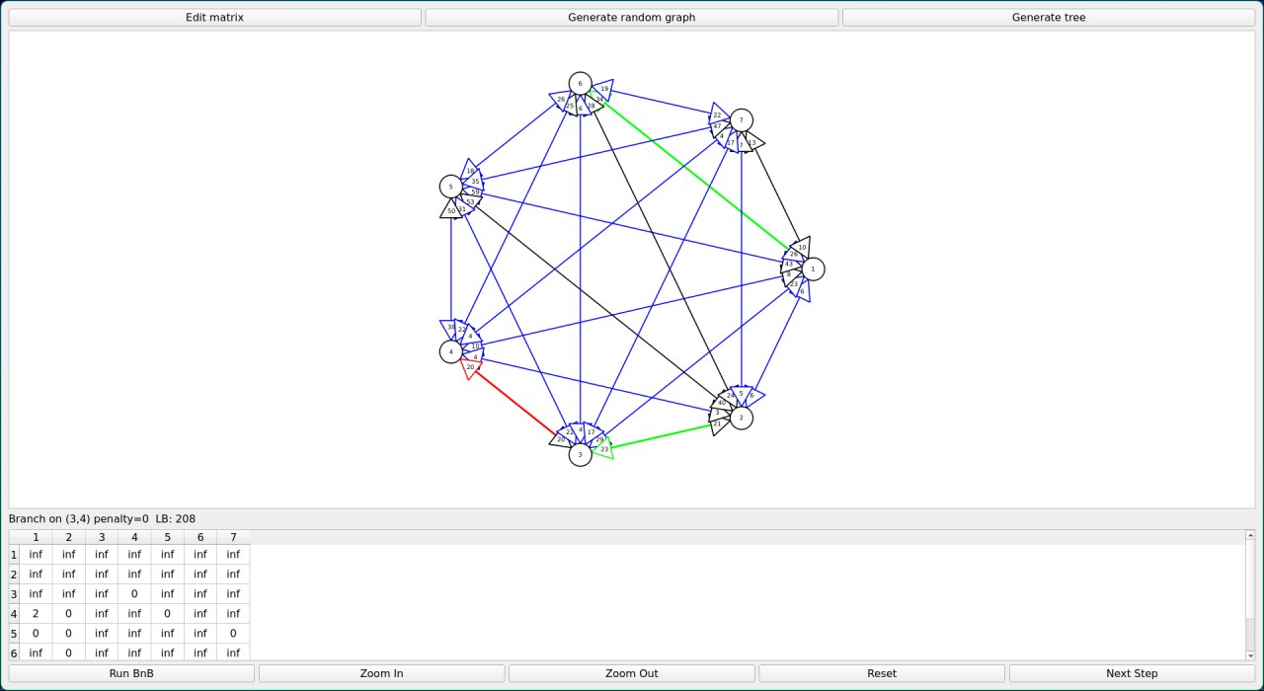
Пример шага алгоритма
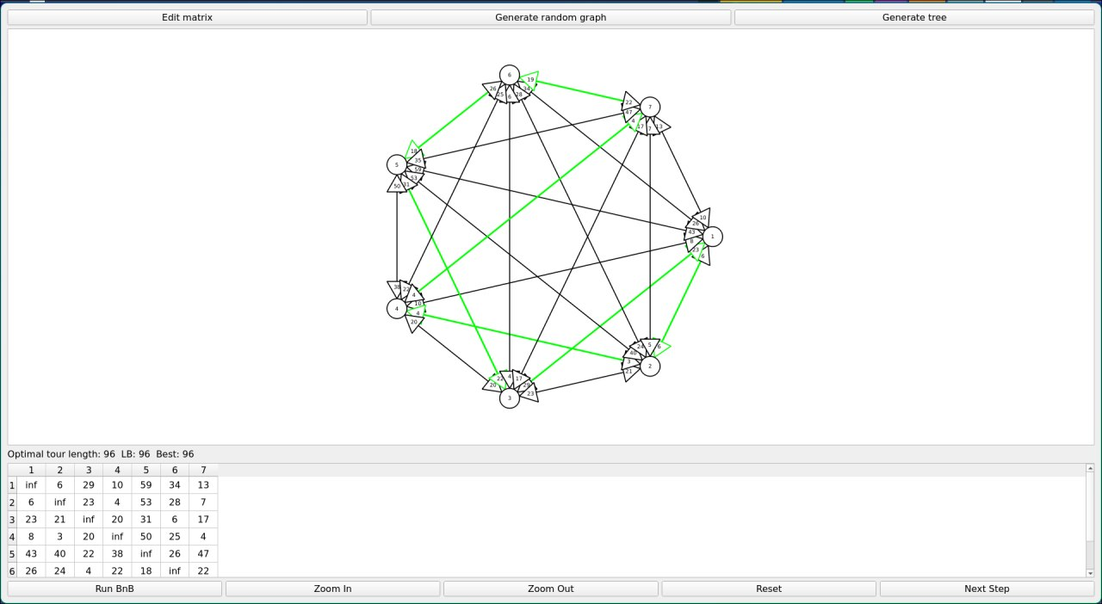
Итоговый цикл: 3→1→2→4→7→6→5→3 с ценой 96

