Министерство науки и высшего образования Российской Федерации
Федеральное государственное автономное образовательное учреждение высшего образования
«Пермский национальный исследовательский политехнический университет»

Электротехнический факультет
Выпускающая кафедра: Информационные технологии и автоматизированные системы (ИТАС)
Направление подготовки: 09.03.04 Программная инженерия

ОТЧЕТ
Лабораторная работа №1
«Графы.»
По дисциплине «Основы алгоритмизации и программирования»
Вариант 22

Выполнил: студент группы РИС-25-2Б
Ильинов Фёдор Михайлович
Принял: Доц. Полякова О. А.

Пермь 2026
ПОСТАНОВКА ЗАДАЧИ
1. Реализовать структуру данных «взвешенный неориентированный граф» с использованием матрицы смежности
2. Разработать алгоритмы:
a) Обхода графа в ширину (BFS)
b) Обхода графа в глубину (DFS)
c) Поиска кратчайших путей от одной вершины до всех остальных (алгоритм Дейкстры)
d) Поиска кратчайших путей между всеми парами вершин (алгоритм Флойда-Уоршелла)
3. Создать графический интерфейс пользователя для взаимодействия с программой
4. Реализовать пошаговую визуализацию работы каждого алгоритма с возможностью просмотра промежуточных результатов
5. Обеспечить возможность редактирования графа (добавление/удаление вершин и рёбер, изменение весов)
6. Обеспечить возможность редактирования матрицы смежности
АНАЛИЗ.
Визуализация графа обеспечивается через UiVertex (вершины) и UiEdge (рёбра), которые наследуют графические элементы Qt и отвечают за отрисовку, цветовую индикацию и состояние рёбер.
Класс GraphWorker выполняет алгоритмы (BFS, DFS, Dijkstra, Floyd), управляет пошаговой визуализацией и связывает модель Graph с графическим представлением.
MatrixEditor отвечает за редактирование матрицы смежности через таблицу Qt и синхронизацию с Graph.
MainWindow выступает контроллером интерфейса, обрабатывает события кнопок и управляет запуском алгоритмов через GraphWorker.
Вариант:
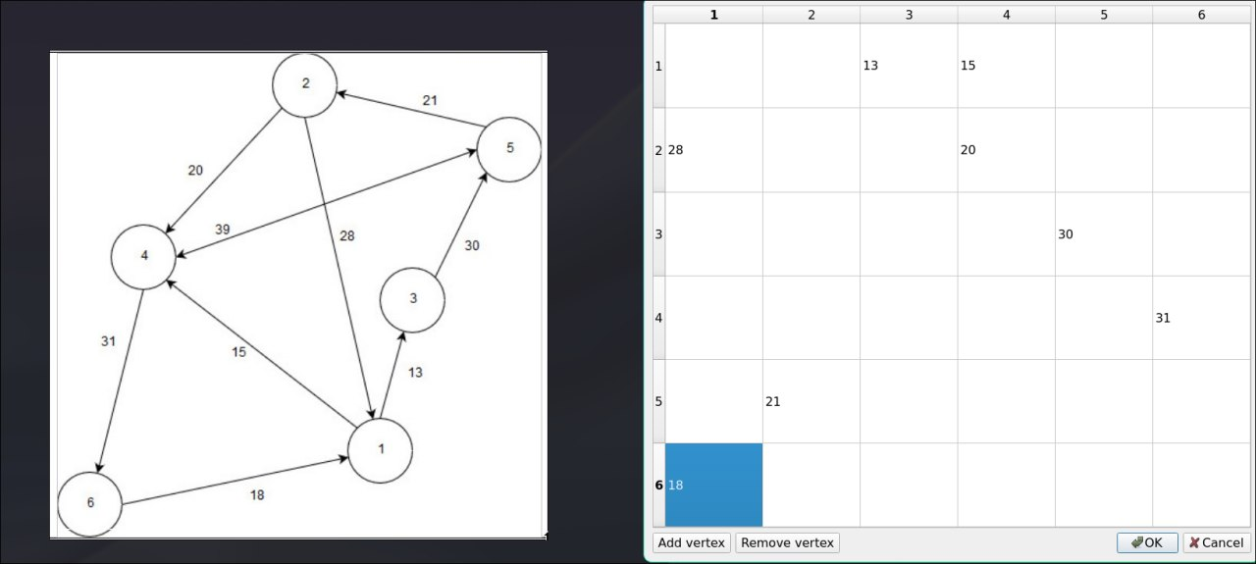
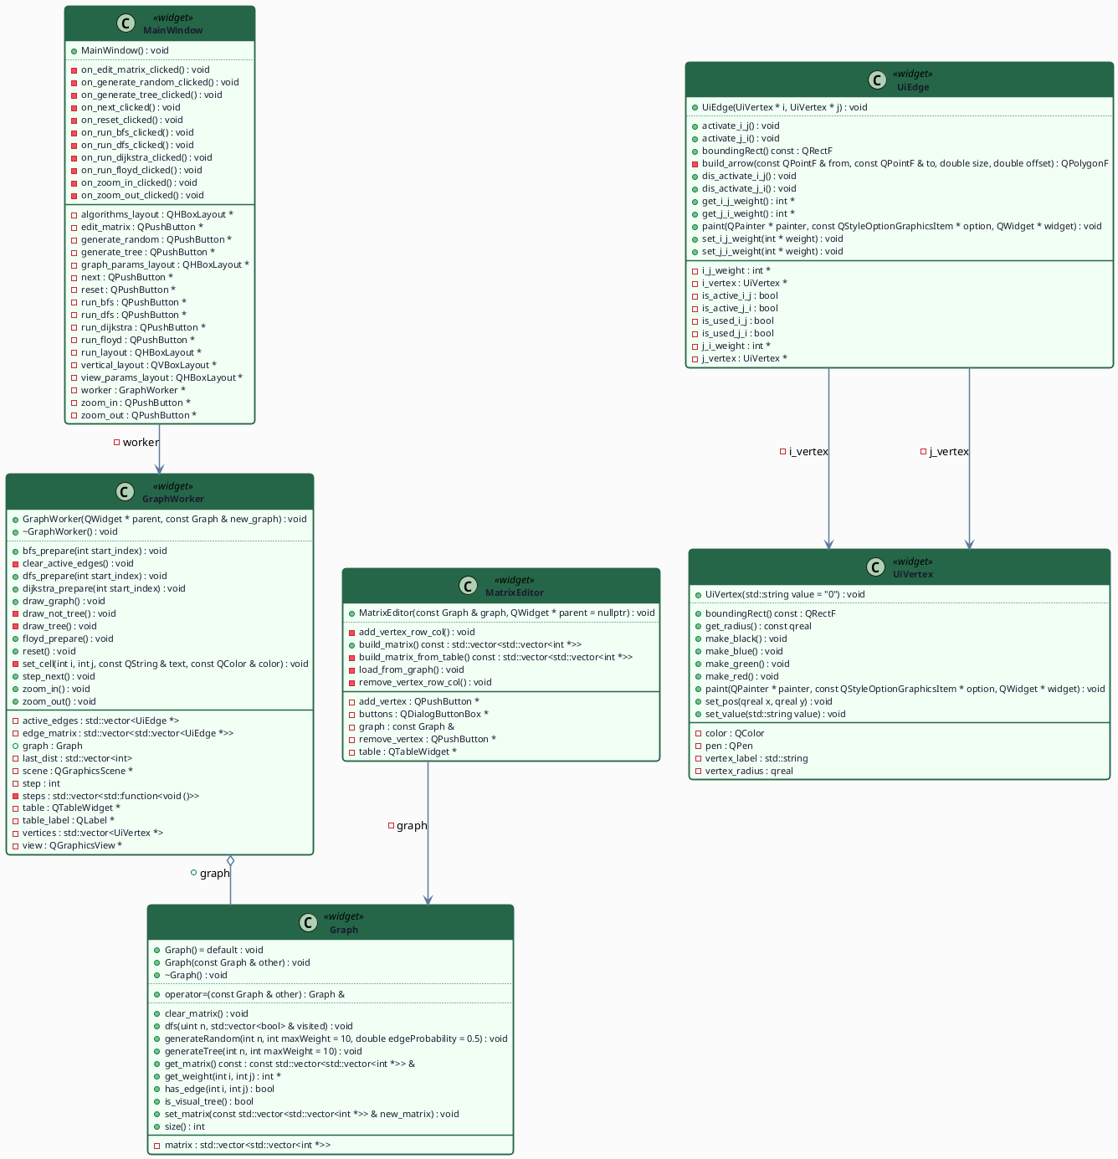
UML-ДИАГРАММА

КОД UiVertex.h
//
// Created by localuser on 5/12/26.
//
#ifndef QTGRAPHVISUALIZATION_UIVERTEX_H
#define QTGRAPHVISUALIZATION_UIVERTEX_H
#include <QGraphicsScene>
#include <QGraphicsItem>
#include <QPainter>
class UiVertex : public QGraphicsItem {
std::string vertex_label = "0";
qreal vertex_radius = 30;
QColor color = Qt::black;
QPen pen = QPen(Qt::black, 3);
public:
UiVertex(std::string value = "0");
void set_pos(qreal x, qreal y);
void set_value(std::string value);
const qreal get_radius();
void make_red();
void make_green();
void make_blue();
void make_black();
QRectF boundingRect() const override;
void paint(QPainter *painter,
const QStyleOptionGraphicsItem *option,
QWidget *widget) override;
};
#endif //QTGRAPHVISUALIZATION_UIVERTEX_H

КОД UiVertex.cpp
//
// Created by localuser on 5/12/26.
//
#include "UiVertex.h"
UiVertex::UiVertex(std::string value) {
vertex_label = value;
}
QRectF UiVertex::boundingRect() const {
return QRectF(-vertex_radius, -vertex_radius,
vertex_radius * 2,
vertex_radius * 2);
}
void UiVertex::paint(QPainter *painter,
const QStyleOptionGraphicsItem *,
QWidget *) {
painter->setPen(pen);
painter->setBrush(Qt::white);
painter->drawEllipse(boundingRect());
painter->setPen(Qt::black);
painter->drawText(boundingRect(),
Qt::AlignCenter,
QString::fromStdString(vertex_label));
}
void UiVertex::set_pos(qreal x, qreal y) {
setPos(x, y);
}
void UiVertex::set_value(std::string value) {
vertex_label = value;
update();
}
const qreal UiVertex::get_radius() {
return vertex_radius;
}
void UiVertex::make_red() {
pen = QPen(Qt::red, 5);
update();
}
void UiVertex::make_blue() {
pen = QPen(Qt::blue, 5);
update();
}
void UiVertex::make_green() {
pen = QPen(Qt::green, 3 );
update();
}
void UiVertex::make_black() {
pen = QPen(Qt::black, 3);
update();
}

КОД UiEdge.h
//
// Created by localuser on 5/12/26.
//
#ifndef QTGRAPHVISUALIZATION_UIEDGE_H
#define QTGRAPHVISUALIZATION_UIEDGE_H
#include <QGraphicsItem>
#include "UiVertex.h"
class UiEdge : public QGraphicsItem {
UiVertex *i_vertex;
UiVertex *j_vertex;
int* i_j_weight = nullptr;
int* j_i_weight = nullptr;
bool is_active_i_j = false;
bool is_active_j_i = false;
bool is_used_i_j = false;
bool is_used_j_i = false;
QPolygonF build_arrow(const QPointF &from, const QPointF &to, double size, double offset);
public:
UiEdge(UiVertex *i, UiVertex *j);
QRectF boundingRect() const override;
void paint(QPainter *painter,
const QStyleOptionGraphicsItem *option,
QWidget *widget) override;
void set_i_j_weight(int* weight);
void set_j_i_weight(int* weight);
void activate_i_j();
void dis_activate_i_j();
void activate_j_i();
void dis_activate_j_i();
int* get_i_j_weight();;
int* get_j_i_weight();;
};
#endif //QTGRAPHVISUALIZATION_UIEDGE_H

КОД UiEdge.cpp
//
// Created by localuser on 5/12/26.
//
#include "UiEdge.h"
#include "UiVertex.h"
UiEdge::UiEdge(UiVertex *i, UiVertex *j) {
i_vertex = i;
j_vertex = j;
}
QRectF UiEdge::boundingRect() const {
auto aleft = std::min(i_vertex->pos().x(), j_vertex->pos().x()) - i_vertex->get_radius();
auto atop = std::min(i_vertex->pos().y(), j_vertex->pos().y()) - i_vertex->get_radius();
auto awidth = abs(i_vertex->pos().x() - j_vertex->pos().x()) + 2 * i_vertex->get_radius();
auto aheight = abs(i_vertex->pos().y() - j_vertex->pos().y()) + 2 * i_vertex->get_radius();
return QRectF(aleft, atop,
awidth,
aheight);
}
void UiEdge::paint(QPainter *painter,
const QStyleOptionGraphicsItem *option,
QWidget *widget) {
if (i_vertex->pos() == j_vertex->pos())
return;
painter->setPen(is_active_i_j || is_active_j_i ? QPen(Qt::red, 5) : QPen(Qt::black, 3));
painter->drawLine(i_vertex->pos(), j_vertex->pos());
if (i_j_weight != nullptr) {
QPolygonF arrow = build_arrow(i_vertex->pos(), j_vertex->pos(), i_vertex->get_radius() * 2,
i_vertex->get_radius());
painter->setPen(is_active_i_j ? QPen(Qt::red, 5) : QPen(Qt::black, 3));
painter->setBrush(QBrush(Qt::white));
painter->drawPolygon(arrow);
QPointF centroid = (arrow[0] + arrow[1] + arrow[2]) / 3.0;
painter->setPen(QPen(Qt::black));
QString text = QString::number(*this->i_j_weight);
if (*i_j_weight == INT_MAX)
text = "+inf";
if (*i_j_weight == INT_MIN)
text = "-inf";
painter->drawText(
(int) (centroid.x() - 20),
(int) (centroid.y() - 10),
40, 20,
Qt::AlignCenter,
text
);
}
if (j_i_weight != nullptr) {
QPolygonF arrow = build_arrow(j_vertex->pos(), i_vertex->pos(), i_vertex->get_radius() * 2,
i_vertex->get_radius());
painter->setPen(is_active_j_i ? QPen(Qt::red, 5) : QPen(Qt::black, 3));
painter->setBrush(QBrush(Qt::white));
painter->drawPolygon(arrow);
QPointF centroid = (arrow[0] + arrow[1] + arrow[2]) / 3.0;
painter->setPen(QPen(Qt::black));
QString text = QString::number(*this->j_i_weight);
if (*j_i_weight == INT_MAX)
text = "+inf";
if (*j_i_weight == INT_MIN)
text = "-inf";
painter->drawText(
(int) (centroid.x() - 20),
(int) (centroid.y() - 10),
40, 20,
Qt::AlignCenter,
text
);
}
}
QPolygonF UiEdge::build_arrow(const QPointF &from, const QPointF &to,
double size, double offset) {
QPointF dir = to - from;
double len = std::sqrt(dir.x() * dir.x() + dir.y() * dir.y());
if (len == 0) return QPolygonF();
QPointF unit = dir / len;
QPointF perp(-unit.y(), unit.x());
double height = size * std::sqrt(3.0) / 2.0;
QPointF tip = to - unit * offset;
QPointF base1 = tip - unit * height + perp * (size / 2.0);
QPointF base2 = tip - unit * height - perp * (size / 2.0);
QPolygonF pol;
pol.resize(3);
pol[0] = tip;
pol[1] = base1;
pol[2] = base2;
return pol;
}
void UiEdge::set_i_j_weight(int *weight) {
i_j_weight = weight;
update();
}
void UiEdge::set_j_i_weight(int *weight) {
j_i_weight = weight;
update();
}
void UiEdge::activate_i_j() {
is_active_i_j = true;
update();
}
void UiEdge::dis_activate_i_j() {
is_active_i_j = false;
update();
}
void UiEdge::activate_j_i() {
is_active_j_i = true;
update();
}
void UiEdge::dis_activate_j_i() {
is_active_j_i = false;
update();
}
int *UiEdge::get_i_j_weight() { return i_j_weight; }
int *UiEdge::get_j_i_weight() { return j_i_weight; }
КОД MatrixEditor.h
//
// Created by localuser on 5/13/26.
//
#ifndef QTGRAPHVISUALIZATION_MATRIXEDITOR_H
#define QTGRAPHVISUALIZATION_MATRIXEDITOR_H
#include <QDialog>
#include <QTableWidget>
#include <QDialogButtonBox>
#include <QPushButton>
#include "Graph.h"
class MatrixEditor : public QDialog {
Q_OBJECT
const Graph &graph;
QTableWidget *table;
QPushButton *add_vertex;
QPushButton *remove_vertex;
QDialogButtonBox *buttons;
void load_from_graph();
void add_vertex_row_col();
void remove_vertex_row_col();
std::vector<std::vector<int *> > build_matrix_from_table() const;
public:
MatrixEditor(const Graph &graph, QWidget *parent = nullptr);
std::vector<std::vector<int *> > build_matrix() const;
};
#endif //QTGRAPHVISUALIZATION_MATRIXEDITOR_H

КОД MainWindow.h
//
// Created by localuser on 5/12/26.
//
#include "MainWindow.h"
#include "UiEdge.h"
MainWindow::MainWindow() : QWidget(nullptr){
vertical_layout = new QVBoxLayout(this);
Graph graph;
worker = new GraphWorker(this, graph);
worker->draw_graph();
graph_params_layout = new QHBoxLayout(nullptr);
edit_matrix = new QPushButton("Edit matrix", this);
generate_random = new QPushButton("Generate random graph", this);
generate_tree = new QPushButton("Generate tree", this);
graph_params_layout->addWidget(edit_matrix);
graph_params_layout->addWidget(generate_random);
graph_params_layout->addWidget(generate_tree);
vertical_layout->addLayout(graph_params_layout);
vertical_layout->addWidget(worker);
algorithms_layout = new QHBoxLayout;
vertical_layout->addLayout(algorithms_layout);
run_bfs = new QPushButton("BFS!", this);
run_dfs = new QPushButton("DFS!", this);
run_dijkstra = new QPushButton("Dijkstra!", this);
run_floyd = new QPushButton("Floyd!", this);
algorithms_layout->addWidget(run_bfs);
algorithms_layout->addWidget(run_dfs);
algorithms_layout->addWidget(run_dijkstra);
algorithms_layout->addWidget(run_floyd);
graph_params_layout = new QHBoxLayout;
vertical_layout->addLayout(graph_params_layout);
run_layout = new QHBoxLayout(nullptr);
reset = new QPushButton("Reset", this);
next = new QPushButton("Next step", this);
run_layout->addWidget(reset);
run_layout->addWidget(next);
vertical_layout->addLayout(run_layout);
zoom_in = new QPushButton("Zoom in", this);
zoom_out = new QPushButton("Zoom out", this);
graph_params_layout->addWidget(zoom_in);
graph_params_layout->addWidget(zoom_out);
connect(edit_matrix, &QPushButton::clicked, this, &MainWindow::on_edit_matrix_clicked);
connect(generate_random, &QPushButton::clicked, this, &MainWindow::on_generate_random_clicked);
connect(generate_tree, &QPushButton::clicked, this, &MainWindow::on_generate_tree_clicked);
connect(zoom_in, &QPushButton::clicked, this, &MainWindow::on_zoom_in_clicked);
connect(zoom_out, &QPushButton::clicked, this, &MainWindow::on_zoom_out_clicked);
connect(run_dfs, &QPushButton::clicked, this, &MainWindow::on_run_dfs_clicked);
connect(run_bfs, &QPushButton::clicked, this, &MainWindow::on_run_bfs_clicked);
connect(run_dijkstra, &QPushButton::clicked, this, &MainWindow::on_run_dijkstra_clicked);
connect(run_floyd, &QPushButton::clicked, this, &MainWindow::on_run_floyd_clicked);
connect(next, &QPushButton::clicked, this, &MainWindow::on_next_clicked);
connect(reset, &QPushButton::clicked, this, &MainWindow::on_reset_clicked);
}
void MainWindow::on_edit_matrix_clicked() {
MatrixEditor editor(worker->graph, this);
if (editor.exec() == QDialog::Accepted) {
worker->graph.set_matrix(editor.build_matrix());
worker->draw_graph();
}
}
void MainWindow::on_zoom_in_clicked() {
worker->zoom_in();
}
void MainWindow::on_zoom_out_clicked() {
worker->zoom_out();
}
void MainWindow::on_generate_tree_clicked() {
QDialog dialog(this);
dialog.setWindowTitle("Vertices amount");
auto *layout = new QVBoxLayout(&dialog);
auto *spin = new QSpinBox(&dialog);
spin->setRange(1, 50);
spin->setValue(1);
auto *buttons = new QDialogButtonBox(QDialogButtonBox::Ok | QDialogButtonBox::Cancel, &dialog);
layout->addWidget(spin);
layout->addWidget(buttons);
connect(buttons, &QDialogButtonBox::accepted, &dialog, &QDialog::accept);
connect(buttons, &QDialogButtonBox::rejected, &dialog, &QDialog::reject);
if (dialog.exec() != QDialog::Accepted) return;
worker->graph.generateTree(spin->value(), 10);
worker->draw_graph();
}
void MainWindow::on_generate_random_clicked() {
QDialog dialog(this);
dialog.setWindowTitle("Vertices amount");
auto *layout = new QVBoxLayout(&dialog);
auto *spin = new QSpinBox(&dialog);
spin->setRange(1, 50);
spin->setValue(1);
auto *buttons = new QDialogButtonBox(QDialogButtonBox::Ok | QDialogButtonBox::Cancel, &dialog);
layout->addWidget(spin);
layout->addWidget(buttons);
connect(buttons, &QDialogButtonBox::accepted, &dialog, &QDialog::accept);
connect(buttons, &QDialogButtonBox::rejected, &dialog, &QDialog::reject);
if (dialog.exec() != QDialog::Accepted) return;
worker->graph.generateRandom(spin->value(), 10, 0.3);
worker->draw_graph();
}
void MainWindow::on_run_dfs_clicked() {
int n = worker->graph.size();
if (n == 0) return;
QDialog dialog(this);
dialog.setWindowTitle("DFS start vertex");
auto *layout = new QVBoxLayout(&dialog);
auto *spin = new QSpinBox(&dialog);
spin->setRange(1, n);
spin->setValue(1);
auto *buttons = new QDialogButtonBox(QDialogButtonBox::Ok | QDialogButtonBox::Cancel, &dialog);
layout->addWidget(spin);
layout->addWidget(buttons);
connect(buttons, &QDialogButtonBox::accepted, &dialog, &QDialog::accept);
connect(buttons, &QDialogButtonBox::rejected, &dialog, &QDialog::reject);
if (dialog.exec() != QDialog::Accepted) return;
worker->reset();
worker->dfs_prepare(spin->value() - 1);
}
void MainWindow::on_run_bfs_clicked() {
int n = worker->graph.size();
if (n == 0) return;
QDialog dialog(this);
dialog.setWindowTitle("BFS start vertex");
auto *layout = new QVBoxLayout(&dialog);
auto *spin = new QSpinBox(&dialog);
spin->setRange(1, n);
spin->setValue(1);
auto *buttons = new QDialogButtonBox(QDialogButtonBox::Ok | QDialogButtonBox::Cancel, &dialog);
layout->addWidget(spin);
layout->addWidget(buttons);
connect(buttons, &QDialogButtonBox::accepted, &dialog, &QDialog::accept);
connect(buttons, &QDialogButtonBox::rejected, &dialog, &QDialog::reject);
if (dialog.exec() != QDialog::Accepted) return;
worker->reset();
worker->bfs_prepare(spin->value() - 1);
}
void MainWindow::on_run_dijkstra_clicked() {
int n = worker->graph.size();
if (n == 0) return;
QDialog dialog(this);
dialog.setWindowTitle("Dijkstra start vertex");
auto *layout = new QVBoxLayout(&dialog);
auto *spin = new QSpinBox(&dialog);
spin->setRange(1, n);
spin->setValue(1);
auto *buttons = new QDialogButtonBox(QDialogButtonBox::Ok | QDialogButtonBox::Cancel, &dialog);
layout->addWidget(spin);
layout->addWidget(buttons);
connect(buttons, &QDialogButtonBox::accepted, &dialog, &QDialog::accept);
connect(buttons, &QDialogButtonBox::rejected, &dialog, &QDialog::reject);
if (dialog.exec() != QDialog::Accepted) return;
worker->reset();
worker->dijkstra_prepare(spin->value() - 1);
}
void MainWindow::on_run_floyd_clicked() {
int n = worker->graph.size();
if (n == 0) return;
worker->reset();
worker->floyd_prepare();
}
void MainWindow::on_next_clicked() {
worker->step_next();
}
void MainWindow::on_reset_clicked() {
worker->reset();
}
КОД MainWindow.cpp
//
// Created by localuser on 5/12/26.
//
#include "MainWindow.h"
#include "UiEdge.h"
MainWindow::MainWindow() : QWidget(nullptr){
vertical_layout = new QVBoxLayout(this);
Graph graph;
worker = new GraphWorker(this, graph);
worker->draw_graph();
graph_params_layout = new QHBoxLayout(nullptr);
edit_matrix = new QPushButton("Edit matrix", this);
generate_random = new QPushButton("Generate random graph", this);
generate_tree = new QPushButton("Generate tree", this);
graph_params_layout->addWidget(edit_matrix);
graph_params_layout->addWidget(generate_random);
graph_params_layout->addWidget(generate_tree);
vertical_layout->addLayout(graph_params_layout);
vertical_layout->addWidget(worker);
algorithms_layout = new QHBoxLayout;
vertical_layout->addLayout(algorithms_layout);
run_bfs = new QPushButton("BFS!", this);
run_dfs = new QPushButton("DFS!", this);
run_dijkstra = new QPushButton("Dijkstra!", this);
run_floyd = new QPushButton("Floyd!", this);
algorithms_layout->addWidget(run_bfs);
algorithms_layout->addWidget(run_dfs);
algorithms_layout->addWidget(run_dijkstra);
algorithms_layout->addWidget(run_floyd);
graph_params_layout = new QHBoxLayout;
vertical_layout->addLayout(graph_params_layout);
run_layout = new QHBoxLayout(nullptr);
reset = new QPushButton("Reset", this);
next = new QPushButton("Next step", this);
run_layout->addWidget(reset);
run_layout->addWidget(next);
vertical_layout->addLayout(run_layout);
zoom_in = new QPushButton("Zoom in", this);
zoom_out = new QPushButton("Zoom out", this);
graph_params_layout->addWidget(zoom_in);
graph_params_layout->addWidget(zoom_out);
connect(edit_matrix, &QPushButton::clicked, this, &MainWindow::on_edit_matrix_clicked);
connect(generate_random, &QPushButton::clicked, this, &MainWindow::on_generate_random_clicked);
connect(generate_tree, &QPushButton::clicked, this, &MainWindow::on_generate_tree_clicked);
connect(zoom_in, &QPushButton::clicked, this, &MainWindow::on_zoom_in_clicked);
connect(zoom_out, &QPushButton::clicked, this, &MainWindow::on_zoom_out_clicked);
connect(run_dfs, &QPushButton::clicked, this, &MainWindow::on_run_dfs_clicked);
connect(run_bfs, &QPushButton::clicked, this, &MainWindow::on_run_bfs_clicked);
connect(run_dijkstra, &QPushButton::clicked, this, &MainWindow::on_run_dijkstra_clicked);
connect(run_floyd, &QPushButton::clicked, this, &MainWindow::on_run_floyd_clicked);
connect(next, &QPushButton::clicked, this, &MainWindow::on_next_clicked);
connect(reset, &QPushButton::clicked, this, &MainWindow::on_reset_clicked);
}
void MainWindow::on_edit_matrix_clicked() {
MatrixEditor editor(worker->graph, this);
if (editor.exec() == QDialog::Accepted) {
worker->graph.set_matrix(editor.build_matrix());
worker->draw_graph();
}
}
void MainWindow::on_zoom_in_clicked() {
worker->zoom_in();
}
void MainWindow::on_zoom_out_clicked() {
worker->zoom_out();
}
void MainWindow::on_generate_tree_clicked() {
QDialog dialog(this);
dialog.setWindowTitle("Vertices amount");
auto *layout = new QVBoxLayout(&dialog);
auto *spin = new QSpinBox(&dialog);
spin->setRange(1, 50);
spin->setValue(1);
auto *buttons = new QDialogButtonBox(QDialogButtonBox::Ok | QDialogButtonBox::Cancel, &dialog);
layout->addWidget(spin);
layout->addWidget(buttons);
connect(buttons, &QDialogButtonBox::accepted, &dialog, &QDialog::accept);
connect(buttons, &QDialogButtonBox::rejected, &dialog, &QDialog::reject);
if (dialog.exec() != QDialog::Accepted) return;
worker->graph.generateTree(spin->value(), 10);
worker->draw_graph();
}
void MainWindow::on_generate_random_clicked() {
QDialog dialog(this);
dialog.setWindowTitle("Vertices amount");
auto *layout = new QVBoxLayout(&dialog);
auto *spin = new QSpinBox(&dialog);
spin->setRange(1, 50);
spin->setValue(1);
auto *buttons = new QDialogButtonBox(QDialogButtonBox::Ok | QDialogButtonBox::Cancel, &dialog);
layout->addWidget(spin);
layout->addWidget(buttons);
connect(buttons, &QDialogButtonBox::accepted, &dialog, &QDialog::accept);
connect(buttons, &QDialogButtonBox::rejected, &dialog, &QDialog::reject);
if (dialog.exec() != QDialog::Accepted) return;
worker->graph.generateRandom(spin->value(), 10, 0.3);
worker->draw_graph();
}
void MainWindow::on_run_dfs_clicked() {
int n = worker->graph.size();
if (n == 0) return;
QDialog dialog(this);
dialog.setWindowTitle("DFS start vertex");
auto *layout = new QVBoxLayout(&dialog);
auto *spin = new QSpinBox(&dialog);
spin->setRange(1, n);
spin->setValue(1);
auto *buttons = new QDialogButtonBox(QDialogButtonBox::Ok | QDialogButtonBox::Cancel, &dialog);
layout->addWidget(spin);
layout->addWidget(buttons);
connect(buttons, &QDialogButtonBox::accepted, &dialog, &QDialog::accept);
connect(buttons, &QDialogButtonBox::rejected, &dialog, &QDialog::reject);
if (dialog.exec() != QDialog::Accepted) return;
worker->reset();
worker->dfs_prepare(spin->value() - 1);
}
void MainWindow::on_run_bfs_clicked() {
int n = worker->graph.size();
if (n == 0) return;
QDialog dialog(this);
dialog.setWindowTitle("BFS start vertex");
auto *layout = new QVBoxLayout(&dialog);
auto *spin = new QSpinBox(&dialog);
spin->setRange(1, n);
spin->setValue(1);
auto *buttons = new QDialogButtonBox(QDialogButtonBox::Ok | QDialogButtonBox::Cancel, &dialog);
layout->addWidget(spin);
layout->addWidget(buttons);
connect(buttons, &QDialogButtonBox::accepted, &dialog, &QDialog::accept);
connect(buttons, &QDialogButtonBox::rejected, &dialog, &QDialog::reject);
if (dialog.exec() != QDialog::Accepted) return;
worker->reset();
worker->bfs_prepare(spin->value() - 1);
}
void MainWindow::on_run_dijkstra_clicked() {
int n = worker->graph.size();
if (n == 0) return;
QDialog dialog(this);
dialog.setWindowTitle("Dijkstra start vertex");
auto *layout = new QVBoxLayout(&dialog);
auto *spin = new QSpinBox(&dialog);
spin->setRange(1, n);
spin->setValue(1);
auto *buttons = new QDialogButtonBox(QDialogButtonBox::Ok | QDialogButtonBox::Cancel, &dialog);
layout->addWidget(spin);
layout->addWidget(buttons);
connect(buttons, &QDialogButtonBox::accepted, &dialog, &QDialog::accept);
connect(buttons, &QDialogButtonBox::rejected, &dialog, &QDialog::reject);
if (dialog.exec() != QDialog::Accepted) return;
worker->reset();
worker->dijkstra_prepare(spin->value() - 1);
}
void MainWindow::on_run_floyd_clicked() {
int n = worker->graph.size();
if (n == 0) return;
worker->reset();
worker->floyd_prepare();
}
void MainWindow::on_next_clicked() {
worker->step_next();
}
void MainWindow::on_reset_clicked() {
worker->reset();
}
КОД main.cpp
#include <QApplication>
#include <QPushButton>
#include "MainWindow.h"
int main(int argc, char* argv[]) {
QApplication a(argc, argv);
MainWindow window;
window.show();
return QApplication::exec();
}
КОД GraphWorker.h
//
// Created by localuser on 5/12/26.
//
#ifndef QTGRAPHVISUALIZATION_GRAPHWORKER_H
#define QTGRAPHVISUALIZATION_GRAPHWORKER_H
#include <QGraphicsView>
#include <QTableWidget>
#include <QLabel>
#include <QWidget>
#include <vector>
#include "UiVertex.h"
#include "UiEdge.h"
#include "Graph.h"
class GraphWorker : public QWidget {
Q_OBJECT
std::vector<UiVertex*> vertices;
std::vector<std::vector<UiEdge*> > edge_matrix;
std::vector<std::function<void()>> steps;
int step = 0;
std::vector<int> last_dist;
std::vector<UiEdge*> active_edges;
QGraphicsScene *scene;
QGraphicsView *view;
QTableWidget* table;
QLabel* table_label;
void draw_tree();
void draw_not_tree();
void clear_active_edges();
void set_cell(int i, int j, const QString& text, const QColor& color);
public:
GraphWorker(QWidget* parent, const Graph& new_graph);
~GraphWorker();
Graph graph;
void draw_graph();
void zoom_in();
void zoom_out();
void dfs_prepare(int start_index);
void step_next();
void reset();
void bfs_prepare(int start_index);
void dijkstra_prepare(int start_index);
void floyd_prepare();
};
#endif //QTGRAPHVISUALIZATION_GRAPHWORKER_H

КОД GraphWorker.cpp
//
// Created by localuser on 5/12/26.
//
#include "GraphWorker.h"
#include <QGraphicsView>
#include <QVBoxLayout>
#include <cmath>
void assign_tree_positions(int v,
int depth,
const std::vector<std::vector<int> > &children,
std::vector<double> &x_pos,
std::vector<double> &y_pos,
int &leaf_counter,
double h_step,
double v_step) {
y_pos[v] = depth * v_step + 60.0;
if (children[v].empty()) {
x_pos[v] = leaf_counter * h_step + 60.0;
leaf_counter++;
return;
}
for (int c: children[v])
assign_tree_positions(c, depth + 1, children, x_pos, y_pos, leaf_counter, h_step, v_step);
x_pos[v] = (x_pos[children[v].front()] + x_pos[children[v].back()]) / 2.0;
}
void GraphWorker::clear_active_edges() {
for (auto *edge: active_edges) {
if (!edge) continue;
edge->dis_activate_i_j();
edge->dis_activate_j_i();
edge->update();
}
active_edges.clear();
}
void GraphWorker::draw_tree() {
scene->clear();
vertices.clear();
edge_matrix.clear();
int n = graph.size();
if (n == 0) return;
std::vector<int> in_degree(n, 0);
for (int i = 0; i < n; i++)
for (int j = 0; j < n; j++)
if (i != j && graph.has_edge(i, j))
in_degree[j]++;
int root = 0;
for (int i = 0; i < n; i++)
if (in_degree[i] == 0) {
root = i;
break;
}
std::vector<std::vector<int> > children(n);
std::vector<bool> used(n, false);
std::queue<int> q;
q.push(root);
used[root] = true;
while (!q.empty()) {
int cur = q.front();
q.pop();
for (int next = 0; next < n; next++) {
if (!used[next] && graph.has_edge(cur, next)) {
used[next] = true;
children[cur].push_back(next);
q.push(next);
}
}
}
const double H_STEP = 200.0;
const double V_STEP = 200.0;
std::vector<double> x_pos(n, 0.0);
std::vector<double> y_pos(n, 0.0);
int leaf_counter = 0;
assign_tree_positions(root, 0, children, x_pos, y_pos, leaf_counter, H_STEP, V_STEP);
double min_x = x_pos[0];
double max_x = x_pos[0];
double min_y = y_pos[0];
double max_y = y_pos[0];
for (int i = 1; i < n; i++) {
min_x = std::min(min_x, x_pos[i]);
max_x = std::max(max_x, x_pos[i]);
min_y = std::min(min_y, y_pos[i]);
max_y = std::max(max_y, y_pos[i]);
}
QPointF center = view->mapToScene(view->viewport()->rect().center());
double shift_x = center.x() - (min_x + max_x) / 2.0;
double shift_y = center.y() - (min_y + max_y) / 2.0;
for (int i = 0; i < n; i++) {
auto *v = new UiVertex(std::to_string(i + 1));
v->set_pos(x_pos[i] + shift_x, y_pos[i] + shift_y);
vertices.push_back(v);
}
edge_matrix.assign(n, std::vector<UiEdge *>(n, nullptr));
for (int i = 0; i < n; i++) {
for (int j = i + 1; j < n; j++) {
if (graph.has_edge(i, j) || graph.has_edge(j, i)) {
auto *e = new UiEdge(vertices[i], vertices[j]);
if (graph.has_edge(i, j)) {
e->set_i_j_weight(graph.get_weight(i, j));
edge_matrix[i][j] = e;
}
if (graph.has_edge(j, i)) {
e->set_j_i_weight(graph.get_weight(j, i));
edge_matrix[j][i] = e;
}
}
}
}
for (auto v: edge_matrix)
for (auto ui_edge: v)
if (ui_edge != nullptr)
scene->addItem(ui_edge);
for (auto vertex: vertices) scene->addItem(vertex);
}
void GraphWorker::draw_not_tree() {
scene->clear();
vertices.clear();
edge_matrix.clear();
int n = graph.size();
if (n == 0) return;
const double radius = 500.0;
const double step = 2.0 * M_PI / n;
QPointF center = view->mapToScene(view->viewport()->rect().center());
for (int i = 0; i < n; i++) {
double angle = step * i;
double x = center.x() + radius * std::cos(angle);
double y = center.y() + radius * std::sin(angle);
auto *v = new UiVertex(std::to_string(i + 1));
v->set_pos(x, y);
vertices.push_back(v);
}
edge_matrix.assign(n, std::vector<UiEdge *>(n, nullptr));
for (int i = 0; i < n; i++) {
for (int j = i + 1; j < n; j++) {
if (graph.has_edge(i, j) || graph.has_edge(j, i)) {
auto *e = new UiEdge(vertices[i], vertices[j]);
if (graph.has_edge(i, j)) {
e->set_i_j_weight(graph.get_weight(i, j));
edge_matrix[i][j] = e;
}
if (graph.has_edge(j, i)) {
e->set_j_i_weight(graph.get_weight(j, i));
edge_matrix[j][i] = e;
}
}
}
}
for (auto v: edge_matrix)
for (auto ui_edge: v)
if (ui_edge != nullptr)
scene->addItem(ui_edge);
for (auto vertex: vertices) scene->addItem(vertex);
}
GraphWorker::GraphWorker(QWidget *parent, const Graph &new_graph) : QWidget(parent) {
table = new QTableWidget(this);
table->hide();
table->setMaximumHeight(200);
table_label = new QLabel(this);
table_label->hide();
scene = new QGraphicsScene(this);
view = new QGraphicsView(scene, this);
graph = new_graph;
view->setRenderHint(QPainter::Antialiasing);
view->setSizePolicy(QSizePolicy::Expanding, QSizePolicy::Expanding);
view->setTransformationAnchor(QGraphicsView::AnchorUnderMouse);
view->setInteractive(true);
view->setDragMode(QGraphicsView::ScrollHandDrag);
QVBoxLayout *layout = new QVBoxLayout(this);
layout->setContentsMargins(0, 0, 0, 0);
layout->addWidget(view);
layout->addWidget(table_label);
layout->addWidget(table);
setLayout(layout);
setSizePolicy(QSizePolicy::Expanding, QSizePolicy::Expanding);
}
GraphWorker::~GraphWorker() {
for (auto *v: vertices) delete v;
for (auto v: edge_matrix)
for (auto ui_edge: v)
if (ui_edge != nullptr)
delete ui_edge;
}
void GraphWorker::zoom_in() {
view->setTransformationAnchor(QGraphicsView::AnchorViewCenter);
view->scale(1.2, 1.2);
}
void GraphWorker::zoom_out() {
view->setTransformationAnchor(QGraphicsView::AnchorViewCenter);
view->scale(1.0 / 1.2, 1.0 / 1.2);
}
void GraphWorker::draw_graph() {
if (graph.is_visual_tree()) {
draw_tree();
return;
}
draw_not_tree();
}
void GraphWorker::dfs_prepare(int start_index) {
steps.clear();
step = 0;
int n = graph.size();
std::vector<bool> used(n, false);
std::function<void(int, int)> dfs = [&](int node, int prev) {
used[node] = true;
steps.push_back([this, node, prev]() {
vertices[prev]->make_blue();
vertices[node]->make_red();
auto edge = edge_matrix[prev][node];
if (edge) {
if (node < prev)
edge->dis_activate_j_i();
else if (node > prev)
edge->dis_activate_i_j();
}
});
for (int j = 0; j < n; j++) {
if (graph.has_edge(node, j) && !used[j]) {
steps.push_back([this, node, j]() {
UiEdge *edge = edge_matrix[node][j];
if (node < j)
edge->activate_i_j();
else
edge->activate_j_i();
});
dfs(j, node);
steps.push_back([this, node, j]() {
vertices[node]->make_red();
vertices[j]->make_blue();
});
}
}
};
dfs(start_index, start_index);
}
void GraphWorker::step_next() {
if (step >= static_cast<int>(steps.size())) return;
steps[step]();
step++;
qDebug() << step;
}
void GraphWorker::reset() {
steps.clear();
step = 0;
clear_active_edges();
for (int i = 0; i < static_cast<int>(vertices.size()); i++) {
vertices[i]->make_black();
vertices[i]->set_value(std::to_string(i + 1));
vertices[i]->update();
}
for (auto v: edge_matrix)
for (auto ui_edge: v)
if (ui_edge != nullptr) {
ui_edge->dis_activate_i_j();
ui_edge->dis_activate_j_i();
ui_edge->update();
}
table->hide();
table_label->hide();
}
void GraphWorker::bfs_prepare(int start_index) {
steps.clear();
step = 0;
int n = graph.size();
std::vector<bool> used(n, false);
std::queue<int> q;
used[start_index] = true;
q.push(start_index);
while (!q.empty()) {
int node = q.front();
q.pop();
for (int j = 0; j < n; j++) {
if (graph.has_edge(node, j) && !used[j]) {
used[j] = true;
q.push(j);
steps.push_back([this, node]() {
vertices[node]->make_red();
});
steps.push_back([this, node, j]() {
auto edge = edge_matrix[node][j];
if (edge)
node < j ? edge->activate_i_j() : edge->activate_j_i();
});
steps.push_back([this, node, j]() {
vertices[node]->make_blue();
auto edge = edge_matrix[node][j];
if (edge)
node < j ? edge->dis_activate_i_j() : edge->dis_activate_j_i();
vertices[j]->make_red();
});
steps.push_back([this, j]() {
vertices[j]->make_blue();
});
}
}
}
}
void GraphWorker::dijkstra_prepare(int start_index) {
steps.clear();
step = 0;
int n = graph.size();
std::vector<bool> used(n, false);
std::vector<int> d(n, INT_MAX);
d[start_index] = 0;
for (int i = 0; i < n; i++)
vertices[i]->set_value(std::to_string(i + 1) + "\n+inf");
vertices[start_index]->set_value(std::to_string(start_index + 1) + "\n0");
for (int i = 0; i < n; i++) {
int v = -1;
for (int j = 0; j < n; j++)
if (!used[j] && (v == -1 || d[j] < d[v]))
v = j;
if (v == -1 || d[v] == INT_MAX) break;
used[v] = true;
steps.push_back([this, v]() {
vertices[v]->make_red();
});
for (int e = 0; e < n; e++) {
auto weight = graph.get_matrix()[v][e];
if (weight == nullptr) continue;
if (d[v] + *weight >= d[e]) continue;
d[e] = d[v] + *weight;
int new_dist = d[e];
std::string new_val = std::to_string(e + 1) + "\n" + std::to_string(new_dist);
steps.push_back([this, v, e, new_val]() {
auto *edge = edge_matrix[v][e];
if (edge)
v < e ? edge->activate_i_j() : edge->activate_j_i();
vertices[e]->make_green();
vertices[e]->set_value(new_val);
});
steps.push_back([this, v, e]() {
auto *edge = edge_matrix[v][e];
if (edge)
v < e ? edge->dis_activate_i_j() : edge->dis_activate_j_i();
vertices[e]->make_black();
});
}
steps.push_back([this, v]() {
vertices[v]->make_blue();
});
}
}
void GraphWorker::set_cell(int i, int j, const QString &text, const QColor &color) {
auto *item = table->item(i, j);
if (!item) {
item = new QTableWidgetItem();
table->setItem(i, j, item);
}
item->setText(text);
item->setBackground(color);
item->setTextAlignment(Qt::AlignCenter);
}
void GraphWorker::floyd_prepare() {
steps.clear();
step = 0;
int n = graph.size();
table->show();
table_label->show();
table->setRowCount(n);
table->setColumnCount(n);
for (int i = 0; i < n; i++) {
table->setHorizontalHeaderItem(i, new QTableWidgetItem(QString::number(i + 1)));
table->setVerticalHeaderItem(i, new QTableWidgetItem(QString::number(i + 1)));
table->setColumnWidth(i, 50);
table->setRowHeight(i, 30);
}
std::vector<std::vector<int> > d(n, std::vector<int>(n, INT_MAX));
for (int i = 0; i < n; i++) d[i][i] = 0;
for (int i = 0; i < n; i++)
for (int j = 0; j < n; j++)
if (graph.get_matrix()[i][j] != nullptr)
d[i][j] = *graph.get_matrix()[i][j];
table_label->setText("Initial stage");
for (int i = 0; i < n; i++)
for (int j = 0; j < n; j++) {
QString val = d[i][j] == INT_MAX ? "+inf" : QString::number(d[i][j]);
set_cell(i, j, val, Qt::white);
}
for (int k = 0; k < n; k++) {
steps.push_back([this, k, d, n]() {
table_label->setText(QString("Throw: %1").arg(k + 1));
for (int i = 0; i < n; i++)
for (int j = 0; j < n; j++) {
QString val = d[i][j] == INT_MAX ? "+inf" : QString::number(d[i][j]);
QColor color = (i == k || j == k) ? QColor(200, 200, 255) : Qt::white;
set_cell(i, j, val, color);
}
for (auto *v: vertices) v->make_black();
vertices[k]->make_blue();
});
for (int i = 0; i < n; i++) {
for (int j = 0; j < n; j++) {
if (d[i][k] == INT_MAX || d[k][j] == INT_MAX) continue;
if (d[i][k] + d[k][j] >= d[i][j]) continue;
d[i][j] = d[i][k] + d[k][j];
int new_dist = d[i][j];
steps.push_back([this, i, j, k, d, n, new_dist]() {
table_label->setText(QString("d[%1][%2] throw %3 = %4")
.arg(i + 1).arg(j + 1).arg(k + 1).arg(new_dist));
for (int a = 0; a < n; a++)
for (int b = 0; b < n; b++) {
QString val = d[a][b] == INT_MAX ? "+inf" : QString::number(d[a][b]);
QColor color = (a == k || b == k) ? QColor(200, 200, 255) : Qt::white;
set_cell(a, b, val, color);
}
for (int b = 0; b < n; b++)
table->item(i, b)->setBackground(QColor(255, 180, 180));
for (int a = 0; a < n; a++)
table->item(a, j)->setBackground(QColor(255, 255, 180));
for (int a = 0; a < n; a++) {
table->item(a, k)->setBackground(QColor(200, 200, 255));
table->item(k, a)->setBackground(QColor(200, 200, 255));
}
set_cell(i, j, QString::number(new_dist), QColor(180, 255, 180));
for (auto *v: vertices) v->make_black();
vertices[k]->make_blue();
vertices[i]->make_red();
vertices[j]->make_green();
});
}
}
}
steps.push_back([this, d, n]() {
table_label->setText("The end");
for (int i = 0; i < n; i++)
for (int j = 0; j < n; j++) {
QString val = d[i][j] == INT_MAX ? "+inf" : QString::number(d[i][j]);
set_cell(i, j, val, QColor(220, 255, 220));
}
for (auto *v: vertices) v->make_black();
});
}
КОД Graph.h
//
// Created by localuser on 5/13/26.
//
#include "MatrixEditor.h"
#include <QHeaderView>
#include <QVBoxLayout>
#include <QHBoxLayout>
MatrixEditor::MatrixEditor(const Graph &graph, QWidget *parent)
: QDialog(parent), graph(graph) {
setWindowTitle("Edit matrix");
table = new QTableWidget(this);
table->setEditTriggers(QAbstractItemView::DoubleClicked
| QAbstractItemView::SelectedClicked
| QAbstractItemView::EditKeyPressed);
table->horizontalHeader()->setSectionResizeMode(QHeaderView::Stretch);
table->verticalHeader()->setSectionResizeMode(QHeaderView::Stretch);
add_vertex = new QPushButton("Add vertex", this);
remove_vertex = new QPushButton("Remove vertex", this);
buttons = new QDialogButtonBox(QDialogButtonBox::Ok | QDialogButtonBox::Cancel, this);
auto *buttons_layout = new QHBoxLayout;
buttons_layout->addWidget(add_vertex);
buttons_layout->addWidget(remove_vertex);
buttons_layout->addWidget(buttons);
auto *main_layout = new QVBoxLayout(this);
main_layout->addWidget(table);
main_layout->addLayout(buttons_layout);
setLayout(main_layout);
load_from_graph();
connect(add_vertex, &QPushButton::clicked, this, &MatrixEditor::add_vertex_row_col);
connect(remove_vertex, &QPushButton::clicked, this, &MatrixEditor::remove_vertex_row_col);
connect(buttons, &QDialogButtonBox::accepted, this, &QDialog::accept);
connect(buttons, &QDialogButtonBox::rejected, this, &QDialog::reject);
}
void MatrixEditor::load_from_graph() {
const auto &matrix = graph.get_matrix();
int n = matrix.size();
table->setRowCount(n);
table->setColumnCount(n);
for (int i = 0; i < n; i++) {
for (int j = 0; j < n; j++) {
if (matrix[i][j] == nullptr) {
table->setItem(i, j, new QTableWidgetItem(""));
} else {
table->setItem(i, j, new QTableWidgetItem(QString::number(*matrix[i][j])));
}
}
}
}
std::vector<std::vector<int *> > MatrixEditor::build_matrix_from_table() const {
int n = table->rowCount();
std::vector<std::vector<int *> > matrix(n, std::vector<int *>(n, nullptr));
for (int i = 0; i < n; i++) {
for (int j = 0; j < n; j++) {
QTableWidgetItem *item = table->item(i, j);
if (!item) continue;
QString text = item->text().trimmed();
if (text.isEmpty()) continue;
bool ok = false;
int value = text.toInt(&ok);
if (!ok) continue;
matrix[i][j] = new int(value);
}
}
return matrix;
}
void MatrixEditor::add_vertex_row_col() {
int n = table->rowCount();
table->setRowCount(n + 1);
table->setColumnCount(n + 1);
for (int i = 0; i < n + 1; i++) {
for (int j = 0; j < n + 1; j++) {
if (table->item(i, j)) continue;
table->setItem(i, j, new QTableWidgetItem(""));
}
}
}
void MatrixEditor::remove_vertex_row_col() {
int n = table->rowCount();
table->setRowCount(n - 1);
table->setColumnCount(n - 1);
for (int i = 0; i < n - 1; i++) {
for (int j = 0; j < n - 1; j++) {
if (table->item(i, j)) continue;
table->setItem(i, j, new QTableWidgetItem(""));
}
}
}
std::vector<std::vector<int *> > MatrixEditor::build_matrix() const {
return build_matrix_from_table();
}
КОД MatrixEditor.cpp
//
// Created by localuser on 5/12/26.
//
#ifndef QTGRAPHVISUALIZATION_GRAPH_H
#define QTGRAPHVISUALIZATION_GRAPH_H
#include <cstdlib>
#include <queue>
#include <vector>
class Graph {
std::vector<std::vector<int *> > matrix;
public:
Graph() = default;
Graph(const Graph &other);
~Graph();
Graph &operator=(const Graph &other);
void clear_matrix();
const std::vector<std::vector<int *> > &get_matrix() const;
void set_matrix(const std::vector<std::vector<int *> > &new_matrix);
bool is_visual_tree();
void generateRandom(int n, int maxWeight = 10, double edgeProbability = 0.5);
void generateTree(int n, int maxWeight = 10);
int size();
bool has_edge(int i, int j);
int *get_weight(int i, int j);
void dfs(uint n, std::vector<bool>& visited);
};
#endif //QTGRAPHVISUALIZATION_GRAPH_H
КОД Graph.cpp
#include "Graph.h"
#include <random>
static std::mt19937 rng(std::random_device{}());
Graph::Graph(const Graph &other) {
set_matrix(other.matrix);
}
Graph::~Graph() {
clear_matrix();
}
void Graph::clear_matrix() {
for (int i = 0; i < matrix.size(); i++)
for (int j = 0; j < matrix[i].size(); j++)
if (matrix[i][j] != nullptr)
delete matrix[i][j];
matrix.clear();
}
Graph &Graph::operator=(const Graph &other) {
if (this == &other)
return *this;
set_matrix(other.matrix);
return *this;
}
const std::vector<std::vector<int *> > &Graph::get_matrix() const {
return matrix;
}
void Graph::set_matrix(const std::vector<std::vector<int *> > &new_matrix) {
clear_matrix();
matrix.resize(new_matrix.size());
for (int i = 0; i < new_matrix.size(); i++)
for (int j = 0; j < new_matrix[i].size(); j++)
if (new_matrix[i][j] == nullptr)
matrix[i].push_back(nullptr);
else
matrix[i].push_back(new int(*new_matrix[i][j]));
}
bool Graph::is_visual_tree() {
int n = matrix.size();
if (n == 0) return false;
int edgeCount = 0;
for (int i = 0; i < n; i++)
for (int j = i + 1; j < n; j++)
if (matrix[i][j] != nullptr || matrix[j][i] != nullptr)
edgeCount++;
if (edgeCount != n - 1) return false;
std::vector<bool> visited(n, false);
std::queue<int> q;
q.push(0);
visited[0] = true;
int visitedCount = 1;
while (!q.empty()) {
int cur = q.front();
q.pop();
for (int next = 0; next < n; next++) {
if (!visited[next] &&
(matrix[cur][next] != nullptr || matrix[next][cur] != nullptr)) {
visited[next] = true;
visitedCount++;
q.push(next);
}
}
}
return visitedCount == n;
}
void Graph::generateRandom(int n, int maxWeight, double edgeProbability) {
for (auto &row: matrix)
for (auto *p: row)
delete p;
matrix.assign(n, std::vector<int *>(n, nullptr));
for (int i = 0; i < n; i++) {
for (int j = 0; j < n; j++) {
if (i == j) continue;
std::bernoulli_distribution edge_dist(edgeProbability);
if (edge_dist(rng)) {
std::uniform_int_distribution<int> weight_dist(1, maxWeight);
matrix[i][j] = new int(weight_dist(rng));
}
}
}
}
void Graph::generateTree(int n, int maxWeight) {
for (auto &row: matrix)
for (auto *p: row)
delete p;
matrix.assign(n, std::vector<int *>(n, nullptr));
std::vector<int> perm(n);
for (int i = 0; i < n; i++) perm[i] = i;
for (int i = n - 1; i > 0; i--) {
std::uniform_int_distribution<int> idx_dist(0, i);
int j = idx_dist(rng);
std::swap(perm[i], perm[j]);
}
for (int i = 1; i < n; i++) {
int parent = perm[std::rand() % i];
int child = perm[i];
std::uniform_int_distribution<int> weight_dist(1, maxWeight);
matrix[parent][child] = new int(weight_dist(rng));
}
}
int Graph::size() {
return matrix.size();
}
bool Graph::has_edge(int i, int j) {
return matrix[i][j];
}
int *Graph::get_weight(int i, int j) {
return matrix[i][j];
}
void Graph::dfs(uint n, std::vector<bool> &visited) {
visited[n] = true;
for (auto& i : matrix[n]) {
if (i != nullptr && !visited[*i]) {
dfs(*i, visited);
}
}
}

РЕЗУЛЬТАТ ВЫПОЛНЕНИЯ
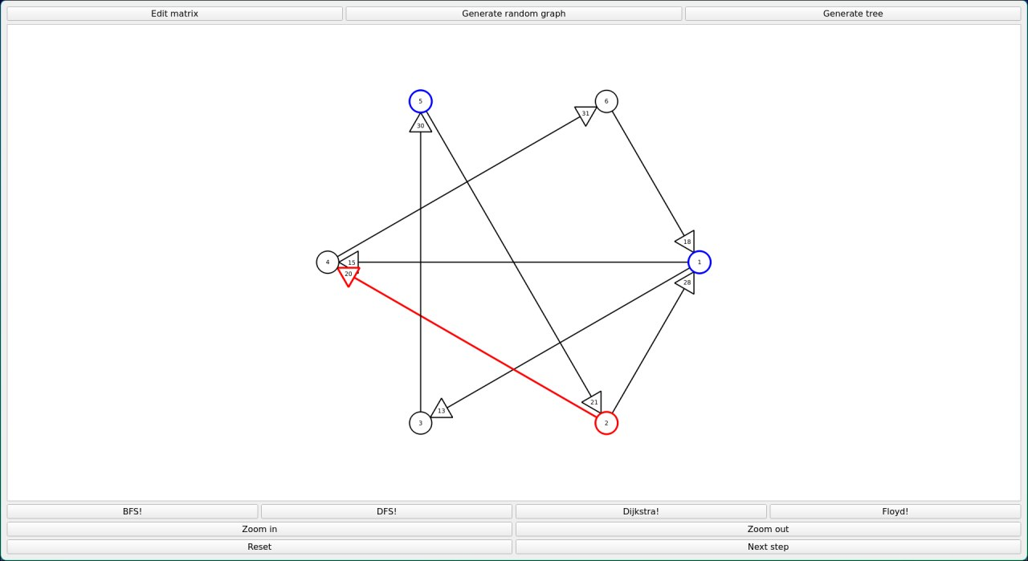
BFS. Путь: 5→2→1, вернулись в 2→4. Синим помечены used vertex, красным – текущий шаг.
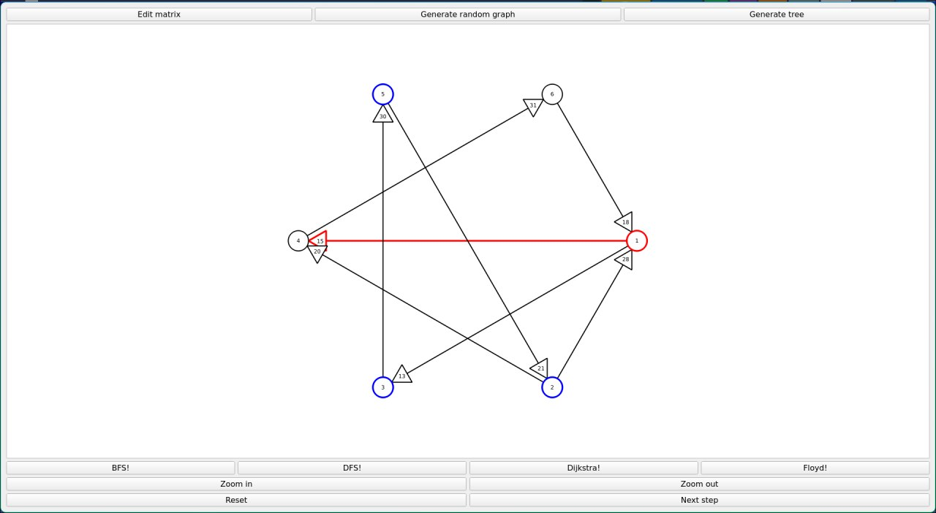
DFS: 5→2→1→3, вернулись 1→4
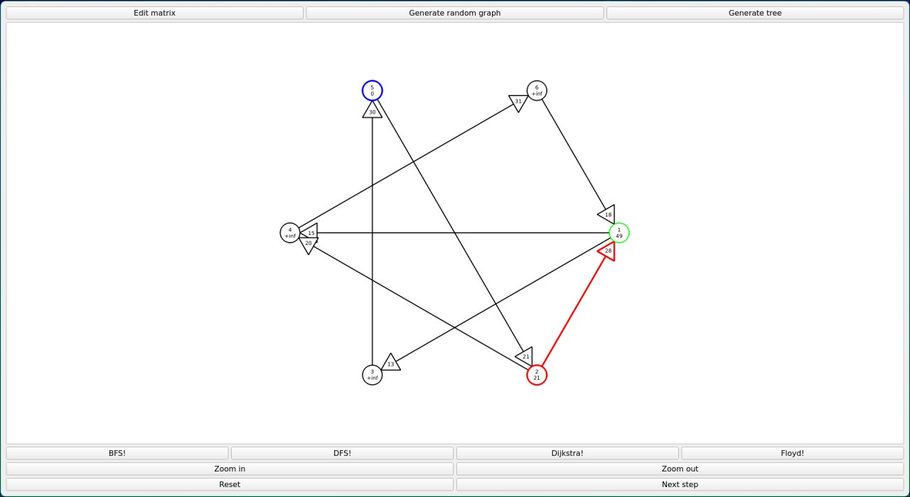
Dijkstra: 5→2→1
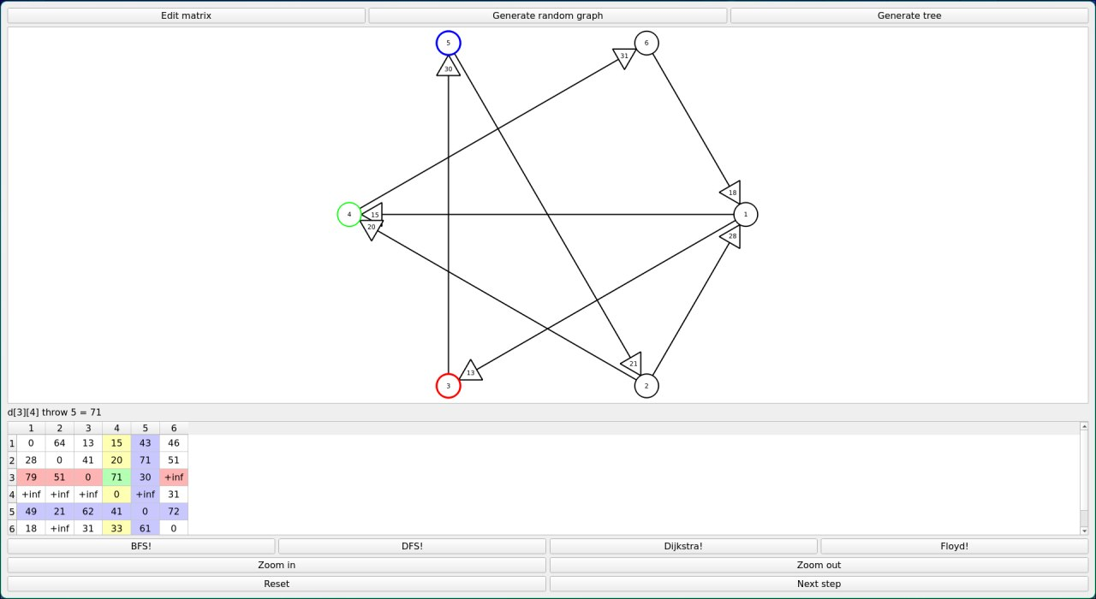
Floyd: Синим помечена 5-я vertex THROW, красным – 3 FROM, желтым – 4 TO. Новое значение [3][4] = сумме клеток, лежащих на пересечении красной+синей линии и желтой+синей.

