ProP  
system for organizing a social event

Setup Document

Course: ProP

Date: 27 February 2015

Group : D

Group Name: ProShots

Students: Ilia Nikushev **[321166]**

Georgi Chishirkov **[319354]**

Mikael Shaghelani Lor **[315860]** Angel Doychinov **[2507579]**

Table of Contents

Preface 4

Client 4

Processes 4

Before the event 4

During the event 5

After the event 6

Functional requirements 6

Internet 6

Software 6

Windows 6

.NET Framework 4.5+ 6

Internet browser 6

Hardware 6

Able to run Windows machine 6

User Interface 7

Website 7

Applications 10

Visitor 10

Book a tent 10

New 10

Manage/View 10

Purchase 10

New 10

View 11

Appointment 11

New 11

View 11

Rent 11

New 11

View 11

History 11

Employee 11

For renting 11

PC Doctor 11

Cashier 11

Administrator 11

Visitors 12

Balance 12

Warnings 12

Shops 12

Employees 12

PC-Doctor 12

Calendar 12

Rent Desk 12

# Preface

Client:   
Brief description of the client and the agreements with the client

Processes  
Description of all the processes every employee and visitor will go through before during and after the event and all the specific exceptional cases that might occur during the time.

Functional requirements  
An overview of all requirements grouped by application and the MoSCoW.

User Interface  
Brief description of the user interface.

# Client

The formal client of this project is Mr. Johnson, he can be contacted at his Facebook page: http://on.fb.me/1aGAgSH or at this email address - rj.johnson@thusj.nl. He is a self-employed owner of a company in charge of organising events and festivals. The main agreements reached with him are – every condition needed to realise our product (e.g. electricity and Wi-Fi) will be present, hardware for the entrances, shops and camping spots will also be present, we will have from Monday to Thursday the week before the event to realise our part, no fixed list or menus will be provided by him for the food stands, no particular application or website requests from sponsors have been made, the only request in relation to the website design is that it has to advertise the event, have an option to buy tickets and connection to the Facebook and Twitter feeds related to the event, application design must be intuitive, easy to use and should be based for all platforms.

# Processes

## Before the event

At that time people can visit the event website and view all of the content on it. It will contain various information about the event and its execution. On the website the user will register an account and afterward he will be able to choose between buying a single ticket for himself and buying multiple for friends (there won’t be a max number of tickets 1 person can buy for friends, when he purchases them he will have to add their names and emails, this will create a partial registration which the friends can later make full by opening the email they will receive after the purchase). For the purchase to be possible the user will have to make the transfer using their PayPal account. A ticket applies for the whole event so you just need to purchase one and you can attend the event for as long as it continues.

With the payment done they will receive a unique identification number (note that this is not the same as the ID number they will get with their authenticators) by email as well as proof of purchase, with this number they can claim their ticket and authenticator card either 1 week before the event at 3 designated places around the city or just come to the event and receive it. After a user buys a ticket on the website they can book a tent in the park, they can either bring their own or book one for the event and receive it when they come in. When they make the booking they can choose how many people it will hold (max 6 per tent), after that they will be able to invite registered users on the website who have also bought a ticket into their tent. When the places have been filled the one who created the booking will pay for it.

Before the event all of the employee information will be added to our database and each of them they will be given a special ID number which will be used to record their current status, place of employment and their routine. They will have a separate entrance where the IDs will be used to get in before and during the event.

The special cases here would be if the ticket limit is reached, if a user buys a ticket after the deadline and also if after a user books a place in the event and wants to get a tent when there are none left. Also if someone purchases a ticket for the event and cannot attend they are allegeable for a refund up until 6 hours before the event.

## During the event

As the event starts people will come in and with the identification numbers they were sent and their names they can claim their ticket and authentication card. Using either the application or the website a user can view the event map with all the different areas marked on it as well as an in-depth schedule of what will happen in the next few days. With their authenticators they will be able to purchase various goods provided in the event such as food, drinks and merchandise, they will also be able to pick up the booking for their tent (the authenticator will basically act as an ID tag proving that he is the person that made the booking) and additionally cameras, laptops, USB cables, chargers and similar stuff from the SD for a period of time.

The authenticator cards can additionally be topped up either through the website (auth. cards will be linked with the user account and PayPal, so transfer using just a laptop is possible) or with one of the placed terminals for the people who are without a laptop or cant connect to the internet. Even as the event proceeds users will still be able to book tents as long as there is a free spot open.

Additionally during the event users that browse the website or have the appropriate application can check their account data in which they can see what they have booked, their current balance, things they have bought and with how much money as well as rented equipment.

For the employees that work in the shops a usual purchase will go like this: the visitor orders an item from the menu in front of the shop (could be food or merchandise), the employee checks in the database if the item is in stock, he will then retrieve it and using the application provided add to the “cart” of the visitor. Afterward all that has to be done is the visitor hands in his authenticator to complete the purchase and a log file of the purchase will be added to the database.

The renting procedure will work in a similar fashion, the visitor will order an item for rent, the employee checks if there are any left and bring it to him, the visitor will then be asked for his auth. card and will be informed about the hourly renting price. The renting will be logged into his profile and can be checked both by him and the employee. When the item is returned the sum for the rent will be paid.

When an user approaches the pc doctor, he will be able to talk to him about what issues he is having at which point an appointment will be made stating the condition of the device and required maintenance.

Special cases: If rented items are not returned, the admin will be informed and all information about visitors that have not returned their items will be showcased. From there they can begin to investigate. If a rented item is returned in a damaged state the visitor will have to pay a fee depending on the damage.

## After the event

All money that is left in the users event accounts will be returned via PayPal to their original bank account and the event account afterward will also be deactivated and closed.

After the event the employee accounts will be closed and their database will become inactive for a period of 1 year after which it will be deleted.

# Functional requirements

## Internet

Our applications communicate together using the internet.

## Software

### Windows

Other operating systems are not supported

### .NET Framework 4.5+

Our applications are made on .NET Framework 4.5 and have functionalities based off it.

### Internet browser

Our website can be viewed correctly on modern browsers.

Internet Explorer 10+  
 Mozilla Firefox  
 Google Chrome

## Hardware

## Able to run Windows machine

With at least 100MB ram more than the operating system’s requirement

# User Interface

## Website

It consists of an interface for a logged in user and regular, unregistered user.   
They have in common the top navigation bar, photos and twitter posts on the right side of the page.

In the bar, they can navigate through the website and find event information, schedule of the event, leagues, sponsors and contact information.  
If the user is not logged in they can do so in the top left corner. Register and forgotten password links can also be found there.  
In the registration page the user have to enter his username, first name, last name, password and email.  
In the forgotten password page he is asked for his email.

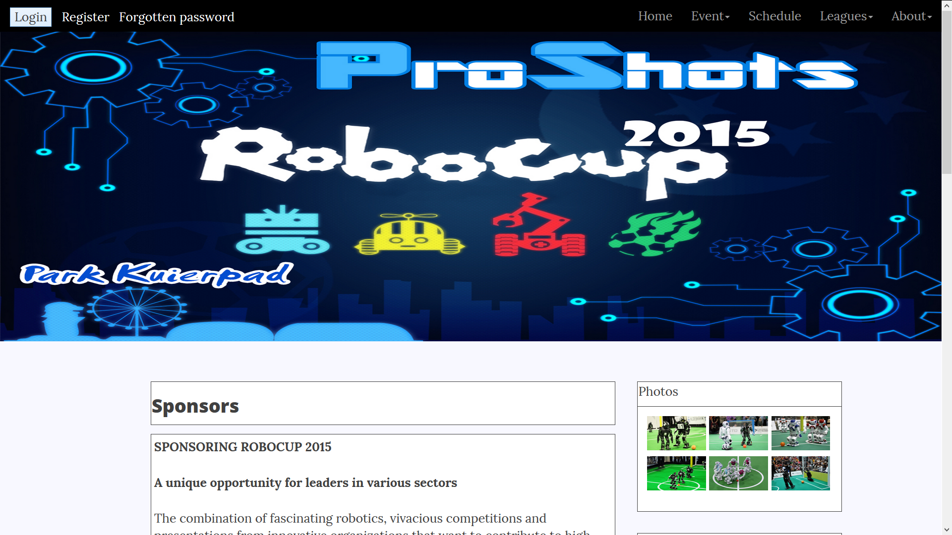

After the user log in to his profile, the register and forgotten password links are removed.   
A message “Welcome, Username | log out” and two new links appear in the top left corner.   
The first is Balance where the users can check their account balance and recharge it with minimum 5 euro.  
The second is Booked items where the users can see a list of the items they have rented during the event.   
After clicking their username the users are brought to a page where they can change their details such as password, email and name.

The front page has information about the event and links to the tickets and camping reservation pages. It also has the leagues and some of the event sponsors.  
 Every league has a read more button. The leagues can be browsed with left and right buttons.

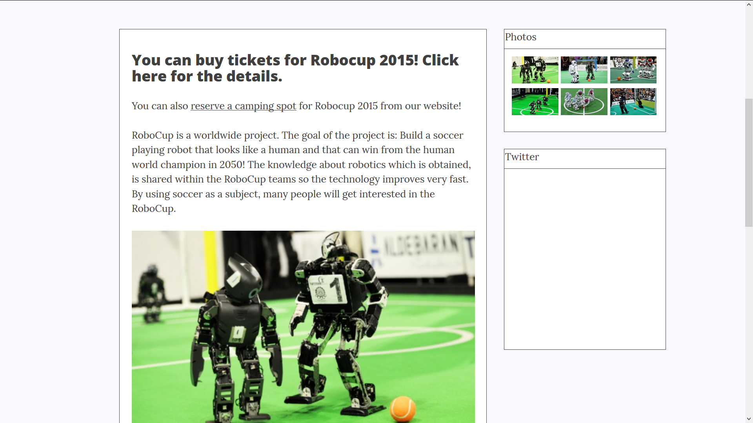

The user must be logged into his account to access the tickets page. The page has a list that will store all visitors who will get ticket. At first the list will contain only the logged user details but the user can write first name, last name and email of an unregistered person and add him to the list, then this person will receive an email for completion of his registration. At the bottom of the page the number of tickets and the total price is shown.

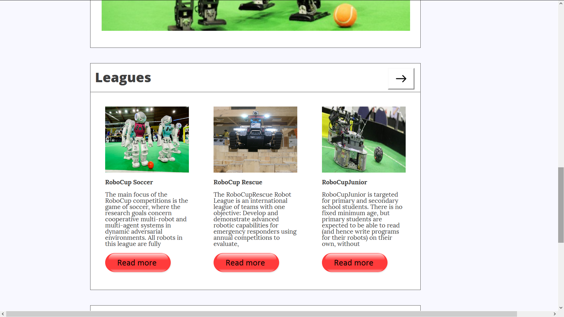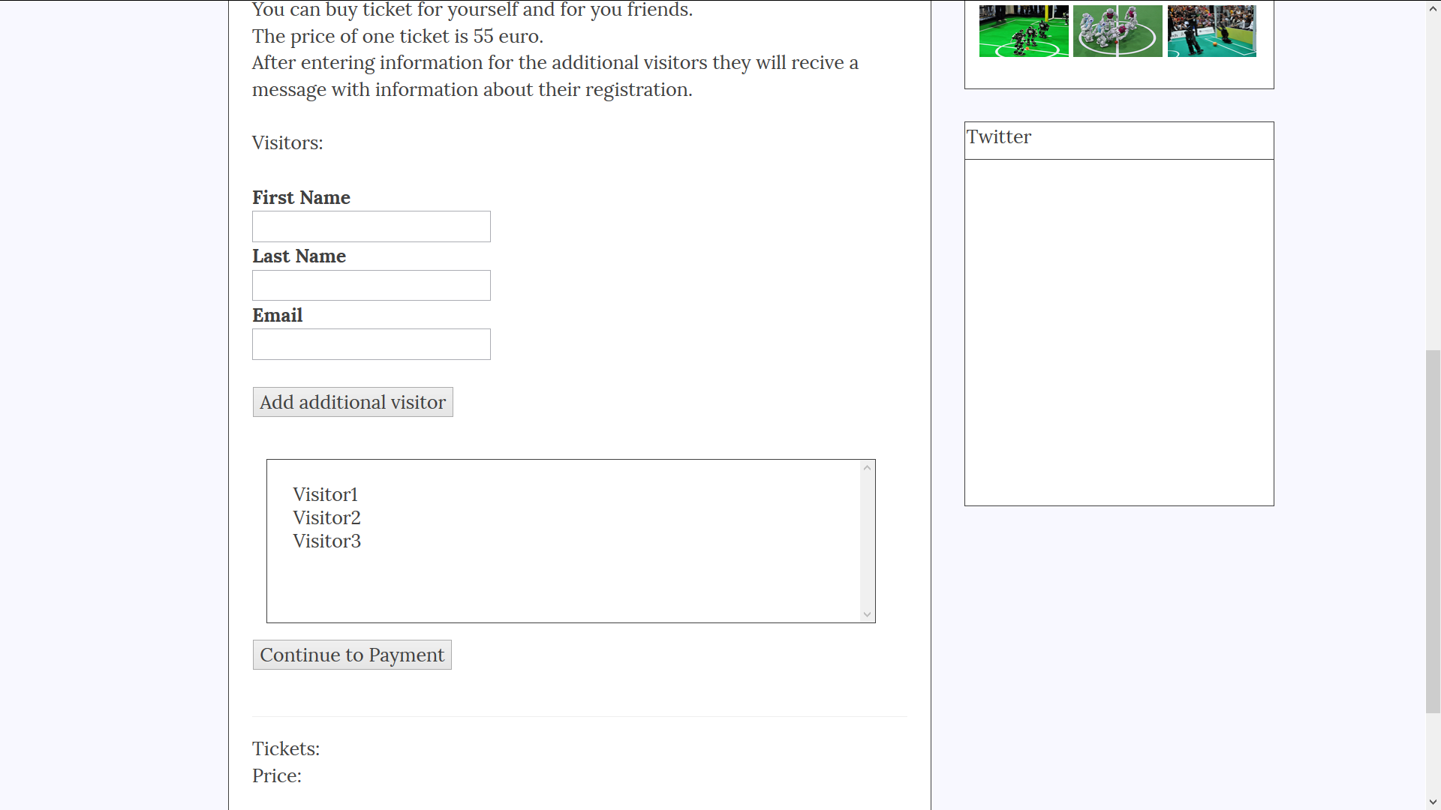

The user must be logged into his account to access the camping spot reservation page. In it he can select available camping spot and chose from 0 to 6 additional visitors for the spot. Depending on how much additional visitors are chosen, email forms will appear. The page will inform that only registered users emails can be entered in the forms.

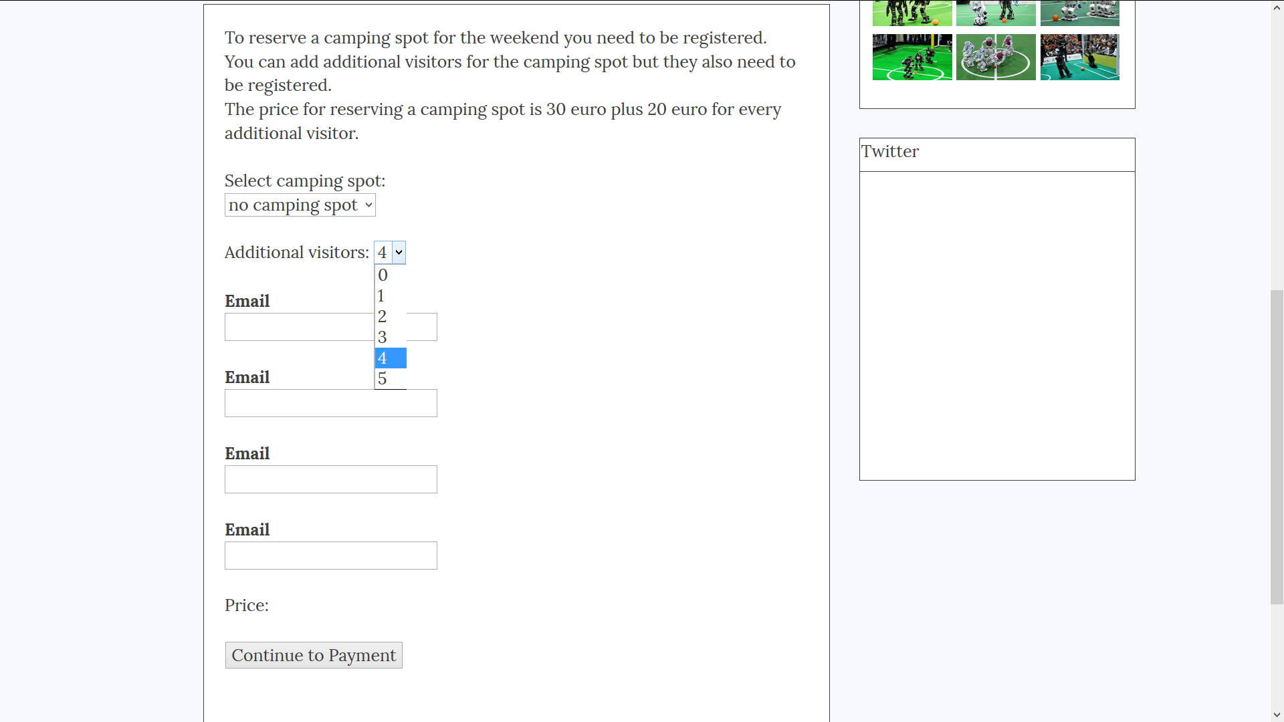

The sponsors page contains information about the peoples sponsoring the event and logos of the sponsors of the event.

Applications  
The **Administrator**, **Employees** and **Visitors** have their own interface with functionalities to help them navigate during the event.

The first window they are presented with is the Login window. They can login either using their account or by presenting their identification card.

### Visitor

After the login, **visitors** are presented with their home screen, providing them basic information (name, email, balance)   
They can add or remove funds from their account using the buttons below their balance  
They can book a tent, purchase , appointment, rent an Item, view their history.  
They can toggle (on/off) the map using the ‘Map’ button.  
On their right, they can see the map of the event, with different areas of interested (PayPal machines, stores, events, camping spots, Information desk, PC Doctor  
At the bottom part of the map they can filter out the pins on the map, showing only a specific type of pin. They can filter it out by type (Shop, PayPal machine, event, camping spot, information desk, PC doctor) and then they can specify a name, if they are searching for a specific pin.  
They can also zoom in/out or focus the map on only the filtered items.

#### Book a tent

##### New

They are brought to a menu with the map of the camping area. There they can see all bookable zones. If they choose so, they can show/hide occupied areas.  
Upon choosing the desired area, they are issued a form in which to fill in other visitors, that are going to share the tent with them (if any) and a field to specify the time period of the booking. At the bottom of the window they can find the Total price of this booking, the Cancel and Confirm button.

##### Manage/View

If they choose to manage their bookings, they can preview all of their bookings on the same map. They can see with whom they have booked it with, till when and if they have checked in.

#### Purchase

##### New

If they choose to make a new purchase they are brought to a list of all the items in stock. They can filter out what they are searching for at the top, by either imputing the name and/or by item type. They can also specify a shop.  
The filter will update the list below. They can select multiple items and preview their purchases at the top right, at their cart.  
Upon pressing **checkout**, their request will be issued to the representing stores and allow the visitors to pick them up. From now on, until they have collected all their items, when they are previewing their cart then can see the order and on its right - a button ‘Show on Map’, which will lead them to a window with the map of the event, having the stores that have the purchased items, pinned.

##### View

If they choose to preview their purchases they will be presented with the list of items they have purchased, grouped by orders.

#### Appointment

##### New

If they choose to make a new appointment, they will be presented with a form to fill in with details of their issue.

##### View

If they choose to preview their appointments, they will be brought to a list of all their appointments. Here they can view everything that has happened with their equipment

#### Rent

##### New

If they choose to rent a new item, they are brought a menu, similar to the purchase menu.

View  
If they choose to preview their rented items, they are brought to a list showing all their items that they have rented, with a status of returned or not.

#### History

After selecting **History**, they are brought to a menu, where they can review all of their actions.  
All important actions that they have taken with our system are present to them (log in, log out, purchase, top up, booking, renting)   
On the top of the menu, they can choose to filter their actions. They can choose from Purchase, Rent, Appointment, Booking and General. It will narrow down the list to the actions that apply to the filter.

### Employee

#### For renting

The Employee is given an interface similar to the one the visitor has. He can preview all items rented and can issue a new item to be rented.

#### PC Doctor

The Employee is given an interface similar to the one the visitor has. He can preview all of the appointments, manage them and issue new.

#### Cashier

The Employee is given an interface similar to the one the visitor has for making new purchases, but with items only from the current shop. The employee can preview all of their sold items.

### Administrator

The administrator can have an overview of the event. He can see a map of the event with all the facilities. On the bottom left he can preview the revenue, warning and number of currently active visitors. If there are warnings, the warning icon will turn red and indicate the number of warnings.

#### Visitors

Here they can preview a list of all the visitors; he can specify different filters to find specific visitors. He can see the number of purchased items, number of items rented and returned, booked tents and total amount spent. At the bottom of the list there is a number indicating total amount spent from all the users that are being presented. He can select every user independently and the sum will change correspondingly.  
When he selects a user, they are brought to an interface similar to the visitor’s, but they can only view, they cannot modify any data.

#### Balance

In this menu the administrator is given an overview of the flow of money. There is a list that specifies the visitor, date, amount and action that is made by the visitor.  
That action can be either a purchase, rent of an item, booking of a tent. When they click on the action, they are brought to a menu, giving details of it.

#### Warnings

In this menu they are given a list of all warnings. If a shop is running out of stock, if an item is not return in time, if there is a malfunctioning machine, if an employee is not checked in. Anything that needs attention and is covered by our program can be found here. Every menu redirects to the corresponding page for its action.

#### Shops

Here they can preview the earnings of each shop, the number of items they have in stock and orders placed.

#### Employees

Here they can preview the current state of the employees. They can find out if they have checked in, are on break or are working. They can preview the history of a certain employee. It consists of the all of their actions made with our system, such as taking a break, working at their station, signing in and logging out.

#### PC-Doctor

Here they can preview all of the appointments issued with the PC doctor. They are given a list with the item that was issued, the visitor that issued the appointment, the time. They can click on the appointment and see the follow up (view actions taken)

#### Calendar

Here they can preview and manage the event schedule. They can add or disable an event.  
If they choose to create an event, they have to specify the name, location and time, entrance fee. A description is optional.

#### Rent Desk

Here they can preview all rented items and if they are returned. They are given a list with the items in concern, the visitor, the date that they have been rented and issued