SQLITE

:השוע איה המ )הלועפ וא ףיעס לכ דיל בותכ )1(

- Create/Drop table:

CREATE TABLE shopping (id INTEGER PRIMARY KEY, name TEXT, amount INTEGER); - This action creating the new table in DB.

DROP TABLE shopping - This action dropping the table in DB.

- Rename table:

ALTER table shopping RENAME to shopp This action renaming the table in DB.
ALTER table shopp RENAME to shopping
Renaming back.

- Insert rows into table:

INSERT INTO shopping VALUES (1, 'Avokado', 5); INSERT INTO shopping VALUES (2, 'Milk', 2); INSERT INTO shopping VALUES (3, 'Bread', 3); INSERT INTO shopping VALUES (4, 'Chocolate', 8); INSERT INTO shopping VALUES (5, 'Bamba', 5); INSERT INTO shopping VALUES (6, 'Orange', 10);
This action creating new listing rows in the table.

- Display table:

select * from shopping
Presenting all data columns in table.

- ?

SELECT id, name FROM shopping
Presenting id and name columns in table.

- ?

SELECT * FROM shopping WHERE amount > 5 SELECT * FROM shopping WHERE amount = 2 SELECT * FROM shopping WHERE name LIKE 'Bamba'
Presenting data per condition.

- ?

DELETE from shopping WHERE name like 'Orange';
Deleted “Orange” row.

- ?

UPDATE shopping SET name = 'Bisli' WHERE name LIKE 'Bamba' UPDATE shopping SET amount=1 WHERE name LIKE 'Milk'
Updating data according to condition.

- ?

ALTER TABLE shopping ADD COLUMN maavar
Created new column.

- ?

UPDATE shopping SET maavar=6 WHERE id=1; UPDATE shopping SET maavar=3 WHERE id=2; UPDATE shopping SET maavar=12 WHERE id=3; UPDATE shopping SET maavar=8 WHERE id=4; UPDATE shopping SET maavar=5 WHERE id=5;
Filling column “maavar” per confition.

- ?

SELECT * FROM shopping WHERE amount > 1 AND maavar > 5 SELECT * FROM shopping WHERE maavar BETWEEN 3 AND 5
Present data according to condition.

- ?

SELECT * FROM shopping ORDER BY maavar SELECT * FROM shopping ORDER BY maavar DESC
Present data ordered by maavar and then decreasing by maavar.

- ?

CREATE TABLE books (id INTEGER PRIMARY KEY, name TEXT); INSERT INTO books VALUES (1, 'SQL PROGRAMMING'); INSERT INTO books VALUES (2, 'CSHARP PROGRAMMING'); DELETE FROM books;
Creating new table, filling the table by books, deleting books.

- ?

SELECT COUNT(*)from shopping SELECT MAX(amount) from shopping SELECT AVG(amount) from shopping SELECT MIN(amount) from shopping
Performing math operations.

- ?

INSERT INTO shopping VALUES (6, 'Onions', 3, 6); INSERT INTO shopping VALUES (7, 'Orio', 1, 8); Select maavar, COUNT(*)FROM shopping GROUP BY maavar
Creating new rows and present amount by maavar.

- ?

SELECT id AS "SECRET", name, amount, maavar FROM shopping
Present “ID” column as a “SECRET”.

- ?

Select maavar, COUNT(*)FROM shopping GROUP BY maavar HAVING COUNT(*)>1
Present data by condition: 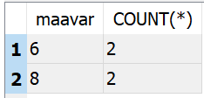

- ?

CREATE TABLE prices (id INTEGER PRIMARY KEY, price INTEGER); INSERT INTO prices VALUES (1, 3);

INSERT INTO prices VALUES (2, 7); INSERT INTO prices VALUES (3, 12); INSERT INTO prices VALUES (4, 5); INSERT INTO prices VALUES (5, 3); INSERT INTO prices VALUES (6, 2);
INSERT INTO prices VALUES (7, 10);

SELECT s.id, s.name, s.amount, s.maavar, p.price FROM shopping s JOIN prices p ON s.id=p.id

Present data by condition:
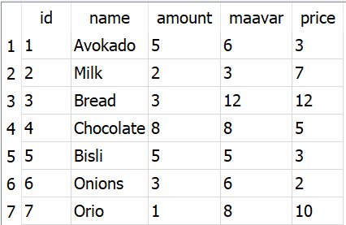

- ? SECRET ךותב בשוחמ המ

SELECT s.id, s.name, s.amount, s.maavar, p.price, s.amount * p.price AS "SECRET" FROM shopping s JOIN prices p ON s.id=p.id
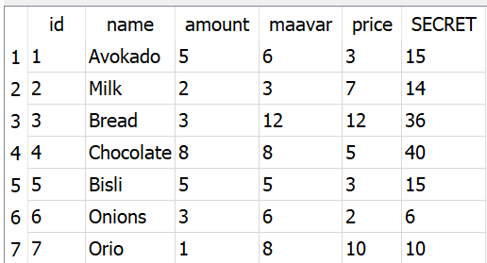

- ?

SELECT s.id, s.name, s.amount, s.maavar, p.price FROM shopping s JOIN prices p ON s.id=p.id WHERE p.price = (SELECT MAX(price) FROM prices)
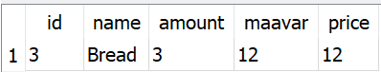

 |  |  |  |  |  |  |  | :רותפ )2(
Students
ID (INTEGER)PRIMARY KEY |  | NAME (TEXT) | CITY (TEXT) |  |  |  | BIRTH (INTEGER)
1 |  | SHALOM |  |  | TEL AVIV |  | 1974
2 |  | YURI |  |  | RAANANA |  | 1980
3 |  | ANAT |  |  | RISHON |  | 1994
4 |  | DANA |  |  | REHOVOT |  | 1990
5 |  | OMER |  | JERUSALEM |  |  | 1987
GRADE
 | ID (INTEGER)PRIMARY KEY |  |  |  | GRADE (INTEGER)
 |  | 1 |  |  | 95
 |  | 2 |  |  | 70
 |  | 3 |  |  | 85
 |  | 4 |  |  | 99
 |  | 5 |  |  | 91

)סולכיאה אלל( תואלבטה תריציל תותליאשה תא בותכ | -
- CREATE TABLE students (id INTEGER PRIMARY KEY, name TEXT, city TRXT, birth INTEGER);
- CREATE TABLE grade (id INTEGER PRIMARY KEY, grade INTEGER);

לביק אוהש ןויצה תא דימלת לכלו םידימלתה לכ תא הסיפדמ רשא אתליאש בותכ | -
SELECT name FROM shopping, JOIN BY id grades, SELECT grade GROUP BY id;

___________________________________________________________________
יתתיכה עצוממה תא תבשחמ רשא אתליאש בותכ | -
SELECT AVG(grade) from grades
NO םיש תרחא 90-מ הובג ןויצה רשאכ YES םיש תעכ .EXCELLENT הדומע תפסוהל אתליאש בותכ | -
ALTER TABLE grade ADD COLUMN EXCELLENT; UPDATE grade SET excellent=YES WHERE grade>90; UPDATE grades SET excellent=NO WHERE grade<90;

רובע קר לביק אוהש ןויצה תא דימלת לכלו םידימלתה לכ תא הסיפדמ רשא אתליאש בותכ* | -
עצוממה לעמ ולביק רשא םידימלתה
___________________________________________________________________
___________________________________________________________________
הובגה ןויצה תא לביק רשא דימלתה רובע ונויצ תאו דימלתה תא הסיפדמ רשא אתליאש בותכ * | -
_______________________________________________________________רתויב
_______________________________________________________________

