InjuryVision 3D
UX/UI Design Document
Low-Fidelity UX Structure, User Flow, Athlete Feedback, and Design Iteration
Project | InjuryVision 3D
Project Type | 3-week individual software engineering project
Product Positioning | Sports self-tracking and recovery awareness web application
Important Scope Note | The app is not a medical diagnosis tool.

Document Overview
- Purpose and product UX direction for InjuryVision 3D.
- Target users, user needs, personas, and MVP user stories.
- Main user flow and information architecture.
- Updated low-fidelity wireframes after feedback from three athlete participants.
- Design rationale for dashboard, 3D body map, injury logging, history, and weekly report.
- User feedback grouped by screen with realistic iteration decisions.
- High-fidelity design direction, accessibility considerations, and implementation-ready design notes.
Design phase status
The low-fidelity wireframes have been tested with a basketball player, gymnastics athlete, and soccer player. The updated screens shown in this document include the improvements made after that feedback round.

1. Purpose of the UX/UI Document
This document explains the user experience, interface structure, design decisions, low-fidelity wireframes, and feedback-based design iteration for InjuryVision 3D. InjuryVision 3D is a sports self-tracking and recovery awareness web application that helps athletes visually track injuries, pain levels, recovery progress, and training load using an interactive 3D body model. The product is intentionally positioned as a self-monitoring tool, not a medical diagnosis product. The interface communicates awareness, reflection, and structured tracking without making medical claims.

2. UX Design Goals
- Make pain logging fast and understandable after training or a match.
- Use the 3D body model as the central interaction for selecting body parts.
- Help users understand current body status at a glance.
- Support recovery reflection through history and weekly reports.
- Keep the MVP realistic for a 3-week individual software project.
- Use safe wording that avoids medical diagnosis language.
- Prepare the structure for a later bright, clean, sporty high-fidelity UI.

3. Target Users
Target User | Description
Basketball players | Users who often deal with ankle, knee, shoulder, and back pain from training or games.
Gym users | Users who want to track soreness, pain, recovery, and training load after workouts.
Runners | Users who want to monitor recurring pain in knees, ankles, calves, hamstrings, or lower back.
Coaches | Users who may want a simple overview of athlete recovery and pain trends.
Sport students | Users who want to reflect on training habits, recovery, and injury awareness.
General active users | Users who train regularly and want a visual way to track pain and recovery.

4. User Needs
- Users need a simple way to log pain or injury after training.
- Users need to quickly select the affected body part.
- Users need a clear visual overview of current body status.
- Users need to understand pain severity without reading long text.
- Users need to view injury history over time.
- Users need to understand whether training load may be connected to pain.
- Users need weekly summaries that are easy to understand.
- Users need the app to feel sporty, modern, trustworthy, and not overly medical.

5. Personas
Persona | Context | Goal | Problem | Need
Alex, 21 | Basketball training 2-3 times per week | Track recurring ankle and knee pain after training and matches. | Often forgets when pain started and whether it improved or worsened. | A visual body-part-based tracking flow and recovery overview.
Sofia, 24 | Strength training 4 times per week | Track soreness and avoid overtraining. | Sometimes ignores pain until it becomes worse. | A simple dashboard showing pain trends, recovery status, and training load.
Mark, 28 | Running 3-5 times per week | Monitor knee, ankle, and lower-back discomfort. | Tracks distance but not pain or recovery. | A weekly report connecting training intensity with pain history.

6. MVP User Stories
ID | User Story | Priority
US1 | As a user, I want to register and log in so that my injury data is saved personally. | Must have
US2 | As a user, I want to view an interactive 3D body model so that I can visually select a body part. | Must have
US3 | As a user, I want to click a body part so that I can log pain or injury for that area. | Must have
US4 | As a user, I want to enter pain level, notes, and recovery status so that I can track my condition. | Must have
US5 | As a user, I want body parts to change color so that I can quickly understand my current status. | Must have
US6 | As a user, I want to view injury history for a body part so that I can track progress over time. | Must have
US7 | As a user, I want to view a dashboard so that I can understand my overall recovery and injury risk. | Must have
US8 | As a user, I want to view a weekly report so that I can reflect on pain and recovery patterns. | Must have
US9 | As a user, I want to log training activity type so that pain logs include sport context. | Should have
US10 | As a user, I want to export my weekly report as PDF so that I can save or share it. | Could have

7. Main User Flow
- User opens the application.
- User logs in or registers.
- User lands on the dashboard.
- User clicks the Open 3D Body Map button.
- User opens the 3D Body Map screen.
- User clicks a body part, such as the left knee.
- The selected body part panel displays current status and recent logs.
- User clicks Add New Log.
- The Add Injury Log modal opens.
- User enters pain level, activity type, current pain status, recovery progress, and notes.
- User saves the log.
- The selected body part status updates.
- Dashboard, Injury History, and Weekly Recovery Report data update.

8. Information Architecture
Page / Section | Purpose
Login | Allows existing users to access the application.
Register | Allows new users to create an account.
Dashboard | Shows recovery overview, pain trend, risk indicator, recent logs, and weekly summary.
3D Body Map | Main interaction screen for selecting body parts and logging pain.
Add Injury Log Modal | Focused form for creating a pain or recovery log for the selected body part.
Injury History | Shows previous injury logs and recovery progress in a timeline structure.
Weekly Report | Summarizes weekly pain, recovery, and optional training load data.
Profile | Allows users to manage basic personal account information.

9. Updated Low-Fidelity Wireframes
The wireframes were created in black and white to focus on structure, usability, content hierarchy, and user flow instead of final visual styling. The updated screens below include the changes made after the athlete feedback sessions.

9.1 Login Screen
The login screen introduces the product and allows users to access their personal tracking data. A short scope disclaimer reminds users that the application is not a medical diagnosis tool.
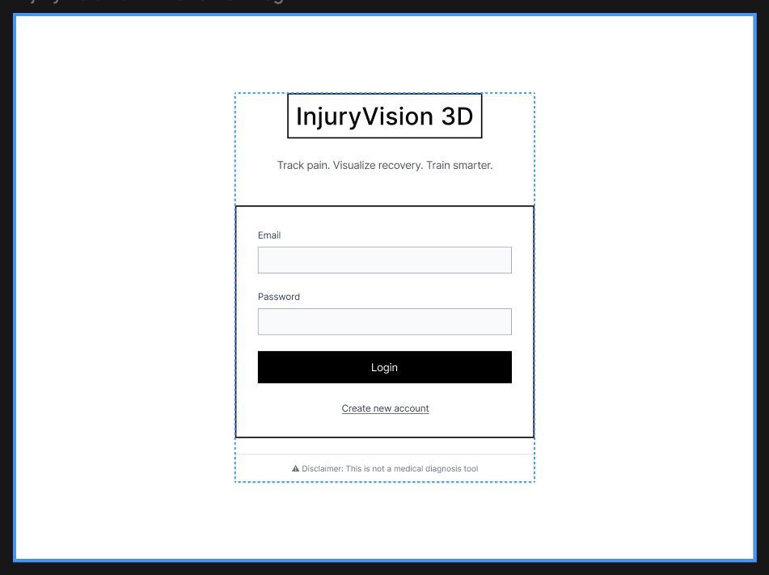
Figure 1. Updated low-fidelity login screen wireframe.

9.2 Register Screen
The register screen keeps the account creation flow simple with only the required fields. This avoids unnecessary friction before the user reaches the dashboard.
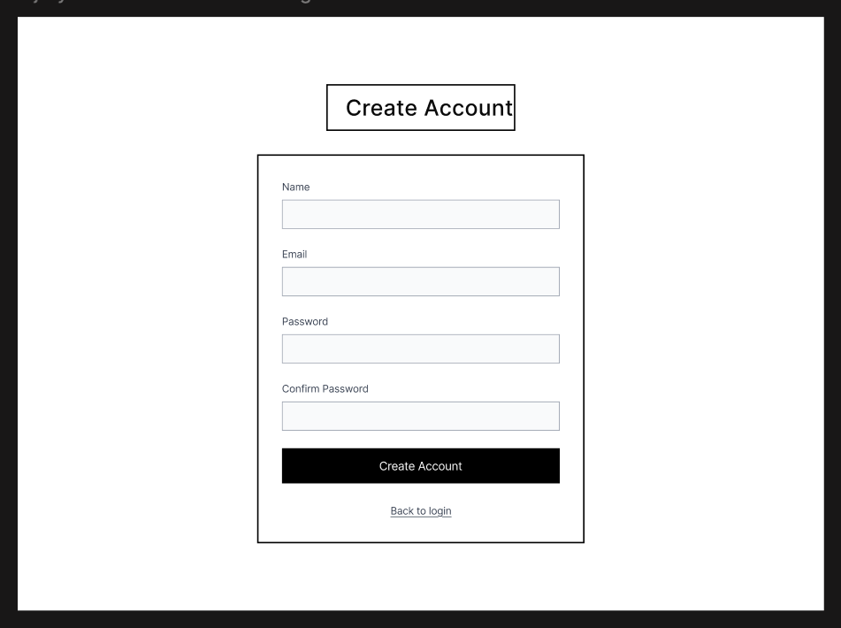
Figure 2. Updated low-fidelity register screen wireframe.

9.3 Dashboard Screen
The dashboard is the first screen after login. After feedback, it includes a clearer insight message and explanatory text under the Injury Risk card. This helps users understand not only the numbers, but also what those numbers mean.
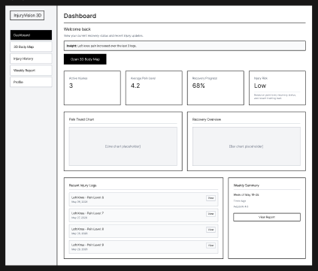
Figure 3. Updated dashboard wireframe after user feedback.
- The Open 3D Body Map button guides the user toward the core feature.
- The insight message gives a quick interpretation of recent data.
- The Injury Risk explanation clarifies that risk is based on pain level, recovery status, and recent training load.
- Recent logs and weekly summary connect daily tracking with longer-term reflection.

9.4 3D Body Map Screen
The 3D Body Map is the core interaction screen. After feedback, the wireframe includes clearer clickable zone labels and interaction notes so users understand that body parts can be selected, previewed, and updated.
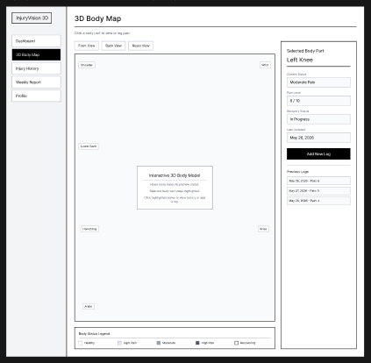
Figure 4. Updated 3D Body Map wireframe with clickable body zone labels.
- Clickable zones are labelled for important sports injury areas such as shoulder, wrist, lower back, hamstring, ankle, and knee.
- The model area explains that users can hover to preview status and select a body zone.
- The selected body part panel keeps current status, pain level, recovery progress, and previous logs visible.
- The Add New Log button keeps the pain logging flow fast.

9.5 Add Injury Log Modal
The Add Injury Log modal appears after the user clicks Add New Log. After feedback, the modal was reviewed for clarity and speed. Users found the current fields understandable, but the strongest improvement suggestion was to add optional sport context such as activity type in the next iteration without making the form too long.
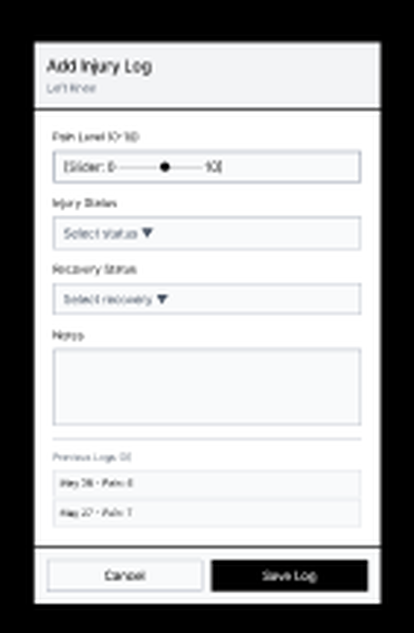
Figure 5. Updated Add Injury Log modal after feedback.
- Pain Level was reframed as a 0-10 question to make it easier to answer.
- Activity Type was identified as the most valuable next form improvement because athletes wanted to know whether pain happened during training, a match, gym, recovery, or another activity.
- The selected body part remains visible at the top of the modal.
- The form remains short enough for a realistic 3-week MVP.

9.6 Injury History Screen
The Injury History screen shows previous logs in a timeline layout. After feedback, helper text was added above the filters and status labels were made clearer so users can scan recurring pain areas faster.
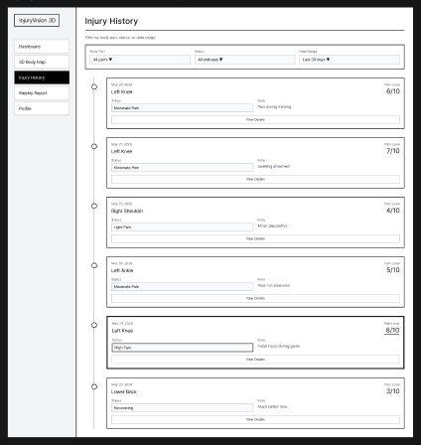
Figure 6. Updated Injury History timeline wireframe after feedback.
- The filter row supports searching by body part, status, or date range.
- Timeline cards separate date, body part, pain level, status, note, and detail action.
- High pain logs can be visually emphasized in the high-fidelity version using badges and status colors.
- The timeline supports reflection over time without overwhelming the user.

9.7 Weekly Recovery Report Screen
The Weekly Recovery Report summarizes weekly pain and recovery patterns. After feedback, the Smart Recovery Suggestions area was adjusted to use safe wording and a clear note that suggestions are based on tracking data and are not medical advice.
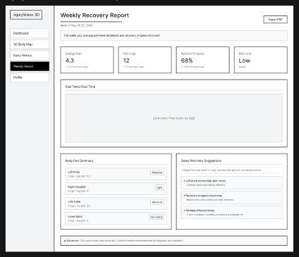
Figure 7. Updated Weekly Recovery Report wireframe after feedback.
- The summary sentence explains the data in plain language.
- Summary cards show average pain, new logs, recovery progress, and risk level.
- The body part summary helps users see which areas need attention.
- Suggestions remain general and safe, avoiding medical diagnosis wording.

10. User Feedback and Design Iteration
After creating the first low-fidelity wireframes, I tested the main injury logging flow with three target users: a basketball player, a gymnastics athlete, and a soccer player. The goal was to validate whether the core flow was understandable before moving into high-fidelity design and implementation.
Test scenario
Imagine you have knee pain after training. Use the wireframes to show how you would log the pain and then check your recovery overview.

10.1 Participants
Participant | User Type | Relevance
Participant 1 | Basketball player | Relevant because basketball players often experience knee, ankle, shoulder, and back pain after training or games.
Participant 2 | Gymnastics athlete | Relevant because gymnasts often experience wrist, shoulder, back, knee, and ankle pain from landings, flexibility, and body control.
Participant 3 | Soccer player | Relevant because soccer players often experience knee, ankle, hamstring, calf, and lower-back discomfort after training or matches.

10.2 Feedback Grouped by Screen
Screen | Feedback Summary
Dashboard | Users found the dashboard useful and understood that Open 3D Body Map was the main action. They suggested adding a clearer insight message and explaining what Injury Risk is based on.
3D Body Map | Users understood the concept, but wanted body zones to be more obviously clickable in the final design. They expected hover states, highlighted zones, selected body part feedback, and labels for important sports injury areas.
Add Injury Log Modal | Users found the modal clear and simple. All three participants suggested adding training or activity context, but keeping the form short.
Injury History | Users found the timeline easy to scan and liked the filters. They suggested making high pain logs stand out more clearly.
Weekly Report | Users found the report useful and liked the plain-language summary. They emphasized that suggestions should not sound like medical diagnosis or treatment.
Navigation | Users understood the sidebar and dashboard call-to-action. No major navigation changes were needed.

10.3 Design Decisions After Feedback
Feedback | Decision | Reason
Make 3D body parts more clickable and visual. | Implement. | This improves the main feature and was mentioned by all users.
Add hover and selected state to body parts. | Implement if technically possible; document as expected interaction. | It improves clarity without increasing scope too much.
Add sport/training context to the log form. | Partially implement. Keep the MVP form simple now and add Activity Type if time allows during high-fidelity/implementation. | It improves usefulness while keeping the form short.
Add pain trigger, pain type, training intensity, and Can I train? fields. | Save as future improvement. | Useful, but too much for the first 3-week MVP form.
Make dashboard insights more actionable. | Implement. Add a simple insight message. | Small text change with high clarity value.
Explain injury risk. | Implement. Add helper text under the Injury Risk card. | Helps users understand what the metric means.
Make high pain logs stand out. | Implement in high-fidelity with badges/status colors. | Improves scanning and supports the color status system.
Add real AI diagnosis. | Do not implement. | Outside scope and conflicts with the product as a self-tracking tool.

10.4 Changes Made in the Updated Wireframes
Screen | Change Made
Dashboard | Added an insight message: Left knee pain increased over the last 3 logs. Added helper text under Injury Risk explaining that it is based on pain level, recovery status, and recent training load.
3D Body Map | Added labels for important sport-related zones such as shoulder, wrist, lower back, hamstring, ankle, and knee. Added interaction notes for hover preview, selected zone highlighting, and clicking highlighted zones.
Add Injury Log Modal | Kept the form short and easy to understand. Activity Type is documented as the next realistic improvement if time allows, with options such as Training, Match, Gym, Recovery, and Other.
Injury History | Added helper text above filters and kept the clean timeline layout. Planned stronger status badges for high-fidelity design.
Weekly Report | Kept the summary sentence and added safe wording around Smart Recovery Suggestions to avoid medical advice.
Navigation | Kept the existing sidebar and dashboard CTA because users found them clear.

11. Design System Direction for High-Fidelity Phase
The next phase should convert the low-fidelity structure into a bright, clean, sporty health dashboard. A bright interface is more suitable than a dark futuristic style because the product focuses on recovery awareness, clarity, and trust.
Element | Direction
Interface mood | Bright, clean, modern, sporty, health-focused, trustworthy.
Background | White or very light blue/grey.
Cards | White cards with soft borders, rounded corners, and light shadows.
Primary action | Blue or teal action button for important actions.
Text | Dark navy or charcoal for strong readability.
Charts | Minimal and readable, with no unnecessary decoration.
3D model area | Clean background with enough space and a clear status legend.
Side panel/modal | Strong hierarchy, short labels, clear actions.

12. Injury Status Color System
The status color system should make the body model easy to understand while always using text labels for accessibility.
Status | Color Direction | Meaning
Healthy / Recovered | Green | No current pain or recovered.
Light Pain | Yellow | Minor pain or discomfort.
Moderate Pain | Orange | Noticeable pain that should be monitored.
High Pain | Red | Strong pain or high concern.
Recovering | Blue | Currently recovering.
Accessibility note
Status colors must always be supported by text labels because color alone is not enough for all users.

13. Accessibility Considerations
- Add text labels next to all status colors.
- Use sufficient contrast in high-fidelity designs.
- Make buttons, forms, and navigation keyboard-accessible.
- Add visible focus states.
- Use validation messages for empty or invalid form fields.
- Use simple language instead of medical jargon.
- Use alt text for important images and icons.
- Avoid communicating meaning through color only.

14. Interaction Design
Interaction | Expected Behavior
Hover body part | Body part highlights and may show a status preview.
Click body part | Selected body part panel opens or updates.
Click Add New Log | Add Injury Log modal opens.
Save injury log | Confirmation appears and the body part status updates.
View dashboard card | User can inspect more detailed data in a related screen.
View chart | Tooltip shows date and pain level.
Mobile view | Side panel becomes a bottom sheet or full-screen modal.

15. MVP Scope Decisions
Include in MVP | Keep Optional / Challenge
Login/register | PDF export
Dashboard | Advanced training load analysis
Interactive 3D body model | Rule-based smart suggestions
Clickable body parts | Upload injury images/reports
Add injury log modal | Advanced body zones
Injury history timeline | Mobile PWA offline mode
Weekly recovery report | Coach/athlete multi-user system
Activity Type field | Sport-specific presets and advanced pain trigger system
This keeps the project realistic for 3 weeks while still showing a strong product concept and technical challenge.

16. Evidence Saved for Documentation
- Screenshot of the original low-fidelity Figma overview.
- Screenshot of the updated dashboard wireframe after feedback.
- Screenshot of the updated 3D Body Map wireframe after feedback.
- Screenshot of the updated Add Injury Log modal.
- Screenshot of the updated Injury History timeline.
- Screenshot of the updated Weekly Recovery Report.
- Interview feedback notes from the basketball, gymnastics, and soccer participants.
- Before/after comparison showing how feedback changed the wireframes.
- Final high-fidelity design screenshots later in the project.

17. Final UX/UI Direction
- Use a bright, clean, health-focused visual style.
- Use the 3D body model as the central interaction.
- Make the dashboard simple and action-oriented.
- Use a side panel and modal for fast pain logging.
- Support all status colors with labels.
- Use weekly reports for reflection, not diagnosis.
- Keep the MVP realistic and polished.
- Use safe product wording that avoids medical claims.
- Document feedback and design iterations clearly.

18. Conclusion
The UX/UI design of InjuryVision 3D focuses on making sports injury and recovery tracking visual, simple, and engaging. The updated low-fidelity wireframes show a complete flow from login to dashboard, 3D body map, injury logging, history, and weekly report. The feedback from three athlete participants validated the main flow and helped improve clarity around clickable body zones, dashboard insights, activity context, history scanning, and safe recovery wording.
The project is now ready to move into high-fidelity UI design. The next design step is to apply a bright sporty visual style, define the final color system, refine the 3D body model interaction, and prepare implementation-ready frontend screens.

