UX/UI Design Document
InjuryVision 3D
Low-Fidelity UX Structure, User Flow, Wireframes, and Feedback Plan

Project | InjuryVision 3D
Project Type | 3-week individual software engineering project
Product Positioning | Sports self-tracking and recovery awareness web application
Important Scope Note | The app is not a medical diagnosis tool.

Document Overview
- Purpose and product UX direction
- Target users, needs, personas, and user stories
- Main user flows and information architecture
- Low-fidelity wireframes with screenshots placed in the correct sections
- Design decisions for dashboard, 3D body map, injury logging, history, and weekly report
- Accessibility, interaction design, responsiveness, and safe product wording
- User feedback interview guide and improvement plan
This revised document focuses on the UX structure of InjuryVision 3D before high-fidelity design. The wireframes remain intentionally black-and-white and low-fidelity so that usability, content hierarchy, and user flow can be tested before visual styling is added.

1. Purpose of the UX/UI Document
This UX/UI Design Document explains the user experience, interface structure, design decisions, low-fidelity wireframes, and feedback plan for InjuryVision 3D.
InjuryVision 3D is a sports self-tracking and recovery awareness web application. The application helps athletes visually track injuries, pain levels, recovery progress, and training load using an interactive 3D body model.
The product is intentionally positioned as a self-monitoring tool, not a medical diagnosis product. The interface should communicate awareness, reflection, and structured tracking without making medical claims.

2. UX Design Goals
- Make pain logging fast and understandable after training.
- Use the 3D body model as the central interaction for selecting body parts.
- Help users understand current body status at a glance.
- Support recovery reflection through history and weekly reports.
- Keep the MVP realistic for a 3-week project.
- Use simple wording that avoids medical diagnosis language.
- Prepare the structure for a later bright, clean, sporty high-fidelity UI.

3. Target Users
Target User | Description
Basketball players | Users who often deal with ankle, knee, shoulder, and back pain from training or matches.
Gym users | Users who want to track soreness, pain, recovery, and training load after workouts.
Runners | Users who want to monitor recurring pain in knees, ankles, calves, hamstrings, or lower back.
Coaches | Users who may want a simple overview of athlete recovery and pain trends.
Sport students | Users who want to reflect on training habits, recovery, and injury awareness.
General active users | Users who train regularly and want a visual way to track pain and recovery.

4. User Needs
- Users need a simple way to log pain or injury after training.
- Users need to quickly select the affected body part.
- Users need a clear visual overview of current body status.
- Users need to understand pain severity without reading long text.
- Users need to view injury history over time.
- Users need to understand whether training load may be connected to pain.
- Users need weekly summaries that are easy to understand.
- Users need the app to feel sporty, modern, trustworthy, and not overly medical.

5. Personas
Persona | Context | Goal | Problem | Need
Alex, 21 | Basketball training 2-3 times per week | Track recurring ankle and knee pain after training and matches. | Often forgets when pain started and whether it improved or worsened. | A visual body-part-based tracking flow and recovery overview.
Sofia, 24 | Strength training 4 times per week | Track soreness and avoid overtraining. | Sometimes ignores pain until it becomes worse. | A simple dashboard showing pain trends, recovery status, and training load.
Mark, 28 | Running 3-5 times per week | Monitor knee, ankle, and lower-back discomfort. | Tracks distance but not pain or recovery. | A weekly report connecting training intensity with pain history.

6. User Stories
ID | User Story | Priority
US1 | As a user, I want to register and log in so that my injury data is saved personally. | Must have
US2 | As a user, I want to view an interactive 3D body model so that I can visually select a body part. | Must have
US3 | As a user, I want to click a body part so that I can log pain or injury for that area. | Must have
US4 | As a user, I want to enter pain level, notes, and recovery status so that I can track my condition. | Must have
US5 | As a user, I want body parts to change color so that I can quickly understand my current status. | Must have
US6 | As a user, I want to view injury history for a body part so that I can track progress over time. | Must have
US7 | As a user, I want to view a dashboard so that I can understand my overall recovery and injury risk. | Must have
US8 | As a user, I want to view a weekly report so that I can reflect on pain and recovery patterns. | Must have
US9 | As a user, I want to log training load so that I can compare training intensity with pain. | Should have
US10 | As a user, I want to export my weekly report as PDF so that I can save or share it. | Could have

7. Main User Flow
The most important MVP flow is the injury logging flow. This flow should be understandable even in low-fidelity wireframes.
- User opens the application.
- User logs in or registers.
- User lands on the dashboard.
- User clicks the Open 3D Body Map button.
- User opens the 3D Body Map screen.
- User clicks a body part, such as the left knee.
- The selected body part panel displays current status and recent logs.
- User clicks Add New Log.
- The Add Injury Log modal opens.
- User enters pain level, injury status, recovery status, and notes.
- User saves the log.
- The selected body part status updates.
- Dashboard, injury history, and weekly report data update.

8. Information Architecture
Page / Section | Purpose
Login | Allows existing users to access the application.
Register | Allows new users to create an account.
Dashboard | Shows recovery overview, pain trend, risk indicator, recent logs, and weekly summary.
3D Body Map | Main interaction screen for selecting body parts and logging pain.
Add Injury Log Modal | Focused form for creating a pain or recovery log for the selected body part.
Injury History | Shows previous injury logs and recovery progress in a timeline structure.
Weekly Report | Summarizes weekly pain, recovery, and optional training load data.
Profile | Allows users to manage basic personal account information.

9. Low-Fidelity Wireframes
The low-fidelity wireframes were created in black and white to focus on structure, user flow, and usability instead of final visual styling. The screenshots below are placed according to the user journey.

9.1 Login Screen
The login screen introduces the product and allows the user to access their personal injury data. It includes a short product message and a clear disclaimer that the app is not a medical diagnosis tool.
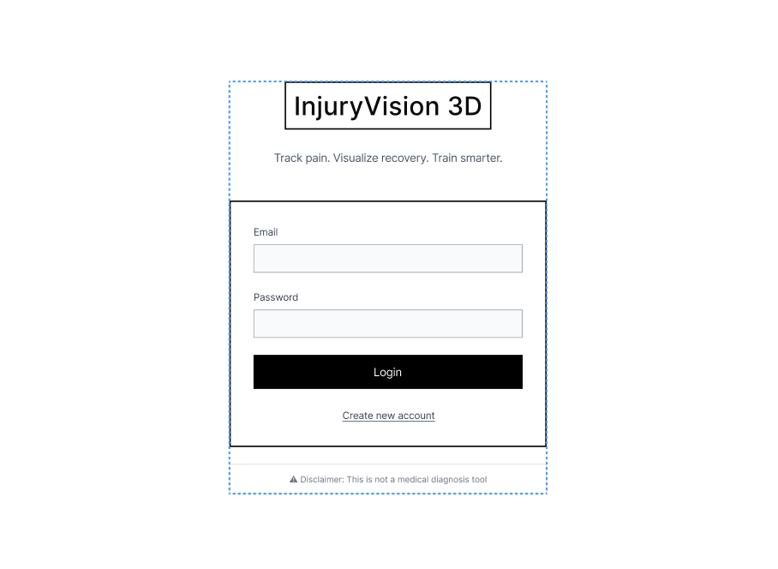
Figure 1. Low-fidelity login screen wireframe.

9.2 Register Screen
The register screen keeps the account creation flow simple with only the required fields. This avoids unnecessary friction before the user reaches the dashboard.
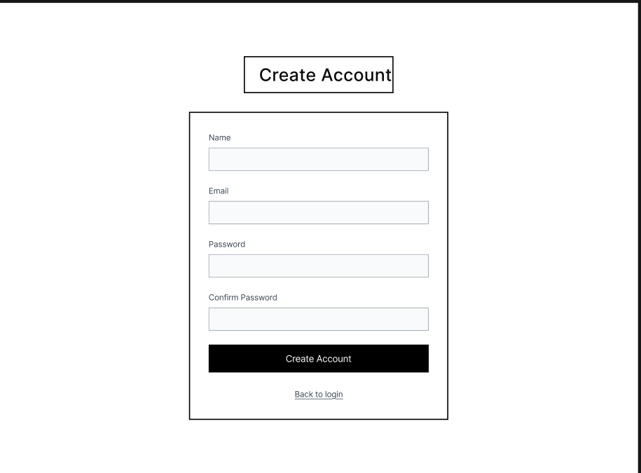
Figure 2. Low-fidelity register screen wireframe.

9.3 Dashboard Screen
The dashboard is the first screen after login. It includes a direct call-to-action button to open the 3D Body Map, which makes the next user step clear. It also summarizes active injuries, average pain level, recovery progress, injury risk, recent logs, and weekly summary.
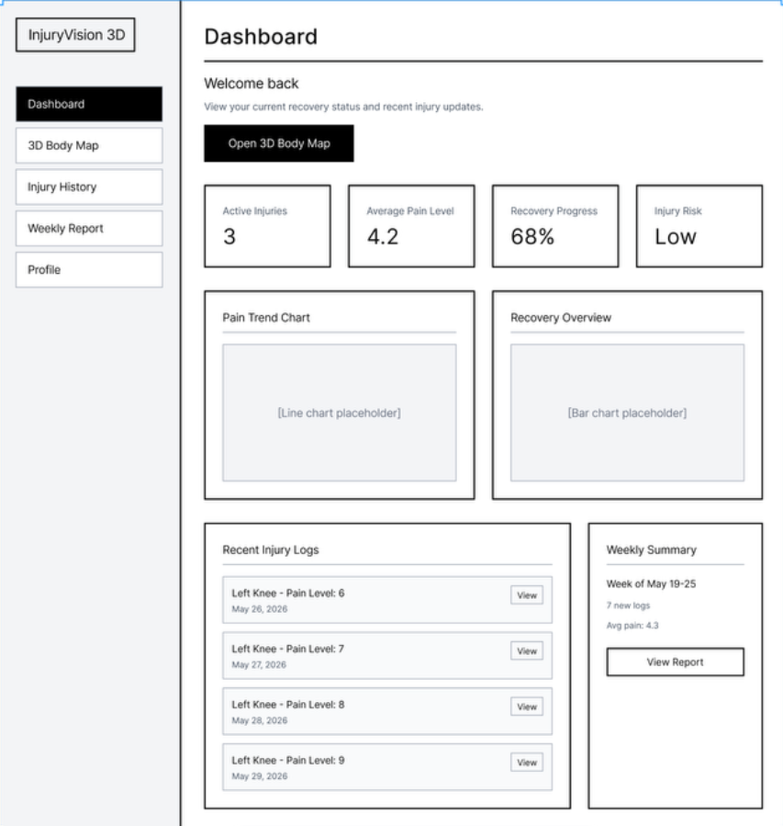
Figure 3. Low-fidelity dashboard wireframe with clear entry point to the 3D Body Map.

Dashboard Design Rationale
- The Open 3D Body Map button guides the user toward the main product feature.
- Four summary cards keep the overview easy to scan.
- Recent injury logs provide immediate context.
- The weekly summary card connects daily logging with longer-term reflection.

9.4 3D Body Map Screen
The 3D Body Map is the core screen of the application. The model placeholder is placed as the main visual focus, with view controls above it and a selected body part panel on the right. The legend explains the meaning of body status labels.
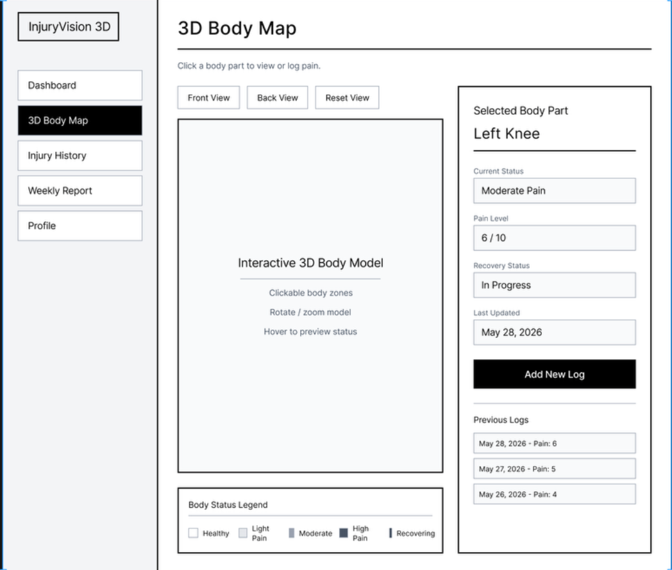
Figure 4. Low-fidelity 3D Body Map wireframe with selected body part panel.

3D Body Map Design Rationale
- The central model area supports the unique 3D interaction of the product.
- Front View, Back View, and Reset View buttons communicate expected 3D controls.
- The right-side panel keeps selected body part information visible without leaving the page.
- The Add New Log button creates a direct path to the injury logging form.
- The body status legend supports users who may not understand the visual status system immediately.

9.5 Add Injury Log Modal
The Add Injury Log modal appears after the user clicks Add New Log. It focuses on the minimum required fields for MVP logging: pain level, injury status, recovery status, and notes. This keeps the form realistic for a 3-week implementation.
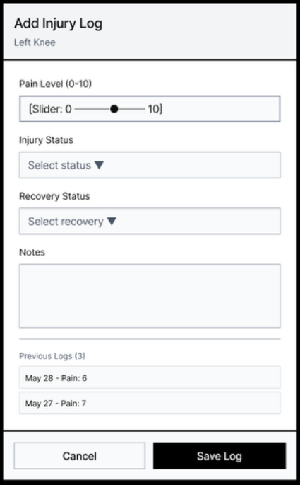
Figure 5. Low-fidelity Add Injury Log modal wireframe.

Add Injury Log Design Rationale
- The modal keeps the user in the context of the selected body part.
- Pain level is entered using a 0-10 slider, which is quick and understandable.
- Status and recovery dropdowns keep data structured.
- The notes field allows personal context after training.
- Cancel and Save Log buttons make the action outcome clear.

9.6 Injury History Screen
The Injury History screen shows previous logs in a timeline layout. The filter row allows the user to narrow results by body part, status, or date range.
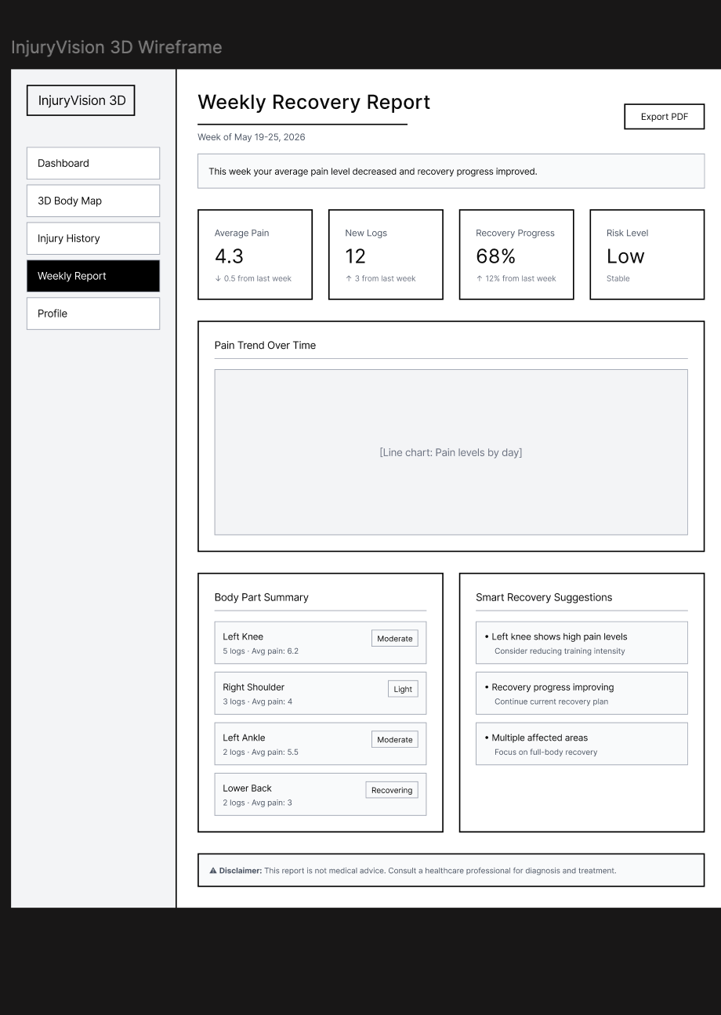
Figure 6. Low-fidelity Injury History timeline wireframe.

Injury History Design Rationale
- The timeline structure supports reflection over time.
- Each log card separates date, body part, pain level, status, note, and details.
- Filters prevent the history from becoming overwhelming as more logs are added.
- The View Details button allows future expansion without overloading the timeline.

9.7 Weekly Recovery Report Screen
The Weekly Recovery Report summarizes the user’s activity for the week. It includes a plain-language summary sentence so that the user can understand the meaning of the numbers quickly.
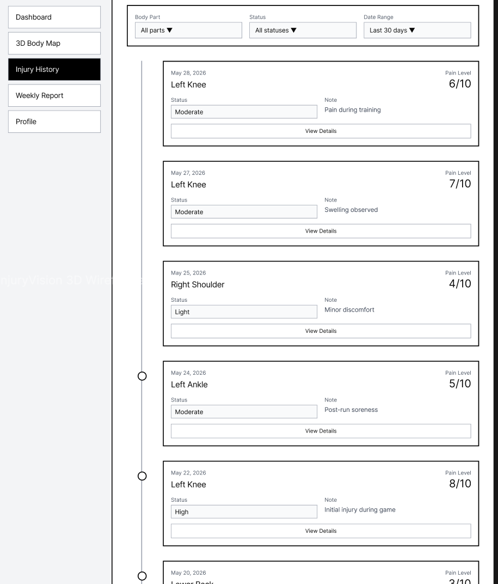
Figure 7. Low-fidelity Weekly Recovery Report wireframe.

Weekly Report Design Rationale
- The summary sentence makes the report more human and understandable.
- Summary cards show the most important weekly metrics.
- The pain trend chart supports visual reflection.
- Body part summary and smart suggestions make the report actionable without sounding medical.
- The disclaimer reinforces that the app is not a diagnosis tool.

10. Design System Direction for High-Fidelity Phase
The next phase should convert the low-fidelity structure into a bright, clean, sporty health dashboard. The design should avoid a dark, futuristic look because the product is about recovery awareness and clarity.
Element | Direction
Interface mood | Bright, clean, modern, sporty, health-focused, trustworthy.
Background | White or very light blue/grey.
Cards | White cards with soft borders, rounded corners, and light shadows.
Primary action | Blue or teal action button for important actions.
Text | Dark navy or charcoal for strong readability.
Charts | Minimal and readable, with no unnecessary decoration.
3D model area | Clean background with enough space and clear status legend.
Side panel/modal | Strong hierarchy, short labels, clear actions.

11. Injury Status Color System
Status | Color Direction | Meaning
Healthy / Recovered | Green | No current pain or recovered.
Light Pain | Yellow | Minor pain or discomfort.
Moderate Pain | Orange | Noticeable pain that should be monitored.
High Pain | Red | Strong pain or high concern.
Recovering | Blue | Currently recovering.

Accessibility note: status colors must always be supported by text labels because color alone is not enough for all users.

12. Accessibility Considerations
- Add text labels next to all status colors.
- Use sufficient color contrast in high-fidelity designs.
- Make buttons, forms, and navigation keyboard-accessible.
- Add visible focus states.
- Use validation messages for empty or invalid form fields.
- Use simple language instead of medical jargon.
- Use alt text for important images and icons.
- Avoid communicating meaning through color only.

13. Interaction Design
Interaction | Expected Behavior
Hover body part | Body part highlights slightly and may show a status preview.
Click body part | Selected body part panel opens or updates.
Click Add New Log | Add Injury Log modal opens.
Save injury log | Confirmation appears and the body part status updates.
View dashboard card | User can inspect more detailed data in a related screen.
View chart | Tooltip shows date and pain level.
Mobile view | Side panel becomes a bottom sheet or full-screen modal.

14. MVP Scope Decisions
Include in MVP | Keep Optional / Challenge
Login/register | PDF export
Dashboard | Training load analysis
Interactive 3D body model | Rule-based smart suggestions
Clickable body parts | Upload injury images/reports
Add injury log modal | Advanced body zones
Injury history timeline | Mobile PWA offline mode
Weekly recovery report | Coach/athlete multi-user system

This keeps the project realistic for 3 weeks while still showing a strong product concept and technical challenge.

15. User Feedback Plan
Before moving into high-fidelity design, the low-fidelity wireframes should be tested with 3 users. Recommended testers are one basketball player or athlete, one gym user or runner, and one software/design student.

Test Scenario
Imagine you have knee pain after training. Use the wireframes to show how you would log the pain and then check your recovery overview.

Interview Questions
- What do you think this application is for?
- After logging in, where would you click first?
- Is it clear how to open the 3D Body Map?
- Is it clear that body parts are clickable?
- What do you expect to happen after clicking a body part?
- Is the Add Injury Log modal easy to understand?
- Are the fields in the injury log form enough, or is something missing?
- Is the dashboard useful, or does it show too much information?
- Is the injury history timeline easy to scan?
- Does the weekly report explain the data clearly?
- Does the app feel like self-tracking instead of medical diagnosis?
- What would you improve first?

Feedback Recording Table
Tester | User Type | Main Feedback | Change Made
User 1 | Basketball player
User 2 | Gym user / runner
User 3 | Software/design student

16. Iteration Plan Based on Feedback
Possible Feedback | Planned Iteration
Users do not notice the main action after login. | Make Open 3D Body Map more prominent or move it higher.
Users do not understand that body parts are clickable. | Add stronger instruction text, hover states, or labels.
Users do not understand status colors. | Move the legend closer to the 3D model and add clear text labels.
Injury logging feels too long. | Remove optional fields from the MVP form.
Weekly report feels too numeric. | Add plain-language interpretation at the top.
The app feels too medical. | Change wording to self-tracking, awareness, and recovery reflection.

17. Evidence to Save for Documentation
- Screenshot of the first low-fidelity Figma overview.
- Screenshot of the improved dashboard wireframe.
- Screenshot of the improved 3D Body Map wireframe.
- Screenshot of the Add Injury Log modal.
- Screenshot of the Injury History timeline.
- Screenshot of the Weekly Recovery Report.
- Screenshot or photo of user feedback notes.
- Before/after comparison after feedback changes.
- Final high-fidelity design screenshots later in the project.

18. Final UX/UI Direction
- Use a bright, clean, health-focused visual style.
- Use the 3D body model as the central interaction.
- Make the dashboard simple and action-oriented.
- Use a side panel and modal for fast pain logging.
- Support all status colors with labels.
- Use weekly reports for reflection, not diagnosis.
- Keep the MVP realistic and polished.
- Use safe product wording that avoids medical claims.
- Test wireframes before moving to high-fidelity UI.
- Document feedback and design iterations clearly.

19. Conclusion
The UX/UI design of InjuryVision 3D focuses on making sports injury and recovery tracking visual, simple, and engaging. The low-fidelity wireframes define the core structure of the application and show how users move from login to dashboard, 3D body map, injury logging, history, and weekly report.
The design is intentionally clean and realistic for a 3-week project. The MVP focuses on the most important flows: selecting a body part, creating an injury log, updating status, reviewing history, and reflecting through a weekly report.
The next step is to test the low-fidelity wireframes with three users, collect feedback, improve the screens if needed, and then move into the bright high-fidelity visual design phase.

