Table of Contents

1. Introduction 2

1.1. Problem statement 2

1.2. Methodology 3

2. Company overview 3

2.1. Description of the organizational structure 3

2.2. Evaluation of organizational structure and problems 4

2.3. Style of leadership 5

2.4. Project stakeholders and expectations 6

2.5. S.W.O.T. analysis 6

2.5.1. Strengths 7

2.5.2. Weaknesses 8

2.5.3. Opportunities 8

2.5.4. Threats 8

2.6. Mission and vision and values 9

3. Business case 10

3.1. Introduction and background 10

3.2. Management summary 11

3.3. Description of problem 11

3.4. Cost/benefit analysis 11

3.5. Risks 12

# Introduction

Nowadays technologies and software take really big part of personal and business life of the population. Almost 99% of the modern business feels the need of software which can optimize and accompany its development, which eventually will lead to faster integration on the market and bigger competitiveness among already established companies.

What is software?

“Organized information in the form of operating systems, utilities, programs, and applications that enable computers to work. “[1]

Complicated right?

However companies are not really interested in the meaning of it, but in the influence of the software on their budget. From business point of view it can optimize the work-flow, improve product quality, faster information travel, increase security and etc. All this taken together in many cases would lead to faster and bigger profit in the face of less used resources.

In order take advantage of the latest technologies available on the market, each company needs to have access to specialized software.

Aalbornification is a start-up running in the event planning field. Being opened in 2009, the company had a limited number of employees and not so much exposure.

Over time the company has developed, increasing also their work amount. With an increased number of events to be handled, the need of organizing the internal information has gained their focus, together with the need of a personalized platform that can give them control over their ticket sales.

Even though the company is already using an online platform for selling tickets, they could benefit of personalized software that can ease their daily work, being shaped to fit their needs.

## Problem statement

Considering the above mentioned information, this project is aiming on formulating and answering a problem statement that will improve the issue of software use in relation to the business activity of Aalbornification.

In this way the problem statement is formulated as follows: How can we design a ticketing platform that will improve the working environment and the tickets booking process for Aalbornification?

## Methodology

# Company overview

The Business Factory is an umbrella company opened in 2009 that has no field of activity, but as the name suggests, it creates new startup concepts for possible future companies. The company has a limited number of permanent employees, as it does not have a constant flux of events. When new concepts for events are created, the company hires the required amount of part time personnel in order to meet the workloads.

Currently the umbrella company has three fully functional companies (Aalbornification opened in 2011, Creathio -2013 and Crowd Move in 2014), and a total number of 7 permanent employees. Two of them are the owners and creators of The Business Factory, Viktor and Andrei. One employee is representing the IT department, and one the creative department, which handles the video editing (fx. Creating promotional videos or after movies of the part events) and other designs. From the remaining employees one is assigned for each of the companies. In this way only one of them is assigned as employee of Aalbornification.

## Description of the organizational structure

*“An effective structure facilitates management and clarifies relationships, roles and responsibilities, levels of authority, and supervisory or reporting lines.”[2]*

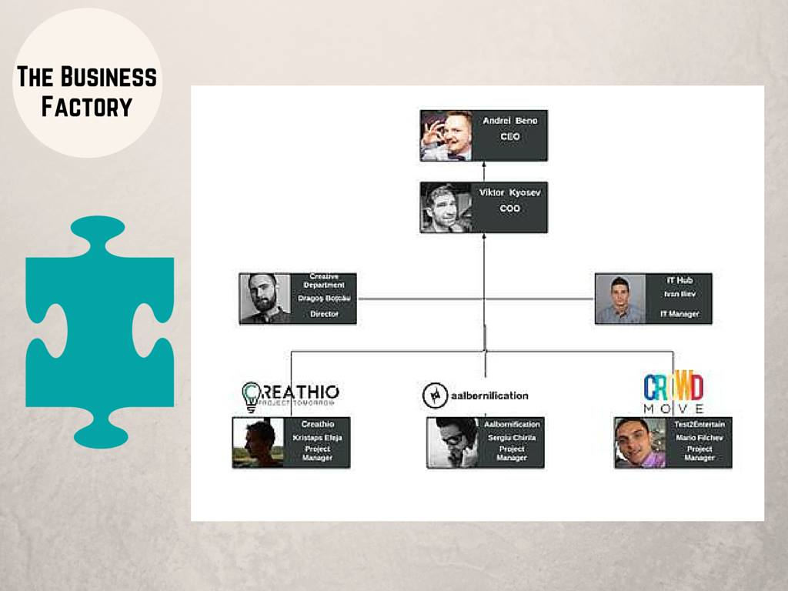

The three sub companies can be considered as departments of the main company. In the graphical representation, the three persons running the sub companies are called “Project managers”, meaning that they are responsible for the projects running in each company. In this way, main company can be considered as having a simple, functional structure, the company being divided into smaller groups based on specialized functional area, in this case the IT and Creative departments, as well as the three different sub companies. Each of these can hire part time staff for the running projects, while the CEO and COO are also taking part actively in the projects of each of the company.

## Evaluation of organizational structure and problems

*“By reviewing an organization’s structure, a manager will be able to determine which human, financial, and technical resources are available, how they should be allocated, and which resources are lacking.”[3]* Evaluating the organizational structure is an important step in discovering the problems that currently occur, or may occur in the company. Having this information can shape the way the solutions and suggestions will be developed in this report.

Considering the limited amount of permanent employees, the organizational structure seems to fit the company, as it allows it to work on different projects at a time, each department being specialized in their own field of activities. However, if the sub companies develop enough, in order to increase the number of their permanent employees, the structured might require being change to Mintzbert’s divisionalized form of organizational structure. *“When a company creates an organizational structure by grouping positions into departments based on geography, product or customer, the company is using a divisional structure. Divisions function independently of one other. They also govern themselves with much autonomy, relying on the parent company in only limited ways, such as for resources.”[4]*

This might happen if one of the company’s demands exceeds the current power of delivering. In this case “*This autonomy means that each division must include people able to perform different business functions, all concentrating exclusively on the objectives of their own division”[5].* An advantage would be that the company can focus better on their specific demands.

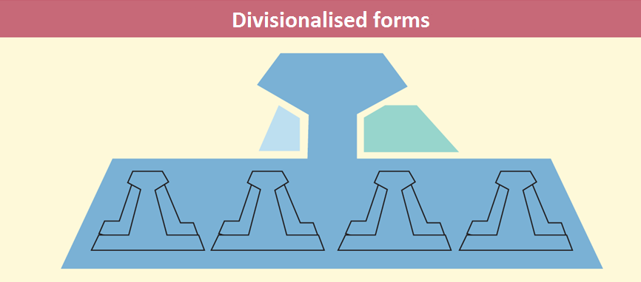[6]

## Style of leadership

Each individual is unique, this is why is important to analyze their styles of leadership. Their styles can influence the way a company is run and the way the employees perform their work. Analyzing and understanding their leadership styles can facilitate the process of shaping a solution to their needs.

With a CEO and a COO, the main company has basically two leaders, both being involved in managing and leading the sub-companies. However, when Aalbornification is hiring extra staff for their projects, the new employees have one more manager, which is the project manager of the sub company.

Andrei has a previous BA in International Hospitality Management, and is currently taking an MSc in entrepreneurial engineering. He is more focused on the business part, and entrepreneurship. He is in charge of business development, finance, funding and defining strategies due to his education and position of CEO.

On the other hand Viktor has also a BA in International Hospitality Management, and is currently studying MSc in Culture, Communication and Globalization and so he is more people focused. He is COO (chief operating officer) and as he says “I deal with HR, creating pipeline of talent (influencing attraction and retention), designing a framework to implement strategy into operations, coaching and mentoring. Anyway, both me and Andrei deal with all sorts of things, I am also in charge of B2G and to large extend B2B and many other things such as Social Media marketing, sponsorships, fund-raising and so on”.

## Project stakeholders and expectations

The stakeholders of the current project are represented first of all by the company with its employees and in the same time by the team developing the project.

The company’s expectations in regards to this project resume to a financial improvement in ticket sales and equally important, they expect to receive customized piece of software that gives them more control over the ticket sale process and an overview of their past activities.

The group developing the projects is of course concerned with developing satisfying software for their clients.

## S.W.O.T. analysis

S.W.O.T. analysis is a strategic tool to identify a business. Each category has its pro’s and con’s.

The S.W.O.T. categories are divided into internal (strengths and weaknesses) and external (opportunities and threads). “Strengths” is the category, which makes the company understand what keeps them stable and running. “Weaknesses” is not necessarily weaknesses, as it aids tracking down the fragile points, which can be turned around as strengths as long as precautions are made. It can be even a type of lure for opposing companies. “Opportunities” is strengths that have not yet been reached. “Threats” are inevitable problems that cannot be dealt with fully unlike “Weaknesses” - they are constants and are outside the company’s reach.

Below is presented and described the SWOT analysis of Aalbornification.

|  |  |
| --- | --- |
| **Strengths**   * trained staff * high popularity | **Weaknesses**   * language barrier * low financial power * not stable working space |
| **Opportunities**   * create an alliance * social network | **Threats**   * customer choice * new entrants * the financial environment |

### Strengths

The main strength of the company is the industry related training of the staff. All of the employees are currently or have been previously enrolled in a management or other related education, most of them at UCN Aalborg. As mentioned in the style of leadership paragraph, the CEO and COO have a previous education in International Hospitality Management, and chose to continue their professional development in a related field of studies.

Since the opening of Aalbornification in 2011, the company quickly became very popular among the international students due to the student parties they were organizing. Later they developed and the events they were organizing became bigger and bigger, catching the interest of the locals. Nowadays their events are targeting both locals and internationals attracted by their distinct events organized in and around Aalborg.

### Weaknesses

As most of the full time employees at Aalbornification, including the CEO and COO, are currently students. This means their financial possibilities are limited, which impacts the ability to invest in the company. This is why they must rely a lot on sponsorships to manage to organize their events.

Their next weakness is the language barrier. As mentioned above, the company relies on sponsorships, and considering the language barrier, this can sometimes be hard to obtain in the conditions that none of their employees can carry a presentation in Danish for the possible sponsors.

Due to the low financial power, the company did not have a stable office where they can carry their daily work. Over the last years, the company changed the location of the office few times, every time their employees were being faced with change and required to reorganize their working environment. This might be representing a weakness for the company, as long as they are unable to provide a stable working office.

### Opportunities

Considering the weaknesses, an opportunity that Aalbornification could benefit of is to create an alliance with a local company. In this way they facilitate their access to the local market and can diversify their range of offered events.

The company managed to turn the use of social network into an opportunity as they promote their events online and most of their event guests are getting informed online. In this way, the use on social media is one of the main ways of promoting their events.

### Threats

The threats that Aalbornification is facing are the threat of an unfavorable customer choice, meaning that the customers might choose to attend other events instead of the events organized by them. Another threat could be represented by new entries on the market.

The current situation of the financial environment could represent a thread for the company as the financial crisis has impacted negatively the buying power of the people, as well as the investment power of possible sponsors, which are highly important for the company.

## Mission and vision and values

Having formulated a mission and vision statements helps the company to clearly communicate their purpose to both the public and their own employees. Aalbornification has already clearly defined their mission and vision.

As found on their official website they say the following: “MISSION - Aalbornification is an event planning agency that delivers tailored services to our clients. We transform corporate and social events into experiences, by creating a fusion between the exclusive and the entertaining.”[7]

And they have also defined their vision in the following statement: “VISION – Our vision is to become the leading provider of entertainment on the Danish market by enriching the social and music culture through international influences.”[8]

Furthermore they present a very specific set of values that are important in the company. These values are also present on their website in the following graphical representation.

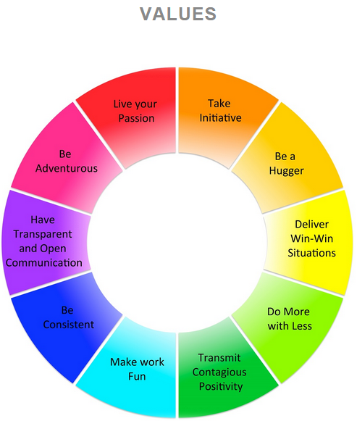[9]

# Business case

## Introduction and background

Even from the beginning of this document, the problem description of this project has been thoroughly shaped, giving a clear goal for this project.

## Management summary

As the problem statement mentions, this projects focuses on the development of a computer software that is meant to improve the tickets handling and booking process for Aalbornification. Having already a clear company overview makes it easier to begin the development of the project.

This project is focusing on developing a solution to the problem statement, in form of a software fitted to the company’s needs. The software is meant to include all the functionalities required in connection to the handling and booking of tickets, for different events that the company is organizing.

The proposed software is intended to give a better overview and more control over the information regarding the tickets, events, employees and other relevant areas. In the same time it will aim to increase the speed and simplify the booking process. The software will be available only to the employees, and is not intended for customer use.

In terms of business, the implementation of such software is expected to benefit the company by raising the employee satisfaction and automatically influencing the sales and revenue.

## Description of problem

The subject of this project is not necessary a problem in the company, but actually a suggested improvement in the way they carry their work. Currently the company uses the online environment for the booking process and this is not meant to be replaced by this option. Through this project, the company is offered an opportunity to improve their work, allowing their employees to have access to software fitted to their daily work, making their work easier. Beside the online booking option that is already in use, they can explore the opportunity of having personalized software that gives control over the data they work with, as well as allowing them to also make bookings for their customers (taken by phone or email).

## Cost/benefit analysis

Even though the access to the current financial situation of the company is limited, this analysis will present only the project related costs and benefits, divided into tangible and intangible.

The tangible costs resume to the value of the physical systems required to run the software. This may include the cost of a server that will host the database entries. In this case the company has to pay the initial cost as well as the maintenance of the system. Alternatively the database could be hosted at an online service, the cost being reduced, but in the same time also the control over the data.

Intangible costs may consist of the employees’ possible resistance to the new software.

Regarding the benefits of the project, it can be mentioned the employee satisfaction, expected to be immediate. This can automatically help bring in an increase in sales, expected to be a long-term benefit.

## Risks

Even though the project is aiming to develop user-friendly software meant to ease the work of the employees, certain risks still exists. One specific risk may be the inability of some of the employees to adapt to the new software, or for this matter the resistance they may present when required to adopt the new software.

## Conclusion

All in all, the benefits of the proposed investment are expected to weight more on long term than the value of the investment. Furthermore immediate changes should be noticeable as soon as the proposed software will be implemented.

Considering this, this project proves to be feasible and the company is encouraged to pursue its development and the implementation.

1. <http://www.businessdictionary.com/definition/software.html#ixzz3Z5DzcrAB>
2. http://www.pathfinder.org/publications-tools/pdfs/Strengthening-You-Organization-A-Series-of-Modules-and-Reference-Materials-for-NGO-and-CBO-Managers-and-Policy-Makers-Organizational-Structure.pdf
3. http://www.pathfinder.org/publications-tools/pdfs/Strengthening-You-Organization-A-Series-of-Modules-and-Reference-Materials-for-NGO-and-CBO-Managers-and-Policy-Makers-Organizational-Structure.pdf
4. http://yourbusiness.azcentral.com/divisionalized-organizational-structure-4924.html
5. http://yourbusiness.azcentral.com/divisionalized-organizational-structure-4924.html
6.
7. http://aalbornification.dk/about-us/
8. http://aalbornification.dk/about-us/
9. http://aalbornification.dk/about-us/