**How to use the “Responsive Routes”?**

*\*Currently, a prototype has been implemented. It works without real maps.\**

1. Joint Trips

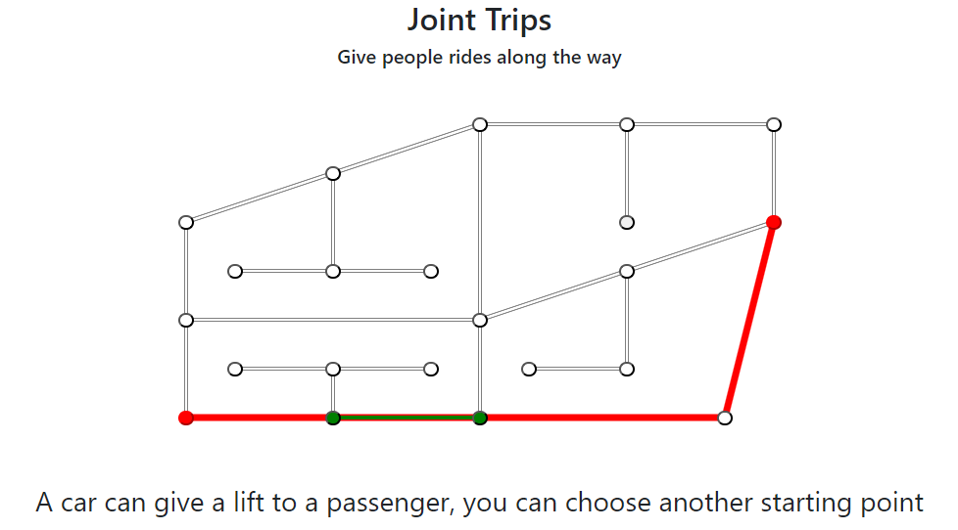

Figure 1.1

Here, a car driver and a passenger enter their routes by choosing a starting point and a destination. The application automatically checks whether a car can give a lift to a passenger.

The red line is the car’s route.

The green line is the passenger’s route.

2. Adaptive Bus Routes

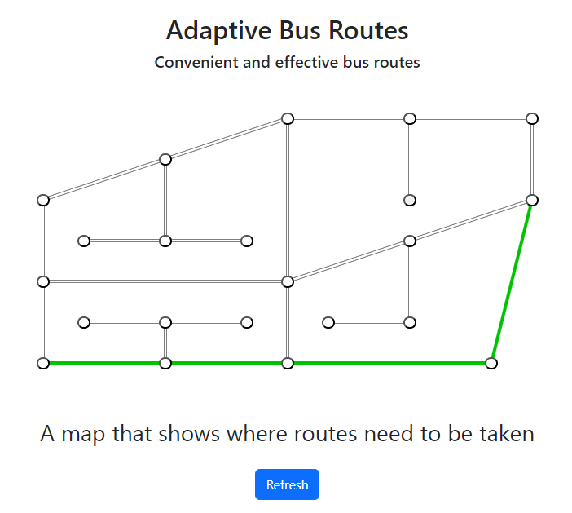

Figure 2.1

Here, as a passenger, you are able to add your route and the bus will choose a route that will be most efficient for you and other passengers with a similar route.

To add a route, you need to choose your starting point and your destination.

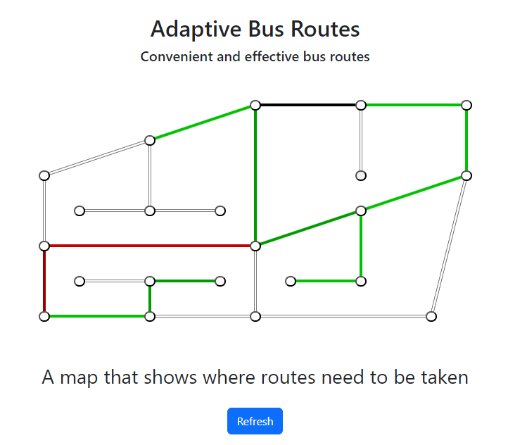

Figure 2.2

The color of routes changes from light green to dark red depending on route congestion as in Figure 2.2.

3. Common issues

1) While using joint trips, make sure that you select the points in the right order. Opposite directions will produce a negative result.

2) Make sure that you select the driver’s points first. Otherwise, the application could produce the opposite result.

3) Please remember that some routes suggested by the program may not be the most effective, as this is the prototype.