*TDT4195: Visual Computing Fundamentals*

*Computer Graphics - Assignment 1*

September 21, 2018

Ilker Canpolat

Gwenaëlle Mege Barriola

Department of Computer and Information Science Norwegian

University of Science and Technology (NTNU)

**Task 1b)**

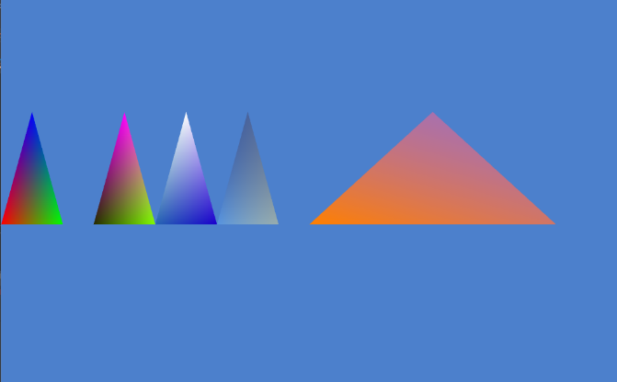

Screenshot of a rendered scene with 5 different triangles where all vertex of each triangles have a differente color.

Vertex Array:

float vertices[] = {

-1.0f, 0.0f, -0.6f,

-0.80f, 0.0f, -0.6f,

-0.90f, 0.5f, -0.6f,

-0.7f, 0.0f, -0.6f,

-0.5f, 0.0f, -0.6f,

-0.6f, 0.5f, -0.6f,

-0.5f, 0.0f, -0.6f,

-0.3f, 0.0f, -0.6f,

-0.4f, 0.5f, -0.6f,

-0.3f, 0.0f, -0.6f,

-0.1f, 0.0f, -0.6f,

-0.2f, 0.5f, -0.6f,

0.0f, 0.0f, -0.6f,

0.8f, 0.0f, -0.6f,

0.4f, 0.5f, -0.6f

};

Colour Array:

float colors[] = {

1.0f, 0.0f, 0.0f, 1.0f,

0.0f, 1.0f, 0.0f, 1.0f,

0.0f, 0.0f, 1.0f, 1.0f,

0.15f, 0.17f, 0.0f, 1.0f,

0.5f, 1.0f, 0.0f, 1.0f,

1.0f, 0.0f, 1.0f, 1.0f,

0.15f, 0.4f, 0.7f, 1.0f,

0.1f, 0.0f, 0.8f, 1.0f,

1.0f, 1.0f, 1.0f, 1.0f,

0.35f, 0.6f, 0.9f, 0.8f,

0.8f, 0.8f, 0.6f, 0.6f,

0.27f, 0.22f, 0.33f, 0.4f,

1.0f, 0.5f, 0.0f, 1.0f,

0.95f, 0.45f, 0.3f, 0.8f,

0.90f, 0.40f, 0.6f, 0.6f,

};

Index Array:

int indices[] = {

0, 1, 2,

3, 4, 5,

6, 7, 8,

9, 10, 11,

12, 13, 14

};

**Task 2a)**

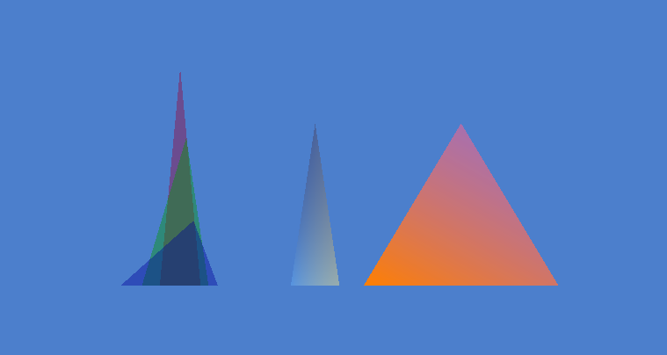

Screenshot where three triangles:

* Overlap in a x-y section.
* Each vertices of a triangle has the same z-coordinate.
* The z-coordinate of each triangle is different.
* All triangles have a transparent color.
* All triangles have a different color.
* Each triangle’s vertices have the same colour.

**Task 2b)**

i) What effects on the blended colour did you observe, and how exchanging triangle colours cause these changes occur?

The triangles are blended in the parts where the x and y of both overlaps. This happens because we changed the alfa to a number smaller than 1, change that adds transparency to the object.

ii) Which changes in the blended colour did you observe, and how did the exchanging of z-coordinates cause these changes to occur? Why was the depth buffer the cause of this effect?

When the z-coordinate is different and the order of the triangles drawn is from back to front, the triangle that is more in the front has, in the parts that overlaps, the color blended by the triangles that are more in the back.

The depth buffer causes this effect because if the z coordinate is different it disposes the triangles in a way that there is distance between them so it is possible to see the changes of colors.

**Task 3b)**

Change A:

Effect: The image is enlarged or reduced in width.

Transformation: Scaling

Axis: x-axis

Change B:

Effect: Tilts the image to the right side in the x-axis.

Transformation: Shearing

Axis: x-axis

Change C:

Effect: Triangles slide to the left or to the right.

Transformation: Translation

Axis: x-axis

Change D:

Effect: One half of the image has been moved downwards, the other half upwards. Furthermore the triangles are tilted away from the center or toward the center.

Transformation: Shearing

Axis: y-axis

Change E:

Effect: Triangles grow or shrink

Transformation: Scaling

Axis: y-axis

Change F:

Effect: Triangles slide up or down

Transformation: Translation

Axis: y-axis