Entire Doc

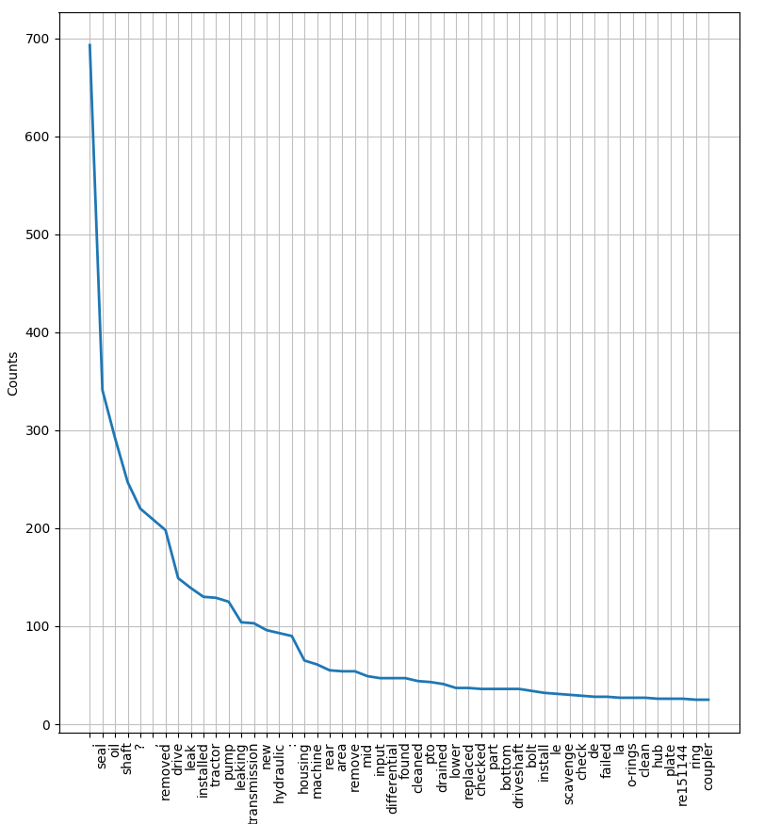

Claim #1

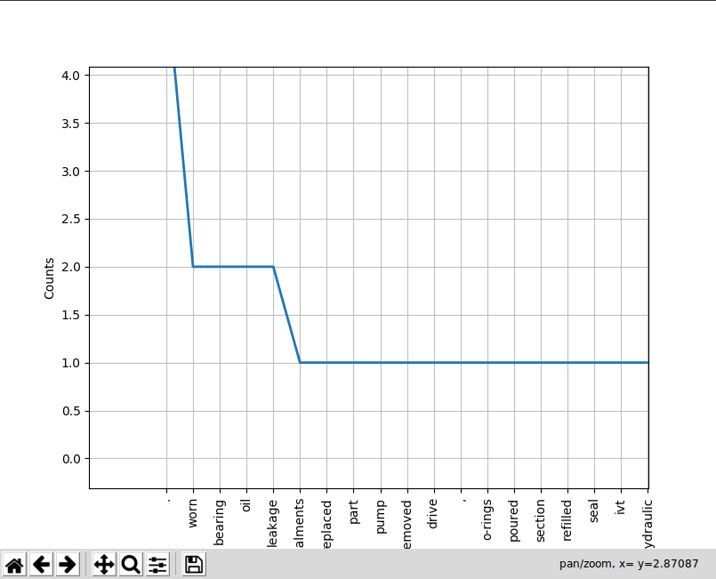

Claim #2

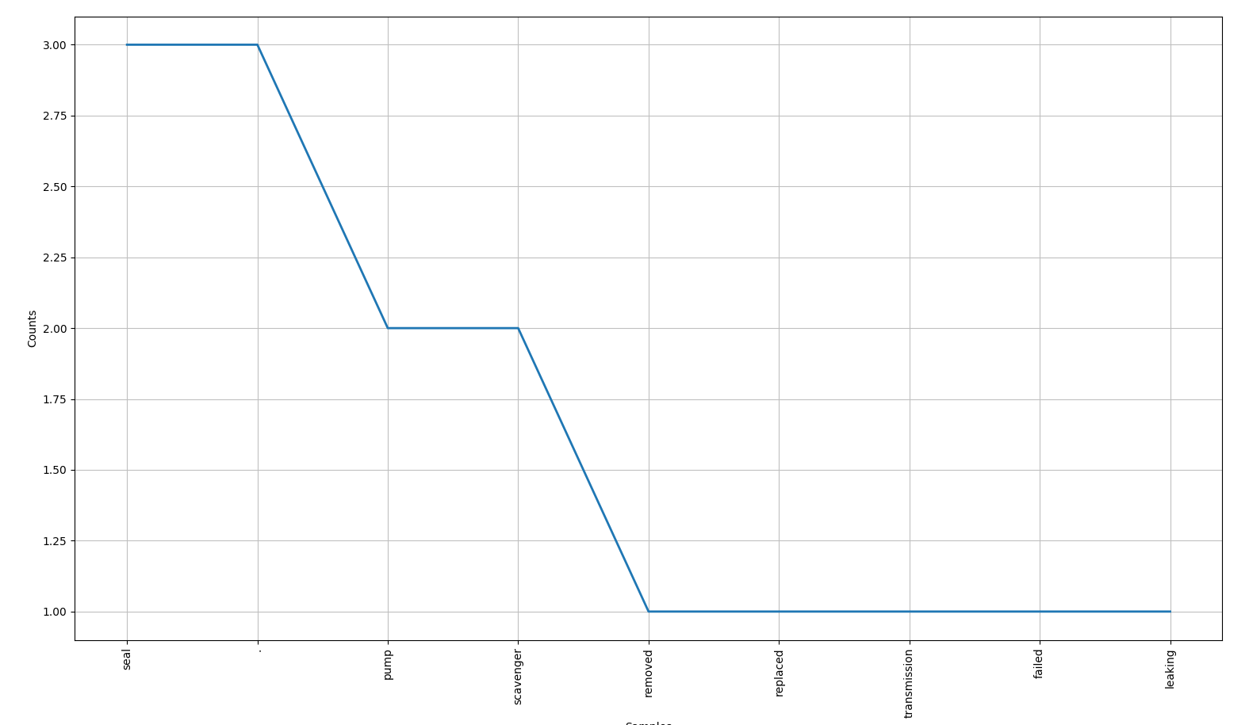

Claim #3

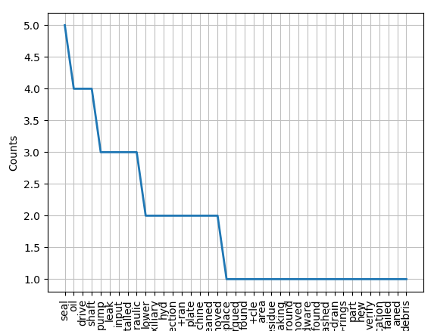

1. Remove punctuations
2. Run Spell Check
2. Dictionary of Locations
3. Explore Neural Nets????

