**Basic JavaScript and HTML Test**

**Overview**

The purpose of the application is to allow end-users to quickly enter and manage a list of name/value pairs.

Although this test must be written without any other persons help, any standard reference material that is used during a normal programming cycle may be used (such as online help or books). No third party class libraries or code snippets may be used, except for jQuery.

Create an HTML application using a UI similar to the one shown below. The application code should be written in HTML and JavaScript.

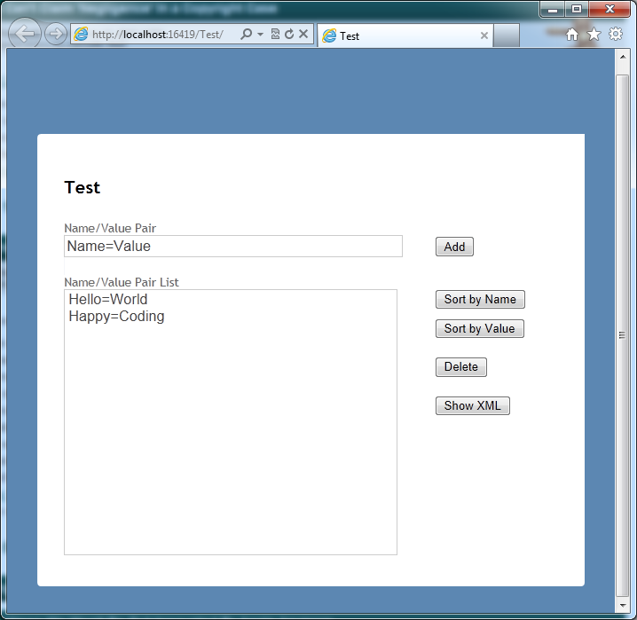

In addition, the UI should adjust based on what screen size is viewing it. For example, if viewed on a mobile phone (i.e. iPhone), the page should automatically adjust to present the layout in a better way. This also applies to re-sizing the browser on desktop, and viewing the page on a tablet.

**Required Features:**

Name/Value pairs are to be entered into the upper textbox. This textbox will be used by the end-user to quickly add Name/Value pairs to the list below.

When a Name/Value pair is about to be added to the list it must be validated to ensure proper syntax. If the syntax is incorrect then the Name/Value pair must not be added. The Name/Value pair entry format is shown below:

*<name> = <value>*

Where <name> is the name portion of the pair, and <value> is the value portion of the pair. Only valid Name/Value pairs can be added. Names and Values can contain only alpha-numeric characters. The equal-sign is used to delimit the pair, spaces before and/or after the equal-sign may be entered by the end user (and should be ignored.)

When the ‘Sort by Name’ button is pressed the list will be sorted ascending by Name.

When the ‘Sort by Value’ button is pressed the list will be sorted ascending by Value.

When the ‘Delete’ button is pressed all selected items in the listbox will be deleted.

When the ‘Show as XML’ button is pressed, all of the items in the listbox must be put into XML format and displayed to the user in some way.

**General Information**

Make any modifications/additions you feel are necessary to enhance the usability of this application. Some of the descriptions (such as ‘Show as XML’) are kept vague on purpose, to allow you to make your own design/implementation decisions. Keep the code clean, well organized and well commented. The quality of the application should be at the same level that you would to create for a paying client/employer. If you have any questions about the description of the application please feel free to send in an email with your inquiry.

Once the test is complete please zip up the project and its associated files. Then email the zip file in along with a copy of your resume.