**Test 1:**

1. Go to <https://lipsum.com/>

2. Switch to Russian language using one of the links and verify the presence of the word «рыба» in the first text area:

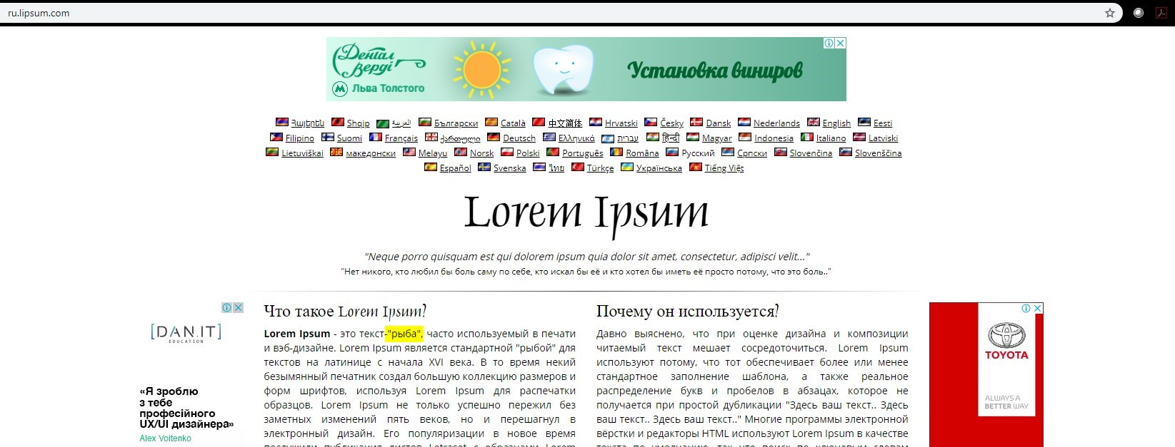

**Test 2:**

1. Go to <https://lipsum.com/>

2. Press “Generate Lorem Ipsum”

3. Determine the number of paragraphs containing the word “lorem” (in this example, there are 2):

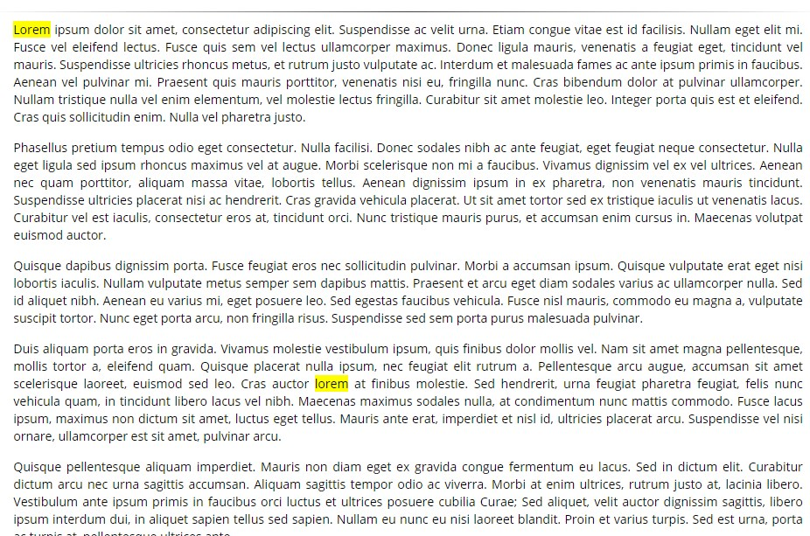

4. Run the generation 10 times and get the average number of paragraphs

5. Fail the test if the value is less than 3.