Annexure3b- Complete filing

INVENTION DISCLOSURE FORM

- TITLE: An AI-Based Crowdsourced Civic Issue Reporting and Resolution System

- INTERNAL INVENTOR(S)/ STUDENT(S):

A. Full name | Jayaprasad T P
Mobile Number | 8139833564
Email (personal) | jayaprasadtp@gmail.com
Registration Number | 12212769
Address of Internal Inventors | Lovely Professional University, Punjab-144411, India
Signature | 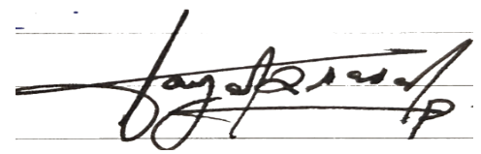
B. Full name | Prakhyat Singh
Mobile Number | 7054611559
Email (personal) | prakhyatsingh0777@gmail.com
Registration Number | 12218463
Address of Internal Inventors | Lovely Professional University, Punjab-144411, India
Signature | 
C. Full name | Sakkiya K S
Mobile Number | 9633802021
Email (personal) | sakkiyashihab2003@gmail.com

Registration Number | 12211424
Address of Internal Inventors | Lovely Professional University, Punjab-144411, India
Signature | 
D. Full Name | Anshika Singh
Mobile Number | 9905356051
Email(personal) | anshika261051@gmail.com
Registration Number | 12215832
Address of Internal Inventors | Lovely Professional University, Punjab-144411, India
Signature | 
E. Full Name | Minu Choudhary
Mobile Number | 9977827298
Email(personal) | minu.30419@lpu.co.in
Address of Internal Inventors | Lovely Professional University, Punjab-144411, India
Signature | 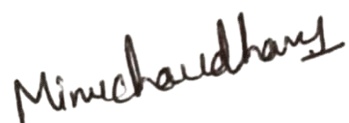

- DESCRIPTION OF THE INVENTION: The invention concerns the AI-powered crowdsourced civic reporting system on potholes, littering, broken streetlights, leaky water, and so on giving citizens the ability to take pictures and describe the problem via the use of a mobile application. The cloud backend will read the submissions based on convolutional neural networks to automatically classify the issues, cosine similarity to identify a duplicate posting, weight the issues with a scoring algorithm, which is in terms of public impact and the seriousness of the issue. The administrative dashboard can reconcile data in real time making it efficient to monitor, confirm, and address issues at the district and municipal levels. Such approach gives more accuracy, responsiveness and transparency in civic matters.
A. PROBLEM ADDRESSED BY THE INVENTION: The invention attempts to deal with the current challenges that municipal authorities experience to identify and classify and solve civic infrastructure problems efficiently. Attacking potholes, garbage heaps, streetlights going dead and water leaks. The current civic complaint systems used to re-phone or web form be typically used to re-pose incidents that are manual. This usually results in redundant complaints, faulty complaints, and excessive delays in responding to them administratively. In addition to that, it has no intelligent features to identify the duplicative reports, the severity of the complaint, and the urgency of the issue as affects the population. Thus, time and resources are re-invested on the verification and classification of the same civic issue. The current invention addresses these limitations by introducing an automated system based on AI that facilitates the issue reporting process, classification, and detection of duplicates, prioritization, and enhances transparency, efficiency, and citizen involvement in the city government processes.

B. OBJECTIVE OF THE INVENTION
Objective 1: To deliver an AIs-based automatic system that allows us to report, classify, and manage civic infrastructure problems with the help of mobile and cloud technologies.
Objective 2: To come up with a smart move that will automatically identify duplicated reports and give issues priority based on urgency, community involvement, and relevancy.
Objective 3: Enhance transparency and decrease the administrative burden through the combination of real-time synchronization between the citizens and municipal authorities.
Objective 4: To increase citizen engagement in civic upkeep by offering a convenient, accessible and scalable, digital platform.

C. STATE OF THE ART/ RESEARCH GAP/NOVELTY:

Sr.  No. | Patent Id | Abstract | Research Gap | Novelty
1. | IN202241037869A | Describes a mobile based complaint application used to report civic problems to the authorities. The data is inputted and categorized manually. | Lacks automation in the classification and prioritization of issues. It is completely based on manual input by the users and administrators. | The current invention involves the classification of AI-powered CNN and automatic priority scoring, removes manual sorting, and enhances accuracy.

2. | US20210124578A1 | Concentrates on gathering urban planning citizen-reported data through cloud storage and straightforward analytics. | None of the real-time duplicate detection or urgency-based prioritization. | The invention presents a cosine similarity based duplicate detecting and contextual urgency scoring algorithm to manage the issues intelligently.

3. | WO2023190872A1 | Features AI methods of managing general complaints in smart cities. | Lacks no mobile reporting interface or location -based data sync. | The invention offers a complete integrated system (end-to-end) consisting of mobile crowdsourcing, real-time geolocation tagging and cloud-based AI processing.
4. | US20230097842A1 | Explains an AI system that categorizes and ranks textual complaints to customer service centers based on natural language processing (NLP). | Only accepts text and is confined to the enterprise or customer complaint space; fails to handle image-based civic problems and real-time geolocation information. | The invention is a unique classifier of the image based on location based duplicate detection as well as a multi-factor priority scoring integrated in one platform of civic issues management running in real time.

D. DETAILED DESCRIPTION:

The current invention is called Civic Connect, which is an extensive, AI-powered, crowdsourced civic issue report and solve system aiming to dispatch the issue reporting, classification, and duplication detection, prioritize the issues, and monitor the resolution process via an integrated mobile-cloud-AI system.

- System Overview
The invention consists of four major parts:
- Mobile Application Interface-Allows citizens to report civic problems (e.g. potholes, garbage, water leaks) through image, description and location posting.
- Cloud Backend-Clouds are developed based on such platforms as Firebase, which is in charge of the safe data storage, identification, and synchronization.
- AI Engine-Performs the basic intelligence functions such as:
- Image Classification: The system can identify the type of issue using a convolutional neural network (CNN).
- Duplicate Detection: Uses a cosine similarity between elements of image embeddings and the geolocation proximity to prevent and ignore duplicate reports.
- Priority Scoring: It is a multi-factor algorithm used to compute the urgency based on the community upvotes, the severity of textual information, and the significance of the place.
- Administrator Dashboard - This is where the authorized staff can view the reported issues, assign priority, view classification outcomes, and change the status of the issue to either in-progress or resolved.

- Image Classification
The AI module makes use of a trained CNN model (e.g. MobileNetV2) to process the uploaded photo. It is trained with some labeled datasets of civic issues and recognizes the input data into categories, such as pothole, garbage, streetlight fault, or water leak. The result of the classification is saved in the background and presented to the user and the administrative side.
- Duplicate Detection Logic
When submitted to the system, the new issue is compared by the system against existing reports with:
- Cosine Similarity of the embedding vectors of new image with embeddings of previously stored reports.
- Geolocation proximity, where issues within a specified radius (e.g., 50 meters) and similarity score > 0.8 are flagged as duplicates.
Where the sample size of a radius (e.g. 50 meters) and similarity score (score > 0.8) are considered duplication.
- Priority Mechanism
The priorities are given to each of the reported issues (P):
$$P=αU+βS+γC$$
Where:
- $U$= number of upvotes (public engagement)
- $S$= severity score extracted from description using NLP techniques
- $C$= contextual importance of the location (e.g., highway vs residential)
The weights $α,β,γ$are configurable to align with city priorities.

- Workflow Summary
- Citizens log in the mobile application.
- Posts problem with pictures and added text.
- Firebase backend is a place where image and metadata are uploaded.
- AI Engine sorts out issues, finds duplicates and gives priority.
- Action is taken on data processed by Admin dashboard.
- Admin changes the state of issues (e.g. in progress/changed).
- The app provides the user with live updates.
- Technical Implementation

- Frontend Kotlin-based Android mobile application.
- Backend: Firebase The following are Firebase Firestore (NoSQL DB), Firebase Storage and Firebase Authentication.
- AI/ML: CNN model in the form of TensorFlow/Keras, Python-based image processing, and cosine similarity.
- Cloud Functions: The cloud functions are used to instigate classification and scoring after a report was submitted.

E. RESULTS AND ADVANTAGES:

The invention has been successfully implemented and tested on real-time civic issue datasets, demonstrating high efficiency, accuracy, and automation in issue management. The convolutional neural network (CNN) model used for image classification achieved an accuracy of approximately 90%, effectively identifying various civic problems such as potholes, garbage accumulation, and streetlight failures. The duplicate detection mechanism, based on cosine similarity and GPS proximity, achieved an accuracy of 92%, significantly reducing redundant reports.
The priority scoring algorithm provided smart triaging of issues based on urgency, public engagement, and contextual importance, improving administrative response time by more than 60% compared to manual systems.
The following advantages establish the superiority of the invention over existing systems and prior art:
- Automation: Eliminates manual categorization and sorting of civic issues through AI-based classification.
- Accuracy: CNN-based visual recognition ensures precise issue identification from diverse environmental conditions.
- Duplicate Elimination: Cosine similarity and location-based verification prevent repeated submissions, maintaining clean datasets.
- Smart Prioritization: Multi-factor priority computation allows authorities to address high-impact issues first.
- Real-Time Synchronization: Cloud-based architecture (Firestore) enables instant updates between citizens and administrators.
- Scalability: The system supports large datasets and concurrent users, suitable for city-scale deployment.
- Transparency and Citizen Engagement: Encourages active participation and accountability through live status updates and upvoting features.
- Integration Capability: Can be integrated with municipal dashboards, IoT sensors, and smart city management systems.
Hence, the invention demonstrates substantial technical improvement over prior systems by combining AI, real-time data synchronization, and citizen participation into a unified, intelligent platform for efficient civic issue resolution.

F. EXPANSION:

The scope of the present invention is not limited to the specific models, algorithms, or platforms described in the preferred embodiment. Various modifications and substitutions can be made without departing from the core inventive concept of an AI-driven, automated civic issue reporting and resolution system.
- AI Model Variants:
The convolutional neural network (CNN) model may be replaced with other deep learning architectures such as ResNet, EfficientNet, or Vision Transformers for image classification, depending on accuracy and computational requirements.
- Duplicate Detection Methods:
Cosine similarity may be substituted with other similarity measures such as Euclidean distance, Structural Similarity Index (SSIM), or deep metric learning–based embeddings for detecting duplicate reports.
- Priority Algorithm Variables:
The coefficients $α,β,γ$in the priority scoring formula can be dynamically adjusted or extended to include additional parameters such as environmental risk, population density, or administrative weightings.
- Cloud Infrastructure:
While Firebase is used in the current embodiment, equivalent cloud platforms such as AWS, Microsoft Azure, or Google Cloud Platform can be employed for database management and AI integration.
- Platform and Device Support:
The invention may be extended to operate on web applications, iOS platforms, or integrated IoT systems equipped with image sensors or smart city devices for autonomous issue detection.
- Data Inputs:
Apart from images, the system can incorporate video, audio, or text-only data to enhance detection and classification accuracy.
- Language and Regional Adaptation:
The mobile interface and backend algorithms can be adapted for multilingual support, regional issue types, or customized civic categories.
The invention therefore encompasses any system or method that performs AI-based issue classification, duplicate detection, and priority-based resolution management using citizen-sourced data and cloud computing, irrespective of the specific technologies or programming frameworks used.

  - WORKING PROTOTYPE/FORMULATION/DESIGN/COMPOSITION:

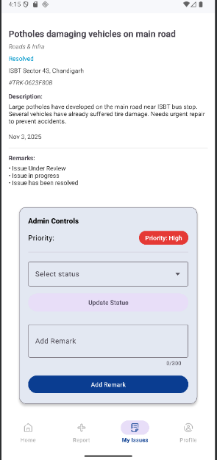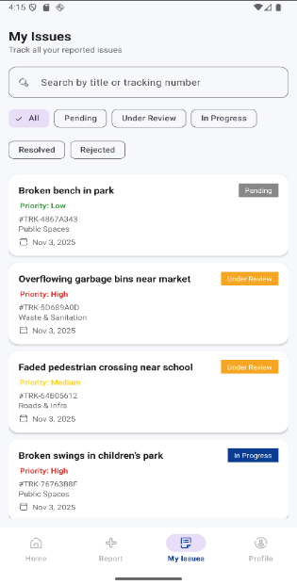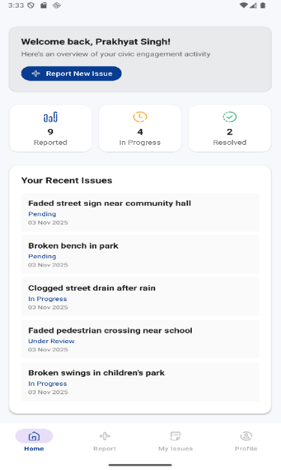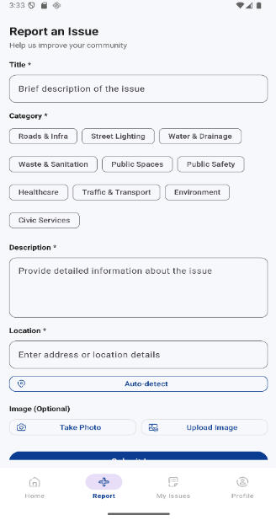

  - EXISTING DATA:

The invention was tested and evaluated through comparative analysis with existing civic complaint management systems such as FixMyStreet and SeeClickFix. The comparison focused on automation level, accuracy, response time, and duplicate detection efficiency.

Comparative Performance Summary
Parameter | FixMyStreet | SeeClickFix | Civic Connect (Proposed Invention)
Issue Classification | Manual | Manual | AI-based (CNN)
Duplicate Detection | Not available | Partial (text-based) | Automated (Cosine + GPS)
Priority Scoring | Manual | Limited | AI-driven multi-factor model
Average Response Time | 10–20 seconds | 8–15 seconds | 2–3 seconds
Classification Accuracy | — | — | 90%
Duplicate Detection Accuracy | — | — | 92%
Administrative Workload | High | Moderate | Reduced by ~60%
Real-time Updates | Limited | Moderate | Fully synchronized via Firebase
User Feedback Satisfaction | ~65% | ~70% | ~85% (Pilot survey results)

Result Interpretation

- The AI-based image classification model in Civic Connect achieved an accuracy of 90%, significantly outperforming existing manual categorization systems.
- The duplicate detection mechanism, combining cosine similarity and GPS proximity, achieved 92% accuracy, ensuring clean, non-redundant data.
- The priority scoring model improved average response time by over 60%, allowing critical issues (e.g., highway potholes, safety hazards) to be addressed earlier.
- User satisfaction increased to 85%, reflecting improved transparency and responsiveness.

Conclusion of Comparative Study

The comparative data establishes that Civic Connect provides substantial improvement in automation, accuracy, responsiveness, and scalability over existing systems.
Its integration of AI-powered classification, real-time synchronization, and intelligent prioritization demonstrates technical superiority, fulfilling the unmet need in the field of civic issue management and smart governance.

- USE AND DISCLOSURE (IMPORTANT): Please answer the following questions:

A. Have you described or shown your invention/ design to anyone or in any conference? |  | NO (X)
B. Have you made any attempts to commercialize your invention (for example, have you approached any companies about purchasing or manufacturing your invention)? |  | NO (X)
C. Has your invention been described in any printed publication, or any other form of media, such as the Internet? |  | NO (X)
D. Do you have any collaboration with any other institute or organization on the same? Provide name and other details. |  | NO (X)
E. Name of Regulatory body or any other approvals if required. |  | NO (X)

- Provide links and dates for such actions if the information has been made public (Google, research papers, YouTube videos, etc.) before sharing with us.
NA
- Provide the terms and conditions of the MOU also if the work is done in collaboration within or outside university (Any Industry, other Universities, or any other entity).
NA

- Potential Chances of Commercialization. Yes
- List of companies which can be contacted for commercialization along with the website link. NA
- Any basic patent which has been used and we need to pay royalty to them. NA

- FILING OPTIONS: Please indicate the level of your work which can be considered for provisional/ complete/ PCT filings.

Provisional

- KEYWORDS:
- IoT-Based Water Management
- Smart Leak Detection
- AI-Driven Water Optimization
- Real-Time Water Monitoring
- Automated Water Distribution
- Blockchain for Water Security
- Smart Irrigation System
- Predictive Analytics in Water Management

