
Request return of personal
property inside a repossessed car
Instructions

You made your letter. Here’s what to do next.

 | - Print the letters.
 | - Sign the letter to the creditor.
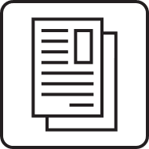 | - Keep copies of the letters for your records.
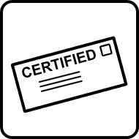 | - Deliver the letter to the creditor by certified mail. You can learn more about certified mail at https://faq.usps.com/s/article/Certified-Mail-The-Basics.
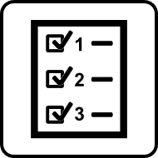 | - Once you learn the repossession agency’s name and address, add them to the letter to the repossession agency, sign and date it, and send it by certified mail.

Do not send these instructions to the creditor or the repossession agency.

